Supplementary Materials for
Surufatinib plus toripalimab combined with etoposide and cisplatin as first-line treatment in advanced small-cell lung cancer patients: a phase Ib/II trial
Author(s) list
Yaxiong Zhang^{1,#}, Yan Huang^{1,#}, Yunpeng Yang^{1,#}, Yuanyuan Zhao^{1,#}, Ting Zhou^{1,#}, Gang Chen¹, Shen Zhao¹, Huaqiang Zhou¹, Yuxiang Ma², Shaodong Hong¹, Hongyun Zhao², Li Zhang^{1,*}, Wenfeng Fang^{1,*}
#These authors contributed equally:
Yaxiong Zhang, Yan Huang, Yunpeng Yang, Yuanyuan Zhao, Ting Zhou.
*Corresponding author:
Wenfeng Fang, (Email: fangwf@sysucc.org.cn)
Li Zhang (Email: zhangli@sysucc.org.cn).

This file includes:
Figures S1 to S5
Tables S1 to S2
Caption for Data S1

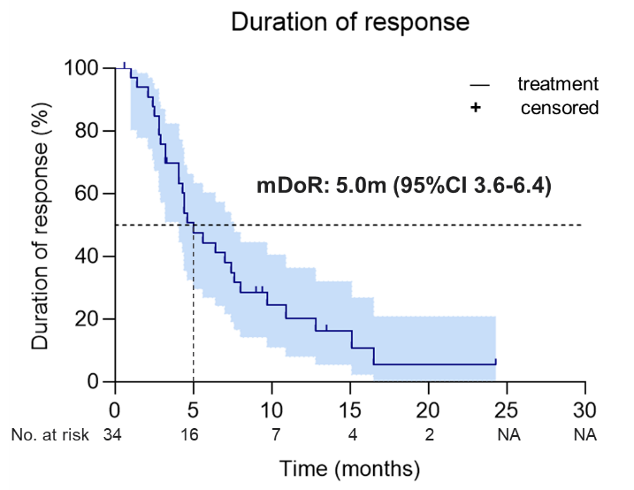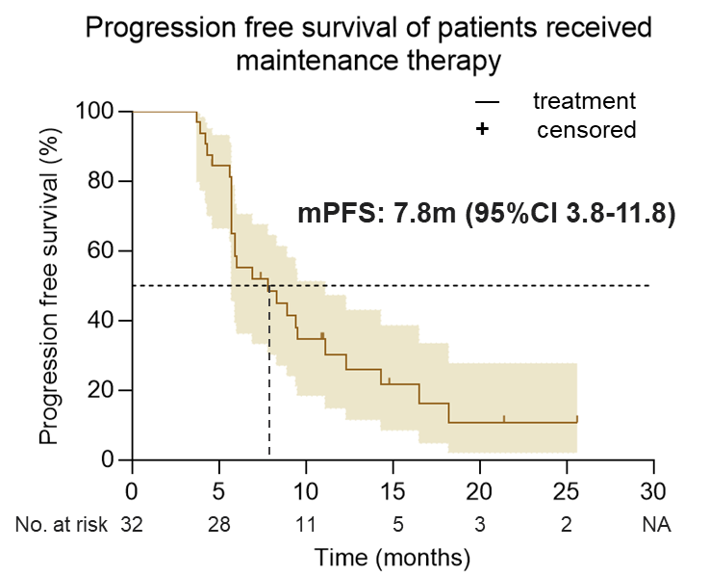

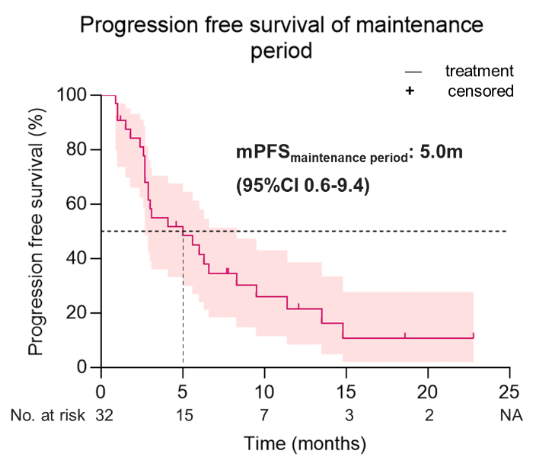
Figures S1. Kaplan–Meier curves of duration of response, progression-free survival of patients received maintenance therapy and progression-free survival of the maintenance period.

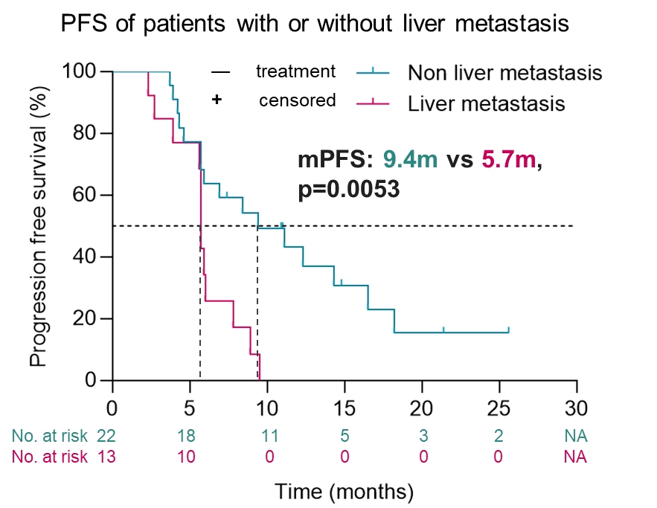
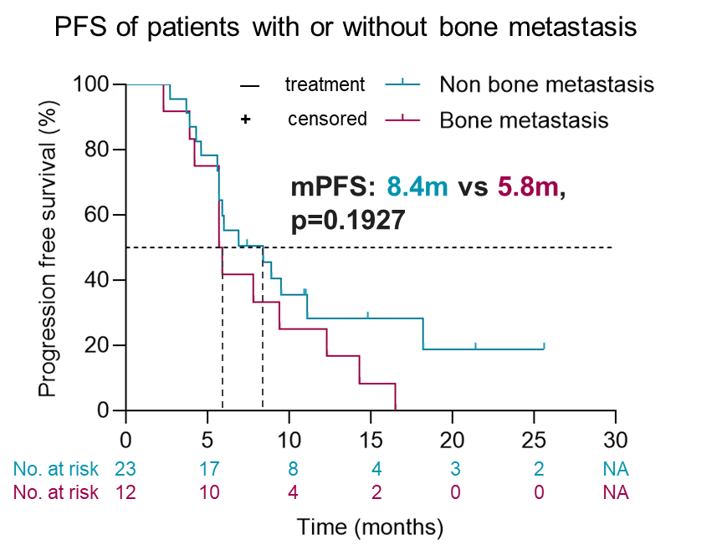
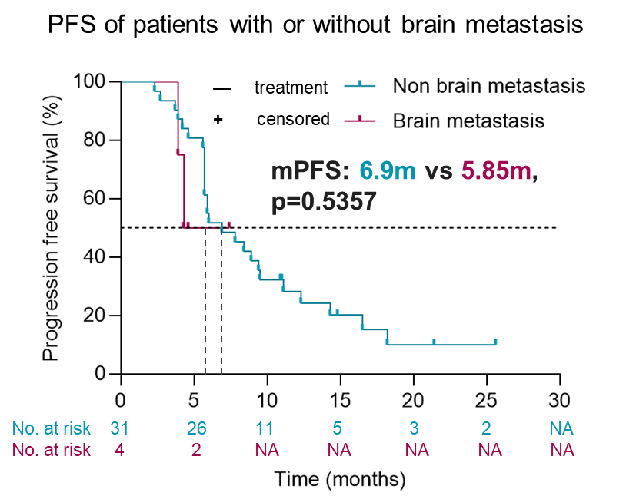
Figure S2. Subgroup analysis of progression-free survival stratified by different metastatic sites.

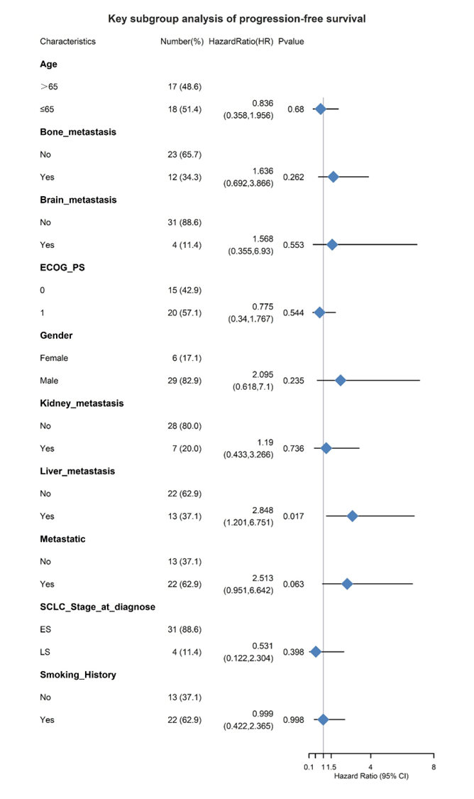
Figure S3. Univariate Cox regression analysis of progression-free survival.

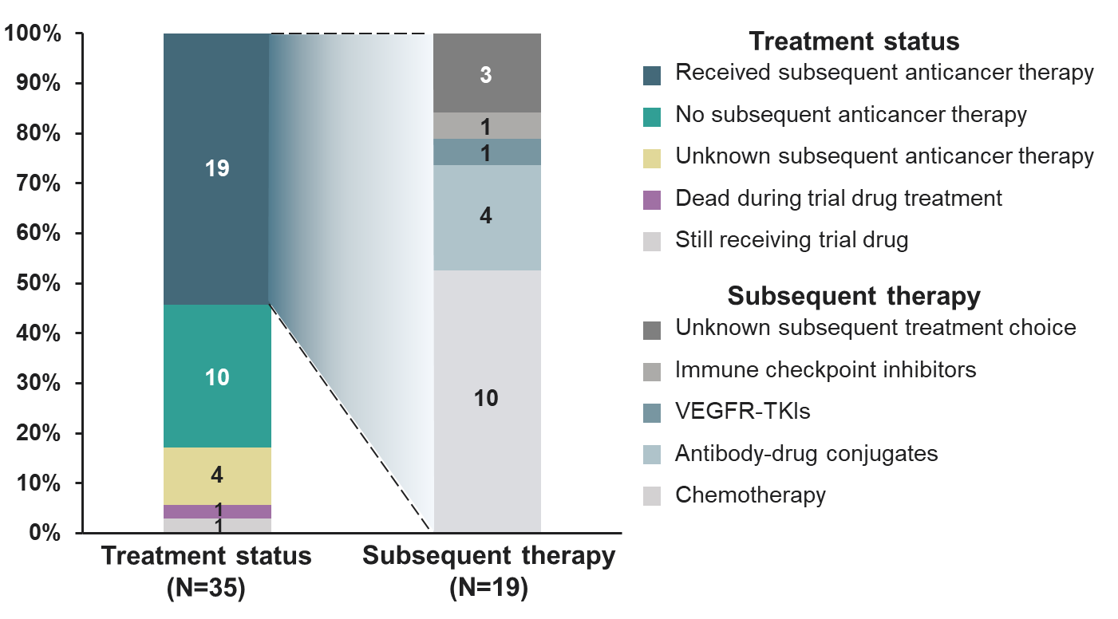

Figure S4. Subsequent therapies of the enrolled patients.

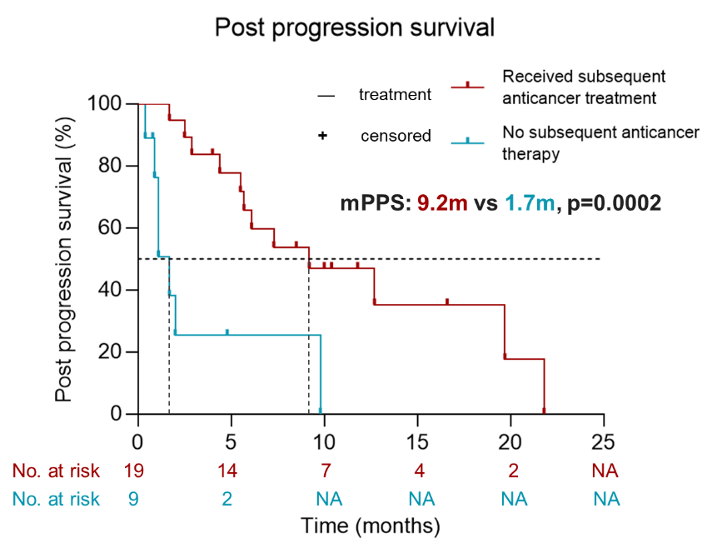

Figure S5. Influence of subsequent therapies on post progression survival of the enrolled patients.

Table S1. Tumor shrinkage rate and PFS & OS stratified by microsatellite status, TMB and PD-L1 expression at baseline.
Patient No. | MSS | TMB | PD-L1 expression | Tumor response (shrinkage rate, %) | PFS  (months) | OS  (months) | Status
1012 | UK | UK | TPS<1% | PR (-36.0) | 3.7 | 5.4 | Dead
1028 | UK | UK | TPS<1% | PR (-63.1) | 6.0 | 6.8 | Loss of follow up
1031 | UK | UK | TPS=30% | PR (-60.7) | 16.5 | 18.2 | Still alive
1039 | MSS | Low (6.72Muts/Mb) | UK | PR (-30.6) | 3.9 | 4.8 | Dead
1026 | MSS | Low  (7.68 Muts/Mb) | UK | PR (-37.7) | 3.9 | 5.0 | Dead
1004 | MSS | Low  (7.68 Muts/Mb) | UK | PR (-59.8) | 4.3 | 10.4 | Dead
1033 | MSS | Low  (7.68 Muts/Mb) | UK | PR (-59.6) | 4.6 | 4.6 | Loss of follow up
1013 | MSS | Low  (6.72 Muts/Mb) | UK | PR (-39.1) | 6.9 | 14.2 | Dead
1006 | MSS | Low  (4.3 Muts/Mb) | UK | PR (-60.5) | 7.4 | 27.1 | Dead
1038 | MSS | High  (10.56 Muts/Mb) | UK | PR (-69.2) | 8.9 | 17.4 | Still alive
1009 | MSS | High  (14.4 Muts/Mb) | UK | PR (-90.8) | 14.8 | 28.9 | Still alive
Abbreviations:TPS tumor proportion score, MSS microsatellite stable, TMB tumor mutational burden, PR partial response, PFS progression free survival, OS overall survival, UK unknown.

Table S2. Serious adverse events.
Events, n (%) | All patients (n=38)
Events, n (%) | Any grade | Grade 3 or higher
Incomplete intestinal obstruction | 1 (2.6) | 1 (2.6)
Platelet count decreased | 2 (5.2) | 2 (5.2)
COVID-19 infection | 1 (2.6) | 1 (2.6)
Transient atrial fibrillation | 1 (2.6) | 0
Pleural effusion | 1 (2.6) | 0
Rash | 1 (2.6) | 0
Hyponatremia | 1 (2.6) | 1 (2.6)
Elevated serum amylase | 1 (2.6) | 1 (2.6)
Neutrophil count decreased | 1 (2.6) | unknown
Febrile neutropenia | 1 (2.6) | 1 (2.6)
Atrial fibrillation | 1 (2.6) | 1 (2.6)

Data S1. (separate file) NGS data of 8 enrolled patients.

