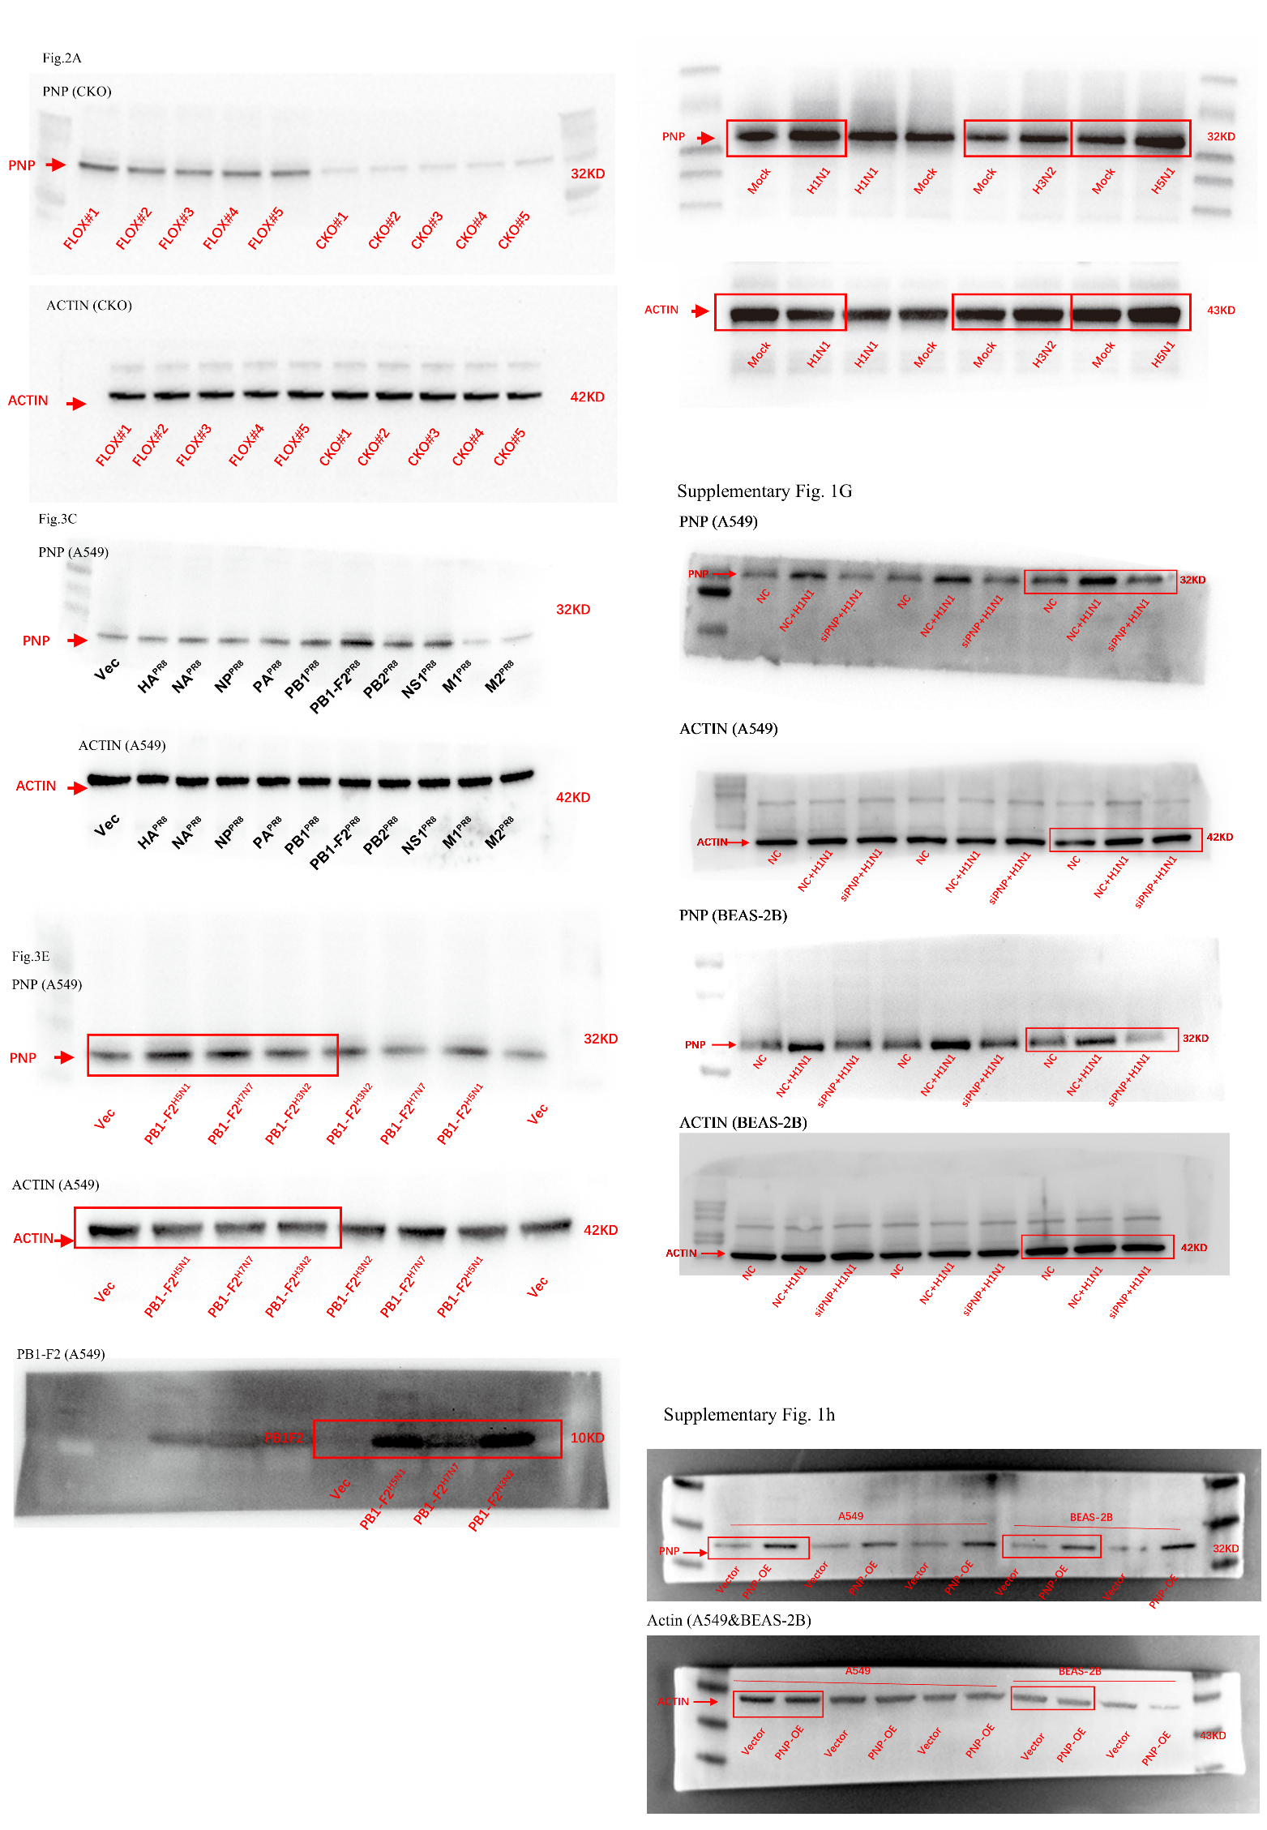
Supplementary Fig. 1g
Fig. 3e
Supplementary Fig. 1h
Supplementary Fig. 1f
Fig. 2a
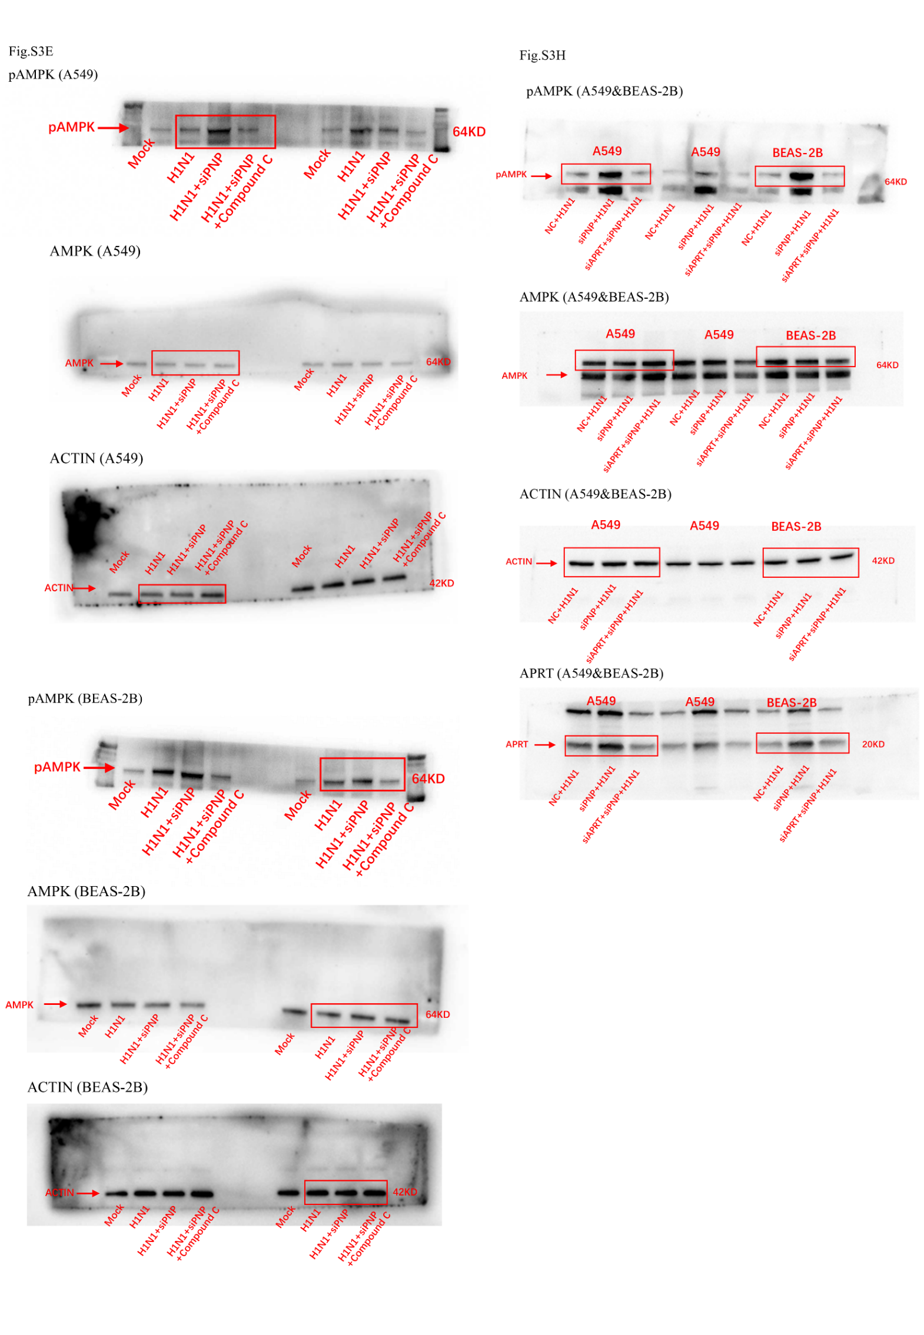
Supplementary Fig. 3h
Supplementary Fig. 3e
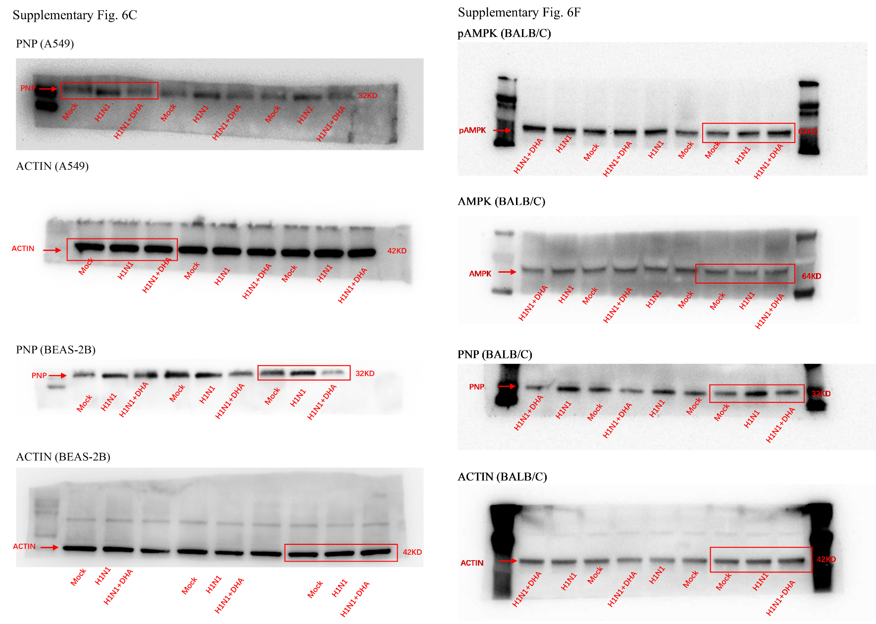
Supplementary Fig. 6f
Supplementary Fig. 6c

