Supplementary Materials for

High fructose consumption aggravates inflammation by promoting effector T cell generation via inducing metabolic reprogramming

Xiao Ma^{#1,2}, Jiao Chen^{#3}, Fang Wang^{#4}, Xinzou Fan¹, Zhenhong Li¹, Hantian Liang¹, Hao Cheng¹, Fang Nan¹, Yubin Lin¹, Xiaoshuang Song¹, Jianan Zhang¹, Fan Gao¹, Wei Zhang^{1,2}, Wenwen Jin⁵, Huiyuan Zhang², Jiyu Tong⁶, Hong Jiang⁷, Xikun Zhou¹, Qiang Zou⁸, Hongbo Hu², Aiping Tong^{1,*}, WanJun Chen^{5,*}, Dunfang Zhang^{1,2,*}

Correspondence to: izdf@163.com (D.Z.); wchen@nih.gov (W.J.C); aipingtong@scu.edu.cn (A.T.).

This PDF file includes:

Figures. S1 to S13
Tables S1 to S2

Other Supplementary Materials for this manuscript include the following:

Original western blots (separate file)
Gating strategies for the flow cytometry data (separate file)

Figure. S1.
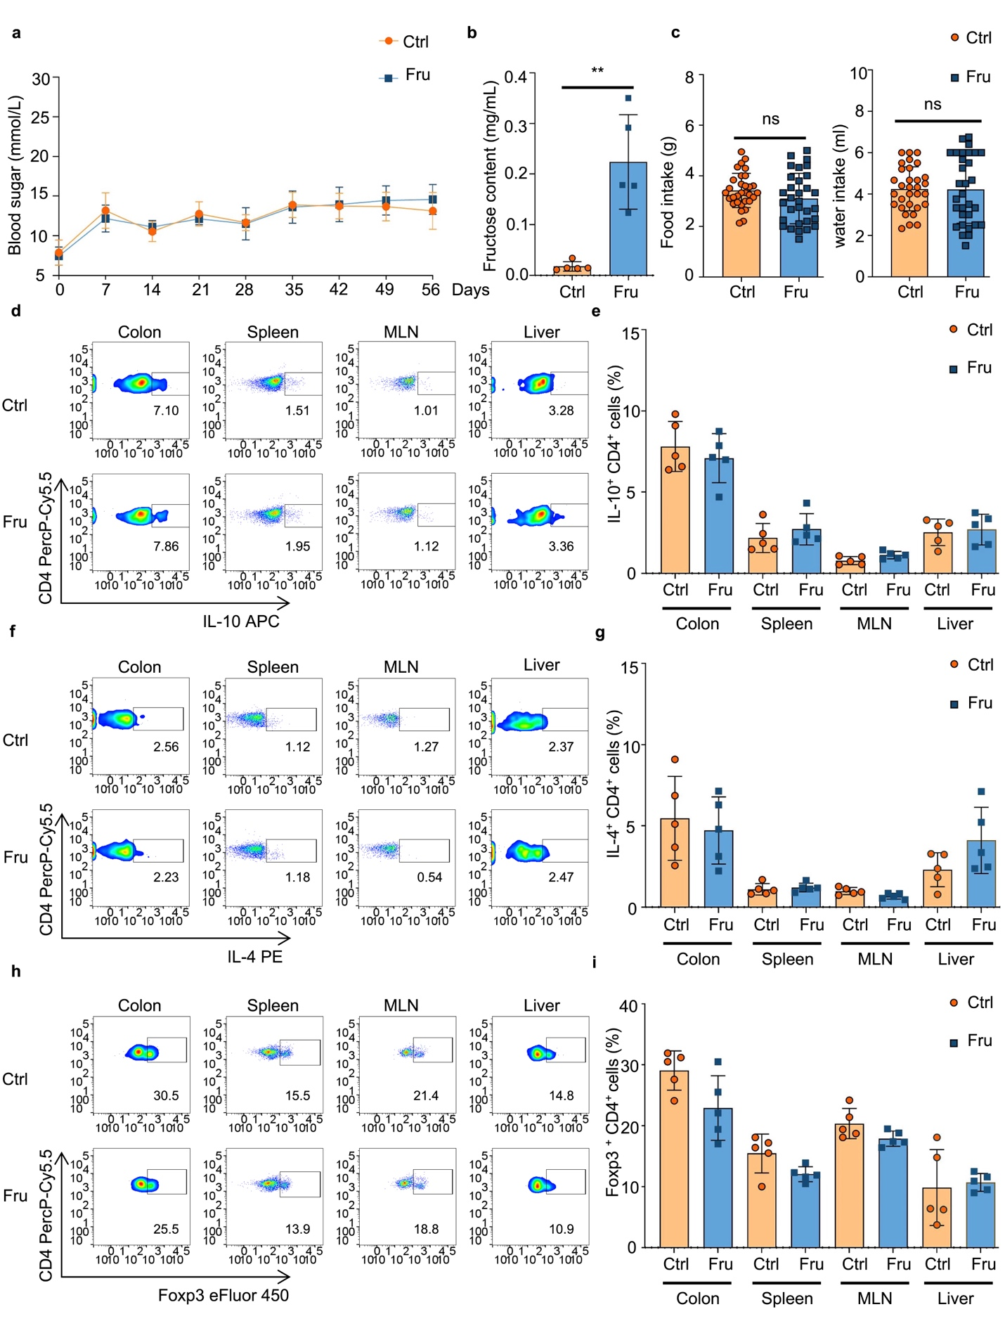
Supplementary Fig. 1. High fructose consumption promotes Th1 and Th17 cell-mediated immunity. C57BL/6 mice were treated with regular drinking water or 20% fructose water for two months, and the status of T cell immune responses was investigated. (a) Changes in blood sugar levels of the indicated mice (n = 10 mice per group). (b) Serum fructose levels in the indicated mice (n = 5 mice per group). (c) The mice's daily diet and water intake were measured every three days. (d–i) Frequencies of IL-10⁺CD4⁺T (Tr1) (d, e), IL-4⁺CD4⁺ T (Th2) (f, g), and Foxp3⁺CD4⁺ regulatory T (Treg) (h, i) cells in the colon, spleen, mesenteric lymph nodes (MLN), and liver of mice. Data are representative of two independent experiments (b–h) or pooled from two independent experiments (a). Unpaired two-tailed Student’s t-tests were used to calculate statistical significance. Summary data are presented as mean ± SD. **p < 0.01.

Figure. S2.
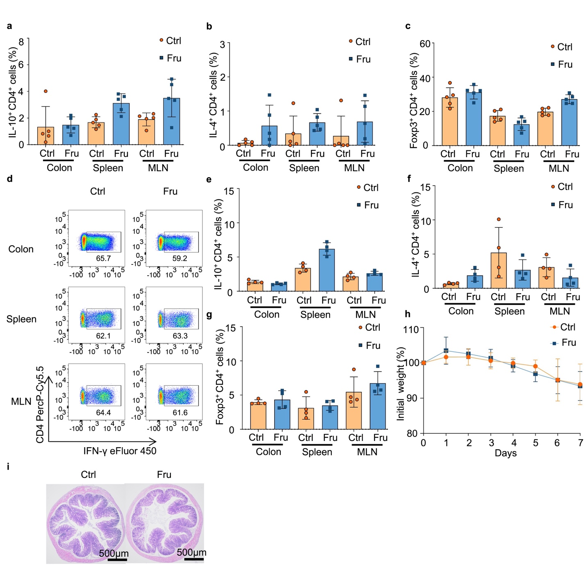
Supplementary Fig. 2. High fructose consumption exacerbates inflammatory bowel disease by promoting Th1 and Th17 cell-mediated immunity in two disease models. (a–c) C57BL/6 mice were treated with regular drinking or 20% fructose water for two months, and a DSS-induced colitis model was established to investigate the disease development (n = 5 mice per group). Bar graphs plots showing the frequencies of Tr1 cells (a), Th2 cells (b), and Treg cells (c) in the colon, spleen, and MLN of DSS-induced colitis mice. (d–g) Rag1^{-/-} mice transferred with CD4⁺CD25⁻CD45RB^{hi} T cells were treated with regular drinking or 20% fructose water and then examined for colitis development (n = 4 mice per group). Bar graphs and representative flow cytometry plots showing the frequencies of Th1 (d), Tr1 (e), Th2 (f), and Treg (g) cells in the colon, spleen, and MLN of T cell transfer colitis mice. (h and i) Nude mice were treated with regular drinking or 20% fructose water for two months, and a DSS-induced colitis model was established to identify the disease development. (h) The changes in body weight during the colitis induction (n = 4 mice per group). (i) Representative histology images of colon sections. Scale bars, 500 μm. Data are representative of two independent experiments. Summary data are presented as mean ± SD.

Figure. S3.
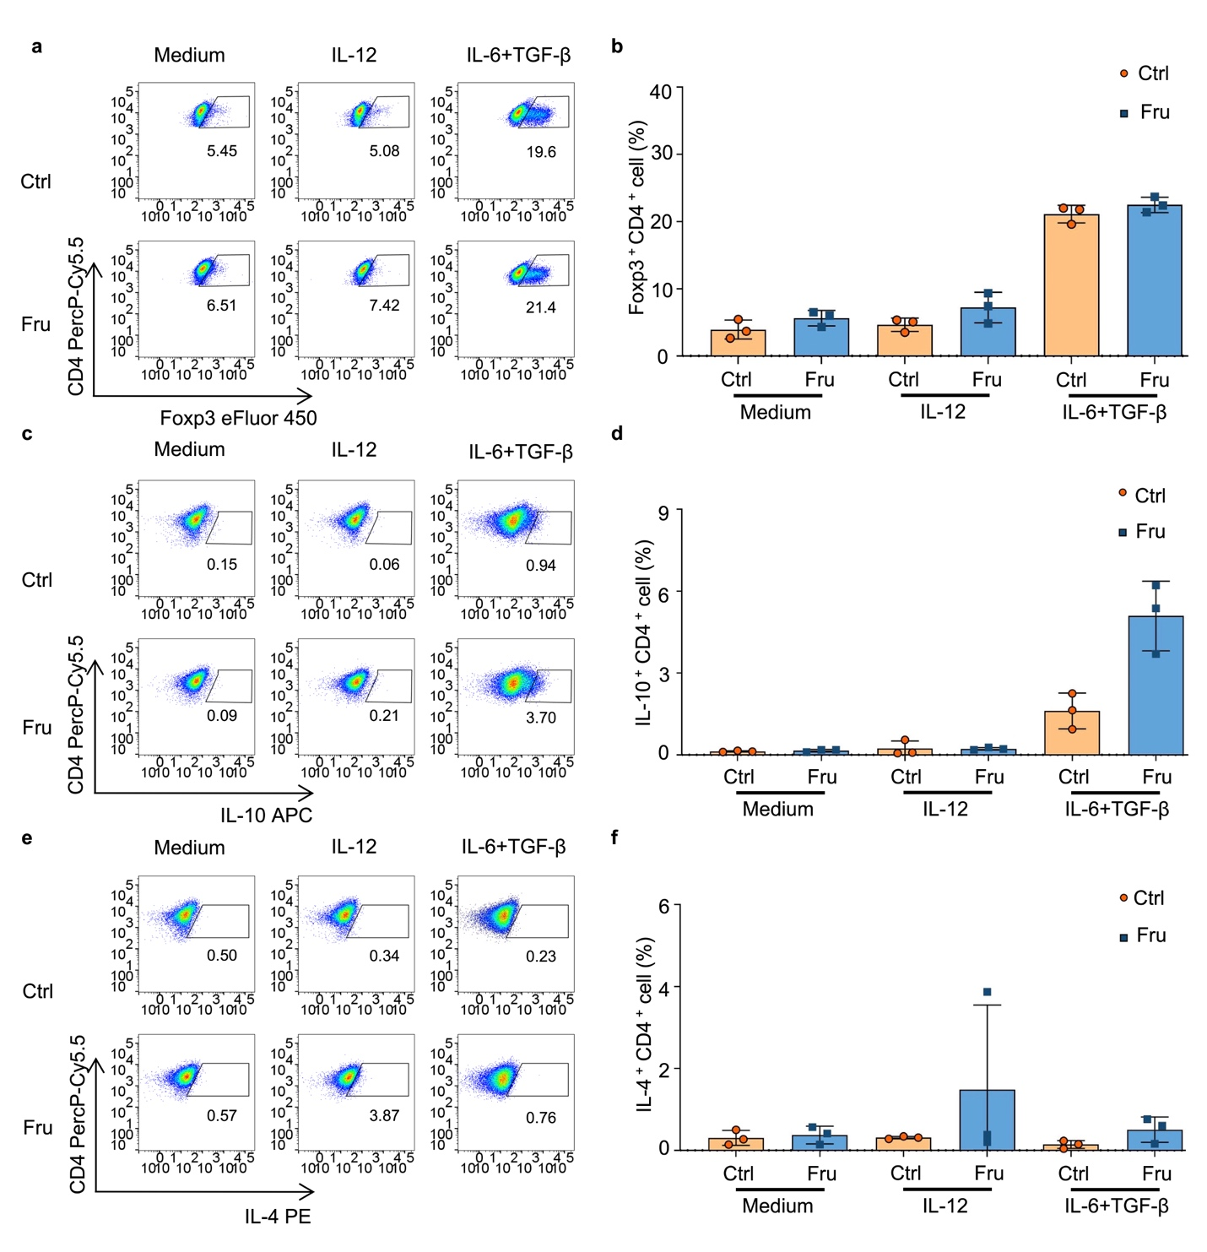
Supplementary Fig. 3. Fructose directly promotes differentiation of Th1 and Th17 cells in vitro. CD4⁺CD25⁻CD62L⁺ naïve T cells were cultured in complete DMEM containing 25 mM glucose or 25 mM fructose, with plate-bound anti-mouse-CD3 (1.5 μg/mL), soluble anti-mouse-CD28 (1.5 μg/mL), with or without indicated cytokines. Th1 cells were induced with recombinant mouse IL-12 (10 ng/mL), and Th17 cells were induced with recombinant human TGF-β1 (2 ng/mL) and recombinant mouse IL-6 (50 ng/mL). Cells were cultured at 37 ℃, 5% CO₂ for three days. (a–f) Frequencies of Treg (a, b), Tr1 (c, d), and Th2 (e, f) cells in indicated groups. Data are representative of three independent experiments (a, c, and e) or pooled from three independent experiments (b, d, and f). Summary data are presented as mean ± SD.

Figure. S4.
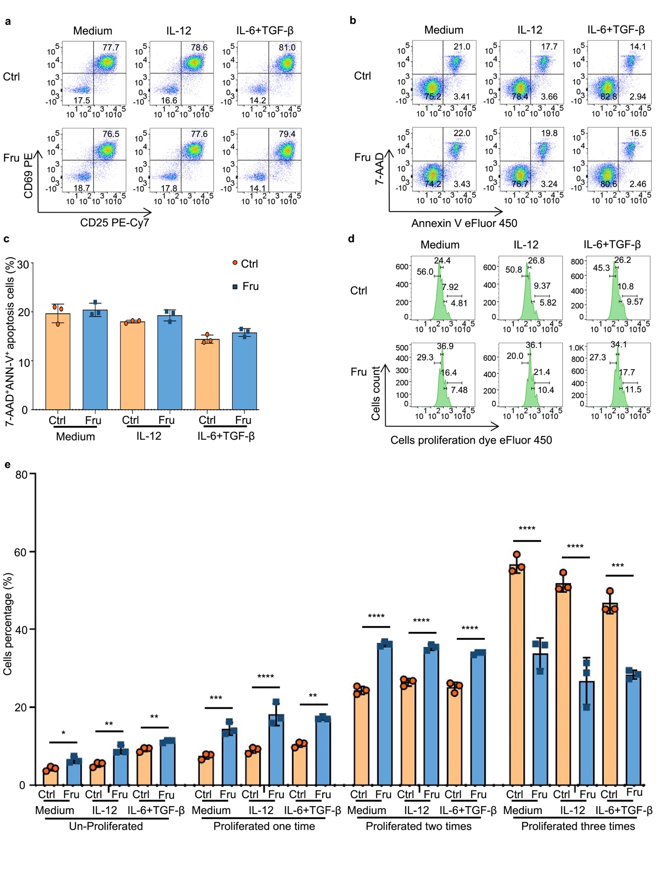
Supplementary Fig. 4. Th1 and Th17 cell differentiation promoted by fructose is not through the regulation of T cell activation. CD4⁺CD25⁻CD62L⁺ naïve T cells were cultured in cDMEM containing 25mM glucose or 25 mM fructose, with plate-bound anti-mouse-CD3 (1.5 μg/mL), soluble anti-mouse-CD28 (1.5 μg/mL), with or without indicated cytokines. Th1 cells were induced with IL-12 (10 ng/mL), and Th17 cells were induced with TGF-β1 (2 ng/mL) and IL-6 (50 ng/mL). Cells were cultured at 37 ℃, 5% CO₂ for 24 hours or three days. (a) Frequencies of CD69⁺CD25⁺ activated T cells in T cells cultured under induction conditions of Th0, Th1, and Th17 cells for 24 hours. (b and c) Apoptosis of T cells cultured under induction conditions of Th0, Th1, and Th17 cells for 24 hours. (d and e) The proliferation of T cells cultured under induction conditions of Th0, Th1, and Th17 cells for three days. Data are representative of three independent experiments (b and d) or are pooled from three independent experiments (c and e). Summary data are presented as mean ± SD. *p < 0.05, **p < 0.01, ***p < 0.001 and ****p < 0.0001, unpaired two-tailed Student’s t-tests.

Figure. S5.
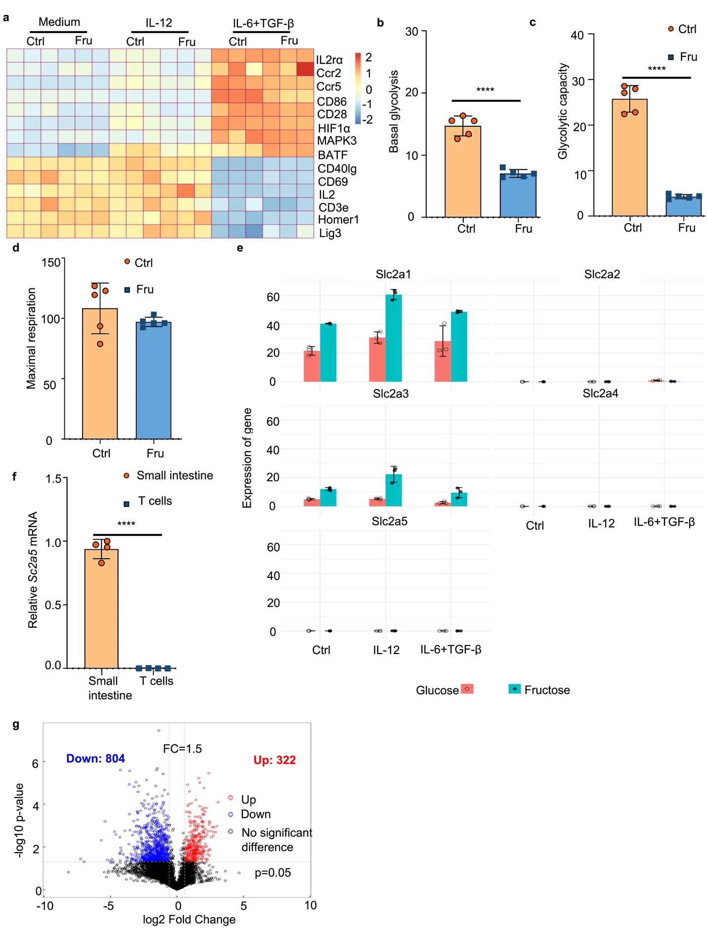
Supplementary Fig. 5. T cells cannot transport and utilize fructose effectively. (a) Expression of genes related to T-cell activation and differentiation between the fructose- and glucose-treated T cells in Th0, Th1, and Th17 induction conditions analyzed by RNA-seq (n = 3 per group). (b–d) Basal glycolysis, glycolytic capacity, and maximal respiration of CD4⁺ T cells cultured in glucose or fructose medium for 24 hours were determined by Seahorse XF Cell Mito Stress Test Kit. (e) Expression of Slc2a1, Slc2a2, Slc2a3, Slc2a4, and Slc2a5 in fructose- and glucose-treated T cells analyzed by RNA-seq (n = 3 per group). (f) The RNA level of Slc2a5 in mouse small intestine and sorted CD4⁺ T cells. (g) A volcanic map of differences between all metabolites detected in the fructose- and glucose-treated T cells (In the figure, the horizontal coordinate is the logarithm of log₂ of the Fold Change, and the vertical coordinate is the logarithm of -log₁₀ of the significance p-value). Significant difference metabolites: Metabolites meeting FC > 1.5 and p-value < 0.05 are shown in red, metabolites meeting FC < 0.67 and p-value < 0.05 are shown in blue, and metabolites with no significant differences are shown in gray) (n = 4 per group). Data are representative of three independent experiments (b–d) or are pooled from at least three independent experiments (a, e–g). Unpaired two-tailed Student’s t-tests were used to calculate statistical significance. Summary data are presented as mean ± SD. ****p < 0.0001.

Figure. S6.
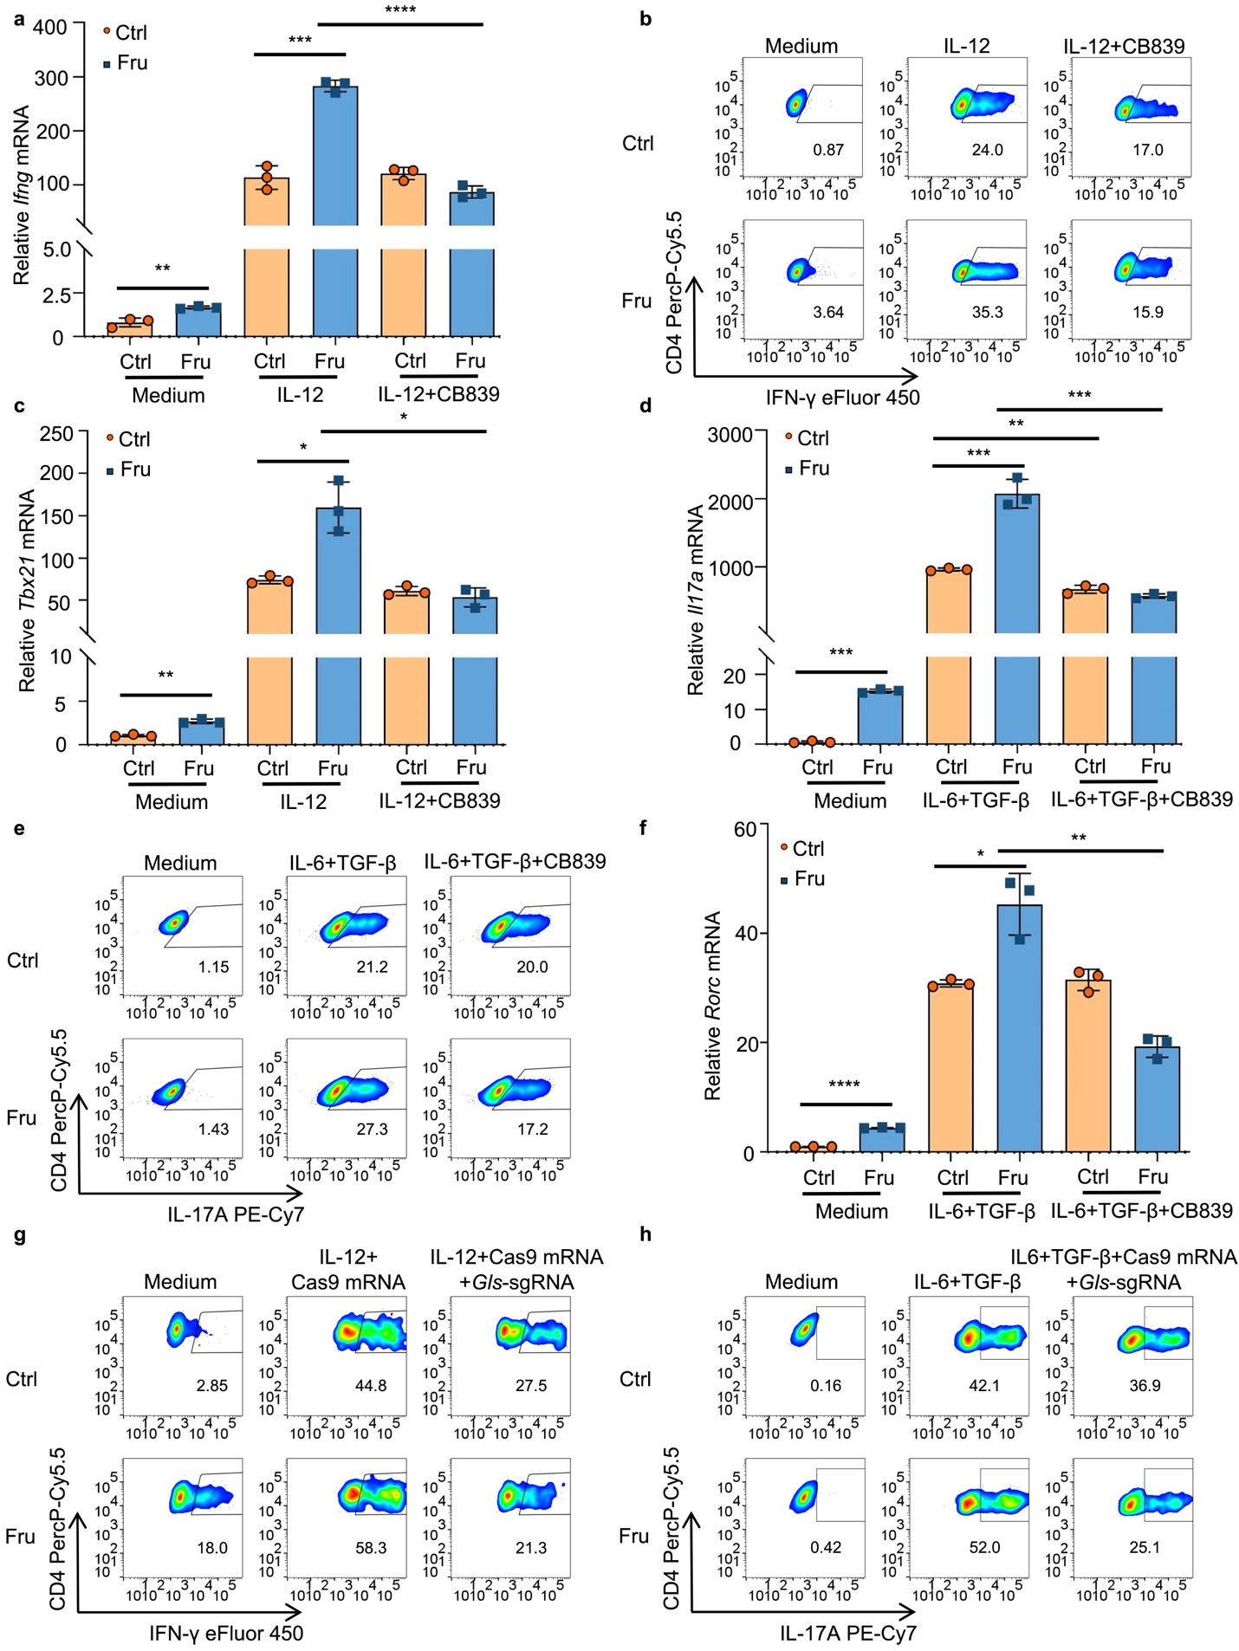
Supplementary Fig. 6. Fructose promotes Th1 and Th17 cell differentiations through a glutamine metabolism-dependent pathway. CD4⁺CD25⁻CD62L⁺ naïve T cells were cultured in cDMEM containing 25 mM glucose or fructose, with plate-bound anti-mouse-CD3 (1.5 μg/mL), soluble anti-mouse-CD28 (1.5 μg/mL), with or without indicated cytokines and CB839. Th1 cells were induced with mouse IL-12 (10 ng/mL), and Th17 cells were induced with human TGF-β1 (2 ng/mL) plus mouse IL-6 (50 ng/mL), and glutamine metabolism pathway was blocked with a glutaminase inhibitor CB839 (1 μM) or by Gls gene knockout using CRISPR/CAS9 system. Cells were cultured at 37 ℃, 5% CO₂ for three days. (a) The RNA level of Ifng under indicated cell culture conditions. (b) Frequencies of IFN-γ⁺ CD4⁺ Th1 cells under indicated cell culture conditions. (c) The RNA level of Tbx21 under indicated cell culture conditions. (d) The RNA level of Il17a under indicated cell culture conditions. (e) Frequencies of IL-17A⁺ CD4⁺ Th17 cells under indicated cell culture conditions. (f) The RNA level of Rorc under indicated cell culture conditions. (g and h) Frequencies of IFN-γ⁺ CD4⁺ Th1 cells (g), IL-17A⁺ CD4⁺ Th17 cells (h) in control T cells or Gls mutant T cells under indicated cell culture conditions. Data are representative of three independent experiments (b, e, g, h) or are pooled from three independent experiments (a, c, d, f). Unpaired two-tailed Student’s t-tests were used to calculate statistical significance. Summary data are presented as mean ± SD. *p < 0.05; **p < 0.01; ***p < 0.001; ****p < 0.0001.

Figure. S7.
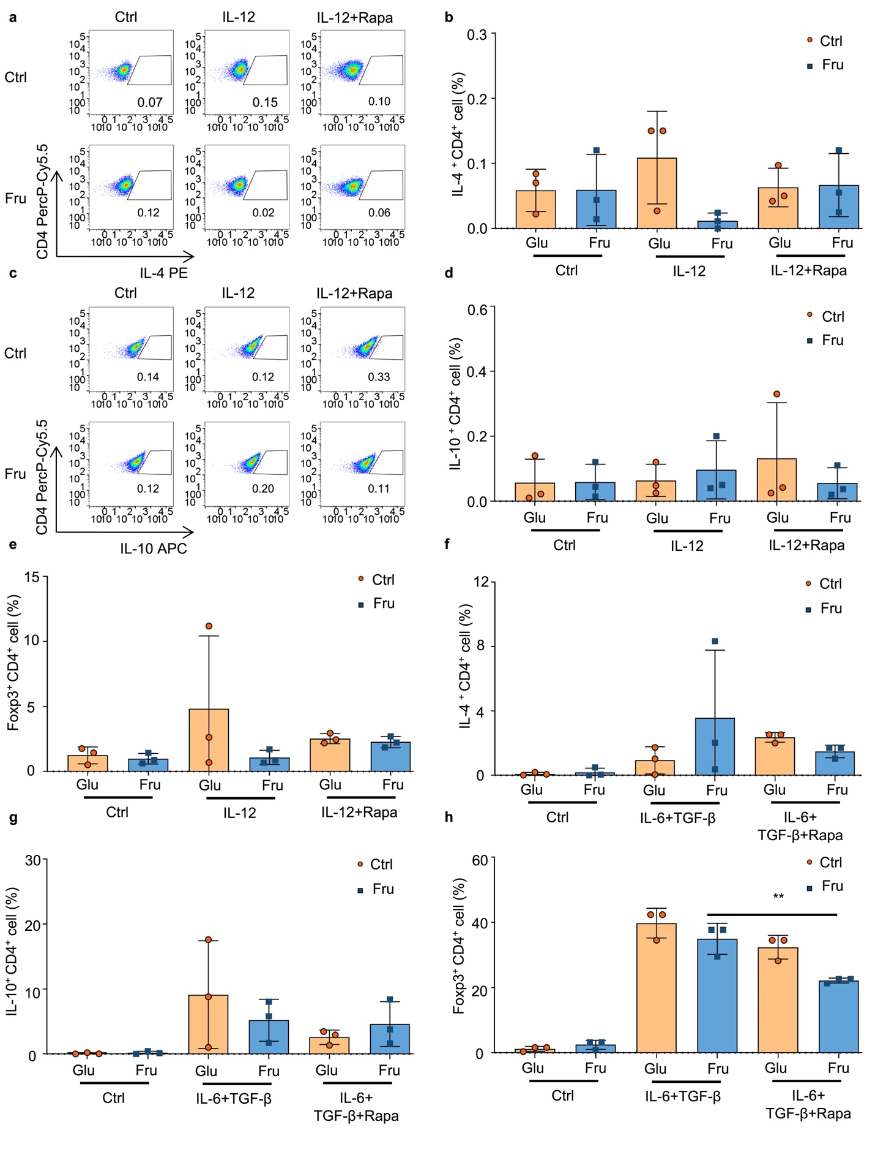
Supplementary Fig. 7. Fructose promotes Th1 and Th17 cell differentiation via glutamine metabolism-dependent mTORC1 activation. CD4⁺CD25⁻CD62L⁺ naïve T cells were cultured in cDMEM containing 25 mM glucose or fructose, with plate-bound anti-mouse-CD3 (1.5 μg/mL) and soluble anti-mouse-CD28 (1.5 μg/mL), with or without indicated cytokines and reagent. Th1 cells were induced with mouse IL-12 (10 ng/mL), and Th17 cell were induced with human TGF-β1 (2 ng/mL) plus mouse IL-6 (50 ng/mL), and mTOR pathway was blocked with rapamycin (100 nM). Cells were cultured at 37 ℃, 5% CO₂ for three days. (a–l) Frequencies of Th2 cells (a, b, and f), Tr1 cells (c, d, and g) and Foxp3⁺Treg cells (e and h) in T cells cultured for three days under indicated cell culture conditions. Data are representative of three independent experiments (a and c) or are pooled from three independent experiments (b, d, e–h). Unpaired two-tailed Student’s t-tests were used to calculate statistical significance. Summary data are presented as mean ± SD. **p < 0.01.

Figure. S8.
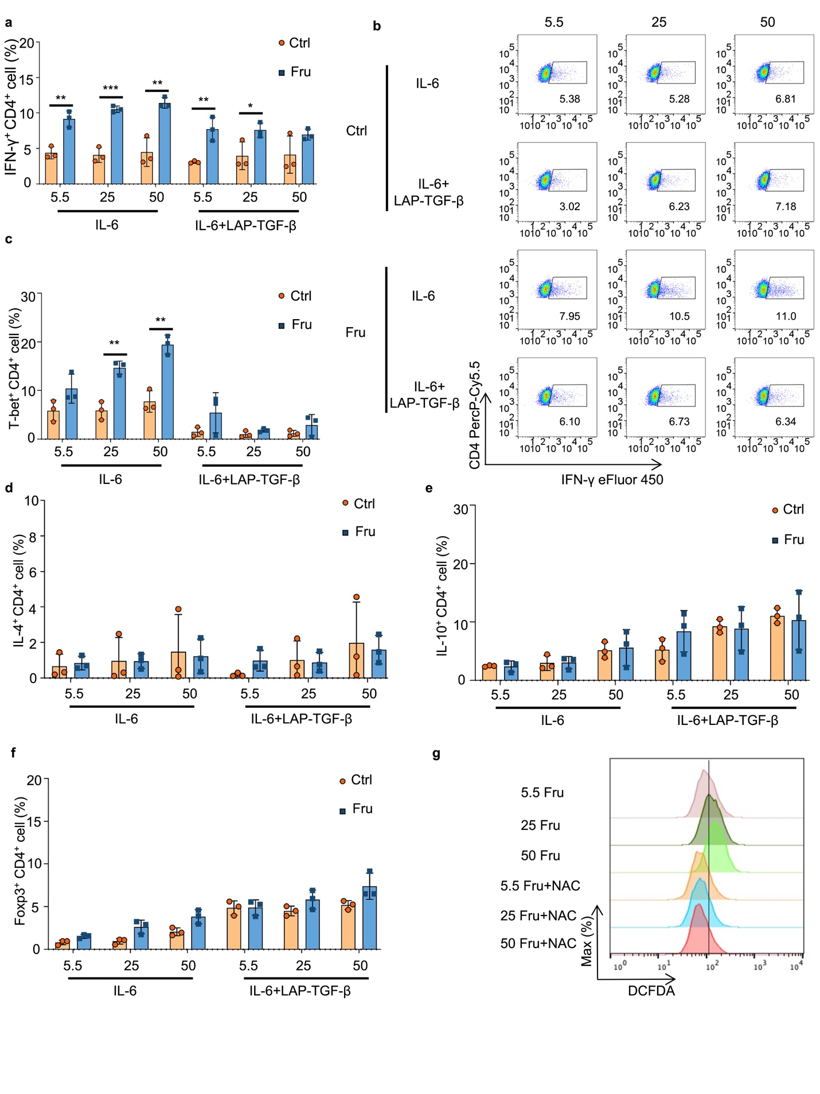
Supplementary Fig. 8. High fructose-induced TGF-β activation is involved in fructose-induced Th17 cell differentiation. CD4⁺CD25⁻CD62L⁺ naïve T cells were cultured for three days in cDMEM containing 5.5, 25, and 50 mM glucose or fructose, with plate-bound anti-mouse-CD3 (1.5 μg/mL) and soluble anti-mouse-CD28 (1.5 μg/mL). Th17 cells were induced with mouse IL-6 (50 ng/mL), with or without human latent TGF-β1 (10 ng/mL). (a, b) Frequencies of IFN-γ⁺CD4⁺ Th1 cells in T cells cultured under indicated cell culture conditions. (c) Frequencies of T-bet⁺CD4⁺ T cells in T cells cultured under indicated cell culture conditions. (d) Frequencies of IL-4⁺CD4⁺ Th2 cells in T cells cultured under indicated cell culture conditions. (e) Frequencies of IL-10⁺CD4⁺ Tr1 cells in T cells cultured under indicated cell culture conditions. (f) Frequencies of Foxp3⁺ Treg cells in T cells cultured under indicated cell culture conditions. (g) CD4⁺CD25⁻CD62L⁺ naïve T cells were cultured in cDMEM containing 5.5, 25, and 50 mM glucose or fructose for 24 hours, with plate-bound anti-mouse-CD3 (1.5 μg/mL) and soluble anti-mouse-CD28 (1.5 μg/mL), with or without NAC (10 mM), and then the production of ROS was determined. Data are representative of three independent experiments (b and g) or are pooled from three independent experiments (a, c–f). Unpaired two-tailed Student’s t-tests were used to calculate statistical significance. Summary data are presented as mean ± SD. *p < 0.05; **p < 0.01; and ***p < 0.001.

Figure. S9.
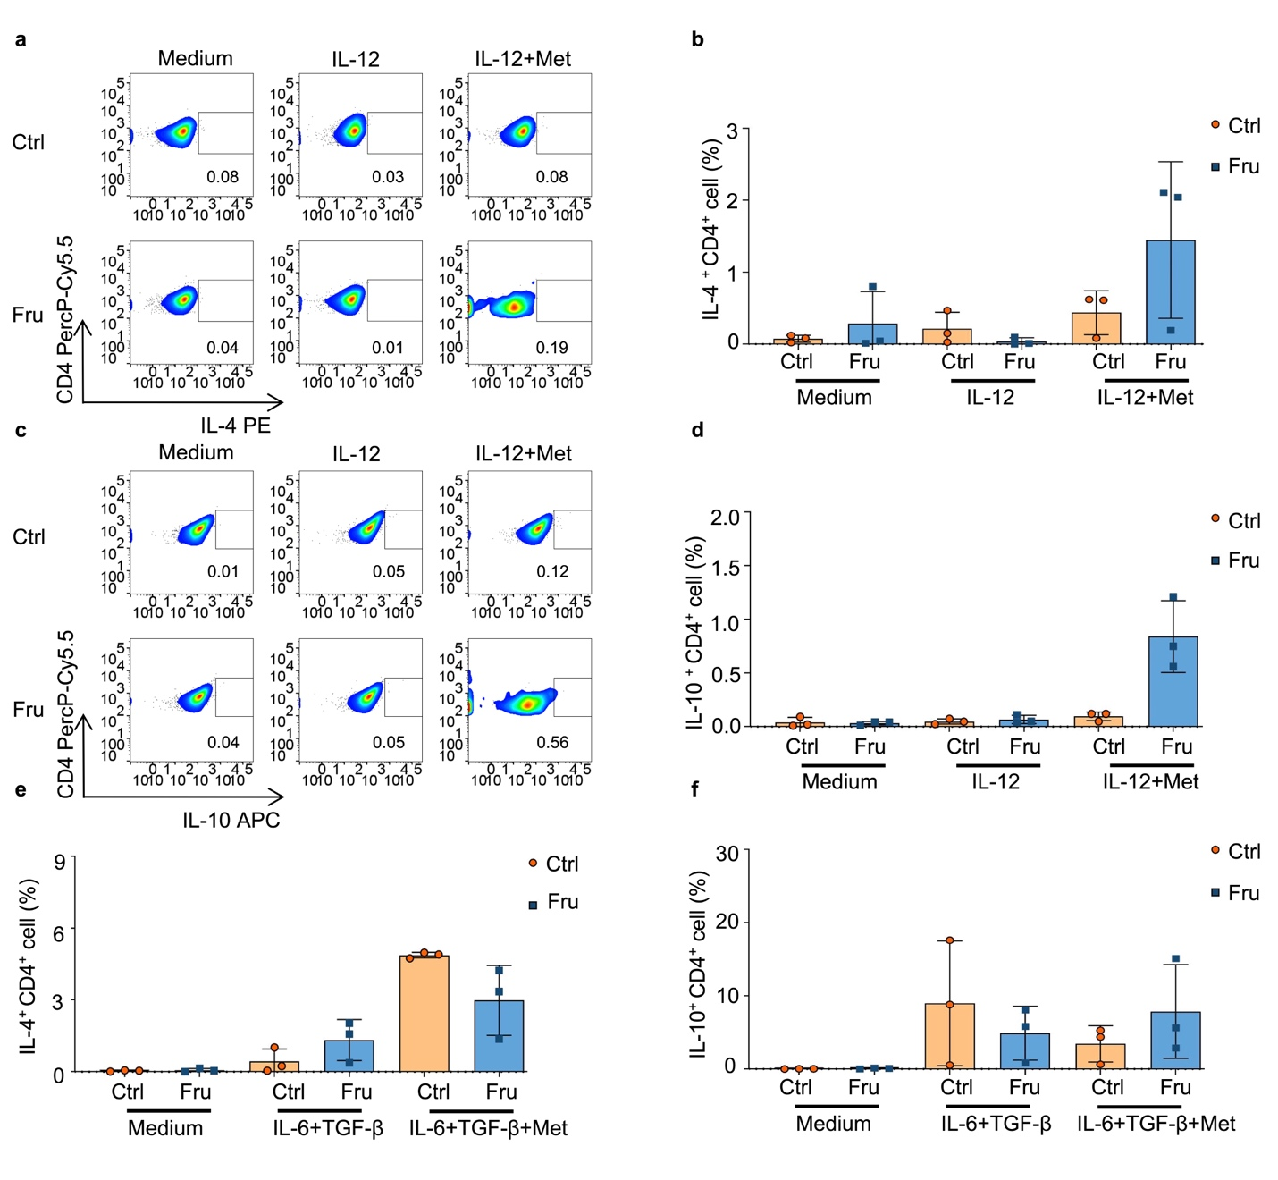
Supplementary Fig. 9. Metformin inhibits fructose induced Th1 and Th17 cell differentiations by suppressing mTORC1. CD4⁺CD25⁻CD62L⁺ naïve T cells were cultured in cDMEM containing 25 mM glucose or fructose for three days, with plate-bound anti-mouse-CD3 (1.5 μg/mL) and soluble anti-mouse-CD28 (1.5 μg/mL), with or without indicated cytokines and reagent. Th1 cells were induced with mouse IL-12 (10 ng/mL), and Th17 cells were induced with TGF-β1 (2 ng/mL) and mouse IL-6 (50 ng/mL). Metformin (5 mM) was used to suppress mTOR pathway. (a–d) Frequencies of IL-4⁺CD4⁺ Th2 (a, b), and IL-10⁺CD4⁺ Tr1 (c, d) cells in T cells cultured under indicated conditions. (e and f) Frequencies of IL-4⁺CD4⁺ Th2 (e) and IL-10⁺CD4⁺ Tr1 (f) cells in T cells cultured under indicated cell culture conditions. Data are representative of three independent experiments (a and c) or are pooled from three independent experiments (b, d–f). Summary data are presented as mean ± SD.

Figure. S10.
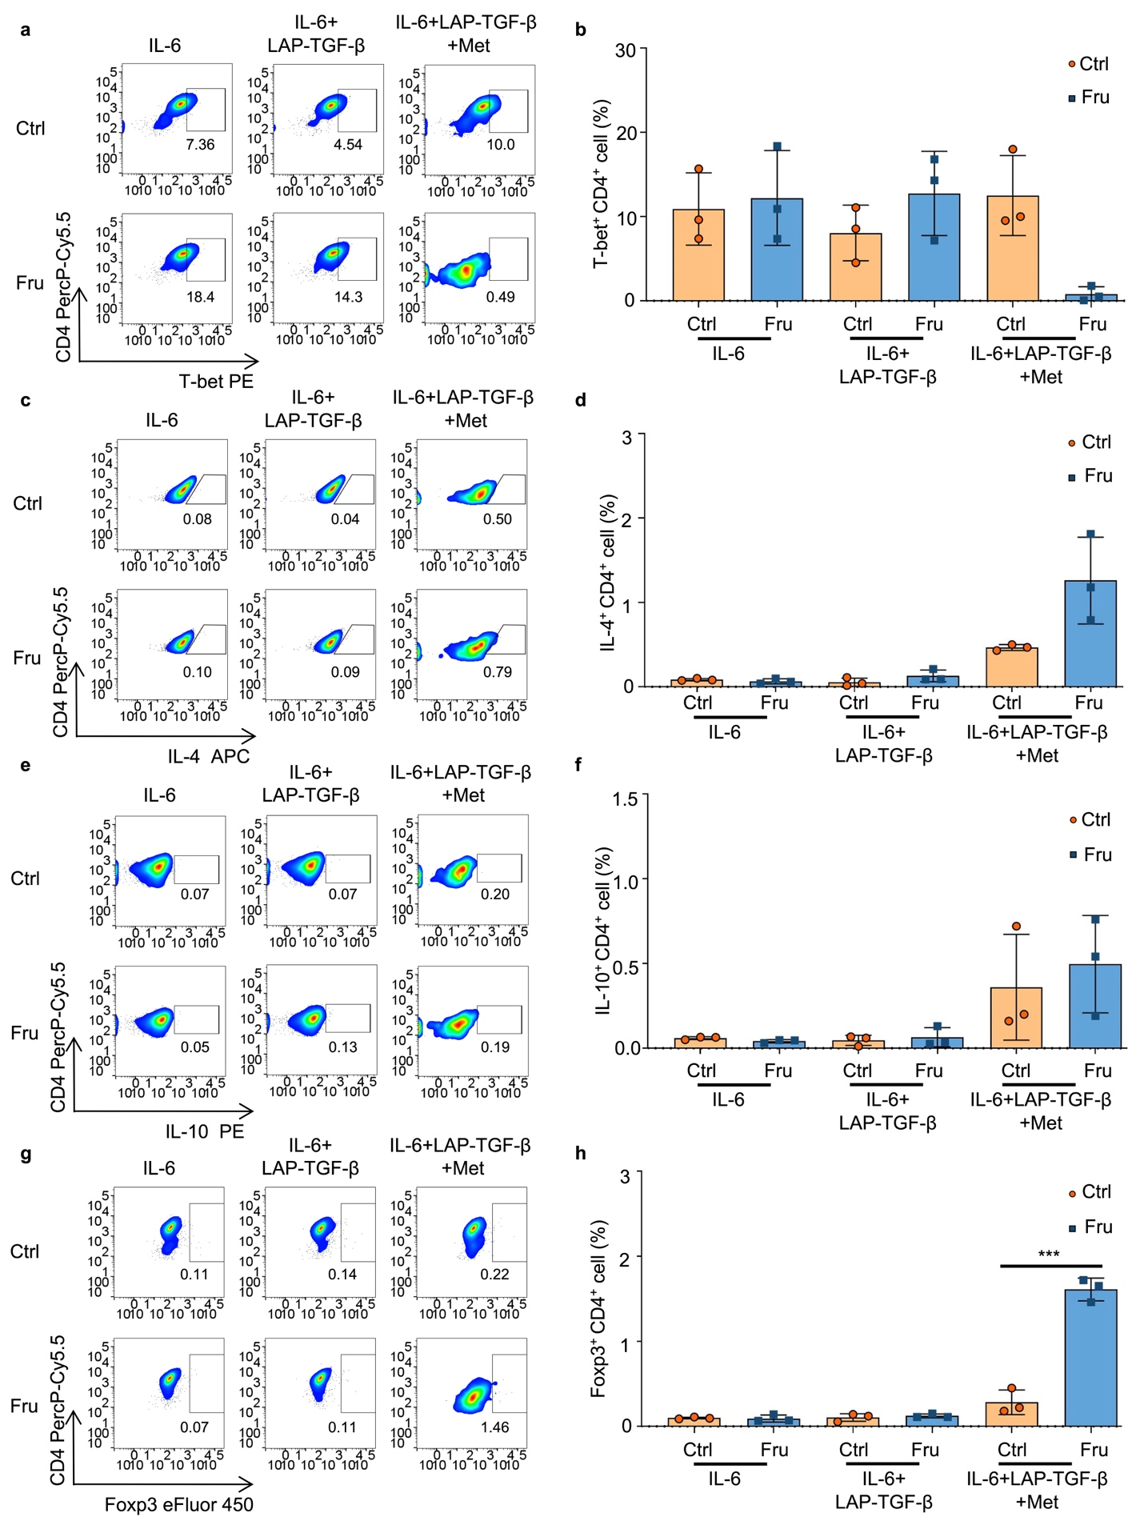
Supplementary Fig. 10. Metformin inhibits fructose-induced TGF-β activation by suppressing ROS production. CD4⁺CD25⁻CD62L⁺ naïve T cells were cultured in cDMEM containing 25 mM glucose or fructose for three days, with plate-bound anti-mouse-CD3 (1.5 μg/mL), soluble anti-mouse-CD28 (1.5 μg/mL), and mouse IL-6 (50 ng/mL), with or without human latent TGF-β1 (10 ng/mL) and metformin (5 mM). (a–h) Frequencies of T-bet⁺CD4⁺ T (a, b), IL-4⁺CD4⁺ Th2 (c, d), IL-10⁺CD4⁺ Tr1 (e, f), and Foxp3⁺Treg cells (g, h) in T cells cultured for three days under indicated cell culture conditions. Data are representative of three independent experiments (a, c, e, and g) or are pooled from three independent experiments (b, d, f, and h). Unpaired two-tailed Student’s t-tests were used to calculate statistical significance. Summary data are presented as mean ± SD. ***p < 0.001.

Figure. S11.
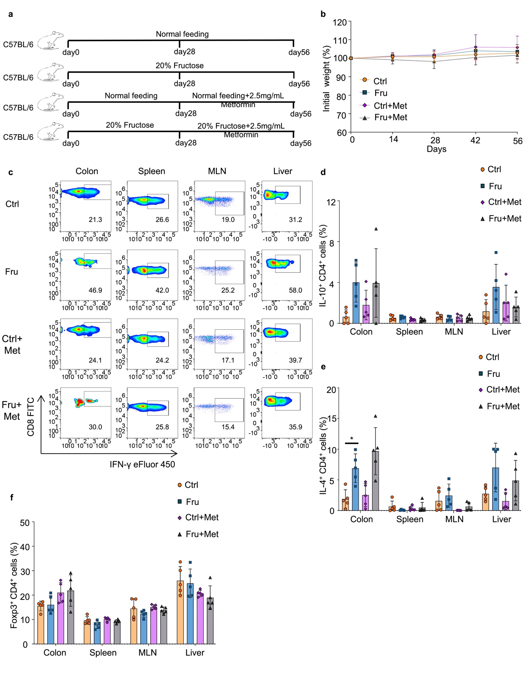
Supplementary Fig. 11. Metformin supplementary inhibits high fructose consumption-induced T cell inflammation in vivo. C57BL/6 mice were treated with regular drinking or 20% fructose water for eight weeks and half of these mice were treated with metformin (2.5 mg/mL) during the fifth to eighth weeks. T-cell immune responses were determined after the mice were euthanized (n = 5 mice per group). (a) Experimental scheme of the metformin supplementary experiment. (b) Changes in body weight during the modeling period. (c–f) Frequencies of IFN-γ⁺CD8⁺ Tc1 (c), IL-10⁺CD4⁺ Tr1 (d), IL-4⁺CD4⁺ Th2 (e), and Foxp3⁺ CD4⁺ Treg (f) cells in the colon, spleen, MLN, and liver tissues of the mice. Data are representative of two independent experiments (b–f). Unpaired two-tailed Student’s t-tests were used to calculate statistical significance. Summary data are presented as mean ± SD. *p < 0.05.

Figure. S12.
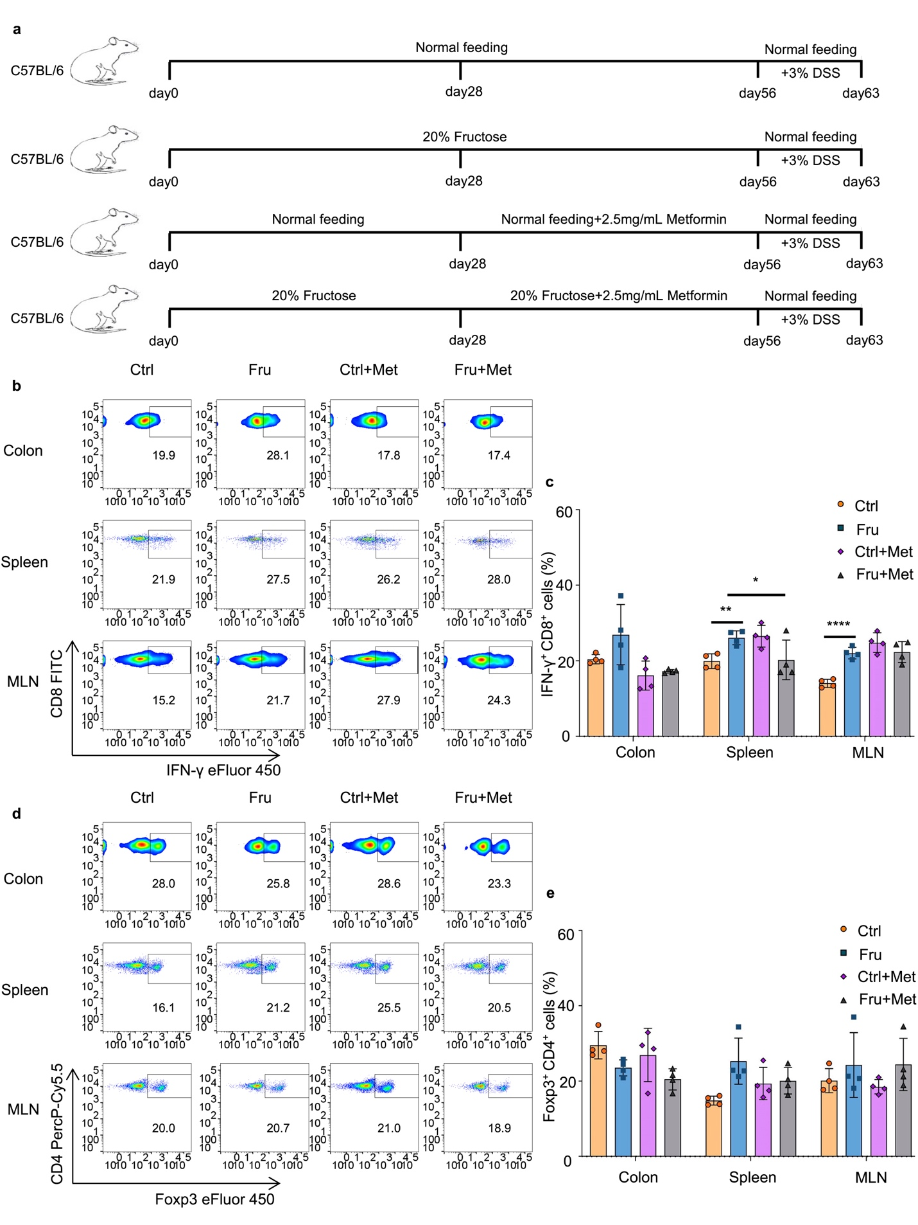
Supplementary Fig. 12. Metformin supplementary inhibits high fructose consumption-induced colitis aggravation. C57BL/6 mice were treated with regular drinking or 20% fructose water for eight weeks and half of these mice were treated with metformin (2.5 mg/mL) during the fifth to eighth weeks, and a DSS-induced colitis model was established to investigate the disease development after fructose water treatment (n = 4 mice per group). (a) Experimental scheme of the DSS-induced colitis model treated with metformin. (b, c) Frequencies of IFN-γ⁺CD8⁺ Tc1 cells in the colon, spleen, and MLN. (d, e) Frequencies of Foxp3⁺CD4⁺ Treg cells in the colon, spleen, and MLN of the mice. Data are representative of two independent experiments (b–e). One-way ANOVA (with Tukey’s multiple-comparisons post-tests) was used to calculate statistical significance. Summary data are presented as mean ± SD. *p < 0.05; **p < 0.01; ****p < 0.0001.

Figure. S13.

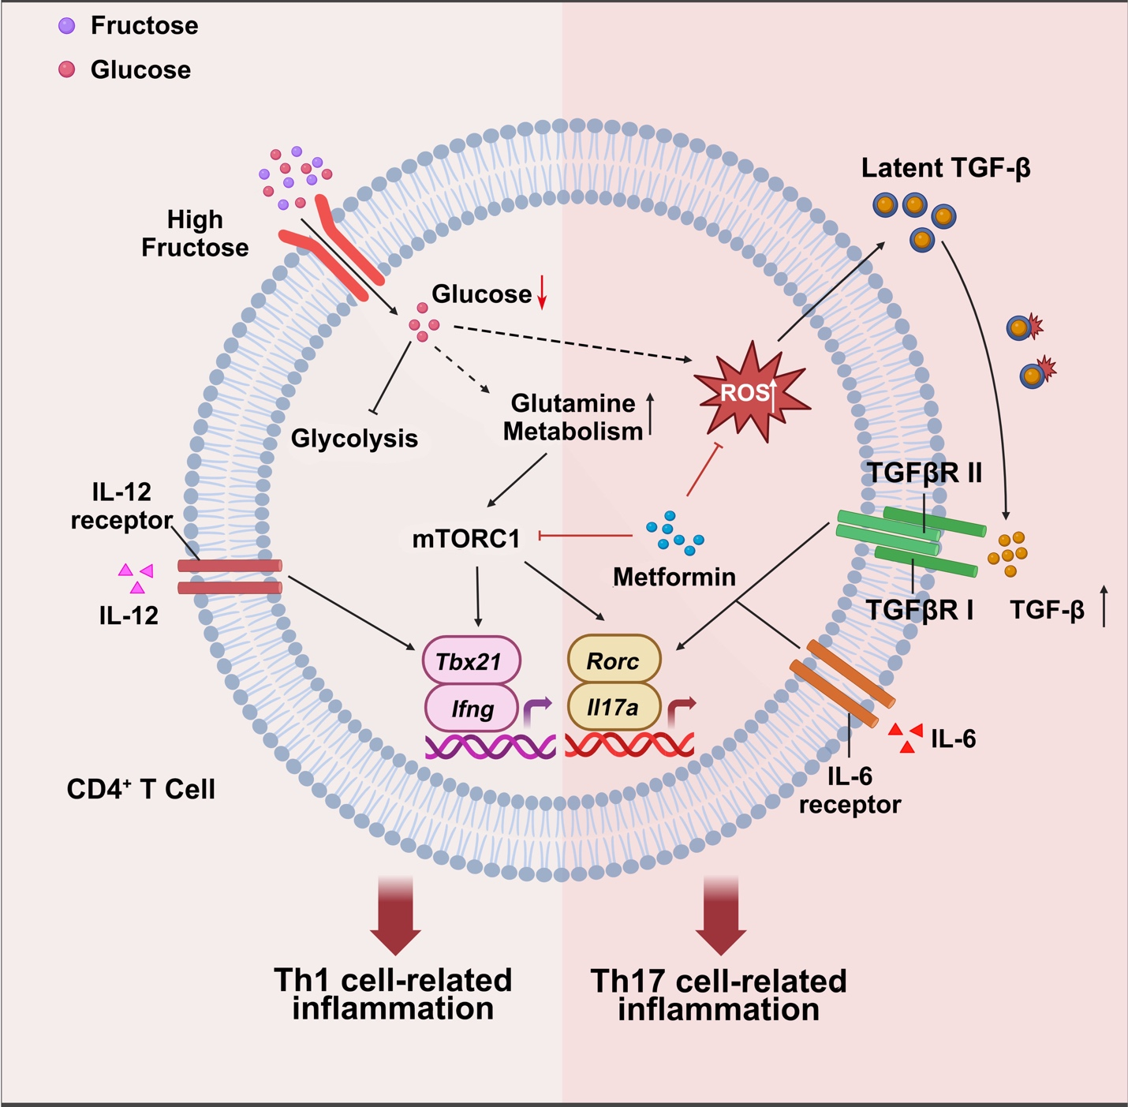

Supplementary Fig. 13. A proposed model for fructose-induced Th1 and Th17 cell generations in T cells. T cells do not express fructose transporter GLUT5 and cannot effectively utilize fructose. Therefore, high fructose microenvironment reduces glucose level in the internal environment and suppresses T cell glycolysis, leading to a compensatory increase in glutamine metabolism in CD4⁺ T cells. The increased glutamine metabolism induces the activation of the mechanistic target of rapamycin complex 1 (mTORC1) by up-regulating the levels of phospho-mTOR (Ser2448), resulting the differentiation of Th1 and Th17 cells. Moreover, high fructose may induce the production of reactive oxygen species (ROS) in CD4⁺ T cells, and ROS-induced transforming growth factor-β (TGF-β) activation is also involved in fructose-induced Th17 cell generation in the presence of IL-6. Besides, metformin reverses fructose-induced Th1 and Th17 cell generation by suppressing mTORC1 activation and reducing ROS-mediated TGF-β activation. This figure was created with BioRender.com.

Supplementary table 1.
The primer sequences used for Q-PCR.
 | Q-PCR primer sequence
HPRT-F | TCAGTCAACGGGGGACATAAA
HPRT-R | GGGGCTGTACTGCTTAACCAG
IFNγ-F | ATGAACGCTACACACTGCATC
IFNγ-R | CCATCCTTTTGCCAGTTCCTC
T-bet-F | GATCACTCAGCTGAAAATCGAC
T-bet-R | AGGCTGTGAGATCATATCCTTG
IL17a-F | GCCAAGGGAGTTAAAGACTTTG
IL17a-R | TGCTACTGTTGATGTTGGGAC
RORγt-F | ACAAATTGAAGTGATCCCTTGC
RORγt-R | GGAGTAGGCCACATTACACTG

Supplementary table 2.
Supplementary Key Resources Table.
Reagents and materials
Reagent or Resource | source | Identifier
Antibodies
Purified anti-mouse CD3 (145-2C11) | Bio X Cell | Cat# BE0001-1; RRID: AB_1107634
Purified anti-mouse CD28 (37.51) | Bio X Cell | Cat# BE0015-1; RRID: AB_1107624
anti-mouse/human/rat/monkey/hamster/canine/ bovine TGF-β (1D11.16.8) | Bio X Cell | Cat# BE0057; RRID: AB_1107757
Anti-mouse CD4 PerCP-Cy5.5 (RM4-5) | Thermo Fisher Scientific | Cat# 45-0042-82; RRID: AB_1107001
Anti-mouse CD8a FITC (53-6.7) | Thermo Fisher Scientific | Cat# 11-0081-85; RRID: AB_464916
Anti-mouse CD8b FITC (H35-17.2) | Thermo Fisher Scientific | Cat# 11-0083-85; RRID: AB_657766
Anti-mouse CD45.2 APC-eFluor 780 (104) | Thermo Fisher Scientific | Cat# 47-0454-82; RRID: AB_1272175
Anti-mouse TCRβ APC-eFluor 780 (H57-597) | Thermo Fisher Scientific | Cat# 47-5961-82; RRID: AB_1272173
Anti-mouse FOXP3 eFluor 450 (FJK-16 s) | Thermo Fisher Scientific | Cat# 48-5773-82; RRID: AB_1518812
Anti-mouse RORgt APC (B2D) | Thermo Fisher Scientific | Cat# 17-6981-82; RRID: AB_2573254
Anti-mouse IL-17A PE-Cy7 (eBio17B7) | Thermo Fisher Scientific | Cat# 25-7177-82; RRID: AB_10732356
Anti-mouse IFN gamma eFluor 450 (XMG1.2) | Thermo Fisher Scientific | Cat# 48-7311-82; RRID: AB_1834366
Anti-mouse T-bet PE (eBio4B10 (4B10)) | Thermo Fisher Scientific | Cat# 12-5825-82; RRID: AB_925761
Anti-mouse IL-10 APC (JES5-16E3) | Thermo Fisher Scientific | Cat# 17-7101-82; RRID: AB_469502
Anti-mouse IL-4 PE (11B11) | Thermo Fisher Scientific | Cat# 12-7041-82; RRID: AB_395391
Anti-mouse IL-10 PE (JES5-16E3) | Thermo Fisher Scientific | Cat# 12-7101-82; RRID: AB_466176
Anti-mouse IL-4 PE-Cy7 (11B11) | Thermo Fisher Scientific | Cat# 25-7041-82; RRID: AB_2573520
Anti-mouse IL-4 APC (11B11) | Thermo Fisher Scientific | Cat# 17-7041-82; RRID: AB_469494
Anti-mouse CD62L (L-Selectin) FITC (MEL-14) | Thermo Fisher Scientific | Cat# 11-0621-85; RRID: AB_465110
Anti-mouse CD69 PE (H1.2F3) | Thermo Fisher Scientific | Cat# 11-0621-85; RRID: AB_465110
Anti-mouse CD44 APC (IM7) | Thermo Fisher Scientific | Cat# 17-0441-83; RRID: AB_469391
Anti-mouse CD25 PE-Cyanine7 (PC61.5) | Thermo Fisher Scientific | Cat# 25-0251-82; RRID: AB_469608
β-Actin (13E5) Rabbit mAb | CST | Cat# 4970; RRID: AB_2223172
mTOR (7C10) Rabbit mAb | CST | Cat# 2983; RRID: AB_2105622
Phospho-mTOR (Ser2448) (D9C2) XP® Rabbit mAb | CST | Cat# 5536; RRID: AB_10693423
Chemicals, Peptides, and Recombinant Proteins
Recombinant Human Latent TGF-β1 | R&D Systems | Cat# 299-LT-005
Recombinant mouse IL-6 | PEPROTECH | Cat# 406-ML-200
Recombinant Human TGF-β1 | PEPROTECH | Cat# 100-21C-50UG
Recombinant Murine IL-12 p70 | PEPROTECH | Cat# 200-12
Glutaminase inhibitors ,CB839 | selleck | Cat# 1439399-58-2
Rapamycin | selleck | Cat# S1039
Metformin HCl | selleck | Cat# S1950
Metformin HCl | Macklin | Cat# 1115-70-4
Dextran Sulfate Sodium Salt, DSS | YEASEN | Cat# 9011-18-1
SB431542 | Selleck.cn | Cat# S1067
N-Acetyl-L-cysteine (NAC) | Medchemexpress | Cat# HY-B0215
D-(+)-Glucose | Sigma | Cat# G6152-500G
D-(-)-Fructose | Sigma | Cat# F0127-500G
D-Fructose | Macklin | Cat# D809612
DNase I | Aladdin | Cat# D106200-1g
Collagenase IV | worthington | Cat# WBC-LS004189
Liberase TL | Roche | Cat# 05401020001
PMA | Sigma | Cat# P8139
Ionomycin calcium salt | Aladdin | Cat# I133497-25mg
Golgi-Plug Protein Transport Inhibitor | BD Biosciences | Cat# 555029
rh Annexin V Pacific Blue™ | Thermo Fisher Scientific | Cat# A35122
7-AAD Viability Staining Solution | Thermo Fisher Scientific | Cat# 00-6993-50
Annexin V Binding Buffer | Thermo Fisher Scientific | Cat# V13246
Zombie Yellow Fixable Viability Kit | BioLegend | Cat# 423104
EDTA | Solarbio | Cat# E1170
DTT (dithiothreitol) | Thermo Fisher Scientific | Cat# R0862
Corning Cell-Tak Cell and Tissue Adhesive | Life Sciences | Cat# 354240
XF RPMI Medium, PH 7.4 | Agilent | Cat# 103576-100
Glucose free DMEM | Thermo Fisher Scientific | Cat# 11966025
Opti-MEM™ | Thermo Fisher Scientific | Cat# 31985070
Fetal Bovine Serum (FBS) | Vivaccell | Cat# C04001-500
Penicillin-Streptomycin | Thermo Fisher Scientific | Cat# 15140122
L-Glutamine | Thermo Fisher Scientific | Cat# 25030081
Sodium Pyruvate | Thermo Fisher Scientific | Cat# 11360070
MEM Non-Essential Amino Acids Solution | Thermo Fisher Scientific | Cat# 11360070
2-Mercaptoethanol | Sigma | Cat# M3148
HEPES Buffer | Thermo Fisher Scientific | Cat# 118-089-721
Bovine Serum Albumin (BSA) | Sigma | Cat# B2064
Bovine Serum Albumin (BSA) | BioFroxx | Cat# 4240GR100
ACK Lysing buffer | Thermo Fisher Scientific | Cat# A1049201
Critical Commercial Assays
CD4⁺ CD62L⁺ T cell Isolation Kit, mouse | Miltenyi Biotec | Cat# 130-106-643
CD4⁺ T Cell Isolation Kit, mouse | Miltenyi Biotec | Cat# 130-095-248
Foxp3/Transcription Factor Staining Buffer Set | Thermo Fisher Scientific | Cat# 00-5523-00
Cytofix/Cytoperm Fixation/ PermeabilizationSolution Kit | BD Biosciences | Cat# 554714
DCFDA / H2DCFDA - Cellular ROS Assay Kit | Medchemexpress | Cat# HY-D0940
CellTrace CFSE Cell Proliferation Kit | Thermo Fisher Scientific | Cat# C34554
Total RNA rapid extraction kit | JIANSHI BIOTECH | Cat# TR205-200
PrimeScript™ RT reagent Kit with gDNA Eraser (Perfect Real Time) | Takara | Cat# RR047A
TB Green® Premix Ex Taq™ II (Tli RNaseH Plus) | Takara | Cat# RR820A
BCA protein concentration determination kit | Solarbio | Cat# PC0020
SDS-PAGE Gel Kit | CWBIO | Cat# CW0022S
Hypersensitive ECL chemiluminescence kit | Beyotime | Cat# P00185
Seahorse XF Cell Mito Stress Test Kit | Agilent | Cat# 103015-100
Full Protein Extraction Kit (strong) | Solarbio | Cat# BC3710
ProteanFect CRISPRMax Cas9 Mouse Primary Immune Cell Gene Editing Transfection Kit | Nanoportal Biotech | Cat# PT06
Fructose content test kit | Suzhou Grace Biotechnolgy Co.,Ltd | Cat# G0530W
Experimental Models: Organisms/Strains
Mouse: C57BL/6 | Jackson Lab | Cat# 000664; RRID: IMSR_JAX:000664
Mouse: Rag1^{-/-} | Jackson Lab | Cat# 002216; RRID:IMSR_JAX:002216
Mouse: BALB/c-nu | Huafukang Biotechnology Co., LTD | Cat# NO.SM-014;RRID: IMSR_RJ: BALB-C-NUDE
Software and Algorithms
FlowJo 9 or FlowJo 10 software | FlowJo | https://www.flowjo.com/solutions/flowjo  RRID: SCR_008520
GraphPad Prism 7 software | GraphPad Software | https://www.graphpad.com/  RRID: SCR_002798
Other
BD LSRFortessa | BD Biosciences | N/A
Real-time fluorescence quantitative PCR instrument | Analytik Jena | qTOWER3G
Seahorse XFe96 Analyzers | Agilent | N/A

Original western blots. (separate file)

Gating strategies for the flow cytometry data. (separate file)

