Uncropped western blots
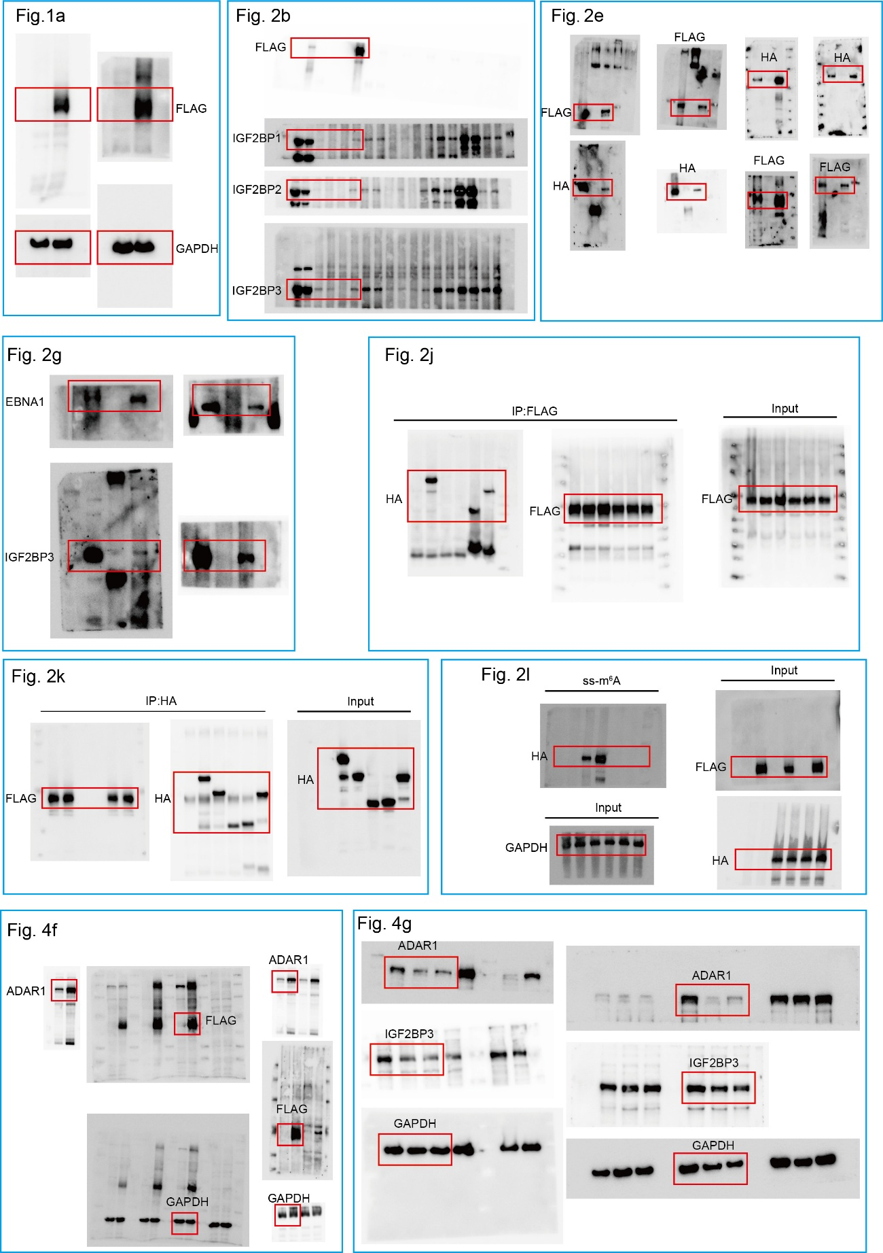

Supplementary Fig. 6. Uncropped western blots for Fig. 1-4.

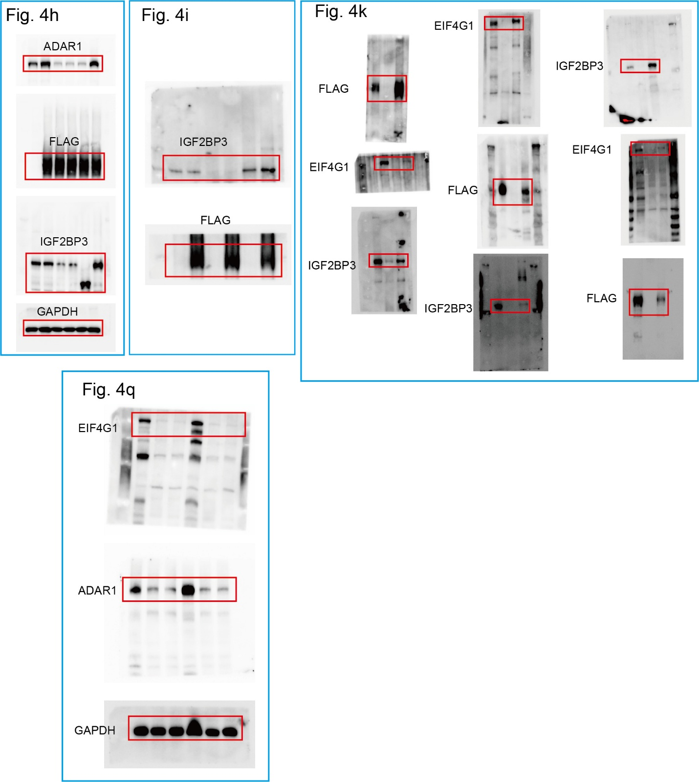

Supplementary Fig. 7. Uncropped western blots for Fig. 4.

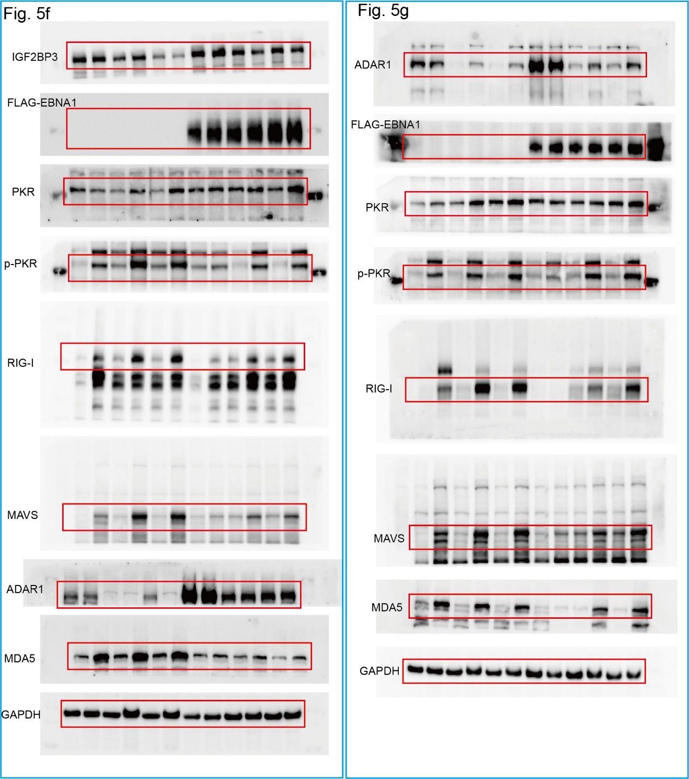

Supplementary Fig. 8. Uncropped western blots for Fig. 5.

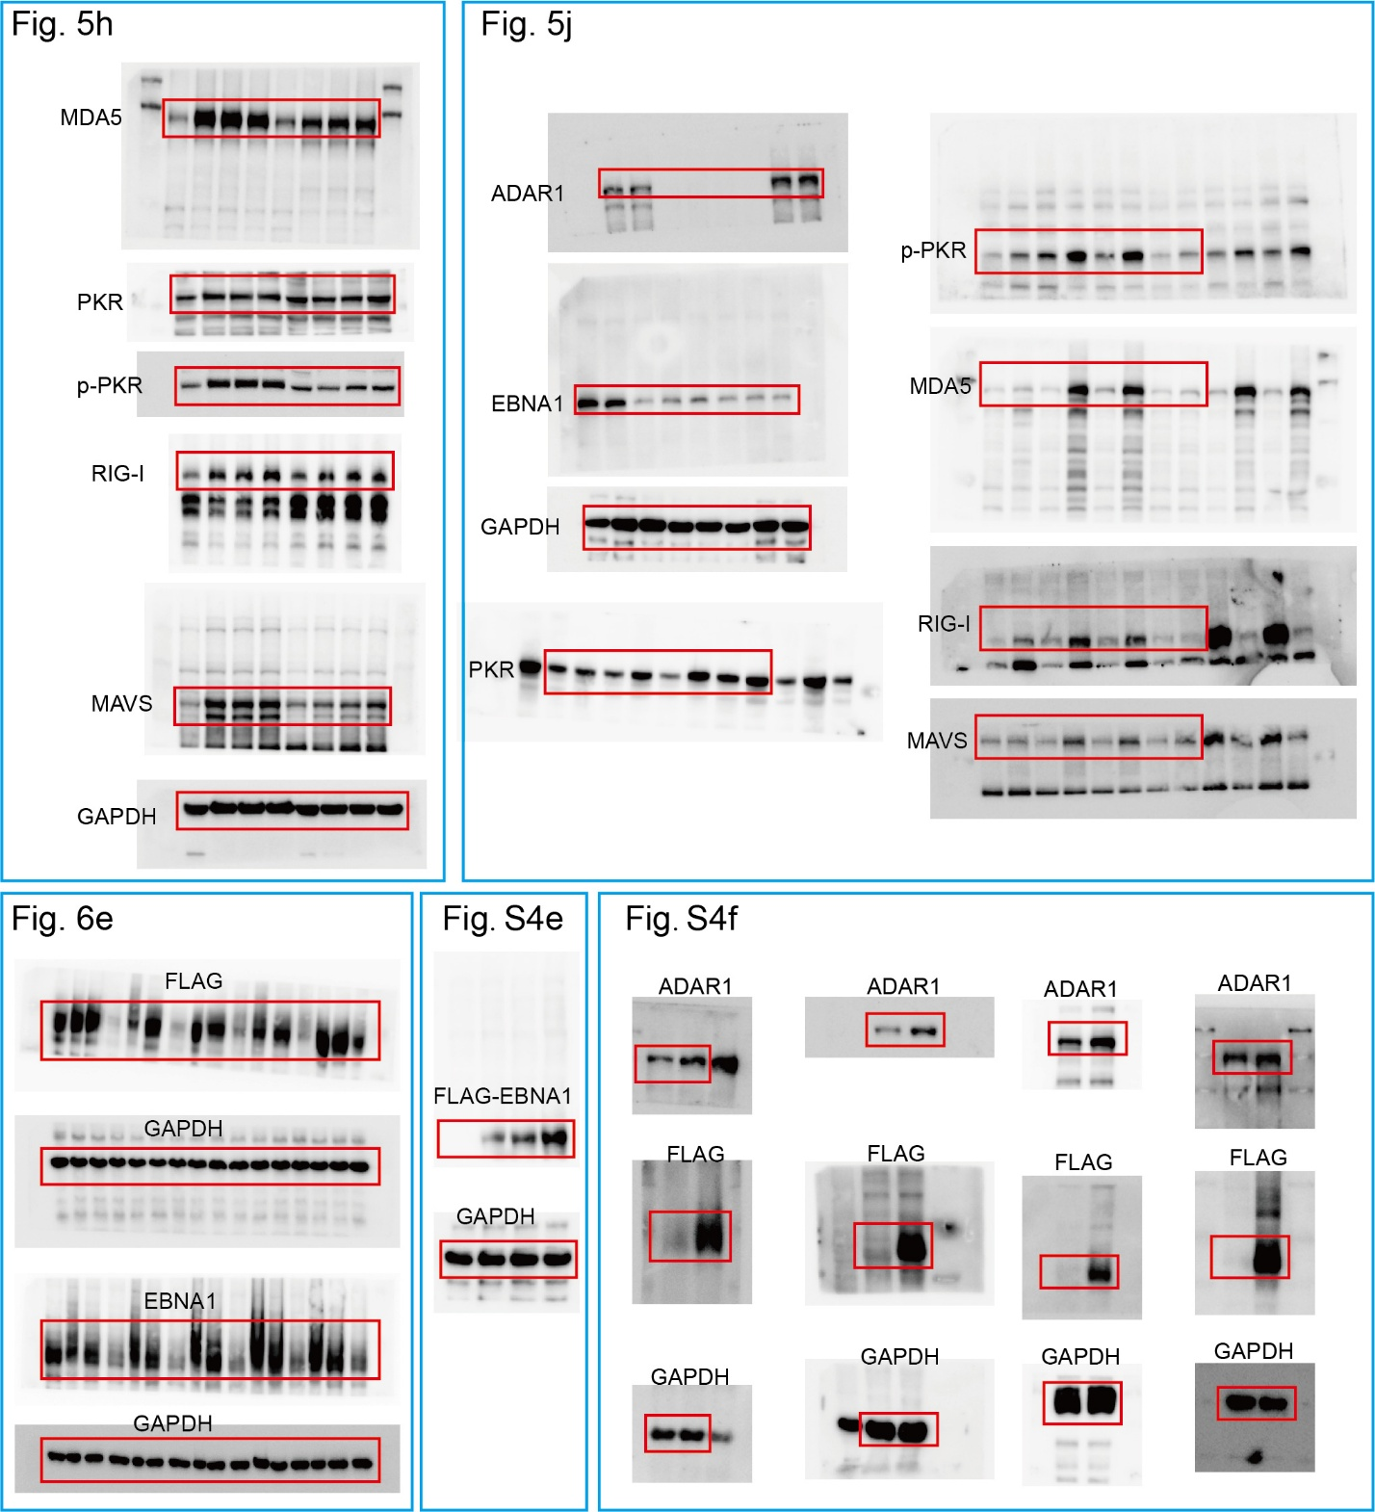

Supplementary Fig. 9. Uncropped western blots for Fig. 5-6, Supplementary Figure 4.

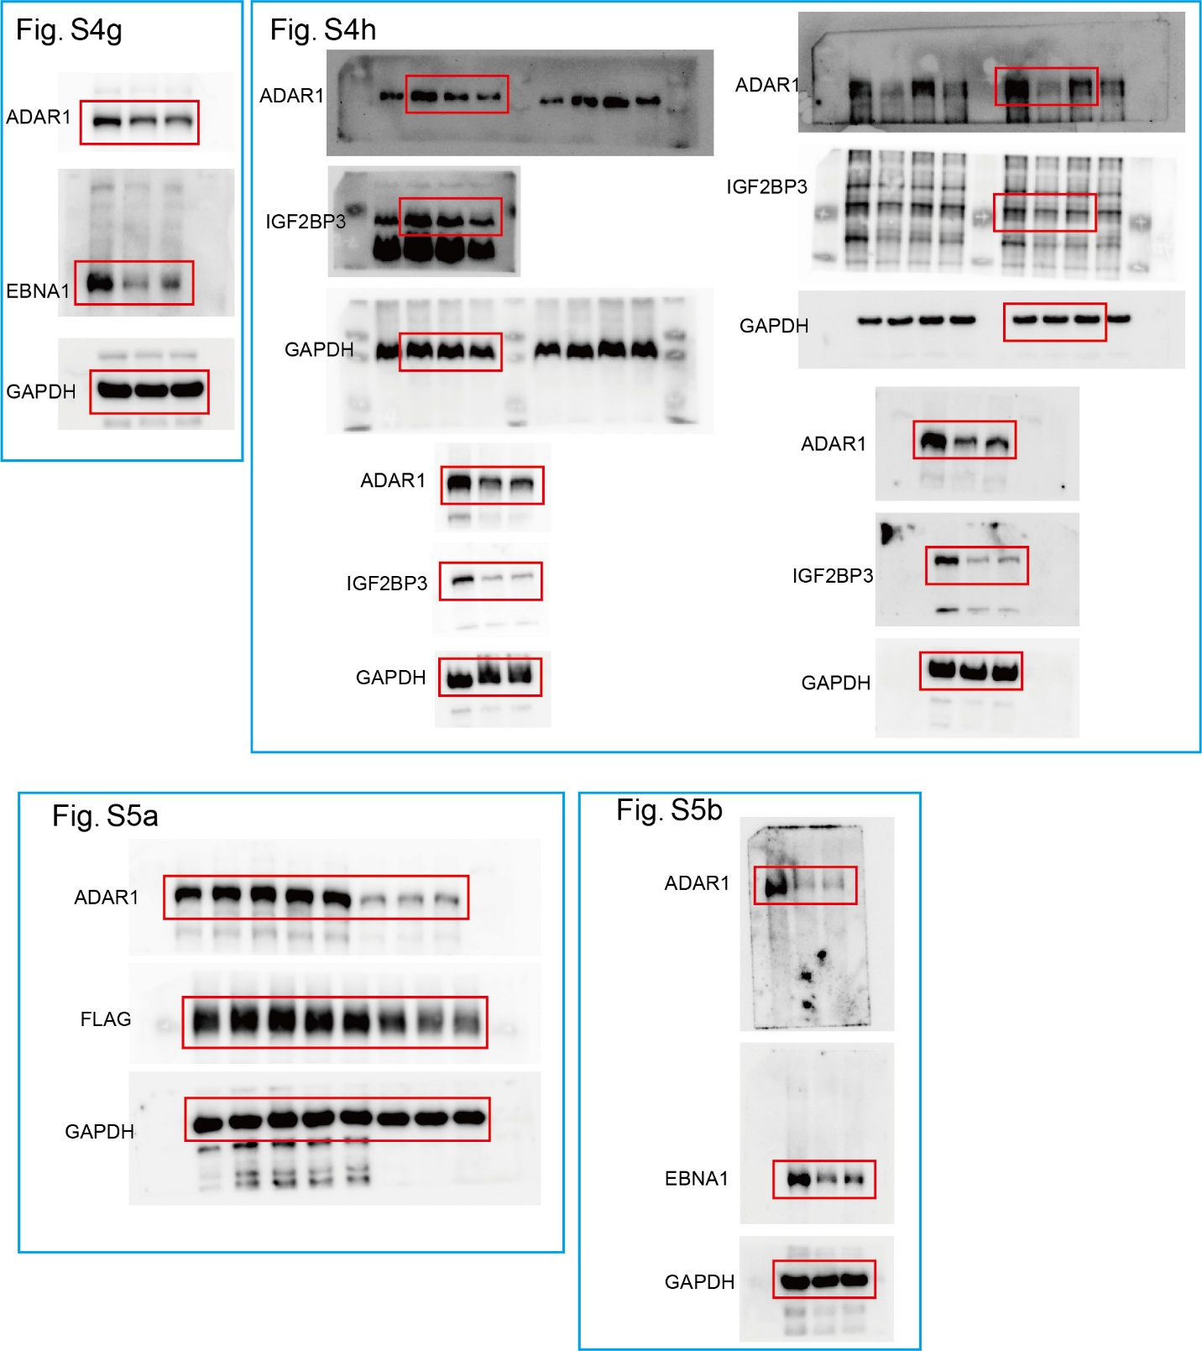

Supplementary Fig. 10. Uncropped western blots for Supplementary Figure 4 and 5.

