Supplementary Materials for

STRATEGIC-1: Multiple-Lines, Randomized, Open-label GERCOR-PRODIG-39 Phase III Trial in Unresectable RAS/BRAF Wild-Type Metastatic Colorectal Cancer

Benoist Chibaudel, MD1*; Louis-Marie Dourthe,MD2; Thierry Andre, MD3; Julie Henriques, Msc4; Vincent Bourgeois, MD5; Pierre-Luc Etienne, MD6; Jérôme Desrame, MD7; Elisabeth Carola, MD8; Olivier Dupuis, MD9; Nabil Baba-Hamed, MD10; Dominique Auby, MD11; Christophe Louvet, MD12; Emmanuel Maillard, MD13; Olivier Romano, MD14; Christophe Tournigand, MD15; Marie-Line Garcia-Larnicol, MD 3,16; Einat Shacham Shmueli, MD17; Brian Healey Bird, MD18; François Ghiringhelli, MD19; Aimery de Gramont, MD1

Correspondence to: Benoist Chibaudel, MD, Department of Medical Oncology, Hôpital Franco-Britannique – Fondation Cognacq-Jay, Cancérologie Paris Ouest, 4, rue Kléber 92300 Levallois-Perret, France; Tel +33(0)147595965; email: benoist.chibaudel@cognacq-jay.fr

This PDF file includes:

Supplementary Text
Supplementary Figures. 1 to 2
Supplementary Tables 1 to 4
Captions for Data 1

Other Supplementary Materials for this manuscript include the following:

Data 1

Supplementary Text
Investigators list.

Principal Investigator | Center Name
ISRAEL
SHACHAM SHMUELI Einat | Sheba Medical Center, Tel Hashomer Hospital
YAROM Nirit | Assaf Harofeh Medical Center
IRLAND
MCDERMOTT Ray | St. Vincent’s University Hospital
POWER Derek | Cork University Hospital (CUH)
GALLAGHER David | St. James’s Hospital (SJH)
HORGAN Anne | University Hospital Waterford (UHW)
FRANCE
CHIBAUDEL Benoist | Hôpital Franco-Britannique – Fondation Cognacq-Jay, Cancérologie Paris Ouest
ANDRE Thierry | CHU Saint-Antoine
DOURTHE Louis Marie | Clinique Sainte Anne
BOURGEOIS Vincent | Centre Hospitalier Boulogne sur Mer
ETIENNE Pierre-Luc | Clinique Armoricaine de Radiologie
DESRAME Jérôme | Hôpital privé Jean Mermoz
CAROLA Elisabeth | GHPSO - Site de Creil
DUPUIS Olivier | Clinique Victor Hugo
GHIRINGHELLI François | Centre Georges François Leclerc
BABA HAMED Nabil | Hôpital Privé Saint Joseph
AUBY Dominique | Hôpital Layné
LOUVET Christophe | Institut Mutualiste Montsouris
MAILLARD Emmanuel | CH Annecy Genevois
ROMANO Olivier | Hôpital Privé de Villeneuve d'Ascq
TOURNIGAND Christophe | CHU Henri-Mondor
GORNET Jean-Marc | CHU Saint-Louis
KHALIL Ahmed | Hôpital Tenon
RINALDI Yves | Hôpital Européen
VILLING Anne-Laure | CentreHospitalier d'Auxerre
Dr BOUREDJI Daoud | CH -Gonesses
DESGRIPPES Romain | Hôpital Broussais
HARTWIG Johannes | Infirmerie Protestante
SIBERTIN-BLANC Camille | Hôpital Sainte Musse
BREYSACHER Gilles | Centre Hospitalier de Colmar
KIM Stefano | CHU Jean Minjoz
GASMI Mohamed | Hôpital Nord
BEDJAOUI Ahmed | Hôpitaux de Léman
REBISCHUNG Christine | GHM
MABRO May | Hôpital Foch
FRIKHA Ahmed | Polyclinique Maymard
HOMOKOS Helen | Hôpital privé de l'Estuaire
BOILLEAU JOLIMOY Geneviève | Polyclinic Parc Drevon
SEITZ Jean-François | Hôpital la Timone
LECAILLE Cédric | Polyclinique Bordeaux Nord Aquitaine
CASTANIE Hélène | Hôpital Privé du confluent SAS
FERRAND François-Régis | HIA Begin
HOCINE Fayçal | Centre hospitalier de Beauvais
BACHET Jean-Baptiste | GH Pitié Salpêtrière
SAUDES Laurence | Centre Hospitalier de Cannes
PERE VERGE Denis | Hôpital Saint Joseph
LEDIT Alain | Clinique des Cèdres
BENOUNNA Jafaar | ICO René Gauducheau
BROCARD Fabien | Centre d’Oncologie de Gentilly
SABAN-ROCHE Léa | ICLOIRE
CHAUVENET Laure | Centre Hospitalier de Sens
VANOLI André | Hôpital Privé Sainte Marie

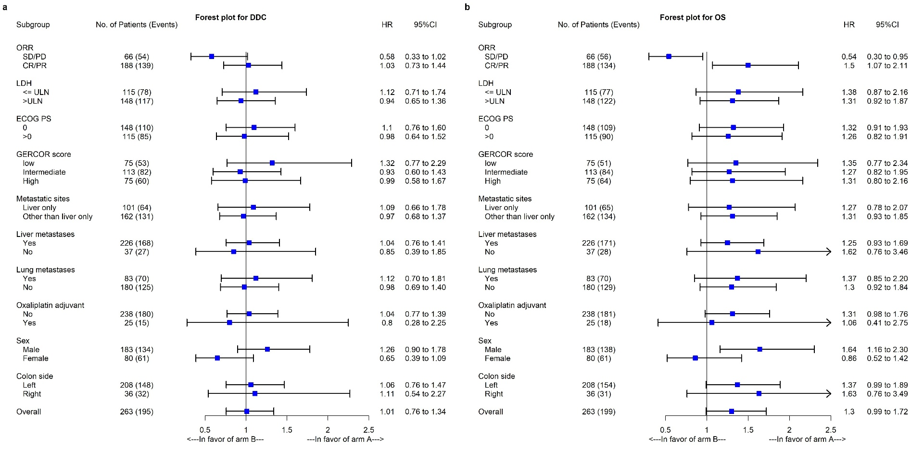

Supplementary Fig. 1.
Forest plot of prespecified subgroups. (a) Duration of disease control. (b) Overall survival.

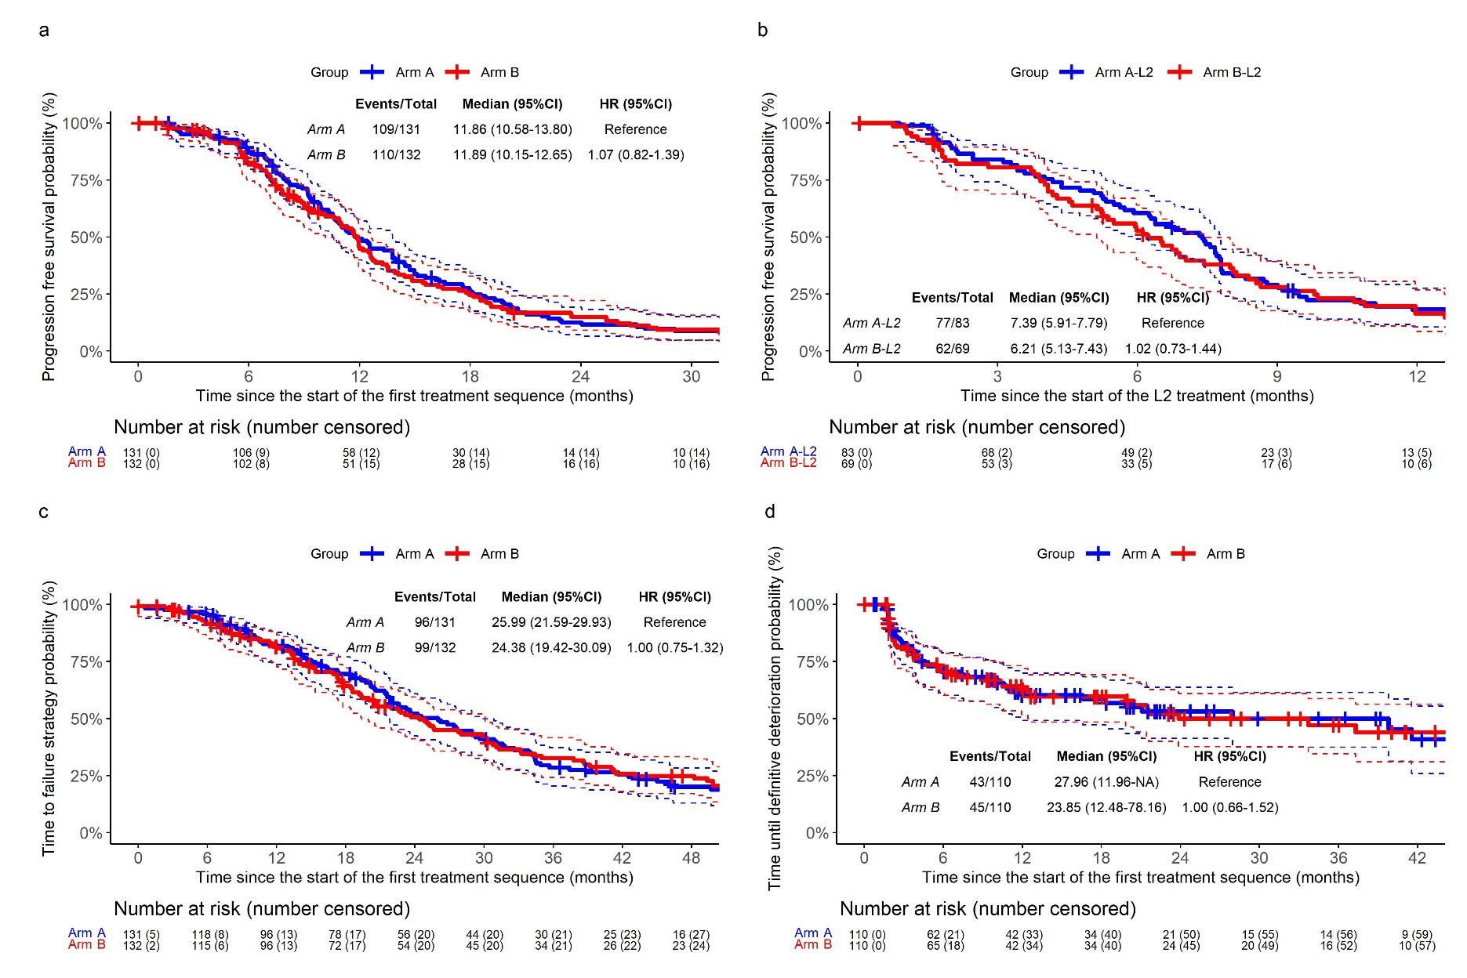

Supplementary Fig. 2.
Secondary endpoints. (a) Progression-free survival in first-line. (b) Progression-free survival in second-line. (c) Time to failure of strategy (TFS). (d) Time until definitive deterioration of Global Health Status (excluding death as an event).
 | Arm A | Arm B
 | n = 83 | n = 69
Death | 9 (25.0) | 18 (32.7)
Progression following full treatment strategy | 0 (0.0) | 4 (7.3)
Patient unfit to continue treatment | 1 (2.8) | 3 (5.4)
Investigator decision | 4 (11.1) | 0 (0.0)
Patient consent withdrawal | 2 (5.6) | 0 (0.0)
Patient choice, no consent withdrawal | 5 (13.9) | 3 (5.4)
Lost to follow-up | 1 (2.8) | 4 (7.3)
Other | 2 (5.6) | 3 (5.4)
New, unplanned therapy | 12 (33.3) | 20 (36.4)

Supplementary Table 1.
Reasons for not receiving second-line treatment.

 | First-line |  |  | Second-line |  |  | Third-line
AE, n (%) | FOLFIRI-cetuximab Arm A  (n = 131) | mFOLFOX7-bevacizumab Arm B  (n = 132) | P-value | mFOLFOX6-bevacizumab Arm A  (n = 83) | FOLFIRI-bevacizumab Arm B  (n = 69) | P-value | Anti-EGFR +/- irinotecan Arm B  (n = 50)
Neutropenia | 16 (12.6) | 17 (13.0) | .928 | 10 (12.4) | 11 (16.4) | .480 | 2 (4.4)
Diarrhea | 13 (10.2) | 4 (3.1) | .021 | 5 (6.2) | 4 (5.9) | 1.000 | 1 (2.2)
Nausea | 8 (6.3) | 2 (1.5) | .058 | 1 (1.2) | 1 (1.5) | 1.000 | 0
Vomiting | 6 (4.7) | 3 (2.3) | .330 | 0 | 0 |  | 0
Mucositis | 5 (3.9) | 6 (4.6) | .788 | 4 (4.9) | 4 (6.0) | 1.000 | 3 (6.7)
Alopecia (grade 1-2) | 49 (38.3) | 24 (18.8) | < .001 | 10 (12.5) | 20 (30.3) | .008 | 7 (15.9)
Neuropathy | 1 (0.8) | 5 (3.8) | .214 | 10 (12.5) | 3 (4.4) | .083 | 2 (4.3)
Hand foot syndrome | 6 (4.7) | 3 (2.3) | .334 | 2 (2.5) | 0 | .501 | 0
Acne-like | 24 (18.6) | 0 | < .001 | 0 | 0 |  | 6 (13.4)
Hypertension | 4 (3.2) | 13 (10.0) | .027 | 6 (7.5) | 4 (6.1) | 1.000 | 1 (2.2)
Fatigue | 11 (8.5) | 5 (3.8) | .114 | 6 (7.5) | 9 (13.4) | .237 | 4 (8.7)

Supplementary Table 2.
Summary of adverse events.

Studies | Population | N | ORR, % | Median PFS, months | Median OS, months
First-line – FOLFIRI-cetuximab
STRATEGIC-1 (arm A) | RAS/BRAF wild-type | 131 | 82.4 | 11.9 | 40.4
CRYSTAL¹ | RAS wild-type | 178 | 66.3 | 11.4 | 28.4
FIRE-3^{2, 3} | RAS wild-type | 199 | 66.0 | 10.3 | 31.1
First-line – FOLFOX-bevacizumab
STRATEGIC (arm B) | RAS/BRAF wild-type | 132 | 65.4 | 11.9 | 34.4
PEAK⁴ | RAS/BRAF wild-type | 79 | 62.0 | 10.1 | 28.9
PARADIGM⁵ | RAS wild-type |  | 67.3 | 12.0 | 31.3
TRICOLORE⁶ | RAS wild-type | 99 | NR | 11.5 | 35.1
ATOM⁷ | RAS wild-type | 61 | 68.4 | 11.5 | 30.4
Second-line – FOLFOX-bevacizumab
STRATEGIC (arm A) | RAS/BRAF wild-type | 83 | 20.7 | 7.4 | 17.0
BAC⁸ | All | 35 | 20.0 | 6.4 | 14.1
HORIZON1⁹ | All | 66 | 27.3 | 7.8 | 19.6
ECOG E3200¹⁰ | All | 286 | 22.7 | 7.3 | 12.9
Second-line – FOLFIRI-bevacizumab
STRATEGIC (arm B) | RAS/BRAF wild-type | 69 | 64.4 | 6.2 | 15.8
BAC⁸ | All | 51 | 23.5 | 6.9 | 15.7
Pooled studies¹¹ | All | 435 | 26.0 | 8.3 | 17.2

Supplementary Table 3.
Efficacy outcomes in the current and previous first-line studies using FOLFIRI-cetuximab or FOLFOX-bevacizumab, and second-line studies using FOLFOX-bevacizumab or FOLFIRI-bevacizumab.

 |  |  | ORR, % |  |  | PFS, months |  |  | OS, months
Studies | Population | N | Bev | EGFR | Delta | Bev | EGFR | HR (95% Cl) | Bev | EGFR | HR (95% Cl)
STRATEGIC | RAS/BRAF wild-type | 208 | 66.4 | 89.1 | 22.7 | 12.0 | 13.8 | 0.86 (0.64 to 1.17) | 35.8 | 44.2 | 0.76 (0.54 to1.06)
CAIRO5^{12–14} | RAS/BRAF wild-type | 230 | 51.8 | 75.8 | 24.0 | 10.6 | 10.3 | 1.12 (0.83 to 1.50) | NR | NR | NR
PARADIGM⁵ | RAS wild-type | 604 | 68.6 | 80.2 | 11.2 | 13.2 | 13.7 | 0.98 (0.82 to 1.17) | 34.3 | 37.9 | 0.82 (0.68 to 0.99)
CALGB/SWOG 80405¹⁵ | RAS wild-type | 325 | 57.9 | 69.4 | 11.5 | 11.1 | 12.0 | 0.84 (0.67 to 1.07) | 32.1 | 37.5 | 0.77 (0.60 to 0.99)
FIRE-3^{2, 3} | RAS wild-type | 273 | 67.6 | 78.8 | 11.2 | 11.0 | 11.0 | 0.97 (0.76 to 1.24) | 28.0 | 38.0 | 0.71 (0.55 to 0.92)

Supplementary Table 4.
Efficacy outcomes in randomized phase III trials for RAS or RAS/BRAF wild-type left-sided mCRC.
Abbreviations: ORR, overall response rate; PFS, progression-free survival; OS, overall survival; Bev, bevacizumab; NR, not reported

1. Van Cutsem E, Köhne C-H, Hitre E, et al: Cetuximab and chemotherapy as initial treatment for metastatic colorectal cancer. N Engl J Med 360:1408–1417, 2009
2. Heinemann V, von Weikersthal LF, Decker T, et al: FOLFIRI plus cetuximab or bevacizumab for advanced colorectal cancer: final survival and per-protocol analysis of FIRE-3, a randomised clinical trial. Br J Cancer 124:587–594, 2021
3. Heinemann V, von Weikersthal LF, Decker T, et al: FOLFIRI plus cetuximab versus FOLFIRI plus bevacizumab as first-line treatment for patients with metastatic colorectal cancer (FIRE-3): a randomised, open-label, phase 3 trial. Lancet Oncol 15:1065–1075, 2014
4. Rivera F, Karthaus M, Hecht JR, et al: Final analysis of the randomised PEAK trial: overall survival and tumour responses during first-line treatment with mFOLFOX6 plus either panitumumab or bevacizumab in patients with metastatic colorectal carcinoma. Int J Colorectal Dis 32:1179–1190, 2017
5. Yoshino, Takayuki, Watanabe, Jun, Shitara, Kohei, et al: Panitumumab (PAN) plus mFOLFOX6 versus bevacizumab (BEV) plus mFOLFOX6 as first-line treatment in patients with RAS wild-type (WT) metastatic colorectal cancer (mCRC): Results from the phase 3 PARADIGM trialJ Clin Oncol 40, 2022 (suppl 17; abstr LBA1)
6. Denda T, Takashima A, Gamoh M, et al: Combination therapy of bevacizumab with either S-1 and irinotecan or mFOLFOX6/CapeOX as first-line treatment of metastatic colorectal cancer (TRICOLORE): Exploratory analysis of RAS status and primary tumour location in a randomised, open-label, phase III, non-inferiority trial. Eur J Cancer 154:296–306, 2021
7. Oki E, Emi Y, Yamanaka T, et al: Randomised phase II trial of mFOLFOX6 plus bevacizumab versus mFOLFOX6 plus cetuximab as first-line treatment for colorectal liver metastasis (ATOM trial). Br J Cancer 121:222–229, 2019
8. Bendell JC, Tournigand C, Swieboda-Sadlej A, et al: Axitinib or bevacizumab plus FOLFIRI or modified FOLFOX-6 after failure of first-line therapy for metastatic colorectal cancer: a randomized phase II study. Clin Colorectal Cancer 12:239–247, 2013
9. Cunningham D, Wong RPW, D’Haens G, et al: Cediranib with mFOLFOX6 vs bevacizumab with mFOLFOX6 in previously treated metastatic colorectal cancer. Br J Cancer 108:493–502, 2013
10. Giantonio BJ, Catalano PJ, Meropol NJ, et al: Bevacizumab in combination with oxaliplatin, fluorouracil, and leucovorin (FOLFOX4) for previously treated metastatic colorectal cancer: results from the Eastern Cooperative Oncology Group Study E3200. J Clin Oncol 25:1539–1544, 2007
11. Beretta GD, Petrelli F, Stinco S, et al: FOLFIRI + bevacizumab as second-line therapy for metastatic colorectal cancer pretreated with oxaliplatin: a pooled analysis of published trials. Med Oncol 30:486, 2013
12. Bond, MJG, Bolhuis, K, Loosveld, OJL, et al.: LBA21 FOLFOX/FOLFIRI plus either bevacizumab or panitumumab in patients with initially unresectable colorectal liver metastases (CRLM) and left-sided and RAS/BRAFV600E wild-type tumour: phase III CAIRO5 study of the Dutch Colorectal Cancer GroupAnn Oncol. 2022;33:S1389.
13. Bond MJG, Bolhuis K, Loosveld OJL, et al: First-line systemic treatment strategies in patients with initially unresectable colorectal cancer liver metastases (CAIRO5): an open-label, multicentre, randomised, controlled, phase 3 study from the Dutch Colorectal Cancer Group. Lancet Oncol 24:757–771, 2023
14. Punt, CJA, Bond, MJG, Bolhuis, K, et al.: FOLFOXIRI + bevacizumab versus FOLFOX/FOLFIRI + bevacizumab in patients with initially unresectable colorectal liver metastases (CRLM) and right-sided and/or RAS/BRAFV600E-mutated primary tumor: Phase III CAIRO5 study of the Dutch Colorectal Cancer GroupJ Clin Oncol 40, 2022 (suppl 17; abstr LBA3506)
15. Venook AP, Niedzwiecki D, Lenz H-J, et al: Effect of First-Line Chemotherapy Combined With Cetuximab or Bevacizumab on Overall Survival in Patients With KRAS Wild-Type Advanced or Metastatic Colorectal Cancer: A Randomized Clinical Trial. JAMA 317:2392–2401, 2017

Data 1. (separate file)
Study protocol.

