Supplementary Materials for

Prostaglandin E₂-driven dedifferentiation of Schwann cells leads to perineural invasion in pancreatic ductal adenocarcinoma
Ling Wang#, Qicai Liu#*, Zhibo Zhang, Shizhong Yang, Juan Tang, Guobin Pan, Yuqing Zheng, Yuting Zhuang, Qiming Wu, Shangeng Weng*, Feng Gao*, Jiahong Dong*
Correspondence to: Qicai Liu (liuqc22@mails.tsinghua.edu.cn), Shangeng Weng (shangeng@sina.com), Feng Gao (fengfang77777@163.com), and Jiahong Dong (dongjiahong@mail.tsinghua.edu.cn)

This PDF file includes:

Figures. S1 to S6
Tables S1 to S4

Other Supplementary Materials for this manuscript include the following:

Dataset 1
Dataset 2

Figure. S1.

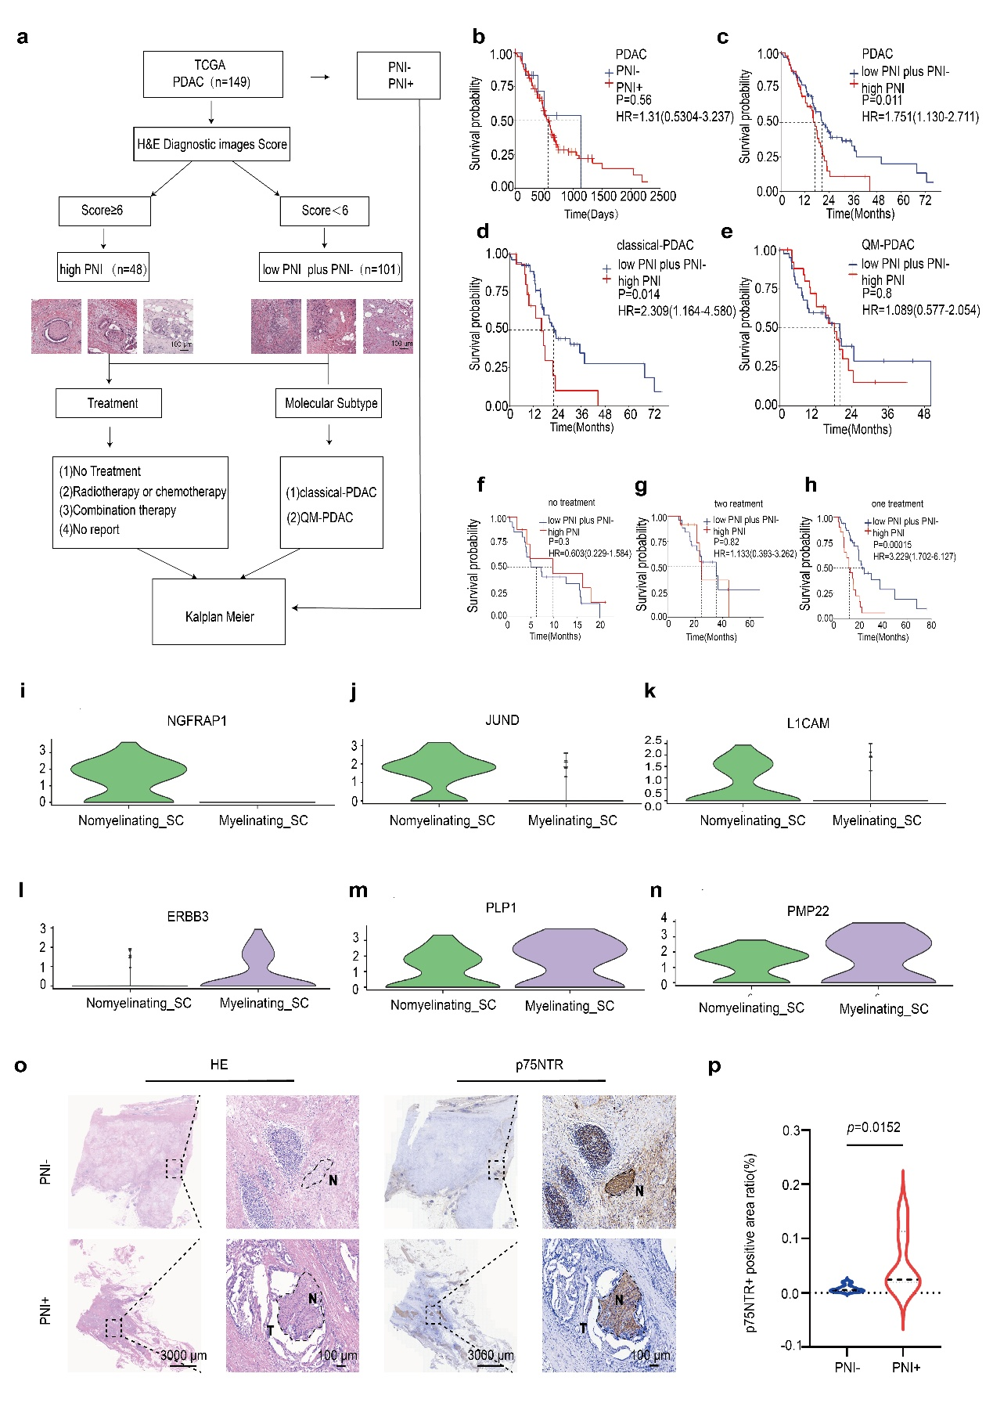

Supplementary Fig. 1 PNI is associated with low survival and dedifferentiated SCs
a A total of 149 PDAC patients’ information were retrieved from TCGA database. Based on pathological images, scoring was performed according to the criteria of the PNI scoring system. According to the scoring results, the patients were divided into the high PNI group (PNI score ≥6, n=48) and the low PNI plus PNI- group (PNI< 6, n=101). Stratified KM survival analysis was conducted based on treatment regimens and molecular subtypes. b KM survival curve analysis of OS difference in “PDAC” patients stratified by PNI+/PNI- groups (p=0.56). c KM survival curve analysis of OS difference in “PDAC” patients stratified by high PNI /low PNI plus PNI- groups (p=0.011). d KM survival curve analysis of OS difference in “classical-PDAC” patients stratified by high PNI/low PNI plus PNI- groups（p=0.014). e KM survival curve analysis of OS difference in “QM-PDAC” patients stratified by high PNI/low PNI plus PNI- groups (p=0.8). f KM survival curve analysis of OS difference in “no treatment” patients stratified by high PNI/low PNI plus PNI- groups (p=0.3). g KM survival curve analysis of OS difference in “two treatment” patients stratified by high PNI/low PNI plus PNI- groups (p=0.82). h KM survival curve analysis of OS difference in “one treatment” patients stratified by high PNI /low PNI plus PNI- groups(p=0.00015). i-n Violin plots showing the expression levels of cell-specific positive markers in two clusters of SCs. o Representative HE staining images of p75NTR and IHC staining images of p75NTR in PNI- and PNI+ tissues, along with the corresponding positive area ratio (n=3). N: Nerve, T: Tumor. Scale bars: 3000 μm (left panels), 100 μm (right panels). p Violin plot showing the distribution of p75NTR-positive area ratio (%) in patients stratified by PNI status (PNI- vs. PNI+). All results are presented as mean ± SDs. Statistical significance was determined by Log-rank test for KM survival analyses (Supplementary Fig. 1b-h) and Mann-Whitney U test (Supplementary Fig. 1p). *p<0.05, **p<0.01, ***p<0.001, ****p<0.0001.

Figure. S2
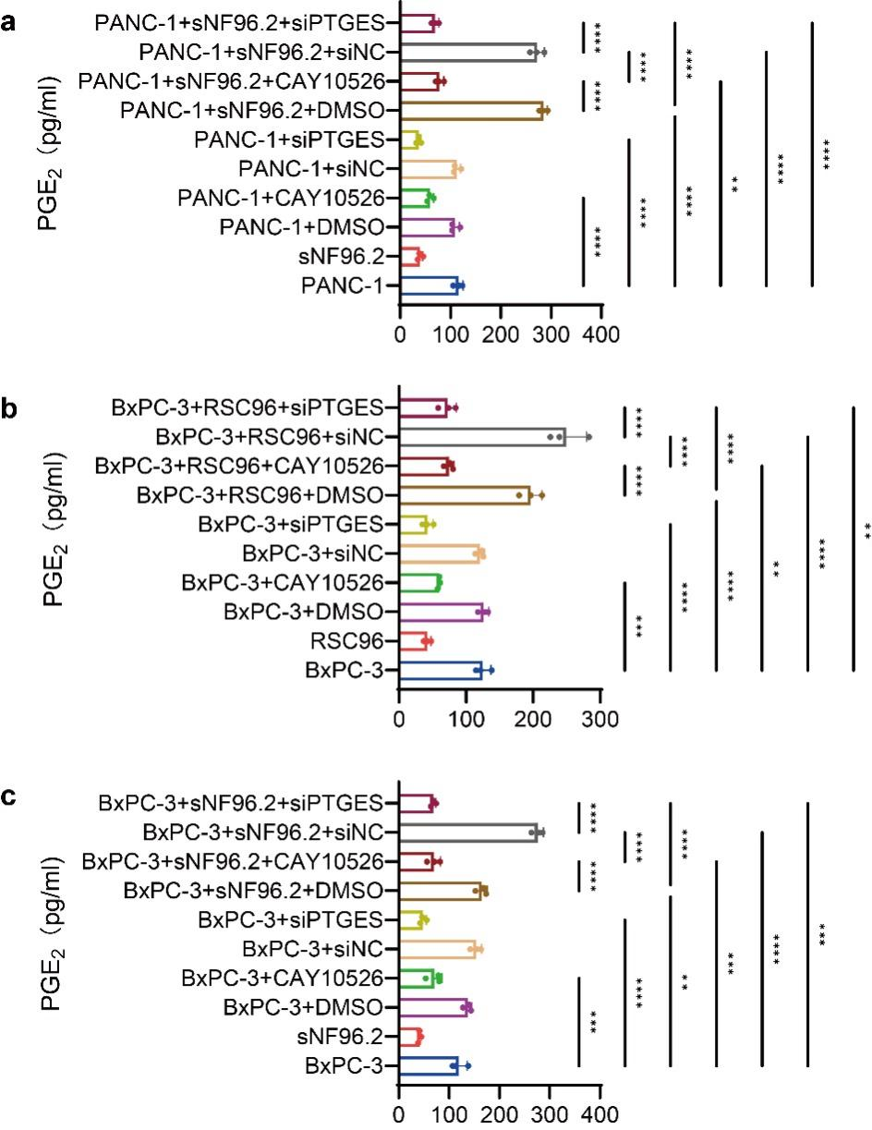
Supplementary Fig. 2 ELISA detection of PGE₂ content in the coculture system
a ELISA was performed to detect the effect of CAY10526 or siPTGES on PGE₂ secretion in the PANC-1-sNF96.2 coculture system (n=3). b ELISA was performed to detect the effect of CAY10526 or siPTGES on PGE₂ secretion in the BxPC-3-RSC96 coculture system (n=3). c ELISA was performed to detect the effect of CAY10526 or siPTGES on PGE₂ secretion in the BxPC-3-sNF96.2 coculture system (n=3). All results are presented as mean ± SDs. Statistical significance was determined by one-way analysis of variance followed by Tukey’s HSD post-hoc test. *p<0.05, **p<0.01, ***p<0.001, ****p<0.0001.

Figure. S3
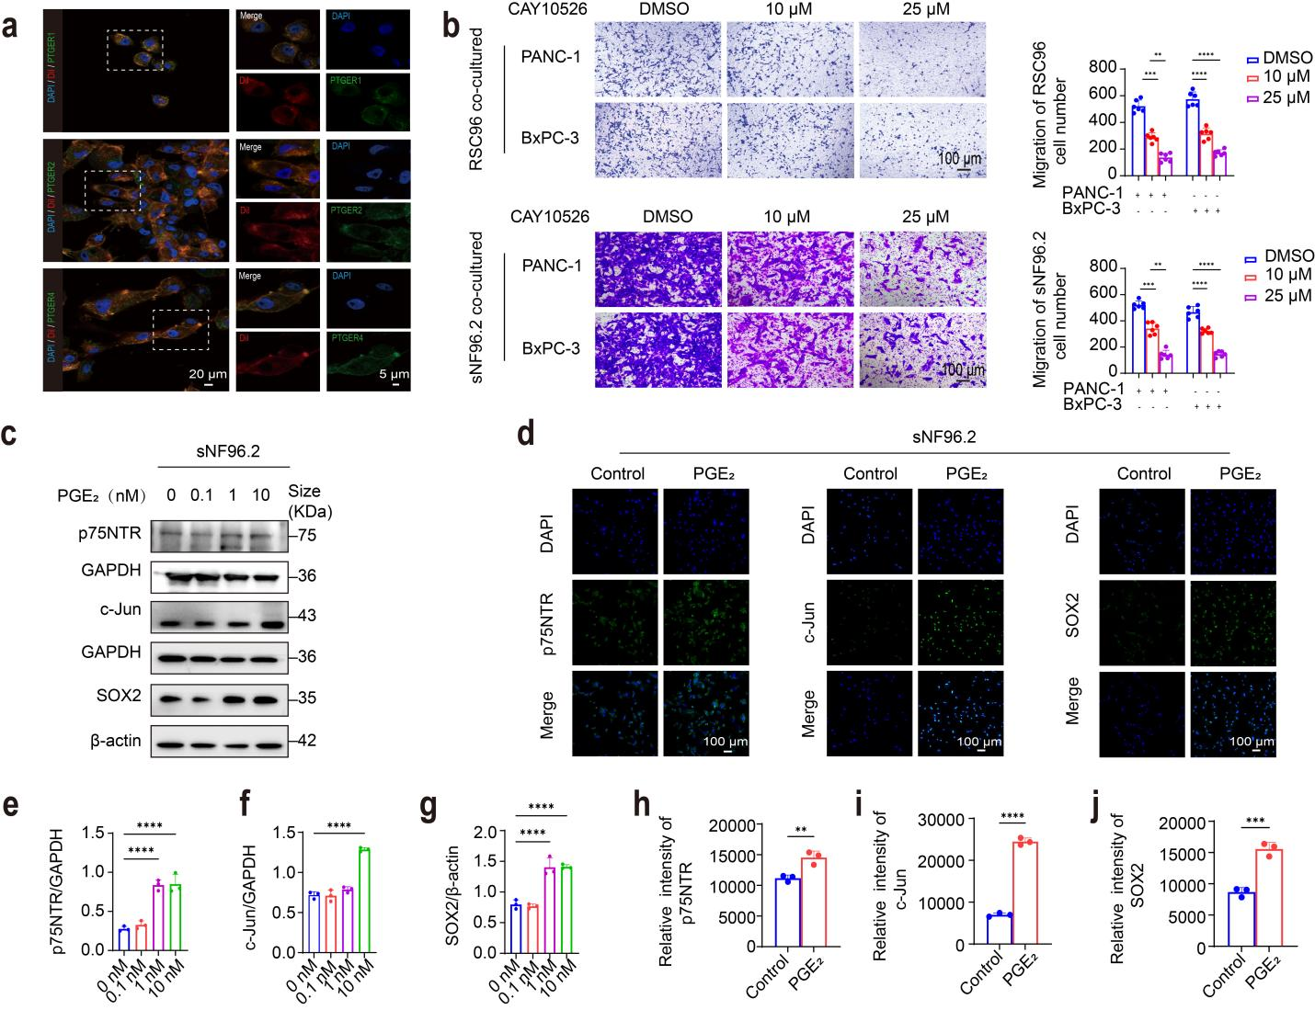
Supplementary Fig. 3 PGE₂ promotes dedifferentiation of sNF96.2 and RSC96 cells in pancreatic cancer
a Representative IF images of Dil, PTGER1/2/4 in sNF96.2 cells. Scale bars: 20 μm (left panels), 5 μm (right panels). b Migration ability of RSC96 and sNF96.2 cells after intervention with different doses of CAY10526. Scale bar: 100 μm (n=6). c, e, f, g Protein expression levels of p75NTR, c-Jun, and SOX2 in sNF96.2 cells after intervention with different doses of PGE₂ (0 nM, 0.1 nM, 1 nM, 10 nM). Relative expression levels were quantified as p75NTR/GAPDH and c-Jun/GAPDH. Since the molecular weight of SOX2 (~35 KDa) is close to that of GAPDH (~36 KDa), SOX2/β-actin was used for quantification (n=3). d, h-j Representative IF images of p75NTR, c-Jun, and SOX2 in sNF96.2 cells after PGE₂ intervention (n=3). Scale bar: 100 μm. Statistics of relative fluorescence intensity between the control and treatment groups. All results are presented as mean ± SDs. Each data point in the bar graphs represents an individual sample. Statistical significance was determined by one-way analysis of variance followed by Tukey’s HSD post-hoc test (for Supplementary Fig. 3b, e-g), two-tailed unpaired t-test (for Supplementary Fig. 3h-j). *p<0.05, **p<0.01, ***p<0.001, ****p<0.0001.

Figure.S4
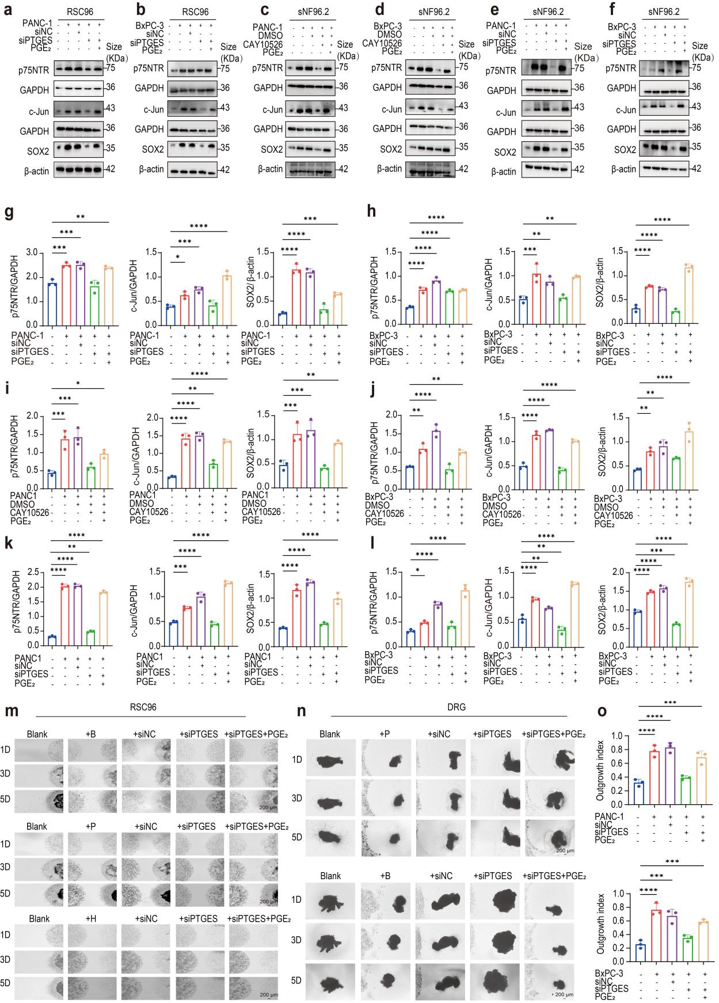
Supplementary Fig. 4 Inhibition of PTGES in pancreatic cancer impairs the dedifferentiation and PNI abilities of SCs
a, g Protein expression levels of p75NTR, c-Jun, and SOX2 in RSC96 cells after siPTGES treatment and PGE₂ supplementation in RSC96-PANC-1 coculture systems (n=3) b, h Protein expression levels of p75NTR, c-Jun, and SOX2 in RSC96 cells after siPTGES treatment and PGE₂ supplementation in RSC96-BxPC-3 coculture systems (n=3). c, d, i, j Protein expression levels of p75NTR, c-Jun, and SOX2 in sNF96.2 cells after CAY10526 treatment and PGE₂ supplementation in sNF96.2-BxPC-3/PANC-1 coculture systems (n=3). e, f, k, l Protein expression levels of p75NTR, c-Jun, and SOX2 in sNF96.2 cells after siPTGES treatment and PGE₂ supplementation in sNF96.2-BxPC-3/PANC-1 coculture systems (n=3). m Results of 3D coculture of RSC96 cells with PANC-1/BxPC-3 cells after siPTGES treatment (n=3). Scale bar: 200 μm. B/P/H: +BxPC-3/PANC-1/HPNE, +siNC: +BxPC-3/PANC-1/HPNE+siNC, +siPTGES: +BxPC-3/PANC-1/HPNE+siPTGES, +siPTGES+PGE₂: +BxPC-3/PANC-1/HPNE+siPTGES+PGE_{2.} n, o Coculture of DRG with PANC-1/BxPC-3 cells after siPTGES treatment, and the growth index of DRG (n=3). Scale bar: 200 μm.+B/P: +BxPC-3/PANC-1, +siNC：+BxPC-3/PANC-1+siNC, +siPTGES: +BxPC-3/PANC-1+siPTGES, +siPTGES+PGE₂: +BxPC-3/PANC-1+siPTGES+PGE_{2.} All results are presented as mean ± SDs. Each data point in the bar graphs represents an individual sample. Statistical significance was determined by one-way analysis of variance followed by Tukey’s HSD post-hoc test (for Supplementary Fig. 4g-l, o) *p<0.05, **p<0.01, ***p<0.001, ****p<0.0001.

Figure. S5
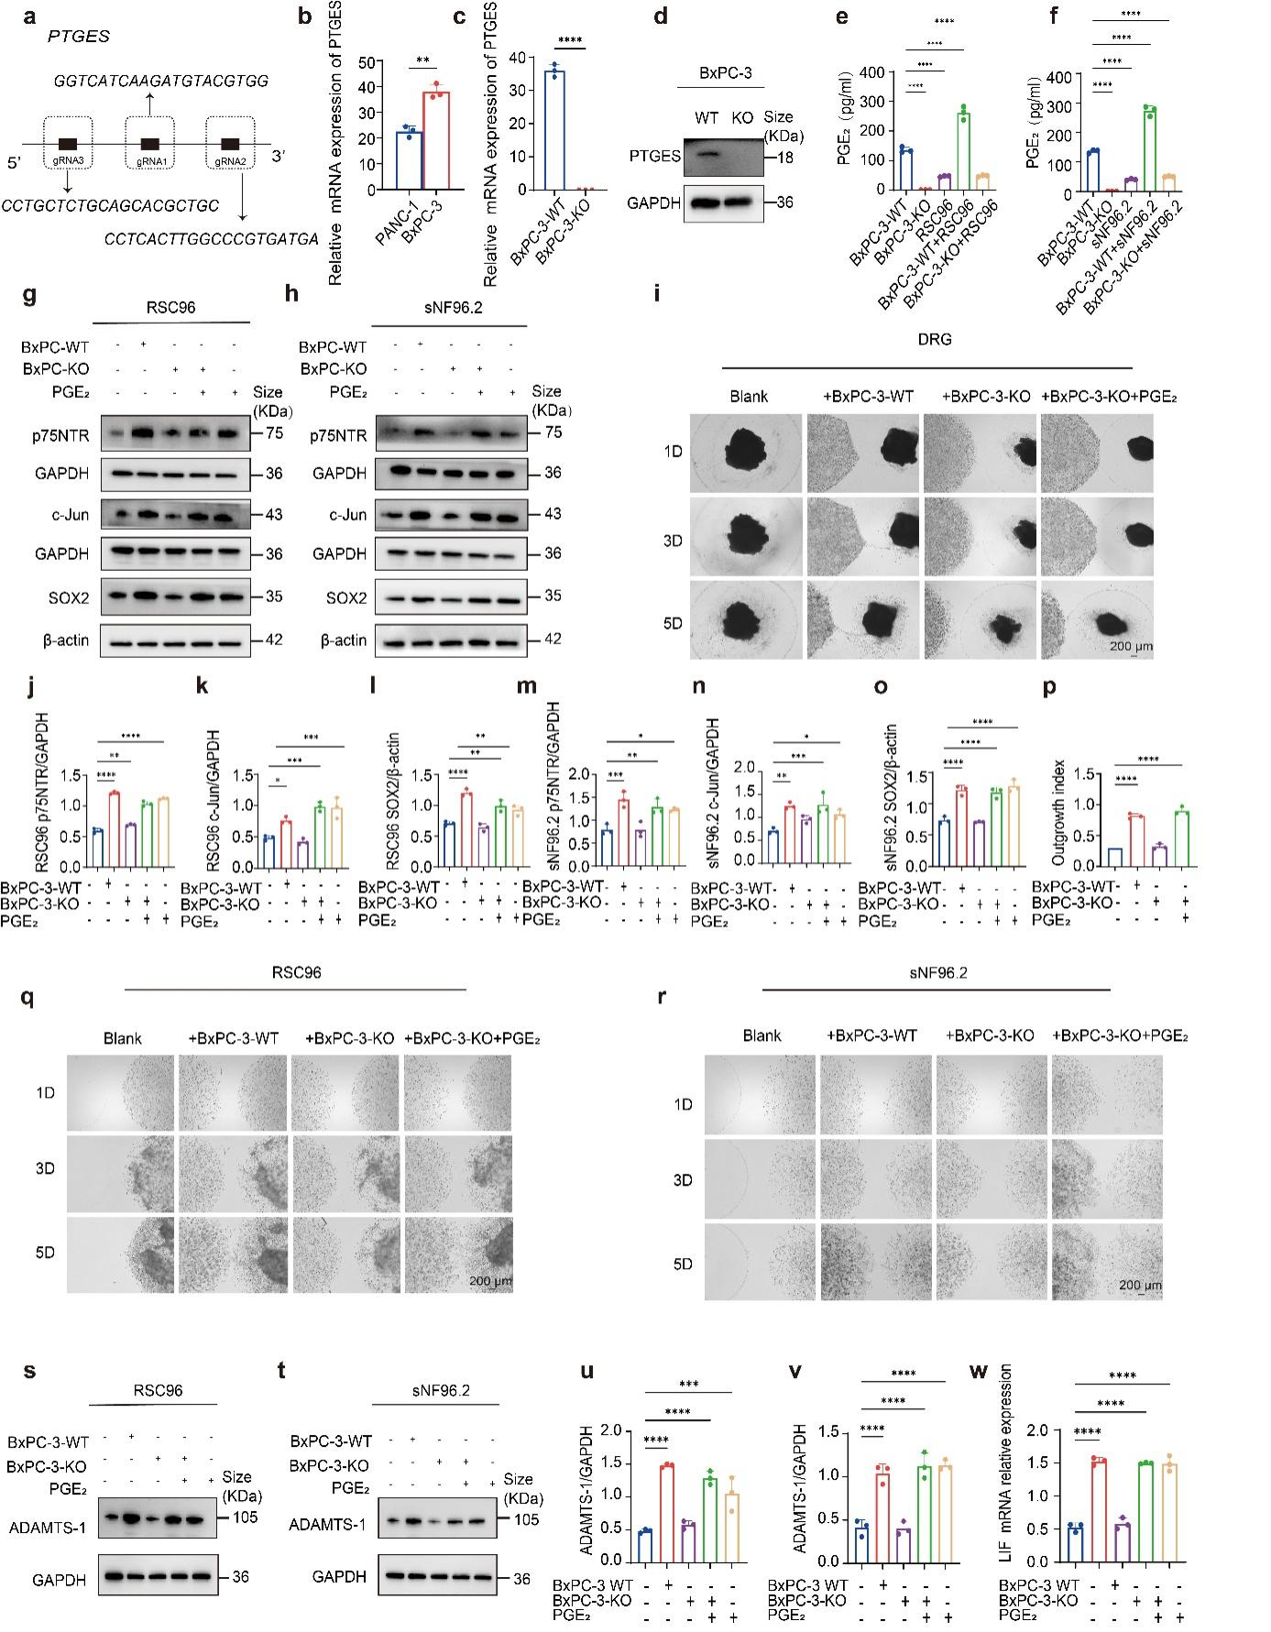
Supplementary Fig. 5 Coculture experiment of BxPC-3-WT cells and BxPC-3-KO cells
a Schematic diagram of PTGES-KO cell line construction in BxPC-3 cell. b Relative expression levels of PTGES mRNA in PANC-1 and BxPC-3 cells detected by RT-qPCR (n=3). c Relative expression levels of PTGES mRNA in BxPC-3-WT and BxPC-3-KO cells detected by RT-qPCR (n=3). d Relative expression levels of PTGES protein in BxPC-3-WT and BxPC-3-KO cells detected by Western Blot (n=3). e-f PGE₂ content in the supernatant of coculture system of BxPC-3-WT/BxPC-3-KO cells with RSC96 or sNF96.2 cells detected by ELISA (n=3). g-h, j-o Relative expression levels of p75NTR, c-Jun and SOX2 proteins in SCs after coculture with BxPC-3-WT/BxPC-3-KO cells detected by Western Blot (n=3). i, p Representative images of DRG cocultured with BxPC-3-WT/BxPC-3-KO cells and quantitative statistical results of DRG growth index (n=3). Scale bar: 200 μm. q-r Representative images of SCs directional migration after 3D coculture of BxPC-3-WT/BxPC-3-KO cells with RSC96 and sNF96.2 cells (n=3). Scale bar: 200 μm. s-v Relative expression level of ADAMTS-1 protein in SCs after coculture with BxPC-3-WT/BxPC-3-KO cells detected by Western Blot (n=3). w Relative expression level of LIF mRNA in SCs after coculture with BxPC-3-WT/BxPC-3-KO cells detected by RT-qPCR (n=3). All results are presented as mean ± SDs. Each data point in the bar graphs represents an individual sample. Statistical significance was determined by two-tailed unpaired t-test (for Supplementary Fig. 5b, c）and one-way analysis of variance (for Supplementary Fig. 5e-f, j-p, u-w）. *p<0.05, **p<0.01, ***p<0.001, ****p<0.0001.

Figure. S6
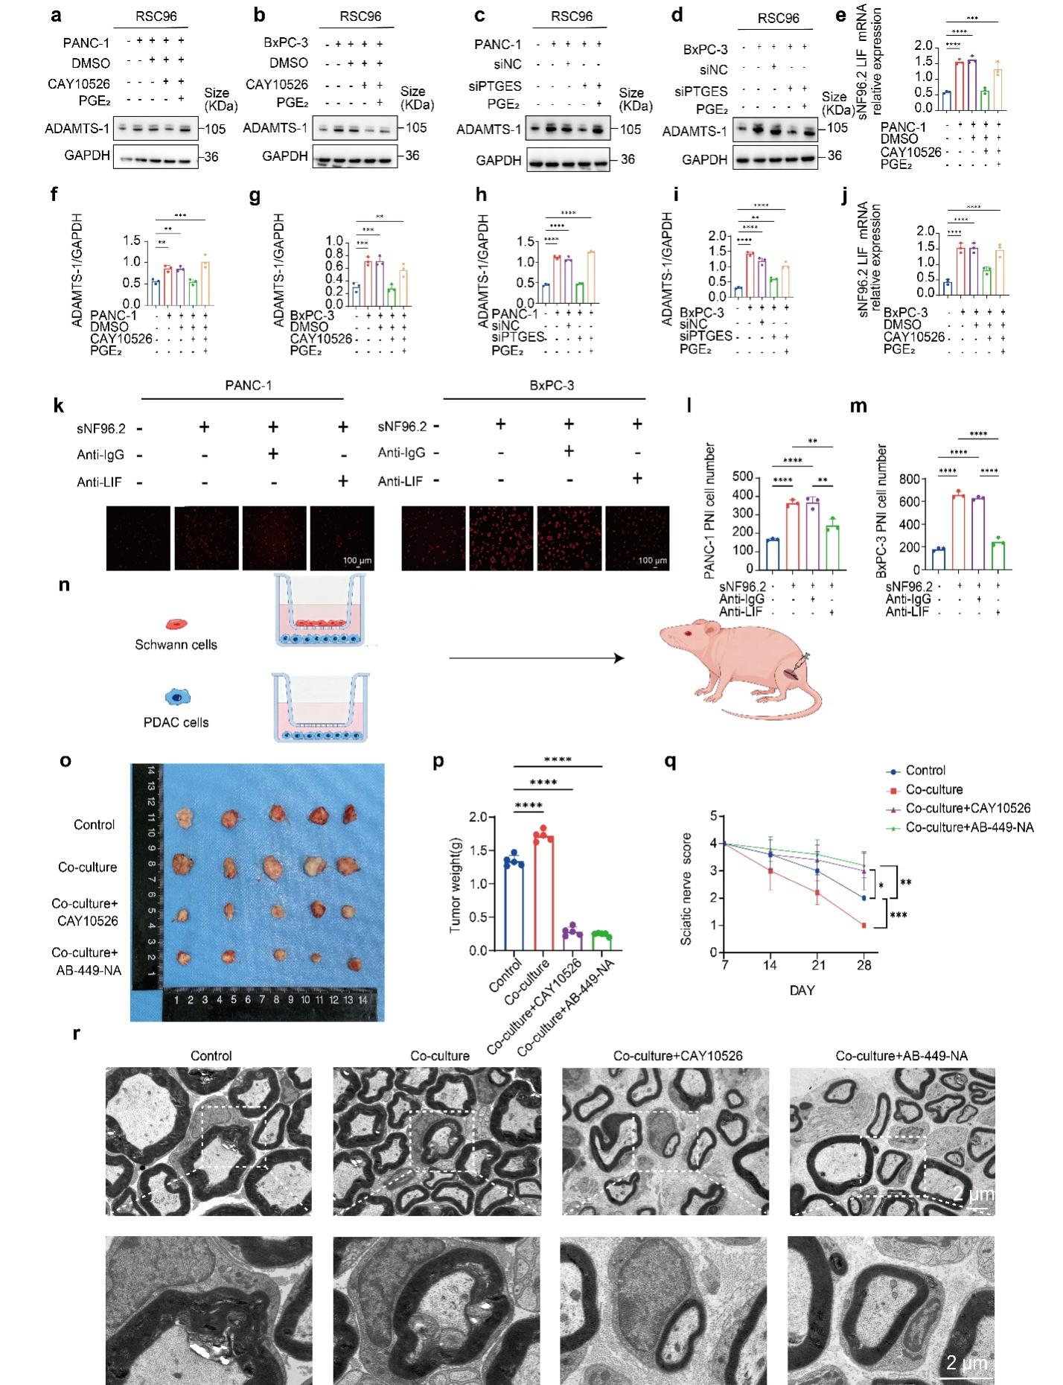
Supplementary Fig. 6 Inhibition of PTGES or LIF can weaken PNI
a, b, f, g Effects of CAY10526 and PGE₂ on ADAMTS-1 protein expression levels in the RSC96-PANC-1/BxPC-3 coculture system (n=3). c, d, h, i Effects of siPTGES and PGE₂ on ADAMTS-1 protein expression levels in the RSC96-PANC-1/BxPC-3 coculture system (n=3). e, j Effects of CAY10526 and PGE₂ on LIF mRNA expression levels in the sNF96.2-PANC-1/BxPC-3 coculture system (n=3). k, l, m Effects of LIF neutralizing antibody on PNI of PANC-1/BxPC-3 cells(n=3). Scale bar: 100 μm. n, o Schematic diagram of the sciatic nerve invasion model in nude mice and representative images of tumors (n=5). p Statistical analysis of tumor weight (n=5). q Statistical analysis of sciatic nerve invasion score (n=5). r Representative TEM images of different treatment groups. Scale bar: 2 μm. All results are presented as mean ± SDs. Each data point in the bar graphs represents an individual sample. Statistical significance was determined by one-way analysis of variance followed by Tukey’s HSD post-hoc test (for Supplementary Fig. 6e-j, l-m, p) and Kruskal-Wallis H test followed by Dunn’s multiple comparisons test (for Supplementary Fig. 6q). *p<0.05, **p<0.01, ***p<0.001, ****p<0.0001.

Table S1. Statistical Chart of Pathological Characteristics of PNI Patients

 | level | Low PNI plus PNI-(n=101) | High PNI  (n=48) | p
Gender | Female | 44 (43.6) | 26 (54.2) | 0.3
 | Male | 57 (56.4) | 22 (45.8)
age_at_index.demographic mean (SD) |  | 64.72 (10.86) | 65.85 (11.66) | 0.563
ajcc_pathologic_stage | Stage IA | 2 (2.0) | 1 (2.1) | 0.61
 | Stage IB | 7 (6.9) | 3 (6.2)
 | Stage IIA | 17 (16.8) | 7 (14.6)
 | Stage IIB | 71 (70.3) | 33 (68.8)
 | Stage III | 3 (3.0) | 1 (2.1)
 | Stage IV | 1 (1.0) | 3 (6.2)
ajcc_pathologic_t | T1 | 2 (2.0) | 2 (4.2) | 0.728
 | T2 | 13 (12.9) | 4 (8.3)
 | T3 | 83 (82.2) | 41 (85.4)
 | T4 | 3 (3.0) | 1 (2.1)
ajcc_pathologic_n | N0 | 28 (27.7) | 9 (18.8) | 0.279
 | N1 | 71 (70.3) | 36 (75.0)
 | N1b | 2 (2.0) | 2 (4.2)
 | NX | 0 (0.0) | 1 (2.1)
ajcc_pathologic_m | M0 | 42 (41.6) | 29 (60.4) | 0.008**
 | M1 | 1 (1.0) | 3 (6.2)
 | MX | 58 (57.4) | 16 (33.3)
Treatment | no | 21 (20.8) | 9 (18.8) | 0.643
 | one | 47 (46.5) | 20 (41.7)
 | two | 25 (24.8) | 12 (25.0)
 | Others | 8 (7.9) | 7 (14.6)
Molecular Subtype | classical-PDAC | 57 (56.4) | 17 (35.4) | 0.011*
 | QM-PDAC | 42 (41.6) | 26 (54.2)
 | Others | 2 (2.0) | 5 (10.4)

Table S2. Perineural invasion score system

Item | Score
Nerve diameter
＜0.1 mm | 0
0.1-0.19 mm | 1
≥2 mm | 2
Number of involves nerves
1 | 0
2-4 | 1
≥5 | 2
Nerve sheath involvement
＜50% | 0
50-100% | 1
Intraneural | 2
Site
Intratumoral | 0
Extratumoral | 1
Mitotic figures within perineural invasion
No | 0
Yes | 1

Table S3. Primers for gene quantification
Name | Sequence (5'-3')
LIF-F（Rat） | TTGCCGTCTGTGCAACAAGT
LIF-R（Rat） | TGGACCACCGCACTAATGAC
GAPDH-F (Rat) | ACGGCAAGTTCAACGGCACAG
GAPDH-R (Rat) | GAAGACGCCAGTAGACTCCACGAC
LIF-F（Homo） | GTTCCCCAACAACCTGGACAA
LIF-R（Homo） | GGTGCCAAGGTACACGACTAT
GAPDH-F（Homo） | CAATGACCCCTTCATTGACC
GAPDH-R（Homo） | GACAAGCTTCCCGTTCTCAG

Table S4. gRNA sequence
gRNA | Sequence (5'-3')
gRNA1 | GGTCATCAAGATGTACGTGG
gRNA2 | CCTCACTTGGCCCGTGATGA
gRNA3 | CCTGCTCTGCAGCACGCTGC

Other Supplementary Materials for this manuscript include the following:
Dataset 1: KEGG analysis of differentially expressed genes (DEGs) between the RSC96 cells cocultured with PANC-1/BxPC-3 cells group and the RSC96 cells monocultured control group, as well as the specific data of the Venn diagram for the overlapping enriched pathways of the two groups.
Dataset 2: Differentially expressed genes from various PNI related databases, intersection genes of the Venn diagram, and differentially expressed genes between the RSC96 cell control group and the RSC96 cell groups (cocultured with PANC-1/BxPC-3 cells or treated with PGE₂).

