Supplementary Materials for

HIF regulatory network reflects kidney disease progression in diabetes and reversal with SGLT2 inhibition
Viji Nair^{1,3#}, Akihiro Minakawa^{1, 2#}, Cathy Smith^{1#}, Celine C. Berthier^{1#}, John Hartman¹, Rajasree Menon³, Damian Fermin¹, Edgar A. Otto¹, Debora L. Gisch⁴, Michael T. Eadon⁴, Sanjay Jain⁵, Ye Ji Choi⁶, Laura Pyle⁶,Felix Eichinger¹, Fadhl M. Alakwaa¹, Michael P. Rose¹, Lalita Subramanian¹, Jamal El Saghir¹, Jeffrey A. Beamish¹, Jeffrey B. Hodgin⁷, Frank C. Brosius^{1,8}, Petter Bjornstad⁶, Peter J. Nelson^{1,9}, Jennifer L. Harder¹, Thomas Werner^{1,3}, Matthias Kretzler^{1,3}*, Jennifer A. Schaub¹*

#co-first authors,
*Correspondence to: schaubj@med.umich.edu, kretzler@med.umich.edu

This PDF file includes:

Supplementary Methods
Supplementary References
Figures. S1 to S12
Tables S1 to S9
Captions for Movie S1

Other Supplementary Materials for this manuscript include the following:

Movie S1

Materials and Methods
Kidney organoid generation
Kidney organoids derived from UM77-2 human embryonic stem cells were generated^{1,2} and treated according to previously described protocols³. Briefly, UM77-2 hESCs were plated at 15,000 cells/well in a 24-well plate, precoated with Geltrex. Next day, cells were sandwiched with Geltrex before treatment with CHIR and Noggin on the third day. After 36h, media was replaced with advanced RPMI supplemented with B27, Glutamax and penicillin-streptomycin, and then replaced every third day until collection day.

Hypoxia and compound treatment
Kidney organoids were cultured under hypoxia as previously described³. At day 23, organoids were placed in the hypoxia chamber, treated with Dapagliflozin (10 µM) in RB media or vehicle control (VC) for 24h and then collected for subsequent processing.

Single cell RNA-sequencing and bioinformatic analysis
Whole well organoid cultures were collected by scraping cells into ice-cold DPBS and single cells dissociated with cold protease as previously described⁴. Single cell suspensions were then sequenced and library prepared on a 10x Genomics Chromium Single Cell 3’ v3.1 platform at the Advanced Genomics Core, University of Michigan. Raw data were aligned to the human reference genome (ENSEMBLE GRCh38.104) with Cell Ranger and feature-barcode matrices were generated. Downstream analysis in Seurat⁵ where cells expressing >500 genes were processed for log-normalization, scaling, identification of highly variable genes, dimensionality reduction with principal component analysis (PCA) and Uniform Manifold Approximation and Projection (UMAP), batch correction using the Harmony algorithm (v1.0) (5), and unsupervised clustering at a resolution of 0.25.

Figure. S1.
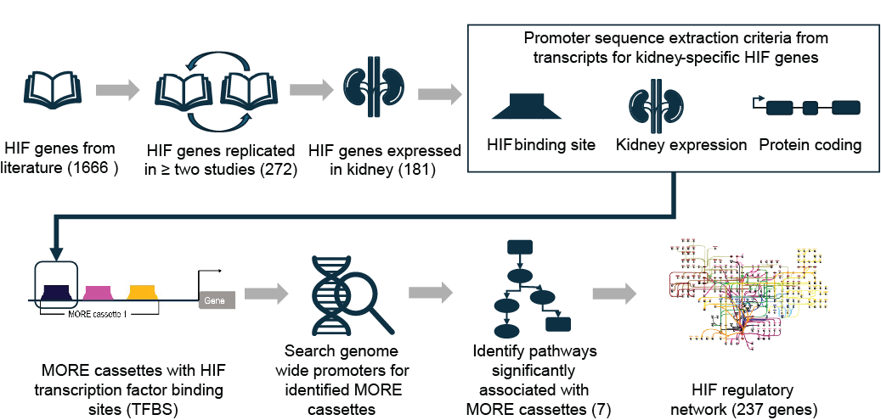

Supplementary Fig. 1. Analytic workflow overview. The 1666 HIF-related genes identified
from literature were narrowed by limiting to those cited in more than one study (272). Looking
at expression in kidney tissue using scRNAseq data from youth with T2D and individuals with
DKD in the KPMP cohort, the list was subsetted to 181. Promoter sequences were extracted
for these 181 genes provided the promoter contained a HIF binding site, encoded a transcript
that was expressed in kidney tissue and was in a protein coding region. We then identified
MORE cassettes within these promoter sequences. A genome wide search to identify other
occurrences of these MORE cassettes in the human genome resulted in a highly redundant
list of genes, which were enriched in 7 pathways. These 7 pathways comprising 237 genes
formed the HIF regulatory network.

Figure. S2.
Supplementary Fig. 2. The hypoxia associated network of genes. Map of gene names for Figure 3a and other network diagrams.

Figure. S3.
Supplementary Fig. 3. The HIF1A transcription factor network. Core of the network of hypoxia associated genes, HIF1A transcription factor pathway, highlighted in pink.

Figure. S4.

Supplementary Fig. 4. Individual pathway diagrams for hypoxia associated regulatory network.
Connectivity diagrams for the seven regulatory pathways within the hypoxia associated network (part 1) HIF1A transcription factor network.

Figure. S5.

Supplementary Fig. 5. Individual pathway diagrams for hypoxia associated regulatory network.
Connectivity diagrams for the seven regulatory pathways within the hypoxia associated network (part 2) HIF2A (EPAS) transcription factor network.

Figure. S6.
Supplementary Fig. 6. Individual pathway diagrams for hypoxia associated regulatory network.
Connectivity diagrams for the seven regulatory pathways within the hypoxia associated network (part 3). a. Hypoxic and oxygen homeostasis regulation of HIF1A b. VEGF hypoxia and angiogenesis

Figure. S7.
Supplementary Fig. 7. Individual pathway diagrams for hypoxia associated regulatory network.
Connectivity diagrams for the seven regulatory pathways within the hypoxia associated network (part 4). a. PDGFRB signaling pathway b. Hypoxia response via HIF activation

Figure. S8.
Supplementary Fig. 8. Individual pathway diagrams for hypoxia associated regulatory network.
Connectivity diagrams for the seven regulatory pathways within the hypoxia associated network (part 5). TGFβ receptor

Figure. S9.

Supplementary Fig. 9. VisiumHD proximal tubular cells gene expression (part1). Scatterplots of VisiumHD gene expression for aPT/dPT (blue), PT (red) and all other spots (grey). Each dot is one cell and the thick horizontal bar is the average expression for that group. Percentage of cells in each category expressing the gene listed at the top. Bar plots below provide cell counts for each group. Significant differences in gene expression (unadjusted p<.05) between aPT/dPT and PT spots are indicated with a star. Comparisons between the two PT categories and Other were only made for CUBN and for that gene significant differences are represented with a star.

Figure. S10.

Supplementary Fig. 10. VisiumHD proximal tubular cells gene expression (part2). Scatterplots of VisiumHD gene expression for aPT/dPT (blue), PT (red) and all other spots (grey). Each dot is one cell and the thick horizontal bar is the average expression for that group. Percentage of cells in each category expressing the gene listed at the top. Bar plots below provide cell counts for each group. Significant differences in gene expression (unadjusted p<.05) between aPT/dPT and PT spots are indicated with a star.

Figure S11.
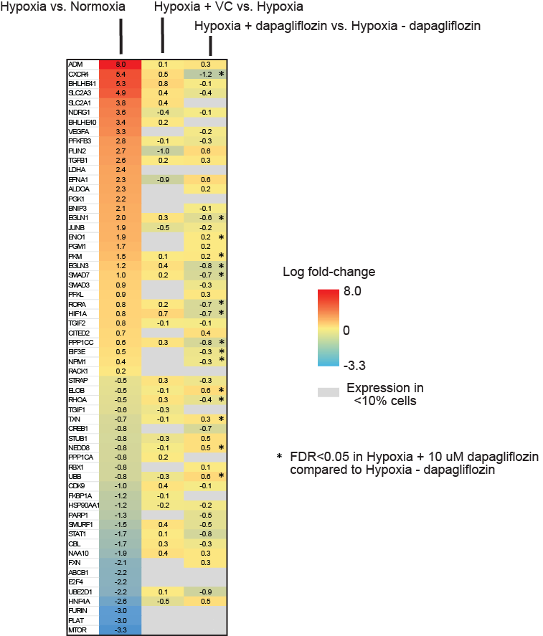

Supplementary Fig. 11. Reversal of hypoxia response gene network in hypoxic organoids.
Log-fold-change heatmap of 60/237 network genes significantly regulated in Hypoxia compared to normoxia and their expression in organoids treated with Dapagliflozin.For validation, we analyzed the expression of the network genes in the proximal tubular (PT) cells of human kidney organoids under Hypoxia and treated with Dapagliflozin. A total of 159/237 network genes were expressed in PT cells under hypoxic condition. A total of 60/159 were significantly regulated in hypoxic PT compared to normoxia, with 16 being significantly reversed with Dapagliflozin
treatment. Abbreviations: VC=vehicle control; FDR – false discovery rate.

Figure S12.

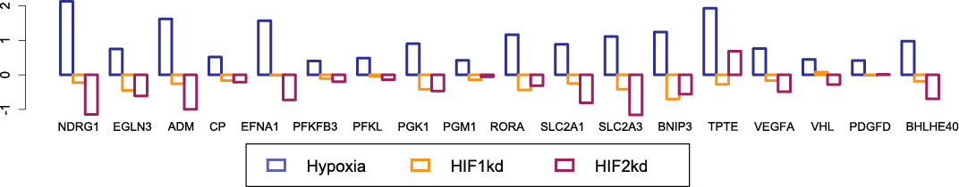

Supplementary Fig. 12. Suppression of key nodes in HIF network with HIF1A and HIF2A knockdown in hypoxic HK2 cells. Differential expression in cultured HK2 cells due to hypoxia and knockdown of HIF-1 and HIF-2 for 18 network genes with hypoxia:normoxia log2 fold-change exceeding 0.4. In all cases, hypoxia:normoxia differential expression is significant at q < .01 after adjustment for multiple testing. In general, the response of these genes to hypoxia is attenuated by suppression of HIF1 or HIF2.

Supplementary References
1 Freedman, B. S. et al. Modelling kidney disease with CRISPR-mutant kidney organoids derived from human pluripotent epiblast spheroids. Nat Commun 6, 8715 (2015).
2 Harder, J. L. et al. Organoid single cell profiling identifies a transcriptional signature of glomerular disease. JCI Insight 4 (2019).
3 Minakawa, A. et al. Dapagliflozin mitigates hypoxia-induced metabolic stress, kidney tubular cell death and fibrosis. bioRxiv, 2025.2012.2013.693777 (2025).
4 Lasse, M. et al. An integrated organoid omics map extends modeling potential of kidney disease. Nat Commun 14, 4903 (2023).
5 Hao, Y. et al. Integrated analysis of multimodal single-cell data. Cell 184, 3573-3587 e3529 (2021).

Movie S1.
This video facilitates visualization of the overlapping pathways that comprise the HIF Regulatory Network, the subsequent validation for the presence of the majority of the network in open chromatin and the alterations with progressive DKD and treatment with SGLT2 inhibitors.

