Supplementary Materials for
Reprogramming the tumor microenvironment with antibody against membrane-proximal AXL to overcome immune checkpoint blockade resistance
Zuming Yang, Shuaishuai Cao, Jiaen Zhang, Xiaohua Nie, Zhimin Wang, Shaojun Yang, Jingshu Wang, Xin Sun, Xueli Kuang, Huiming Huang, Zifan Wei, Pengfei Duan, Mingwan Tang, Liyu Zhang, Zhenhua Ren, Xun Lan, Yang-Xin Fu, Liguo Zhang, Xuyuan Zhang, Yong Liang

Correspondence to: yongliang@tsinghua.edu.cn (Y.L.); zxy_better@ibp.ac.cn (X.Z.); liguozhang@ibp.ac.cn (L.Z.); yangxinfu@tsinghua.edu.cn (Y.F.)

This PDF file includes:
Figures. S1 to S5

Other Supplementary Materials for this manuscript include the following:
Data S1. Supplementary Data S1_Uncropped_WB_images.pdf

Figure. S1
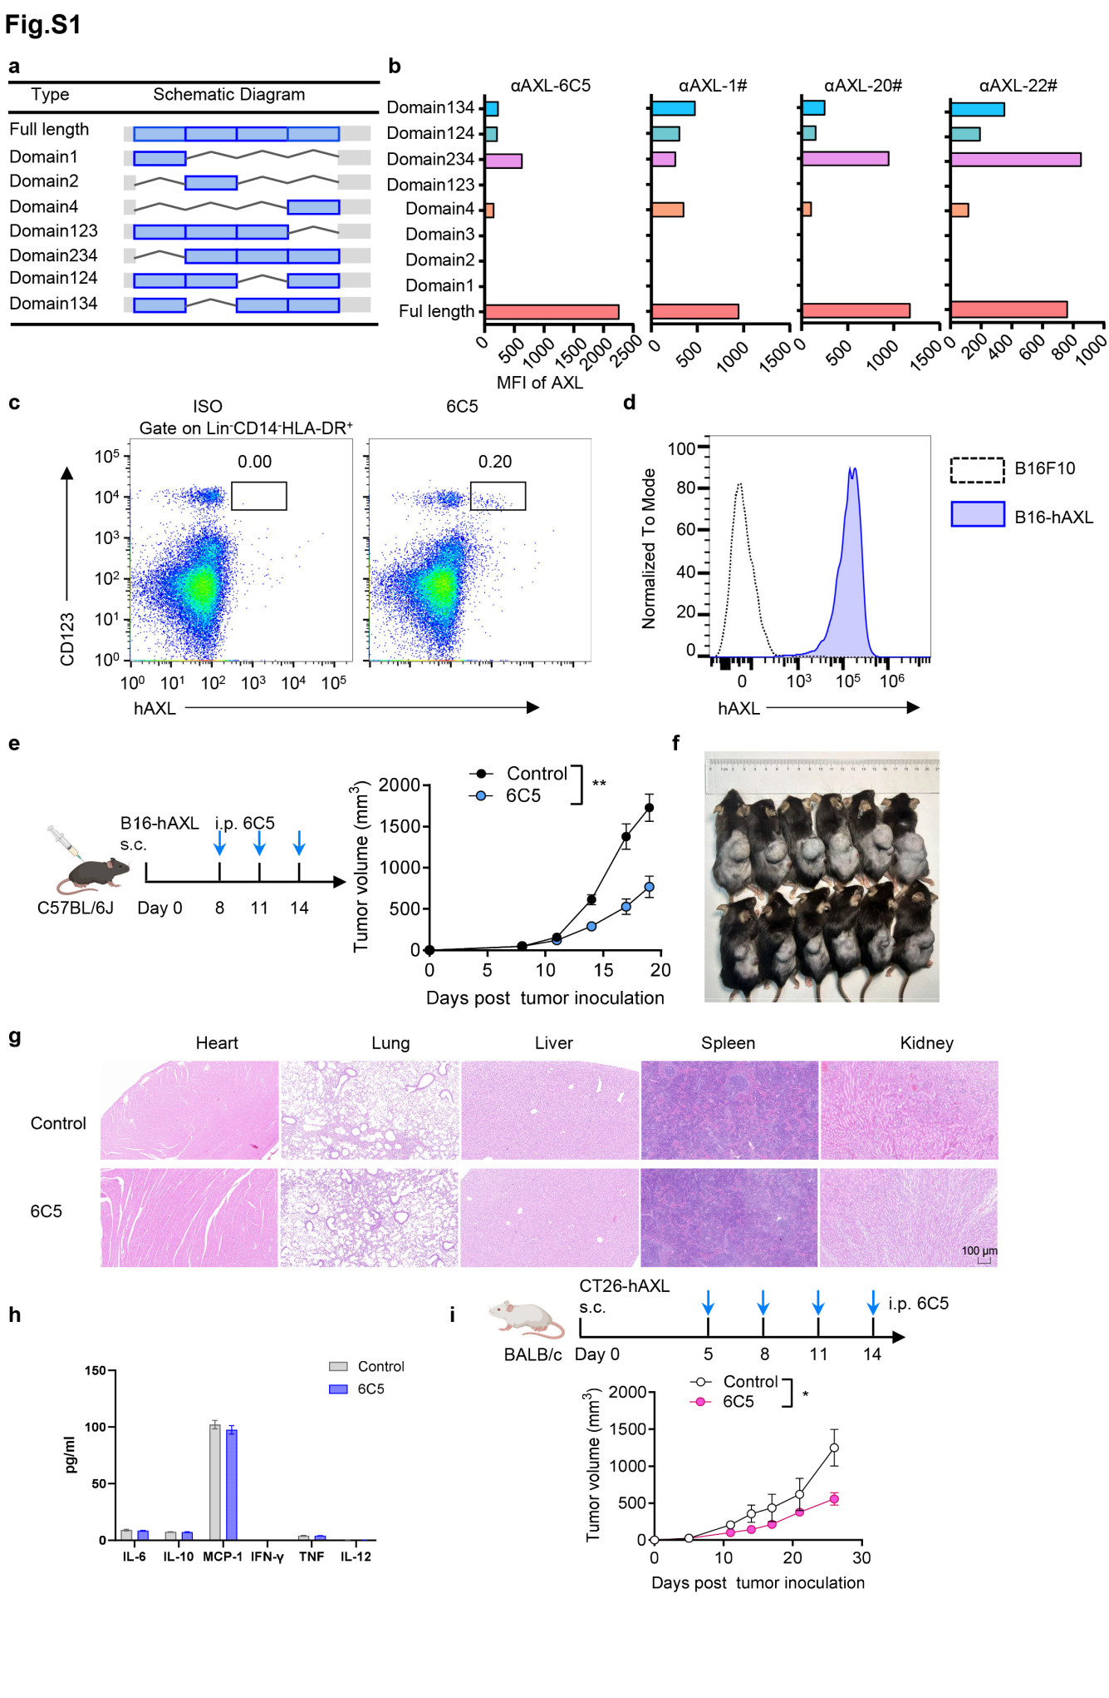
Figure. S1 Development of antibodies targeting distinct epitopes of AXL. a Schematic representation of hAXL with different truncations. b Binding of anti-hAXL antibodies to cell surface-expressed hAXL truncation mutants. c Binding of 6C5 to native AXL expressed on AXL⁺ dendritic cells in human PBMCs. d Flow cytometry analysis of hAXL expression on B16-hAXL tumor cells. e-f Male C57BL/6J mice (n=6) bearing B16-hAXL tumors were treated with PBS or 6C5 (200µg per mice) via intraperitoneal injection on days 8, 11 and 14. Tumor growth curves (e). Representative image of tumors (f). g-h C57BL/6J mice bearing B16-hAXL tumors were treated as in (e, f). H&E staining of major organs collected 10 days after the first treatment, Scale bar = 100 µm (g). Cytokine levels in blood samples (h). i BALB/c mice (n=6) bearing CT26-hAXL tumors were treated with PBS or 6C5 (200µg per mice) on days 5, 8, 11 and 14. Data indicate means ± SEM and are repeated two or three independent times. Statistical analysis for tumor growth was performed using a two-way ANOVA. *P < 0.05, **P < 0.01.

Figure. S2
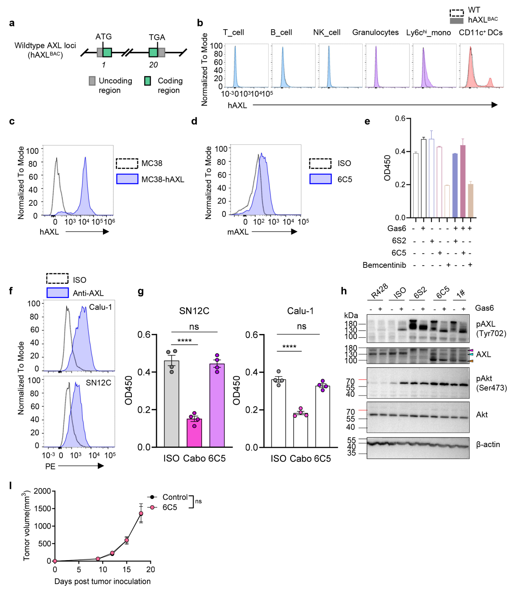
Figure. S2 Antitumor effects of the 6C5 antibody are independent of direct inhibition of tumor cell growth. a Schematic of the transgenic hAXL locus in hAXL^{BAC} mice. b Flow cytometric analysis of hAXL expression on immune cell subsets from splenocytes of hAXL^{BAC} mice. c Detection of hAXL expression on MC38-hAXL tumor cells by flow cytometry. d Binding of 6C5 to mouse AXL (mAXL) expressed on the cell surface. e Effects of anti-AXL antibodies and bemcentinib on B16-hAXL cell growth in vitro. Cells were cultured with 400 ng/mL Gas6 in the presence of 10 µg/mL antibodies or 2 µM bemcentinib for 72 h, and viability was measured by CCK-8 assay. f AXL expression levels on SN12C and Calu-1 analyzed by flow cytometry. g Effect of 6C5 on the growth of SN12C and Calu-1, assessed by CCK-8 assay. h Calu-1 cells were serum-starved for 24 hours, preincubated with 100 μg/mL of indicated antibodies or 5 μM R428 for 2 h and stimulated with or without Gas6 for 30 min. Phosphorylation of AXL and Akt was assessed by western blotting. β-actin was used as loading control. i Tumor growth curves of NSG-SGM3 mice (n=8 per group) bearing B16-hAXL tumor following treated with PBS or 6C5 (200 μg per mice) on days 9, 12 and 15. Data indicate means ± SEM and are repeated two or three independent times. Statistical analysis for tumor growth was performed using a two-way ANOVA. For (g), unpaired two-tailed t test was applied. ns (not significant), ****P < 0.0001.

Figure. S3
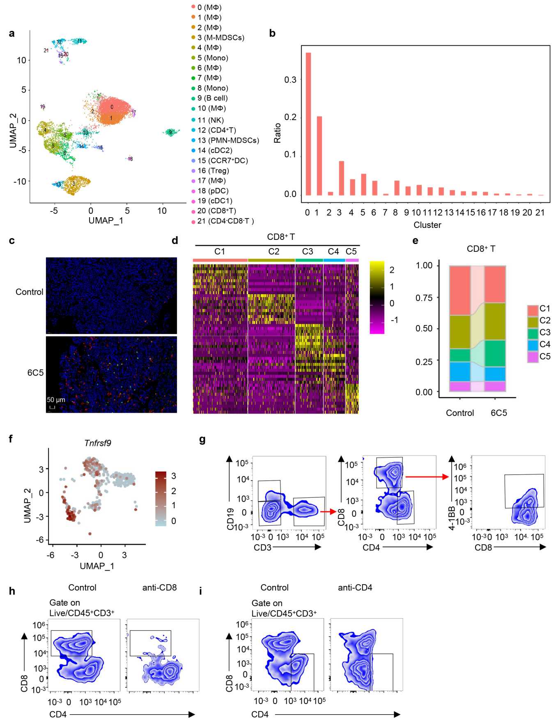
Figure. S3 Therapeutic effect of 6C5 antibody depends on CD8⁺ T cells. a UMAP visualization of total CD45⁺ cells isolated from tumors, identifying 22 distinct clusters. b Proportions of tumor-infiltrating immune cells. c.C57BL/6J mice bearing B16-hAXL tumors were treated with PBS (control) or 6C5 (200 µg per mouse) via intraperitoneal injection on days 8 and 11. Tumors were collected on day 5 following the first administration for immunofluorescence analysis of CD45⁺ cells(red) and CD8⁺ T cells(green) infiltration, Scale bar = 50 µm. d Heatmap of top differentially expressed genes (DEGs) of each CD8⁺ T cell population. e Bar graph showing the proportion of CD8⁺ T cell clusters identified within the tumor. f Feature plot showing the expression of 4-1BB (Tnfrsf9) in CD8⁺ T cell populations. g Flow cytometry gating strategy for 4-1BB⁺CD8⁺ T cells, pre-gated on live/CD45⁺ cells. h Flow cytometry was performed to assess the depletion effect of anti-CD8 on intratumoral CD8⁺ T cells. i Flow cytometry was performed to assess the depletion effect of anti-CD4 on intratumoral CD4⁺ T cells.

Figure. S4
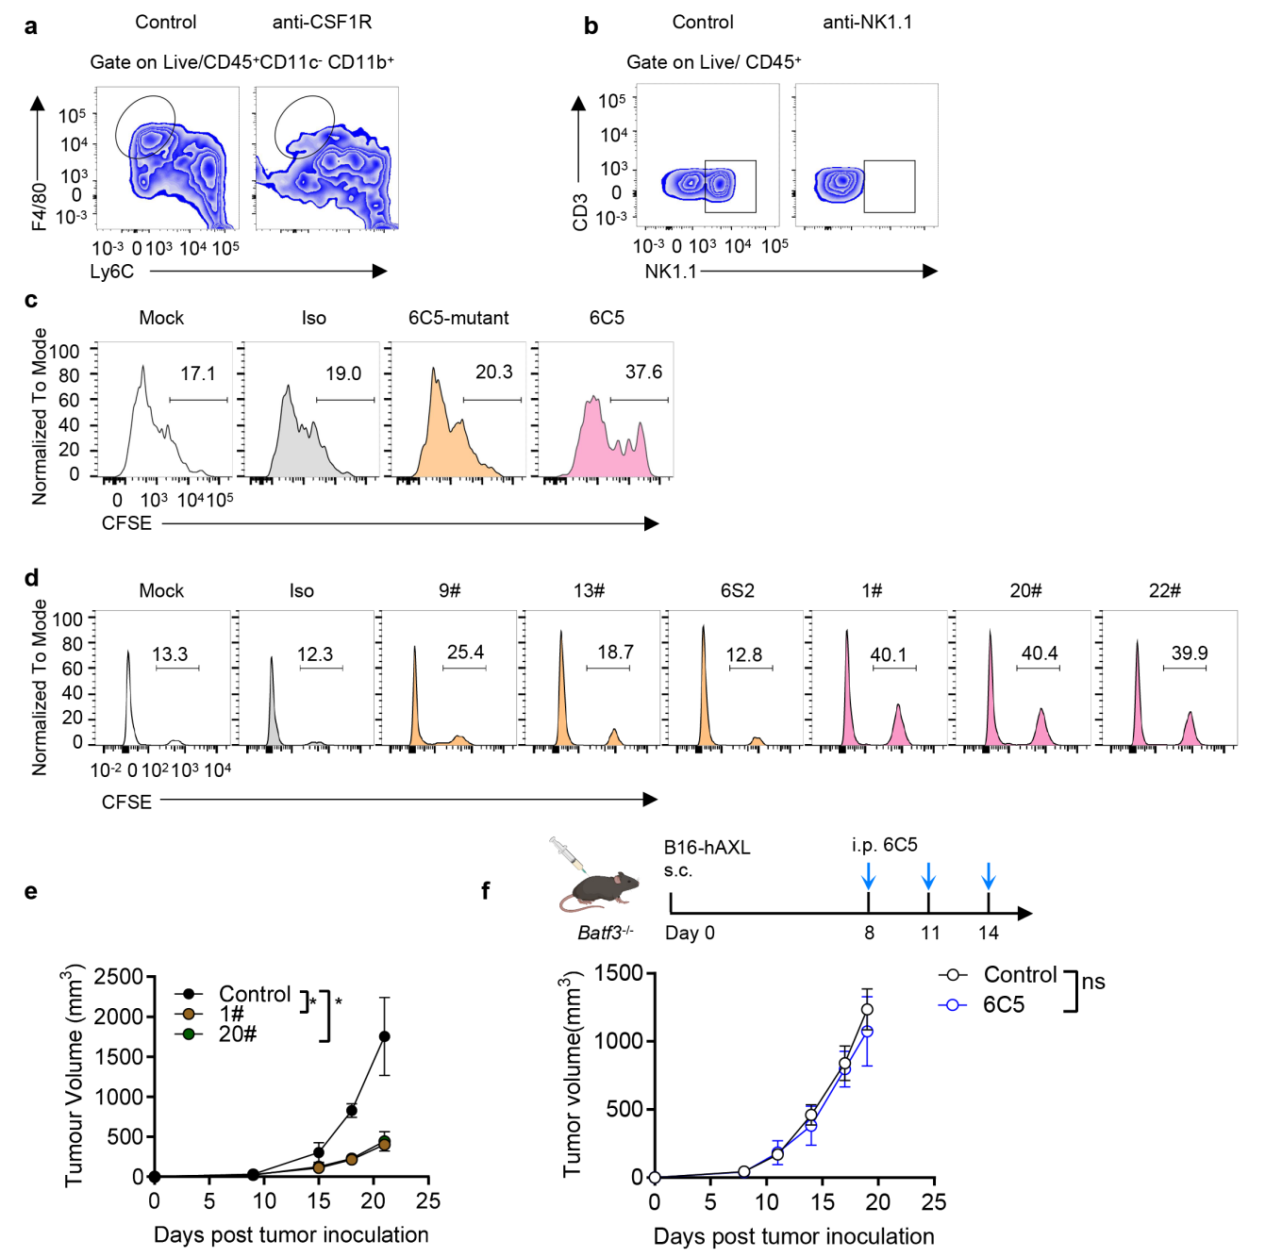
Figure. S4 Antibodies targeting membrane-proximal epitopes of AXL enhance macrophage-mediated ADCP effect. a Flow cytometric analysis of macrophage depletion in tumors following anti-CSF1R treatment. b Flow cytometric evaluation of NK cells depletion in tumors after anti-NK1.1 administration. c Representative flow plots showing phagocytosis of B16-hAXL tumor cells by macrophages in the presence of 6C5 or an Fc mutated variant 6C5 (6C5-mutant). d Representative flow plots showing macrophage-mediated phagocytosis of B16-hAXL tumor cells induced by antibodies targeting different AXL epitopes. e Tumor growth curves in hAXL^{BAC} mice bearing B16-hAXL tumors treated with PBS (control, n=4), 1# (200 μg per mice, n=5) and 20# (200 μg per mice, n=5) via intraperitoneal injection on days 9, 12 and 15. f Tumor growth curves of Batf3^{-/-} mice bearing B16-hAXL tumor were treated with PBS (control, n=8) or 6C5 (200 μg per mice, n=7) by intraperitoneal injection on days 8, 11 and 14. Data indicate means ± SEM and are repeated two or three independent times. Statistical analysis for tumor growth was performed using a two-way ANOVA. ns (not significant), *P < 0.05.

Figure. S5

Figure. S5 The therapeutic efficacy of the 6C5 antibody depends on type I interferon signaling. a Feature plots illustrate the expression of type I interferon-related genes across distinct cell clusters. b Tumor growth curves of Ifnar1 KO C57BL/6 mice (n=6 per group) bearing B16-hAXL tumor were treated with PBS or 6C5 (200 μg per mice) via intraperitoneal injection on days 8, 11, 14. c Tumor growth curves in C57BL/6 mice (n=5 per group) and Lyz2-cre Ifnar1^{f/f} mice (n=5 per group) bearing B16-hAXL tumor. d C57BL/6J mice(n=5) bearing B16-hAXL tumor were treated with PBS or 6C5(200μg per mice) on days 8, 11 and 14. Tumors were collected on day 8 after the first dose for flow cytometric analysis. e Gating strategy for identifying PD-1^{hi}Foxp3⁻CD4⁺ T cells. f Venn diagram depicting shared and unique TCR clonotypes among tumor derived Treg, PD-1^{hi}Foxp3⁻CD4⁺ T and PD-1⁻Foxp3⁻CD4⁺ T cells subsets. Numbers indicate unique or overlapping clonotypes. g Stacked bar graph showing the cumulative frequencies of the top 10 TCR clonotypes within tumor infiltrating Treg, PD-1^{hi}Foxp3⁻CD4⁺ T and PD-1⁻Foxp3⁻CD4⁺ T populations. h Cumulative frequencies of the top 10 clonotypes from PD-1^{hi}Foxp3⁻CD4⁺ T among the three CD4⁺ T cell subsets. i Cumulative frequencies of the top 10 clonotypes from PD-1⁻Foxp3⁻CD4⁺ T among the three CD4⁺ T cell subsets. j Tumor growth curves of C57BL/6 mice that experienced complete tumor regression after 6C5 plus anti-CD4 combination therapy, following subcutaneous rechallenge with B16-hAXL tumor cells. Data indicate means ± SEM and are repeated two or three independent times. Statistical analysis for tumor growth was performed using a two-way ANOVA. For (d), unpaired two-tailed t test was applied. ns (not significant), *P < 0.05, **P < 0.01 and ****P < 0.0001.

Data S1. (separate file)
Uncropped images of Western blot membranes.

