Supplementary Materials for

Efficacy and safety of toripalimab in combination with cetuximab in patients with recurrent or metastatic head and neck squamous cell carcinoma (R/M HNSCC): A phase 1b/2 study

Authors: Ye Guo^{1, #}, Zhendong Li^{2, #}, Liqiong Xue^{1, #}, Jinguan Lin³, Song Qu⁴, Chuanzheng Sun⁵, Meiyu Fang⁶, Youhua Zhu⁷, Jingfeng Zong⁸, Wantao Chen⁹, Guochun Cao¹⁰, Jin Wu¹¹, Minghua Ge¹², Zhiming Li¹³, Siyang Wang¹⁴, Xudong Wang¹⁵, Hao Jiang¹⁶, Desheng Hu¹⁷, Liangfang Shen¹⁸, Yumei Wei¹⁹, Chuan Jin²⁰, Hong Zhang²¹, Xiaoming Huang²², Yan Sun²³, Jianhua Shi²⁴, Mo Wang²⁵, Xianming Luo²⁵, Shijuan Kuang²⁵, Shuanghui Wei²⁵, Rong Deng²⁵, Yuteng Shen²⁵

Correspondence to: pattrickguo@gmail.com

This PDF file includes:

Supplementary Text 1
Figure S1
Tables S1 to S5

Supplementary Text
Dose-limiting toxicity criteria
The severity of Adverse Events will be graded according to NCI-CTCAE version 5.0.
During the Ib phase, any of the following toxicities that occurred during the tolerability observation period (within 21 days after the first dose) and were related to the study drug would be considered as dose-limiting toxicity:
- Grade ≥3 hematologic toxicity, defined as follows:
  - Grade 4 Neutropenia, lasting ≥5 days;
  - Grade ≥3 febrile neutropenia;
  - Grade 3 platelet count decreased, lasting for ≥ 7 days, or with obvious haemorrhagic manifestations;
  - Grade 4 platelet count decreased, for ≥ 5 days;
  - Grade ≥4 anemia.
- Grade ≥3 non-hematologic toxicity, except:
- Nausea, vomiting, diarrhea, and weakness of ≥ Grade 3 were improved to ≤ Grade 2 within 3 days with symptomatic supportive treatment;
- Grade 3 Infusion reaction or Grade 3 fever (symptomatic supportive treatment may be used), lasting no more than 6 hours;
- Grade 3 skin toxicity improved to ≤ grade 2 within 7 days of symptomatic supportive treatment;
- Asymptomatic ≥ Grade 3 laboratory test abnormalities improve to ≤ Grade 2 or baseline within 3 days of symptomatic supportive treatment;
- Isolated grade 3 or greater amylase or lipase investigation abnormal.
- Dose of cetuximab <80% of the projected dose due to relevant toxicity.
- Other unexpected, persistent toxicity that, in the judgment of the SMC, requires discontinuation of the studied treatment.

Figure S1.

a

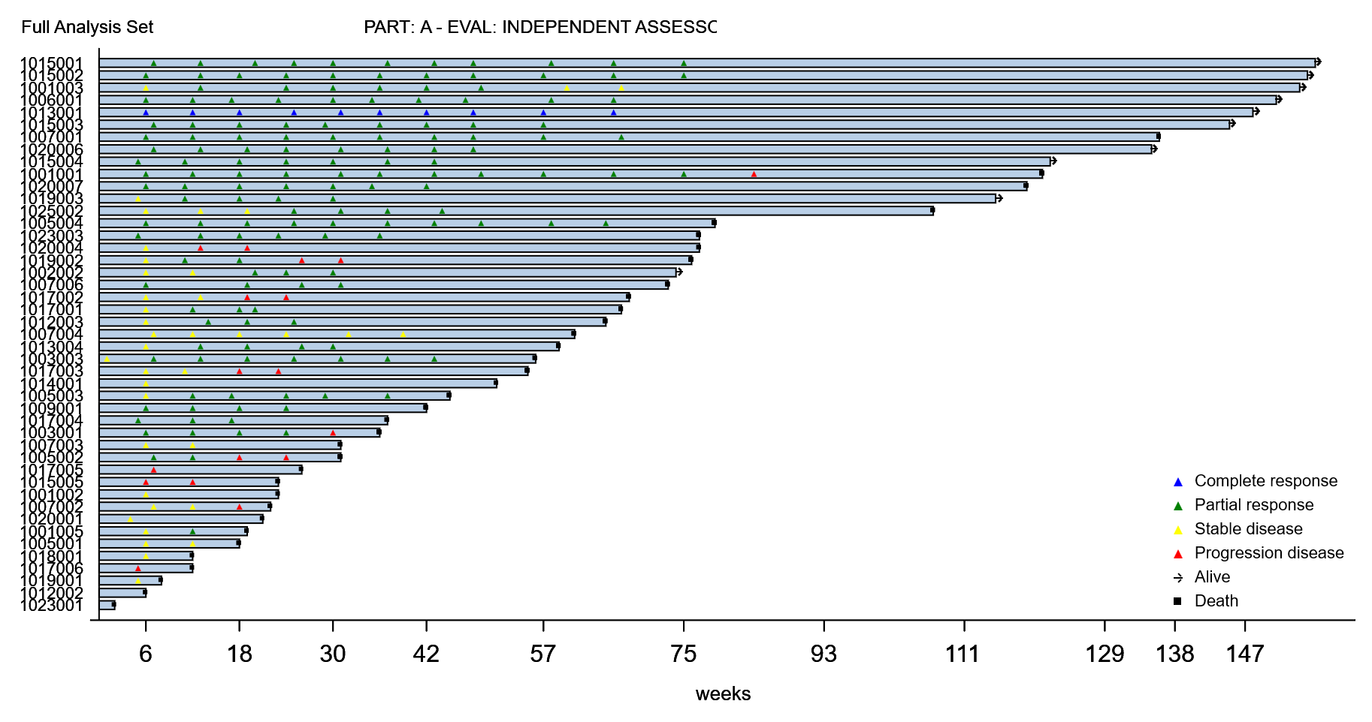

b

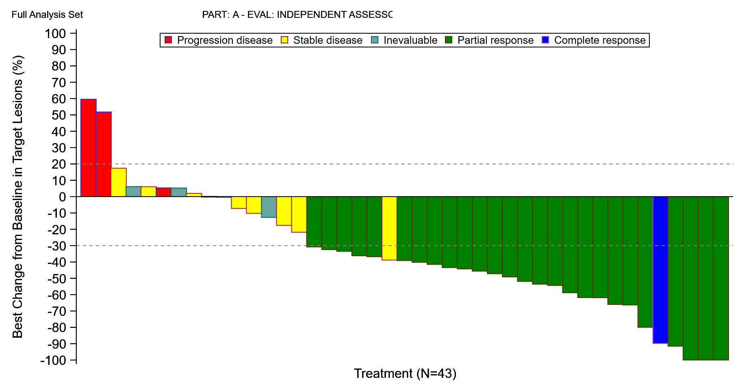

c

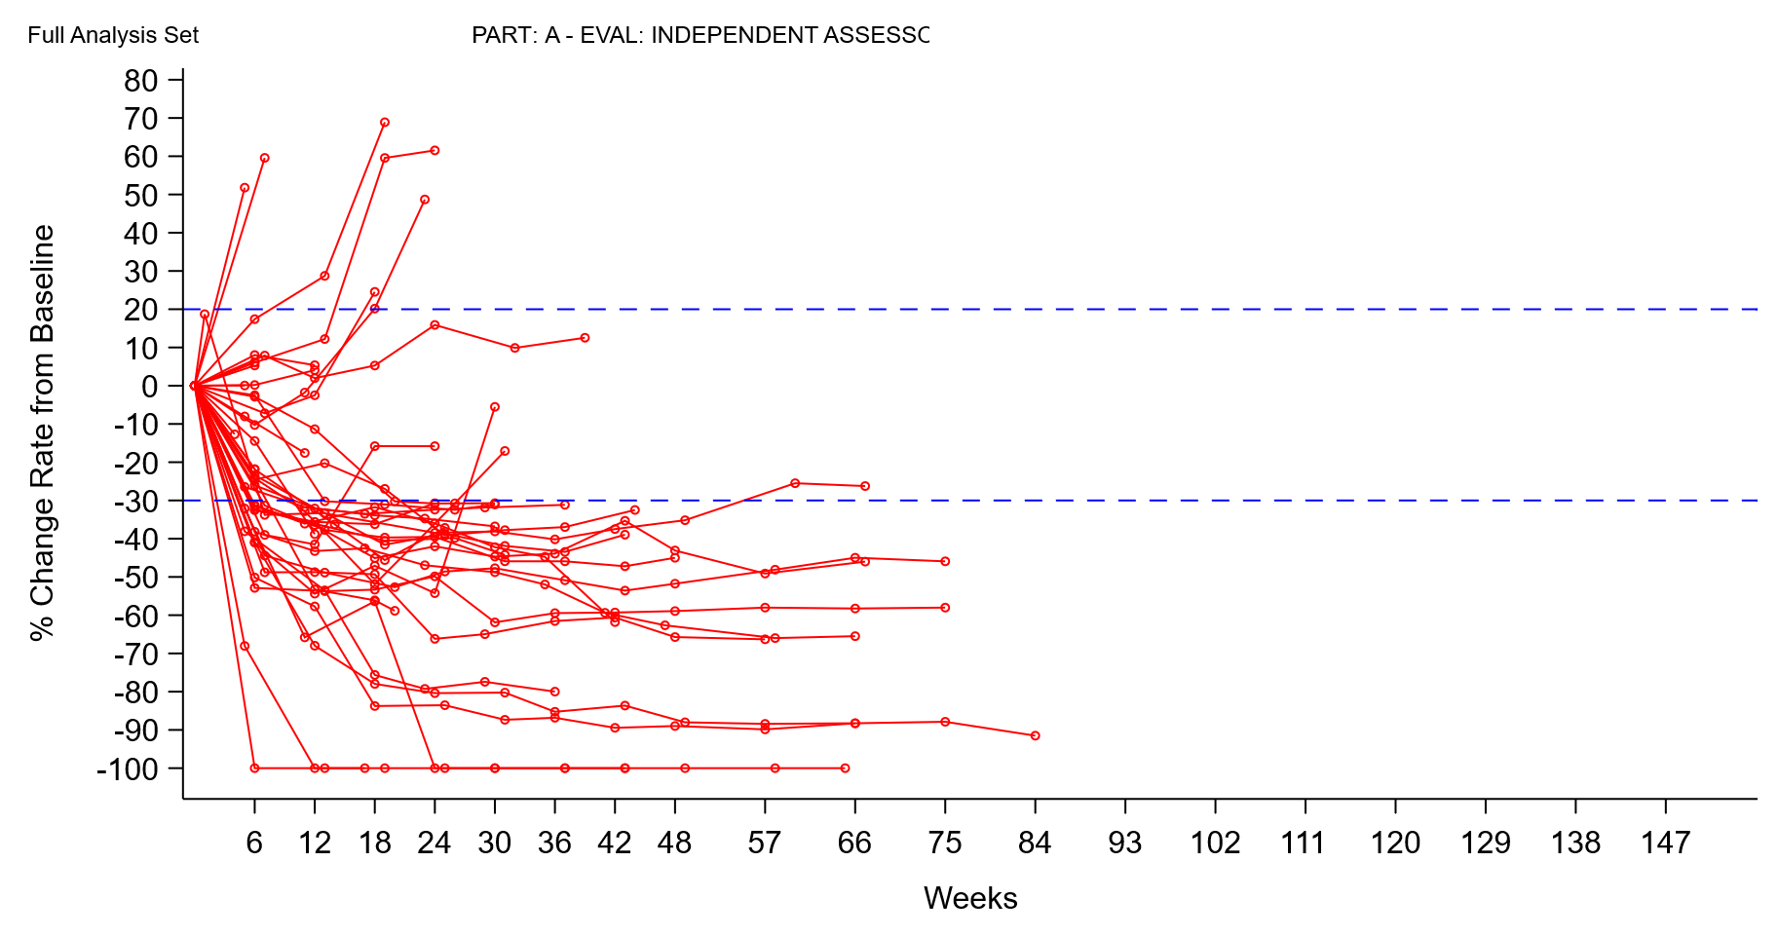

d

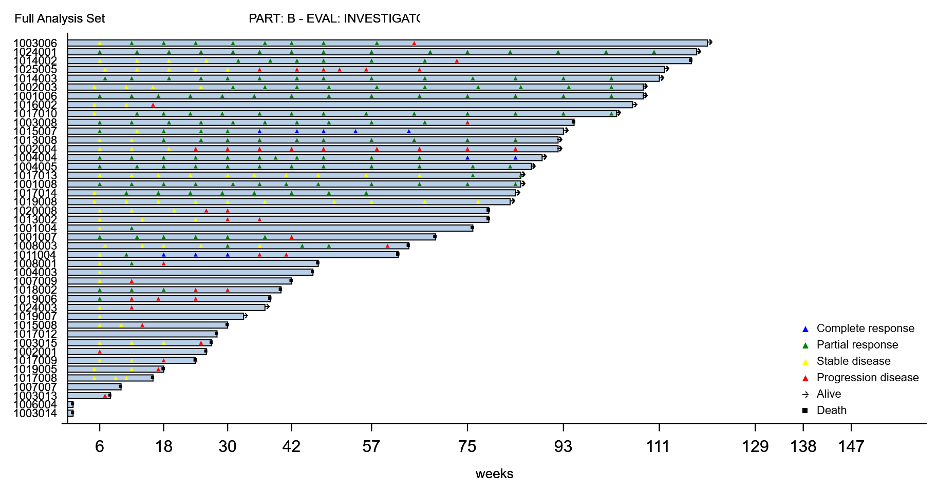

e

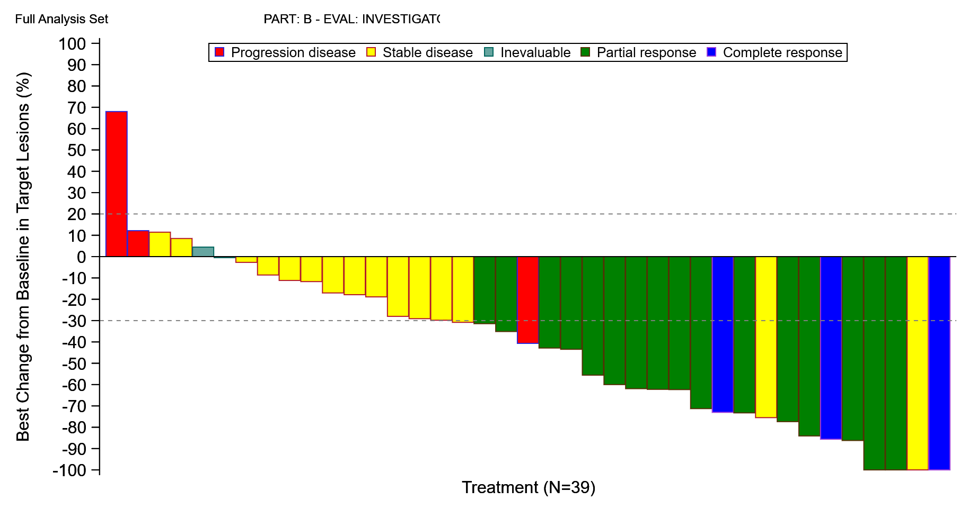

f

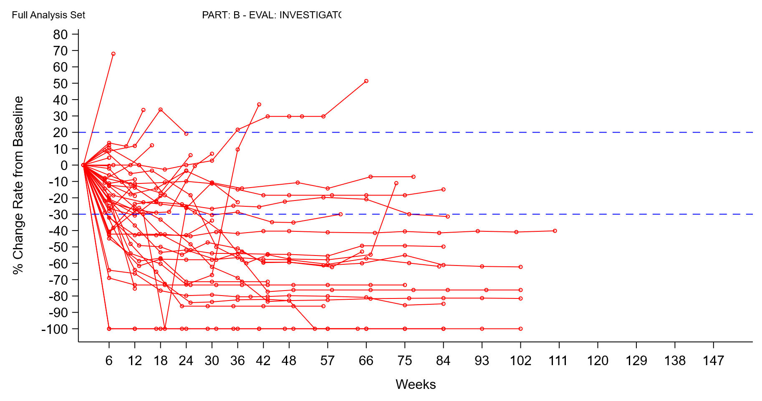
Supplementary Figure 1. Antitumor response. a. Swimmer plot showing treatment exposure and response duration in cohort A. b. Waterfall plot showing the percentage change in the sum of target lesion diameters from baseline in cohort A. c. Spider plot showing the percentage change in the sum of target lesion diameters during treatment in cohort A. d. Swimmer plot showing treatment exposure and response duration in cohort B. e. Waterfall plot showing the percentage change in the sum of target lesion diameters from baseline in cohort B. f. Spider plot showing the percentage change in the sum of target lesion diameters during treatment in cohort B. Tumor response was assessed by IRC in cohort A and by investigator in cohort B per RECIST v1.1.

Table S1.
Pharmacokinetics of Single and Multiple Dosing of Toripalimab and Cetuximab
Drugs | Dose | C_{max}  (μg/mL) | AUC_{0-inf}  (h*μg/mL) | T_{1/2}  (h) | Vz  (mL) | CL  (mL/h)
Toripalimab | Single dose | 91.0 (18.8%) | 19404 (29.1%) | 205 (29.6%) | 3752 (28.2%) | 13.4 (29.4%)
Toripalimab | Multiple dose | 113 (16.6%) | 28517 (39.9%) | 226 (14.1%) | 2967 (25.2%) | 9.35 (30.8%)
Cetuximab | Single dose | 213 (12.0%) | 15474 (27.4%) | 58.6 (19.6%) | 3477 (15.5%) | 42.9 (28.4%)
Cetuximab | Multiple dose | 202 (33.5%) | 16619 (36.4%) | 68.1 (16.3%) | 2443 (18.9%) | 25.6 (26.9%)
Data are presented as mean (CV).
Abbreviations: Cmax, maximum plasma concentration; AUC0-inf, area under the curve from time zero to infinity; T1/2, half-life; Vz, volume of distribution; CL, clearance.

Table S2.
Summary of CTCAE Grade ≥ 3 Treatment-Emergent Adverse Events (by SOC/PT) in Phase 1 and Phase 2 (Safety Set)
 | Phase 1b  N=13 | Phase 2  Cohort A  N=45 | Phase 2  Cohort B  N=43 | Total  N=88
System Organ Class
Preferred Term, n (%)
Infections and Infestations | 2 (15.4) | 7 (15.6) | 5 (11.6) | 12 (13.6)
Infectious Pneumonia | 0 | 1 (2.2) | 2 (4.7) | 3 (3.4)
Soft Tissue Infection | 0 | 1 (2.2) | 1 (2.3) | 2 (2.3)
Pityriasis Versicolor | 0 | 0 | 1 (2.3) | 1 (1.1)
Otitis Media | 0 | 0 | 1 (2.3) | 1 (1.1)
COVID-19 Pneumonia | 1 (7.7) | 1 (2.2) | 0 | 1 (1.1)
Infectious Aspiration Pneumonia | 1 (7.7) | 1 (2.2) | 0 | 1 (1.1)
COVID-19 | 0 | 1 (2.2) | 0 | 1 (1.1)
Septic Shock | 0 | 1 (2.2) | 0 | 1 (1.1)
Device-Related Infection | 0 | 1 (2.2) | 0 | 1 (1.1)
Metabolism and Nutrition Disorders | 0 | 7 (15.6) | 4 (9.3) | 11 (12.5)
Hypomagnesemia | 0 | 5 (11.1) | 2 (4.7) | 7 (8.0)
Hypokalemia | 0 | 3 (6.7) | 1 (2.3) | 4 (4.5)
Hypocalcemia | 0 | 1 (2.2) | 1 (2.3) | 2 (2.3)
Benign, Malignant and Unspecified Neoplasms (Including Cysts and Polyps) | 2 (15.4) | 6 (13.3) | 2 (4.7) | 8 (9.1)
Tumor Haemorrhage | 2 (15.4) | 4 (8.9) | 2 (4.7) | 6 (6.8)
Cancer Pain | 0 | 1 (2.2) | 0 | 1 (1.1)
Head and Neck Cancer | 0 | 1 (2.2) | 0 | 1 (1.1)
Investigations | 0 | 2 (4.4) | 5 (11.6) | 7 (8.0)
White Blood Cell Count Decreased | 0 | 2 (4.4) | 1 (2.3) | 3 (3.4)
Alanine Aminotransferase Increased | 0 | 0 | 1 (2.3) | 1 (1.1)
Amylase Increased | 0 | 0 | 1 (2.3) | 1 (1.1)
Weight Decreased | 0 | 0 | 1 (2.3) | 1 (1.1)
Aspartate Aminotransferase Increased | 0 | 0 | 1 (2.3) | 1 (1.1)
Electrocardiogram QT Prolongation | 0 | 0 | 1 (2.3) | 1 (1.1)
Platelet Count Decreased | 0 | 0 | 1 (2.3) | 1 (1.1)
Lipase Increased | 0 | 0 | 1 (2.3) | 1 (1.1)
Neutrophil Count Decreased | 0 | 0 | 1 (2.3) | 1 (1.1)
Skin and Subcutaneous Tissue Disorders | 0 | 1 (2.2) | 5 (11.6) | 6 (6.8)
Rash | 0 | 1 (2.2) | 2 (4.7) | 3 (3.4)
Acneiform Dermatitis | 0 | 0 | 2 (4.7) | 2 (2.3)
Exfoliative Dermatitis | 0 | 0 | 1 (2.3) | 1 (1.1)
Gastrointestinal Disorders | 1 (7.7) | 5 (11.1) | 1 (2.3) | 6 (6.8)
Oral Mucositis | 0 | 3 (6.7) | 0 | 3 (3.4)
Dysphagia | 0 | 0 | 1 (2.3) | 1 (1.1)
Oral Pain | 1 (7.7) | 1 (2.2) | 0 | 1 (1.1)
Gastric Perforation | 0 | 1 (2.2) | 0 | 1 (1.1)
Respiratory, Thoracic and Mediastinal Disorders | 2 (15.4) | 3 (6.7) | 2 (4.7) | 5 (5.7)
Dyspnea | 0 | 1 (2.2) | 1 (2.3) | 2 (2.3)
Laryngeal Oedema | 0 | 0 | 1 (2.3) | 1 (1.1)
Respiratory Failure | 0 | 0 | 1 (2.3) | 1 (1.1)
Pulmonary Embolism | 1 (7.7) | 1 (2.2) | 0 | 1 (1.1)
Sputum Retention | 1 (7.7) | 1 (2.2) | 0 | 1 (1.1)
Vascular and Lymphatic Disorders | 1 (7.7) | 4 (8.9) | 1 (2.3) | 5 (5.7)
Hypertension | 0 | 1 (2.2) | 1 (2.3) | 2 (2.3)
Shock Haemorrhagic | 1 (7.7) | 1 (2.2) | 0 | 1 (1.1)
Aneurysm | 0 | 1 (2.2) | 0 | 1 (1.1)
Shock | 0 | 1 (2.2) | 0 | 1 (1.1)
Nervous System Disorders | 1 (7.7) | 5 (11.1) | 0 | 5 (5.7)
Headache | 1 (7.7) | 1 (2.2) | 0 | 1 (1.1)
Postherpetic Neuralgia | 0 | 1 (2.2) | 0 | 1 (1.1)
Epilepsy | 0 | 1 (2.2) | 0 | 1 (1.1)
Coma | 0 | 1 (2.2) | 0 | 1 (1.1)
Intracranial Tumor Haemorrhage | 0 | 1 (2.2) | 0 | 1 (1.1)
Lacunar Infarction | 0 | 1 (2.2) | 0 | 1 (1.1)
Injury, Poisoning and Procedural Complications | 0 | 2 (4.4) | 2 (4.7) | 4 (4.5)
Infusion-Related Reaction | 0 | 1 (2.2) | 1 (2.3) | 2 (2.3)
Fracture | 0 | 0 | 1 (2.3) | 1 (1.1)
Femoral Neck Fracture | 0 | 1 (2.2) | 0 | 1 (1.1)
Hematological and Lymphatic System Disorders | 0 | 2 (4.4) | 1 (2.3) | 3 (3.4)
Anemia | 0 | 2 (4.4) | 1 (2.3) | 3 (3.4)
Musculoskeletal and Connective Tissue Disorders | 0 | 1 (2.2) | 1 (2.3) | 2 (2.3)
Myalgia | 0 | 0 | 1 (2.3) | 1 (1.1)
Myasthenia | 0 | 1 (2.2) | 0 | 1 (1.1)
Cardiac Disorders | 0 | 1 (2.2) | 1 (2.3) | 2 (2.3)
Immune-Mediated Myocarditis | 0 | 0 | 1 (2.3) | 1 (1.1)
Myocardial Infarction | 0 | 1 (2.2) | 0 | 1 (1.1)
General Disorders and Administration Site Conditions | 0 | 0 | 1 (2.3) | 1 (1.1)
Unexplained Death | 0 | 0 | 1 (2.3) | 1 (1.1)
Renal and Urinary Disorders | 0 | 0 | 1 (2.3) | 1 (1.1)
Nephrolithiasis | 0 | 0 | 1 (2.3) | 1 (1.1)
Immune System Disorders | 1 (7.7) | 1 (2.2) | 0 | 1 (1.1)
Type IV Hypersensitivity Reaction | 1 (7.7) | 1 (2.2) | 0 | 1 (1.1)

Table S3.
Overall Summary of Treatment-Emergent Adverse Events in Phase 1b and Phase 2 (Safety Set)
 | Phase 1b  N=13 | Phase 2  Cohort A  N=45 | Phase 2  Cohort B  N=43 | Total  N=88
TEAE | 13 (100) | 45 (100) | 42 (97.7) | 87 (98.9)
Treatment-related | 11 (84.6) | 42 (93.3) | 40 (93.0) | 82 (93.2)
Grade ≥3 TEAEs | 5 (38.5) | 24 (53.3) | 22 (51.2) | 46 (52.3)
Treatment-related | 0 | 14 (31.1) | 14 (32.6) | 28 (31.8)
SAEs | 6 (46.2) | 21 (46.7) | 15 (34.9) | 36 (40.9)
Treatment-related | 1 (7.7) | 6 (13.3) | 7 (16.3) | 13 (14.8)
Grade ≥3 SAEs | 5 (38.5) | 18 (40.0) | 15 (34.9) | 33 (37.5)
TEAEs leading to treatment discontinuation | 4 (30.8) | 8 (17.8) | 1 (2.3) | 9 (10.2)
Treatment-related | 0 | 3 (6.7) | 1 (2.3) | 4 (4.5)
irAEs | 5 (38.5) | 12 (26.7) | 3 (7.0) | 15 (17.0)
Grade ≥3 irAEs | 0 | 0 | 1 (2.3) | 1 (1.1)
Infusion-related Reaction | 2 (15.4) | 7 (15.6) | 5 (11.6) | 12 (13.6)
Toripalimab -related | 1 (7.7) | 2 (4.4) | 2 (4.7) | 4 (4.5)
Cetuximab-related | 1 (7.7) | 5 (11.1) | 5 (11.6) | 10 (11.4)
Grade ≥3 infusion reaction | 0 | 1 (2.2) | 2 (4.7) | 3 (3.4)
Fatal TEAE | 3 (23.1) | 7 (15.6) | 2 (4.7) | 9 (10.2)
Treatment-related | 0 | 0 | 1 (2.3) | 1 (1.1)
Abbreviations: TEAE = treatment-emergent adverse event; SAE = serious adverse event; irAE = immune-related adverse event.

Table S4.
Treatment-Emergent Adverse Events leading to discontinuation in Phase 2 (Safety Set)
 | Cohort A  N=45 | Cohort B  N=43
Tumor haemorrhage | 2 (4.4) | 0
Pulmonary embolism | 1 (2.2) | 0
Sputum retention | 1 (2.2) | 0
Shock haemorrhagic | 1 (2.2) | 0
Coma | 1 (2.2) | 0
Myasthenia | 1 (2.2) | 0
Infusion-related reactions | 1 (2.2) | 0
Gastric perforation | 1 (2.2) | 0
Rash | 0 | 1 (2.3)

Table S5.
Approval Committee or Internal Review Board
Clinical research institution | Ethical Approval Number
Shanghai East Hospital | 2020-072
Liaoning Cancer Hospital & Institution | 20210131
Hunan Cancer Hospital | 2021药审【243】号
Guangxi Medical University Cancer Hospital | CS2021 (12)
Yunnan Cancer Hospital | YW202172
Zhejiang Cancer Hospital | IRB[2021]220号
Hubei Cancer Hospital | 【2021】第6号
Fujian Cancer Hospital | 2021-063-02/20210906
Shanghai Ninth People's Hospital, Shanghai Jiao Tong University School of Medicine | SH9H-2020-C45
Jiangsu Cancer Hospital | 2021-001
Harbin Medical University Cancer Hospital | 2020-70
Zhejiang Provincial People's hospital | 2021YW031
Sun Yat-sen University Cancer Center | A2020-122-01
The Fifth Affiliated Hospital, Sun Yat-sen University | 中大五院【2020】伦字第（Y129-1）号
Tianjin Cancer Hospital | E20210491/2021.6.29
The First Affiliated Hospital of Bengbu Medical University | 【2021】011
Xiangya Hospital Central South University | 伦审GCP第（202104040）号
Shandong Second Provincial General Hospital | （伦审）2021-006-01/2021-05-13
Guangzhou Medical University Affiliated Cancer Hospital | 医伦案初审[2020]第51号
West China Hospital of Sichuan University | 2020年临床试验（西药）审（267）号/2020.12.14
Sun Yat-Sen Memorial Hospital, Sun Yat-Sen University | 2021-YW-011-002
Beijing Cancer Hospital | 2021YW67/2021.4.6
Linyi Cancer Hospital | XY2104

