Supplementary Materials for

BMAL1 regulates circadian rhythms via phase separation–mediated transcriptional hub formation

Wenzhen Gao^{1,2}, Li Zhu^{1,3}, Yali Wei^{1,4}, Guowen Luo^{1,2}, Jiahe Wang^{1,2}, Lijie Wang^{1,2}, Zhengying Peng¹, Xuan Li¹, Zhuoxuan Wu^{1,2}, Jingyi Li^{1,2}, Yanfen Wu^{1,2}, Xiaoxiao Wang^{1,2}, Junjun Jing¹, Shujuan Zou^{1,3}, Qing Zhao^{1,3}, Yi Fan^{1,4#}, Quan Yuan^{1#}, Chenchen Zhou^{1,2#}
Correspondence to: Chenchenzhou5510@scu.edu.cn

This PDF file includes:

Figures. S1 to S5
Tables S1 to S2

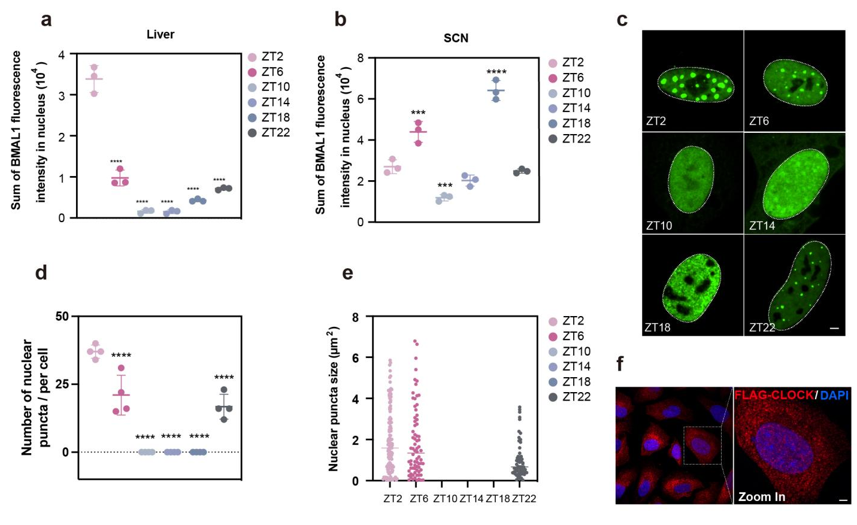
Figure. S1. BMAL1 condensate formation across the circadian cycle. (a, b) Quantification of the total nuclear BMAL1 fluorescence intensity in mouse liver (a) and suprachiasmatic nucleus (SCN) (b). (c) Representative images revealing the rhythmic assembly and disassembly of BMAL1 puncta in the nucleus over a 24-hour cycle. White dashed lines delineate the nuclear boundaries. Scale bar, 5 μm. (d, e) Quantitative analysis corresponding to the images in (c), showing the number of BMAL1 puncta per nucleus (d) and the average size of the nuclear puncta (e) across different time points. (f) Representative immunofluorescence images of U2OS transfected with FLAG-CLOCK. Protein expression was detected using an anti-FLAG antibody (red), and nuclei were stained with DAPI (blue). Scale bar, 5 µm.

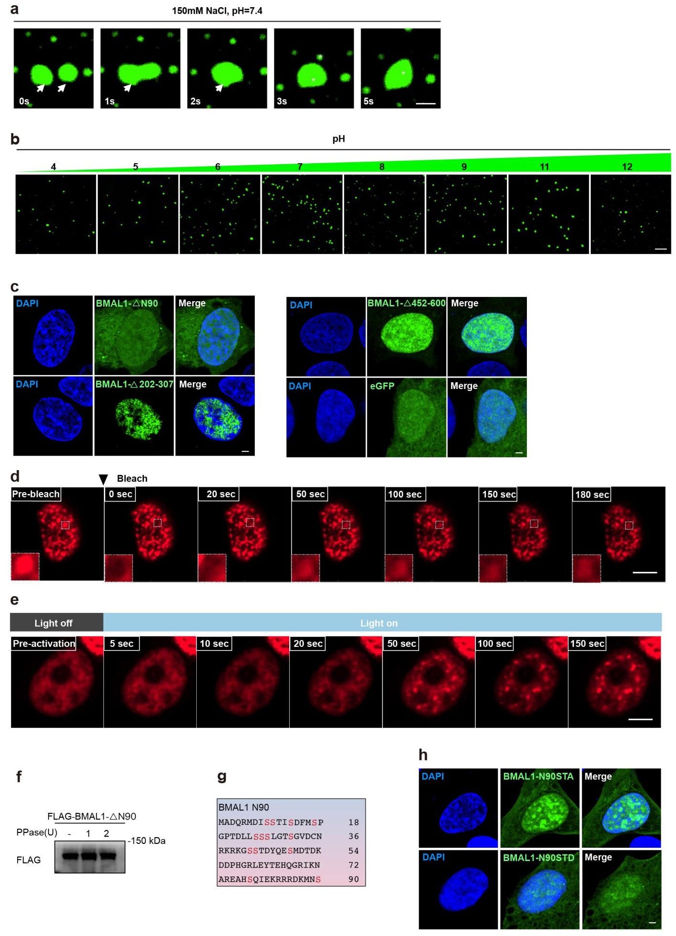
Figure. S2. Biophysical characterization and phosphorylation analysis of BMAL1 phase separation. (a) Fusion of eGFP-BMAL1 protein droplets in vitro. Scale bar, 1 µm. (b) Representative images showing eGFP-BMAL1 condensates at different pH levels. Scale bars, 10 µm. (c) Representative images of eGFP-BMAL1-ΔN90, eGFP-BMAL1-Δ202-307, eGFP-BMAL1-Δ452-600, and an eGFP control overexpressed in U2OS cells at ZT2. Scale bars, 5 µm. (d) FRAP analysis of opto-BMAL1-N90. Scale bar, 2 µm. (e) Time-resolved optoDroplet formation of BMAL1-N90. Scale bar, 2 μm. (f) Western blot analysis of purified FLAG-BMAL1-ΔN90 protein. Protein was incubated with or without λ-phosphatase (λ-PPase). (g) Amino acid sequence of the BMAL1 N-terminal region (residues 1-90). The serine (S) residues highlighted in red indicate potential phosphorylation sites targeted for mutagenesis. (h) Representative images of BMAL1-N90STA and BMAL1-N90STD overexpressed in U2OS at ZT2. Scale bars, 5 µm.

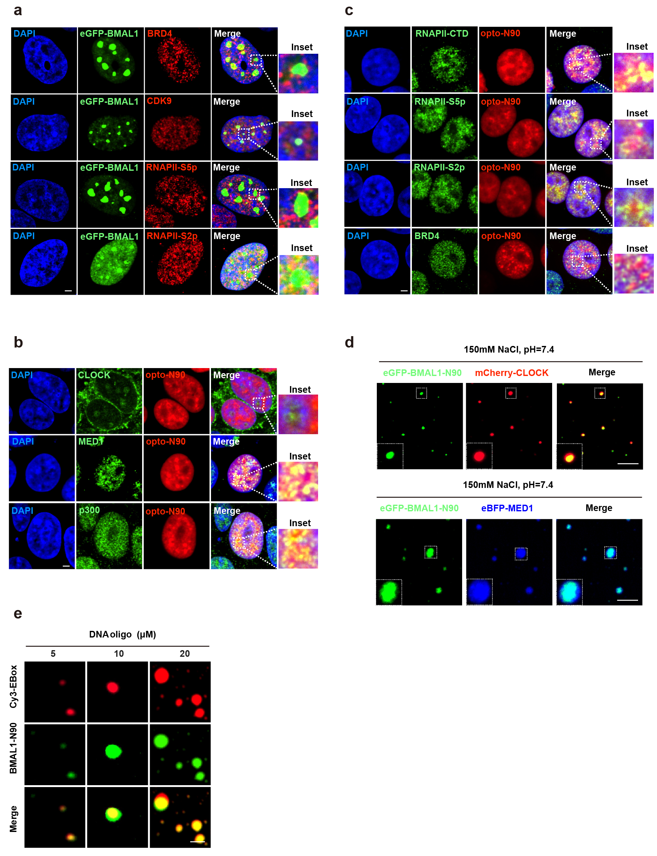

Figure. S3. Association of BMAL1-N90 with transcriptional co-activators and DNA in nuclear condensates. (a) Representative immunofluorescence images showing the nuclear colocalization of eGFP-BMAL1 with BRD4, CDK9, RNAPII-S5p, RNAPII-S2p in U2OS cells at ZT2. Scale bar, 5 µm. (b, c) Representative immunofluorescence images showing the nuclear distribution of opto-BMAL1-N90 alongside CLOCK, MED1, and p300 in (b), and RNAPII-CTD, RNAPII-S5p, RNAPII-S2p, and BRD4 in (c) in U2OS cells at ZT2. Scale bars, 5 µm. (d) Fluorescence images of an in vitro protein system. eGFP-BMAL1-N90 forms liquid-like droplets that effectively partition mCherry-CLOCK and eBFP-MED1 IDR protein. Scale bars,10 μm. (e) Representative fluorescence images of BMAL1-N90 droplets (green) in the presence of increasing concentrations of Cy3-labeled E-box DNA oligonucleotides (red). Scale bar, 1 μm.

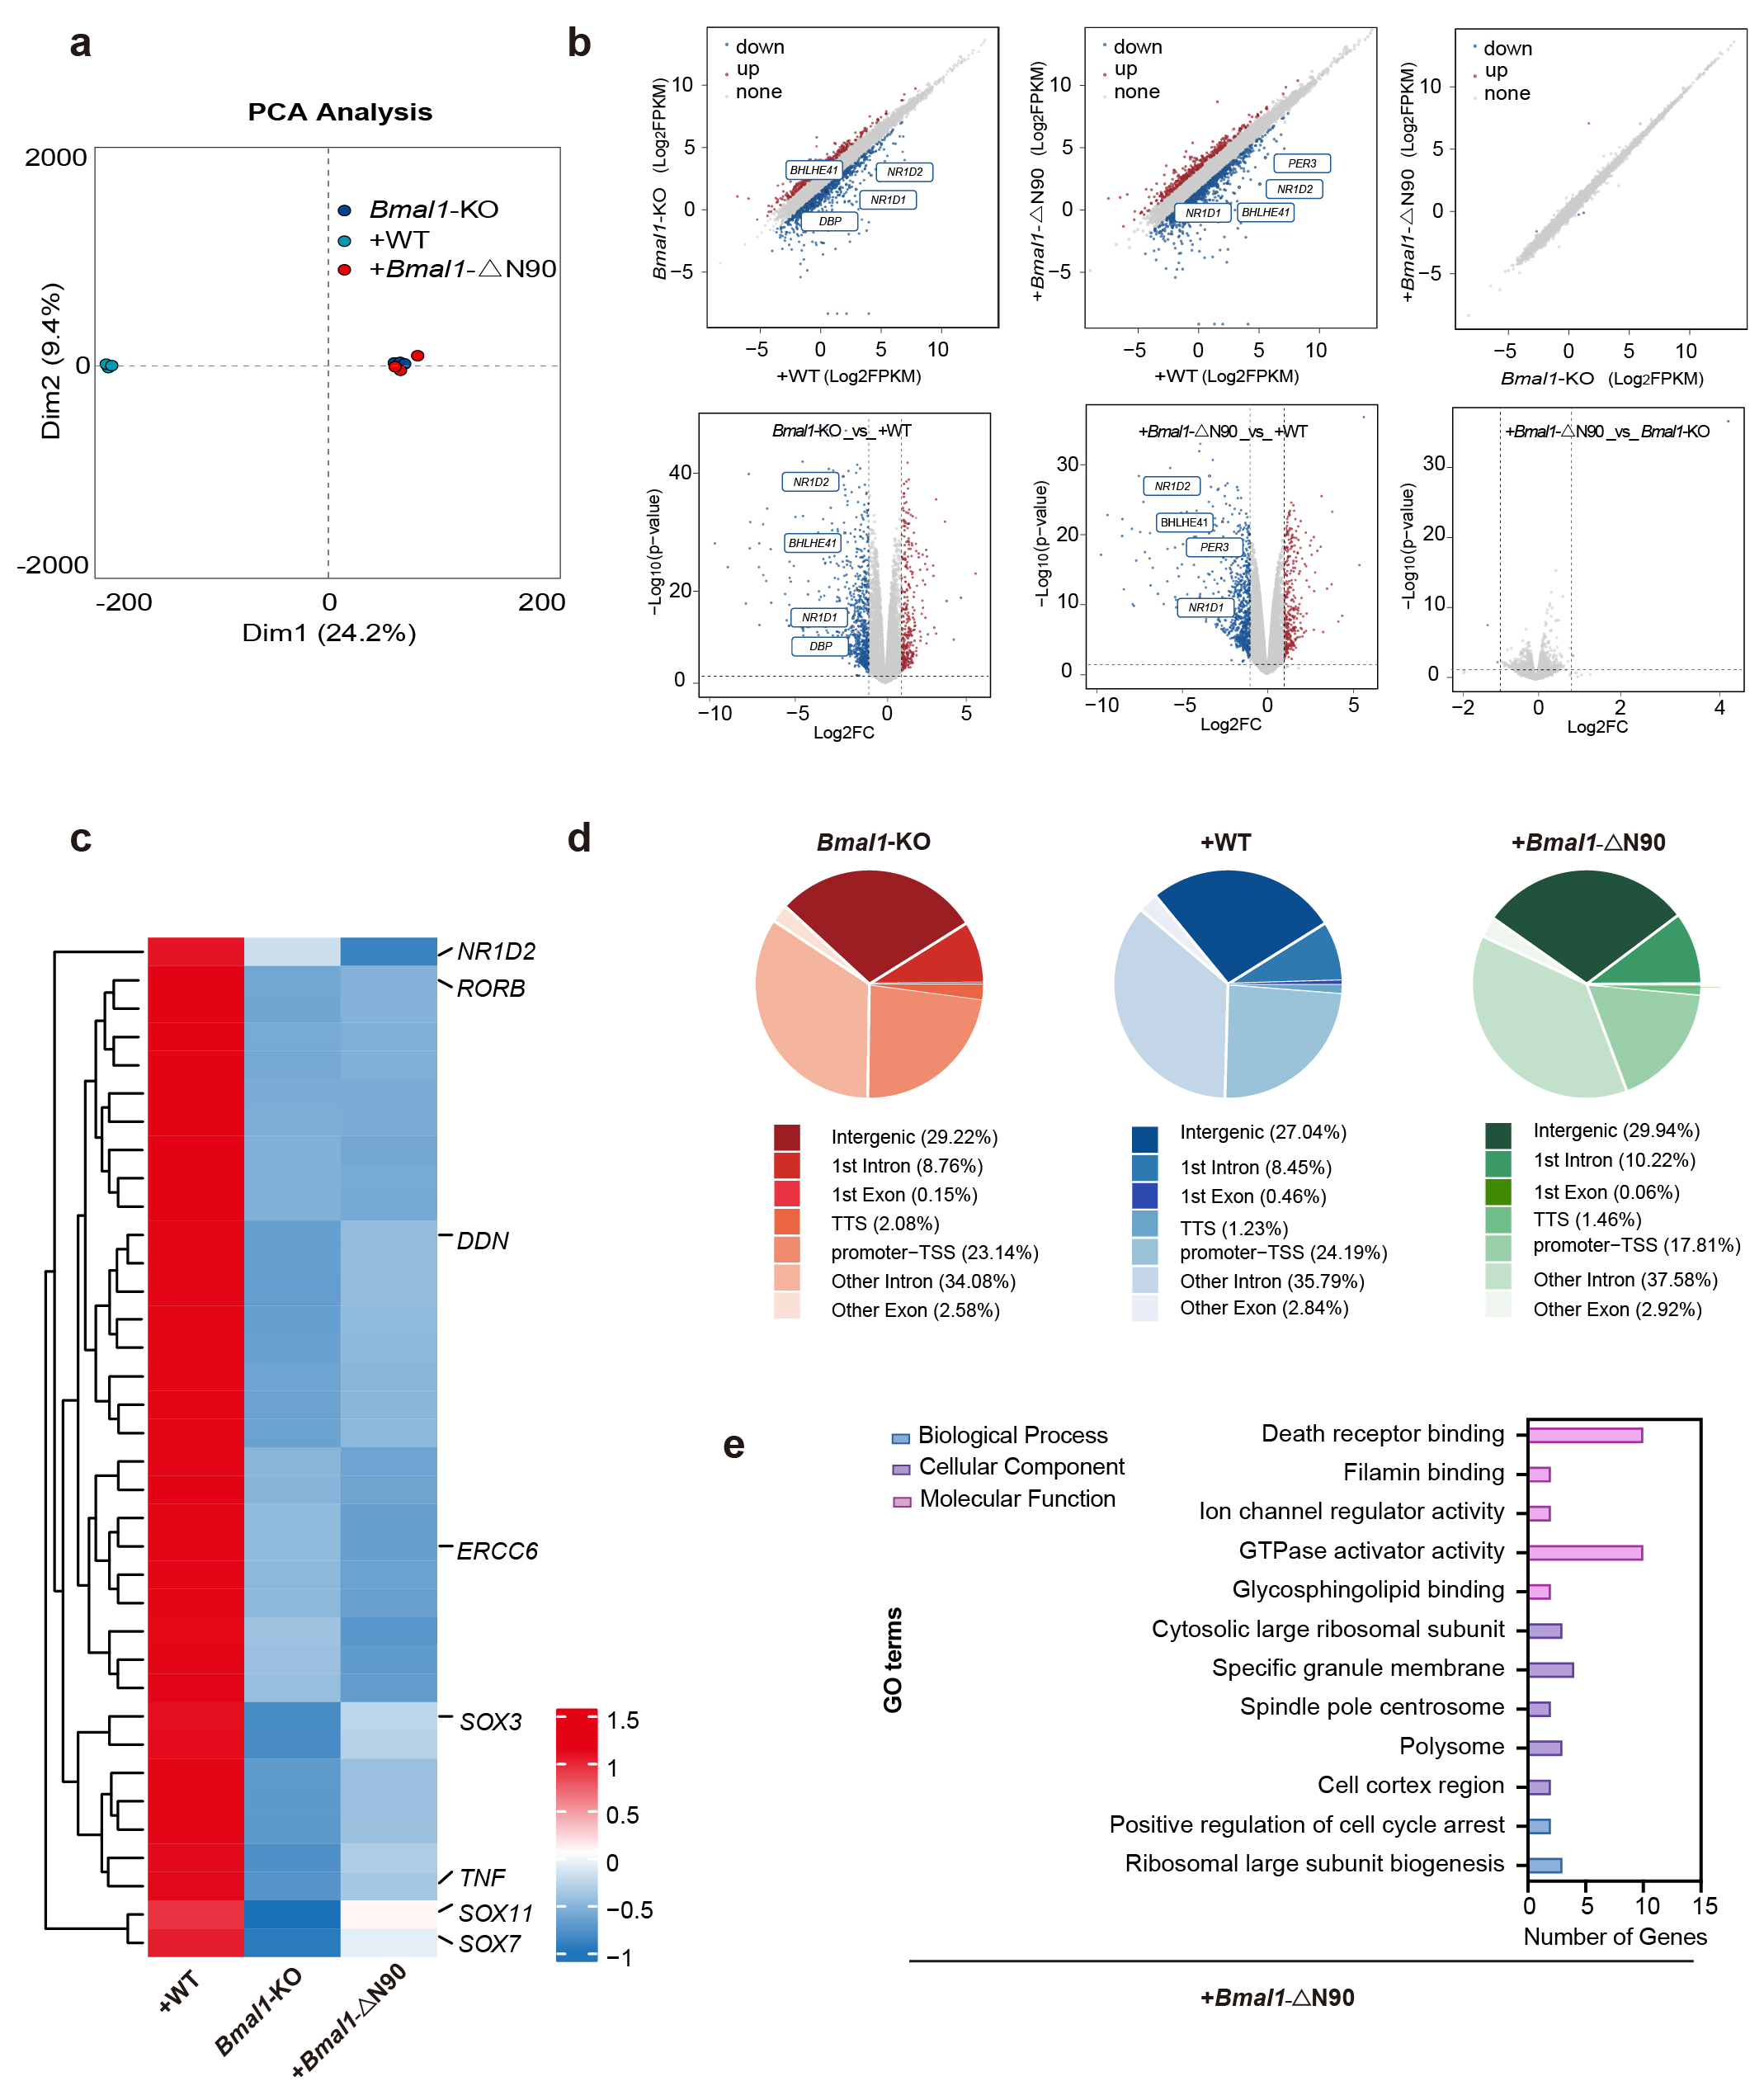

Figure. S4. RNA_seq anlysis and Genome-wide H3K27ac occupancy analysis. (a) Principal component analysis (PCA) of the bulk RNA-seq. (b) Scatter plots (top) and volcano plots (bottom) comparing global gene expression levels among the three groups. Significantly upregulated and downregulated genes are colored red and blue, respectively. Genes with no significant changes are shown in grey. Representative clock-related genes are labeled. (c) Heatmap displaying genes with reduced H3K27ac occupancy at ZT2 in Bmal1-KO and Bmal1-ΔN90 mutant cells compared to +WT cells. The color scale indicates Z-score normalized signal intensity (blue = low, red = high). Representative circadian and regulatory genes (e.g., NR1D2, RORB, TNF, SOX3) are labeled on the right. (d) Genomic annotation and classification of rhythmic H3K27ac regions. The percentage of regions annotated is shown if greater than 0.05 %. (e) Gene Ontology (GO) enrichment analysis of H3K27ac-associated rhythmic genes in Bmal1-KO cells rescued with BMAL1-ΔN90 mutant. Terms are categorized into Biological Process (blue), Cellular Component (purple), and Molecular Function (pink). The x-axis represents the number of genes enriched in each category.

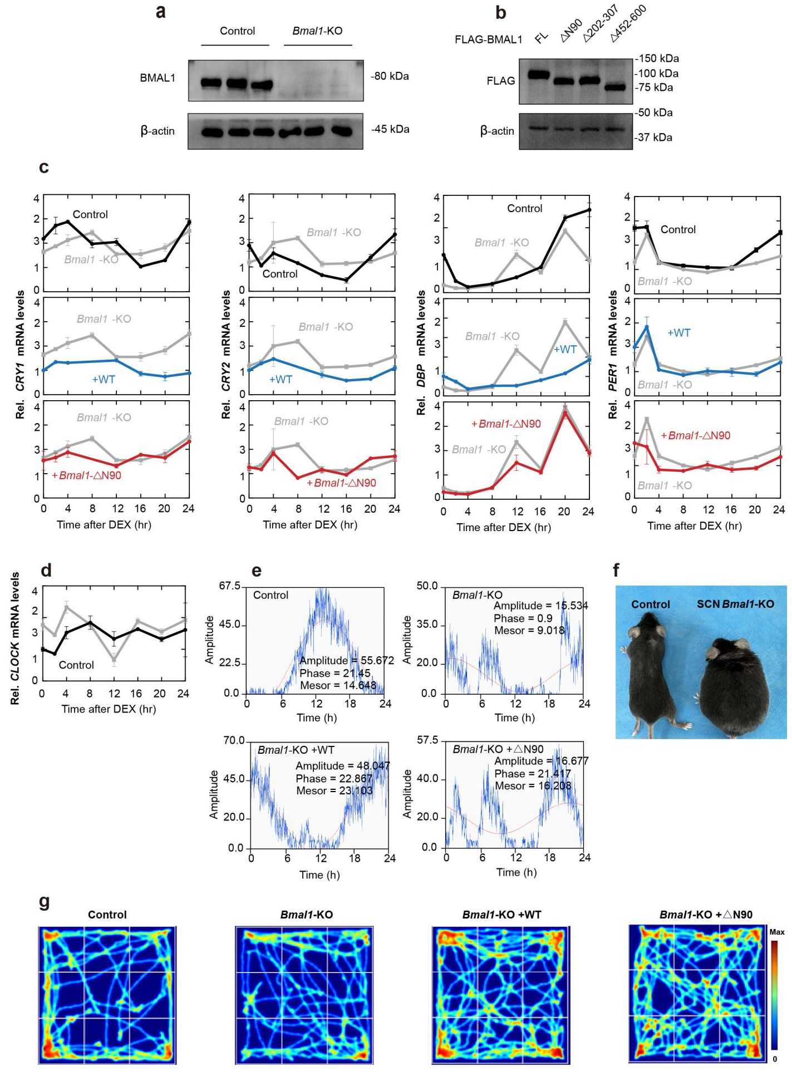

Figure. S5. The phase separation ability of BMAL1 is essential for circadian rhythmicity in vitro and in vivo. (a) Western blot validation of Bmal1 knockout efficacy in U2OS cells. (b) Western blot analysis of cell lysates from U2OS cells stably expressing FLAG-BMAL1-FL or the indicated deletion mutants (ΔN90, Δ202–307, Δ452–600). (c, d) Temporal mRNA expression profiles of five clock genes (CRY1, CRY2, DBP, PER1, and CLOCK) in U2OS cells. Transcript levels were normalized to GAPDH. Comparison of Control (black), Bmal1-KO (grey), and KO cells rescued with Bmal1-FL (blue, WT) or Bmal1-ΔN90 (red). Data are presented as mean ± SD (n = 3). (e) Representative 24-hour activity profiles of mice with different BMAL1 genotypes. Blue traces represent the actual activity data, red dashed lines indicate the cosine wave fit. Key circadian parameters (Amplitude, Phase, and Mesor) derived from Cosinor analysis are inset for each group. (f) Representative gross morphology of control and SCN-specific Bmal1 knockout mice. (g) Tracking plots illustrating mice movement patterns over a 5-minute session in the open field test. The color gradient (blue to red) represents the time spent or density of movement in each location, with red indicating high-frequency areas.

 | P-value for rhythms | R² | Function of fitted curve | P-value of fit
Control | 0.012 | 0.988 | 98.18 + 36.91cos(2πt/15.01-6.01) | 0.001
Bmal1-KO | 0.106 | 0.894 | 49.43 + 21.39cos(2πt/18.75-4.16) | 0.015
+WT | 0.032 | 0.968 | 90.82 + 25.19cos(2πt/21.19-3.21) | 0.002
+Bmal1-ΔN90 | 0.052 | 0.948 | 72.24 + 37.21cos(2πt/48.00-5.66) | 0.005

Table S1. Statistical parameters of cosinor analysis.

Gene | Forward Primer | Reverse Primer
NR1D1 | GCAAGGGCTTTTTCCGTCG | GCGGACGATGGAGCAATTCT
NR1D2 | GTTACCTGTGCAACACTGGAGG | ACTGCTGGAGTGAAGCTCATCG
PER2 | AGCTGCTTGGACAGCGTCATCA | CCTTCCGCTTATCACTGGACCT
PER3 | GGCAGATGATGTCCAAGCCTTAC | ATCGCCGTGGACAGGATCTGTG
CRY1 | TGTGATTCGTGGACAACCAG | TAGCTGCGTCTCGTTCCTTT
CRY2 | AGGAGAACCACGACGAGA | TCCGCTTCACCTTTTTATAC
DBP | CCACGAGACCTTTGACCCTC | GCCGGCTCCAGTATTTCTCA
PER1 | CTGCTACAGGCACGTTCAAG | CTCAGGGACCAAGGCTAGTG
CLOCK | CAGCCAGTGATGTCTCAAGC | ATGCGTGTCCGTTGTTCC

Table S2. qPCR primer sequences used in this study.

