Supplementary Materials for

Phosphoproteomics distinguishes disease-specific mechanisms for human phospholamban cardiomyopathy reversible by RNA therapy.

Frederik E. Deiman; Nils Bömer; Pia Davidsson; Daniela Später; Annet N. Linders; Itamar B. Dias; Karla F. Arevalo Gomez; Antonio Esquivel Gaytan; Jumo Zhu; Anna Walentinsson; Susanna Engberg; Neil Hattersley; Damla Etal; Christine Ahlstrom; Adam E. Mullick; Kenny M. Hansson; Herman H.W. Silljé; Niels Grote Beverborg; Peter van der Meer*

Correspondence to: p.van.der.meer@umcg.nl

This PDF file includes:

Materials and Methods
Figures. S1 to S7
Tables S1 to S4

Materials and Methods
R14^{Δ/+} patient derived iPSC line generation and maintenance
To assess transcriptomic effects of PLN-targeted RNA therapy (Fig. S6), patient derived iPSC-lines were generated. To generate patient-derived R14^{Δ/+} iPSCs, fibroblasts were obtained from a skin biopsy of an end-stage R14^{Δ/+} patient. These fibroblasts were cultured in DMEM (Lonza, #BE15-604) supplemented with 15% FCS (Thermo fisher, #A5256701), 1% sodium pyruvate (Thermo fisher, #11360070), 1% GlutaMAX (Thermo fisher, #35050061), 1% non-essential amino acids (Thermo fisher, #11140050), and 1% Pen/Strep (Thermo fisher, #15070063). Passaging was performed using Trypsin (Thermo fisher, #25300054). The fibroblasts were reprogrammed into iPSCs via nucleofection with three plasmids (pCXLE-hSK #27078, pCXLE-hMLN #270799, and pCXLE-hOCT3/4 #27076; Addgene plasmids) as described in previous studies¹⁻². Each iPSC clone was maintained through single-cell passaging using 1x TrypLE (Thermo fisher, #12604-021) and cultured on Geltrex-coated surfaces (Thermo fisher, #A1413301) in Essential 8 medium (Thermo fisher, #A1517001) with 0.5% Pen/Strep (Thermo fisher, #15070-063). The medium was changed daily, and the cells were kept at 37°C with 5% CO2 and full atmospheric humidity.

RNA Extraction and Sequencing of R14^{Δ/+} patient derived and wild type iPSC-CMs
RNA was extracted from iPSC-CMs using the RNAdvance Cell v2 protocol on the Biomek i7 Hybrid system (Beckman Coulter). RNA quantity and quality were assessed using the standard RNA analyser kit (Agilent, #DNF-471-0500) on a 96-channel Fragment Analyzer (Agilent Technologies), with all samples exhibiting high RIN values (lowest RIN = 8.3). For each sample, a total of 100 ng of RNA was used as input, prepared using a Tecan Fluent liquid handling automation system (Tecan). Libraries were prepared using the KAPA mRNA HyperPrep Kit (Roche, #08098) with full automation on the Tecan Fluent system. Library quantification was performed using the 96-channel Fragment Analyzer and the standard sensitivity NGS kit (Agilent Technologies). Concentration was measured using a Qubit instrument with the DNA high sensitivity kit (Thermo fisher). Fragment sizes were confirmed on the Fragment Analyzer with the high sensitivity NGS kit (Agilent, #DNF-474-0500). Library pools were diluted to 1.8 nM and sequenced on the NovaSeq 6000 platform (Illumina) using a NovaSeq 6000 S1 Reagent Kit (100 cycles). Sequencing yielded an average of 32.4 million reads per sample.

Statistical Analyses
Differential analysis was conducted with DESeq2 comparing cells treated with 10 µM SCR-ASO versus PBS. Genes were considered significantly differentially expressed using the following cut-offs: adjP < 0.05, log₂FC > 0.5.

References
1. Okita, K. et al. A more efficient method to generate integration-free human iPS cells. Nat Methods 8, 409–412 (2011).
2. Takahashi, K. et al. Induction of Pluripotent Stem Cells from Adult Human Fibroblasts by Defined Factors. Cell 131;5, 861–872 (2007).

Figure. S1.

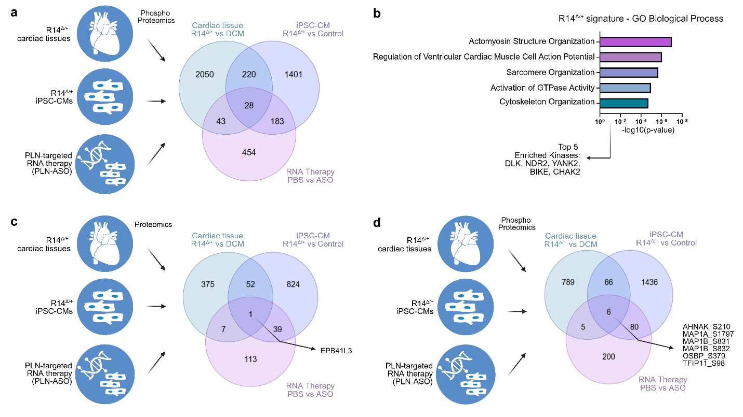

Integrative proteomic and phosphoproteomic overlap across patient tissue, iPSC-CMs, and RNA therapy. a Venn diagram showing overlap of DEPSs identified by phosphoproteomics in R14^{Δ/+} cardiac tissue vs. DCM controls, R14^{Δ/+} iPSC-CMs vs. isogenic controls, and PLN-targeted RNA therapy-treated iPSC-CMs vs. PBS. Twenty-eight phosphorylation sites were identified as R14^{Δ/+} signature, with 22 reversed by RNA therapy. Phosphosite fold-change correlation between PLN R14^{Δ/+} cardiac tissue and iPSC-CMs was low and not statistically significant (Pearson r = -0.106, p = 0.094), consistent with fundamental biological differences between end-stage human myocardium and iPSC-CMs. Therefore, subsequent analyses focused on the shared disease-associated phosphorylation signature rather than global phosphoproteomic concordance. b Gene ontology enrichment analysis of biological processes related to the 248 DEPSs that are the R14^{Δ/+} signature between cardiac tissue and iPSC-CMs, with indicated top kinases (supplementary Table S4). c Venn diagram showing overlap of differentially expressed proteins identified by global proteomics across patient tissue, iPSC-CMs, and RNA therapy-treated cells. Only EPB41L3 was consistently altered across all three conditions. d Venn diagram showing overlap of DEPSs after applying a stricter fold-change threshold (log₂FC > 0.58), identifying six phosphorylation sites consistently regulated across patient tissue, iPSC-CMs, and RNA therapy.

Figure. S2.

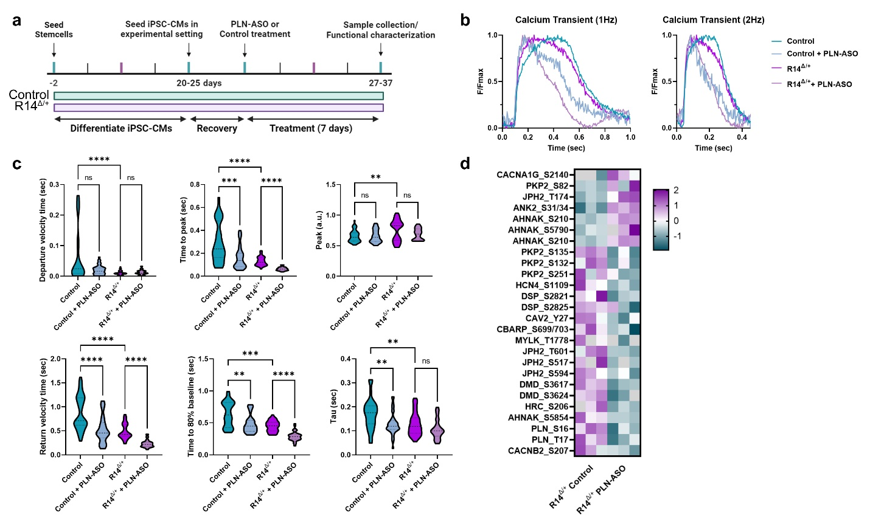

Functional characterization of iPSC-CM calcium transients after vehicle or PLN-ASO therapy with calcium related DEPSs. a Workflow for functional characterization of R14^{Δ/+} and isogenic control after PLN-ASO therapy. b Representative calcium transients under pacing conditions. c Calcium parameters derived from calcium transient at 1 Hz, including departure velocity time (time from the beginning of the transient to reach maximum departure velocity), time to peak (time from beginning of the transient till the maximal deflection), peak (maximal deflection from baseline), return velocity time (duration between reaching 95% of the peak value and achieving the maximum return velocity during the recovery phase), time to 80% baseline (time to reduce systolic calcium level by 80%) and tau (decay time constant). d Calcium-related DEPSs identified associated to the GO-term regulation of calcium ion transmembrane transporter activity (GO:1901019). Violin plots represent mean and quartiles. Significance was examined using Kruskal-Wallis with Dunn multiple comparisons test. * P<0.05, ** P<0.01, *** P<0.001, **** P<0.0001.

Figure. S3.

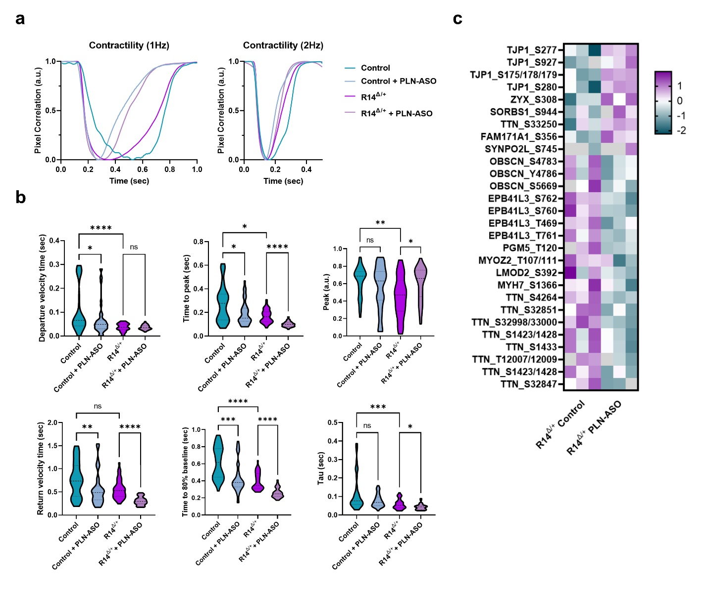

Functional characterization of iPSC-CM contractility after vehicle or PLN-ASO therapy with contractility related DEPSs. a Representative contractility traces under pacing conditions. b Contractility parameters derived from contractility transients at 1 Hz, including departure velocity time, time to peak, peak, return velocity time, time to 80% baseline and tau. c Contractility-related DEPSs identified associated to the GO-term actomyosin structure organization (GO:0031032). Violin plots represent mean and quartiles. Significance was examined using Kruskal-Wallis with Dunn multiple comparisons test. * P<0.05, ** P<0.01, *** P<0.001, **** P<0.0001.

Figure. S4.
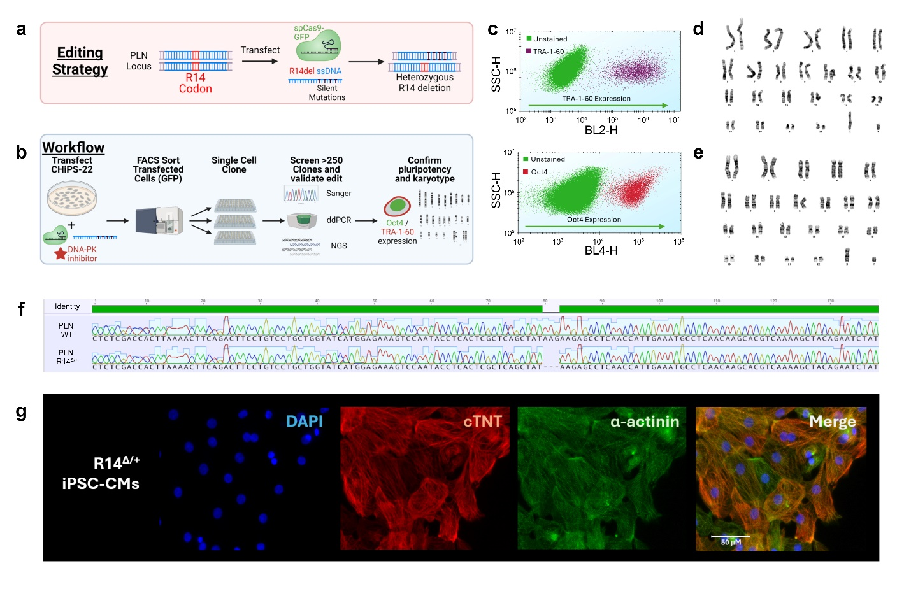
Outline of cell engineering and validation workflow for CRISPR-Cas9 engineered R14^{Δ/+} iPSC line. a Editing strategy to delete codon coding for R14^{Δ/+} using CRISPR-Cas9. b Overview of engineering workflow to generate, isolate, screen and validate single cell clones. c FACS Analysis of heterozygous PLN R14^{Δ/+} clone for expression of pluripotency markers Oct4 and TRA-1-60 confirms >97% expression. d Karyotype derived from R14^{Δ/+} stem cell line, normal male karyotype is observed in cells examined (N=20). e Karyotype derived from isogenic control (WT) stem cell line, normal male karyotype is observed in cells examined (N=20). f Sanger sequencing of wildtype and R14^{Δ/+} PLN. g Immunofluorescence characterization of R14^{Δ/+} iPSC-derived cardiomyocytes (iPSC-CMs). Cells were stained for nuclei (DAPI, blue), cardiac troponin T (cTnT, red), and α-actinin (green), demonstrating cardiomyocyte identity and organized sarcomeric structure. Merge shows co-localization of cardiac markers.

Figure. S5.
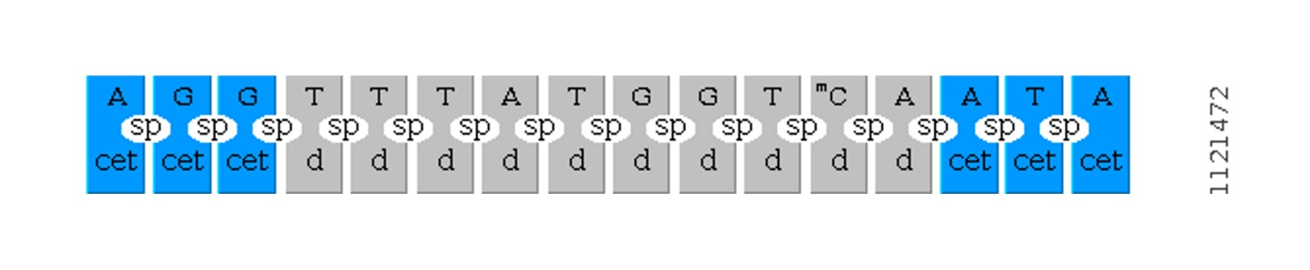

Structure and chemistry of the PLN-ASO used in this study. The ASO has a gapmer design with the sequence motif kkk-10-kkk, consisting of a central DNA gap flanked by chemically modified nucleotides. The wings (denoted "k") are composed of constrained ethyl (cEt) modified nucleotides for enhanced stability and affinity, while the central 10-mer DNA gap supports RNase H activity. The full donor DNA sequence used to generate the ASO (synthesized by Merck) is: C*T*TCAGACTTCCTGTCCTGCTGGTATCATGGAGAAAGTCCAATACCTCACTCGCTCAGCTATAAGAGCCTCAACCATTGAAATGCCTCAACAAGCACG*T*C;

With phosphorothioate linkages indicated by * for improved nuclease resistance and pharmacokinetics. The ASO chemistry was designed to maximize potency and stability for targeting PLN.

Figure. S6.

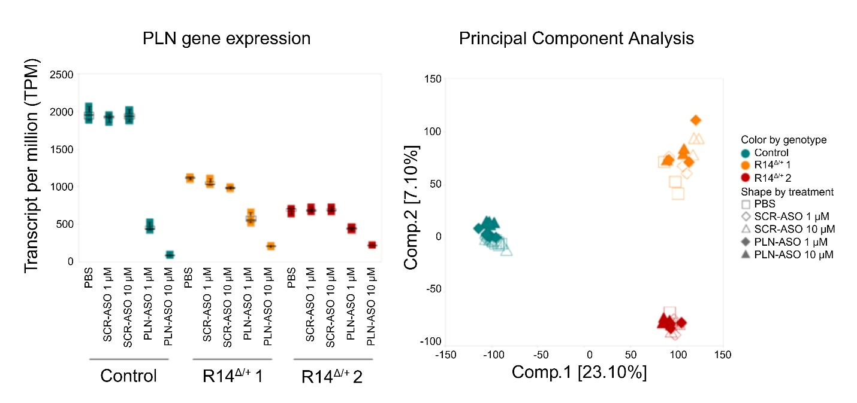

RNA therapy transcriptomics confirms target engagement of PLN-ASO in iPSC-CMs and limited non-specific effects. RNA sequencing analysis, including PLN mRNA and principal component analysis. To assess potential non-specific effects of ASO exposure, RNA sequencing was performed following treatment with a scrambled (SCR)-ASO in PLN R14^{Δ/+} iPSC-derived cardiomyocytes. Only a limited number of transcripts (ADSSL1, ATF5, CIART, IPO5, LRPPRC, PTGDS, SERPINB9, and TMEM176A) were consistently altered across two independent R14^{Δ/+} lines. None of these genes are directly associated with calcium handling, sarcomeric organization, or excitation-contraction coupling. No overlap was observed with the phosphoproteomic signatures associated with PLN R14^{Δ/+} cardiomyopathy or their reversal following PLN-targeted ASO treatment, suggesting minimal non-specific transcriptional effects of the scrambled ASO under the conditions used.

Figure. S7.

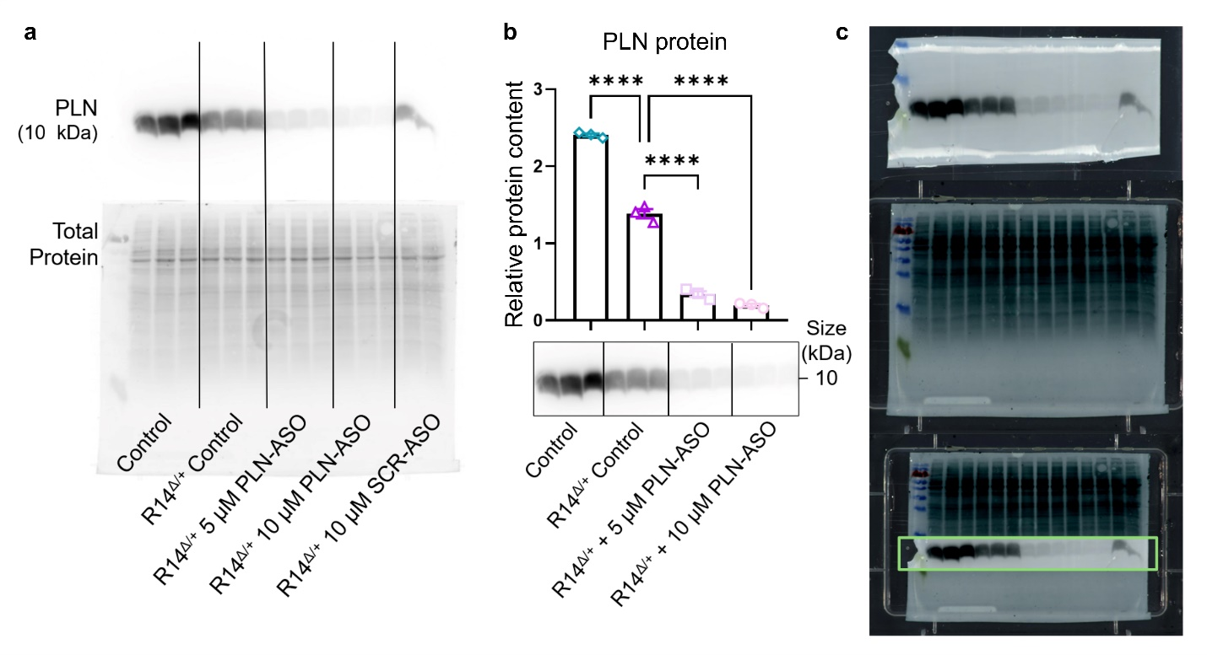
Complete western blot membranes of the western blot in this study. a Complete western blot membrane of Fig. 4c, where PLN protein content (top membrane) was corrected for total protein present on the membrane (bottom membrane). Western blot quantifications used target and loading control bands from the same membrane. b processed western blot as presented in the manuscript. c. overlay of PLN and total protein stain.

Table S1.
Description | Query Coverage | E value | Percent Identity | Accession Length | Accession | Downregulated in Proteomics?
PLN, mRNA | 1 | 0.029 | 1 | 2989 | NM_002667.5 | Yes
SCAF11, mRNA | 1 | 7.1 | 0.9375 | 7552 | NM_004719.3 | No
FAM98B, mRNA | 1 | 7.1 | 0.9375 | 4388 | NM_173611.4 | No
ZNF431, transcript variant 2, mRNA | 1 | 28 | 1 | 13894 | NM_133473.4 | No
ZDHHC3, transcript variant 1, mRNA | 0.94 | 7.1 | 1 | 12594 | NM_001135179.2 | No
GRIN2A, transcript variant 1, mRNA | 0.94 | 7.1 | 1 | 14706 | NM_001134407.3 | No
ZNF639, transcript variant 3, mRNA | 0.94 | 7.1 | 1 | 5962 | NM_001303426.2 | No
MFSD8, transcript variant 10, mRNA | 0.94 | 28 | 1 | 4422 | NM_001371596.2 | No
RNF213, transcript variant 3, mRNA | 0.94 | 28 | 0.9333 | 21079 | NM_001256071.3 | No
FAM200B, mRNA | 0.94 | 28 | 0.9333 | 4287 | NM_001145191.2 | No

BLAST homology and proteomic validation of PLN-ASO specificity. BLAST analysis of the PLN-targeting antisense oligonucleotide against the human RefSeq transcriptome. PLN was the only transcript with full-length perfect complementarity and low E-value, whereas additional short sequence matches showed reduced identity, incomplete query coverage, or high E-values consistent with chance alignments. Proteomics demonstrated selective downregulation of PLN without decreased abundance of candidate BLAST-matched proteins, supporting sequence-specific PLN targeting under the experimental conditions used.

Table S2.
DEPSs | log2FC | log2FC (noTTN)
AHNAK_S210 | 0.5834 | 0.6629
ARHGAP23_S361 | 0.4654 | 0.6086
CCDC61_T285 | 0.6003 | 0.8681
DENND5B_S1076 | -0.3401 | -0.4224
DNAJC2_S47 | 0.4896 | 0.6781
HMGA1_S102 | 0.5580 | 0.4867
INTS1_S307 | 0.3391 | 0.5146
LDB3_T135 | 0.7788 | 0.9102
MAP1A_S1797 | 1.0394 | 1.4804
MAP1B_S831 | 0.7283 | 1.1033
MAP1B_S832 | 0.6564 | 1.0005
MYOZ2_T107 | 0.3242 | 0.3865
MYOZ2_T111 | 0.3264 | 0.3882
OSBP_S379 | 0.5091 | 0.6193
PI4KA_S257 | 1.6639 | 2.3247
PLEC_S4622 | 0.5930 | 0.9467
PNN_S66 | 0.3165 | 0.2376
RAP1GAP2_S609 | 0.4298 | 0.4877
SLK_S565 | 0.5745 | 0.5667
SLK_S571 | 0.3064 | 0.3362
SPTBN1_S2138 | 0.5116 | 0.6479
SVIL_S319 | -0.4436 | -0.5444
TFIP11_S98 | 0.7664 | 0.6132
TNKS1BP1_S1620 | 0.6357 | 0.8372
TNKS1BP1_S1621 | 0.6074 | 0.8243
TTN_S12009 | 0.8045 | 0.8099
TTN_T12007 | 0.8045 | 0.8099
ZNF318_S136 | -0.4876 | -0.5836

Sensitivity analysis of differential protein abundance after exclusion of TTN variant carriers from the DCM control cohort. Comparable directionality and magnitude of fold changes following exclusion of TTN carriers (Correlation efficient; 0.969) support the interpretation that the observed signaling alterations reflect PLN-specific features within advanced cardiomyopathy, rather than artifacts driven by TTN-mutated myocardium.

Table S3.
Rank | Protein | Mean rank | Overlapping Proteins
1 | PKG2 | 5 | RAP1GAP2,SVIL,AHNAK,INTS1,DENND5B,ARHGAP23,TTN,ZNF318,PI4KA,TNKS1BP1,SPTBN1,PLEC
2 | CK1A | 8 | SVIL,SLK,AHNAK,INTS1,MAP1B,MAP1A,TNKS1BP1,CCDC61,SPTBN1,TTN,PLEC
3 | BIKE | 9 | SVIL,SLK,AHNAK,MAP1B,MAP1A,OSBP,TNKS1BP1,LDB3,CCDC61,TTN,PLEC
4 | IKKB | 10 | SVIL,SLK,AHNAK,INTS1,MAP1B,MAP1A,ZNF318,TNKS1BP1,SPTBN1,TTN,PLEC
5 | CK1G1 | 11 | SVIL,PNN,SLK,AHNAK,MAP1B,MAP1A,TNKS1BP1,CCDC61,SPTBN1,ARHGAP23,TTN
6 | MSK2 | 12 | PNN,SLK,AHNAK,INTS1,DENND5B,ZNF318,TNKS1BP1,LDB3,ARHGAP23,TTN,PLEC
7 | AURA | 13 | SVIL,SLK,INTS1,DENND5B,MAP1B,ZNF318,TNKS1BP1,SPTBN1,ARHGAP23,TTN,PLEC
8 | P70S6K | 14 | RAP1GAP2,SVIL,PNN,SLK,AHNAK,ZNF318,TNKS1BP1,CCDC61,ARHGAP23,TTN,PLEC
9 | DCAMKL1 | 27 | RAP1GAP2,SVIL,AHNAK,OSBP,ZNF318,PI4KA,LDB3,ARHGAP23,TTN,PLEC
10 | PKG1 | 31 | RAP1GAP2,SVIL,DENND5B,ZNF318,PI4KA,TNKS1BP1,LDB3,ARHGAP23,TTN,PLEC

Exploratory kinase enrichment analysis (KEA) of the integrative phosphoproteomic dataset. KEA showing rank (lower indicates stronger consensus), enriched kinases, mean KEA3 rank (mean ranking position across KEA3 resources), and associated overlapping DEPS-containing proteins. Kinases are ranked by mean enrichment score derived from overlapping annotated substrates within the DEPS list. “Overlapping proteins” indicates the number of phosphoproteins within the DEPS set annotated as substrates of the respective kinase in the reference database. KEA results are exploratory and dependent on current kinase-substrate annotation coverage; therefore, identified kinases should be interpreted as hypothesis-generating upstream regulatory candidates rather than definitive evidence of kinase activation.

Table S4.
Kinase enrichment analysis, DEPSs at 0.3 FC
Rank | Protein | Mean rank | Overlapping Proteins
1 | DLK* | 1 | 55 proteins
2 | NDR2 | 9 | 46 proteins
3 | YANK2 | 13 | 47 proteins
4 | BIKE | 16 | 44 proteins
5 | CHK2 | 17 | 44 proteins
6 | MEKK6 | 30 | 45 proteins
7 | P70S6K | 31 | 43 proteins
8 | MLK2 | 35 | 41 proteins
9 | ILK | 36 | 70 proteins
10 | MST1 | 36 | 42 proteins

Exploratory kinase enrichment analysis of disease-associated phosphosites in PLN R14^{Δ/+} cardiomyopathy. Kinase enrichment analysis (KEA) was performed on DEPSs identified in PLN R14^{Δ/+} samples relative to controls. log₂FC > 0.3 was applied to capture the broader disease-associated phosphorylation landscape Kinases are ranked by mean enrichment score derived from overlapping annotated substrates within the DEPS list. “Overlapping proteins” indicates the number of phosphoproteins within the DEPS set annotated as substrates of the respective kinase in the reference database. KEA results are exploratory and dependent on current kinase-substrate annotation coverage; therefore, identified kinases should be interpreted as hypothesis-generating upstream regulatory candidates rather than definitive evidence of kinase activation. Enriched kinases included stress-activated MAPK pathway components (DLK, MLK2, MEKK6 and YANK2), cytoskeletal and mechanotransduction-associated regulators (NDR2, MST1 and ILK), vesicle-trafficking and cytoskeleton-associated kinase BIKE, checkpoint kinase CHAK2, and growth-associated kinase p70S6K. The convergence of stress-responsive MAPK signaling with cytoskeletal and mechanotransduction pathways is consistent with the actomyosin- and cytoskeleton-enriched phosphorylation signature observed in PLN R14^{Δ/+} myocardium. Together, these analysis suggest that PLN-dependent calcium dysregulation is associated with coordinated engagement of stress-activated MAPK, cytoskeletal, and inflammatory signaling networks, providing mechanistic context for the disease-associated phosphoproteomic remodeling observed in human myocardium and iPSC-derived cardiomyocytes. Because KEA relies on curated kinase-substrate annotations and does not directly measure kinase activity, these findings should be interpreted as prioritization of candidate upstream regulators for future functional perturbation studies.

