Supplementary Materials for

Targeting ER export disrupts metabolic resilience in multiple myeloma

Utku Horzum, Herbert Oberacher, Margot Haun, Stephan Geley, Monica Roman-Trufero, Holger Auner, Agnieszka Martowicz, Gerold Untergasser, Eberhard Gunsilius, Wolfgang Willenbacher, Hamdullah Yanik, Gunes Esendagli, Dominik Wolf, Hesso Farhan

Correspondence to: hesso.farhan@i-med.ac.at , utku.horzum@i-med.ac.at

This PDF file includes:

Materials and Methods
Figures. S1 to S23
Tables S1 to S2
Uncropped images of western blots
Key resources
Extended statistics

Materials and Methods

Cell culture and transfection
Human multiple myeloma (MM) cell lines KMS-12PE, AMO-1, and NCI-H929 were cultured in RPMI-1640 supplemented with 10% fetal bovine serum (FBS), 2 mM L-glutamine, 100 mg/mL penicillin and streptomycin 100 U/mL. The other 6 MM cell lines were cultured under the following conditions: URVIN in RPMI-1640 supplemented with 15% FBS and 1 ng/mL interleukin-6 (IL-6); FOLE in RPMI-1640 with 15% human serum (HS); OH-2 and KJON in RPMI-1640 containing 15% HS and 1 ng/mL IL-6; and VOLIN in RPMI-1640 with 15% FBS. All cells were maintained in a humidified incubator at 37°C with 5% CO₂. Cells were passaged at a seeding density of 5 × 10⁵ cells/mL every 3–4 days. The passage routine is critical for MM cell lines. Cells that have been passaged many times and in an irregular manner tend to change their growth behavior and morphology, and are less susceptible to transfection. The day prior to transfection, cell media were refreshed to provide optimal gas exchange and logarithmic growth of cells. On day of transfection, cells were washed twice in RPMI media and resuspended in the same serum free media at a concentration of 2.0 x 10⁵ cells in 50 μL RPMI. After 25 min, serum-starved cells were transferred to the wells of 96-well flat bottom plate, and gently shaken for uniform distribution. After an extra 5 min for placing of cells to the surface of well, transfection complexes (900 ng siRNA in 50 uL RPMI containing 6 uL HiPerfect reagent) were gently added from one side of the well onto the cells. Plate was centrifuged at 30xg for 30 min at RT with slow acceleration/deceleration in a benchtop centrifuge with swinging bucket rotor and plate carriers. Following centrifugation, 200 uL of fresh growth media were immediately added to each wells. This brings the final siRNA concentration to 200 nM. Then, cells were incubated in their standard growth conditions (37°C, 5% CO2). The experiments were performed 48 h after the transfection. The transfection efficiencies were greater than 70% based on the mRNA and protein levels of target genes. The synchronization of cargo traffic in the early secretory pathway by blocking membrane traffic from the ER, temperature block, was performed at 10°C for 1 hour using a heat block. The cells were then applied to slides by cytospin for 3 min at 50xg and for 1 min at 150xg in a pre-cooled centrifuge. Same centrifugation values were used to prepare all cytospun MM samples for immunofluorescence analysis. To assess cell viability and ATP levels, we used the ATP-based CellTiter-Glo Luminescent Cell Viability assay according to manufacturer’s instructions. Senescence was evaluated using the Beta-Glo Assay System according to the manufacturer’s instructions. Glutamine levels were measured using the Glutamine/Glutamate-Glo Assay according to the manufacturer’s instructions. Cellular metabolic rates were measured using a Seahorse XF96 Analyzer, with the Mito Stress Test Kit and the Glycolytic Rate Assay Kit, following the manufacturer's recommendations and necessary optimizations. MM cells infected with the cell membrane marker, GFP-CaaX, were used in ex ovo experiments. To generate stable cell line, lentiviral infection of MM cells was performed. For lentivirus production, HEK293T cells were transiently transfected with a lentiviral GFP-CaaX vector together with pCMV-VSV-G and psPAX2 in a respective ratio of 2:1:1. PEI was used as a transfection agent. The media on the HEK293T cells was replaced with fresh media 8–16 hours post transfection. After cells were cultured for 2 days, the supernatant was collected and passed through a 0.45-mm syringe filter unit. MM cells were infected with lentivirus containing cell culture supernatant and 8 mg/mL polybrene. GFP-positive cells were isolated using BD FACS Aria-III cell sorter. SEC24A&B knockdowns were also achieved using RNA interference in NCI-H929 cell line. Briefly, complementary shRNA oligonucleotides directed against SEC24A or SEC24B were designed, annealed and cloned into the pENTR-THTIII vector. Sequence-verified THT-shRNA cassettes were recombined into the GATEWAY-based lentiviral doxycycline-regulated conditional RNAi vector pGLTR-X Puro or GFP. Lentiviral particles were produced by the same way using HEK293T cells. Infected NCI-H929 cells were selected in two steps with puromycin for SEC24A and sorted based on GFP for SEC24B vice versa. Scrambled shRNA was used as the non-targeting control. Successful knockdowns of SEC24A and SEC24B were confirmed by Western blotting. In parallel, shRNA-expressing NCI-H929 cells were also infected with a luciferase reporter vector followed by a selection with hygromycin as previously described above.

Immunofluorescence microscopy
Cytospin samples were fixed with 4% paraformaldehyde (PFA) for 15 min at room temperature. Next, cells were washed twice with PBS and permeabilized in 0.1% Triton-X 100 solution for 3 min at room temperature. Afterwards, samples were rinsed twice with PBS, and blocked using 3% BSA in PBS for 1 hour at RT. After blocking nonspecific binding sites, samples were incubated with the primary antibodies diluted in PBS with 3% BSA for 1 hour at RT. Samples were then washed with PBS three times and incubated with florescence-conjugated secondary antibodies diluted in PBS with 3% BSA for 1 hour at RT. After washing three times with PBS, slides were mounted on glass coverslips using polyvinyl alcohol. To assess vacuolization, cytospun samples were stained with 10% May-Grunwald Giemsa. To assess the secretory load of multiple myeloma cells, steady-state cells were cytospun, stained with an anti–human immunoglobulin G, A, and M (H+L) antibody conjugated to FITC, and counterstained with DAPI to visualize nuclei. All images were acquired with a Nikon Spinning Disk Eclipse Ti2 confocal microscope equipped with a 60x oil immersion objective.

Western blotting
MM cell lines were transfected with siRNAs against SEC24A and/or SEC24B or negative control (as described above). Drugs or corresponding amounts of DMSO treatments were performed overnight at standard growth conditions. Protein lysates were extracted from the MM cell lines at 48 h after transfection. Cells were washed with ice-cold PBS and homogenized with lysis buffer (150 mM NaCl, 1% NP-40, 0.5% sodium deoxycholate, 0.1% sodium dodecyl sulfate, 50 mM Tris-HCl (pH 8), and 1 mM PMSF supplemented with protease and phosphatase inhibitor cocktail) for 30 min at 4ºC. Crude extracts were then centrifuged at 20,000xg at 4ºC for 15 min to remove cell debris, and proteins in the supernatant were quantified using the Bradford assay. The supernatants were mixed with Laemmli reducing buffer and further denatured at 95ºC for 5 min. Equal amount of proteins were loaded and resolved on 10% SDS-PAGE for nearly all analyses except LC3 which was separated on 15% gels. After electrophoretic separation, proteins were transferred to nitrocellulose membranes and blocked with 5% skim milk in TBS-Tween 20 at RT for 1 hour. Membranes were then incubated with primary antibodies overnight at 4ºC. HRP-conjugated secondary antibodies were applied to the membranes for 1 hour at RT. We detected puromycin incorporation by immunoblotting with the 2A4 monoclonal antibody to puromycin. Cells were pretreated with cycloheximide (25 μM) for 10 min in culture conditions and washed twice with fresh growth media. Then, cells were labeled with 10 μg/ml of puromycin for indicated times at their standard culture conditions. Puromycin incorporation into cells detected by anti-puromycin blot or flow cytometry. Immunoblots were visualized and recorded using enhanced chemiluminescence reagent and ChemiDot imaging system.

Flow Cytometry
Flow cytometry data were acquired by BD Fortessa flow cytometer and analyzed by FlowJo software. To measure misfolded protein level, cells were treated with TPE-MI (50 μM in PBS) for 30 min at 37 °C and then washed and resuspended in PBS for flow cytometry analysis. Secretory loads of multiple myeloma cells were measured by calculating the ratio of intracellular immunoglobulin MFI in brefeldin A-treated cells relative to steady-state cells. Briefly, cells were treated with brefeldin A (5 µg/mL) for 4 h, intracellularly stained with an anti–human immunoglobulin G, A, and M (H+L) antibody conjugated to FITC, and analyzed by flow cytometry. Mitochondrial membrane depolarization was measured by JC1 MitoProbe. Briefly, cells washed once by adding warm PBS and incubated in a fresh growth medium with 2 μM of JC-1 dye at 37 °C, 5% CO₂ for 20 min. Then, cells were washed once by adding warm PBS and analyzed immediately by flow cytometry. For experiments involving viability of AMO-1 cells treated with Z-VAD-FMK, torin-1, and kifunensine at the indicated concentrations overnight, apoptosis was measured by flow cytometry analysis using Annexin V and 7-AAD apoptosis detection kit according to the manufacturer’s protocols. The purity of isolated patient-derived myeloma cells was assessed via flow cytometry following surface staining of CD138, CD19 and CD56 molecules.

Quantitative analysis of amino acids and biogenic amines
Sample preparation
AMO-1 cells treated with siRNAs for 48 h or cycloheximide (25 ug/ml) for 4 h were collected and washed three times with PBS. Cells were then resuspended at a density of 1.0 x 10⁶ cells per 250 μL of PBS, and subjected to homogenization with repeated freeze thaw cycles following mechanical disruption using 25G syringe. The homogenates were clarified by centrifugation at 20,000x g for 15 min and clear supernatants were collected. Protein concentrations were determined by the Bradford assay. The supernatants were stored at –80°C.
Chemicals
Methanol, acetonitrile, and water (all HPLC grade) were obtained from Honeywell (Seelze, Germany). Triethylamine, phenyl isothiocyanate, acetic acid, the amino acid standards (A9906, asparagine, glutamine, kynurenine), and the stable isotope labeled amino acid mix solution (96378) were purchased from Sigma-Aldrich (St. Louis, MO, USA). Tryptophan-D5 were provided by Toronto Research Chemicals (Toronto, Ontario, Canada). To prepare stock solutions of asparagine, glutamine, kynurenine and tryptophan-D5, 1.0 mg of the standards were dissolved in methanol-water (1:1, v/v). For the preparation of calibration standards, the reference standard solutions were mixed and dissolved in methanol-water (1:1, v/v) to reach concentrations between 50 nM and 250 µM.

Derivatization procedure
10 µL of the cell lysates or calibration standards were pipetted into a 1.5 mL vial and mixed with 5 µL of the internal standard solution (2.5 µM of each internal standard in methanol-water (1:1, v/v)) as well as 65 µL methanol, 5 µL water, 10 µl triethylamine and 10 µL phenyl isothiocyanate. Derivatization was performed at room temperature for 30 min, after which, the excess reagent was removed by drying at 60 °C with a gentle stream of nitrogen. The dried samples were dissolved with 100 µL of methanol-water (1:3, v/v).

Liquid chromatography-tandem mass spectrometry
The LC-MS/MS system consisted of Acquity UPLC H-Class Plus Bio System (Waters, Milford, MA, USA) and a QTrap 6500+ mass spectrometer (Sciex, Framingham, MA, USA). Separations were accomplished on an Eclipse XBD-C18 column (3.5 µm, 3.0 × 100 mm, Agilent) using a ten-minute gradient of 2–98% acetonitrile in aqueous 0.5% acetic acid solution. The flow rate was set to 250 µL/min, and the column temperature was kept at 50 °C. The injection volume was 10 µL. Mass spectrometry detection was performed with electrospray ionization in positive ion mode. Multiple reaction monitoring was carried out using the precursor-to-product ion transitions summarized in Table 1. The peak area ratios of analyte-specific ions to the corresponding internal standard ions obtained from the calibration standards versus concentrations were used to fit 1/x−weighted linear, least squares regression models. The calibration models were used to calculate the analyte concentrations from the peak area ratios of analyte-specific ions to the corresponding internal standard ions obtained from the samples.

Table 1. Multireaction monitoring transitions for the targets and the corresponding internal standards.
Target | Q1 (m/z) | Q3 (m/z) | Internal Standard
Alanine | 225 | 44 | Alanine-¹³C₃¹⁵N
Arginine | 310 | 217 | Arginine-¹³C₆
Aspartic acid | 269 | 116 | Aspartic acid-¹³C₄
Glutamic acid | 283 | 130 | Glutamic acid-¹³C₅
Glycine | 211 | 76 | Glycine-¹³C₂¹⁵N
Histidine | 291 | 110 | Histidine-¹³C₆
Leucine | 267 | 43 | Leucine-¹³C₆¹⁵N
Isoleucine | 267 | 69 | Isoleucine-¹³C₆¹⁵N
Lysine | 417 | 324 | Lysine-¹³C₆
Methionine | 285 | 104 | Methionine-¹³C₅¹⁵N
Phenylalanine | 301 | 120 | Phenylalanine-¹³C₆
Proline | 251 | 70 | Proline-¹³C₅
Serine | 241 | 60 | Serine-¹³C₃¹⁵N
Threonine | 255 | 74 | Threonine-¹³C₄
Tryptophan | 340 | 188 | Tryptophan-D₅
Tyrosine | 317 | 136 | Tyrosine-¹³C₆
Valine | 253 | 72 | Valine-¹³C₅
Asparagine | 268 | 87 | Serine-¹³C₃¹⁵N
Carnosine | 362 | 110 | Arginine-¹³C₆
Citrulline | 311 | 113 | Serine-¹³C₃¹⁵N
Glutamine | 282 | 130 | Serine-¹³C₃¹⁵N
Kynurenine | 344 | 146 | Tryptophan-D₅
Ornithine | 403 | 310 | Methionine-¹³C₅¹⁵N
c4-OH-Pro | 267 | 68 | Arginine-¹³C₆
Alanine-¹³C₃¹⁵N | 229 | 47
Arginine-¹³C₆ | 316 | 223
Aspartic acid-¹³C₄ | 273 | 120
Glycine-¹³C₂¹⁵N | 214 | 79
Histidine-¹³C₆ | 297 | 115
Leucine-¹³C₆¹⁵N | 274 | 92
Isoleucine-¹³C₆¹⁵N | 423 | 330
Lysine-¹³C₆ | 307 | 126
Phenylalanine-¹³C₆ | 256 | 74
Proline-¹³C₅ | 245 | 63
Serine-¹³C₃¹⁵N | 259 | 63
Threonine-¹³C₄ | 259 | 77
Tyrosine-¹³C₆ | 323 | 142
Valine-¹³C₅ | 258 | 76
Glutamic acid-¹³C₅ | 288 | 135
Methionine-¹³C₅¹⁵N | 291 | 109
Tryptophan-D₅ | 345 | 193

The MxP® Quant 500 kit (Biocrates, Innsbruck, Austria) was used as a ready-to-use platform according to the manufacturer’s instructions for targeted metabolite quantification in Supplementary Figures 14 and 15. Data were processed using the Biocrates proprietary MetIDQ software, which is an integral component of the kit.

ELISA
Supernatants for immunoglobulin analysis were harvested after 48 hours from wells in which AMO-1 or NCI-H929 MM cell lines were transfected with siRNA targeting a non-specific sequence (Ctrl) or siRNA targeting SEC24A&B. Supernatants were centrifuged at 500x g for 5 min to exclude any cell contamination. Then, cell-free supernatants were harvested and incubated with IgA antibody-coated ELISA plates according to the manufacturer’s instructions. All samples were assayed in duplicate. IgA concentrations were calculated by interpolation from a standard curve generated using a microplate reader at a wavelength of 450 nm. To quantify GFP levels of tumor spheroids containing GFP-CaaX transfected MM cells, each MM spheroid transferred into 0.5 mL cell extraction buffer PTR containing 200 µg/ml protease inhibitors. After 10 min of incubation on ice, three freeze-thaw cycles were performed using liquid nitrogen and 37ºC water bath, with vigorous vortexing after each cycle. The homogenates were then centrifuged at 18,000 x g for 20 minutes at 4°C. The supernatants were collected and further diluted 10-fold. Following preparation of samples, GFP levels were determined using SimpleStep ELISA kit according to the manufacturer’s instructions.
Image analysis
All image processing steps are carried out using the ImageJ software (version 1.53q, National Institutes of Health). In the first step, all fluorescence images were background subtracted. ERES images were filtered using LOG3D plugin (Sage et al. 2005) before thresholding. Identified ERES were analyzed with ‘Analyze Particles’ command. Image stacks of ER were filtered, segmented and analyzed by plugins of 3D ImageJ Suite (Ollion et al. 2013).

Chick embryo chorioallantoic membrane (CAM) assay
CAM of fertilized White Leghorn chicken eggs was used mainly following the protocol published by Martowicz (Martowicz et al. 2015). MM cells expressing GFP-CaaX treated with siRNAs for 24 hr were collected and suspended at a density of 250,000 cells per 30 μL of growth factor-reduced Matrigel. MM spheroids were formed with the polymerization of Matrigel for 30 min at 37°C. MM spheroids were then placed on the surface of the CAM (2 cm away from the embryo), in 9-day-old chicken embryos (four onplants for per embryo). After four days of in vivo growth in an egg incubator (Grumbach) at 37°C and 70% humidity, MM spheroids were imaged using a fluorescence stereomicroscope (Olympus SZX10), and images were acquired with cellSens Standard Imaging Software (v.1.18, Olympus). To quantify the growth of MM spheroids, GFP-levels were measured by a commercial SingleStep GFP ELISA Kit using biotinylated anti-GFP antibodies, according to the manufacturer’s protocol.

Intrafemural multiple myeloma model in NSG mice
NOD.Cg-Prkdc^{scid} Il2rg^{tm1Wjl}/SzJ (NSG) ) immunocompromised mice were purchased from Kobay Experimental Animal Production Laboratory (Türkiye) and maintained under specific pathogen-free conditions in individually ventilated cages with ad libitum access to food and water. All animal procedures were approved by Animal Care and Use Committee of Kobay Laboratory [Ethical approval no: 778] and were performed in accordance with national and institutional ethical guidelines. For generation of the orthotopic MM model, inducible shRNA-expressing NCI-H929 cells (50.000 cells in 10 μL) were injected intrafemorally into the NSG mice (6–8 weeks old). Tumors were allowed to establish for 2 weeks before induction of shRNA expression. Doxycycline was administered intraperitoneally (i.p.) at a dose of 2.5 mg/kg, twice at 5-day intervals. Following two rounds of doxycycline induction, the mice were injected i.p. with 100 μl of CycLuc1 (5 mM) and imaged ten minutes post-injection. Tumor progression was monitored by bioluminescent imaging (BLI) using an in vivo imaging system (Newton 7.0). The total photon flux (photons/sec) was measured from region over the entire hindlimb of the mouse. All tumor inoculation and imaging procedures were conducted under anesthesia with ketamine (60 mg/kg) and xylazine (10 mg/kg).

Ethics statement and clinical specimens
Bone marrow aspirates obtained from patients with newly diagnosed or relapsed MM following signed informed consent in compliance with the Declaration of Helsinki. The study was approved by the ethics committee of the Medical University of Innsbruck (Nr: 1198/2021). Bone marrow samples were subjected to red blood cell (RBC) lysis, according to manufacturer’s instructions (Biolegend). Cells were washed twice with PBS and resuspended in MACS buffer (Miltenyi Biotech). Then, CD138⁺ myeloma cells were separated by positive MACS selection using CD138⁺ microbeads. After purity check by surface staining of CD138, CD19 and CD56 molecules (as described above), CD138⁺ myeloma cells at a purity over 75% were used in assays. For survival analyses, we used the survival data from the Multiple Myeloma Research Foundation (MMRF) CoMMpass Study dataset. Transcript per Million (TPM) reads values of SEC24 paralogs were used for survival analyses. The MMRF genomic data can be found on the Genomic Data Commons (GDC) Data Portal (https://portal.gdc.cancer.gov/).

SUPPLEMENTARY FIGURES:

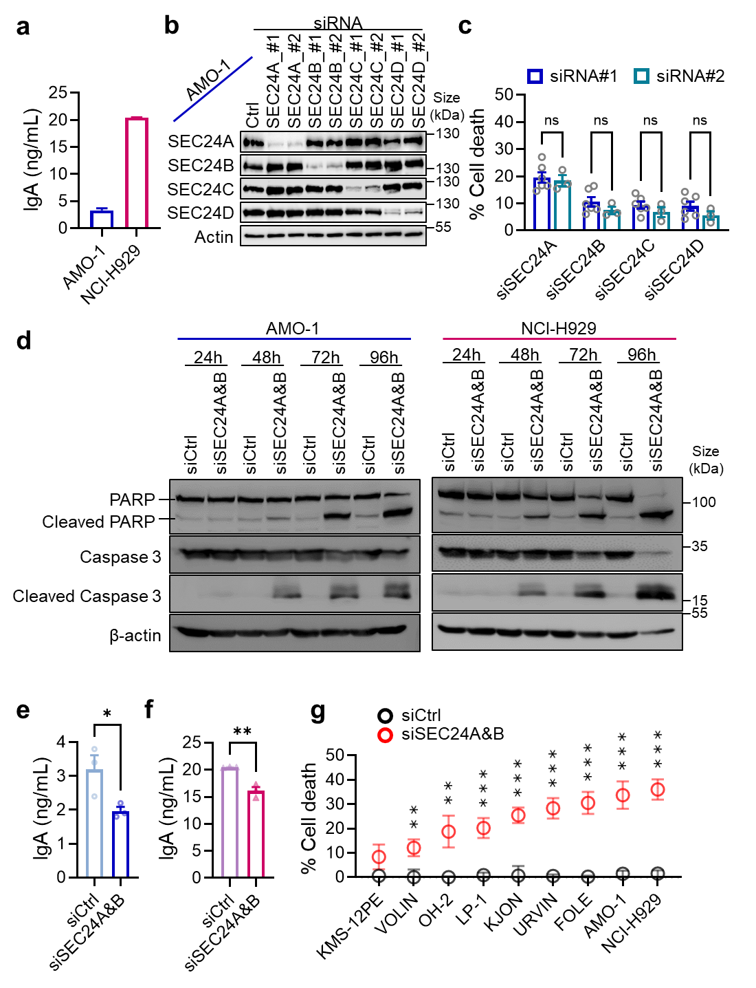

Figure S1. a ELISA quantification of IgA titers in AMO-1 and NCI-H929 MM cell lines. The supernatant was collected at 48 hours for IgA ELISA analysis. b Rationally designed siRNA oligos targeting SEC24 paralogs were evaluated for silencing efficiency. Transient transfections of AMO-1 cells with siRNAs against SEC24 paralogs demonstrated acceptable knockdown efficiencies, as determined by immunoblotting after 48 hours. c After 48 hours of knockdown, cell viability was measured for each siRNA targeting SEC24 paralogs in AMO-1 cells. Cell viability was assessed using the CellTiter-Glo assay, and data were normalized to cells treated with negative control siRNA. ns = non-significant, Student’s unpaired two-tailed t-test. siRNA#1 and siRNA#2 indicate two different siRNAs targeting the same gene. d PARP and Caspase-3 cleavage were detected at multiple time points following co-depletion of SEC24A&B, compared with control condition. (e and f) Changes in IgA secretion were assessed by ELISA using the supernatant of e AMO-1 and f NCI-H929 cells at 48 hours post-transfection with negative control or SEC24A&B siRNAs. g The impact of SEC24A&B depletion on cell viability was assessed in multiple MM cell lines: non-secretory KMS-12PE, IgG-secreting VOLIN, IgG-secreting OH-2, IgG-secreting LP-1, FLC-secreting KJON, IgG-secreting URVIN, IgA/FLC-secreting FOLE, IgA-secreting AMO-1, and IgA-secreting NCI-H929. Cell viability was assessed using the CellTiter-Glo assay. Gray circles, siCtrl; red circles, siSEC24A&B. ***P < .001, **P < .01, Student’s unpaired two-tailed t-test.

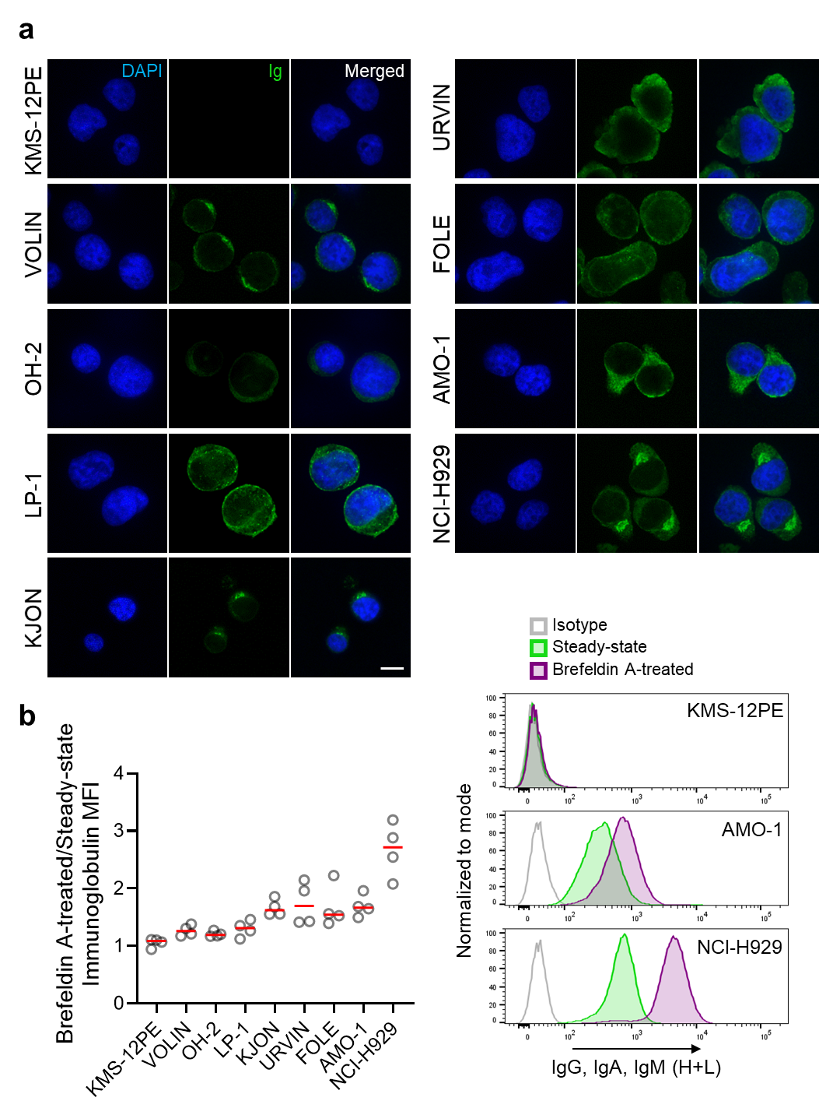

Figure S2. a Multiple myeloma cells were labeled at steady state with an anti-human immunoglobulin G, A, and M (H+L) antibody conjugated to FITC and counterstained with DAPI to visualize nuclei. All images were acquired using identical microscopy settings. Scale bar, 10 µm. b, Multiple myeloma cells were treated with brefeldin A (5 µg/mL) for 4 h and intracellularly stained with an anti-human immunoglobulin G, A, and M (H+L) antibody conjugated to FITC. Immunoglobulin median fluorescence intensity (MFI) in brefeldin A–treated cells was normalized to steady-state MFI (n = 4 independent experiments). Overlaid histograms show representative flow cytometry profiles of the non-secretory KMS-12PE, moderately secretory AMO-1, and hypersecretory NCI-H929 cell lines at their steady state and Brefeldin A-treated states.

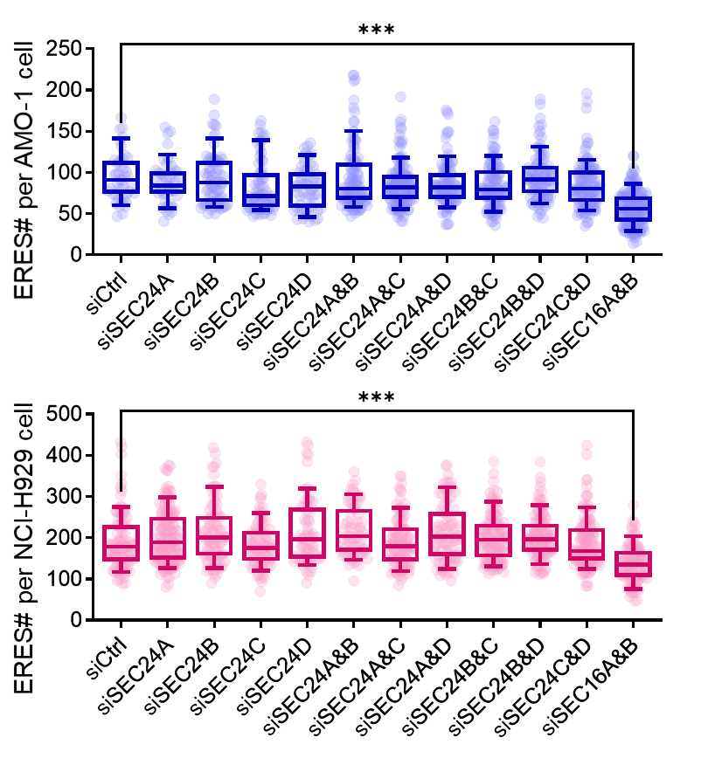

Figure S3. Knockdown of any of the SEC24 paralogs did not exert a negative effect on ERES. AMO-1 (blue) and NCI-H929 (pink) cells were treated with siRNA against the indicated gene, followed by fixation and staining after 48 hours with anti-SEC31 to label ERESs. Quantification of the number of ERESs per cell is displayed. Data are from three independent experiments with at least 60 cells per condition. Each symbol represents individual data points. Lines represent the median, edges represent the interquartile range, and whiskers represent the 10th and 90th percentiles. Statistical significance was measured using one-way ANOVA followed by Dunnett’s test, ***P < .001. Statistical significance is presented only in comparison to the control.

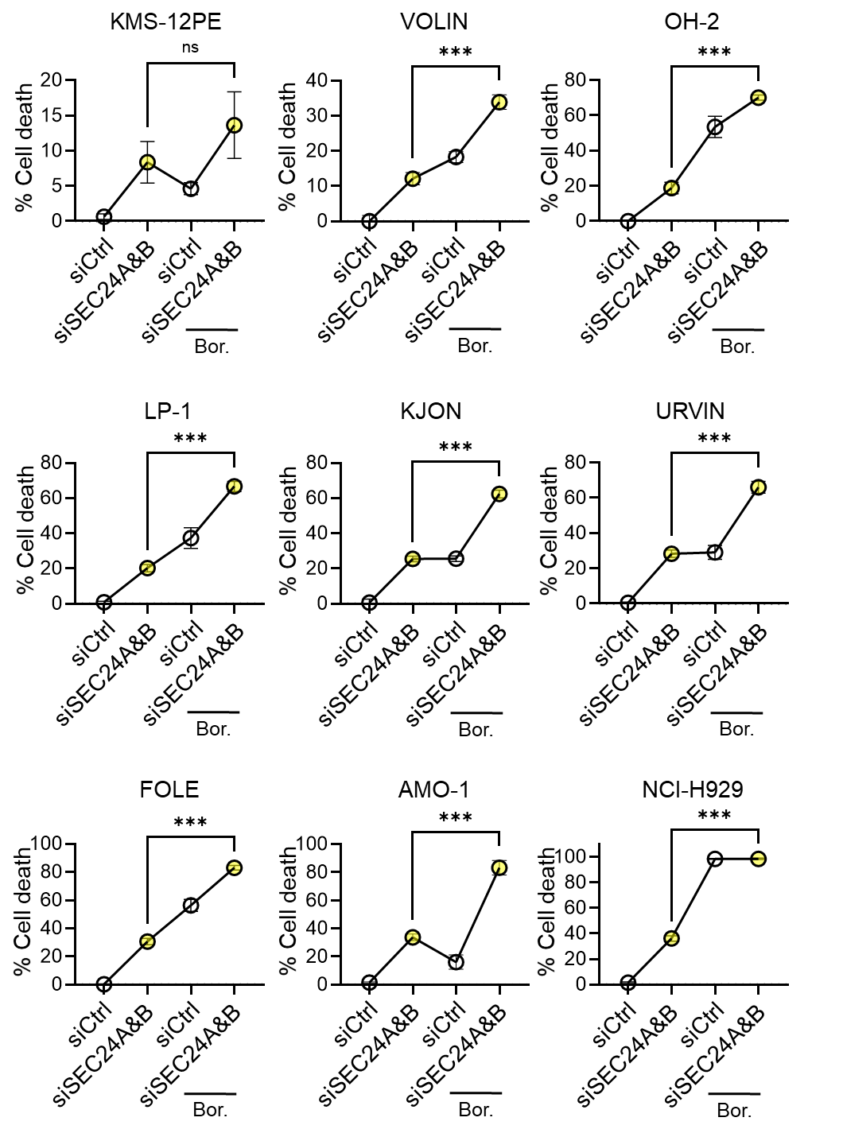
Figure S4. The effect of bortezomib (Bor.) after SEC24A&B depletion on cell viability was assessed in multiple MM cell lines: non-secretory KMS-12PE, IgG-secreting VOLIN, IgG-secreting OH-2, IgG-secreting LP-1, FLC-secreting KJON, IgG-secreting URVIN, IgA/FLC-secreting FOLE, IgA-secreting AMO-1, and IgA-secreting NCI-H929. Cells were treated with 5 nM bortezomib during the last 16 hours of the 48-hour knockdown. Gray circles, siCtrl; yellow-filled circles, siSEC24A&B. Data were generated in ≥3 independent experiments. ***P < .001, Student’s unpaired two-tailed t-test.

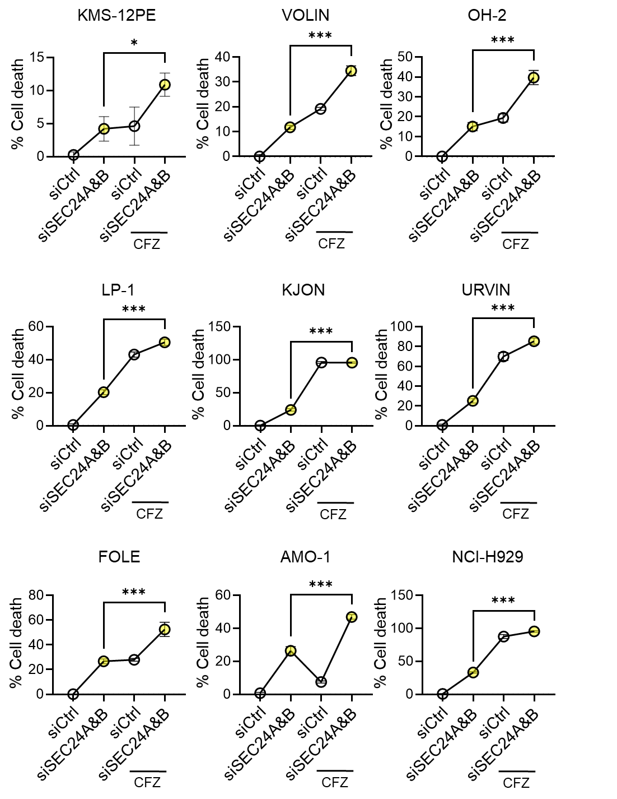
Figure. S5. The effect of carfilzomib (CFZ) after SEC24A&B depletion on cell viability was assessed in multiple MM cell lines: non-secretory KMS-12PE, IgG-secreting VOLIN, IgG-secreting OH-2, IgG-secreting LP-1, FLC-secreting KJON, IgG-secreting URVIN, IgA/FLC-secreting FOLE, IgA-secreting AMO-1, and IgA-secreting NCI-H929. Cells were treated with 10 nM carfilzomib during the last 16 hours of the 48-hour knockdown. Gray circles, siCtrl; yellow-filled circles, siSEC24A&B. Data were generated in ≥3 independent experiments. ***P ≤ 0.001, * P ≤ 0.05, Student’s unpaired two-tailed t-test.

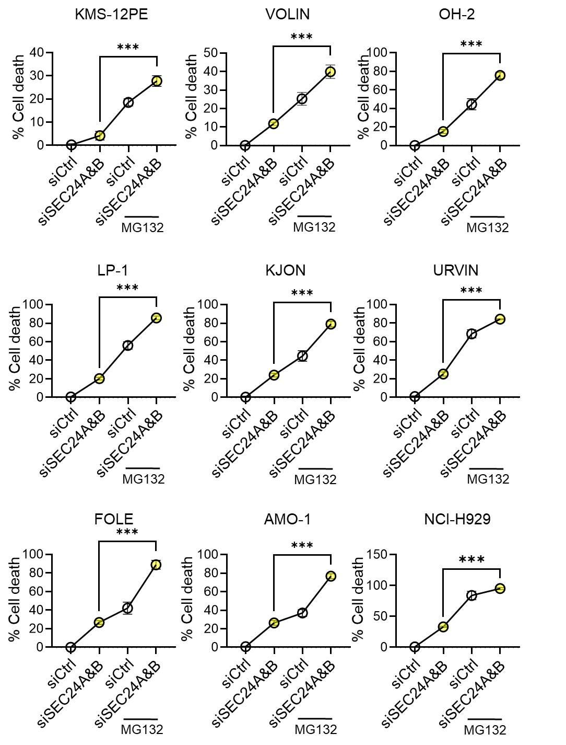
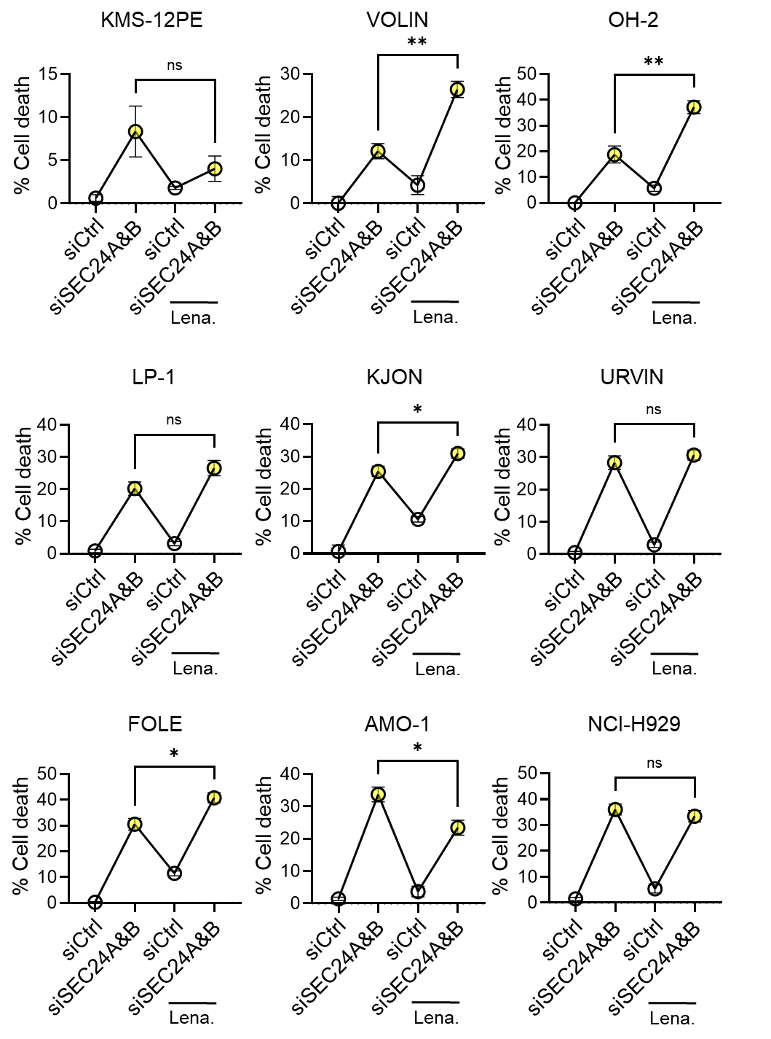
Figure S6. The effect of MG132 after SEC24A&B depletion on cell viability was assessed in multiple MM cell lines: non-secretory KMS-12PE, IgG-secreting VOLIN, IgG-secreting OH-2, IgG-secreting LP-1, FLC-secreting KJON, IgG-secreting URVIN, IgA/FLC-secreting FOLE, IgA-secreting AMO-1, and IgA-secreting NCI-H929. Cells were treated with 10 μM MG132 during the last 16 hours of the 48-hour knockdown. Gray circles, siCtrl; yellow-filled circles, siSEC24A&B. Data were generated in ≥3 independent experiments. ***P < .001, Student’s unpaired two-tailed t-test.

Figure S7. The effect of lenalidomide after SEC24A&B depletion on cell viability was assessed in multiple MM cell lines: non-secretory KMS-12PE, IgG-secreting VOLIN, IgG-secreting OH-2, IgG-secreting LP-1, FLC-secreting KJON, IgG-secreting URVIN, IgA/FLC-secreting FOLE, IgA-secreting AMO-1, and IgA-secreting NCI-H929. Cells were treated with 50 μM lenalidomide during the knockdown period. Cell viability were measured using the CellTiter-Glo assay after 48 hours of knockdowns. Gray circles, siCtrl; yellow-filled circles, siSEC24A&B. Data were generated in ≥3 independent experiments. ***P < .001, **P < .01, *P < .05, Student’s unpaired two-tailed t-test.
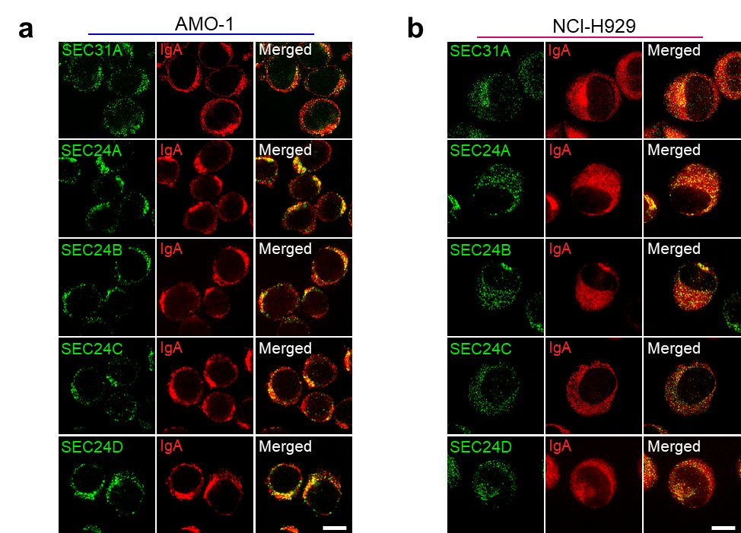

Figure S8. a AMO-1 or b NCI-H929 cells were incubated at 10°C for 60 min to increase the local concentration of Igs at ERES. Cells were then spun onto coverslips and processed for immunofluorescence staining using antibodies against SEC24 paralogs (green) and IgA (red). SEC31A staining (green) was used as a positive control representing almost all ERES. Scale bar, 10 µm.

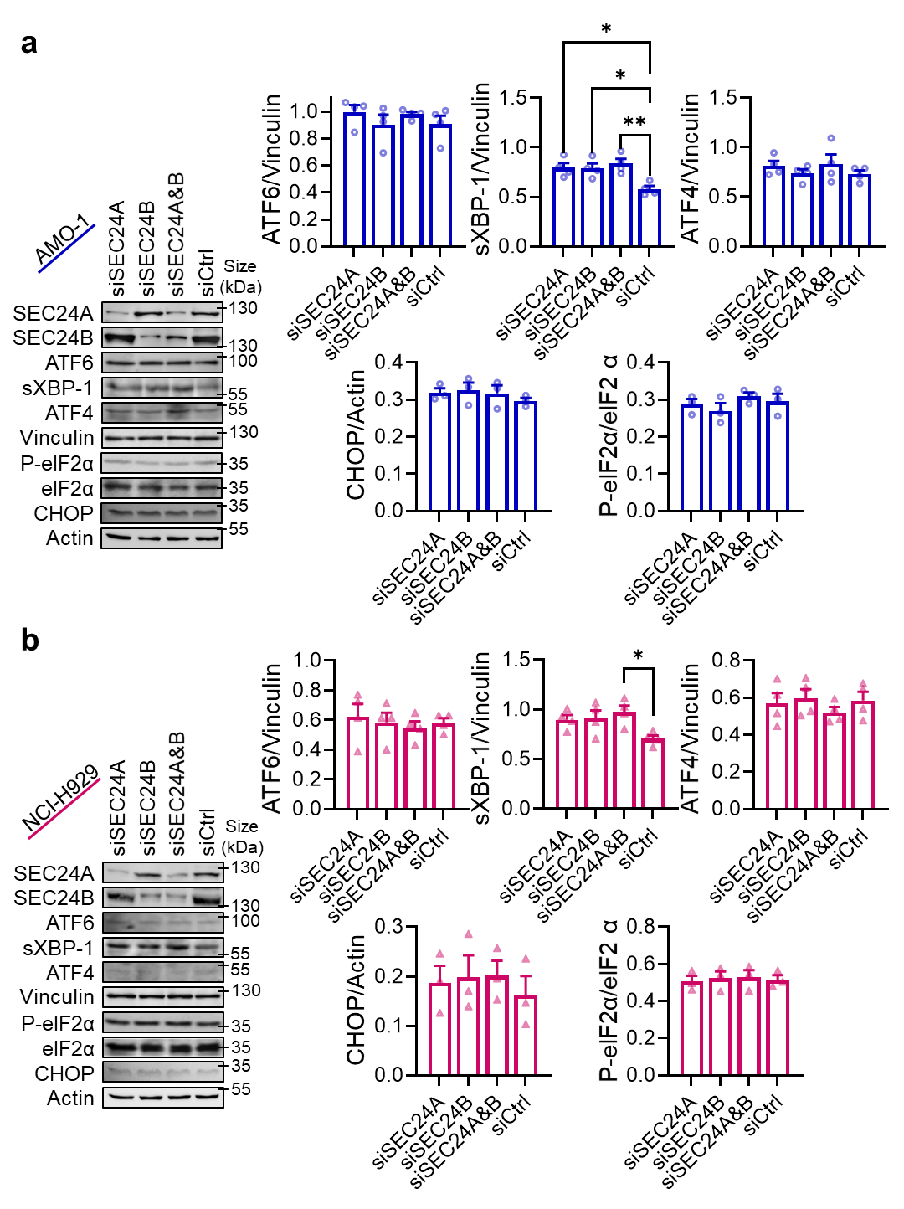
Figure S9. Immunoblot quantifications of ATF6, sXBP-1, ATF4, phosphor-eIF2α, and CHOP in a AMO-1 and b NCI-H929 cells after 48 hours of knockdown of the indicated SEC24 paralogs and their combinations. Protein band intensity was evaluated using ImageJ software and normalized to vinculin or actin. Significance was tested using the Tukey multiple comparison test (one-way ANOVA, **P < .01; *P < .05). Data are presented as mean values ± SEM.

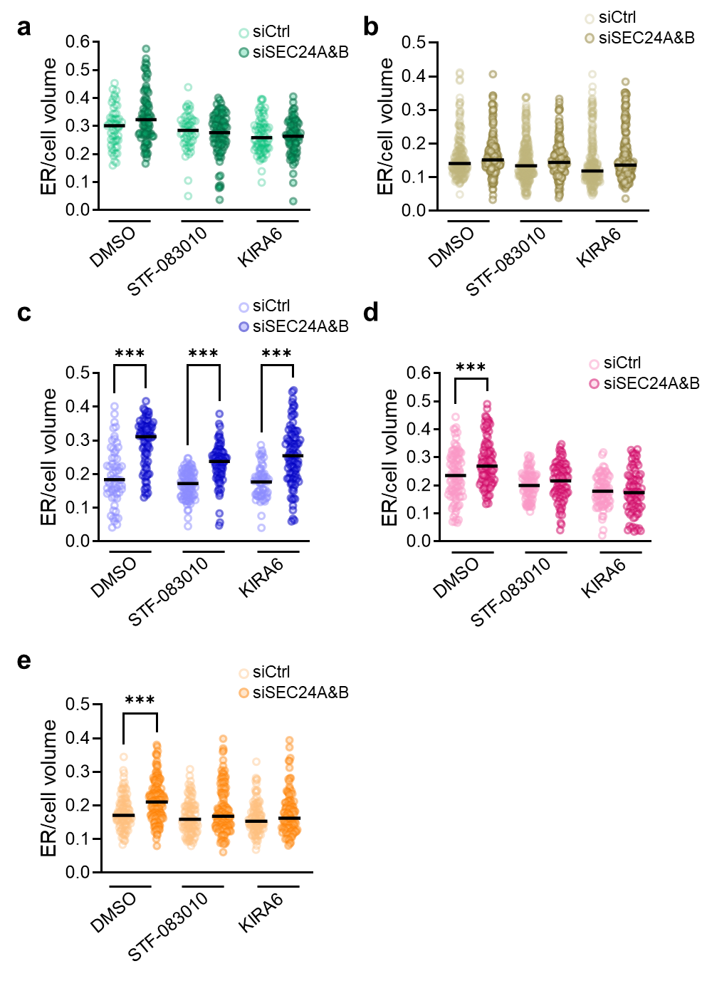
Figure S10. The increase in ER volume was dependent on IRE1 activity in the secretory MM cell lines. a KMS-12PE, b OH-2, c AMO-1, d NCI-H929, and e FOLE cell lines were treated with control or SEC24A&B siRNAs for 48 hours in the presence of DMSO (Ctrl), 10 µM STF-083010, or 2 nM KIRA-6 for 16 hours. Cells were stained with calnexin for the ER, and confocal images of 3D reconstructions of the ER were acquired. Image stacks with 0.1 μm steps along the z-axis were used to analyze ER morphology using ImageJ 3D-suite. ER volume was normalized to the corresponding cell volume. Quantification was performed from three independent experiments. Horizontal solid black lines represent medians. Dots represent individual cells (n > 60 for each condition). Statistical analysis was performed using one-way ANOVA with Tukey’s correction for multiple comparisons, ***P < .001. Statistical significance is illustrated only when comparing with the corresponding control condition.

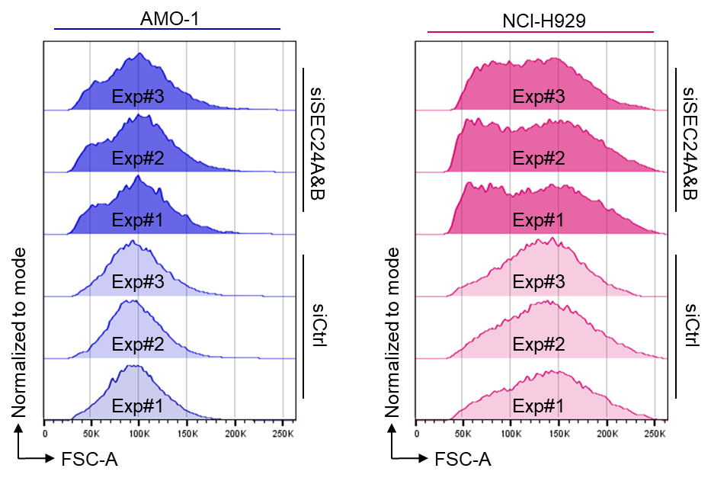

Figure S11. AMO-1 or NCI-H929 cells were transfected with either a non-targeting control siRNA (siCtrl) or siRNA targeting SEC24A&B for 48 hours. Cell size was measured by flow cytometry. Overlaid histograms represent three independent experiments (exp #1, 2, and 3).

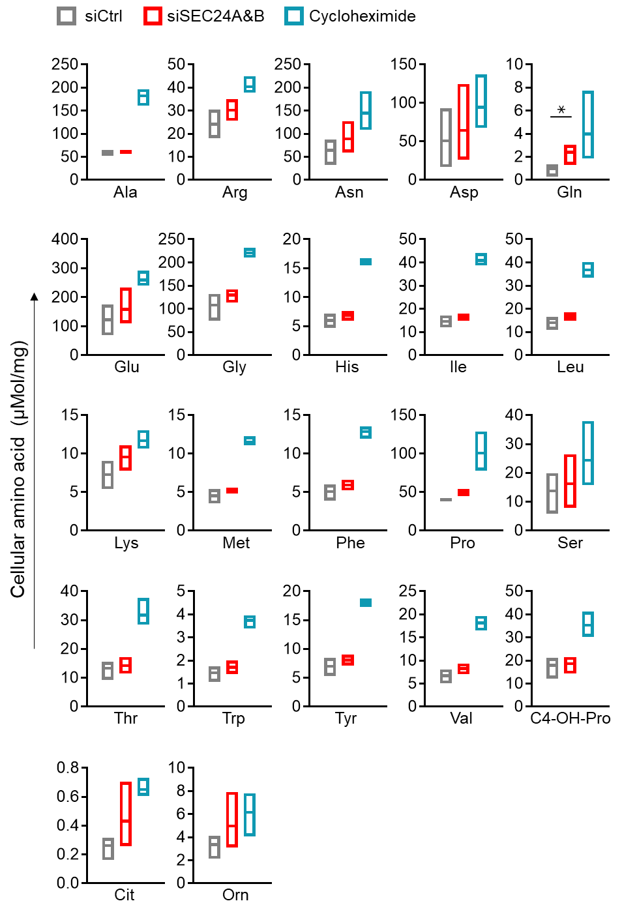

Figure S12.
Alteration of ER export resulted in an increase in almost all amino acids. AMO-1 cells were transfected with siRNA targeting a non-specific sequence (Ctrl) or siRNA targeting SEC24A&B for 48 hours, or treated with 25 μg/ml cycloheximide for 6 hours. Cells were then homogenized by three freeze-thaw cycles and passed through a 25G syringe at least 30 times, followed by centrifugation at 20,000 g for 20 minutes. Intracellular amino acid levels were measured in the supernatants. The data were normalized to protein concentration using the Bradford method. Floating bars represent the minimum to maximum, with a line at the median (n = 3 independent experiments). Statistical significance was measured using one-way ANOVA followed by Dunnett’s test, *P < .05. Statistical significance is illustrated only when comparing the siSEC24A&B-treated condition with the control condition.

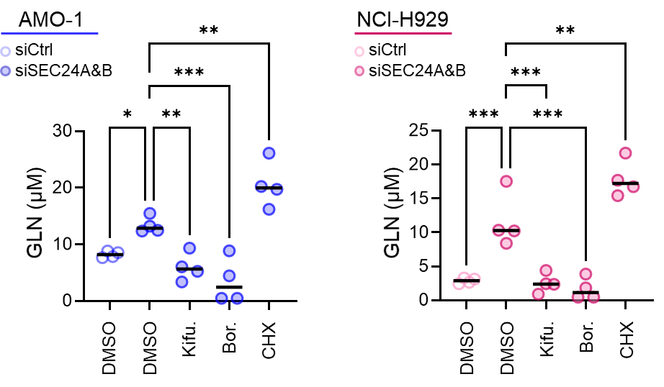

Figure S13. AMO-1 and NCI-H929 cells were transfected with siRNAs targeting the SEC24A and SEC24B paralogs. Cells were treated with kifunensine (2 µM) for 16 h, bortezomib (500 pM) for 4 h, or cycloheximide (200 nM) for 4 h. Glutamine levels were measured from 20,000 cells using the Glutamine/Glutamate-Glo assay at the end of 48 hours of knockdown. Each circle represents an independent experiment, and horizontal lines indicate median values. Statistical significance was determined by one-way ANOVA with Tukey’s multiple-comparison test (*P < 0.05, **P < 0.01, ***P < 0.001).

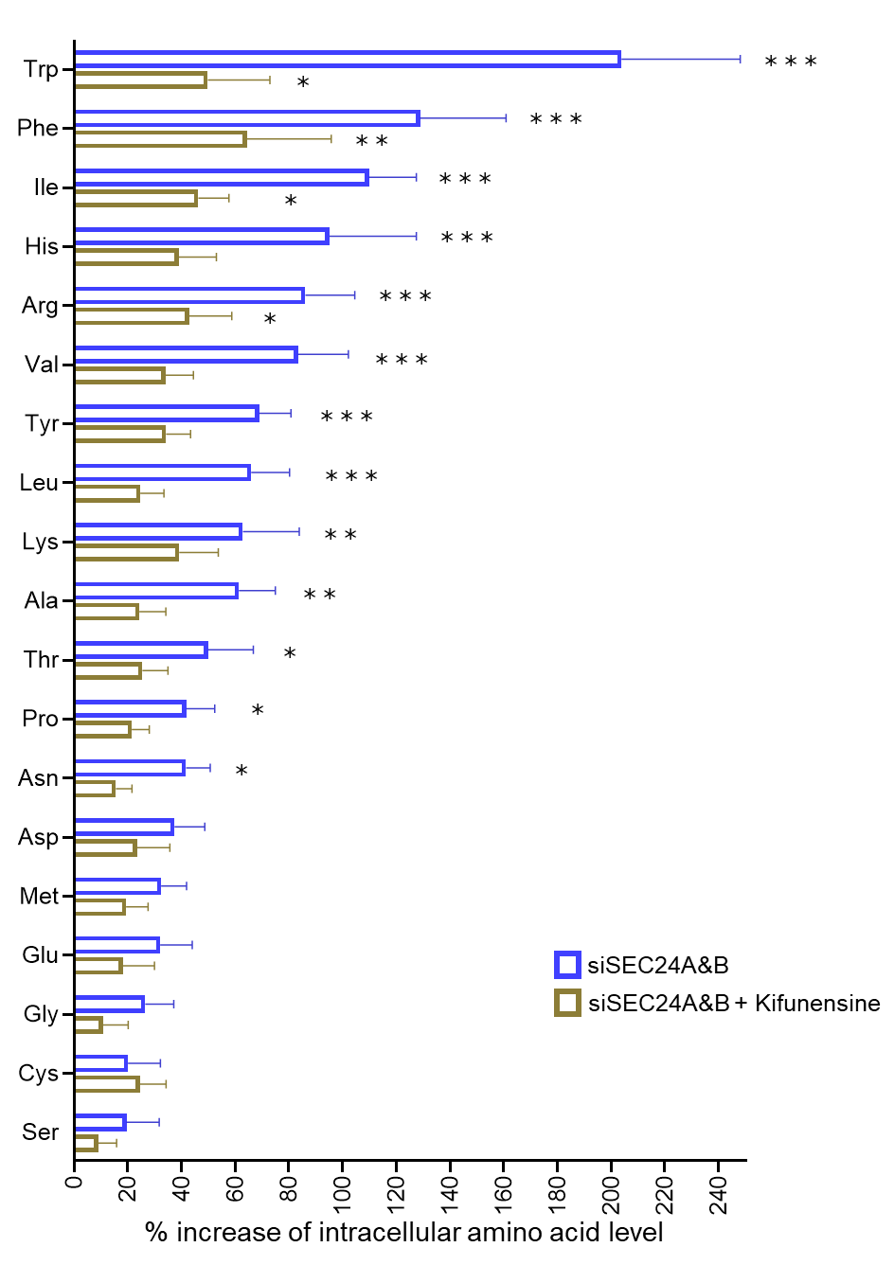

Figure S14. AMO-1 cells were transfected with siRNA targeting a non-specific sequence (Ctrl) or siRNA targeting SEC24A&B for 48 hours. SEC24A&B-depleted cells were treated with kifunensine (2 μM) during the last 16 hours of the 48-hour. Cells were then homogenized by three freeze-thaw cycles and passed through a 25G syringe at least 30 times, followed by centrifugation at 20,000 g for 20 minutes. Intracellular amino acid levels were measured in the supernatants. The data were normalized to protein concentration using the Bradford method. Bar graphs represent mean ± SEM from four independent experiments. Statistical significance was assessed using Tukey’s multiple-comparison test following two-way ANOVA (***P < 0.001; **P < 0.01; *P < 0.05). Statistical significance is shown only for comparisons between siSEC24A&B-treated conditions and the siCtrl condition.
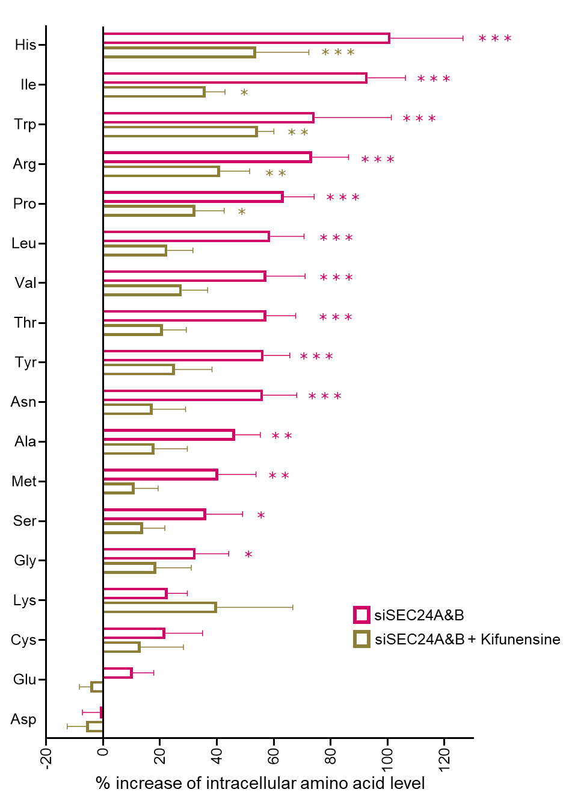
Figure S15. NCI-H929 cells were transfected with siRNA targeting a non-specific sequence (Ctrl) or siRNA targeting SEC24A&B for 48 hours. SEC24A&B-depleted cells were treated with kifunensine (2 μM) during the last 16 hours of the 48-hour. Cells were then homogenized by three freeze-thaw cycles and passed through a 25G syringe at least 30 times, followed by centrifugation at 20,000 g for 20 minutes. Intracellular amino acid levels were measured in the supernatants. The data were normalized to protein concentration using the Bradford method. Bar graphs represent mean ± SEM from four independent experiments. Statistical significance was assessed using Tukey’s multiple-comparison test following two-way ANOVA (***P < 0.001; **P < 0.01; *P < 0.05). Statistical significance is shown only for comparisons between siSEC24A&B-treated conditions and the siCtrl condition.

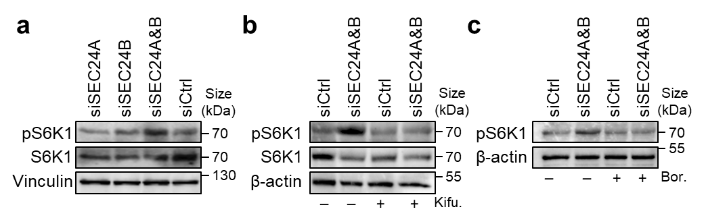

Figure S16. Silencing SEC24A&B resulted in high mTORC1 activity. a NCI-H929 cells were transfected with the indicated SEC24 siRNAs or control siRNA and subjected to western blot analyses of phosphorylated and total S6K1 after 48 hours of knockdown. b NCI-H929 cells transfected with siCtrl or siSEC24A&B were treated with 2 μM of kifunensine for 16 hours, c or with 200 nM of bortezomib for 4 hours, and then subjected to immunoblots of phosphorylated and total S6K1 at the end of the 48-hour knockdown period. Data are representative of three or more independent experiments.

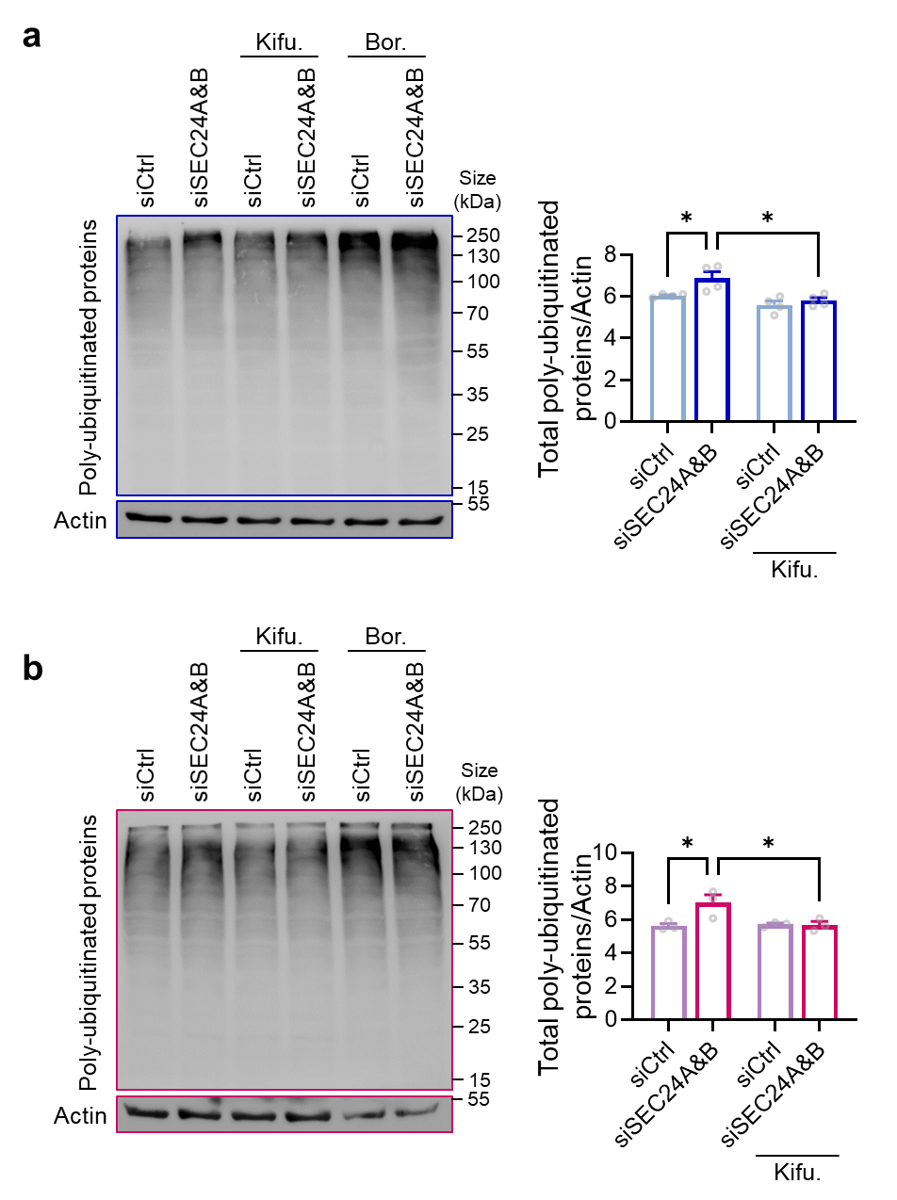

Figure S17. Western blot analysis of total ubiquitin-bound protein levels. Western blot performed on a AMO-1 and b NCI-H929 cell lines transfected with siCtrl or siSEC24A&B. Cells were treated with 1 μM of kifunensine for the last 16 hours, or with 200 nM of bortezomib for the last 4 hours, and then subjected to immunoblots of total ubiquitin-bound protein at the end of the 48-hour knockdown period. Total ubiquitin-bound protein levels was quantified by densitometry analysis, normalized on actin levels. Data represent three independent experiments. Statistical significance was determined by one-way ANOVA with Tukey’s multiple comparison test (*P < .05). Data are presented as mean values ± SEM.

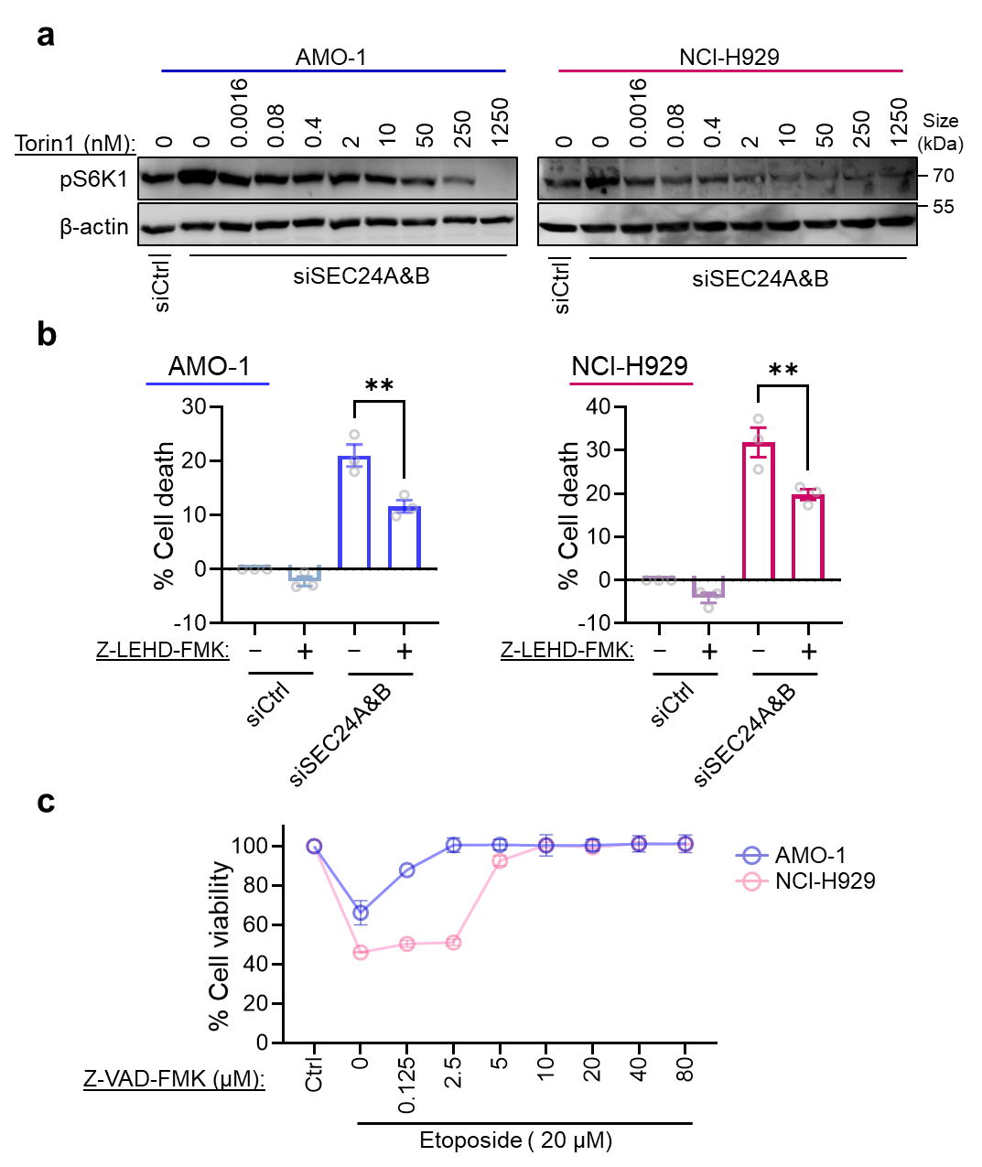

Figure S18. a Representative immunoblots showing the effects of increasing concentrations of Torin-1 in SEC24A&B co-depleted (siSEC24A&B) AMO-1 and NCI-H929 cells compared with control cells (siCtrl). b AMO-1 and NCI-H929 cells were treated with Z-LEHD-FMK (2 µM) or DMSO during the final 16 h of a 48-h SEC24A&B or control siRNA transfection. Cell viability was assessed by CellTiter-Glo. Data are presented as mean ± SEM from three independent experiments. Statistical significance was determined by one-way ANOVA with Tukey’s multiple-comparison test (**P < 0.01). c Dose–response curves of AMO-1 and NCI-H929 cells treated with increasing concentrations of Z-VAD-FMK. Cells were exposed to etoposide (20 µM) for 16 h in the presence of the indicated concentrations of Z-VAD-FMK, and cell viability was measured by CellTiter-Glo (n = 3 independent experiments).

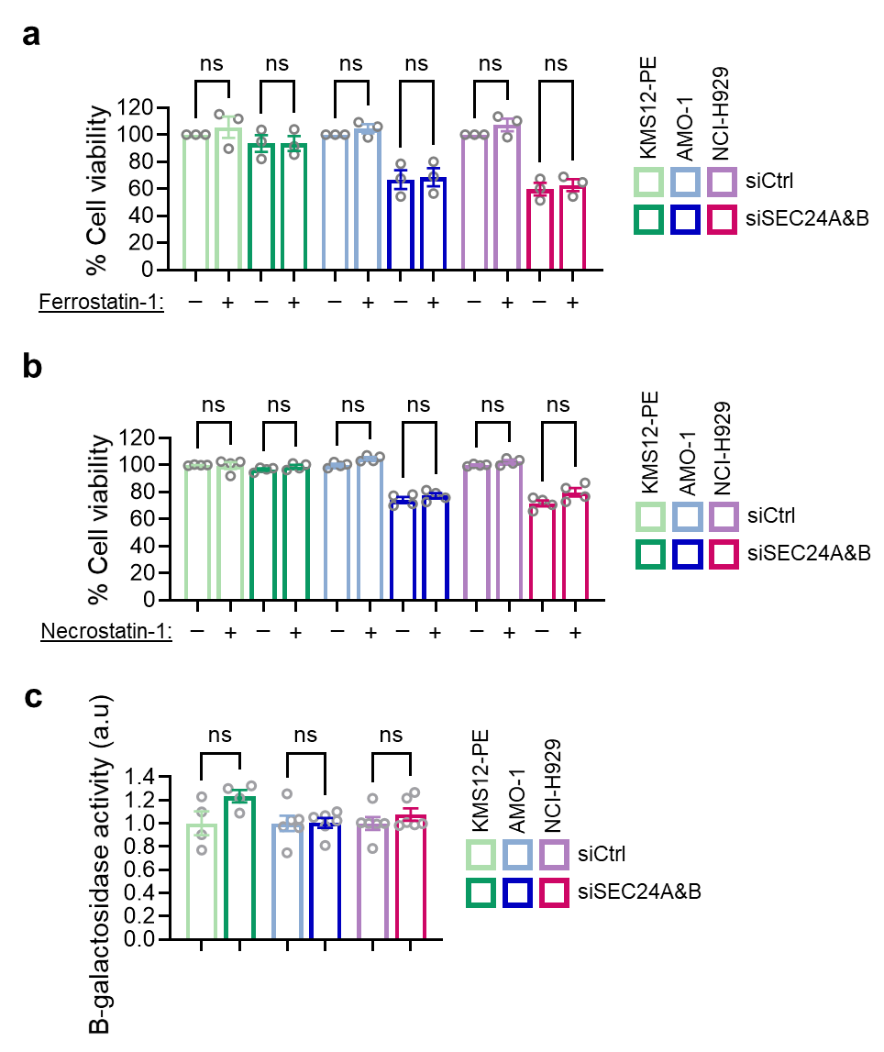

Figure S19. Ferroptosis, necroptosis and senescence failed to show appreciable activities in SEC24A&B-depleted MM cell lines. KMS-12PE (green), AMO-1 (blue), and NCI-H929 (pink) MM cell lines were transfected with non-targeting siRNAs (Ctrl) or SEC24A&B siRNAs, and further treated with the anti-ferroptosis compound ferrostatin-1 (1 μM) or b anti-necroptosis compound necrostatin-1 (30 μM) for 24 hours. At the end of the total 48 hours of siRNA-mediated silencing, cell viability was measured using the CellTiterGlo assay. c Senescence-associated β-galactosidase activity was evaluated using the Beta-Glo Assay System following siRNA-mediated silencing of SEC24A&B in MM cell lines for 48 hours. Each gray circle represents an independent experiment, and the data are shown as mean ± SEM; Student’s t-test, ns = nonsignificant.

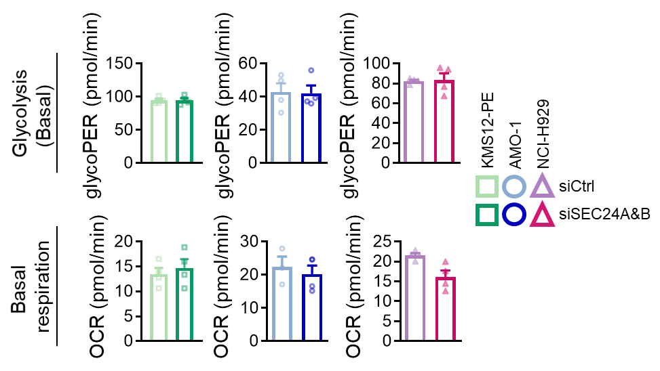

Figure S20. No striking differences in basal glycolysis and basal respiration were observed under knockdown conditions compared to controls. After 48 hours of control or SEC24A&B siRNA-mediated transfection, the glycolytic proton efflux rate (glycoPER), an indicator of glycolysis, and the oxygen consumption rate (OCR), an indicator of OXPHOS, were measured on a Seahorse XF96 Analyzer under basal conditions. Compared with controls, no significant differences were detected by Student’s t-test.

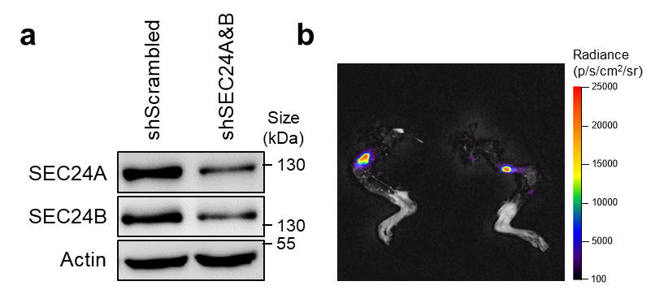

Figure S21. NCI-H929 cells expressing scrambled shRNA or SEC24A&B shRNA were incubated with 1 µg/mL doxycycline for 96 hours. a Immunoblots validating knockdown of SEC24A and SEC24B paralogs. b At the end of the experiment, mice were sacrificed and hind limbs were dissected. Representative bioluminescence images of hind limbs from a mouse bearing scrambled shRNA show femoral localization of myeloma cells.

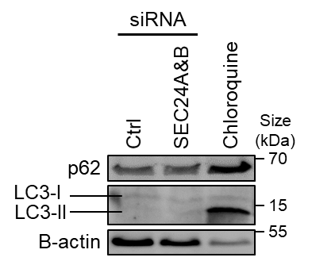

Figure S22. Blocking ER export did not affect autophagic activity. Protein expression of p62 and LC3 in AMO-1 cells, following the silencing of SEC24A&B, was monitored by immunoblotting. Cells were treated with the lysosomal inhibitor chloroquine (50 μM) for 16 hours as a positive control. Increased levels of p62 and LC3-II indicate either enhanced autophagic flux or a fusion defect between autophagosomes and lysosomes.

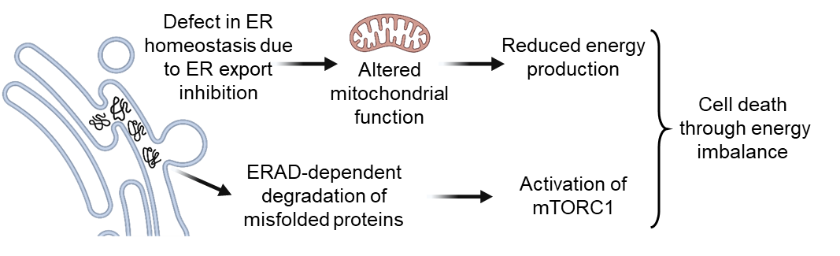

Figure S23. Schematic demonstration of the major findings. Icons were drawn using BioRender.

Table S1. Secretory status of MM cell lines.

Cell line | Secretion type
KMS-12PE | Non-secretory
VOLIN | IgG
OH-2 | IgG
LP-1 | IgG
KJON | FLC
URVIN | IgG
FOLE | IgA/FLC
AMO-1 | IgA
NCI-H929 | IgA

Table S2. MM patient samples used in the study.

Sample number | Age/  Sex | M protein isotype | Best response | BM at biopsy | MM activity | Line of therapy
1 | 56/M | FLC λ | CR | 2% clonal PCs | PD (EMM, Bone) | 3
2 | 68/F | FLC κ | MRDneg. sCR | MRD neg. CR | CR | 1
3 | 71/M | IgA κ | CR | 5.6% clonal PCs | PD | 7
4 | 56/F | IgG κ | sCR | 0,0037% clonal PCs | MRDpos. sCR | 1
5 | 57/F | IgG κ | sCR | 42% clonal PCs | treatment naive at biopsy! | 0
6 | 50/M | FLC λ | sCR | 30% clonal PCs | treatment naive at biopsy! | 0
7 | 65/M | FLC κ | MRDneg. sCR | 10,5% clonal PCs | treatment naive at biopsy! | 0
8 | 48/F | IgA κ | MRDneg. sCR | 14% clonal PCs | treatment naive at biopsy! | 0
9 | 68/F | FLC λ | MRDpos sCR | 17,5% clonal PCs | PD | 1
10 | 82/M | FLC κ | VGPR | 33% clonal PCs | treatment naive at biopsy! | 0
11 | 60/M | FLC κ | MRDpos sCR | 6,5% clonal PCs | PD | 0
12 | 55/F | FLC λ | MRDneg. sCR | MRDneg. sCR | MRDneg. sCR | 1
13 | 63/F | IgA λ | MRDneg. sCR | MRDneg. sCR | MRDneg. sCR | 1
14 | 74/F | IgG λ | VGPR | 31% clonal PCs | treatment naive at biopsy! | 0
15 | 82/M | FLC λ | VGPR | 53% clonal PCs | treatment naive at biopsy! | 0
16 | 72/M | IgG κ | MRDneg. sCR | MRDneg. sCR | MRDneg. sCR | 1
17 | 71/F | IgG κ | NA | no clonal PCs | NA | 0

Sample number 17: Monoclonal gammopathy of undetermined significance.
F, female; M, male; MRD, minimal residual disease; CR, complete response; sCR, stringent complete response; VGPR, very good partial response; EMM, extramedullary myeloma; PC, plasma cell; PD, progressive disease; NA, not applicable.

Uncropped Images of Western Blots

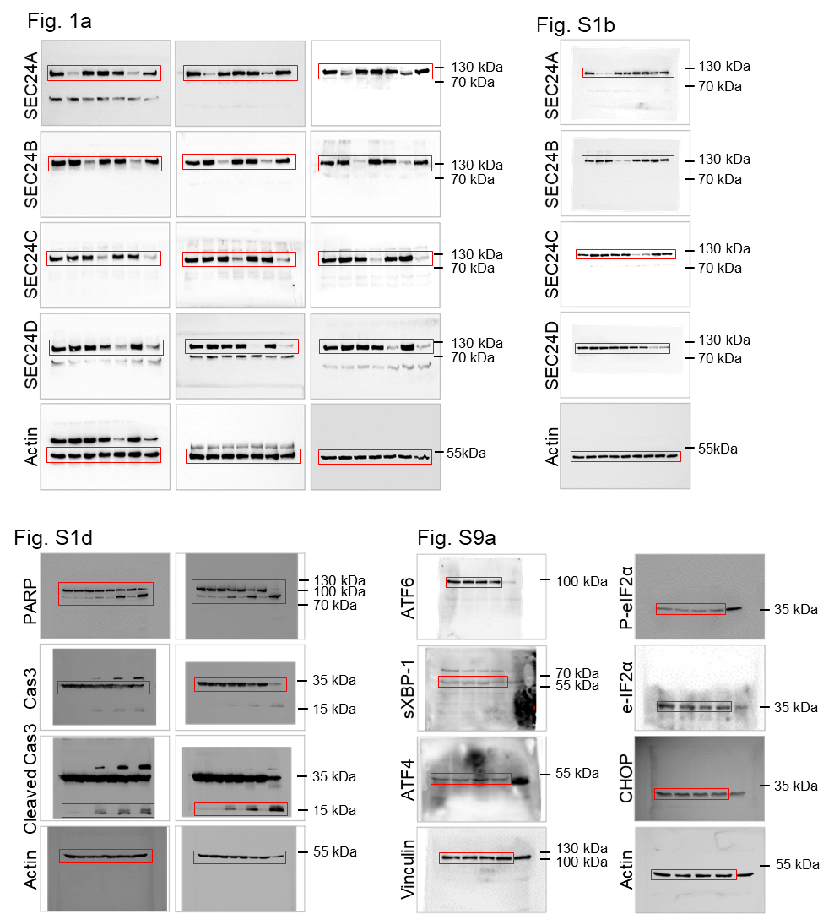

Uncropped Images of Western Blots

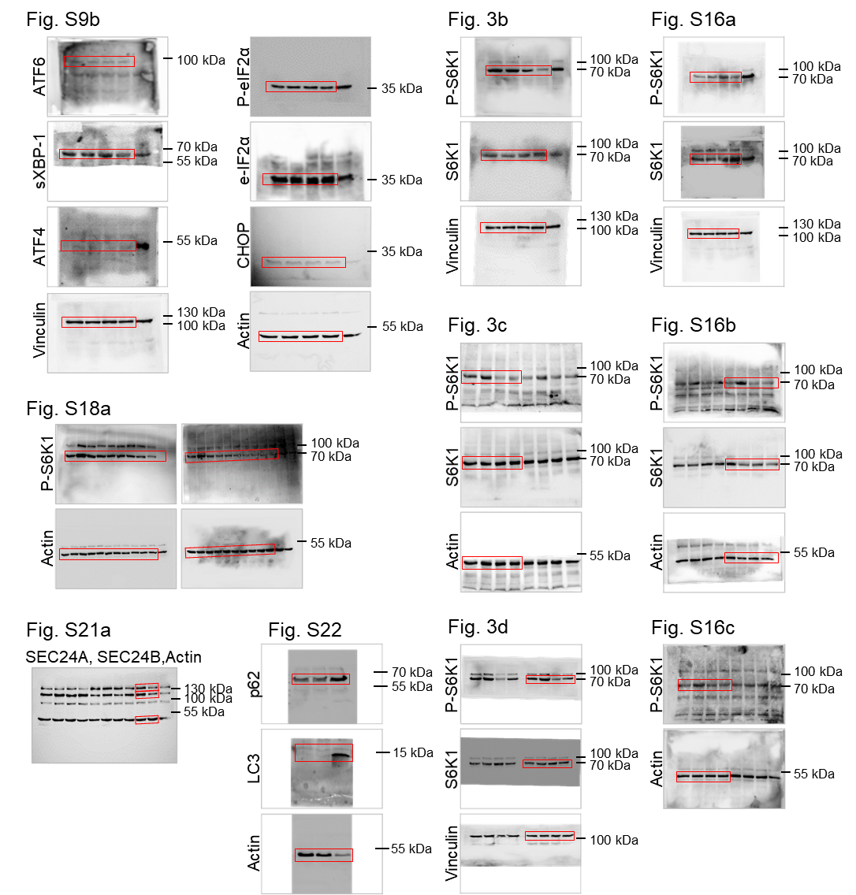
KEY RESOURCES
REAGENT | SOURCE | IDENTIFIER
Rabbit SEC24A antibody | Invitrogen | #PA5-66043
Rabbit SEC24B antibody | Bethyl Laboratories | #A304-876A
Rabbit SEC24C antibody | Bethyl Laboratories | #A304-759A
Rabbit SEC24D antibody | Bethyl Laboratories | #A304-813A
Rabbit SEC16A antibody | Bethyl Laboratories | #A300-648A
Rabbit SEC16B antibody | Abnova | #PAB19201
Mouse SEC31A antibody | BD biosciences | #612351
Rabbit Calnexin antibody | Abcam | #ab22595
Rabbit SEC24C antibody | Cell signaling | #14676
Rabbit SEC24B antibody | Cell signaling | #12042
Rat ATF6 antibody | Biolegend | #853102
Mouse sXBP-1 antibody | Biolegend | #647502
Rabbit ATF4 antibody | Cell signaling | #11815
Mouse Vinculin antibody | Sigma-Aldrich | #SAB4200729
Mouse Beta Actin antibody | Santa Cruz Biotechnology | #sc-47778
Rabbit p70 S6 kinase antibody | Cell signaling | #9202
Rabbit phospho-p70 S6 kinase antibody | Cell signaling | #9205
Mouse Puromycin antibody | Biolegend | # 381508
Mouse SQSTM1/p62 antibody | Abnova | #K7241-2C11
Rabbit LC3 antibody | MBL | #PM036
Mouse CD138 antibody | Biolegend | #356531
Mouse CD19 antibody | Biolegend | #302207
Mouse CD56 antibody | Biolegend | #318303
Goat anti-Human IgG/IgA/IgM Secondary Antibody, TRITC | Invitrogen | #A18852
Goat anti-Human IgG/IgA/IgM Secondary Antibody, FITC | Invitrogen | #A18848
Mouse CHOP antibody | Cell signaling | # 2895S
Rabbit phospho-eIF2α (Ser51) antibody | Cell signaling | # 3597S
Mouse eIF2α antibody | Cell signaling | #2103
Rabbit Ubiquitin antibody | Cell signaling | #43124
Caspase 3 | Cell signaling | #9662
PARP | Cell signaling | #9542
Goat anti-Mouse IgG (H+L) Secondary Antibody, Alexa Fluor 488 | Invitrogen | #A-11001
Goat anti-Mouse IgG (H+L) Secondary Antibody, Alexa Fluor 568 | Invitrogen | #A-11031
Goat anti-Mouse IgG (H+L) Secondary Antibody, Alexa Fluor 647 | Invitrogen | #A-21235
Goat anti-Rabbit IgG (H+L) Secondary Antibody, Alexa Fluor 488 | Invitrogen | #A-11008
Goat anti-Rabbit IgG (H+L) Secondary Antibody, Alexa Fluor 568 | Invitrogen | #A-11011
Goat anti-Rabbit IgG (H+L) Secondary Antibody, Alexa Fluor 647 | Invitrogen | #A-21244
CD138 MicroBeads | Miltenyi Biotec | #130-051-301
CellTiter-Glo 2.0 Cell Viability Assay kit | Promega | #G9242
Glutamine/Glutamate-Glo Assay | Promega | #J8021
Annexin V Apoptosis Detection Kit with 7-AAD | Biolegend | #640930
SimpleStep GFP ELISA kit | Abcam | #ab171581
Goat Anti-Human IgG+IgM+IgA H&L ELISA kit | Abcam | #ab102416
Beta-Glo Assay kit | Promega | #E4720
Cytofix/Cytoperm Fixation/Permeabilization Kit | BD biosciences | # 554714
Seahorse XF Glycolytic Rate Assay Kit | Agilent | #103346-100
Seahorse XF Cell Mito Stress Test Kit | Agilent | #103010-100
Seahorse XF Media, Supplements & Calibrant | Agilent | #103010-100
Seahorse FluxPaks | Agilent | #103022-100
May-Grunwald's eosin methylene blue | Merck Millipore | #101352
Giemsa's azur-eosin-methylene blue | Merck Millipore | #109203
JC-1 | Enzo | #ENZ-52304
Bradford Protein Assay Dye | Bio-Rad | #5000006
TPE-MI | MedChemExpress | #HY-143218
HiPerFect Transfection Reagent | Qiagen | #301707
PEI Transfection Reagent | MedChemExpress | #HY-K2014
Polybrene | MedChemExpress | #HY-112735
Cycloheximide | Sigma-Aldrich | #239765
Puromycin | InvivoGen | #ant-pr-1
Bortezomib | Selleckchem | #S1013
Lenalidomide | MedChemExpress | #HY-A0003
Torin 1 | MedChemExpress | #HY-13003
Kifunensine | MedChemExpress | #HY-19332
STF-083010 | MedChemExpress | #HY-15845
KIRA-6 | MedChemExpress | #HY-19708
Z-VAD-FMK | Selleckchem | #S7023
Z-LEHD-FMK | MedChemExpress | #HY-P1010
Brefeldin A | Sigma-Aldrich | #B6542
MG132 | Selleckchem | #S2619
Carfilzomib | Cayman Chemical | #17554
Etoposide | Sigma-Aldrich | #E1383
Necrostatin-1 | MedChemExpress | # HY-15760
Ferrostatin-1 | MedChemExpress | #HY-100579
Chloroquine | MedChemExpress | #HY-17589A
Protease and Phosphatase Inhibitor | Thermo Scientific | #A32961
Matrigel | Corning | #356230
Fetal Bovine Serum | Gibco | #A5256701
Penicillin-Streptomycin | Gibco | #15070063
L-Glutamine | Gibco | #25030149
RPMI 1640 Medium | Gibco | #21870076
L-15 Medium | Sigma-Aldrich | #L1518
pCMV-VSV-G | Addgene | #8454
psPAX2 | Addgene | #12260
pHR GFP-CaaX | Addgene | #113020
Triton X-100 | Sigma-Aldrich | #X100
Paraformaldehyde | Sigma-Aldrich | #158127
Polyvinyl alcohol mounting medium with DABCO | Sigma-Aldrich | #10981
PAGE gel solution | Carl Roth | #3029.1
TEMED | Sigma-Aldrich | #T9281
Ammonium persulfate | Sigma-Aldrich | #A3678
Dimethyl sulfoxide | Sigma-Aldrich | #34869
Sodium dodecyl sulfate | Carl Roth | #CN30.2
Sodium deoxycholate monohydrate | Thermo Scientific | #B20759
Sodium chloride | Carl Roth | #P029.3
TRIS | Carl Roth | #4855.3
Tween 20 | Thermo Scientific | #A85115
White Leghorn chicken eggs | Schropper | #BeLSL
Doxycycline hyclate | MedChemExpress | #HY-N0565B
CycLuc1 | MedChemExpress | #HY-111653

siRNAs
Target | Sense strand (5' - 3') | Anti-sense strand (5' - 3')
NegCtrl_#1 | CTTCAACGCCACCTACGTCGA | TCGACGTAGGTGGCGTTGAAG
NegCtrl_#2 | UGUUCUUAGGCCCAUUUCAGA | UCUGAAAUGGGCCUAAGAACA
NegCtrl_#3 | CTTCAACGCCACCTACGTCGA | TCGACGTAGGTGGCGTTGAAG
SEC24A_#1 | CUUUGAAUUGGCAAUAUAACU | AGUUAUAUUGCCAAUUCAAAG
SEC24A_#2 | CAGUUAAAGAUAAUUCAUUCU | AGAAUGAAUUAUCUUUAACUG
SEC24B_#1 | CAAACGUGUGGAUGCUUAUGA | UCAUAAGCAUCCACACGUUUG
SEC24B_#2 | GAGGAACCCUUUACAAAUACA | UGUAUUUGUAAAGGGUUCCUC
SEC24C_#1 | GGAAAUACAAGUUUAACCACA | UGUGGUUAAACUUGUAUUUCC
SEC24C_#2 | UGAUUCAUCCCAACUUAUACA | UGUAUAAGUUGGGAUGAAUCA
SEC24D_#1 | AGGUGCUCCACUUCUAUAAUG | CAUUAUAGAAGUGGAGCACCU
SEC24D_#2 | CAAAAGAGGCCAUAUUCAAUG | CAUUGAAUAUGGCCUCUUUUG

EXTENDED STATISTICS
Results of statistical analyses for Figure 1b
2way ANOVA Comparisons | Summary | P Value
siCtrl_ AMO1 vs. siCtrl_ KMS-12PE | ns | 0.815
siCtrl_ AMO1 vs. siCtrl_ NCI-H929 | ns | 0.992
siCtrl_ AMO1 vs. siSEC24A_ AMO1 | *** | <.001
siCtrl_ AMO1 vs. siSEC24A_ KMS-12PE | ns | 0.606
siCtrl_ AMO1 vs. siSEC24A_ NCI-H929 | *** | <.001
siCtrl_ AMO1 vs. siSEC24B_ AMO1 | ** | 0.002
siCtrl_ AMO1 vs. siSEC24B_ KMS-12PE | ns | 0.947
siCtrl_ AMO1 vs. siSEC24B_ NCI-H929 | *** | <.001
siCtrl_ AMO1 vs. siSEC24C_ AMO1 | ** | 0.006
siCtrl_ AMO1 vs. siSEC24C_ KMS-12PE | ns | 0.645
siCtrl_ AMO1 vs. siSEC24C_ NCI-H929 | *** | <.001
siCtrl_ AMO1 vs. siSEC24D_ AMO1 | * | 0.017
siCtrl_ AMO1 vs. siSEC24D_ KMS-12PE | ns | 0.938
siCtrl_ AMO1 vs. siSEC24D_ NCI-H929 | *** | <.001
siCtrl_ AMO1 vs. siSEC24A&B_ AMO1 | *** | <.001
siCtrl_ AMO1 vs. siSEC24A&B_ KMS-12PE | ns | 0.051
siCtrl_ AMO1 vs. siSEC24A&B_ NCI-H929 | *** | <.001
siCtrl_ AMO1 vs. siSEC24A&C_ AMO1 | *** | <.001
siCtrl_ AMO1 vs. siSEC24A&C_ KMS-12PE | * | 0.041
siCtrl_ AMO1 vs. siSEC24A&C_ NCI-H929 | *** | <.001
siCtrl_ AMO1 vs. siSEC24A&D_ AMO1 | *** | <.001
siCtrl_ AMO1 vs. siSEC24A&D_ KMS-12PE | * | 0.031
siCtrl_ AMO1 vs. siSEC24A&D_ NCI-H929 | *** | <.001
siCtrl_ AMO1 vs. siSEC24B&C_ AMO1 | *** | <.001
siCtrl_ AMO1 vs. siSEC24B&C_ KMS-12PE | * | 0.035
siCtrl_ AMO1 vs. siSEC24B&C_ NCI-H929 | *** | <.001
siCtrl_ AMO1 vs. siSEC24B&D_ AMO1 | *** | <.001
siCtrl_ AMO1 vs. siSEC24B&D_ KMS-12PE | ns | 0.583
siCtrl_ AMO1 vs. siSEC24B&D_ NCI-H929 | *** | <.001
siCtrl_ AMO1 vs. siSEC24C&D_ AMO1 | *** | <.001
siCtrl_ AMO1 vs. siSEC24C&D_ KMS-12PE | ** | 0.001
siCtrl_ AMO1 vs. siSEC24C&D_ NCI-H929 | *** | <.001
siCtrl_ KMS-12PE vs. siCtrl_ NCI-H929 | ns | 0.814
siCtrl_ KMS-12PE vs. siSEC24A_ AMO1 | *** | <.001
siCtrl_ KMS-12PE vs. siSEC24A_ KMS-12PE | ns | 0.516
siCtrl_ KMS-12PE vs. siSEC24A_ NCI-H929 | *** | <.001
siCtrl_ KMS-12PE vs. siSEC24B_ AMO1 | ** | 0.005
siCtrl_ KMS-12PE vs. siSEC24B_ KMS-12PE | ns | 0.885
siCtrl_ KMS-12PE vs. siSEC24B_ NCI-H929 | *** | <.001
siCtrl_ KMS-12PE vs. siSEC24C_ AMO1 | * | 0.013
siCtrl_ KMS-12PE vs. siSEC24C_ KMS-12PE | ns | 0.547
siCtrl_ KMS-12PE vs. siSEC24C_ NCI-H929 | *** | <.001
siCtrl_ KMS-12PE vs. siSEC24D_ AMO1 | * | 0.029
siCtrl_ KMS-12PE vs. siSEC24D_ KMS-12PE | ns | 0.787
siCtrl_ KMS-12PE vs. siSEC24D_ NCI-H929 | *** | <.001
siCtrl_ KMS-12PE vs. siSEC24A&B_ AMO1 | *** | <.001
siCtrl_ KMS-12PE vs. siSEC24A&B_ KMS-12PE | ns | 0.058
siCtrl_ KMS-12PE vs. siSEC24A&B_ NCI-H929 | *** | <.001
siCtrl_ KMS-12PE vs. siSEC24A&C_ AMO1 | *** | <.001
siCtrl_ KMS-12PE vs. siSEC24A&C_ KMS-12PE | * | 0.049
siCtrl_ KMS-12PE vs. siSEC24A&C_ NCI-H929 | *** | <.001
siCtrl_ KMS-12PE vs. siSEC24A&D_ AMO1 | *** | <.001
siCtrl_ KMS-12PE vs. siSEC24A&D_ KMS-12PE | * | 0.039
siCtrl_ KMS-12PE vs. siSEC24A&D_ NCI-H929 | *** | <.001
siCtrl_ KMS-12PE vs. siSEC24B&C_ AMO1 | *** | <.001
siCtrl_ KMS-12PE vs. siSEC24B&C_ KMS-12PE | * | 0.042
siCtrl_ KMS-12PE vs. siSEC24B&C_ NCI-H929 | *** | <.001
siCtrl_ KMS-12PE vs. siSEC24B&D_ AMO1 | *** | <.001
siCtrl_ KMS-12PE vs. siSEC24B&D_ KMS-12PE | ns | 0.498
siCtrl_ KMS-12PE vs. siSEC24B&D_ NCI-H929 | *** | <.001
siCtrl_ KMS-12PE vs. siSEC24C&D_ AMO1 | ** | 0.002
siCtrl_ KMS-12PE vs. siSEC24C&D_ KMS-12PE | ** | 0.002
siCtrl_ KMS-12PE vs. siSEC24C&D_ NCI-H929 | *** | <.001
siCtrl_ NCI-H929 vs. siSEC24A_ AMO1 | *** | <.001
siCtrl_ NCI-H929 vs. siSEC24A_ KMS-12PE | ns | 0.624
siCtrl_ NCI-H929 vs. siSEC24A_ NCI-H929 | *** | <.001
siCtrl_ NCI-H929 vs. siSEC24B_ AMO1 | ** | 0.003
siCtrl_ NCI-H929 vs. siSEC24B_ KMS-12PE | ns | 0.942
siCtrl_ NCI-H929 vs. siSEC24B_ NCI-H929 | *** | <.001
siCtrl_ NCI-H929 vs. siSEC24C_ AMO1 | ** | 0.009
siCtrl_ NCI-H929 vs. siSEC24C_ KMS-12PE | ns | 0.661
siCtrl_ NCI-H929 vs. siSEC24C_ NCI-H929 | *** | <.001
siCtrl_ NCI-H929 vs. siSEC24D_ AMO1 | * | 0.024
siCtrl_ NCI-H929 vs. siSEC24D_ KMS-12PE | ns | 0.946
siCtrl_ NCI-H929 vs. siSEC24D_ NCI-H929 | *** | <.001
siCtrl_ NCI-H929 vs. siSEC24A&B_ AMO1 | *** | <.001
siCtrl_ NCI-H929 vs. siSEC24A&B_ KMS-12PE | ns | 0.059
siCtrl_ NCI-H929 vs. siSEC24A&B_ NCI-H929 | *** | <.001
siCtrl_ NCI-H929 vs. siSEC24A&C_ AMO1 | *** | <.001
siCtrl_ NCI-H929 vs. siSEC24A&C_ KMS-12PE | * | 0.049
siCtrl_ NCI-H929 vs. siSEC24A&C_ NCI-H929 | *** | <.001
siCtrl_ NCI-H929 vs. siSEC24A&D_ AMO1 | *** | <.001
siCtrl_ NCI-H929 vs. siSEC24A&D_ KMS-12PE | * | 0.038
siCtrl_ NCI-H929 vs. siSEC24A&D_ NCI-H929 | *** | <.001
siCtrl_ NCI-H929 vs. siSEC24B&C_ AMO1 | *** | <.001
siCtrl_ NCI-H929 vs. siSEC24B&C_ KMS-12PE | * | 0.041
siCtrl_ NCI-H929 vs. siSEC24B&C_ NCI-H929 | *** | <.001
siCtrl_ NCI-H929 vs. siSEC24B&D_ AMO1 | *** | <.001
siCtrl_ NCI-H929 vs. siSEC24B&D_ KMS-12PE | ns | 0.601
siCtrl_ NCI-H929 vs. siSEC24B&D_ NCI-H929 | *** | <.001
siCtrl_ NCI-H929 vs. siSEC24C&D_ AMO1 | *** | <.001
siCtrl_ NCI-H929 vs. siSEC24C&D_ KMS-12PE | ** | 0.002
siCtrl_ NCI-H929 vs. siSEC24C&D_ NCI-H929 | *** | <.001
siSEC24A_ AMO1 vs. siSEC24A_ KMS-12PE | *** | <.001
siSEC24A_ AMO1 vs. siSEC24A_ NCI-H929 | ns | 0.32
siSEC24A_ AMO1 vs. siSEC24B_ AMO1 | ** | 0.002
siSEC24A_ AMO1 vs. siSEC24B_ KMS-12PE | *** | <.001
siSEC24A_ AMO1 vs. siSEC24B_ NCI-H929 | ns | 0.797
siSEC24A_ AMO1 vs. siSEC24C_ AMO1 | *** | <.001
siSEC24A_ AMO1 vs. siSEC24C_ KMS-12PE | *** | <.001
siSEC24A_ AMO1 vs. siSEC24C_ NCI-H929 | ns | 0.741
siSEC24A_ AMO1 vs. siSEC24D_ AMO1 | *** | <.001
siSEC24A_ AMO1 vs. siSEC24D_ KMS-12PE | *** | <.001
siSEC24A_ AMO1 vs. siSEC24D_ NCI-H929 | ns | 0.393
siSEC24A_ AMO1 vs. siSEC24A&B_ AMO1 | *** | <.001
siSEC24A_ AMO1 vs. siSEC24A&B_ KMS-12PE | ** | 0.002
siSEC24A_ AMO1 vs. siSEC24A&B_ NCI-H929 | *** | <.001
siSEC24A_ AMO1 vs. siSEC24A&C_ AMO1 | ns | 0.506
siSEC24A_ AMO1 vs. siSEC24A&C_ KMS-12PE | ** | 0.002
siSEC24A_ AMO1 vs. siSEC24A&C_ NCI-H929 | ns | 0.278
siSEC24A_ AMO1 vs. siSEC24A&D_ AMO1 | ns | 0.51
siSEC24A_ AMO1 vs. siSEC24A&D_ KMS-12PE | ** | 0.003
siSEC24A_ AMO1 vs. siSEC24A&D_ NCI-H929 | * | 0.032
siSEC24A_ AMO1 vs. siSEC24B&C_ AMO1 | ns | 0.804
siSEC24A_ AMO1 vs. siSEC24B&C_ KMS-12PE | ** | 0.003
siSEC24A_ AMO1 vs. siSEC24B&C_ NCI-H929 | ns | 0.26
siSEC24A_ AMO1 vs. siSEC24B&D_ AMO1 | * | 0.025
siSEC24A_ AMO1 vs. siSEC24B&D_ KMS-12PE | *** | <.001
siSEC24A_ AMO1 vs. siSEC24B&D_ NCI-H929 | ** | 0.01
siSEC24A_ AMO1 vs. siSEC24C&D_ AMO1 | ** | 0.007
siSEC24A_ AMO1 vs. siSEC24C&D_ KMS-12PE | ns | 0.07
siSEC24A_ AMO1 vs. siSEC24C&D_ NCI-H929 | *** | <.001
siSEC24A_ KMS-12PE vs. siSEC24A_ NCI-H929 | *** | <.001
siSEC24A_ KMS-12PE vs. siSEC24B_ AMO1 | * | 0.038
siSEC24A_ KMS-12PE vs. siSEC24B_ KMS-12PE | ns | 0.614
siSEC24A_ KMS-12PE vs. siSEC24B_ NCI-H929 | *** | <.001
siSEC24A_ KMS-12PE vs. siSEC24C_ AMO1 | ns | 0.081
siSEC24A_ KMS-12PE vs. siSEC24C_ KMS-12PE | ns | 0.962
siSEC24A_ KMS-12PE vs. siSEC24C_ NCI-H929 | *** | <.001
siSEC24A_ KMS-12PE vs. siSEC24D_ AMO1 | ns | 0.148
siSEC24A_ KMS-12PE vs. siSEC24D_ KMS-12PE | ns | 0.705
siSEC24A_ KMS-12PE vs. siSEC24D_ NCI-H929 | *** | <.001
siSEC24A_ KMS-12PE vs. siSEC24A&B_ AMO1 | *** | <.001
siSEC24A_ KMS-12PE vs. siSEC24A&B_ KMS-12PE | ns | 0.209
siSEC24A_ KMS-12PE vs. siSEC24A&B_ NCI-H929 | *** | <.001
siSEC24A_ KMS-12PE vs. siSEC24A&C_ AMO1 | *** | <.001
siSEC24A_ KMS-12PE vs. siSEC24A&C_ KMS-12PE | ns | 0.183
siSEC24A_ KMS-12PE vs. siSEC24A&C_ NCI-H929 | *** | <.001
siSEC24A_ KMS-12PE vs. siSEC24A&D_ AMO1 | *** | <.001
siSEC24A_ KMS-12PE vs. siSEC24A&D_ KMS-12PE | ns | 0.153
siSEC24A_ KMS-12PE vs. siSEC24A&D_ NCI-H929 | *** | <.001
siSEC24A_ KMS-12PE vs. siSEC24B&C_ AMO1 | *** | <.001
siSEC24A_ KMS-12PE vs. siSEC24B&C_ KMS-12PE | ns | 0.163
siSEC24A_ KMS-12PE vs. siSEC24B&C_ NCI-H929 | *** | <.001
siSEC24A_ KMS-12PE vs. siSEC24B&D_ AMO1 | ** | 0.006
siSEC24A_ KMS-12PE vs. siSEC24B&D_ KMS-12PE | ns | 0.977
siSEC24A_ KMS-12PE vs. siSEC24B&D_ NCI-H929 | *** | <.001
siSEC24A_ KMS-12PE vs. siSEC24C&D_ AMO1 | * | 0.017
siSEC24A_ KMS-12PE vs. siSEC24C&D_ KMS-12PE | * | 0.016
siSEC24A_ KMS-12PE vs. siSEC24C&D_ NCI-H929 | *** | <.001
siSEC24A_ NCI-H929 vs. siSEC24B_ AMO1 | *** | <.001
siSEC24A_ NCI-H929 vs. siSEC24B_ KMS-12PE | *** | <.001
siSEC24A_ NCI-H929 vs. siSEC24B_ NCI-H929 | ns | 0.232
siSEC24A_ NCI-H929 vs. siSEC24C_ AMO1 | *** | <.001
siSEC24A_ NCI-H929 vs. siSEC24C_ KMS-12PE | *** | <.001
siSEC24A_ NCI-H929 vs. siSEC24C_ NCI-H929 | ns | 0.225
siSEC24A_ NCI-H929 vs. siSEC24D_ AMO1 | *** | <.001
siSEC24A_ NCI-H929 vs. siSEC24D_ KMS-12PE | *** | <.001
siSEC24A_ NCI-H929 vs. siSEC24D_ NCI-H929 | ns | 0.939
siSEC24A_ NCI-H929 vs. siSEC24A&B_ AMO1 | *** | <.001
siSEC24A_ NCI-H929 vs. siSEC24A&B_ KMS-12PE | *** | <.001
siSEC24A_ NCI-H929 vs. siSEC24A&B_ NCI-H929 | *** | <.001
siSEC24A_ NCI-H929 vs. siSEC24A&C_ AMO1 | ns | 0.718
siSEC24A_ NCI-H929 vs. siSEC24A&C_ KMS-12PE | *** | <.001
siSEC24A_ NCI-H929 vs. siSEC24A&C_ NCI-H929 | ns | 0.883
siSEC24A_ NCI-H929 vs. siSEC24A&D_ AMO1 | ns | 0.714
siSEC24A_ NCI-H929 vs. siSEC24A&D_ KMS-12PE | *** | <.001
siSEC24A_ NCI-H929 vs. siSEC24A&D_ NCI-H929 | ns | 0.236
siSEC24A_ NCI-H929 vs. siSEC24B&C_ AMO1 | ns | 0.448
siSEC24A_ NCI-H929 vs. siSEC24B&C_ KMS-12PE | *** | <.001
siSEC24A_ NCI-H929 vs. siSEC24B&C_ NCI-H929 | ns | 0.85
siSEC24A_ NCI-H929 vs. siSEC24B&D_ AMO1 | ** | 0.002
siSEC24A_ NCI-H929 vs. siSEC24B&D_ KMS-12PE | *** | <.001
siSEC24A_ NCI-H929 vs. siSEC24B&D_ NCI-H929 | ns | 0.107
siSEC24A_ NCI-H929 vs. siSEC24C&D_ AMO1 | *** | <.001
siSEC24A_ NCI-H929 vs. siSEC24C&D_ KMS-12PE | * | 0.011
siSEC24A_ NCI-H929 vs. siSEC24C&D_ NCI-H929 | ** | 0.007
siSEC24B_ AMO1 vs. siSEC24B_ KMS-12PE | ** | 0.008
siSEC24B_ AMO1 vs. siSEC24B_ NCI-H929 | ** | 0.008
siSEC24B_ AMO1 vs. siSEC24C_ AMO1 | ns | 0.674
siSEC24B_ AMO1 vs. siSEC24C_ KMS-12PE | * | 0.033
siSEC24B_ AMO1 vs. siSEC24C_ NCI-H929 | * | 0.015
siSEC24B_ AMO1 vs. siSEC24D_ AMO1 | ns | 0.43
siSEC24B_ AMO1 vs. siSEC24D_ KMS-12PE | * | 0.012
siSEC24B_ AMO1 vs. siSEC24D_ NCI-H929 | *** | <.001
siSEC24B_ AMO1 vs. siSEC24A&B_ AMO1 | *** | <.001
siSEC24B_ AMO1 vs. siSEC24A&B_ KMS-12PE | ns | 0.521
siSEC24B_ AMO1 vs. siSEC24A&B_ NCI-H929 | *** | <.001
siSEC24B_ AMO1 vs. siSEC24A&C_ AMO1 | *** | <.001
siSEC24B_ AMO1 vs. siSEC24A&C_ KMS-12PE | ns | 0.579
siSEC24B_ AMO1 vs. siSEC24A&C_ NCI-H929 | *** | <.001
siSEC24B_ AMO1 vs. siSEC24A&D_ AMO1 | *** | <.001
siSEC24B_ AMO1 vs. siSEC24A&D_ KMS-12PE | ns | 0.66
siSEC24B_ AMO1 vs. siSEC24A&D_ NCI-H929 | *** | <.001
siSEC24B_ AMO1 vs. siSEC24B&C_ AMO1 | ** | 0.001
siSEC24B_ AMO1 vs. siSEC24B&C_ KMS-12PE | ns | 0.632
siSEC24B_ AMO1 vs. siSEC24B&C_ NCI-H929 | *** | <.001
siSEC24B_ AMO1 vs. siSEC24B&D_ AMO1 | ns | 0.393
siSEC24B_ AMO1 vs. siSEC24B&D_ KMS-12PE | * | 0.041
siSEC24B_ AMO1 vs. siSEC24B&D_ NCI-H929 | *** | <.001
siSEC24B_ AMO1 vs. siSEC24C&D_ AMO1 | ns | 0.692
siSEC24B_ AMO1 vs. siSEC24C&D_ KMS-12PE | ns | 0.47
siSEC24B_ AMO1 vs. siSEC24C&D_ NCI-H929 | *** | <.001
siSEC24B_ KMS-12PE vs. siSEC24B_ NCI-H929 | *** | <.001
siSEC24B_ KMS-12PE vs. siSEC24C_ AMO1 | * | 0.021
siSEC24B_ KMS-12PE vs. siSEC24C_ KMS-12PE | ns | 0.648
siSEC24B_ KMS-12PE vs. siSEC24C_ NCI-H929 | *** | <.001
siSEC24B_ KMS-12PE vs. siSEC24D_ AMO1 | * | 0.044
siSEC24B_ KMS-12PE vs. siSEC24D_ KMS-12PE | ns | 0.9
siSEC24B_ KMS-12PE vs. siSEC24D_ NCI-H929 | *** | <.001
siSEC24B_ KMS-12PE vs. siSEC24A&B_ AMO1 | *** | <.001
siSEC24B_ KMS-12PE vs. siSEC24A&B_ KMS-12PE | ns | 0.079
siSEC24B_ KMS-12PE vs. siSEC24A&B_ NCI-H929 | *** | <.001
siSEC24B_ KMS-12PE vs. siSEC24A&C_ AMO1 | *** | <.001
siSEC24B_ KMS-12PE vs. siSEC24A&C_ KMS-12PE | ns | 0.068
siSEC24B_ KMS-12PE vs. siSEC24A&C_ NCI-H929 | *** | <.001
siSEC24B_ KMS-12PE vs. siSEC24A&D_ AMO1 | *** | <.001
siSEC24B_ KMS-12PE vs. siSEC24A&D_ KMS-12PE | ns | 0.054
siSEC24B_ KMS-12PE vs. siSEC24A&D_ NCI-H929 | *** | <.001
siSEC24B_ KMS-12PE vs. siSEC24B&C_ AMO1 | *** | <.001
siSEC24B_ KMS-12PE vs. siSEC24B&C_ KMS-12PE | ns | 0.059
siSEC24B_ KMS-12PE vs. siSEC24B&C_ NCI-H929 | *** | <.001
siSEC24B_ KMS-12PE vs. siSEC24B&D_ AMO1 | *** | <.001
siSEC24B_ KMS-12PE vs. siSEC24B&D_ KMS-12PE | ns | 0.594
siSEC24B_ KMS-12PE vs. siSEC24B&D_ NCI-H929 | *** | <.001
siSEC24B_ KMS-12PE vs. siSEC24C&D_ AMO1 | ** | 0.003
siSEC24B_ KMS-12PE vs. siSEC24C&D_ KMS-12PE | ** | 0.004
siSEC24B_ KMS-12PE vs. siSEC24C&D_ NCI-H929 | *** | <.001
siSEC24B_ NCI-H929 vs. siSEC24C_ AMO1 | ** | 0.002
siSEC24B_ NCI-H929 vs. siSEC24C_ KMS-12PE | *** | <.001
siSEC24B_ NCI-H929 vs. siSEC24C_ NCI-H929 | ns | 0.931
siSEC24B_ NCI-H929 vs. siSEC24D_ AMO1 | *** | <.001
siSEC24B_ NCI-H929 vs. siSEC24D_ KMS-12PE | *** | <.001
siSEC24B_ NCI-H929 vs. siSEC24D_ NCI-H929 | ns | 0.293
siSEC24B_ NCI-H929 vs. siSEC24A&B_ AMO1 | *** | <.001
siSEC24B_ NCI-H929 vs. siSEC24A&B_ KMS-12PE | ** | 0.005
siSEC24B_ NCI-H929 vs. siSEC24A&B_ NCI-H929 | *** | <.001
siSEC24B_ NCI-H929 vs. siSEC24A&C_ AMO1 | ns | 0.373
siSEC24B_ NCI-H929 vs. siSEC24A&C_ KMS-12PE | ** | 0.006
siSEC24B_ NCI-H929 vs. siSEC24A&C_ NCI-H929 | ns | 0.203
siSEC24B_ NCI-H929 vs. siSEC24A&D_ AMO1 | ns | 0.376
siSEC24B_ NCI-H929 vs. siSEC24A&D_ KMS-12PE | ** | 0.008
siSEC24B_ NCI-H929 vs. siSEC24A&D_ NCI-H929 | * | 0.022
siSEC24B_ NCI-H929 vs. siSEC24B&C_ AMO1 | ns | 0.622
siSEC24B_ NCI-H929 vs. siSEC24B&C_ KMS-12PE | ** | 0.008
siSEC24B_ NCI-H929 vs. siSEC24B&C_ NCI-H929 | ns | 0.189
siSEC24B_ NCI-H929 vs. siSEC24B&D_ AMO1 | ns | 0.06
siSEC24B_ NCI-H929 vs. siSEC24B&D_ KMS-12PE | *** | <.001
siSEC24B_ NCI-H929 vs. siSEC24B&D_ NCI-H929 | ** | 0.007
siSEC24B_ NCI-H929 vs. siSEC24C&D_ AMO1 | * | 0.021
siSEC24B_ NCI-H929 vs. siSEC24C&D_ KMS-12PE | ns | 0.123
siSEC24B_ NCI-H929 vs. siSEC24C&D_ NCI-H929 | *** | <.001
siSEC24C_ AMO1 vs. siSEC24C_ KMS-12PE | ns | 0.072
siSEC24C_ AMO1 vs. siSEC24C_ NCI-H929 | ** | 0.005
siSEC24C_ AMO1 vs. siSEC24D_ AMO1 | ns | 0.712
siSEC24C_ AMO1 vs. siSEC24D_ KMS-12PE | * | 0.03
siSEC24C_ AMO1 vs. siSEC24D_ NCI-H929 | *** | <.001
siSEC24C_ AMO1 vs. siSEC24A&B_ AMO1 | *** | <.001
siSEC24C_ AMO1 vs. siSEC24A&B_ KMS-12PE | ns | 0.765
siSEC24C_ AMO1 vs. siSEC24A&B_ NCI-H929 | *** | <.001
siSEC24C_ AMO1 vs. siSEC24A&C_ AMO1 | *** | <.001
siSEC24C_ AMO1 vs. siSEC24A&C_ KMS-12PE | ns | 0.833
siSEC24C_ AMO1 vs. siSEC24A&C_ NCI-H929 | *** | <.001
siSEC24C_ AMO1 vs. siSEC24A&D_ AMO1 | *** | <.001
siSEC24C_ AMO1 vs. siSEC24A&D_ KMS-12PE | ns | 0.923
siSEC24C_ AMO1 vs. siSEC24A&D_ NCI-H929 | *** | <.001
siSEC24C_ AMO1 vs. siSEC24B&C_ AMO1 | *** | <.001
siSEC24C_ AMO1 vs. siSEC24B&C_ KMS-12PE | ns | 0.892
siSEC24C_ AMO1 vs. siSEC24B&C_ NCI-H929 | *** | <.001
siSEC24C_ AMO1 vs. siSEC24B&D_ AMO1 | ns | 0.203
siSEC24C_ AMO1 vs. siSEC24B&D_ KMS-12PE | ns | 0.087
siSEC24C_ AMO1 vs. siSEC24B&D_ NCI-H929 | *** | <.001
siSEC24C_ AMO1 vs. siSEC24C&D_ AMO1 | ns | 0.415
siSEC24C_ AMO1 vs. siSEC24C&D_ KMS-12PE | ns | 0.287
siSEC24C_ AMO1 vs. siSEC24C&D_ NCI-H929 | *** | <.001
siSEC24C_ KMS-12PE vs. siSEC24C_ NCI-H929 | *** | <.001
siSEC24C_ KMS-12PE vs. siSEC24D_ AMO1 | ns | 0.134
siSEC24C_ KMS-12PE vs. siSEC24D_ KMS-12PE | ns | 0.74
siSEC24C_ KMS-12PE vs. siSEC24D_ NCI-H929 | *** | <.001
siSEC24C_ KMS-12PE vs. siSEC24A&B_ AMO1 | *** | <.001
siSEC24C_ KMS-12PE vs. siSEC24A&B_ KMS-12PE | ns | 0.192
siSEC24C_ KMS-12PE vs. siSEC24A&B_ NCI-H929 | *** | <.001
siSEC24C_ KMS-12PE vs. siSEC24A&C_ AMO1 | *** | <.001
siSEC24C_ KMS-12PE vs. siSEC24A&C_ KMS-12PE | ns | 0.168
siSEC24C_ KMS-12PE vs. siSEC24A&C_ NCI-H929 | *** | <.001
siSEC24C_ KMS-12PE vs. siSEC24A&D_ AMO1 | *** | <.001
siSEC24C_ KMS-12PE vs. siSEC24A&D_ KMS-12PE | ns | 0.14
siSEC24C_ KMS-12PE vs. siSEC24A&D_ NCI-H929 | *** | <.001
siSEC24C_ KMS-12PE vs. siSEC24B&C_ AMO1 | *** | <.001
siSEC24C_ KMS-12PE vs. siSEC24B&C_ KMS-12PE | ns | 0.149
siSEC24C_ KMS-12PE vs. siSEC24B&C_ NCI-H929 | *** | <.001
siSEC24C_ KMS-12PE vs. siSEC24B&D_ AMO1 | ** | 0.005
siSEC24C_ KMS-12PE vs. siSEC24B&D_ KMS-12PE | ns | 0.94
siSEC24C_ KMS-12PE vs. siSEC24B&D_ NCI-H929 | *** | <.001
siSEC24C_ KMS-12PE vs. siSEC24C&D_ AMO1 | * | 0.015
siSEC24C_ KMS-12PE vs. siSEC24C&D_ KMS-12PE | * | 0.014
siSEC24C_ KMS-12PE vs. siSEC24C&D_ NCI-H929 | *** | <.001
siSEC24C_ NCI-H929 vs. siSEC24D_ AMO1 | ** | 0.002
siSEC24C_ NCI-H929 vs. siSEC24D_ KMS-12PE | *** | <.001
siSEC24C_ NCI-H929 vs. siSEC24D_ NCI-H929 | ns | 0.28
siSEC24C_ NCI-H929 vs. siSEC24A&B_ AMO1 | *** | <.001
siSEC24C_ NCI-H929 vs. siSEC24A&B_ KMS-12PE | ** | 0.009
siSEC24C_ NCI-H929 vs. siSEC24A&B_ NCI-H929 | *** | <.001
siSEC24C_ NCI-H929 vs. siSEC24A&C_ AMO1 | ns | 0.355
siSEC24C_ NCI-H929 vs. siSEC24A&C_ KMS-12PE | * | 0.011
siSEC24C_ NCI-H929 vs. siSEC24A&C_ NCI-H929 | ns | 0.197
siSEC24C_ NCI-H929 vs. siSEC24A&D_ AMO1 | ns | 0.358
siSEC24C_ NCI-H929 vs. siSEC24A&D_ KMS-12PE | * | 0.014
siSEC24C_ NCI-H929 vs. siSEC24A&D_ NCI-H929 | * | 0.024
siSEC24C_ NCI-H929 vs. siSEC24B&C_ AMO1 | ns | 0.581
siSEC24C_ NCI-H929 vs. siSEC24B&C_ KMS-12PE | * | 0.013
siSEC24C_ NCI-H929 vs. siSEC24B&C_ NCI-H929 | ns | 0.184
siSEC24C_ NCI-H929 vs. siSEC24B&D_ AMO1 | ns | 0.093
siSEC24C_ NCI-H929 vs. siSEC24B&D_ KMS-12PE | *** | <.001
siSEC24C_ NCI-H929 vs. siSEC24B&D_ NCI-H929 | ** | 0.008
siSEC24C_ NCI-H929 vs. siSEC24C&D_ AMO1 | * | 0.037
siSEC24C_ NCI-H929 vs. siSEC24C&D_ KMS-12PE | ns | 0.161
siSEC24C_ NCI-H929 vs. siSEC24C&D_ NCI-H929 | *** | <.001
siSEC24D_ AMO1 vs. siSEC24D_ KMS-12PE | ns | 0.061
siSEC24D_ AMO1 vs. siSEC24D_ NCI-H929 | *** | <.001
siSEC24D_ AMO1 vs. siSEC24A&B_ AMO1 | *** | <.001
siSEC24D_ AMO1 vs. siSEC24A&B_ KMS-12PE | ns | 0.997
siSEC24D_ AMO1 vs. siSEC24A&B_ NCI-H929 | *** | <.001
siSEC24D_ AMO1 vs. siSEC24A&C_ AMO1 | *** | <.001
siSEC24D_ AMO1 vs. siSEC24A&C_ KMS-12PE | ns | 0.928
siSEC24D_ AMO1 vs. siSEC24A&C_ NCI-H929 | *** | <.001
siSEC24D_ AMO1 vs. siSEC24A&D_ AMO1 | *** | <.001
siSEC24D_ AMO1 vs. siSEC24A&D_ KMS-12PE | ns | 0.837
siSEC24D_ AMO1 vs. siSEC24A&D_ NCI-H929 | *** | <.001
siSEC24D_ AMO1 vs. siSEC24B&C_ AMO1 | *** | <.001
siSEC24D_ AMO1 vs. siSEC24B&C_ KMS-12PE | ns | 0.868
siSEC24D_ AMO1 vs. siSEC24B&C_ NCI-H929 | *** | <.001
siSEC24D_ AMO1 vs. siSEC24B&D_ AMO1 | ns | 0.102
siSEC24D_ AMO1 vs. siSEC24B&D_ KMS-12PE | ns | 0.157
siSEC24D_ AMO1 vs. siSEC24B&D_ NCI-H929 | *** | <.001
siSEC24D_ AMO1 vs. siSEC24C&D_ AMO1 | ns | 0.237
siSEC24D_ AMO1 vs. siSEC24C&D_ KMS-12PE | ns | 0.173
siSEC24D_ AMO1 vs. siSEC24C&D_ NCI-H929 | *** | <.001
siSEC24D_ KMS-12PE vs. siSEC24D_ NCI-H929 | *** | <.001
siSEC24D_ KMS-12PE vs. siSEC24A&B_ AMO1 | *** | <.001
siSEC24D_ KMS-12PE vs. siSEC24A&B_ KMS-12PE | ns | 0.103
siSEC24D_ KMS-12PE vs. siSEC24A&B_ NCI-H929 | *** | <.001
siSEC24D_ KMS-12PE vs. siSEC24A&C_ AMO1 | *** | <.001
siSEC24D_ KMS-12PE vs. siSEC24A&C_ KMS-12PE | ns | 0.088
siSEC24D_ KMS-12PE vs. siSEC24A&C_ NCI-H929 | *** | <.001
siSEC24D_ KMS-12PE vs. siSEC24A&D_ AMO1 | *** | <.001
siSEC24D_ KMS-12PE vs. siSEC24A&D_ KMS-12PE | ns | 0.071
siSEC24D_ KMS-12PE vs. siSEC24A&D_ NCI-H929 | *** | <.001
siSEC24D_ KMS-12PE vs. siSEC24B&C_ AMO1 | *** | <.001
siSEC24D_ KMS-12PE vs. siSEC24B&C_ KMS-12PE | ns | 0.077
siSEC24D_ KMS-12PE vs. siSEC24B&C_ NCI-H929 | *** | <.001
siSEC24D_ KMS-12PE vs. siSEC24B&D_ AMO1 | ** | 0.002
siSEC24D_ KMS-12PE vs. siSEC24B&D_ KMS-12PE | ns | 0.684
siSEC24D_ KMS-12PE vs. siSEC24B&D_ NCI-H929 | *** | <.001
siSEC24D_ KMS-12PE vs. siSEC24C&D_ AMO1 | ** | 0.005
siSEC24D_ KMS-12PE vs. siSEC24C&D_ KMS-12PE | ** | 0.006
siSEC24D_ KMS-12PE vs. siSEC24C&D_ NCI-H929 | *** | <.001
siSEC24D_ NCI-H929 vs. siSEC24A&B_ AMO1 | *** | <.001
siSEC24D_ NCI-H929 vs. siSEC24A&B_ KMS-12PE | *** | <.001
siSEC24D_ NCI-H929 vs. siSEC24A&B_ NCI-H929 | *** | <.001
siSEC24D_ NCI-H929 vs. siSEC24A&C_ AMO1 | ns | 0.795
siSEC24D_ NCI-H929 vs. siSEC24A&C_ KMS-12PE | *** | <.001
siSEC24D_ NCI-H929 vs. siSEC24A&C_ NCI-H929 | ns | 0.832
siSEC24D_ NCI-H929 vs. siSEC24A&D_ AMO1 | ns | 0.791
siSEC24D_ NCI-H929 vs. siSEC24A&D_ KMS-12PE | *** | <.001
siSEC24D_ NCI-H929 vs. siSEC24A&D_ NCI-H929 | ns | 0.232
siSEC24D_ NCI-H929 vs. siSEC24B&C_ AMO1 | ns | 0.527
siSEC24D_ NCI-H929 vs. siSEC24B&C_ KMS-12PE | *** | <.001
siSEC24D_ NCI-H929 vs. siSEC24B&C_ NCI-H929 | ns | 0.802
siSEC24D_ NCI-H929 vs. siSEC24B&D_ AMO1 | ** | 0.005
siSEC24D_ NCI-H929 vs. siSEC24B&D_ KMS-12PE | *** | <.001
siSEC24D_ NCI-H929 vs. siSEC24B&D_ NCI-H929 | ns | 0.109
siSEC24D_ NCI-H929 vs. siSEC24C&D_ AMO1 | ** | 0.001
siSEC24D_ NCI-H929 vs. siSEC24C&D_ KMS-12PE | * | 0.017
siSEC24D_ NCI-H929 vs. siSEC24C&D_ NCI-H929 | ** | 0.008
siSEC24A&B_ AMO1 vs. siSEC24A&B_ KMS-12PE | *** | <.001
siSEC24A&B_ AMO1 vs. siSEC24A&B_ NCI-H929 | ns | 0.469
siSEC24A&B_ AMO1 vs. siSEC24A&C_ AMO1 | *** | <.001
siSEC24A&B_ AMO1 vs. siSEC24A&C_ KMS-12PE | *** | <.001
siSEC24A&B_ AMO1 vs. siSEC24A&C_ NCI-H929 | ** | 0.001
siSEC24A&B_ AMO1 vs. siSEC24A&D_ AMO1 | *** | <.001
siSEC24A&B_ AMO1 vs. siSEC24A&D_ KMS-12PE | *** | <.001
siSEC24A&B_ AMO1 vs. siSEC24A&D_ NCI-H929 | * | 0.025
siSEC24A&B_ AMO1 vs. siSEC24B&C_ AMO1 | *** | <.001
siSEC24A&B_ AMO1 vs. siSEC24B&C_ KMS-12PE | *** | <.001
siSEC24A&B_ AMO1 vs. siSEC24B&C_ NCI-H929 | ** | 0.001
siSEC24A&B_ AMO1 vs. siSEC24B&D_ AMO1 | *** | <.001
siSEC24A&B_ AMO1 vs. siSEC24B&D_ KMS-12PE | *** | <.001
siSEC24A&B_ AMO1 vs. siSEC24B&D_ NCI-H929 | ns | 0.071
siSEC24A&B_ AMO1 vs. siSEC24C&D_ AMO1 | *** | <.001
siSEC24A&B_ AMO1 vs. siSEC24C&D_ KMS-12PE | *** | <.001
siSEC24A&B_ AMO1 vs. siSEC24C&D_ NCI-H929 | ns | 0.71
siSEC24A&B_ KMS-12PE vs. siSEC24A&B_ NCI-H929 | *** | <.001
siSEC24A&B_ KMS-12PE vs. siSEC24A&C_ AMO1 | *** | <.001
siSEC24A&B_ KMS-12PE vs. siSEC24A&C_ KMS-12PE | ns | 0.94
siSEC24A&B_ KMS-12PE vs. siSEC24A&C_ NCI-H929 | *** | <.001
siSEC24A&B_ KMS-12PE vs. siSEC24A&D_ AMO1 | *** | <.001
siSEC24A&B_ KMS-12PE vs. siSEC24A&D_ KMS-12PE | ns | 0.861
siSEC24A&B_ KMS-12PE vs. siSEC24A&D_ NCI-H929 | *** | <.001
siSEC24A&B_ KMS-12PE vs. siSEC24B&C_ AMO1 | *** | <.001
siSEC24A&B_ KMS-12PE vs. siSEC24B&C_ KMS-12PE | ns | 0.888
siSEC24A&B_ KMS-12PE vs. siSEC24B&C_ NCI-H929 | *** | <.001
siSEC24A&B_ KMS-12PE vs. siSEC24B&D_ AMO1 | ns | 0.182
siSEC24A&B_ KMS-12PE vs. siSEC24B&D_ KMS-12PE | ns | 0.219
siSEC24A&B_ KMS-12PE vs. siSEC24B&D_ NCI-H929 | *** | <.001
siSEC24A&B_ KMS-12PE vs. siSEC24C&D_ AMO1 | ns | 0.335
siSEC24A&B_ KMS-12PE vs. siSEC24C&D_ KMS-12PE | ns | 0.238
siSEC24A&B_ KMS-12PE vs. siSEC24C&D_ NCI-H929 | *** | <.001
siSEC24A&B_ NCI-H929 vs. siSEC24A&C_ AMO1 | *** | <.001
siSEC24A&B_ NCI-H929 vs. siSEC24A&C_ KMS-12PE | *** | <.001
siSEC24A&B_ NCI-H929 vs. siSEC24A&C_ NCI-H929 | *** | <.001
siSEC24A&B_ NCI-H929 vs. siSEC24A&D_ AMO1 | *** | <.001
siSEC24A&B_ NCI-H929 vs. siSEC24A&D_ KMS-12PE | *** | <.001
siSEC24A&B_ NCI-H929 vs. siSEC24A&D_ NCI-H929 | ** | 0.007
siSEC24A&B_ NCI-H929 vs. siSEC24B&C_ AMO1 | *** | <.001
siSEC24A&B_ NCI-H929 vs. siSEC24B&C_ KMS-12PE | *** | <.001
siSEC24A&B_ NCI-H929 vs. siSEC24B&C_ NCI-H929 | *** | <.001
siSEC24A&B_ NCI-H929 vs. siSEC24B&D_ AMO1 | *** | <.001
siSEC24A&B_ NCI-H929 vs. siSEC24B&D_ KMS-12PE | *** | <.001
siSEC24A&B_ NCI-H929 vs. siSEC24B&D_ NCI-H929 | * | 0.022
siSEC24A&B_ NCI-H929 vs. siSEC24C&D_ AMO1 | *** | <.001
siSEC24A&B_ NCI-H929 vs. siSEC24C&D_ KMS-12PE | *** | <.001
siSEC24A&B_ NCI-H929 vs. siSEC24C&D_ NCI-H929 | ns | 0.339
siSEC24A&C_ AMO1 vs. siSEC24A&C_ KMS-12PE | *** | <.001
siSEC24A&C_ AMO1 vs. siSEC24A&C_ NCI-H929 | ns | 0.623
siSEC24A&C_ AMO1 vs. siSEC24A&D_ AMO1 | ns | 0.995
siSEC24A&C_ AMO1 vs. siSEC24A&D_ KMS-12PE | *** | <.001
siSEC24A&C_ AMO1 vs. siSEC24A&D_ NCI-H929 | ns | 0.117
siSEC24A&C_ AMO1 vs. siSEC24B&C_ AMO1 | ns | 0.676
siSEC24A&C_ AMO1 vs. siSEC24B&C_ KMS-12PE | *** | <.001
siSEC24A&C_ AMO1 vs. siSEC24B&C_ NCI-H929 | ns | 0.593
siSEC24A&C_ AMO1 vs. siSEC24B&D_ AMO1 | ** | 0.004
siSEC24A&C_ AMO1 vs. siSEC24B&D_ KMS-12PE | *** | <.001
siSEC24A&C_ AMO1 vs. siSEC24B&D_ NCI-H929 | * | 0.045
siSEC24A&C_ AMO1 vs. siSEC24C&D_ AMO1 | *** | <.001
siSEC24A&C_ AMO1 vs. siSEC24C&D_ KMS-12PE | * | 0.019
siSEC24A&C_ AMO1 vs. siSEC24C&D_ NCI-H929 | ** | 0.002
siSEC24A&C_ KMS-12PE vs. siSEC24A&C_ NCI-H929 | *** | <.001
siSEC24A&C_ KMS-12PE vs. siSEC24A&D_ AMO1 | *** | <.001
siSEC24A&C_ KMS-12PE vs. siSEC24A&D_ KMS-12PE | ns | 0.921
siSEC24A&C_ KMS-12PE vs. siSEC24A&D_ NCI-H929 | *** | <.001
siSEC24A&C_ KMS-12PE vs. siSEC24B&C_ AMO1 | ** | 0.001
siSEC24A&C_ KMS-12PE vs. siSEC24B&C_ KMS-12PE | ns | 0.948
siSEC24A&C_ KMS-12PE vs. siSEC24B&C_ NCI-H929 | *** | <.001
siSEC24A&C_ KMS-12PE vs. siSEC24B&D_ AMO1 | ns | 0.211
siSEC24A&C_ KMS-12PE vs. siSEC24B&D_ KMS-12PE | ns | 0.192
siSEC24A&C_ KMS-12PE vs. siSEC24B&D_ NCI-H929 | *** | <.001
siSEC24A&C_ KMS-12PE vs. siSEC24C&D_ AMO1 | ns | 0.38
siSEC24A&C_ KMS-12PE vs. siSEC24C&D_ KMS-12PE | ns | 0.27
siSEC24A&C_ KMS-12PE vs. siSEC24C&D_ NCI-H929 | *** | <.001
siSEC24A&C_ NCI-H929 vs. siSEC24A&D_ AMO1 | ns | 0.619
siSEC24A&C_ NCI-H929 vs. siSEC24A&D_ KMS-12PE | *** | <.001
siSEC24A&C_ NCI-H929 vs. siSEC24A&D_ NCI-H929 | ns | 0.324
siSEC24A&C_ NCI-H929 vs. siSEC24B&C_ AMO1 | ns | 0.387
siSEC24A&C_ NCI-H929 vs. siSEC24B&C_ KMS-12PE | *** | <.001
siSEC24A&C_ NCI-H929 vs. siSEC24B&C_ NCI-H929 | ns | 0.968
siSEC24A&C_ NCI-H929 vs. siSEC24B&D_ AMO1 | ** | 0.002
siSEC24A&C_ NCI-H929 vs. siSEC24B&D_ KMS-12PE | *** | <.001
siSEC24A&C_ NCI-H929 vs. siSEC24B&D_ NCI-H929 | ns | 0.163
siSEC24A&C_ NCI-H929 vs. siSEC24C&D_ AMO1 | *** | <.001
siSEC24A&C_ NCI-H929 vs. siSEC24C&D_ KMS-12PE | * | 0.01
siSEC24A&C_ NCI-H929 vs. siSEC24C&D_ NCI-H929 | * | 0.014
siSEC24A&D_ AMO1 vs. siSEC24A&D_ KMS-12PE | *** | <.001
siSEC24A&D_ AMO1 vs. siSEC24A&D_ NCI-H929 | ns | 0.116
siSEC24A&D_ AMO1 vs. siSEC24B&C_ AMO1 | ns | 0.68
siSEC24A&D_ AMO1 vs. siSEC24B&C_ KMS-12PE | *** | <.001
siSEC24A&D_ AMO1 vs. siSEC24B&C_ NCI-H929 | ns | 0.589
siSEC24A&D_ AMO1 vs. siSEC24B&D_ AMO1 | ** | 0.004
siSEC24A&D_ AMO1 vs. siSEC24B&D_ KMS-12PE | *** | <.001
siSEC24A&D_ AMO1 vs. siSEC24B&D_ NCI-H929 | * | 0.044
siSEC24A&D_ AMO1 vs. siSEC24C&D_ AMO1 | *** | <.001
siSEC24A&D_ AMO1 vs. siSEC24C&D_ KMS-12PE | * | 0.02
siSEC24A&D_ AMO1 vs. siSEC24C&D_ NCI-H929 | ** | 0.002
siSEC24A&D_ KMS-12PE vs. siSEC24A&D_ NCI-H929 | *** | <.001
siSEC24A&D_ KMS-12PE vs. siSEC24B&C_ AMO1 | ** | 0.002
siSEC24A&D_ KMS-12PE vs. siSEC24B&C_ KMS-12PE | ns | 0.973
siSEC24A&D_ KMS-12PE vs. siSEC24B&C_ NCI-H929 | *** | <.001
siSEC24A&D_ KMS-12PE vs. siSEC24B&D_ AMO1 | ns | 0.256
siSEC24A&D_ KMS-12PE vs. siSEC24B&D_ KMS-12PE | ns | 0.161
siSEC24A&D_ KMS-12PE vs. siSEC24B&D_ NCI-H929 | *** | <.001
siSEC24A&D_ KMS-12PE vs. siSEC24C&D_ AMO1 | ns | 0.446
siSEC24A&D_ KMS-12PE vs. siSEC24C&D_ KMS-12PE | ns | 0.315
siSEC24A&D_ KMS-12PE vs. siSEC24C&D_ NCI-H929 | *** | <.001
siSEC24A&D_ NCI-H929 vs. siSEC24B&C_ AMO1 | ns | 0.053
siSEC24A&D_ NCI-H929 vs. siSEC24B&C_ KMS-12PE | *** | <.001
siSEC24A&D_ NCI-H929 vs. siSEC24B&C_ NCI-H929 | ns | 0.344
siSEC24A&D_ NCI-H929 vs. siSEC24B&D_ AMO1 | *** | <.001
siSEC24A&D_ NCI-H929 vs. siSEC24B&D_ KMS-12PE | *** | <.001
siSEC24A&D_ NCI-H929 vs. siSEC24B&D_ NCI-H929 | ns | 0.68
siSEC24A&D_ NCI-H929 vs. siSEC24C&D_ AMO1 | *** | <.001
siSEC24A&D_ NCI-H929 vs. siSEC24C&D_ KMS-12PE | *** | <.001
siSEC24A&D_ NCI-H929 vs. siSEC24C&D_ NCI-H929 | ns | 0.117
siSEC24B&C_ AMO1 vs. siSEC24B&C_ KMS-12PE | ** | 0.002
siSEC24B&C_ AMO1 vs. siSEC24B&C_ NCI-H929 | ns | 0.364
siSEC24B&C_ AMO1 vs. siSEC24B&D_ AMO1 | * | 0.013
siSEC24B&C_ AMO1 vs. siSEC24B&D_ KMS-12PE | *** | <.001
siSEC24B&C_ AMO1 vs. siSEC24B&D_ NCI-H929 | * | 0.018
siSEC24B&C_ AMO1 vs. siSEC24C&D_ AMO1 | ** | 0.004
siSEC24B&C_ AMO1 vs. siSEC24C&D_ KMS-12PE | * | 0.045
siSEC24B&C_ AMO1 vs. siSEC24C&D_ NCI-H929 | *** | <.001
siSEC24B&C_ KMS-12PE vs. siSEC24B&C_ NCI-H929 | *** | <.001
siSEC24B&C_ KMS-12PE vs. siSEC24B&D_ AMO1 | ns | 0.24
siSEC24B&C_ KMS-12PE vs. siSEC24B&D_ KMS-12PE | ns | 0.171
siSEC24B&C_ KMS-12PE vs. siSEC24B&D_ NCI-H929 | *** | <.001
siSEC24B&C_ KMS-12PE vs. siSEC24C&D_ AMO1 | ns | 0.423
siSEC24B&C_ KMS-12PE vs. siSEC24C&D_ KMS-12PE | ns | 0.299
siSEC24B&C_ KMS-12PE vs. siSEC24C&D_ NCI-H929 | *** | <.001
siSEC24B&C_ NCI-H929 vs. siSEC24B&D_ AMO1 | ** | 0.002
siSEC24B&C_ NCI-H929 vs. siSEC24B&D_ KMS-12PE | *** | <.001
siSEC24B&C_ NCI-H929 vs. siSEC24B&D_ NCI-H929 | ns | 0.175
siSEC24B&C_ NCI-H929 vs. siSEC24C&D_ AMO1 | *** | <.001
siSEC24B&C_ NCI-H929 vs. siSEC24C&D_ KMS-12PE | ** | 0.009
siSEC24B&C_ NCI-H929 vs. siSEC24C&D_ NCI-H929 | * | 0.015
siSEC24B&D_ AMO1 vs. siSEC24B&D_ KMS-12PE | ** | 0.007
siSEC24B&D_ AMO1 vs. siSEC24B&D_ NCI-H929 | *** | <.001
siSEC24B&D_ AMO1 vs. siSEC24C&D_ AMO1 | ns | 0.646
siSEC24B&D_ AMO1 vs. siSEC24C&D_ KMS-12PE | ns | 0.981
siSEC24B&D_ AMO1 vs. siSEC24C&D_ NCI-H929 | *** | <.001
siSEC24B&D_ KMS-12PE vs. siSEC24B&D_ NCI-H929 | *** | <.001
siSEC24B&D_ KMS-12PE vs. siSEC24C&D_ AMO1 | * | 0.018
siSEC24B&D_ KMS-12PE vs. siSEC24C&D_ KMS-12PE | * | 0.017
siSEC24B&D_ KMS-12PE vs. siSEC24C&D_ NCI-H929 | *** | <.001
siSEC24B&D_ NCI-H929 vs. siSEC24C&D_ AMO1 | *** | <.001
siSEC24B&D_ NCI-H929 vs. siSEC24C&D_ KMS-12PE | *** | <.001
siSEC24B&D_ NCI-H929 vs. siSEC24C&D_ NCI-H929 | ns | 0.233
siSEC24C&D_ AMO1 vs. siSEC24C&D_ KMS-12PE | ns | 0.69
siSEC24C&D_ AMO1 vs. siSEC24C&D_ NCI-H929 | *** | <.001
siSEC24C&D_ KMS-12PE vs. siSEC24C&D_ NCI-H929 | *** | <.001

Results of statistical analyses for Figure 2a, b
1way ANOVA Comparisons of AMO-1 | Summary | P Value
siCtrl vs. siSEC24A | *** | 0.0008
siCtrl vs. siSEC24B | *** | <0.0001
siCtrl vs. siSEC24A&B | *** | <0.0001
siSEC24A&B vs. siSEC24A | * | .042
siSEC24A&B vs. siSEC24B | ns | .818
siSEC24A vs. siSEC24B | * | .015
1way ANOVA Comparisons of NCI-H929 | Summary | P Value
siCtrl vs. siSEC24A | * | 0.0410
siCtrl vs. siSEC24B | ** | 0.0063
siCtrl vs. siSEC24A&B | ** | 0.0092
siSEC24A&B vs. siSEC24A | ns | .220
siSEC24A&B vs. siSEC24B | ns | .854
siSEC24A vs. siSEC24B | ns | .113

Results of statistical analyses for Supplemental Figure 3
1way ANOVA Comparisons_ERES# per AMO-1 cell | Summary | P Value
siCtrl vs. siSEC24A | ns | 0.999
siCtrl vs. siSEC24B | ns | >.999
siCtrl vs. siSEC24C | ns | 0.632
siCtrl vs. siSEC24D | ns | 0.51
siCtrl vs. siSEC24A&B | ns | >.999
siCtrl vs. siSEC24A&C | ns | 0.89
siCtrl vs. siSEC24A&D | ns | 0.937
siCtrl vs. siSEC24B&C | ns | 0.754
siCtrl vs. siSEC24B&D | ns | >.999
siCtrl vs. siSEC24C&D | ns | 0.736
siCtrl vs. siSEC16A&B | *** | <.001
siSEC24A vs. siSEC24B | ns | >.999
siSEC24A vs. siSEC24C | ns | 0.994
siSEC24A vs. siSEC24D | ns | 0.974
siSEC24A vs. siSEC24A&B | ns | 0.998
siSEC24A vs. siSEC24A&C | ns | >.999
siSEC24A vs. siSEC24A&D | ns | >.999
siSEC24A vs. siSEC24B&C | ns | >.999
siSEC24A vs. siSEC24B&D | ns | 0.984
siSEC24A vs. siSEC24C&D | ns | >.999
siSEC24A vs. siSEC16A&B | *** | <.001
siSEC24B vs. siSEC24C | ns | 0.686
siSEC24B vs. siSEC24D | ns | 0.557
siSEC24B vs. siSEC24A&B | ns | >.999
siSEC24B vs. siSEC24A&C | ns | 0.934
siSEC24B vs. siSEC24A&D | ns | 0.972
siSEC24B vs. siSEC24B&C | ns | 0.805
siSEC24B vs. siSEC24B&D | ns | >.999
siSEC24B vs. siSEC24C&D | ns | 0.782
siSEC24B vs. siSEC16A&B | *** | <.001
siSEC24C vs. siSEC24D | ns | >.999
siSEC24C vs. siSEC24A&B | ns | 0.359
siSEC24C vs. siSEC24A&C | ns | >.999
siSEC24C vs. siSEC24A&D | ns | >.999
siSEC24C vs. siSEC24B&C | ns | >.999
siSEC24C vs. siSEC24B&D | ns | 0.193
siSEC24C vs. siSEC24C&D | ns | >.999
siSEC24C vs. siSEC16A&B | *** | <.001
siSEC24D vs. siSEC24A&B | ns | 0.27
siSEC24D vs. siSEC24A&C | ns | 0.996
siSEC24D vs. siSEC24A&D | ns | 0.996
siSEC24D vs. siSEC24B&C | ns | >.999
siSEC24D vs. siSEC24B&D | ns | 0.142
siSEC24D vs. siSEC24C&D | ns | >.999
siSEC24D vs. siSEC16A&B | *** | <.001
siSEC24A&B vs. siSEC24A&C | ns | 0.662
siSEC24A&B vs. siSEC24A&D | ns | 0.819
siSEC24A&B vs. siSEC24B&C | ns | 0.443
siSEC24A&B vs. siSEC24B&D | ns | >.999
siSEC24A&B vs. siSEC24C&D | ns | 0.399
siSEC24A&B vs. siSEC16A&B | *** | <.001
siSEC24A&C vs. siSEC24A&D | ns | >.999
siSEC24A&C vs. siSEC24B&C | ns | >.999
siSEC24A&C vs. siSEC24B&D | ns | 0.406
siSEC24A&C vs. siSEC24C&D | ns | >.999
siSEC24A&C vs. siSEC16A&B | *** | <.001
siSEC24A&D vs. siSEC24B&C | ns | >.999
siSEC24A&D vs. siSEC24B&D | ns | 0.596
siSEC24A&D vs. siSEC24C&D | ns | >.999
siSEC24A&D vs. siSEC16A&B | *** | <.001
siSEC24B&C vs. siSEC24B&D | ns | 0.237
siSEC24B&C vs. siSEC24C&D | ns | >.999
siSEC24B&C vs. siSEC16A&B | *** | <.001
siSEC24B&D vs. siSEC24C&D | ns | 0.203
siSEC24B&D vs. siSEC16A&B | *** | <.001
siSEC24C&D vs. siSEC16A&B | *** | <.001
1way ANOVA Comparisons_ERES# per NCI-H929 cell | Summary | P Value
siCtrl vs. siSEC24A | ns | 0.997
siCtrl vs. siSEC24B | ns | 0.655
siCtrl vs. siSEC24C | ns | 0.998
siCtrl vs. siSEC24D | ns | 0.673
siCtrl vs. siSEC24A&B | ns | 0.478
siCtrl vs. siSEC24A&C | ns | >.999
siCtrl vs. siSEC24A&D | ns | 0.556
siCtrl vs. siSEC24B&C | ns | >.999
siCtrl vs. siSEC24B&D | ns | 0.987
siCtrl vs. siSEC24C&D | ns | >.999
siCtrl vs. siSEC16A&B | *** | <.001
siSEC24A vs. siSEC24B | ns | 0.987
siSEC24A vs. siSEC24C | ns | 0.647
siSEC24A vs. siSEC24D | ns | 0.984
siSEC24A vs. siSEC24A&B | ns | 0.928
siSEC24A vs. siSEC24A&C | ns | 0.968
siSEC24A vs. siSEC24A&D | ns | 0.967
siSEC24A vs. siSEC24B&C | ns | >.999
siSEC24A vs. siSEC24B&D | ns | >.999
siSEC24A vs. siSEC24C&D | ns | 0.86
siSEC24A vs. siSEC16A&B | *** | <.001
siSEC24B vs. siSEC24C | ns | 0.125
siSEC24B vs. siSEC24D | ns | >.999
siSEC24B vs. siSEC24A&B | ns | >.999
siSEC24B vs. siSEC24A&C | ns | 0.431
siSEC24B vs. siSEC24A&D | ns | >.999
siSEC24B vs. siSEC24B&C | ns | 0.982
siSEC24B vs. siSEC24B&D | ns | 0.998
siSEC24B vs. siSEC24C&D | ns | 0.222
siSEC24B vs. siSEC16A&B | *** | <.001
siSEC24C vs. siSEC24D | ns | 0.156
siSEC24C vs. siSEC24A&B | ns | 0.077
siSEC24C vs. siSEC24A&C | ns | >.999
siSEC24C vs. siSEC24A&D | ns | 0.091
siSEC24C vs. siSEC24B&C | ns | 0.76
siSEC24C vs. siSEC24B&D | ns | 0.544
siSEC24C vs. siSEC24C&D | ns | >.999
siSEC24C vs. siSEC16A&B | *** | <.001
siSEC24D vs. siSEC24A&B | ns | >.999
siSEC24D vs. siSEC24A&C | ns | 0.469
siSEC24D vs. siSEC24A&D | ns | >.999
siSEC24D vs. siSEC24B&C | ns | 0.978
siSEC24D vs. siSEC24B&D | ns | 0.997
siSEC24D vs. siSEC24C&D | ns | 0.274
siSEC24D vs. siSEC16A&B | *** | <.001
siSEC24A&B vs. siSEC24A&C | ns | 0.289
siSEC24A&B vs. siSEC24A&D | ns | >.999
siSEC24A&B vs. siSEC24B&C | ns | 0.914
siSEC24A&B vs. siSEC24B&D | ns | 0.98
siSEC24A&B vs. siSEC24C&D | ns | 0.141
siSEC24A&B vs. siSEC16A&B | *** | <.001
siSEC24A&C vs. siSEC24A&D | ns | 0.343
siSEC24A&C vs. siSEC24B&C | ns | 0.987
siSEC24A&C vs. siSEC24B&D | ns | 0.926
siSEC24A&C vs. siSEC24C&D | ns | >.999
siSEC24A&C vs. siSEC16A&B | *** | <.001
siSEC24A&D vs. siSEC24B&C | ns | 0.957
siSEC24A&D vs. siSEC24B&D | ns | 0.994
siSEC24A&D vs. siSEC24C&D | ns | 0.164
siSEC24A&D vs. siSEC16A&B | *** | <.001
siSEC24B&C vs. siSEC24B&D | ns | >.999
siSEC24B&C vs. siSEC24C&D | ns | 0.931
siSEC24B&C vs. siSEC16A&B | *** | <.001
siSEC24B&D vs. siSEC24C&D | ns | 0.771
siSEC24B&D vs. siSEC16A&B | *** | <.001
siSEC24C&D vs. siSEC16A&B | *** | <.001

Results of statistical analyses for Supplementary Figure 10
1way ANOVA Comparisons of KMS-12PE | Summary | P Value
siCtrl vs. siSEC24A&B | ns | 0.06
siCtrl vs. siCtrl STF-083010 | ns | 0.89
siCtrl vs. siSEC24A&B STF-083010 | ns | 0.351
siCtrl vs. siCtrl KIRA6 | ns | 0.213
siCtrl vs. siSEC24A&B KIRA6 | ns | 0.056
siSECsiSEC24A&B vs. siCtrl STF-083010 | ** | 0.002
siSECsiSEC24A&B vs. siSEC24A&B STF-083010 | *** | <.001
siSECsiSEC24A&B vs. siCtrl KIRA6 | *** | <.001
siSECsiSEC24A&B vs. siSEC24A&B KIRA6 | *** | <.001
siCtrl STF-083010 vs. siSEC24A&B STF-083010 | ns | 0.973
siCtrl STF-083010 vs. siCtrl KIRA6 | ns | 0.9
siCtrl STF-083010 vs. siSEC24A&B KIRA6 | ns | 0.588
siSEC24A&B STF-083010 vs. siCtrl KIRA6 | ns | >.999
siSEC24A&B STF-083010 vs. siSEC24A&B KIRA6 | ns | 0.92
siCtrl KIRA6 vs. siSEC24A&B KIRA6 | ns | 0.988
1way ANOVA Comparisons of OH-2 | Summary | P Value
siCtrl vs. siSEC24A&B | ns | .987
siCtrl vs. siCtrl STF-083010 | ns | .331
siCtrl vs. siSEC24A&B STF-083010 | ns | .910
siCtrl vs. siCtrl KIRA6 | ns | .107
siCtrl vs. siSEC24A&B KIRA6 | ns | >.999
siSECsiSEC24A&B vs. siCtrl STF-083010 | ns | .071
siSECsiSEC24A&B vs. siSEC24A&B STF-083010 | ns | .558
siSECsiSEC24A&B vs. siCtrl KIRA6 | * | .016
siSECsiSEC24A&B vs. siSEC24A&B KIRA6 | ns | .946
siCtrl STF-083010 vs. siSEC24A&B STF-083010 | ns | .955
siCtrl STF-083010 vs. siCtrl KIRA6 | ns | .977
siCtrl STF-083010 vs. siSEC24A&B KIRA6 | ns | .469
siSEC24A&B STF-083010 vs. siCtrl KIRA6 | ns | .684
siSEC24A&B STF-083010 vs. siSEC24A&B KIRA6 | ns | .967
siCtrl KIRA6 vs. siSEC24A&B KIRA6 | ns | .171
1way ANOVA Comparisons of AMO-1 | Summary | P Value
siCtrl vs. siSEC24A&B | *** | <.001
siCtrl vs. siCtrl STF-083010 | ns | 0.156
siCtrl vs. siSEC24A&B STF-083010 | * | 0.022
siCtrl vs. siCtrl KIRA6 | ns | 0.584
siCtrl vs. siSEC24A&B KIRA6 | *** | <.001
siSEC24A&B vs. siCtrl STF-083010 | *** | <.001
siSEC24A&B vs. siSEC24A&B STF-083010 | *** | <.001
siSEC24A&B vs. siCtrl KIRA6 | *** | <.001
siSEC24A&B vs. siSEC24A&B KIRA6 | ** | 0.005
siCtrl STF-083010 vs. siSEC24A&B STF-083010 | *** | <.001
siCtrl STF-083010 vs. siCtrl KIRA6 | ns | 0.991
siCtrl STF-083010 vs. siSEC24A&B KIRA6 | *** | <.001
siSEC24A&B STF-083010 vs. siCtrl KIRA6 | *** | <.001
siSEC24A&B STF-083010 vs. siSEC24A&B KIRA6 | ns | 0.288
siCtrl KIRA6 vs. siSEC24A&B KIRA6 | *** | <.001
1way ANOVA Comparisons of FOLE | Summary | P Value
siCtrl vs. siCtrl STF-083010 | ns | .469
siCtrl vs. siCtrl KIRA6 | ns | .387
siCtrl vs. siSEC24A&B | *** | <.001
siCtrl vs. siSEC24A&B STF-083010 | ns | .974
siCtrl vs. siSEC24A&B KIRA6 | ns | .998
siCtrl STF-083010 vs. siCtrl KIRA6 | ns | >.999
siCtrl STF-083010 vs. siSEC24A&B | *** | <.001
siCtrl STF-083010 vs. siSEC24A&B STF-083010 | ns | .093
siCtrl STF-083010 vs. siSEC24A&B KIRA6 | ns | .732
siCtrl KIRA6 vs. siSEC24A&B | *** | <.001
siCtrl KIRA6 vs. siSEC24A&B STF-083010 | ns | .065
siCtrl KIRA6 vs. siSEC24A&B KIRA6 | ns | .652
siSEC24A&B vs. siSEC24A&B STF-083010 | *** | <.001
siSEC24A&B vs. siSEC24A&B KIRA6 | *** | <.001
siSEC24A&B STF-083010 vs. siSEC24A&B KIRA6 | ns | .832
1way ANOVA Comparisons of NCI-H929 | Summary | P Value
siCtrl vs. siSEC24A&B | *** | <.001
siCtrl vs. siCtrl STF-083010 | * | 0.026
siCtrl vs. siSEC24A&B STF-083010 | ns | 0.319
siCtrl vs. siCtrl KIRA6 | *** | <.001
siCtrl vs. siSEC24A&B KIRA6 | *** | <.001
siSEC24A&B vs. siCtrl STF-083010 | *** | <.001
siSEC24A&B vs. siSEC24A&B STF-083010 | *** | <.001
siSEC24A&B vs. siCtrl KIRA6 | *** | <.001
siSEC24A&B vs. siSEC24A&B KIRA6 | *** | <.001
siCtrl STF-083010 vs. siSEC24A&B STF-083010 | ns | 0.927
siCtrl STF-083010 vs. siCtrl KIRA6 | ns | 0.357
siCtrl STF-083010 vs. siSEC24A&B KIRA6 | ns | 0.251
siSEC24A&B STF-083010 vs. siCtrl KIRA6 | * | 0.042
siSEC24A&B STF-083010 vs. siSEC24A&B KIRA6 | * | 0.024
siCtrl KIRA6 vs. siSEC24A&B KIRA6 | ns | >.999

