Supplementary Materials for
Oral Nonpeptide GLP-1 Receptor Agonist VCT220 for Obesity Treatment: a Randomized, Double-blind, Phase II Trial
Linong Ji¹*#, Leili Gao^{1#}, Ben Li², Mei Liu², Xianghua Zhang³, Chao Meng⁴
Correspondence to: jiln@bjmu.edu.cn

This PDF file includes:
Supplementary Text
Figure. S1
Tables S1 to S11

Other Supplementary Materials for this manuscript include the following:
Study protocol

Supplementary Text

Study objectives, protocol summary, and ethics review approval

Study objectives
1. Primary objective
To evaluate the weight reduction efficacy of different doses of VCT220 tablets in overweight or obese non-diabetic subjects.
2. Secondary objectives
To assess the safety profile of different doses of VCT220 tablets in overweight or obese non-diabetic subjects.
To evaluate the pharmacokinetic (PK) characteristics of different doses of VCT220 tablets.
3. Exploratory objective
To explore the correlation between VCT220 exposure, observed weight loss efficacy, and incidence of adverse events (AEs), providing insights into dose-response and safety relationships.

Protocol summary
1. Study design
This study was a multicenter, randomized, double-blind, placebo-controlled, Phase II clinical trial.
Screening phase (up to 2 weeks): Participants underwent initial assessments, including physical exams, laboratory tests, and baseline data collection.
Treatment phase (16 weeks): Subjects received VCT220 or placebo daily, with the dose titrated to predetermined levels.
Safety follow-up phase (2 weeks): Monitoring for delayed or persistent adverse events after the treatment phase.
Randomization: A total of 240 subjects were planned, randomly assigned in a 3:1 ratio to treatment and placebo groups.
The study included parallel groups for multiple dose levels (80 mg, 120 mg, and 160 mg), and 160mg group further divided into fast titraton (FT) and slow titration (ST) arms.

2. Dosing regimen
VCT220 or dose-matched placebo was administered orally once daily with meals, preferably at breakfast. Dose-titration regimen is detailed below:
Group | Subjects (N) | Week 1 | Week 2 | Week 3 | Week 4 | Week 5 | Week 6 | Weeks 7–16
80 mg dose group | 60 | 20 mg | 40 mg | 80 mg | 80 mg | 80 mg | 80 mg | 80 mg
80 mg placebo group | 20 | 20 mg | 40 mg | 80 mg | 80 mg | 80 mg | 80 mg | 80 mg
120 mg dose group | 60 | 20 mg | 40 mg | 60 mg | 80 mg | 120 mg | 120 mg | 120 mg
120 mg placebo group | 20 | 20 mg | 40 mg | 60 mg | 80 mg | 120 mg | 120 mg | 120 mg
160 mg rapid titration group | 30 | 20 mg | 40 mg | 80 mg | 120 mg | 160 mg | 160 mg | 160 mg
160 mg placebo group (rapid) | 10 | 20 mg | 40 mg | 80 mg | 120 mg | 160 mg | 160 mg | 160 mg
160 mg slow titration group | 30 | 20 mg | 20 mg | 40 mg | 40 mg | 80 mg | 120 mg | 160 mg
160 mg placebo group (slow) | 10 | 20 mg | 20 mg | 40 mg | 40 mg | 80 mg | 120 mg | 160 mg

3. Safety follow-up
All subjects were monitored for 2 weeks after the treatment phase to identify delayed adverse events, ensuring comprehensive safety evaluation.
4. Eligibility criteria
Key Inclusion | - Male or female subjects aged 18-75 years (inclusive) when signing the informed consent form..
 | - BMI: ≥28 kg/m² with or without comorbidities, or 24–28 kg/m² with at least one of the following comorbidities: prediabetes (impaired fasting glucose and/or impaired glucose tolerance), hypertension, dyslipidemia, fatty liver, or overweight-associated obstructive sleep apnea syndrome.
 | - Subjects who have undergone diet control or exercise control alone for at least 12 weeks before screening, resulting in a stable weight within 12 weeks before screening (weight change < 5%, weight change = [maximum weight - minimum weight]/maximum weight; based on subjects' self-report).
 | - Subjects who have no fertility plan and voluntarily take effective contraceptive measures without any plans to donate sperm or eggs during the study and within 90 days after the end of study.
 | - Subjects who are willing and able to maintain a stable diet and exercise during the study and fill in diary cards on time.
 | - Subjects who are able to understand the procedures and methods of this study, willing to complete this study in strict accordance with the clinical study protocol, and voluntarily sign the informed consent form.
Key Exclusion | - Pre-existing endocrinopathy or monogenic obesity, including but not limited to hypothalamic obesity, pituitary obesity, hypothyroid obesity, Cushing’s syndrome, insulinoma, acromegaly, or hypogonadism.
 | - Prior bariatric or weight-reduction surgery (except acupuncture for weight loss, liposuction, or abdominal lipectomy performed >1 year before screening), or planned surgical treatment for obesity during the study, such as gastric bypass, gastric banding, etc.
 | - Currently on a weight-loss program and not yet in the maintenance phase at screening (based on self-report).
 | - Previous diagnosis of type 1, type 2, or any other specific type of diabetes.
 | - Prior use of any glucagon-like peptide-1 receptor agonist (GLP-1 RA), GLP-1-related multi-target agonists (e.g., GLP-1/glucose-dependent insulinotropic polypeptide [GIP] dual agonist, GLP-1/glucagon receptor [GCGR] dual agonist), or combination products containing a GLP-1 agonist.
 | - Laboratory Abnormalities: HbA1c ≥6.5%, fasting glucose ≥7.0 mmol/L, or eGFR <60 mL/min/1.73m².
 | - Within 12 weeks before screening, use of any of the following drugs or treatments:

Ethics review approval
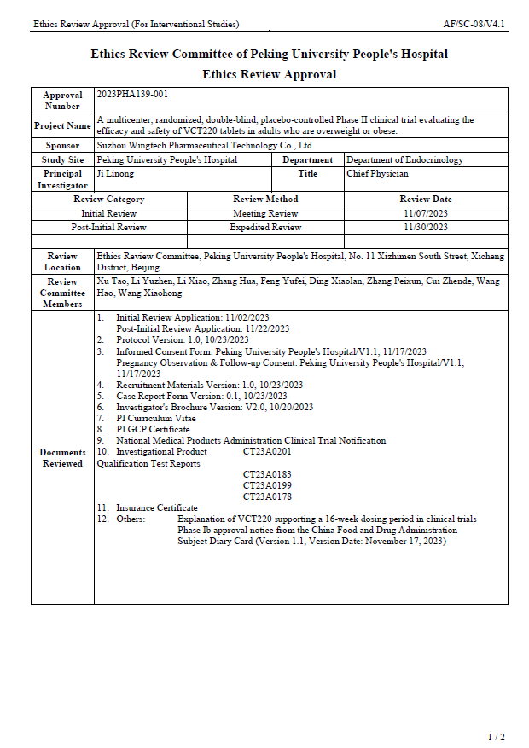

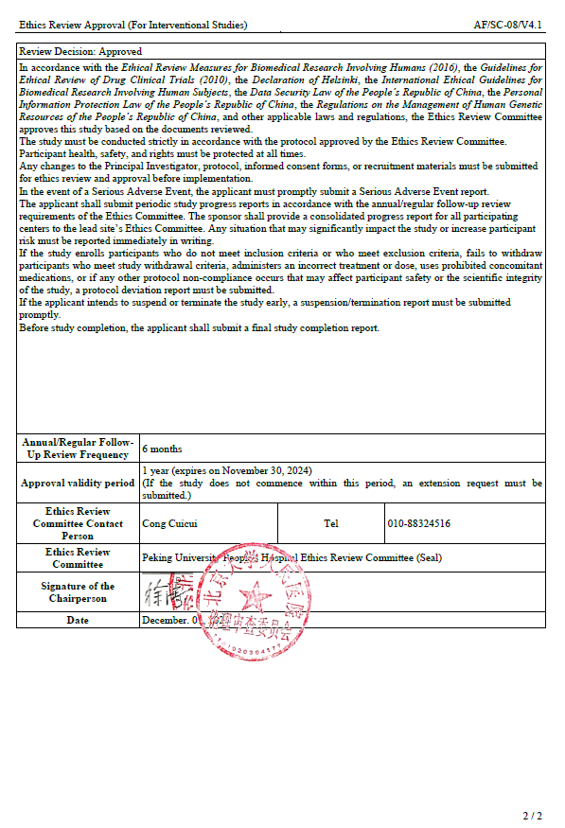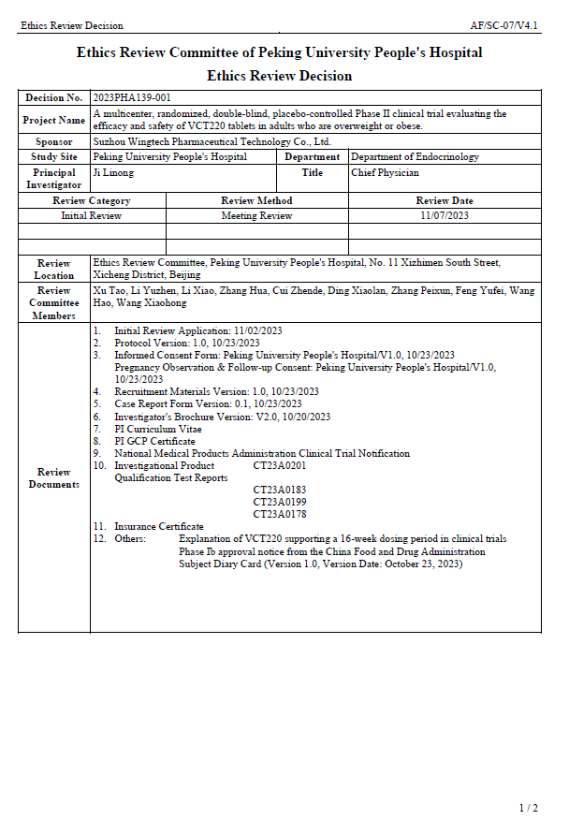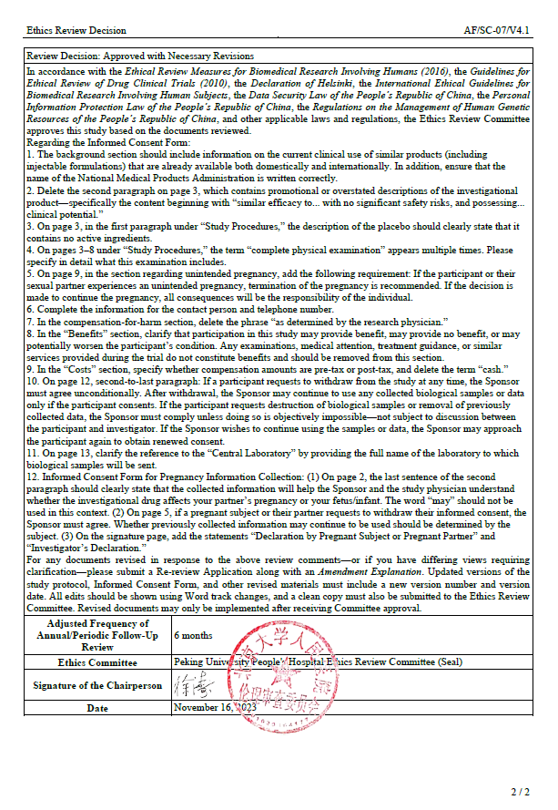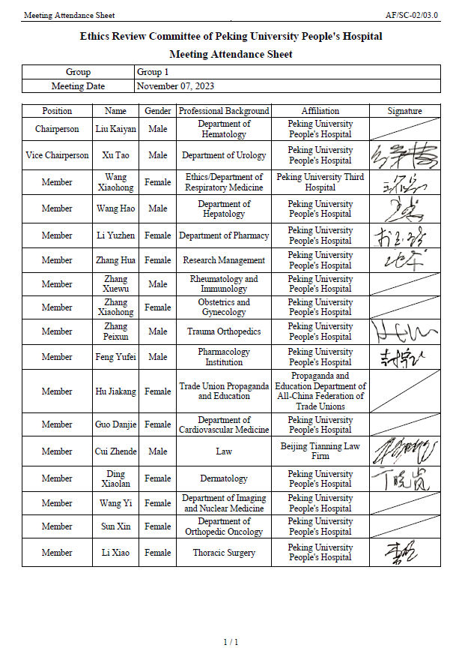

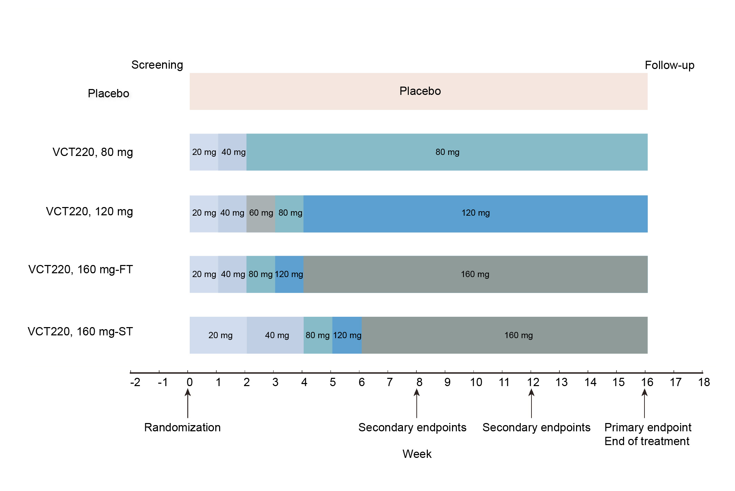
Figure. S1. Dosage and endpoints. ST slow titration, FT fast titration

Table S1. Least square mean (LSM) and standard error (SE) of the percentage change in body weight from baseline at each planned visit - FAS
Visit | VCT220 80mg  (N=65) | VCT220 120mg  (N=62) | VCT220 160mg-ST  (N=31) | VCT220 160mg-FT  (N=31) | VCT220 160mg-pooled  (N=62) | Placebo  (N=61)
V1 (Baseline) | - | - | - | - | - | -
V2 | -0.875 (0.162) | -1.113 (0.165) | -1.241 (0.233) | -1.596 (0.234) | -1.418 (0.165) | -0.391 (0.166)
V3 | -2.242 (0.220) | -2.239 (0.225) | -2.180 (0.316) | -3.462 (0.317) | -2.821 (0.223) | -0.761 (0.229)
V4 | -2.977 (0.271) | -3.521 (0.279) | -3.859 (0.389) | -5.001 (0.396) | -4.421 (0.277) | -1.050 (0.282)
V5 | -3.458 (0.336) | -4.466 (0.347) | -5.355 (0.486) | -6.228 (0.487) | -5.791 (0.344) | -1.165 (0.346)
V6 | -4.640 (0.426) | -6.130 (0.444) | -7.602 (0.617) | -8.808 (0.629) | -8.195 (0.440) | -1.323 (0.440)
V7 | -5.751 (0.487) | -7.424 (0.502) | -9.404 (0.707) | -9.725 (0.730) | -9.496 (0.504) | -1.610 (0.500)
V8 (Follow up) | -5.266 (0.496) | -7.195 (0.522) | -8.488 (0.745) | -9.260 (0.733) | -8.881 (0.522) | -1.505 (0.513)
Analysis was performed using an ANCOVA model, with baseline body weight as a covariate and treatment groups as explanatory variables. Missing body weight data at Week 16 (Visit 7) were imputed using the MI method under the MAR assumption, while no imputation was applied for body weight data at other visits. FAS full analysis set, ANCOVA analysis of covariance, MI multiple imputation, MAR missing at random

Table S2. Sensitivity analysis 1 of the primary endpoint (MMRM): percentage change in body weight from baseline to week 16 - FAS
 | VCT220 80mg  (N=65) | VCT220 120mg  (N=62) | VCT220 160mg -ST  (N=31) | VCT220 160mg-FT  (N=31) | VCT220 160mg-pooled  (N=62) | Placebo  (N=61)
LSM (SE) of percentage change in body weight | -5.709 (0.357) | -7.537 (0.365) | -9.891 (0.438) | -9.644 (0.434) | -9.766 (0.366) | -1.623 (0.366)
95% CI for LSM of percentage change | (-6.411, -5.007) | (-8.255, -6.820) | (-10.752, -9.031) | (-10.497, -8.792) | (-10.484, -9.048) | (-2.341, -0.904)
Estimated difference in LSM vs. Placebo | -4.086 | -5.915 | -8.269 | -8.022 | -8.143
95% CI for estimated difference vs. Placebo | (-5.091, -3.082) | (-6.930, -4.899) | (-9.389, -7.148) | (-9.136, -6.907) | (-9.159, -7.128)
P-value vs. Placebo | <0.001 | <0.001 | <0.001 | <0.001 | <0.001
Analysis was performed using a MMRM model, with baseline body weight as a covariate, and treatment group, scheduled visit, and the treatment-by-visit interaction as fixed effects. FAS full analysis set, LSM least-squares mean, SE standard error, CI, confidence interval, MMRM mixed-effects model for repeated measures

Table S3. Sensitivity analysis 2 of the primary endpoint (ANCOVA with site effects and titration regimen as model factors): percentage change in body weight from baseline to week 16 - FAS
 | VCT220 80mg  (N=65) | VCT220 120mg  (N=62) | VCT220 160mg -ST  (N=31) | VCT220 160mg-FT  (N=31) | VCT220 160mg-pooled  (N=62) | Placebo  (N=61)
LSM (SE) of percentage change in body weight | -5.760 (0.495) | -7.412 (0.510) | -9.386 (0.714) | -9.746 (0.732) | -9.498 (0.512) | -1.600 (0.508)
95% CI for LSM of percentage change | (-6.730, -4.790) | (-8.411, -6.412) | (-10.787, -7.986) | (-11.181, -8.311) | (-10.501, -8.495) | (-2.596, -0.605)
Estimated difference in LSM vs. Placebo | -4.160 | -5.812 | -7.786 | -8.146 | -7.897
95% CI for estimated difference vs. Placebo | (-5.528, -2.792) | (-7.198, -4.425) | (-9.482, -6.091) | (-9.874, -6.418) | (-9.286, -6.509)
P-value vs. Placebo | <0.001 | <0.001 | <0.001 | <0.001 | <0.001
Analysis was performed using an ANCOVA model, with baseline body weight as a covariate, treatment group as the explanatory variable, and center and titration regimen included as random effects. Missing body weight data at Week 16 will be imputed using MI under the MAR assumption. FAS full analysis set, LSM least-squares mean, SE standard error, CI confidence interval, ANCOVA analysis of covariance, MI multiple imputation, MAR missing at random

Table S4. Least square mean (LSM) and standard error (SE) of change from baseline in SBP (mmHg) at each planned visit - FAS
Visit | VCT220 80mg  (N=65) | VCT220 120mg  (N=62) | VCT220 160mg -ST  (N=31) | VCT220 160mg-FT  (N=31) | VCT220 160mg-pooled  (N=62) | Placebo  (N=61)
V1 (Baseline) | - | - | - | - | - | -
V2 | -0.0 (1.08) | -2.4 (1.10) | -2.4 (1.55) | -2.2 (1.56) | -2.3 (1.10) | -0.8 (1.12)
V3 | -5.1 (1.13) | -3.9 (1.15) | -4.0 (1.62) | -5.4 (1.64) | -4.7 (1.15) | -1.3 (1.17)
V4 | -6.0 (1.22) | -6.0 (1.26) | -4.6 (1.78) | -8.2 (1.78) | -6.4 (1.26) | -2.0 (1.27)
V5 | -5.4 (1.15) | -6.2 (1.19) | -7.5 (1.67) | -7.1 (1.70) | -7.3 (1.19) | -2.9 (1.19)
V6 | -5.0 (1.20) | -8.0 (1.25) | -7.5 (1.76) | -10.9 (1.76) | -9.2 (1.25) | -3.4 (1.24)
V7 | -5.2 (1.19) | -7.2 (1.22) | -8.9 (1.76) | -10.4 (1.73) | -9.7 (1.23) | -3.1 (1.21)
V8 (Follow up) | -5.5 (1.06) | -7.2 (1.11) | -8.9 (1.59) | -7.7 (1.56) | -8.3 (1.11) | -4.3 (1.09)
Analysis was performed using an ANCOVA model, with baseline SBP as a covariate and treatment groups as explanatory variables. SBP systolic blood pressure, FAS full analysis set, ANCOVA analysis of covariance

Table S5. Least square mean (LSM) and standard error (SE) of change from baseline in DBP (mmHg) at each planned visit - FAS
Visit | VCT220 80mg  (N=65) | VCT220 120mg  (N=62) | VCT220 160mg-ST  (N=31) | VCT220 160mg-FT  (N=31) | VCT220 160mg-pooled  (N=62) | Placebo  (N=61)
V1 (Baseline) | - | - | - | - | - | -
V2 | -0.2 (0.65) | -1.0 (0.66) | 0.4 (0.93) | -1.9 (0.94) | -0.8 (0.66) | -0.6 (0.67)
V3 | -2.4 (0.77) | -1.3 (0.79) | -1.6 (1.11) | -3.3 (1.13) | -2.5 (0.79) | -1.3 (0.80)
V4 | -2.9 (0.78) | -3.2 (0.81) | -1.0 (1.14) | -4.7 (1.14) | -2.8 (0.81) | -1.3 (0.81)
V5 | -2.7 (0.74) | -3.9 (0.76) | -3.1 (1.07) | -4.4 (1.09) | -3.7 (0.76) | -1.0 (0.76)
V6 | -3.3 (0.84) | -5.1 (0.88) | -3.9 (1.24) | -5.0 (1.24) | -4.5 (0.88) | -2.4 (0.87)
V7 | -3.8 (0.79) | -5.3 (0.81) | -4.3 (1.16) | -5.5 (1.14) | -4.9 (0.82) | -1.2 (0.80)
V8(Follow up) | -4.1 (0.77) | -6.5 (0.81) | -6.3 (1.15) | -7.3 (1.13) | -6.8 (0.81) | -2.6 (0.79)
Analysis was performed using an ANCOVA model, with baseline DBP as a covariate and treatment groups as explanatory variables. DBP diastolic blood pressure, FAS full analysis set, ANCOVA analysis of covariance

Table S6. Mean and standard deviation (SD) of change from baseline in ALT (U/L) from baseline at each planned visit - SS
Visit | VCT220 80mg  (N=65) | VCT220 120mg  (N=62) | VCT220 160mg-ST  (N=31) | VCT220 160mg-FT  (N=31) | VCT220 160mg-pooled  (N=62) | Placebo  (N=61)
V1 (Baseline) | - | - | - | - | - | -
V2 | 0.99 (20.741) | -3.33 (13.044) | -3.01 (9.011) | -9.47 (12.026) | -6.24 (11.031) | -0.37 (14.680)
V3 | -1.73 (18.082) | -5.98 (12.592) | -6.55 (11.894) | -11.07 (18.960) | -8.78 (15.801) | -1.05 (16.104)
V4 | -6.2 (15.247) | -8.06 (13.721) | -8.02 (11.235) | -14.54 (16.197) | -11.28 (14.206) | -2.65 (16.199)
V5 | -4.11 (21.065) | -9.16 (12.053) | -9.20 (12.790) | -12.80 (19.767) | -10.97 (16.545) | -4.09 (10.904)
V6 | -7.66 (18.179) | -11.91 (14.971) | -9.94 (11.479) | -12.24 (30.176) | -11.09 (22.658) | -4.10 (12.857)
V7 | -4.62 (16.420) | -11.93 (16.783) | -10.51 (17.726) | -11.55 (28.105) | -11.04 (23.382) | -2.97 (14.314)
V8 (Follow up) | -2.39 (19.804) | -9.00 (18.678) | -9.11 (15.324) | -8.38 (25.609) | -8.74 (21.006) | -1.14 (15.094)
Descriptive statistics was used to summarize, by treatment group, data at each scheduled visit and change from baseline for ALT. Baseline value is defined as the last available value prior to randomization; change from baseline is defined as the difference between the measured value obtained and the baseline value. ALT alanine aminotransferase, SS safety analysis set

Table S7. Mean and standard deviation (SD) of change from baseline in AST (U/L) from baseline at each planned visit - SS
Visit | VCT220 80mg  (N=65) | VCT220 120mg  (N=62) | VCT220 160mg-ST  (N=31) | VCT220 160mg-FT  (N=31) | VCT220 160mg-pooled  (N=62) | Placebo  (N=61)
V1 (Baseline) | - | - | - | - | - | -
V2 | 5.19 (32.980) | -1.71 (6.274) | -0.92 (6.765) | -5.35 (11.364) | -3.14 (9.539) | -0.16 (7.150)
V3 | 0.32 (9.441) | -3.18 (5.528) | -1.57 (6.216) | -5.99 (13.493) | -3.75 (10.596) | -0.48 (6.939)
V4 | -3.03 (6.621) | -3.46 (5.709) | -2.89 (5.553) | -7.13 (13.040) | -5.01 (10.164) | -1.06 (7.516)
V5 | -1.82 (7.503) | -4.21 (7.668) | -3.36 (6.726) | -5.69 (10.842) | -4.50 (8.986) | -2.06 (5.957)
V6 | -2.35 (9.467) | -5.20 (9.491) | -3.03 (5.487) | -5.06 (13.901) | -4.05 (10.524) | -1.59 (6.349)
V7 | -2.60 (8.017) | -4.72 (10.128) | -3.64 (7.136) | -4.36 (12.320) | -4.01 (10.029) | -0.95 (6.905)
V8 (Follow up) | -1.12 (6.751) | -4.54 (11.327) | -3.15 (7.525) | -4.47 (10.623) | -3.82 (9.174) | 0.60 (7.890)
Descriptive statistics was used to summarize, by treatment group, data at each scheduled visit and change from baseline for AST. Baseline value is defined as the last available value prior to randomization; change from baseline is defined as the difference between the measured value obtained and the baseline value. AST aspartate aminotransferase, SS safety analysis set

Table S8. Percent change in body weight from baseline at 16 weeks by baseline BMI strata based on Chinese criteria for obesity subgroup - FAS
BMI ≥ 28 kg/m² | VCT220 80mg  (N=61) | VCT220 120mg  (N=57) | VCT220 160mg-ST  (N=30) | VCT220 160mg-FT  (N=28) | VCT220 160mg-pooled  (N=58) | Placebo  (N=58)
LSM (SE) of percentage change in body weight | -5.837 (0.517) | -7.400 (0.542) | -9.336 (0.737) | -9.561 (0.794) | -9.363 (0.535) | -1.611 (0.527)
95% CI for LSM of percentage change | (-6.850, -4.824) | (-8.462, -6.338) | (-10.781, -7.891) | (-11.116, -8.005) | (-10.412, -8.313) | (-2.644, -0.579)
Estimated difference vs. Placebo (95% CI) | -4.225 (-5.674, -2.777) | -5.789 (-7.270, -4.307) | -7.725 (-9.501, -5.948) | -7.949 (-9.816, -6.083) | -7.751 (-9.223, -6.280)
Analysis was performed using an ANCOVA model, with baseline body weight as a covariate and treatment groups as explanatory variables. Missing body weight data at 16 weeks will be handled using MI based on the MAR assumption. FAS full analysis set, BMI body mass index, LSM least-squares mean, SE standard error, CI confidence interval, ANCOVA analysis of covariance, MI multiple imputation, MAR missing at random

Table S9. Percent change in body weight from baseline at 16 weeks by baseline BMI strata based on Chinese criteria for overweight subgroup - FAS
24 kg/m² ≤ BMI < 28 kg/m² plus ≥ 1 comorbidity | VCT220 80mg  (N=4) | VCT220 120mg  (N=5) | VCT220 160mg-ST  (N=1) | VCT220 160mg-FT  (N=3) | VCT220 160mg-pooled  (N=4) | Placebo  (N=3)
LSM (SE) of percentage change in body weight | -4.287 (1.139) | -7.957 (1.045) | -11.452 (2.267) | -10.719 (1.348) | -10.902 (1.159) | -1.829 (1.360)
95% CI for LSM of percentage change | (-6.748, -1.827) | (-10.215, -5.698) | (-16.350, -6.553) | (-13.632, -7.806) | (-13.407, -8.398) | (-4.767, 1.109)
Estimated difference vs. Placebo (95% CI) | -2.458 (-6.340, 1.423) | -6.128 (-9.713, -2.542) | -9.623 (-15.334, -3.911) | -8.890 (-13.160, -4.620) | -9.073 (-13.041, -5.106)
Analysis was performed using an ANCOVA model, with baseline body weight as a covariate and treatment groups as explanatory variables. Missing body weight data at 16 weeks will be handled using MI based on the MAR assumption. FAS full analysis set, BMI body mass index, LSM least-squares mean, SE standard error, CI confidence interval, ANCOVA analysis of covariance, MI multiple imputation, MAR missing at random

Table S10. Percent change in body weight from baseline at 16 weeks by baseline BMI strata based on U.S. criteria for obesity subgroup - FAS
BMI ≥ 28 kg/m² | VCT220 80mg  (N=39) | VCT220 120mg  (N=40) | VCT220 160mg-ST  (N=22) | VCT220 160mg-FT  (N=22) | VCT220 160mg-pooled  (N=44) | Placebo  (N=46)
LSM (SE) of percentage change in body weight | -5.718 (0.664) | -7.595 (0.665) | -9.885 (0.900) | -9.694 (0.962) | -9.734 (0.645) | -1.651 (0.615)
95% CI for LSM of percentage change | (-7.020, -4.417) | (-8.899, -6.291) | (-11.648, -8.122) | (-11.578, -7.809) | (-10.997, -8.471) | (-2.856, -0.447)
Estimated difference vs. Placebo (95% CI) | -4.067 (-5.840, -2.293) | -5.943 (-7.719, -4.167) | -8.233 (-10.368, -6.099) | -8.042 (-10.278, -5.807) | -8.083 (-9.830, -6.335)
Analysis was performed using an ANCOVA model, with baseline body weight as a covariate and treatment groups as explanatory variables. Missing body weight data at 16 weeks will be handled using MI based on the MAR assumption. FAS full analysis set, BMI body mass index, LSM least-squares mean, SE standard error, CI confidence interval, ANCOVA analysis of covariance, MI multiple imputation, MAR missing at random

Table S11. Percent change in body weight from baseline at 16 weeks by baseline BMI strata based on U.S. criteria for overweight subgroup - FAS
24 kg/m² ≤ BMI < 28 kg/m² plus ≥ 1 comorbidity | VCT220 80mg  (N=24) | VCT220 120mg  (N=18) | VCT220 160mg-ST  (N=7) | VCT220 160mg-FT  (N=9) | VCT220 160mg-pooled  (N=16) | Placebo  (N=13)
LSM (SE) of percentage change in body weight | -5.856 (1.265) | -7.390 (1.459) | -7.032 (7.256) | -9.958 (2.024) | -8.635 (1.521) | -1.546 (1.695)
95% CI for LSM of percentage change | (-8.336, -3.376) | (-10.249, -4.531) | (-21.268, 7.203) | (-13.924, -5.991) | (-11.616, -5.654) | (-4.868, 1.777)
Estimated difference vs. Placebo (95% CI) | -4.310 (-8.494, -0.126) | -5.844 (-10.205, -1.484) | -5.487 (-19.983, 9.010) | -8.412 (-13.580, -3.244) | -7.089 (-11.555, -2.624)
Analysis was performed using an ANCOVA model, with baseline body weight as a covariate and treatment groups as explanatory variables. Missing body weight data at 16 weeks will be handled using MI based on the MAR assumption. FAS full analysis set, BMI body mass index, LSM least-squares mean, SE standard error, CI confidence interval, ANCOVA analysis of covariance, MI multiple imputation, MAR missing at random

