Supplementary Materials for

Synthetic lethality in cancer: mechanisms, therapeutic exploitation and clinical translation
Cristina Camps-Fajol, Jordi Minguillón, Jordi Surrallés
Correspondence to: jsurralles@santpau.cat; jordi.surralles@uab.cat

This PDF file includes:
Figures. S1 to S10

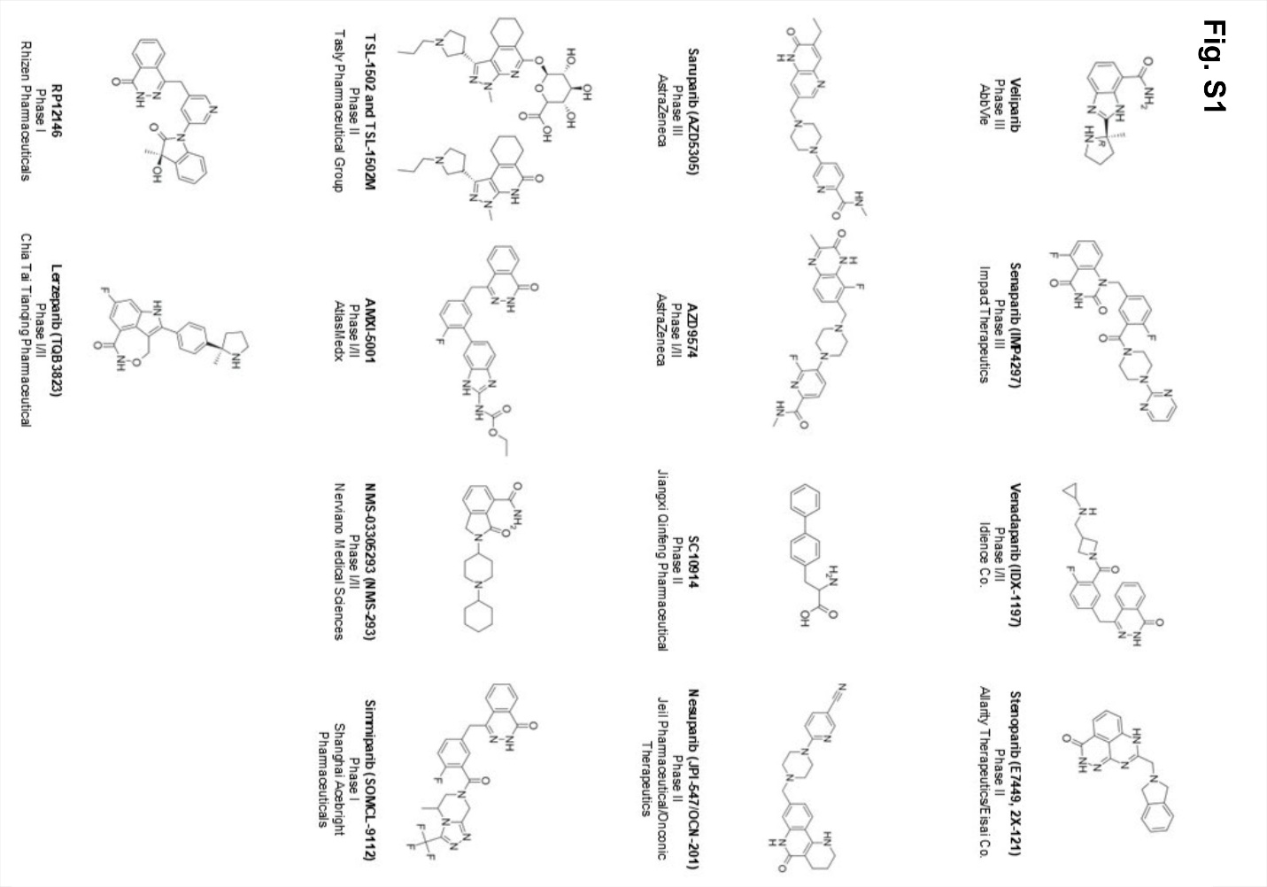

Supplementary Figure 1 Structure of other PARPi that have progressed to clinical trials. AbbVie’s compound veliparib, which has received several FDA Orphan Drug Designations for different cancers that have been posteriorly revoked/withdrawn, has been explored in different Phase III trials for breast and ovarian cancer, NSCLC and glioblastoma. In Phase III clinical trials are also senaparib (IMP4297) from Impact Therapeutics and venadaparib (IDX-1197) from Idience Co. Stenoparib is a dual inhibitor of PARP1/2 and tankyrase1/2, that was originally developed by Eisai Co. and currently by Allarity Therapeutics, and that is involved in Phase II clinical trials. AstraZeneca is developing two additional PARPi, saruparib (AZD5305) and AZD9574, the first one included in Phase III trials and the second one in a Phase I/II trial. SC10914 is a compound from Jiangxi Qinfeng Pharmaceutical Co. Ltd being studied in Phase II trials for BRCA1/2-mutated prostate, breast and ovarian cancer. Also in Phase II are the dual PARP and tankyrase inhibitor nesuparib (JPI-547/OCN-201) from Onconic Therapeutics Inc. and TSL-1502 from Tasly Pharmaceutical Group. Being explored in Phase I/II studies are the dual PARP1/2 and microtubule polymerization inhibitor AMXI-5001 (AtlasMedx, Inc.), NMS-03305293 (Nerviano Medical Sciences S.r.l.) and lerzeparib (TQB3823, Chia Tai Tianqing Pharmaceutical). Several other PARPi are still in Phase I trials: simmiparib (SOMCL-9112, Shanghai Acebright Pharmaceuticals Co.), RP12146 (Rhizen Pharmaceuticals), HWH340 (Hubei Biological Medicine Industrial Technology Institute) and ABT-767. The last two compounds have not been included as their structure has not yet been disclosed

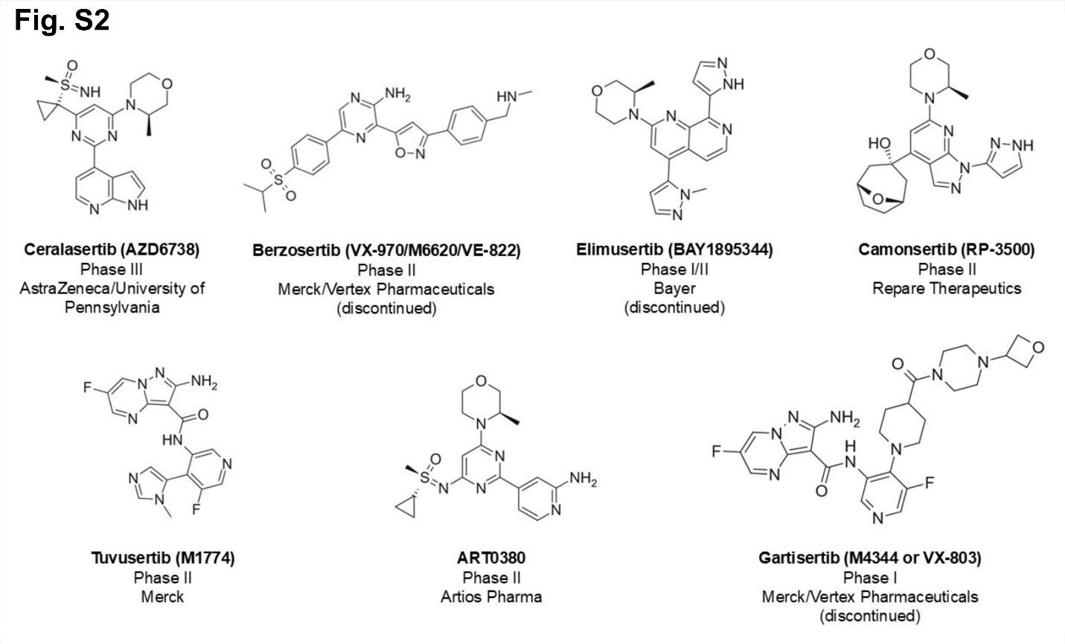

Supplementary Figure 2 ATR inhibitors undergoing clinical trials. Ceralasertib from AstraZeneca/University of Pennsylvania is the most advanced ATRi (Phase III), followed by berzosertib (Phase II), discovered by Vertex Pharmaceuticals and licensed to Merck, Bayer’s elimusertib (Phase I/II), Repare Therapeutics’ camonsertib (Phase II), Merck’s tuvusertib, Artios Pharma’s alnodesertib (Phase I/II) and gartisertib (Phase I), which was also discovered by Vertex Pharmaceuticals and acquired by Merck. SC0245, from the Chinese Biocity, has not been included as its structure has not yet been disclosed

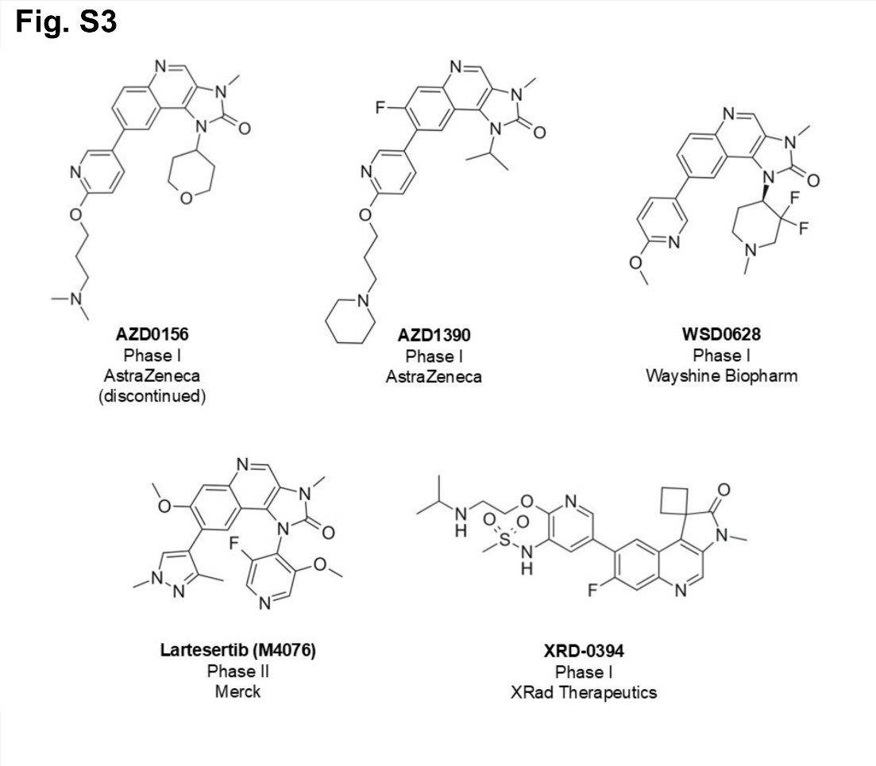

Supplementary Figure 3 ATM inhibitors undergoing clinical trials. AZD0156 has been dropped from AstraZeneca’s pipeline to prioritize the development of AZD1390. Other ATMi undergoing clinical trials are the Wayshine Biopharm’s compound WSD0628, Merck’s lartesertib and the dual ATM/DNA-PKi XRD-0394 developed by XRad Therapeutics. All of them remain in Phase I stages of clinical trials

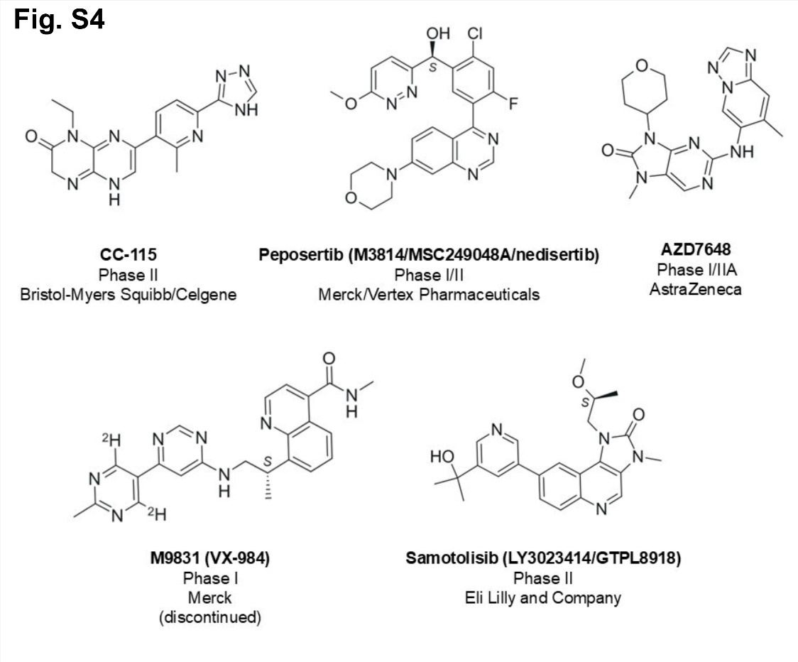

Supplementary Figure 4 DNA-PK inhibitors undergoing clinical trials. The dual mTOR/DNA-PK inhibitor CC-115, initially developed by Celgene Corp, and samotolisib, both at Phase II clinical trials, are being developed by Bristol-Myers Squibb and Eli Lilly and Company, respectively. Peposertib developed by Vertex Pharmaceuticals and posteriorly licensed to Merck KGaA Merck is at Phase I/II, and AstraZeneca’s compound AZD7648 and Merck’s M9831 compound remain in Phase I stages of clinical trials
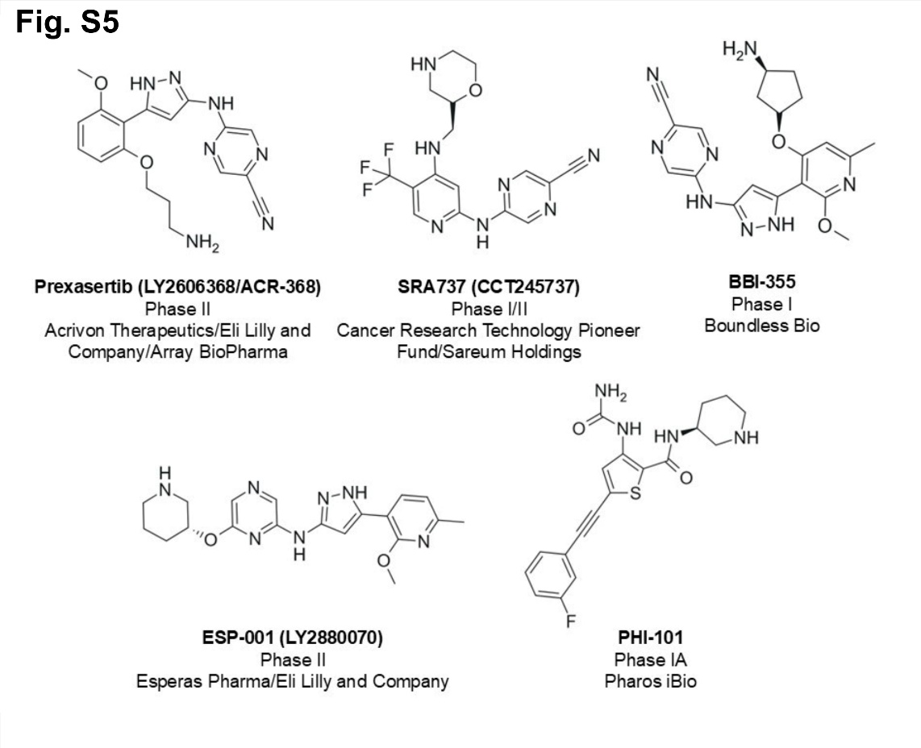

Supplementary Figure 5 CHK1/2 inhibitors undergoing clinical trials. Acrivon Therapeutics gained rights from Eli Lilly and Company to develop and commercialize the CHK1i originally discovered by Array BioPharma, prexasertib (Phase II). Another CHK1i that is in Phase II trials is ESP-001, a molecule being developed by Esperas Pharma and originally discovered through a research and development program at Eli Lilly and Company. SRA737, developed by scientists at the Institute of Cancer Research (more concretely by the Cancer Research Technology Pioneer Fund) in collaboration with Sareum Holdings, is currently at Phase I/II trials. BBI-355 developed by Boundless Bio and the dual FLT3/CHK2 inhibitor PHI-101 from Pharos iBio remain in Phase I. Also in Phase I is the CHK1i PEP07 developed by Sentinel Oncology, but its structure has not yet been disclosed

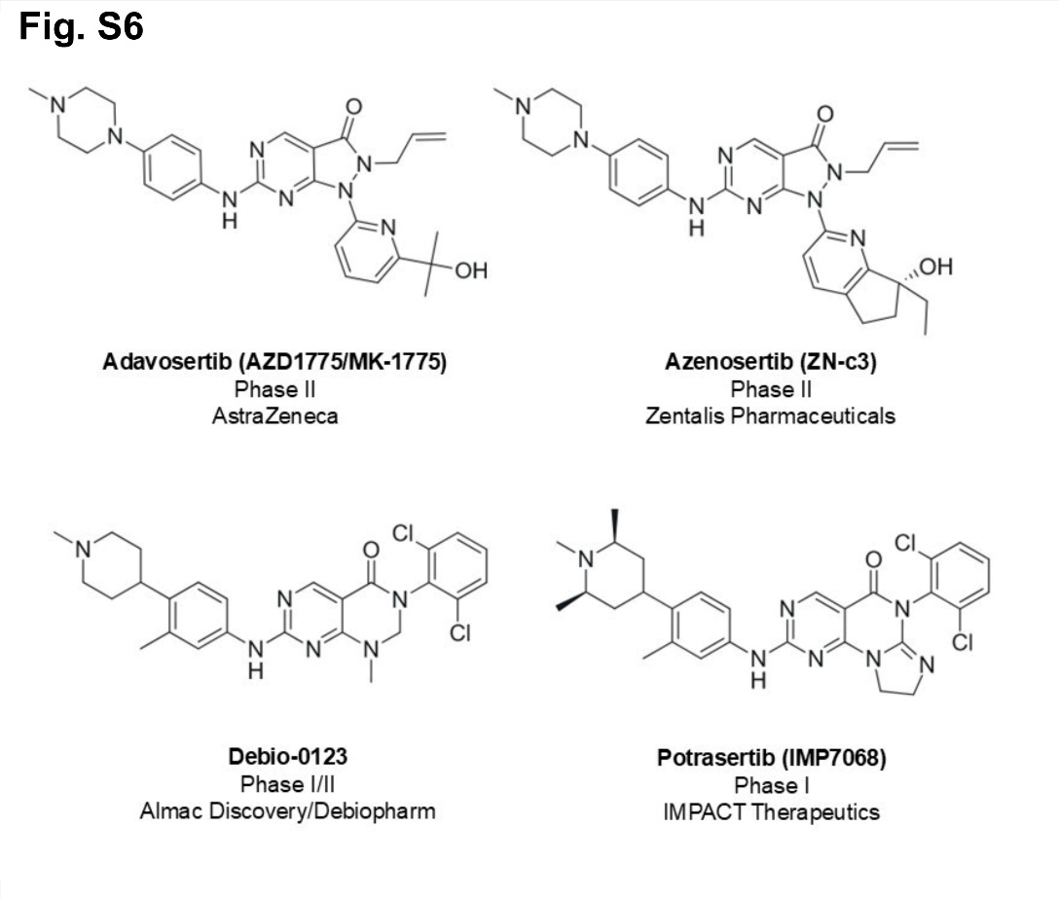

Supplementary Figure 6 WEE1 inhibitors undergoing clinical trials. Adavosertib and azenosertib, that are in Phase II trials have been developed by AstraZeneca and Zentalis Pharmaceuticals, respectively. Also in Phase II is Debio-0123, which was discovered by Almac Discovery and then in-licensed by Debiopharm. Potrasertib, developed by IMPACT Therapeutics, SY-4835 (structure not disclosed) from Shouyao Holdings and APR-1051 (structure not disclosed) from Aprea Therapeutics remain in Phase I clinical trials

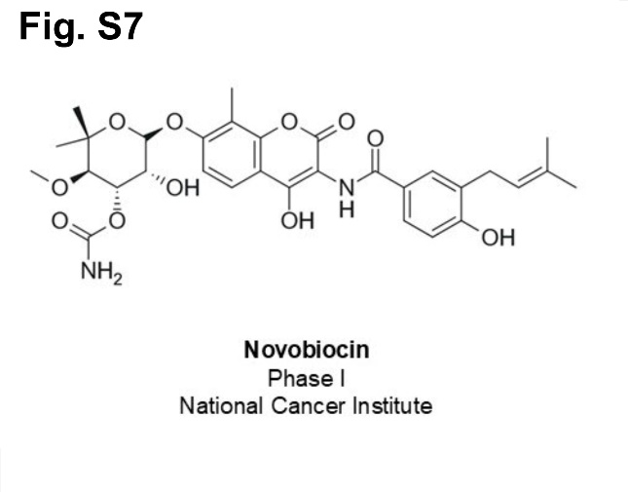

Supplementary Figure 7 POLQ inhibitor undergoing clinical trials. The coumarin antibiotic novobiocin produced by Streptomyces niveus is included in a Phase I trial for cancer sponsored by the US National Cancer Institute

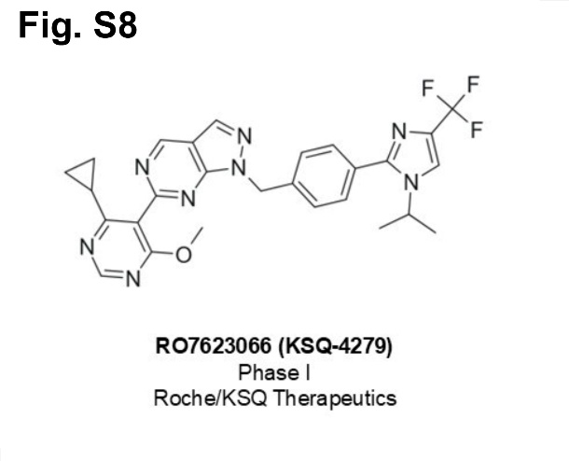

Supplementary Figure 8 USP1 inhibitors undergoing clinical trials. RO7623066 is a USP1i that was discovered by KSQ Therapeutics, posteriorly licensed to Roche, and is currently being studied in a FIH trial. The other USP1i from Exelixis under clinical trials, XL309, has not been included as its structure has not yet been disclosed

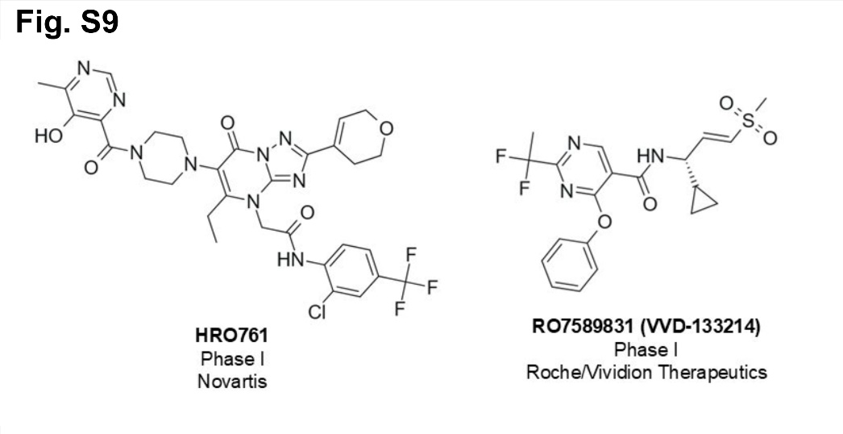

Supplementary Figure 9 WRN inhibitors undergoing clinical trials. HRO761 is a WRNi from Novartis that is currently being studied in a FIH trial for MMR-deficient or MSI solid tumors. RO7589831 is another WRNi discovered by Vividion Therapeutics and later licensed to Roche that is included in a Phase I trial for the same tumor types. The other WRNi under clinical trials developed by IDEAYA in collaboration with GlaxoSmithKline, GSK4418959, has not been included as its structure has not yet been disclosed

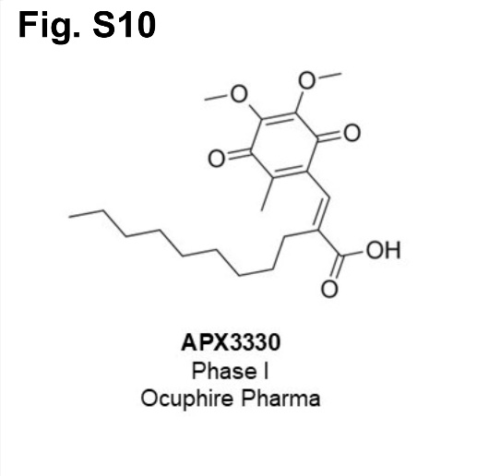

Supplementary Figure 10 Ref-1/APE1 inhibitor undergoing clinical trials. APX3330 is a Ref-1/APE1i developed by Occuphire Pharma that is being studied in a Phase I trial for advanced solid tumors

