Supplementary Materials for

A genomically unique, melanoma-restricted noncanonical antigen enables receptor-defined T cell targeting

Thomas Morgan Hulen¹, Michael Douglas Crowther¹, Luke Alexander Schuster¹, Shawez Khan¹, Aimilia Schina¹, Marco Donia¹, Mads Hald Andersen¹, Inge Marie Svane¹, Özcan Met^{1,2#}

Correspondence to: Ozcan.Met@regionh.dk

This PDF file includes:

Supplementary Text
Figures. S1 to S5
Tables S1 to S5

Supplementary Text
Written code relevant to this work is publicly available at:
https://github.com/thomashulen/hulen-et-al.-NCP-2026

The following transcript sequences have been uploaded as datasets that are relevant to this work:
- Dataset 1: EVA001
- Dataset 2: EVA002
- Dataset 3: EVA003
- Dataset 4: EVA003 600-nt core
- Dataset 5: LLM peptide

Public normal/control skin RNA sequencing data were obtained from GEO accession GSE147704 / SRA accession SRP254484 while public melanoma RNA sequencing data were obtained from GEO accession GSE98394 / SRA accession SRP106011.

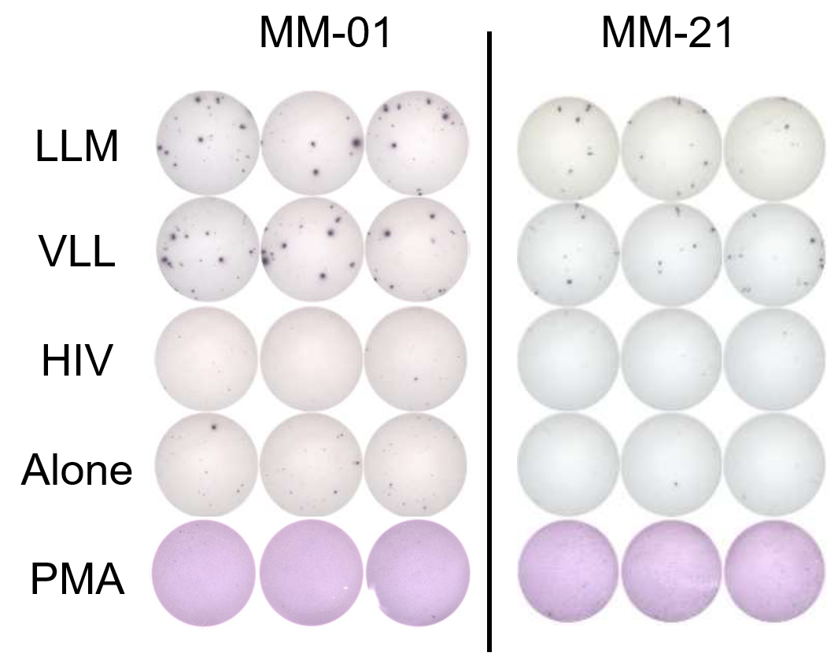

Figure. S1.
Melanoma TILs from two patients react to individual EVA003-derived peptides. ELISPOT well images of MM-01 and MM-21 as quantified in Fig. 2f.

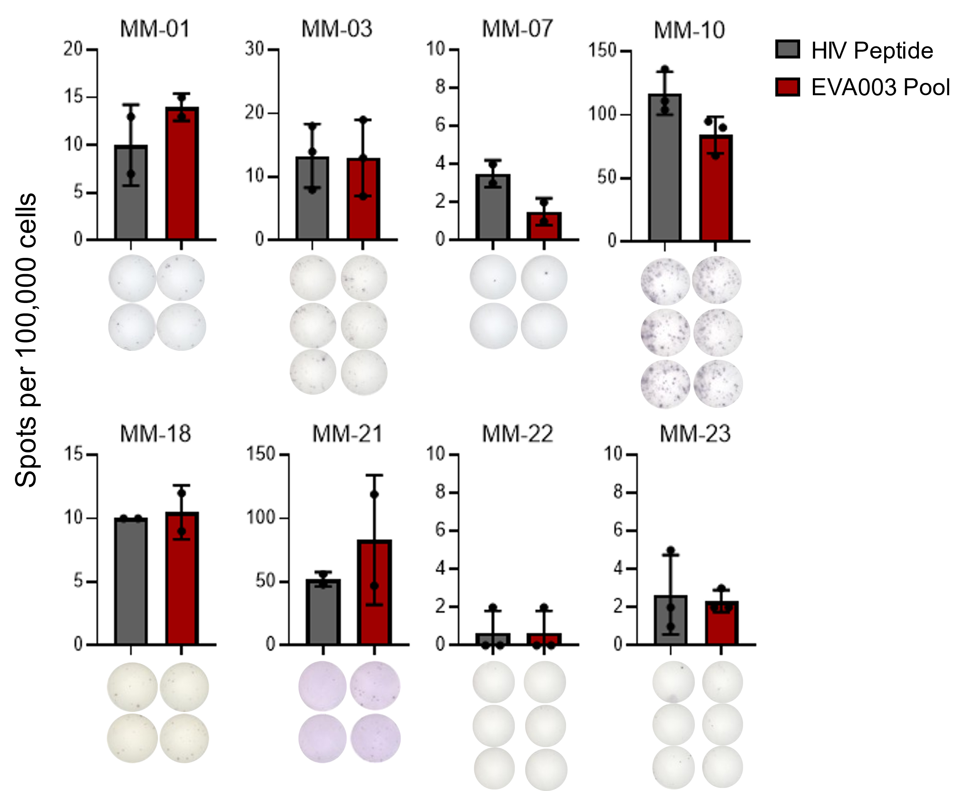

Figure. S2.
Melanoma TILs stimulated with EVA003-derived pooled peptides. TILs from eight out of nine HLA-A*03:01 patients were available for IFNγ ELISPOT screen. TILs from MM-01 and MM-21 show IFNγ production upon stimulation with the EVA003 peptide pool compared to stimulation with HIV peptide. Experiment done in duplicates and triplicates depending on availability of TILs. Individual well images displayed below datasets.

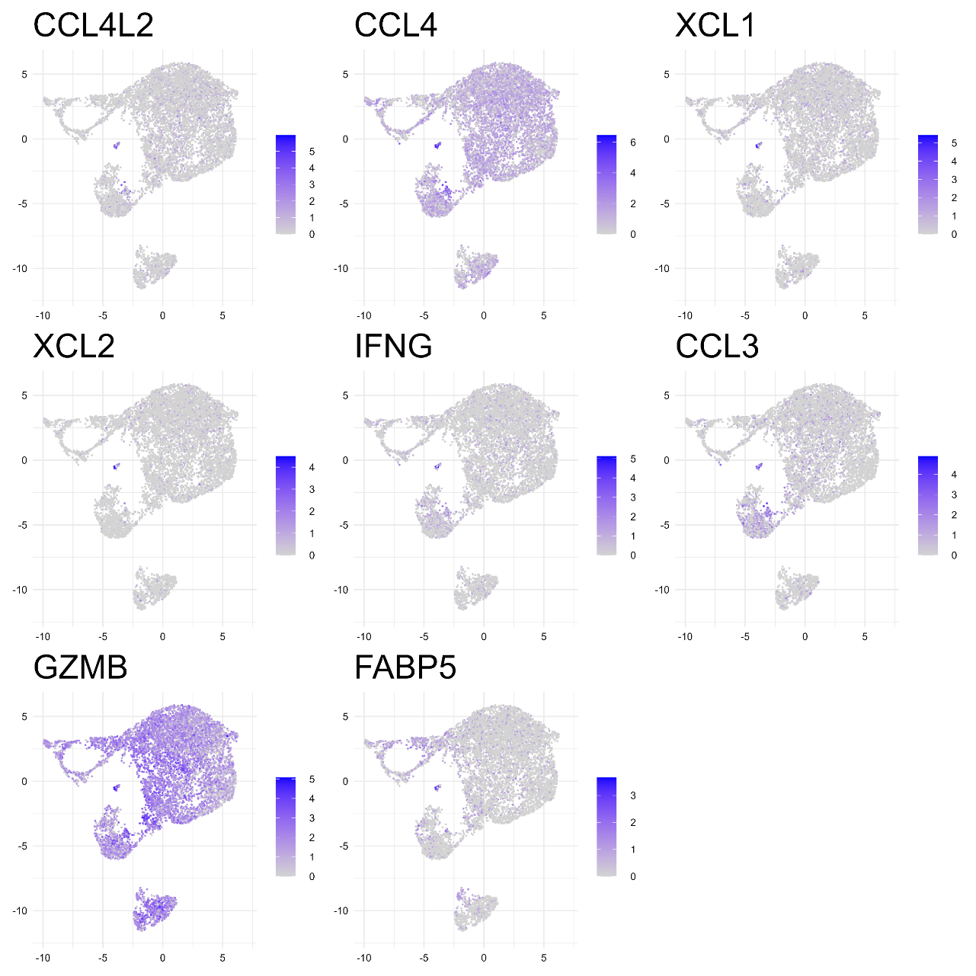

Figure. S3.
Top cluster-defining genes identified by single-cell transcript profiling. a, 10X Genomics single-cell RNA sequencing was performed on MM-01 TILs stimulated with LLM peptide. Each panel shows UMAP projection of all cells with blue/grey scale reflecting intensity of expression of the eight most differentially expressed genes contributing most to clustering seen in main text Fig. 4a.

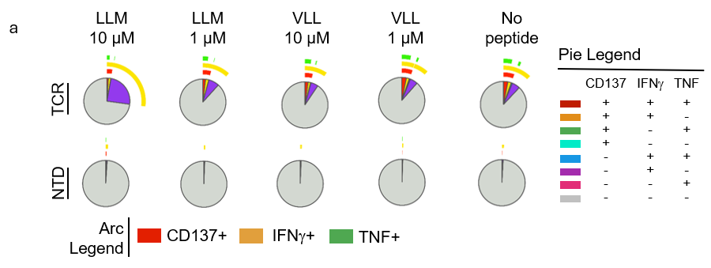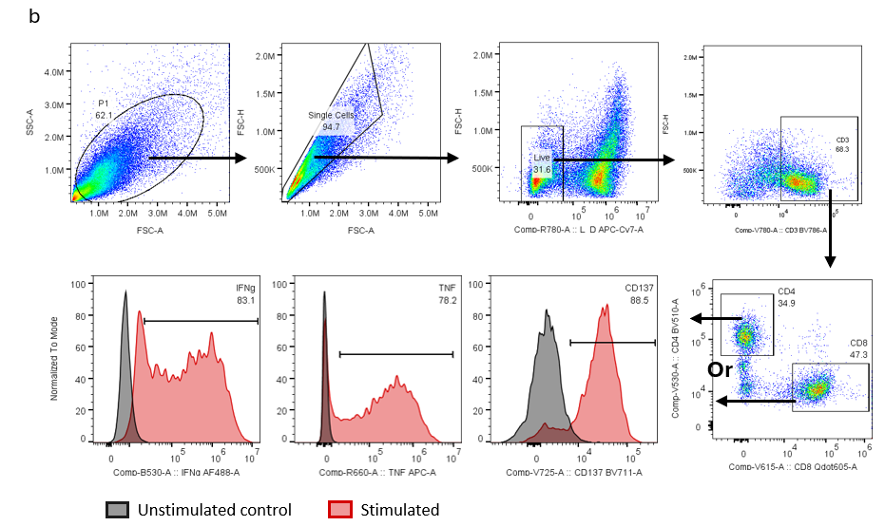

Figure. S4.
Intracellular cytokine stain of TCR-T cells stimulated with peptide pulsed T2-A3 cells. a, SPICE analysis of CD4⁺ compartment. Pie chart fractions indicate expression combinations while arcs represent individual marker expression (n=2). b, gating strategy used for analysis.

a
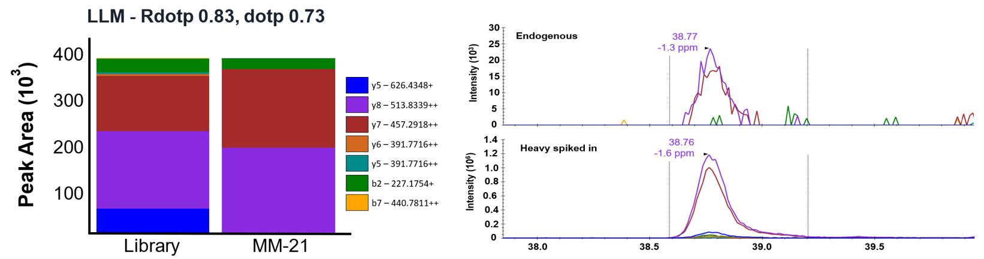

b
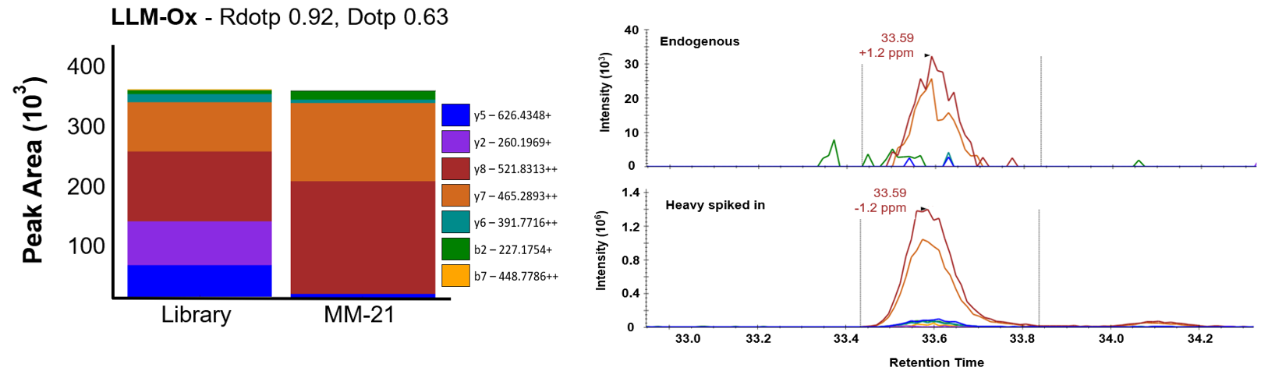

c
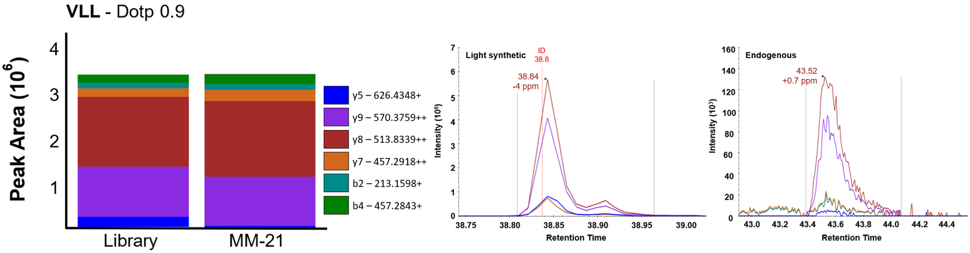

Figure. S5.
LC-MS confirmation of LLM and VLL peptides in MM-21 tumor.
For each peptide, a, LLM, b, methionine-oxidized for of LLM (LLM-Ox), c, VLL, the stacked bar plots show the relative peak area contributed by individual fragment ions (b- and y-type, with charge state indicated) in the reference spectral library versus the experimental sample; Dot product (dotp) and reference dot product (Rdotp) scores; parts per million (ppm). Vertical gray lines denote integration boundaries used for peak area quantification.

Table S1.
Genomic and structural characteristics of melanoma-associated noncanonical transcripts EVA001, EVA002, EVA003. Summary of the genomic localization and structural features of the melanoma-associated noncanonical transcripts. Genomic coordinates are reported in hg38 reference assembly format.
Transcript | Chromosome | Strand orientation | Genomic coordinates | Exons | Nearest neighbors
EVA001 | 20 | - | chr20:61.738–61.755 Mb | 2 | CDH4,  CDH4-AS1
EVA002 | 8 | + | chr8:29.748–29.798 Mb | 4 | LINC02099, LINC00589
EVA003 | 6 | - | chr6:104.283–104.350 Mb | 3 | TFAP2A-AS1, LINC00518

Table S2.
Detailed HLA allele information for each patient included in RNA sequencing dataset.

Patient | Class I HLA
MM-01 | A0202, A0301, B0702, B4001, C0702, C0304
MM-02 | A0201, A0201, B0702, B4402, C1601, C1203
MM-03 | A0201, A3001, B1302, B1501, C0304, C0602
MM-04 | A0201, A3002, B4001, C0304
MM-05 | A0201, A2402, B0702, B4403, C0201, C0401
MM-06 | A0201, A0301, B3501, B3501, C0401, C0401
MM-07 | A0201, A0301, B0702, B3509, C0702, C0702
MM-08 | A0201, A6801, B4001, B5101, C1402, C1402
MM-09 | A0201, B4402
MM-10 | A0201, A0201, B0702, B4402, C0702
MM-11 | A0201, A6801, B4402
MM-12 | A0101, A0201, B1501, B4001, C0304
MM-13 | A0201, A2402, B5101, C0701
MM-14 | A0201, B4001, B4403, C0304, C0401
MM-15 | A0201, A2402, A2601, B0702, B0801, C0701, C0702
MM-16 | A0201, A6801, B0702, B2705, C0202, C0702
MM-17 | A0101, A0201, B0702, B5201, C0702, C1202
MM-18 | A0201, A0301, B0702, B4001, C0702, C0702
MM-19 | A0201, A6801, B1501, B4402, C0304, C0704
MM-20 | A0201, A0201, B4402, B4402, C0501, C0501
MM-21 | A0101, A0301, B0702, B4402, C0702
MM-22 | A0301, B2705, B3501, C0303, C0401
MM-23 | A0301, A6801, B3501, B5501, C0303, C0401

Table S3.
EVA003 overlapping peptides included in pooled and deconvoluted IFNγ ELISPOT screens.

Peptide | Sequence
EVA003-1 | MNTPNIVSLRAHQPE
EVA003-2 | NIVSLRAHQPEVGII
EVA003-3 | LRAHQPEVGIIPSVL
EVA003-4 | QPEVGIIPSVLLMRP
EVA003-5 | GIIPSVLLMRPLRIK
EVA003-6 | SVLLMRPLRIKGVFH
EVA003-7 | MRPLRIKGVFHHIHS
EVA003-8 | RIKGVFHHIHSPLHG
EVA003-9 | VFHHIHSPLHGENQG
EVA003-10 | IHSPLHGENQGFTLC
EVA003-11 | LHGENQGFTLCLQGA
EVA003-12 | NQGFTLCLQGAPPSS
EVA003-13 | TLCLQGAPPSSSV

Table S4.
NetMHC version 4.0 analysis of peptides LLMRPLRIK and VLLMRPLRIK. Rank threshold for strong binding peptides = 0.500. Rank threshold for weak binding peptides = 2.000. n.d. = no data.

Peptide | HLA | 1-log50k (aff) | Affinity (nM) | % Rank | Bind
LLMRPLRIK | A*01:01 | 0.053 | 28178.95 | 29.00 | n.d.
LLMRPLRIK | A*02:01 | 0.086 | 19681.35 | 27.00 | n.d.
LLMRPLRIK | A*03:01 | 0.722 | 20.22 | 0.08 | Strong Bind
LLMRPLRIK | A*24:01 | 0.027 | 37405.00 | 38.00 | n.d.
LLMRPLRIK | A*26:01 | 0.050 | 29012.09 | 38.00 | n.d.
LLMRPLRIK | B*07:02 | 0.085 | 19898.69 | 30.00 | n.d.
LLMRPLRIK | B*08:01 | 0.078 | 21493.14 | 15.00 | n.d.
LLMRPLRIK | B*27:05 | 0.170 | 7928.59 | 27.00 | n.d.
LLMRPLRIK | B*39:01 | 0.033 | 34931.19 | 7.50 | n.d.
LLMRPLRIK | B*40:01 | 0.059 | 26493.85 | 40.00 | n.d.
LLMRPLRIK | B*58:01 | 0.060 | 26161.43 | 25.00 | n.d.
LLMRPLRIK | B*15:01 | 0.078 | 21614.88 | 39.00 | n.d.
VLLMRPLRIK | A*01:01 | 0.041 | 32255.61 | 47.00 | n.d.
VLLMRPLRIK | A*02:01 | 0.260 | 2992.41 | 7.50 | n.d.
VLLMRPLRIK | A*03:01 | 0.719 | 20.90 | 0.08 | Strong Bind
VLLMRPLRIK | A*24:01 | 0.106 | 15948.72 | 9.50 | n.d.
VLLMRPLRIK | A*26:01 | 0.035 | 34164.18 | 55.00 | n.d.
VLLMRPLRIK | B*07:02 | 0.039 | 32807.87 | 43.00 | n.d.
VLLMRPLRIK | B*08:01 | 0.212 | 5042.03 | 5.00 | n.d.
VLLMRPLRIK | B*27:05 | 0.083 | 20391.04 | 19.00 | n.d.
VLLMRPLRIK | B*39:01 | 0.016 | 42182.78 | 90.00 | n.d.
VLLMRPLRIK | B*40:01 | 0.032 | 35504.27 | 65.00 | n.d.
VLLMRPLRIK | B*58:01 | 0.043 | 31516.99 | 60.00 | n.d.
VLLMRPLRIK | B*15:01 | 0.041 | 32004.96 | 55.00 | n.d.

Table S5.
EVA003-transfection and LCMS of CaSki cell line. Representative table of MS/MS-identified peptides containing oxidized methionine (M+15.99 Da). Peptides were identified with high confidence scores (-10LgP), low mass error (ppm), and strong signal intensity. The two EVA003-derived peptides, LLMRPLRIK and VLLRPLRIK, were detected with oxidation at methionine residues M3 and M4, respectively, as indicated by site-localized AScore values of 1000.00. Peptide identification was consistent across technical replicates with comparable retention times (RT), chomatrographic peak areas, and intensities. These data confirm the presence and site-specific oxidation of methionine residues in the analyzed peptides.

Peptide | -10LgP | Mass | Length | ppm | m/z | z | RT | Area | Intensity | Scan | PTM | AScore
LLM(+15.99) RPLRIK | 99,39 | 1154,7 | 9 | -0,2 | 386 | 3 | 36.9698 | 72344 | 672698 | 14056 | Oxidation (M) | M3:Oxidation (M):1000.00
LLM(+15.99) RPLRIK | 112,34 | 1154,7 | 9 | -0,1 | 386 | 3 | 37.129 | 85927 | 690055 | 14123 | Oxidation (M) | M3:Oxidation (M):1000.00
VLLM(+15.99) RPLRIK | 28,9 | 1253,8 | 10 | 0,1 | 419 | 3 | 42.8834 | 1E+06 | 3267517 | 16268 | Oxidation (M) | M4:Oxidation (M):1000.00
VLLM(+15.99) RPLRIK | 90,54 | 1253,8 | 10 | -0,3 | 419 | 3 | 42.7593 | 1E+06 | 2814837 | 16399 | Oxidation (M) | M4:Oxidation (M):1000.00
VLLM(+15.99) RPLRIK | 32,26 | 1253,8 | 10 | -0,3 | 419 | 3 | 42.7593 | 1E+06 | 2814837 | 16605 | Oxidation (M) | M4:Oxidation (M):1000.00

