Supplement 1. Physical activity infographic
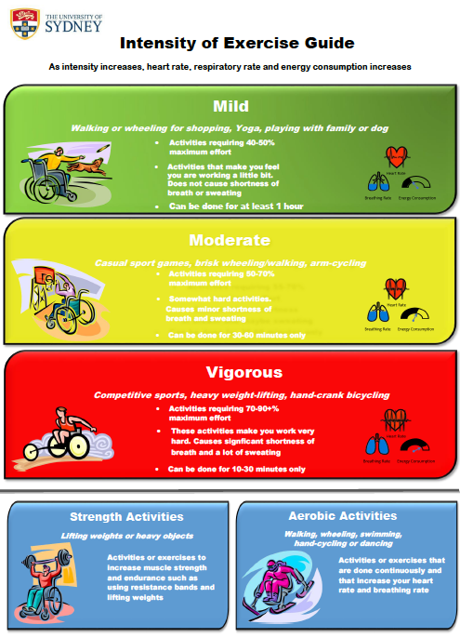

Supplement 2. Multivariate regression of motivations predicting leisure-time physical activity volume
LTPA | Predicting motive | B | s.e. | β | t | p-value
Mild  R² = 0.06  p = .553 | Appearance/weight management | -1.57 | 3.68 | -0.06 | -0.37 | .674
Mild  R² = 0.06  p = .553 | Social engagement | -3.00 | 3.17 | -0.26 | -1.36 | .399
Mild  R² = 0.06  p = .553 | Enjoyment/revitalisation | 4.22 | 3.67 | 0.31 | 1.46 | .295
Mild  R² = 0.06  p = .553 | Negative health avoidance | -0.89 | 8.72 | -0.02 | -0.12 | .915
Mild  R² = 0.06  p = .553 | Health and fitness | 2.46 | 6.4 | 0.09 | 0.50 | .738
MV  R² = 0.21  p = .009 | Appearance/weight management | -7.15 | 4.05 | -0.27 | -1.77 | .082
MV  R² = 0.21  p = .009 | Social engagement | 3.08 | 2.08 | 0.26 | 1.48 | .143
MV  R² = 0.21  p = .009 | Enjoyment/revitalisation | 2.63 | 2.73 | 0.19 | 0.97 | .338
MV  R² = 0.21  p = .009 | Negative health avoidance | -3 | 7.21 | -0.07 | -0.41 | .683
MV  R² = 0.21  p = .009 | Health and fitness | 7.26 | 4.65 | 0.26 | 0.12 | .123
Strength  R² = 0.10  p = .258 | Appearance/weight management | -3.53 | 2.43 | -0.24 | -1.45 | .151
Strength  R² = 0.10  p = .258 | Social engagement | 0.31 | 1.25 | 0.05 | 0.25 | .805
Strength  R² = 0.10  p = .258 | Enjoyment/revitalisation | 0.92 | 1.64 | 0.12 | 0.56 | .577
Strength  R² = 0.10  p = .258 | Negative health avoidance | -3.82 | 4.32 | -0.17 | -0.88 | .380
Strength  R² = 0.10  p = .258 | Health and fitness | 4.74 | 2.79 | 0.3 | 1.70 | .094
Total  R² = 0.25  p = .002 | Appearance/weight management | -10.28 | 6.13 | -0.25 | -1.68 | .050
Total  R² = 0.25  p = .002 | Social engagement | -0.19 | 3.14 | -0.01 | -0.06 | .963
Total  R² = 0.25  p = .002 | Enjoyment/revitalisation | 8.62 | 4.13 | 0.4 | 2.09 | .089
Total  R² = 0.25  p = .002 | Negative health avoidance | -12.08 | 10.91 | -0.19 | -1.12 | .228
Total  R² = 0.25  p = .002 | Health and fitness | 15.88 | 7.04 | 0.37 | 2.26 | .022
LTPA: leisure-time physical activity; MV: moderate-to-vigorous

Supplement 3. Multivariate regression of leisure-time physical activity volume predicting gains
Gain | Predicting LTPA volume | B | s.e. | β | t | p-value
Appearance/weight management  R² = 0.12  p = .050 | Mild | -0.01 | 0.01 | -0.38 | -0.81 | .008
Appearance/weight management  R² = 0.12  p = .050 | MV | 0 | 0.01 | -0.01 | -0.12 | .961
Appearance/weight management  R² = 0.12  p = .050 | Strength | -0.00 | 0.01 | -0.04 | -0.11 | .779
Appearance/weight management  R² = 0.12  p = .050 | Total | 0.01 | 0.01 | 0.51 | 0.65 | .031
Social engagement  R² = 0.09  p = .102 | Mild | -0.01 | 0.06 | -0.07 | -0.15 | .788
Social engagement  R² = 0.09  p = .102 | MV | 0.03 | 0.06 | 0.29 | 0.60 | .232
Social engagement  R² = 0.09  p = .102 | Strength | 0.01 | 0.07 | 0.04 | 0.13 | .881
Social engagement  R² = 0.09  p = .102 | Total | 0.00 | 0.06 | 0.03 | 0.04 | .960
Enjoyment/revitalisation  R² = 0.16  p = .012 | Mild | -0.02 | 0.03 | -0.22 | -0.48 | .188
Enjoyment/revitalisation  R² = 0.16  p = .012 | MV | 0.01 | 0.03 | 0.07 | 0.15 | .621
Enjoyment/revitalisation  R² = 0.16  p = .012 | Strength | 0.01 | 0.04 | 0.03 | 0.10 | .849
Enjoyment/revitalisation  R² = 0.16  p = .012 | Total | 0.02 | 0.03 | 0.44 | 0.57 | .183
Negative health avoidance  R² = 0.11  p = .067 | Mild | 0 | 0.02 | -0.01 | -0.02 | .970
Negative health avoidance  R² = 0.11  p = .067 | MV | 0.01 | 0.02 | 0.15 | 0.40 | .389
Negative health avoidance  R² = 0.11  p = .067 | Strength | 0.01 | 0.03 | 0.17 | 0.64 | .358
Negative health avoidance  R² = 0.11  p = .067 | Total | 0.00 | 0.02 | 0.1 | 0.14 | .798
Health and fitness  R² = 0.19  p = .004 | Mild | -0.01 | 0.02 | -0.17 | -0.39 | .329
Health and fitness  R² = 0.19  p = .004 | MV | 0.01 | 0.02 | 0.23 | 0.51 | .202
Health and fitness  R² = 0.19  p = .004 | Strength | 0.01 | 0.03 | 0.15 | 0.50 | .465
Health and fitness  R² = 0.19  p = .004 | Total | 0.01 | 0.02 | 0.22 | 0.31 | .489
LTPA: leisure-time physical activity; MV: moderate-to-vigorous

Supplement 4. Motivation and Gain scores between physical activity guideline adherents and non-adherents

*Scores between Guideline adherents gains scores and Guideline non-adherents gains scores were significantly different at the p≤0.05 level

