Supplementary material

Appendix A. Sensitivity analysis
Fig. A1 shows the color plot with continuous variations in both N concentration and the benefit from toxin production (𝛽). The toxin production rate is high when the benefit from toxin production remains within certain range. However, it decreases at very high benefit range as organisms receive large benefit by producing small amount of toxin (Fig. A1b). As a result, benefits of toxin production in terms of population growth rate remains high when benefits are high and also N concentration is high.
Fig. A2 shows the color plot with continuous variations in both N concentration and the metabolic cost of synthesizing toxin ($r_{T}$). When the cost is relatively low, an increase in N concentration increases toxin production (Fig A2b), as organisms get more benefit from toxin production rather than increasing division rate. However, when the toxin production is costly and N is sufficient in the system, organisms invest their energy in increasing division rate rather than production of costly toxin. Although, since low N does not support high growth, organisms produce toxin to increase their population growth rate in spite of their high cost.

Figure legends
Figure A1. Surface plots of optimal allocation of N to toxin production (a), toxin production rate (b), and cellular toxin content (c), as well as absolute and relative changes in cell division rate (($µ\left(θ^{*}\right)-$µ$\left(θ=0\right)$and ($µ\left(θ^{*}\right)-$µ$\left(θ=0\right)$)×100/µ$\left(θ=0\right)$)) (d, e), and population growth rates (($g\left(θ^{*}\right)-$g$\left(θ=0\right)$and ($g\left(θ^{*}\right)-g\left(θ=0\right)$)×100/g$\left(θ=0\right)$)) (f, g) of defended relative to undefended cells as a function of N-availability and the strength of toxicity (𝛽). The position of arrow indicates the value of 𝛽 used for other figures. The phytoplankton biomasses X=$90 μg C L^{-1}$, zooplankton biomasses Z=1$0 μg C L^{-1}$, light intensity L=150 $μE m^{-2}s^{-1}$, and phosphorous concentration P=120 $μg P L^{-1}$ in all plots.
Figure A2. Surface plots of optimal allocation of N to toxin production (a), toxin production rate (b), and cellular toxin content (c) as well as absolute and relative changes in cell division rate (($µ\left(θ^{*}\right)-$µ$\left(θ=0\right)$and ($µ\left(θ^{*}\right)-$µ$\left(θ=0\right)$)×100/µ$\left(θ=0\right)$)) (d, e) and population growth rates (($g\left(θ^{*}\right)-$g$\left(θ=0\right)$and ($g\left(θ^{*}\right)-g\left(θ=0\right)$)×100/g$\left(θ=0\right)$)) (f, g) of defended relative to undefended cells as a function of N-availability and the cost of toxin production ($r_{T}$). The position of arrow indicates the value of $r_{T}$ used for other figures. The phytoplankton biomasses X=$90 μg C L^{-1}$, zooplankton biomasses Z=1$0 μg C L^{-1}$, light intensity L=150 $μE m^{-2}s^{-1}$, and phosphorous concentration P=120 $μg P L^{-1}$ in all plots.
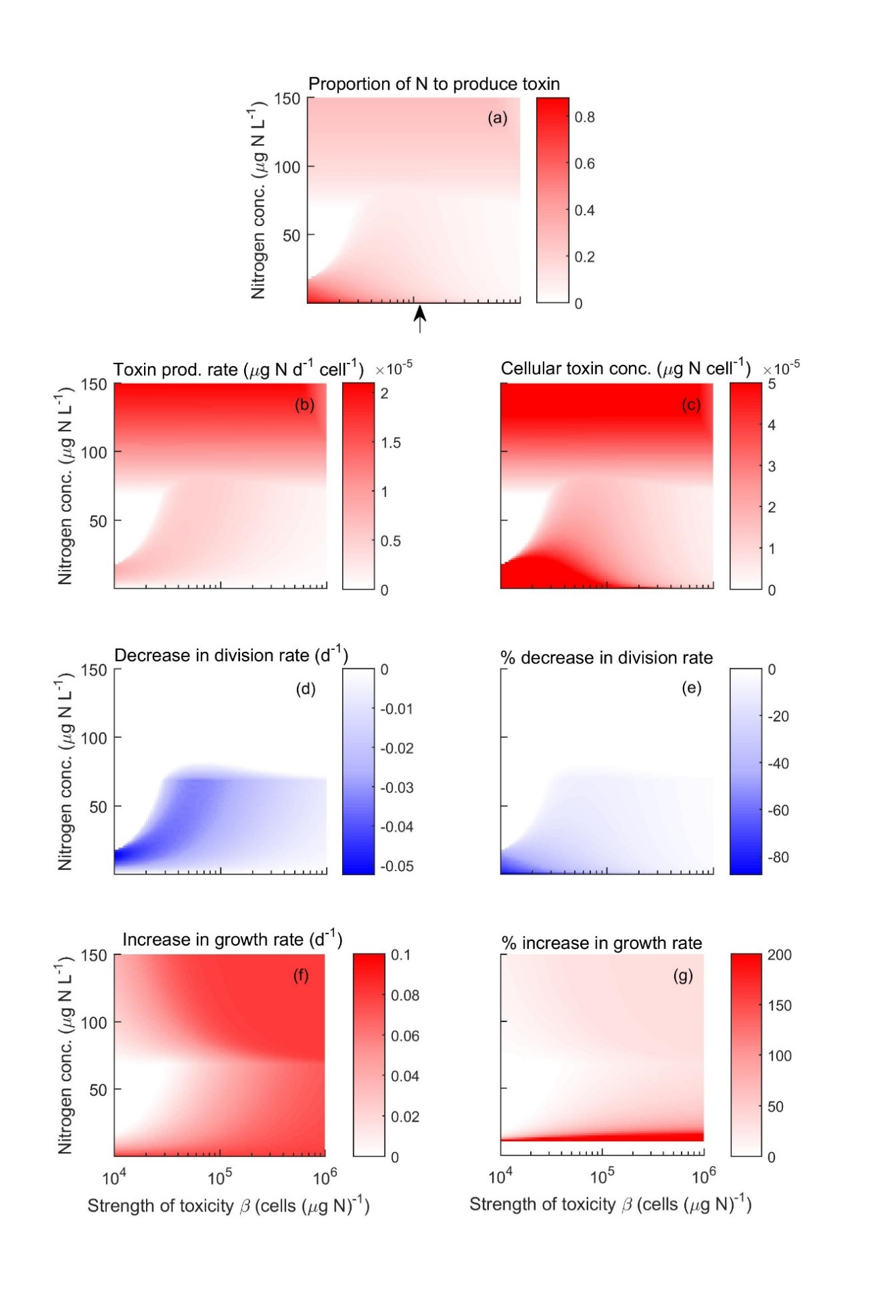
Figure A1
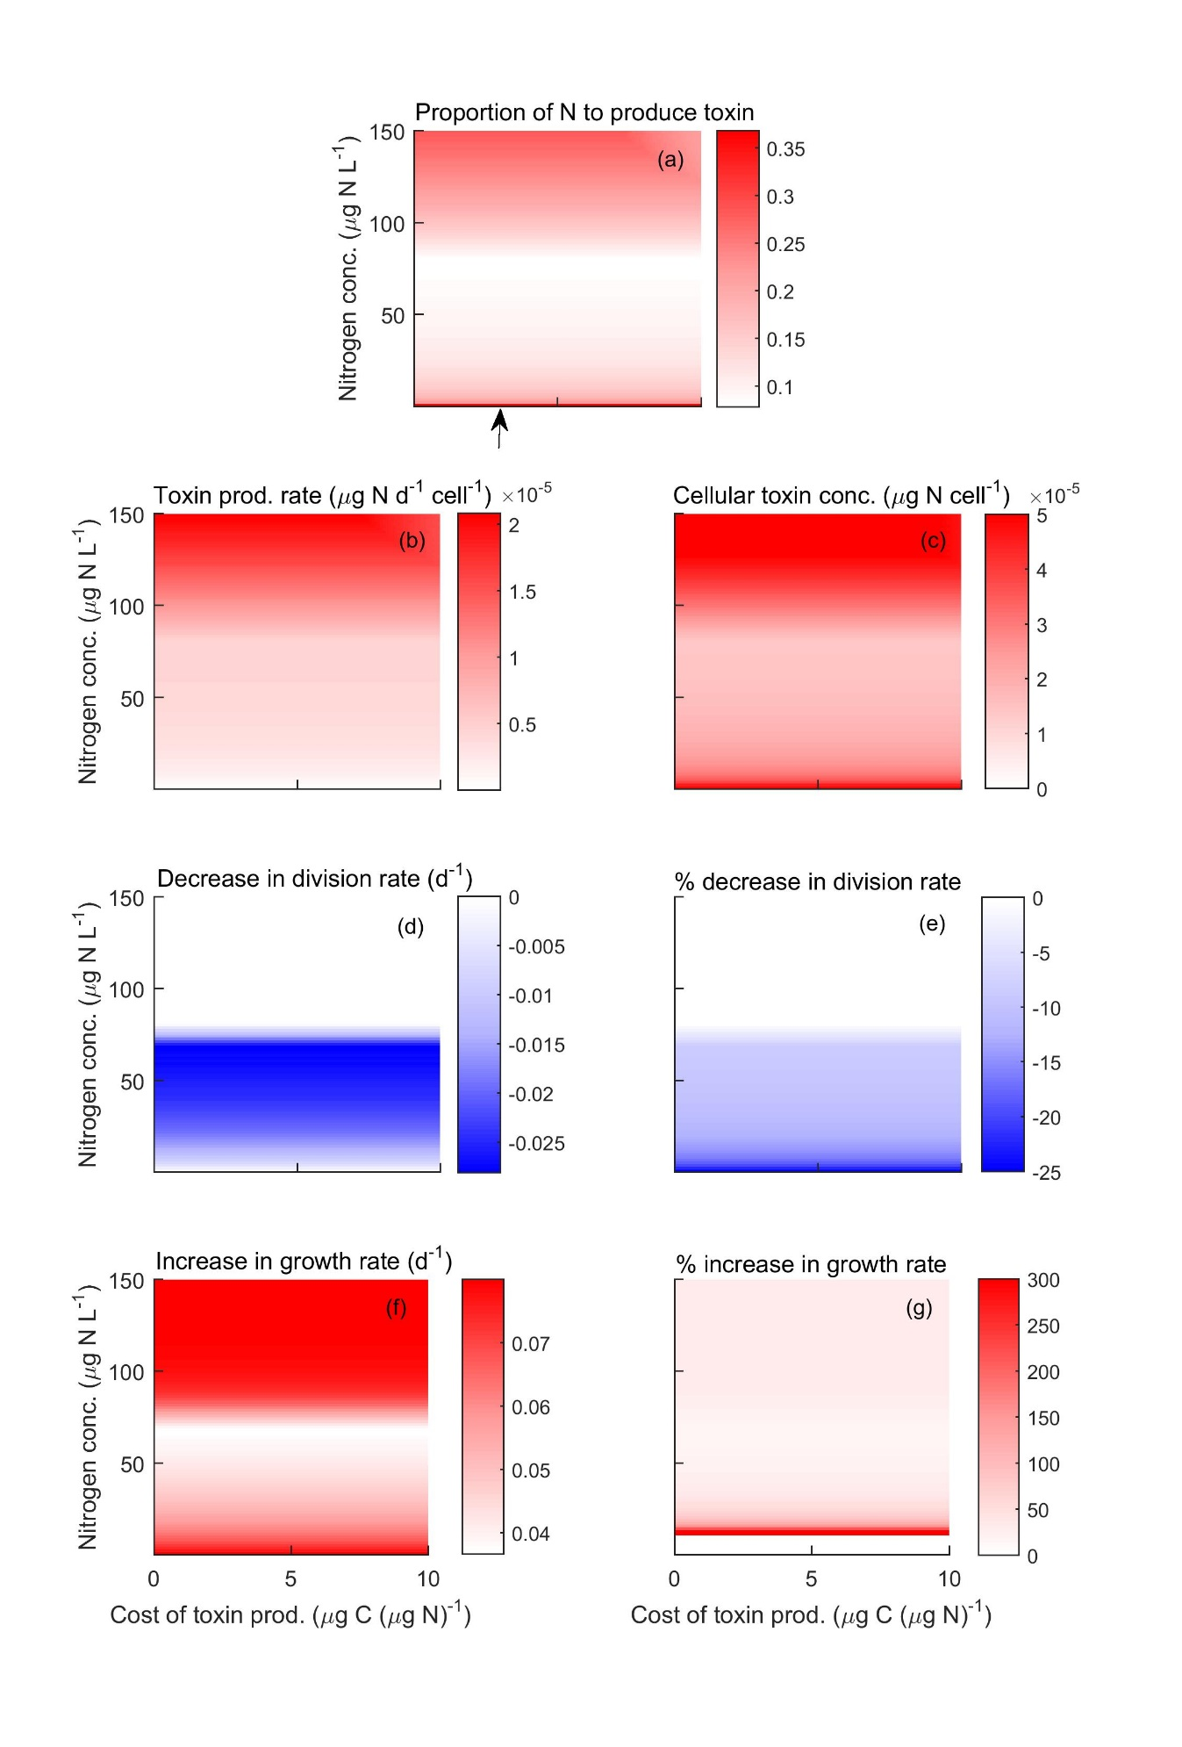
Figure A2

