Table S1. Overview of selected metabolic pathways inferred from the genome of Synechococcus strains BS55D and BS56D. Putative anaerobic pathways were added (fermentation and chlorophyll biosynthesis). Identity percentages and query coverages with closest Synechococcus relatives were determined with BLASTP.
Protein/enzyme | Metabolic pathway | closest genome | % identity (BLASTP) | Query coverage
D-lactate dehydrogenase ldhA | Lactate and acetate Heterofermentation | Synechococcus sp. RS9917 | 86 | 99
Xylulose-5-phosphate phoshphoketolase/Fructose-6-phosphate phosphoketolase xfp xpk | Lactate and acetate Heterofermentation | Synechococcus sp. RS9917 | 93 | 99
Acetate Kinase ackA | Lactate and acetate Heterofermentation | Synechococcus sp. RS9917 | 81 | 98
Acetolactate synthase large subunit ilvB ilvG ilvI | Acetoin synthesis | Synechococcus sp. RS9917 | 91 | 99
Acetolactate synthase small subunit ilvH ilvN | Acetoin synthesis | Synechococcus sp. RS9917 | 96 | 99
Acetolactate synthase catabolic alsC budB | Acetoin synthesis | Synechococcus sp. CB0101 | 73 | 99
Alpha-acetolactate decarboxylase alsD budA aldC | Acetoin synthesis | Synechococcus sp. CB0101 | 71 | 95
Cyanate hydratase CynS | Cyanate hydrolysis | Synechococcus sp. RS9916 | 73 | 96
Nitrite reductase nirA | Nitrate and nitrite ammonification | Synechococcus sp. RS9917 | 87 | 98
Nitrite transporter focA | Nitrate and nitrite ammonification | Synechococcus sp. CB0205 | 94 | 93
Nitrite transporter CorA | Nitrate and nitrite ammonification | Synechococcus sp. RS9917 | 68 | 98
Nitrate transporter nrtP | Nitrate and nitrite ammonification | Synechococcus sp. CB0101 | 93 | 99
Assimilatory nitrate reductase narB | Nitrate and nitrite ammonification | Synechococcus sp. MIT S9508 | 82 | 99
Light-independent protochlorophyllide reductase subunit N chlN | Tetrapyrrole, chlorophyll biosynthesis | Synechococcus sp. RS9916 | 88 | 98
Light-independent protochlorophyllide reductase subunit B chlB | Tetrapyrrole, chlorophyll biosynthesis | Synechococcus sp. RS9916 | 85 | 100
Light-independent protochlorophyllide reductase subunit L chlL | Tetrapyrrole, chlorophyll biosynthesis | Synechococcus sp. WH8109 | 94 | 100
Light-dependent Protochlorophyllide reductase por | Tetrapyrrole, chlorophyll biosynthesis | Synechococcus sp. RS9917 | 90 | 93
Aerobic oxygen-dependent MPE cyclase ChlE | Tetrapyrrole, chlorophyll biosynthesis (aerobic) | Synechococcus sp. RS9917 | 92 | 100
Oxygen dependent oxidase hemF | Tetrapyrrole, chlorophyll biosynthesis (aerobic) | Synechococcus sp. MIT S9509 | 84 | 100
radical SAM family variant BchE | Tetrapyrrole, chlorophyll biosynthesis (anaerobic) | Synechococcus sp. RS9916 | 92 | 97
oxygen-independent oxidase hemN | Tetrapyrrole, chlorophyll biosynthesis (anaerobic) | Synechococcus sp. RS9917 | 77 | 98

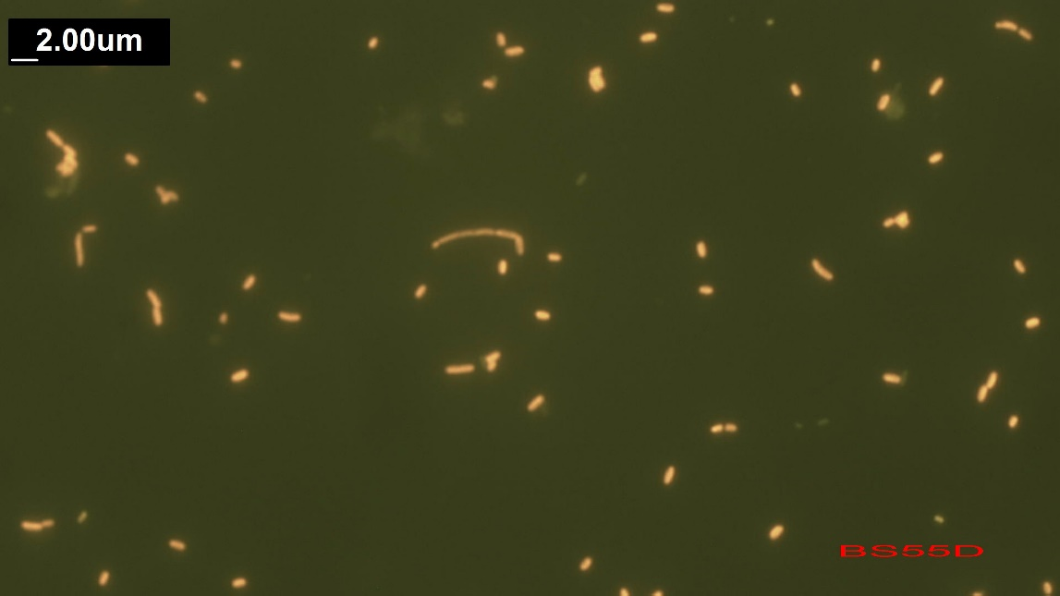
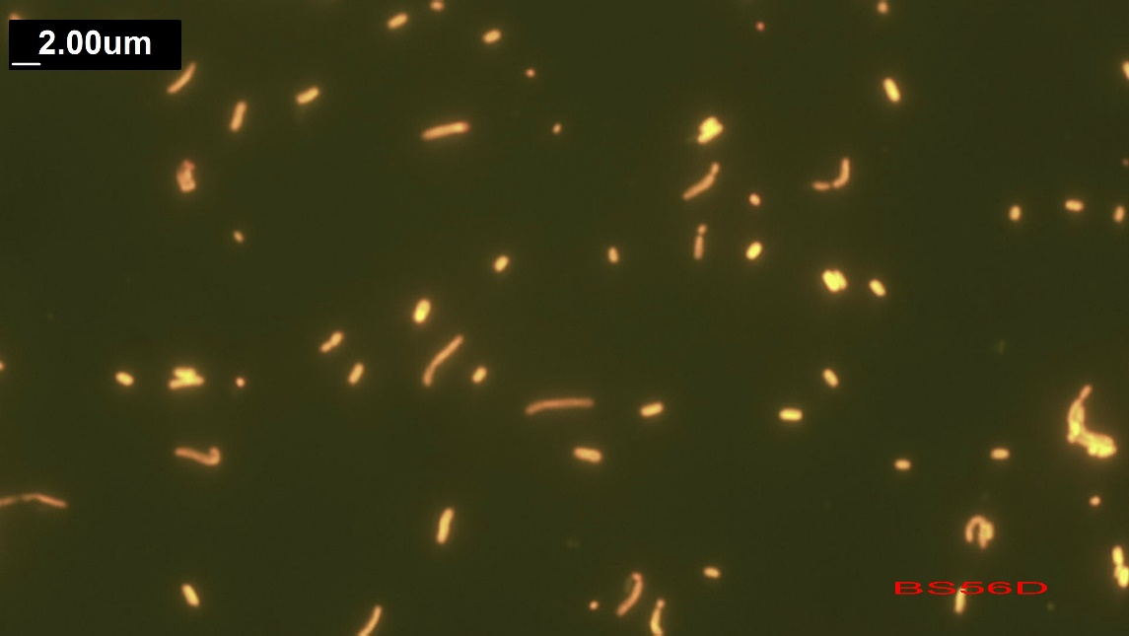

Fig. S1. Synechococcus strain BS55D (size: 1.30x0.69 µm) and Synechococcus BS56D (size: 1.69x0.79µm) isolated from the western gyre of Black Sea at 750 m. The elongated forms are 3-4 µm long. Longer filaments are visible in old cultures under light/oxic conditions (size: 16.6 x 0.36 µm). In the experiment the majority of the cells were short rods.

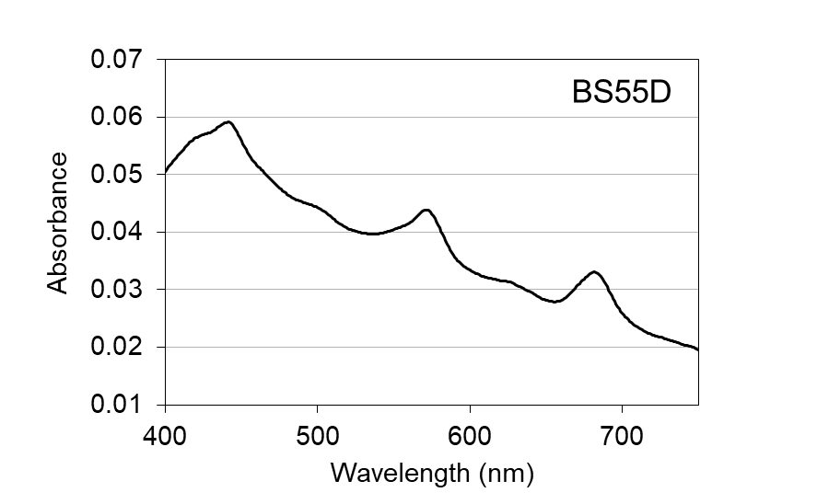
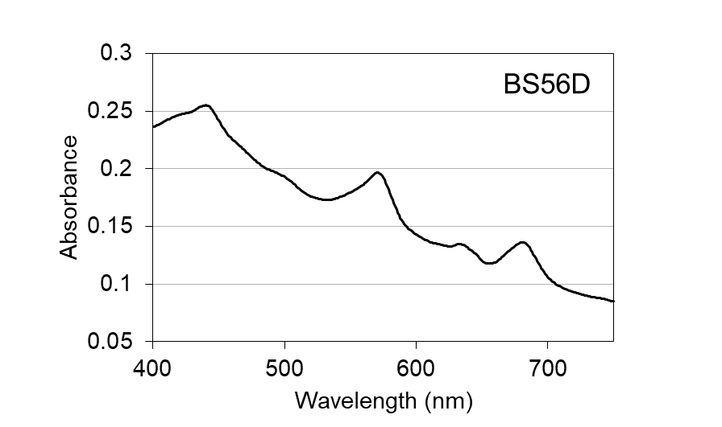

Fig. S2. Absorption spectra of the two Synechococcus strains BS55D (upper) and BS56D (lower). In vivo absorbance spectra of the diluted cultures were measured with a double monochromator spectrophotometer (SAFAS UVMC2) in the wavelength range 400 – 750 nm. Spectra were recorded with a 1 nm interval and 5 nm slit width in a quartz cuvette of 1 cm. 50µL of NaClO 10% was directly added in the cuvette and the samples read again to record the scatter. Absorbance due to scatter was subtracted from the spectra values at each wavelength for each sample.

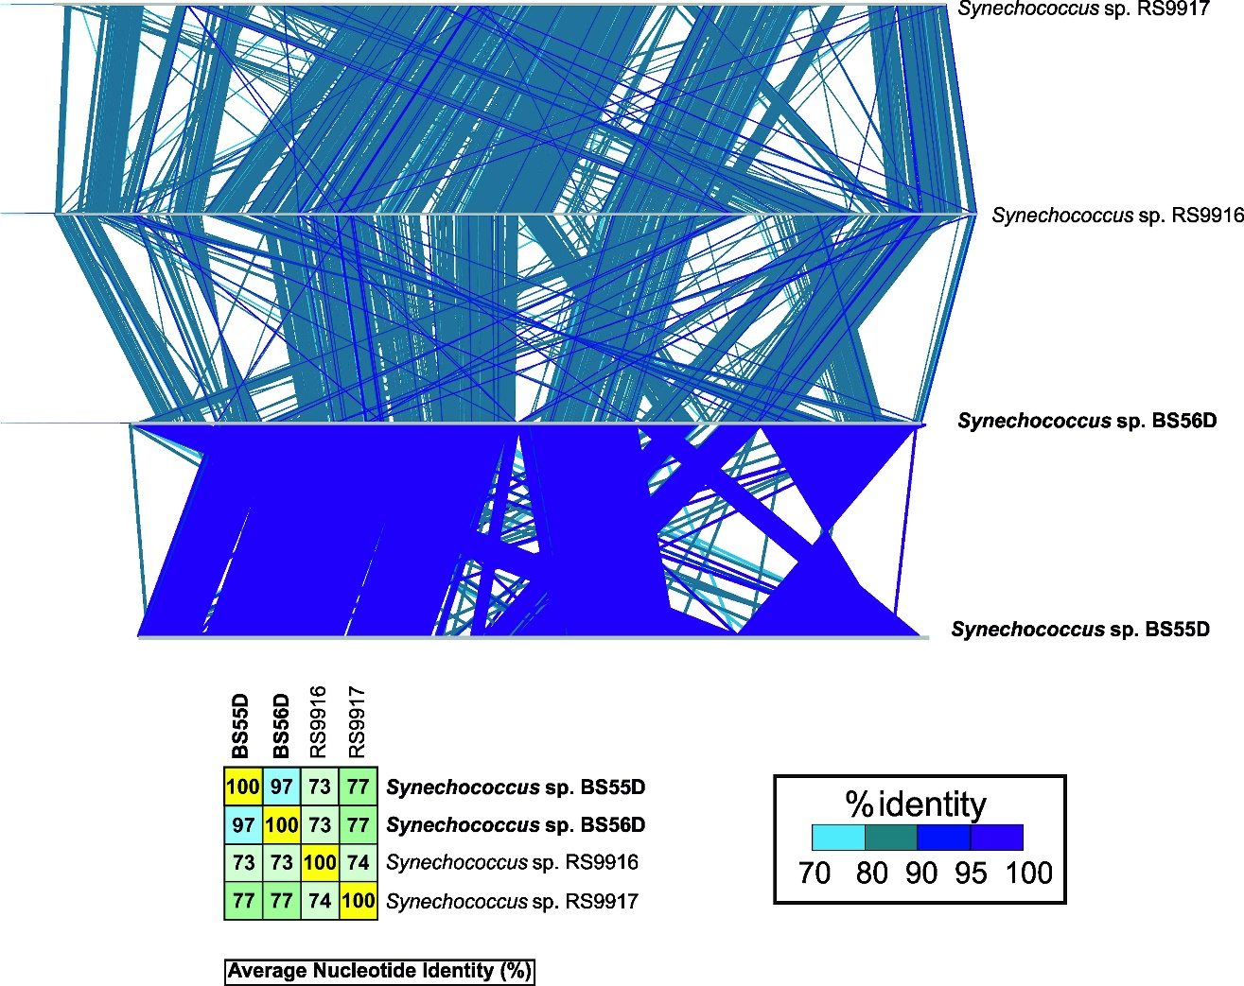

Fig. S3. Synteny plots between Red Sea strains Synechococcus sp. RS9917/RS9916 and Black Sea strain Synechococcus sp. BS56D. Comparison made with BLASTN with >70% identity hits and >100 bp of alignment lengths. Average Nucleotide Identity (ANI) between Red Sea and Black Sea strains is also shown.
The comparison of the synteny between Red Sea strains vs Black Sea deep strains revealed a very similar genetic organization between RS9917/RS9916 and BS55D/BS56D strains, even though ANI (Average Nucleotide Identity) between Black Sea and Red Sea strains was lower than 80%. This illustrate the adaptability of these organisms as it is encoded in the genome through standing ancestral pathways.

