Supplementary information

Materials and Methods

Preparation of microorganisms
A total of 8 bacterial species, including 5 Gram-negative and 3 Gram-positive bacteria and differing widely in their phylogeny and in traits were used in the experiments (Supplementary Table 1). Well-grown bacterial cultures on 0.8% H₂O Agar with 16 ml/l Artificial Root Exudates (ARE) [1] were enriched by suspension in 3 ml Neff’s Modified Amoebae Saline (NMAS) buffer [2] that was carefully scraped off the agar plates and vortexed in centrifuge tubes. Optical densities of all bacterial cultures were measured at 320 nm and adjusted to an OD of 0.5 by adding NMAS to cultures with higher OD.
Eight common soil fungi from the three major phylogenetic groups of Mucoromycotina, Ascomycota and Basidiomycota were used in the experiments (Supplementary Table 2). Well-grown cultures on universal fungal media plates containing 2% agar and 1.5 % malt-extract were suspended by adding 5 ml sterile demineralized H₂O, carefully scraping off spores and mycelia and vortexing in centrifuge tubes. Optical densities of all fungal cultures were measured at 546 nm and adjusted to an OD of 0.5 by adding sterile demineralized H₂O.
The plasmodium-forming protist Physarum polycephalum was grown on 1 % H₂O agar with 2% powdered oatmeal in the dark at 22-26 °C for 2-3 days. An agar block (6 mm in diameter) was cut from the plasmodial front to be used in the experiments.

Decomposition experiment under different temperatures
We set up a microcosm experiment in April 2019 to test the effect of microbial predation by the model protist P. polycephalum on litter decomposition by microorganisms. These microcosms consisted of 50-ml Falcon tubes to which we added 0.5 g leaf litter (Quercus robur), which was collected in the field in October 2017 immediately upon senescence and then was air-dried, sterilized by gamma irradiation (25 kGray) and cut into 1-cm pieces.
We created a microbial inoculum by equally mixing suspensions of all eight bacterial and fungal species. One day after adding the leaf litter, the microbial inoculum (40 μl) was added to half of the tubes. NMAS buffer (40 μl) was added to the other half as control to adjust potential effects of added nutrients. We allowed for microbial establishment for one week and then protists were added to the microcosms by transferring agar pieces containing plasmodium of P. polycephalum. Agar pieces without protist plasmodium were added to microbe-only treatments or controls (i.e., no microbial inoculum). We established four protist treatments: no protists (control), low, medium, or high concentrations (Supplementary Table 3). Half of the tubes were incubated at low temperature (17˚C for 16 hours by day and 13˚C for 8 hours at night) and the other half at high temperature (21˚C for 16 hours by day and 16˚C for 8 hours at night). This resulted in a total of 16 treatments: 2 microbial inocula (yes/no) × 4 protist treatments (no, or low, mid, or high concentration) × 2 temperature treaments (17/21 ˚C). We used six replicates per treatment, resulting in 96 microcosms in total. As we could not avoid contamination by airborne microbes when opening the tubes for measurements throughout the experiment, the non-microbe controls were only used to check whether initial microbial inoculation was successful (i.e., resulted in increased respiration). As such, we compared non-microbial treatments with microbial treatments in a separate analysis to evaluate the success of initiating a decomposer microbiome. For the latter analyses, the non-microbe treatments were excluded to allow a balanced analysis to test for the impact of protists on decomposition. Microcosms were incubated in the climate chambers for nine weeks. Throughout the 9 weeks of the experiment, we watered the tubes four times using sterilized water (a total of 2.5 g microcosm⁻¹, equaling approx. 60% water holding capacity) to maintain a moist environment to sustain microbial activity. Microcosms were incubated with a cap loosely placed on top of them, to allow for CO₂ exchange.
We measured the microbial respiration (CO₂ efflux) to investigate microbial activity throughout the experiment. Measurements were collected at day 3, 8, 10, 15, 17, 23, 30, 44 and 58 of the experiment. Measurements at day 3 and 8 were before the addition of protists (establishment phase of microbial inocula), day 10 was two days after the addition of protists. When starting the sampling procedure, we closed all microcosms using lids with a septum. We included four empty tubes (no litter, no inocula) as measurement controls. All tubes were flushed with CO₂-free air for 2 min at 2 bar, incubated for 4 h at 17˚C and 21˚C, respectively. After 4 h we collected 12 ml of headspace CO₂ with a syringe and transferred this into Exetainers (Labco, Lampeter, United Kingdom). Exetainers were stored at 4 °C until measurement on a CH₄/CO₂ analyser (Thermo Scientific Trace Ultra Gas Chromatography system using Tri-Plus RSH injection Robot (Thermo Scientific). CO₂ concentrations (µg/g litter) were calculated using Chromeleon 7.2 (Thermo Scientific).
We determined litter mass loss by comparing the initial litter mass (g) and litter mass (g) after freeze-drying (Manual Labconco Freezone 12 Freeze-dryer) the samples for four days at the end of the experiment. A subsample of the litter was ground and used to determine the content of carbon (C) and nitrogen (N) on an Element Analyzer (Thermo Scientific Flash EA 1112).

Interaction experiment through volatiles between Physarum and other microbes
Two-compartment petri plates (90 mm) were filled half with ARE agar to be inoculated in the center of one side with a 6 mm Physarum plasmodium-containing agar blocks. The other half was filled with Nutrient Agar (3 g beef extract, 5 g peptone, 15 g agar) for inoculating 20 µl suspension of individual bacteria or with Potato Dextrose Agar (4 g potato extract, 20 g dextrose, 15 g agar) for inoculating 20 µl of individual fungi. Bacterial and fungal suspensions were equally spread across the surface with a sterile plastic L rod (Fig. S3). Uninoculated culture media served as controls. Five replicate plates were prepared per treatment and incubated at 20ºC in the dark. Then, the distance travelled by the plasmodia was measured after 3 days of incubation. Controls were established where no bacteria or fungi were added on the other side of the protist. All plates were sealed with air-permeable parafilm to reduce an accumulation of air in the containers. As the protists and bacteria/fungi were inoculated to different sides of the petri dishes and no contamination of any microbe to the non-inoculated side was observed throughout the experiment, we used the setup to test for volatile-induced effects of the bacteria and fungi on the protist, as often these volatile effects mirror those of direct predation interactions [3].

Data Analyses
Data were analysed in R [4].
To test the effect of the microbial inoculum on initial CO₂ production (first week after addition of microbial inocula) we used a general linear model with microbial inoculum (yes or no microbes added), temperature treatment (17 or 21ºC) and their interaction as fixed factors and cumulative CO₂ production in the first week as a response variable. This test was used to check whether the microbial inoculum was effective, i.e., resulted in CO₂ respiration. For further analyses we focused only on the microcosms with microbial inocula because we were not able to maintain microcosms without microbial inocula sterile and because our main aim was to test how predation by protists affected decomposition processes. To test how protist addition affected cumulative CO₂ production (total CO₂ production in the period after protist addition), litter mass loss and litter C and N content in the remaining litter we used general linear models with protist concentration (no protists and low, medium and high concentrations) and temperature treatment as fixed factors. To test the interaction between the model protist and other microbes, we used a general linear model with plasmodial length as a response variable and bacterial and fungal species as respective fixed factors.

Supplementary Tables
Supplementary Table 1. Bacteria used in the experiment
Code | Gram stain | Bacterial family | Bacterial strain
B1 | Gram (-) | Sphingobacteriaceae | Pedobacter sp. VuD
B2 | Gram (-) | Oxalobacteraceae | Janthinobacterium sp. ADdo
B3 | Gram (-) | Pseudomonadaceae | Pseudomonas sp. AD21
B4 | Gram (+) | Paenibacillaceae | Paenibacillus sp. Add7
B5 | Gram (-) | Rhodanobacteraceae | Dyella sp. AD56
B6 | Gram (+) | Bacillaceae | Bacillus sp. V102
B7 | Gram (-) | Enterobacteraceae | Serratia plymuthica PR1-2C
B8 | Gram (-) | Oxalobacteraceae | Collimonas pratensis T91

Supplementary Table 2. Fungal cultures used in the experiments
Code | Fungal | Fungal (sub)phylum | Fungal strain
F1 | Saprotroph | Mucoromycotina | Rhizopus oryzae
F2 | Saprotroph | Mucoromycotina | Mucor hiemalis
F3 | Plant pathogen | Basidiomycota | Rhizoctonia sp.
F4 | Saprotroph | Basidiomycota | Ceratobasidium sp.
F5 | Plant pathogen | Ascomycota | Fusarium oxysporum
F6 | Plant pathogen | Ascomycota | Phoma exigua
F7 | Saprotroph | Ascomycota | Penicillium chrysogenum
F8 | Saprotroph | Ascomycota | Trichoderma citrinoviride

Supplementary Table 3. The communities of protists with (+) or without (–) fungi and bacteria. Communities 1, 3, 5 and 7 were established as an initial control to check for successful inoculation but were not further analysed as the containers were not maintained sterile during measurement. All communities were incubated at 17 and 21°C, resulting in 16 experimental treatments in total.
Communities | P. polycephalum concentration | P. polycephalum plasmodium-containing agar blocks (1 cm²) added to microcosms | Bacteria & Fungi
1 | No protists | Circular area of sterile agar | –
2 | No protists | Circular area of sterile agar | +
3 | Low | ¼ area of agar with plasmodium + ¾ of sterile agar | –
4 | Low | ¼ area of agar with plasmodium + ¾ of sterile agar | +
5 | Medium | ½ area of agar with plasmodium + ½ of sterile agar | –
6 | Medium | ½ area of agar with plasmodium + ½ of sterile agar | +
7 | High | Full circular area of agar with plasmodium | –
8 | High | Full circular area of agar with plasmodium | +

Supplementary Figures

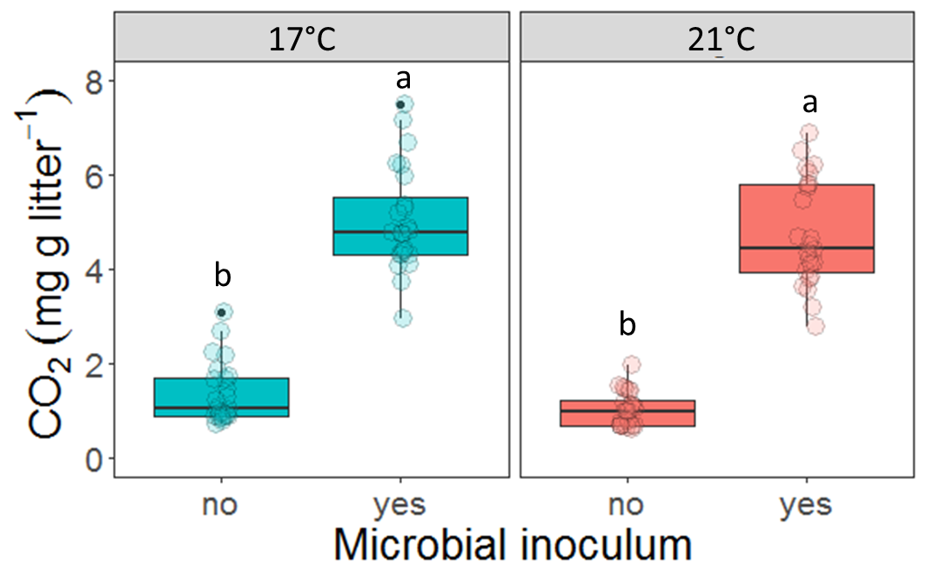
Fig. S1. Boxplots showing cumulative CO₂ respiration measured in the first week after the addition of the microbial inoculum (before the addition of the protists) at 17° and 21°C. Different letters above the boxes indicate significant differences (p < 0.05) between treatments, as was indicated in a Tukey HSD posthoc test. Tukey tests were carried out across inoculum × temperature interactions, so letters can be compared across facets.
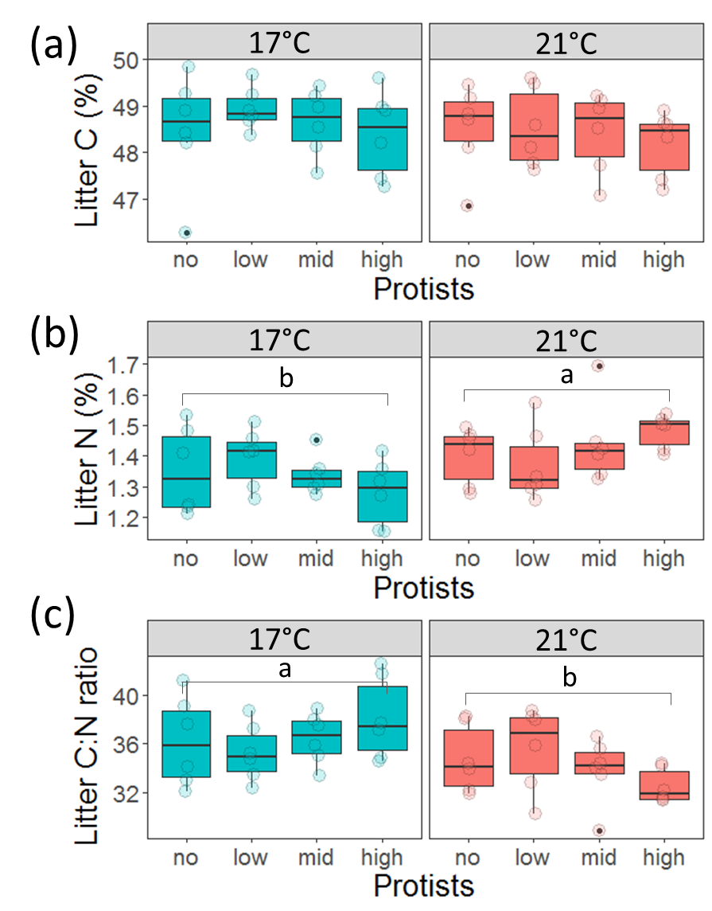
Fig. S2. Boxplots showing (a) litter carbon content (C), (b) litter N (N) content and (c) litter C:N ratio at 17° and 21°C at the end of the experiment. Different letters above the boxes indicate significant differences (p < 0.05) between treatments, as was indicated in a Tukey HSD posthoc test. Tukey tests were carried out across temperature treatments, so letters can be compared across facets.
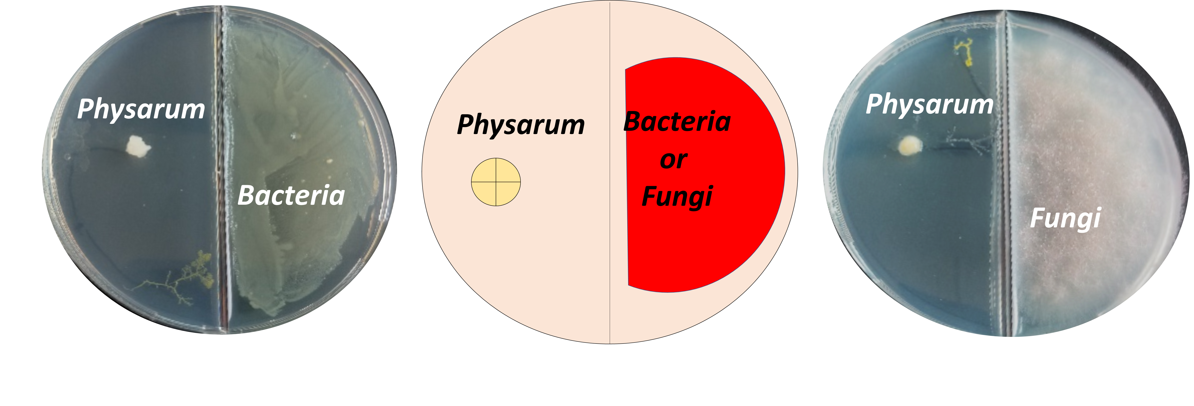
Fig. S3. Setup of the interaction experiment between Physarum polycephalum and individual bacterial and fungal species.

References
1 Baudoin, E., Benizri, E. & Guckert, A. Impact of artificial root exudates on the bacterial community structure in bulk soil and maize rhizosphere. Soil Biology and Biochemistry 35, 1183-1192 (2003).
2 Page, F. C. (Freshwater Biological Association (Ambleside), 1976).
3 Schulz-Bohm, K., Geisen, S., Wubs, E. R. J., Song, C., de Boer, W. & Garbeva, P. The prey's scent - Volatile organic compound mediated interactions between soil bacteria and their protist predators. ISME J 11, 817–820 (2017).
4 R: A language and environment for statistical computing. R Foundation for Statistical Computing, Vienna, Austria. URL http://www.R-project.org/ (R Foundation for Statistical Computing, Vienna, Austria, 2019).

