Electrogenic sulfide oxidation mediated by cable bacteria stimulate sulfate reduction in Freshwater sediments

Supplementary Information

Tobias Sandfeld^{1,2}, Ugo Marzocchi^{2,4,}, Caitlin Petro^{1,2,3}, Andreas Schramm^{1,2,3} and Nils Risgaard-Petersen^{1,2,3}.
- Institute for Bioscience Aarhus University, Aarhus, Denmark
- Center for Geomicrobiology, Aarhus University, Aarhus, Denmark
- Center for Electromicrobiology Aarhus University, Aarhus, Denmark
- Department of Chemistry, Vrjie Universiteit Brussel, Brussels, Belgium

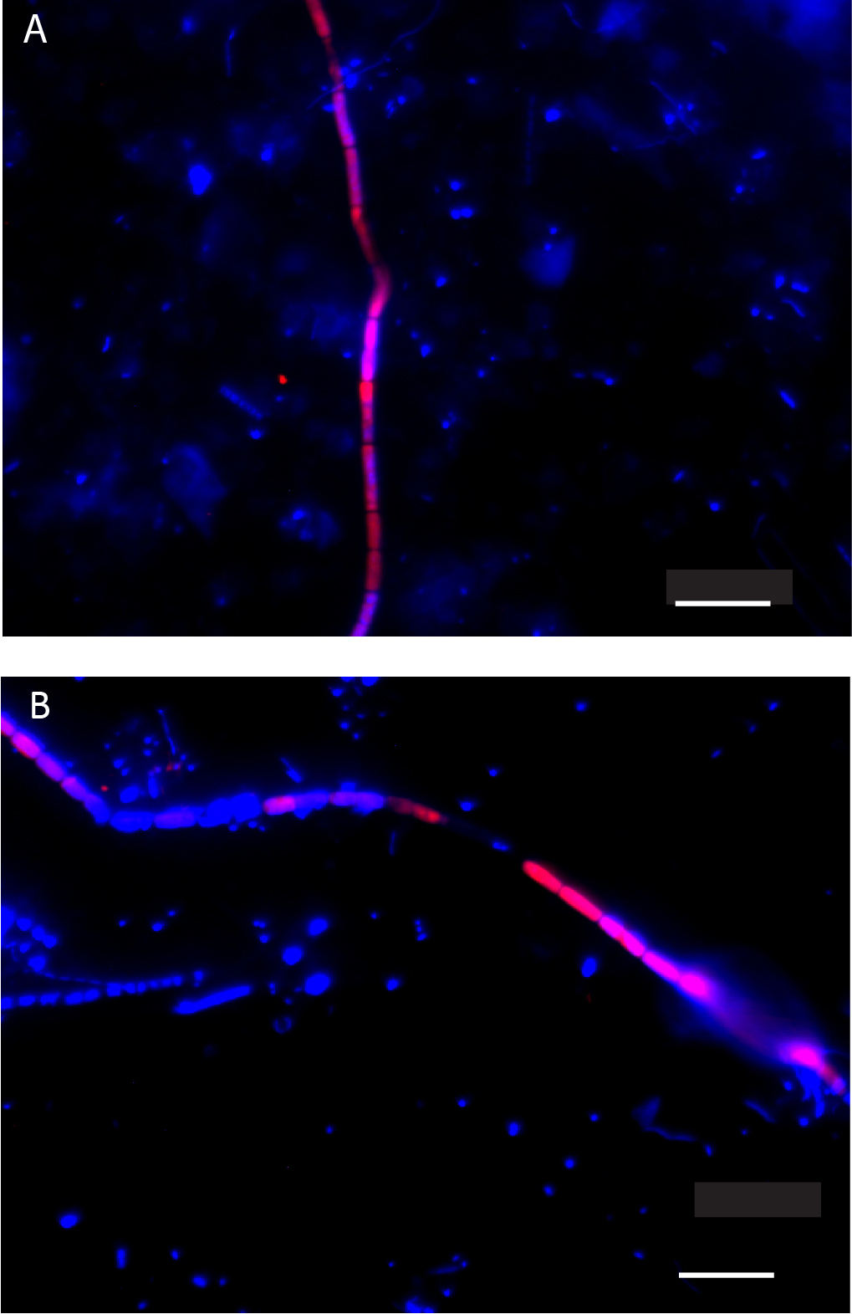
Figure S1. FISH image of cable bacteria from ES sediments from Vilhelmsborg Sø (A) and Skanderborg Sø (B). Cable bacteria are visualized by the DSB 706 probe (red) and counterstained with DAPI (blue). Scale bars represent a length of 10 µm.

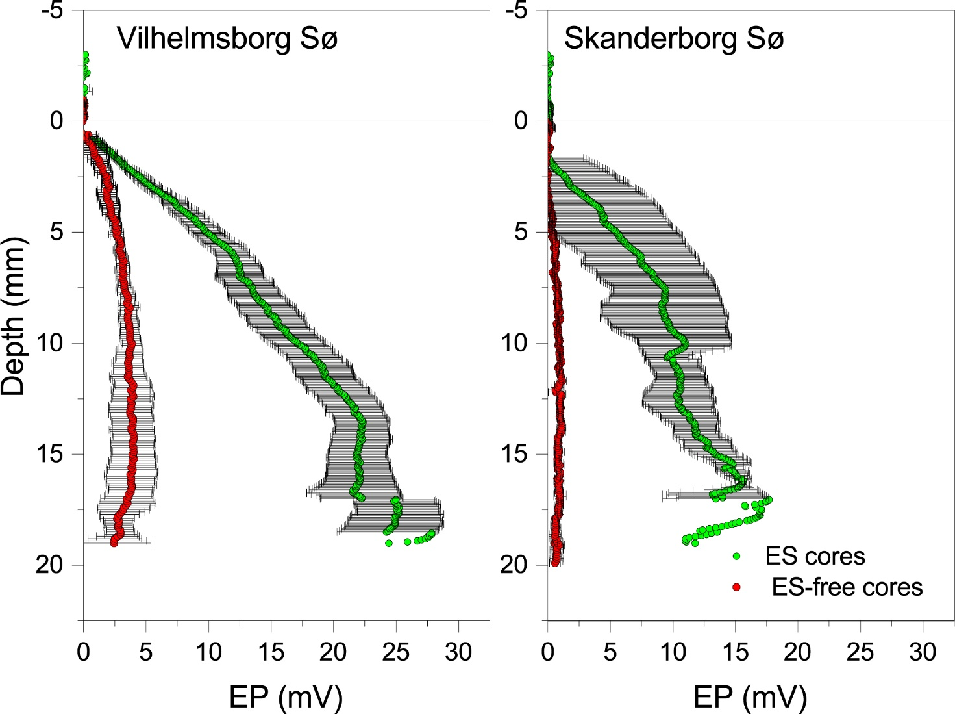

Figure S2: Electric potential distribution in ES (green) and ES-free cores (red) from Vilhelmsborg Sø and Skanderborg Sø. Data are represented as the mean of profiles measured in three replicate cores. Error bars represent standard error of the mean.

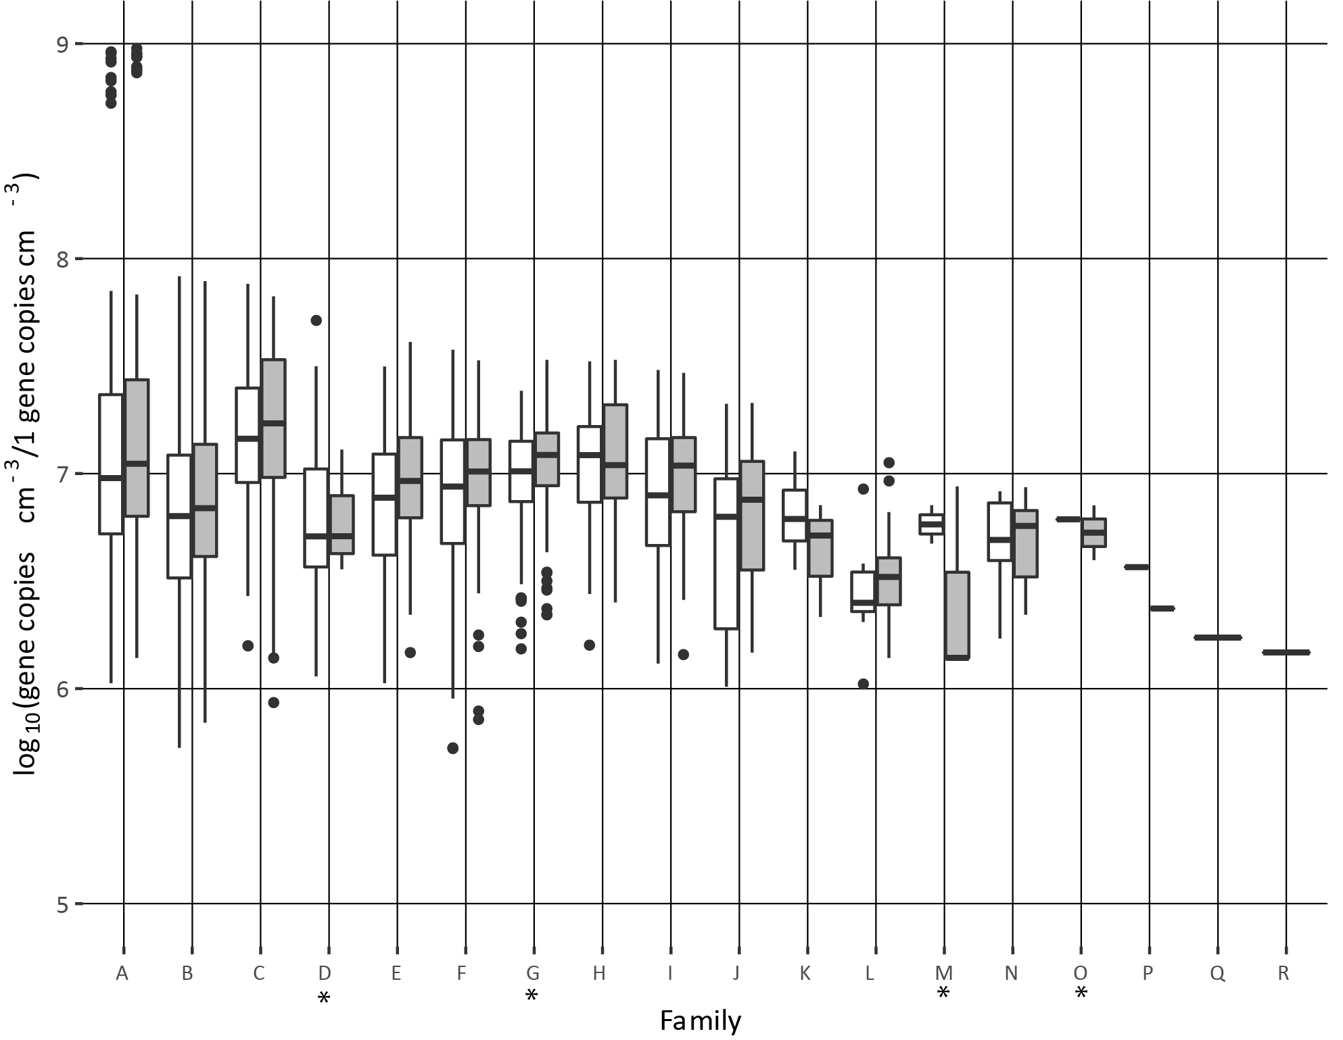

Figure S3. dsrB genes assigned to families in ES cores (white) and ES-free cores (grey) from Vilhelmsborg Sø. Horizontal line represent the median and vertical lines represent the lower (25%) and upper (75%) quantiles. Letters on the x-axis represent families. Asterisk indicate those with oxidative dsrAB genes. With the nomenclature Family/Order/ Supercluster/Type, the families are:
ID | Family
A | Desulfobacteraceae/Deltaproteobacteria/Deltaproteobacteria_supercluster/Reductive_bacterial_type_dsrAB
B | Unclassified/Unclassified/Unclassified/Unclassified
C | Unclassified/Unclassified/Deltaproteobacteria_supercluster/Reductive_bacterial_type_dsrAB
D | Unclassified/Gammaproteobacteria/Proteobacteria/Oxidative_bacterial_type_dsrAB
E | Unclassified/Unclassified/Environmental_supercluster_1/Reductive_bacterial_type_dsrAB
F | Desulfobulbaceae/Deltaproteobacteria/Deltaproteobacteria_supercluster/Reductive_bacterial_type_dsrAB
G | Unclassified/Betaproteobacteria/Proteobacteria/Oxidative_bacterial_type_dsrAB
H | Desulfobacca_acetoxidans_lineage/Deltaproteobacteria/Deltaproteobacteria_supercluster/Reductive_bacterial_type_dsrAB
I | Uncultured_family-level_lineage_5/Unclassified/FACA_group_sensu_lato/Reductive_bacterial_type_dsrAB
J | Unclassified/Unclassified/FACA_group_sensu_lato/Reductive_bacterial_type_dsrAB
K | Uncultured_family-level_lineage_10/Unclassified/Nitrospirae_supercluster/Reductive_bacterial_type_dsrAB
L | Uncultured_family-level_lineage_9/Unclassified/Environmental_supercluster_1/Reductive_bacterial_type_dsrAB
M | Unclassified/Unclassified/Proteobacteria/Oxidative_bacterial_type_dsrAB
N | Uncultured_family-level_lineage_6/Unclassified/FACA_group_sensu_lato/Reductive_bacterial_type_dsrAB
O | Unclassified/Unclassified/Unclassified/Oxidative_bacterial_type_dsrAB
P | Uncultured_family-level_lineage_1/Unclassified/Deltaproteobacteria_supercluster/Reductive_bacterial_type_dsrAB
Q | Gordonibacter/Actinobacteria/FACA_group_sensu_lato/Reductive_bacterial_type_dsrAB
R | Desulfomonile_tiedjei_lineage/Deltaproteobacteria/Deltaproteobacteria_supercluster/Reductive_bacterial_type_dsrAB

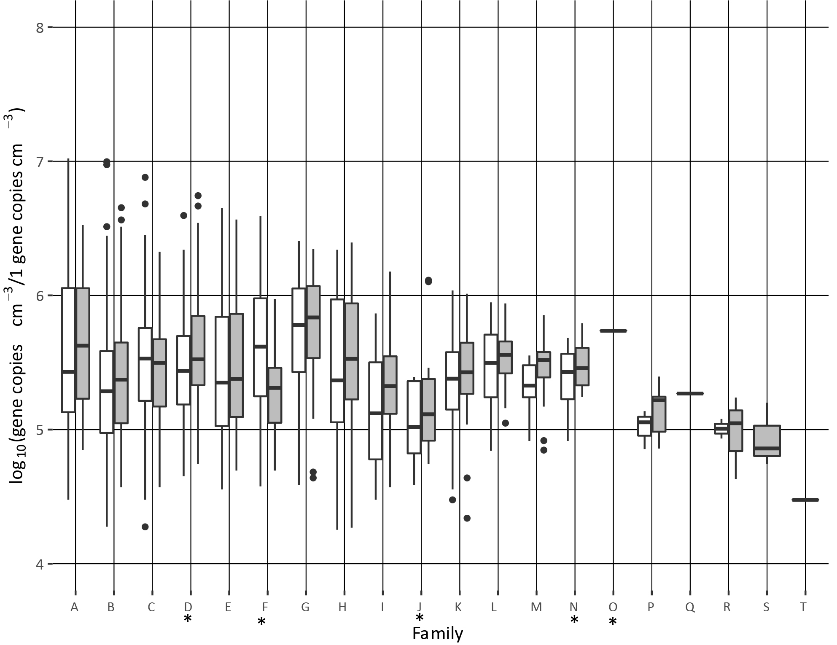
Figure S4. dsrB genes assigned to families in ES cores (white) and ES-free cores (grey) from Skanderborg Sø. Horizontal line represent the median and vertical lines represent the lower (25%) and upper (75%) quantiles. Asterisk indicate those with oxidative dsrAB genes. With the nomenclature Family/Order/ Supercluster/Type, the families are:

ID | Family
A | Unclassified/Unclassified/Environmental_supercluster_1/Reductive_bacterial_type_dsrAB
B | Unclassified/Unclassified/Unclassified/Unclassified
C | Desulfobacteraceae/Deltaproteobacteria/Deltaproteobacteria_supercluster/Reductive_bacterial_type_dsrAB
D | Unclassified/Betaproteobacteria/Proteobacteria/Oxidative_bacterial_type_dsrAB
E | Uncultured_family-level_lineage_5/Unclassified/FACA_group_sensu_lato/Reductive_bacterial_type_dsrAB
F | Unclassified/Gammaproteobacteria/Proteobacteria/Oxidative_bacterial_type_dsrAB
G | Uncultured_family-level_lineage_9/Unclassified/Environmental_supercluster_1/Reductive_bacterial_type_dsrAB
H | Unclassified/Unclassified/Deltaproteobacteria_supercluster/Reductive_bacterial_type_dsrAB
I | Unclassified/Unclassified/FACA_group_sensu_lato/Reductive_bacterial_type_dsrAB
J | Unclassified/Unclassified/Proteobacteria/Oxidative_bacterial_type_dsrAB
K | Desulfobulbaceae/Deltaproteobacteria/Deltaproteobacteria_supercluster/Reductive_bacterial_type_dsrAB
L | Desulfobacca_acetoxidans_lineage/Deltaproteobacteria/Deltaproteobacteria_supercluster/Reductive_bacterial_type_dsrAB
M | Uncultured_family-level_lineage_6/Unclassified/FACA_group_sensu_lato/Reductive_bacterial_type_dsrAB
N | Unclassified/Alphaproteobacteria/Proteobacteria/Oxidative_bacterial_type_dsrAB
O | Unclassified/Unclassified/Unclassified/Oxidative_bacterial_type_dsrAB
P | Uncultured_family-level_lineage_10/Unclassified/Nitrospirae_supercluster/Reductive_bacterial_type_dsrAB
Q | Uncultured_family-level_lineage_1/Unclassified/Deltaproteobacteria_supercluster/Reductive_bacterial_type_dsrAB
R | Desulfomonile_tiedjei_lineage/Deltaproteobacteria/Deltaproteobacteria_supercluster/Reductive_bacterial_type_dsrAB
S | Sporomusaceae/Clostridia/FACA_group_sensu_lato/Reductive_bacterial_type_dsrAB
T | Syntrophobacteraceae/Deltaproteobacteria/Deltaproteobacteria_supercluster/Reductive_bacterial_type_dsrAB

