Supplementary Information:
Climate change alters temporal dynamics of alpine soil microbial functioning and biogeochemical cycling via earlier snowmelt

Supplementary materials and methods
Soil sampling
The five sub-samples of soil taken for molecular analyses were added to sterile MP Bio lysing matrix E tubes containing DNA/RNA shield solutionTM (Zymo Research Corp, Irvine, CA, USA) to achieve 10% w/v sample to preservation buffer. Lysis was immediately performed in the field using an MP Bio SuperFastPrep1 and Homogenizer (MP Biomedicals, Santa Ana, CA, USA) for 30 sec at full speed.

PLFA analyses
PLFAs were extracted from freeze-dried soil, as modified by Buyer and Sasser [1], and analysed on a gas chromatograph (Agilent 7890A Gas chromatograph, Santa Clara, CA, USA). Abundance of PLFAs was expressed in nmol PLFA g⁻¹ dry soil. PLFAs were assigned as indicators of fungal and bacterial abundance, with 18:2ω6,9 used for fungi; 16:1ω9, cy17:0, 18:1ω7 and cy19:0 used for Gram-negative bacteria; a15:0, i15:0, i16:0, a17:0 and i17:0 used for Gram-positive bacteria; 15:0 and 17:0 used for bacteria; and 18:1ω9, 16:0 and 18:0 considered as non-specific biomarkers [2–4]. The marker 18:1ω9 is sometimes used as a fungal marker, however, this is only recommended if it correlates closely with the main fungal marker 18:2ω6,9, and when 18:2ω6,9 is abundant, otherwise 18:1ω9 can be an indicator of bacteria [3]. Total PLFA abundance and the ratios of fungal to bacterial markers and Gram positive (+) to Gram negative (-) bacterial markers were also calculated.

Soil respiration measurements
To test if snow manipulation treatments affected soil respiration, CO₂ flux measurements were taken during two of the soil sampling time points (spring 12/6 and summer 8/7), and three additional time points (20/6, 21/6 and 13/8). Circular gas sampling collars were inserted into the soil (Ø = 10 cm) in June and vegetation was removed from the soil respiration collars prior to each sampling. During sampling the SRC was sealed onto gas sampling collars and CO₂ flux was measured over 2 minutes.

Extracellular enzyme assays
We measured a suite of eight extracellular soil enzymes, specifically β-glucosidase (GLC), cellobiohydrolase (CBH), β-xylosidase (XYL), phenol oxidase (POX), peroxidase (PER), N-acetylglucosaminidase (NAG), phosphatase (PHO), and urease (URE). GLC and CBH contribute to the degradation of cellulose and other β-1,4 glucans [5]. XYL contributes to the breakdown of the complex plant cell wall polysaccharide xylan [6]. NAG degrades chitin and other β-1,4-linked glucosamine polymers [5]. PHO hydrolyses phosphomonoesters, and in some cases phosphodiesters, releasing phosphate [5], and URE hydrolyses urea to ammonia. POX and PER play a large role in the degradation of polyphenols (e.g. lignin, tannin and their degradation products) [5].
GLC, CBH, XYL, NAG and PHO were measured photometrically according to Jackson et al. [7], with modifications. First, 3.75 g of sieved soil was suspended in 5 mL of sodium acetate buffer (50 mM, pH 5.0). Then 150 μl of this soil slurry was introduced into a 96-well deepwell block and mixed with 150 μl of a substrate solution: 20 mM pNP-β-glucopyranoside for GLC, 2 mM pNP-β-D-cellobioside for CBH, 10 mM pNP-β-xylopyranoside for XYL, 5 mM pNP-β-N-acetylglucosaminide for NAG and 5 mM pNP -phosphate disodium salt hexahydrate for PHO. Blocks were incubated at 18 °C for 0.5 h (PHO), 1.5 h (GLC), 2 h (CBH and NAG) or 3 h (XYL) under continuous shaking. Blocks were then centrifuged (2900 x g, 5 min), 100 µl of the supernatant pipetted into transparent 96-well plates and mixed with 200 µl of 50 mM NaOH solution. Absorbance was measured at 405 nm in a plate reader (EZ400 Research, Biochrom, Germany) and corrected for soil and substrate colouration. pNP concentration was calculated from an absorbance calibration curve of pNP at concentrations up to 0.5 mM. Reported activity is the mean of four analytical replicates for each soil sample.
POX and PER activities were measured photometrically as described in De Long et al. [8]. Briefly, 0.25 g of soil was suspended in 25 ml of sodium acetate buffer (50 mM, pH 5.0). Then 0.4 ml of soil slurry was extracted under continuous shaking and mixed (1:1) with a 20 mM L-3,4-dihydroxyphenylalanin (L-DOPA) solution in a deep-well block. Blocks were shaken for 10 min and centrifuged (2900 x g, 5 min), and then 250 µl of the supernatant was pipetted into transparent 96-well plates. For peroxidase activity, wells additionally received 10 µl of a 0.3% H₂O₂ solution. Absorbance was measured at 450 nm in a plate reader (EZ400 Research, Biochrom, Germany) at the starting time point (t0), after 1.5 h (t1 for PER) and after 20 h (t1 for POX) at 18 °C. Enzyme activity was calculated from the difference in absorption between the two time points, corrected for substrate colouration, and using a previously published value of the micromolar extinction coefficient of oxidized L-DOPA (7.9 µmol-1) [9]. For PER activity, POX activity was subtracted as both enzymes could be oxidizing DOPA in the presence of O₂ and H₂O₂. Reported activity is the mean of three analytical replicates for each soil sample.
URE activity was evaluated by ammonia production according to Kandeler & Gerber [10], with modifications. First, 1 g of soil was incubated with 500 µl of 80 mM urea solution at 18 °C for 2 h. Then ammonia was extracted with 10 ml of 2 M KCl, and ammonia in extracts before and after incubation was evaluated with an Auto Analyzer AA3 (Seal Analytical, UK) by the Berthelot reaction. Reported activity is the mean of three analytical replicates for each soil sample.

DNA extraction
Prior to DNA extraction samples were thawed at room temperature and treated to an additional lysis step on MP Bio FastPrep24 Homogenizer for 30 sec at 5 m/s. Samples were centrifuged at 14,000 x g for 10 min and 400 µl of supernatant transferred to Zymo-Spin™ IV Spin Filter and further centrifuged at 8,000 x g for 1 minute. Filtrate was combined with 1200 µl soil binding buffer and DNA extraction continued as per manufacturer’s protocol. Eluted DNA was stored at -20 °C prior to downstream analysis.

2-step Illumina PCR protocol
Extracted DNA was quantified using the nanodrop 8000 UV-Vis spectrophotometer (ThermoFisher scientific, MA, USA). To produce Illumina tagged libraries a 2-step PCR protocol was employed. The first step amplifies using a gene specific primer (Bold) with addition of an Illumina adapter (IA).
16S IA primers:
16SV5IAF ACACTCTTTCCCTACACGACGCTCTTCCGATCTGGATTAGATACCCTGGTA
16SV6AIR AGACGTGTGCTCTTCCGATCTCGACRRCCARGCANCACCT
ITS IA primers:
ITS2IAF ACACTCTTTCCCTACACGACGCTCTTCCGATCTTCCTCCGCTTATTGATATGC
ITS2IAR AGACGTGTGCTCTTCCGATCTGTGARTCATCGAATCTTTG
Approx 20 ng DNA template was combined with 1 µl 10mM dNTPs, 0.5 µl Illumina tag primer F (100µM), 0.5 µl Illumina adapter primer R (100µM), 0.5 µl Q5 High fidelity DNA polymerase (New England Biolabs, MA, USA), 10 µl 5X Q5 Reaction Buffer, and molecular grade water to a total of 50 µl. Initial PCR consisted of initial denaturation of 30 seconds at 98°C, followed by 20 cycles of 10 seconds at 98 °C, 10 seconds at 50 °C and 20 seconds at 72 °C. A final extension of 10 minutes at 72 °C was also included to complete the reaction. Once finished PCR products were purified using ZR-96 DNA clean up kit (Zymo research, CA, USA) according to manufacturer’s protocol. Final product was eluted in 40 µl molecular grade water.
2nd step primers are specific to the Illumina adapter, additionally they contain unique barcodes[11] and the sequence the Illumina sequencing primers bind to. These primers are called the Illumina tag primers (IT). Illumina tag primer combinations for each sample can be provided by the corresponding author upon request.
Approx 10 µl PCR step 1 template was combined with 1 µl 10mM dNTPs 5 µl (10mM of each) Illumina tag primers mix , 0.5 µl Q5 High fidelity DNA polymerase (New England Biolabs) 10 µl 5X Q5 Reaction Buffer, and molecular grade water to a total of 50 µl. Initial PCR consisted of Initial denaturation of 30 seconds at 98 °C, followed by 10 cycles of 10 seconds at 98 °C, 20 seconds at 62 °C and 30 seconds at 72 °C. A final extension of 2 minutes at 72 °C was also included to complete the reaction.

Statistical analyses
To test our first question, whether seasonal transitions in soil microbial community composition during spring snowmelt are closely linked to shifts in soil microbial functioning and biogeochemical cycling, we determined the sampling time-points at which different soil microbial and biogeochemical parameters became significantly different from their winter (28/3), pre-snowmelt means. To test our second question, whether changes in snowmelt timing alter the timing of these transitions, we determined how our snow manipulation treatments affected the sampling time-point at which the transition occurred for different soil microbial and biogeochemical parameters. To test our third question, whether preceding winter conditions affected soil microbial community composition, functioning and biogeochemical cycling during the phenological phase of snowmelt, we determined whether soil microbial and biogeochemical parameters differed in response to our treatments during the phenological phase of snowmelt, by comparing the removal treatment on 01/06, the control treatment on 08/06, and the addition treatment on the 12/06. Comparing these specific treatment – sampling time-point combinations allowed us to control for the shift in timing of snowmelt due to our treatments. Linear mixed effects models accounted for temporal autocorrelation, and if required following model diagnostic checks, a constant variance structure was applied using the varIdent function, and/or data were either log₁₀ or square root transformed, to meet assumptions of normality and homoscedasticity of model residuals. Wald chi-square tests were used to test if fixed effects were significant, using the Anova function from the R package “car”. If a fixed effect was significant (p < 0.05), differences between estimated marginal means were tested for significance (p < 0.05) with a Tukey HSD post-hoc test, using the “emmeans” R package. Due to the large number of comparisons when analysing relative abundances of bacterial and fungal orders, as well as relative gene abundances, p-values were adjusted for multiple tests using the “Benjamini-Hochberg (BH)” adjustment. To visualise the relationship between fungal and bacterial community profiles from differing sampling time-points and treatments, nonmetric multidimensional scaling (NMDS) was performed using the metaMDS function, based on dissimilarities calculated using the Bray–Curtis index within samples using the R packages “Phyloseq” and “Vegan”. Ternary plots were created using the ternary plot function of the “vcd” package.
To calculate snowmelt timing, plots were checked daily during the snowmelt period and the first date that a plot was completely snow free was classified as that plot’s snowmelt date, which was given the value 0. Dates before snowmelt were given sequential negative numbers, e.g. 10 days before snowmelt was -10, and days after snowmelt were given sequential positive numbers, e.g. 3 days after snowmelt was 3. “Snowmelt timing” therefore represented how close (temporally) each plot was to complete melt-out, when it was sampled during the snowmelt (1/6) sampling time point. The effect of snowmelt timing on all measured variables was assessed using linear regression. P-values from the effects of snowmelt timing were also adjusted for multiple tests using the “Benjamini-Hochberg (BH)” adjustment, and if required following model diagnostic checks, data were log₁₀ transformed to meet assumptions of normality and homoscedasticity of model residuals.
References
1. Buyer JS, Sasser M. High throughput phospholipid fatty acid analysis of soils. Appl Soil Ecol 2012; 61: 127–130.
2. Zelles L. Fatty acid patterns of phospholipids and lipopolysaccharides in the characterisation of microbial communities in soil: A review. Biol Fertil Soils 1999; 29: 111–129.
3. Frostegård Å, Tunlid A, Bååth E. Use and misuse of PLFA measurements in soils. Soil Biol Biochem 2011; 43: 1621–1625.
4. Willers C, Jansen van Rensburg PJ, Claassens S. Phospholipid fatty acid profiling of microbial communities-a review of interpretations and recent applications. J Appl Microbiol 2015; 119: 1207–1218.
5. Sinsabaugh RL, Lauber CL, Weintraub MN, Ahmed B, Allison SD, Crenshaw C, et al. Stoichiometry of soil enzyme activity at global scale. Ecol Lett 2008; 11: 1252–1264.
6. Collins T, Gerday C, Feller G. Xylanases, xylanase families and extremophilic xylanases. FEMS Microbiol Rev 2005; 29: 3–23.
7. Jackson CR, Tyler HL, Millar JJ. Determination of Microbial Extracellular Enzyme Activity in Waters, Soils, and Sediments using High Throughput Microplate Assays. J Vis Exp 2013; (80): e50399.
8. De Long JR, Semchenko M, Pritchard WJ, Cordero I, Fry EL, Jackson BG, et al. Drought soil legacy overrides maternal effects on plant growth. Funct Ecol 2019; 33: 1400–1410.
9. DeForest JL. The influence of time, storage temperature, and substrate age on potential soil enzyme activity in acidic forest soils using MUB-linked substrates and l-DOPA. Soil Biol Biochem 2009; 41: 1180–1186.
10. Kandeler E, Gerber H. Short-Term Assay of Soil Urease Activity Using Colorimetric Determination of Ammonium Article in Biology and Fertility of Soils. Biol Fertil Soils 1988; 6: 68–72.
11. Kozich JJ, Westcott SL, Baxter NT, Highlander SK, Schloss PD. Development of a dual-index sequencing strategy and curation pipeline for analyzing amplicon sequence data on the miseq illumina sequencing platform. Appl Environ Microbiol 2013; 79: 5112–5120.

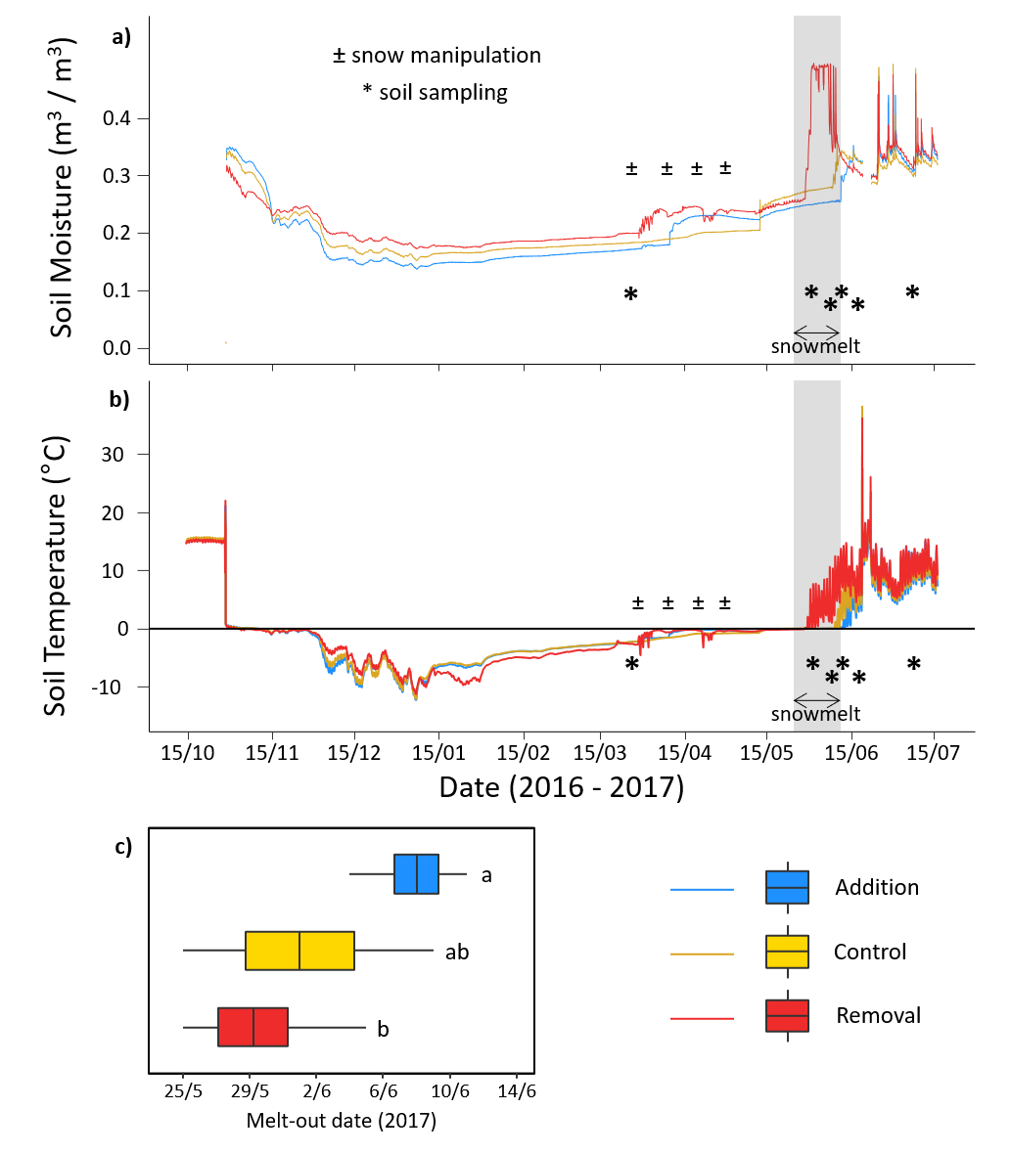
Figure S1 | Snow manipulation treatment effects on soil climate and snowmelt timing (melt-out date). (a) Soil moisture and (b) temperature before and during the experiment (15th Oct 2016 – 15th Jul 2017), (c) Melt-out date (i.e., the first day that each plot was snow free). For (c), treatments with different letters are significantly different (p < 0.05). Boxplots show mean, ± SE and range. All dates here and throughout are in day/month format.
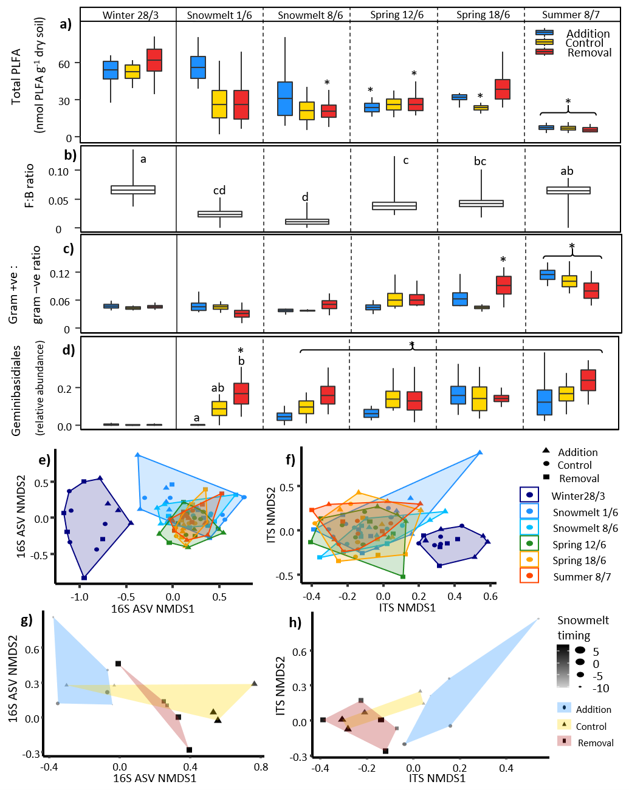
Figure S2 | Seasonal transitions and the effect of snow manipulation treatments on soil microbial community composition. (a) Total PLFA abundance, (b) Fungal: bacterial (F:B) ratio, (c) gram-positive: gram-negative bacterial ratio, (d) Geminibasidiales relative abundance, (e and g) NMDS plot of bacterial (16S), and (f and h) fungal (ITS2) ASV communities. For (a, c, and d) only relevant significant differences (p < 0.05) are shown; which demonstrate (1) how timing of the seasonal transition differs between treatments (i.e. differences between winter 28/3 treatment means and means of the same treatment in other sampling time points) indicated with *; and (2) any significant differences between treatment means within individual time points (lowercase letters). For (b) significant differences (p < 0.05) between sampling time-points are indicated by lowercase letters. For (e and f), points represent soil microbial communities in different treatments (shapes) at different sampling time points (colours). For (g and h), points represent soil microbial communities in different treatments (shape and colour) during the snowmelt (1/6) time-point, with size and shading of points indicating snowmelt timing (days before/ after melt-out). Boxplots show mean, ± SE and range.

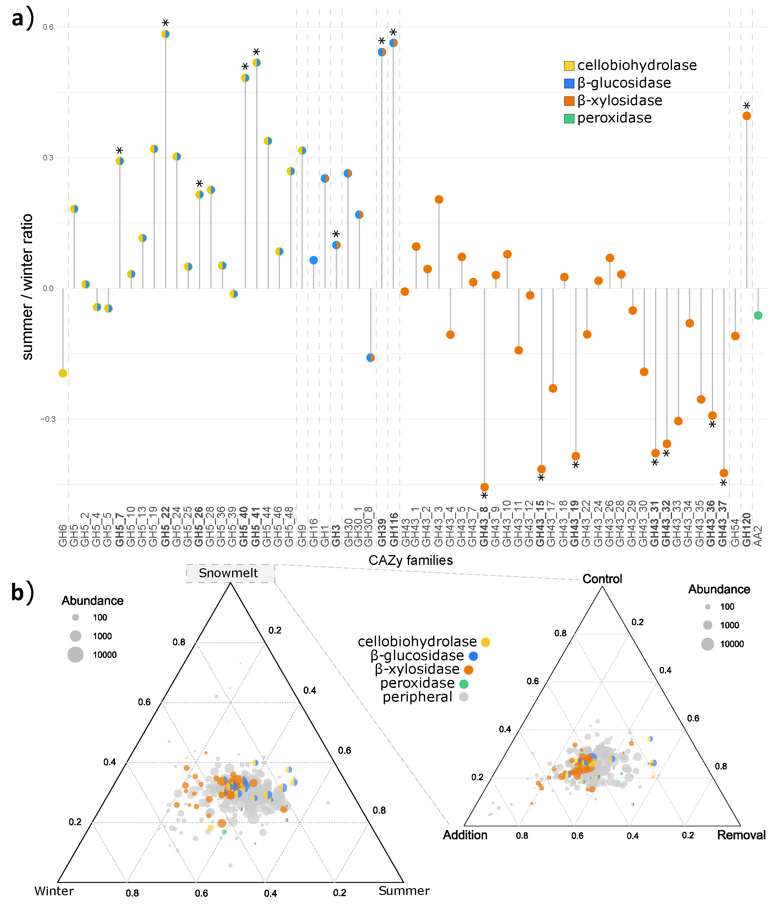
Figure S3 | Changes in the catabolic potential of microbial communities for carbohydrate-active enzymatic (CAZy) activities. (a) Relative potential for selected activities presented as the summer (8/7): winter (28/3) log-ratio, with zero showing no change, positive numbers showing higher potential in summer and negative numbers showing higher potential in winter. Asterisks and bold names indicate statistically significant changes in the abundances of the studied (sub)families. (b) Distribution and abundance of CAZy (sub)families during different seasons (left) and in treatments during snowmelt (1/6) (right). Colours depict (sub)families for different extracellular enzymes.

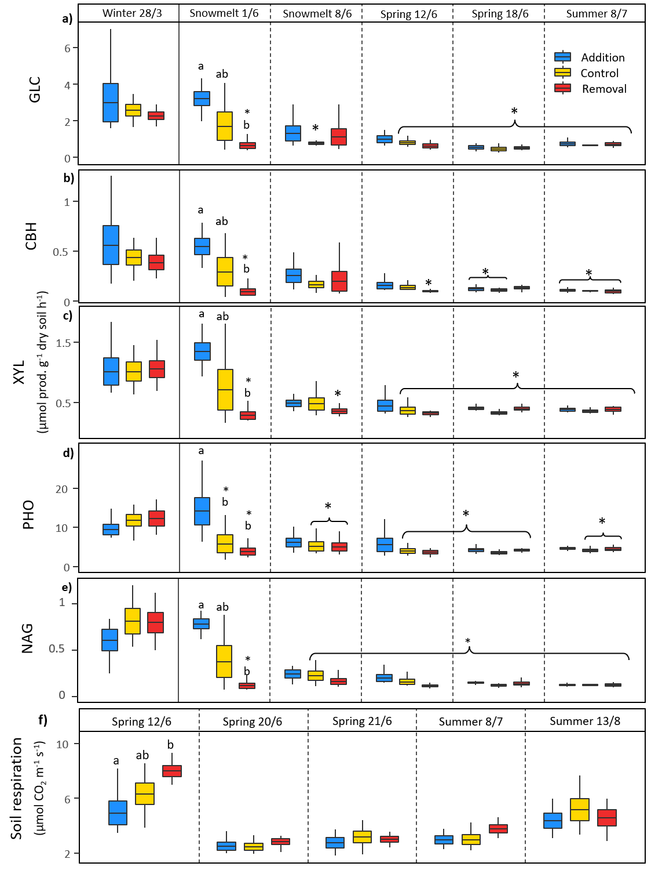
Figure S4 | Seasonal transitions and the effect of snow manipulation treatments on potential activity of extracellular enzymes and soil respiration. (a) β-glucosidase (GLC), (b) cellobiohydrolase (CBH), (c) β-xylosidase (XYL), (d) phosphatase, (e) N-acetylglucosaminidase, and (f) soil respiration. For (a - e) only relevant significant differences (p < 0.05) are shown; which demonstrate (1) how timing of the seasonal transition differs between treatments (i.e., differences between winter 28/3 treatment means and means of the same treatment in other sampling time points) indicated with *; and (2) any significant differences between treatment means within individual time points (lowercase letters). For f) significant differences (p < 0.05) between treatments within sampling time-points are indicated by lowercase letters. Boxplots show mean, ± SE and range.

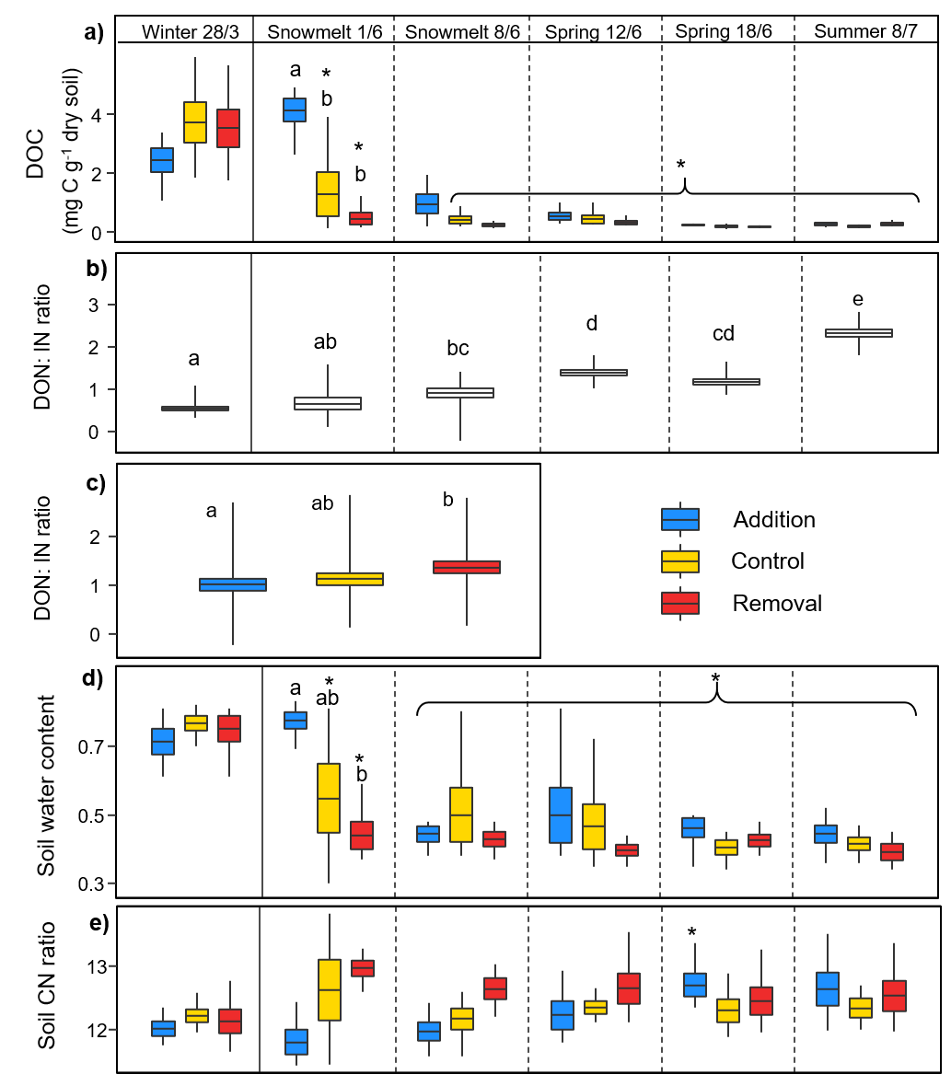
Figure S5 | Seasonal transitions and the effect of snow manipulation treatments on soil biogeochemistry and water content. (a) Dissolved organic carbon (DOC), (b) and (c) Dissolved organic N (DON): available inorganic N ratio, (d) Gravimetric soil water content (proportion of wet weight), and (e) soil C:N ratio. For (a, d and e) only relevant significant differences (p < 0.05) are shown; which demonstrate (1) how timing of the seasonal transition differs between treatments (i.e. differences between winter 28/3 treatment means and means of the same treatment in other sampling time points) indicated with *; and (2) any significant differences between treatment means within individual time points (lowercase letters). Significant differences (p < 0.05) between sampling time-points (b) and treatments (c) indicated by lowercase letters. Boxplots show mean, ± SE and range.

Table S1 | Significant (p < 0.05) seasonal transitions in the soil microbial community composition of high alpine grassland between winter (28/3) and summer (8/7). Seasonal means (± SE) and percentage change (%Δ) as % of winter are shown with Wald chi-square test statistic (chi²), degrees of freedom (Df) and p-values from linear mixed effects models. Only seasonal differences that are significant (p < 0.05) following Tukey post-hoc tests are shown. Total, fungal and bacterial PLFA measured in nmol PLFA g⁻¹ dry soil and relative abundances of bacterial and fungal orders given as proportions. Untransformed data are given but * indicates models were log₁₀ transformed and † indicates models were square root transformed to meet model assumptions.
 | winter  (mean ± SE) | summer (mean ± SE) | %Δ | chi² | Df | p-value
Soil microbial community composition
Total PLFA abundance | 56.55 ± 4.18 | 6.70 ± 0.80 | -88 | 319.2 | 5 | <0.01
Fungal PLFA abundance† | 2.28 ± 0.28 | 0.31 ± 0.04 | -86 | 315.4 | 5 | <0.01
Bacterial PLFA abundance | 34.82 ± 2.69 | 4.77 ± 0.50 | -86 | 301.8 | 5 | <0.01
Gram+: gram- bacterial ratio | 0.03 ± 0.002 | 0.1 ± 0.01 | 201 | 123.8 | 5 | <0.01
Relative abundances of bacterial orders*
Actinomycetales | 0.105 ± 0.006 | 0.061 ± 0.003 | -42 | 58.62 | 5 | <0.01
Acidobacteriales | 0.027 ± 0.004 | 0.11 ± 0.004 | 301 | 232.17 | 5 | <0.01
Ellin5290 | 0.003 ± 0.001 | 0.012 ± 0.001 | 314 | 64.89 | 5 | <0.01
Saprospirales | 0.052 ± 0.009 | 0.072 ± 0.004 | 40 | 23.53 | 5 | <0.01
Ellin6513 | 0.004 ± 0.001 | 0.021 ± 0.003 | 395 | 112.47 | 5 | <0.01
Solibacterales | 0.027 ± 0.004 | 0.073 ± 0.003 | 170 | 159.76 | 5 | <0.01
Solirubrobacterales | 0.014 ± 0.001 | 0.008 ± 0.001 | -41 | 37.91 | 5 | <0.01
Relative abundances of fungal orders*
Pezizales | 0.093 ± 0.02 | 0.011 ± 0.003 | -88 | 58.71 | 5 | <0.01
Geminibasidiales | 0.002 ± 0.001 | 0.172 ± 0.032 | 8480 | 198.37 | 5 | <0.01
Helotiales | 0.132 ± 0.011 | 0.256 ± 0.018 | 93 | 54.09 | 5 | <0.01
Pleosporales | 0.063 ± 0.006 | 0.032 ± 0.005 | -50 | 19.59 | 5 | <0.01
Atheliales | 0.091 ± 0.012 | 0.026 ± 0.005 | -71 | 37.28 | 5 | <0.01

Table S2 | Significant (p < 0.05) seasonal transitions in the activity of eight extracellular soil enzymes important for biogeochemical cycling in a high alpine grassland from winter (28/3) to summer (8/7). Seasonal means (± SE) and percentage change (%Δ) as % of winter are shown with Wald chi-square test statistic (chi²), degrees of freedom (Df) and p-values from linear mixed effects models. Only seasonal differences that are significant (p < 0.05) following Tukey post-hoc tests are shown. All potential enzymatic activities given in µmol prod. g⁻¹ dry soil h⁻¹, except for Urease, which was measured as mg NH₄⁺ g⁻¹ dry soil h⁻¹; and potential enzyme activities relative to microbial biomass, i.e., microbial biomass-specific enzyme activity, are in nmol prod. (or µg NH₄⁺ for Urease) nmol⁻¹ PLFA h⁻¹. Untransformed data are given but * indicates models were log₁₀ transformed to meet model assumptions.
 | winter  (mean ± SE) | summer  (mean ± SE) | %Δ | chi² | Df | p-value
Potential enzyme activity*
β-glucosidase (GLC) | 2.62 ± 0.35 | 0.71 ± 0.04 | -73 | 116.5 | 5 | <0.01
Cellobiohydrolase (CBH) | 0.46 ± 0.07 | 0.11 ± 0.01 | -77 | 70.4 | 5 | <0.01
β-xylosidase (XYL) | 1.03 ± 0.10 | 0.38 ± 0.01 | -63 | 310.8 | 5 | <0.01
N-acetylglucosaminidase (NAG) | 0.74 ± 0.07 | 0.13 ± 0.004 | -83 | 2313.4 | 5 | <0.01
Phosphatase (PHO) | 11.18 ± 0.91 | 4.43 ± 0.18 | -60 | 91.0 | 5 | <0.01
Urease (URE) | 0.51 ± 0.04 | 0.11 ± 0.01 | -78 | 966.2 | 5 | <0.01
Phenol oxidase (POX) | 0.42 ± 0.04 | 0.64 ± 0.03 | 52 | 105.8 | 5 | <0.01
Peroxidase (PER) | 11.67 ± 0.81 | 20.42 ± 1.09 | 75 | 85.5 | 5 | <0.01
Microbial biomass-specific enzyme activity*
β-glucosidase (GLC) | 49.31 ± 5.86 | 122.19 ± 14.65 | 148 | 78.6 | 5 | <0.01
Cellobiohydrolase (CBH) | 8.87 ± 1.31 | 19.34 ± 2.74 | 118 | 41.2 | 5 | <0.01
β-xylosidase (XYL) | 19.30 ± 1.54 | 67.68 ± 8.97 | 250 | 64.3 | 5 | <0.01
Phosphatase (PHO) | 213.06 ± 17.04 | 797.43 ± 95.56 | 274 | 66.8 | 5 | <0.01
Phenol oxidase (POX) | 8.69 ± 1.23 | 116.09 ± 16.52 | 1237 | 98.5 | 5 | <0.01
Peroxidase (PER) | 237.44 ± 30.42 | 3816.82 ± 549.17 | 1507 | 391.7 | 5 | <0.01

Table S3 | Significant (p < 0.05) seasonal transitions in environmental soil variables related to biogeochemical cycling in a high alpine grassland from winter (28/3) to summer (8/7). Seasonal means (± SE) and percentage change (%Δ) as % of winter are shown with Wald chi-square test statistic (chi²), degrees of freedom (Df) and p-values shown from linear mixed effects models. Only seasonal differences that are significant (p < 0.05) following Tukey post-hoc tests are shown. Untransformed data are given but * indicates models were log₁₀ transformed to meet model assumptions.
 | winter  (mean ± SE) | summer (mean ± SE) | %Δ | chi² | Df | p-value
Soil pH | 6.8 ± 0.03 | 4.9 ± 0.02 | -27 | 5030.3 | 5 | <0.01
DOC (mg C g⁻¹ dry soil)* | 3.23 ± 0.35 | 0.247 ± 0.022 | -92 | 223.3 | 5 | <0.01
DON (mg N g⁻¹ dry soil)* | 0.30 ± 0.04 | 0.05 ± 0.002 | -83 | 548.2 | 5 | <0.01
Available NH₄⁺ (mg N g⁻¹ dry soil)* | 0.54 ± 0.04 | 0.003 ± 0.0001 | -99 | 3229.4 | 5 | <0.01
Available NO₃⁻ (mg N g⁻¹ dry soil)* | 0.01 ± 0.001 | 0.02 ± 0.001 | 46 | 204.4 | 5 | <0.01
DON: available inorganic N ratio | 0.5 | 2.3 | 329 | 316.4 | 5 | <0.01
Soil water content* | 0.74 ± 0.02 | 0.42 ± 0.01 | -44 | 159.1 | 5 | <0.01
Net NH₄⁺ mineralisation rate (µg N g⁻¹ dry soil day⁻¹) | -22.29 ± 3.76 | 1.69 ± 0.19 | NA | 94.2 | 4 | <0.01
Net NO₃⁻ mineralisation rate (µg N g⁻¹ dry soil day⁻¹) | 60.60 ± 6.74 | -0.39 ± 0.12 | NA | 159.3 | 4 | <0.01

Table S4 | Significant snow manipulation treatment effects on soil microbial community composition, functioning, biogeochemical cycling, and pH. Wald chi-square test statistic (chi²), degrees of freedom (Df) and p-values from linear mixed effects models are shown. Only variables with treatment effects that were significant (p < 0.05) following Tukey post-hoc tests are shown. *log₁₀ transformed and †square root transformed to meet model assumptions.
 | Fixed effect |  | chi² | Df | p-value
Soil microbial community composition
Total PLFA abundance | treatment |  | 3.2 | 2 | 0.2
 | sampling time point: treatment |  | 19.0 | 10 | 0.04
Fungal PLFA abundance† | treatment |  | 5.7 | 2 | 0.06
 | sampling time point: treatment |  | 32.5 | 10 | <0.01
Bacterial PLFA abundance | treatment |  | 1.9 | 2 | 0.39
 | sampling time point: treatment |  | 18.7 | 10 | 0.04
Gram+: Gram- bacterial ratio | treatment |  | 3.5 | 2 | 0.18
 | sampling time point: treatment |  | 21.7 | 10 | 0.02
Geminibasidiales* | treatment |  | 3.8 | 2 | 0.15
 | sampling time point: treatment |  | 48.4 | 10 | <0.01
Potential enzyme activity*
β-glucosidase (GLC) | treatment |  | 12.3 | 2 | <0.01
 | sampling time point: treatment |  | 25.5 | 10 | <0.01
Cellobiohydrolase (CBH) | treatment |  | 10.4 | 2 | 0.01
 | sampling time point: treatment |  | 26.7 | 10 | <0.01
β-xylosidase (XYL) | treatment |  | 3.2 | 2 | 0.2
 | sampling time point: treatment |  | 92.0 | 10 | <0.01
N-acetylglucosaminidase (NAG) | treatment |  | 4.0 | 2 | 0.13
 | sampling time point: treatment |  | 98.9 | 10 | <0.01
Phosphatase (PHO) | treatment |  | 4.7 | 2 | 0.1
 | sampling time point: treatment |  | 34.6 | 10 | <0.01
Urease (URE) | treatment |  | 22.1 | 2 | <0.01
 | sampling time point: treatment |  | 50.2 | 10 | <0.01
Microbial biomass-specific enzyme activity*
Urease (URE) | treatment |  | 11.5 | 2 | <0.01
 | sampling time point: treatment |  | 5.4 | 10 | 0.87
Soil biogeochemical cycling and pH
Soil pH | treatment | 1.3 |  | 2 | 0.53
 | sampling time point: treatment | 195.3 |  | 10 | <0.01
DOC* | treatment | 11.4 |  | 2 | <0.01
 | sampling time point: treatment | 45.8 |  | 10 | <0.01
DON* | treatment | 6.8 |  | 2 | 0.03
 | sampling time point: treatment | 36.8 |  | 10 | <0.01
Available NH₄⁺ * | treatment | 0.7 |  | 2 | 0.72
 | sampling time point: treatment | 25.2 |  | 10 | <0.01
Available NO₃⁻ * | treatment | 18.7 |  | 2 | <0.01
 | sampling time point: treatment | 19.4 |  | 10 | 0.04
DON: available inorganic N ratio | treatment | 10.2 |  | 2 | 0.01
 | sampling time point: treatment | 9.7 |  | 10 | 0.47
Soil water content* | treatment | 5.1 |  | 2 | 0.08
 | sampling time point: treatment | 24.2 |  | 10 | 0.01
Table S5 | Significant effect of snowmelt timing (p < 0.05) on measures of soil microbial community composition, functioning and biogeochemical cycling during the second sampling time point (snowmelt 1st June 2017). Relative abundances of bacterial and fungal orders are given as proportions. Untransformed regression co-efficients (β) shown. * indicates models were log₁₀ transformed to meet model assumptions.
 | β | p-value | r²
Soil microbial community
Total PLFA (nmol PLFA g⁻¹ dry soil)* | -2.3 | <0.01 | 0.51
Fungal PLFA (nmol PLFA g⁻¹ dry soil) | -0.1 | <0.01 | 0.68
Bacterial PLFA (nmol PLFA g⁻¹ dry soil)* | -1.2 | <0.01 | 0.49
F:B ratio | -0.003 | <0.01 | 0.85
Bacterial order relative abundances*
Ellin6513 | 0.001 | <0.01 | 0.50
Ellin5290 | 0.001 | <0.01 | 0.70
Fungal order relative abundances*
Pezizales | -0.01 | <0.01 | 0.69
Geminibasidiales | 0.01 | <0.01 | 0.63
Potential enzyme activity
URE (mg NH₄⁺ g⁻¹ dry soil h⁻¹)* | -0.03 | <0.01 | 0.68
NAG (µmol prod. g⁻¹ dry soil h⁻¹) | -0.05 | <0.01 | 0.71
PHO (µmol prod. g⁻¹ dry soil h⁻¹)* | -0.8 | <0.01 | 0.52
CBH (µmol prod. g⁻¹ dry soil h⁻¹) | -0.03 | <0.01 | 0.65
XYL (µmol prod. g⁻¹ dry soil h⁻¹) | -0.08 | <0.01 | 0.79
GLC (µmol prod. g⁻¹ dry soil h⁻¹) | -0.2 | <0.01 | 0.71
Microbial biomass-specific enzyme activity*
POX (nmol prod. nmol⁻¹ PLFA h⁻¹) | 0.01 | <0.01 | 0.50
PER (nmol prod. nmol⁻¹ PLFA h⁻¹) | 0.4 | <0.01 | 0.50
Biogeochemical cycling and other soil properties
pH | -0.08 | <0.01 | 0.73
DOC (mg C g⁻¹ dry soil) | -0.2 | <0.01 | 0.61
NH₄⁺-N (mg N g⁻¹ dry soil)* | -0.04 | 0.02 | 0.40
DON (mg N g⁻¹ dry soil) | -0.01 | <0.01 | 0.67
Gravimetric soil water content | -0.03 | <0.01 | 0.77
Soil CN ratio | 0.09 | <0.01 | 0.55

