Supplementary Information
Di & Akther et al
Contents
Text S1. Aligned sequences of natural OspC variants and evolutionary analogs 2
Text S2. R Markdown. Simulation of maximal antigen divergence and evolutionary analogs using genetic algorithms 4
Part 1. Maximize separation with and without crossing-over 4
Part 2. Validate seq separation 5
Part 3. Obtain centroids 7
Part 4. Validation with tree 7
Part 5. Show session info 9
Fig S1. SDS-PAGE images of purified recombinant OspC proteins 10
Fig S2. ELISA results of natural OspC variants and evolutionary analogs with human sera 11
Fig S3. ELISA results with P. leucopus mouse sera 12
Fig S4. Heatmap of ELISA readings of OspC natural variants and evolutionary analogs with naturally infected human and P. leucopus sera 13
Fig S5. Structural superimposition of evolutionary analogs with a solved OspC template 14
Reference cited 15

Text S1. Aligned sequences of natural OspC variants and evolutionary analogs
The alignment includes sequences of 16 natural OspC variants (“A” through “U”) prevalent in the Northeast US [1, 2] and the six evolutionary analogs (“Root”, “Consense”, and “Centroids”). The first 18 residues at the N-terminus were removed from each recombinant protein construct. The constructs also contained a 10X histidine tag at the N-terminus (not shown).
L CNNSGKDGNASVNS-ADESVKGPNLVEISKKITDSNAVVIAVKEVETLLVSIDELA-KAI
N CNNSGKDGNASTNS-ADESVKGPNLTEISKKITESNAVVLAVKEVAALLSSIDELA-KAI
E CNNSGKDGNASANS-ADESVKGPNLTEISKKITESNAVVLAVKEVETLLASIDELATKAI
G CNNSGKDGNASTNS-ADESVKGPNLAEISKKITESNAVVLAVKEVAALLSSIDELA-KAI
B CNNSGKDGNTSANS-ADESVKGPNLTEISKKITDSNAVLLAVKEVEALLSSIDELA-KAI
U CNNSGKDGNASANS-ADESVKGPNLAEISKKITESNAVVLAVKEVEALLASIDEIGSKAI
D CNNSGKDGNTSANS-ADESVKGPNLTEISKKITDSNAVLLAVKEVEVLLSSIDELAKKAI
H CNNSGKDGNASANS-ADESVKGPNLTEISKKITESNAVVLAVKEVETLLASINQLA-KAI
J CNNSGKDGNTSANS-ADESVKGPNLTEISKKITESNAVVLAVKEIETLLASIDELATKAI
I CNNSGKDGNTSANS-ADESVKGPNLTEISKKITESNAVVLAVKEVETLLTSIDELA-KAI
A CNNSGKDGNTSANS-ADESVKGPNLTEISKKITDSNAVLLAVKEVEALLSSIDEIAAKAI
K CNNSGKDGNTSANS-ADESVKGPNLTEISKKITESNAVVLAVKEIETLLASIDELATKAI
C CNNSGKDGNASANS-ADESVKGPNLTEISKKITESNAVVLAVKEVETLLASIDELA-KAI
M CNNSGKDGNTSANS-ADESVKGPNLTEISKKITESNAVVLAVKEVETLLASIDEVAKKAI
T CNNSGKDGNASVNS-ADESVKGPNLTEISKKITESNAVVLAVKEVETLLASIDELANKAI
F CNNSGKDGNTSANS-ADESVKGPNLTEISKKITESNAVVLAVKEIETLLSSIDELATKAI
Root CNNSGKDGNTSANS-ADESVKGPNLTEISKKITESNAVVLAVKEVETLLASIDELATKAI
Centroid_2 CNNSGKDGNASANS-ADESVKGPNLTEISKKITESNAVVLAVKEVEALLASIDELA-KAI
Centroid_1 CNNSGKDGNASTNS-ADESVKGPNLTEISKKITESNAVVLAVKEVETLLSSIDELT-KAI
Centroid_4 CNNSGKDGNASTNS-ADESVKGPNLTEISKKITESNAVVLAVKEVETLLASIDELA-KAI
Centroid_3 CNNSGKDGNASANS-ADESVKGPNLTEISKKITESNAVVLAVKEVETLLSSIDELA-KAI
Consensus CNNSGKDGNASANS-ADESVKGPNLTEISKKITESNAVVLAVKEVETLLASIDELATKAI
*********:*.** **********.*******:****::****: .** **::: ***

L GKKIEAGGTLGSDGAHNGSLLAGAYKIATEITAN---LSKLKASEDLKEKITKAKECSEK
N GKKINNN-GLDDVQNFNASLLAGAHTISKLVTEK---LSKLKNSEGLKEKIEDAKKCSDD
E GKKIGNN-GLEANQSKNTSLLSGAYAISDLIAEK---LNVLKN-EELKEKIDTAKQCSTE
G GKKIEQN-GLGADANHNTSLLAGAHEISTLIKQK---LDGLKN-EGLNKEIEAAKKCSAA
B GKKIKNDGSLDNEANRNESLLAGAYTISTLITQK---LSKLNGSEGLKEKIAAAKKCSEE
U GKRIQAN-GLQDLQGQNGSLLAGAYAISNLITQKINVLNGLKNSEELKEKINEAKGCSEK
D GKKIDQNNALGTLDNHNGSLLAGAYAISALITEK---LSSIKDSGELKAEIEKAKKCSES
H GKKIDQNGTLGDDGGQNGSLLAGAYAISTVIIEK---LSTLKNVEELKEKITKAKDCSEK
J GKKIDNNAGLGAEVGQNGSLLAGAYAISTVIIEK---LSTLKNVEELKEKITKAKDCSEK
I GKKIKNDVSLDNEADHNGSLISGAYLISTLITKK---ISAIKDSGELKAEIEKAKKCSEE
A GKKIHQNNGLDTENNHNGSLLAGAYAISTLIKQK---LDGLKN-EGLKEKIDAAKKCSET
K GKKIQQNGGLAVEAGHNGTLLAGAYTISKLITQK---LDGLKNSEKLKEKIENAKKCSED
C GKKIKNDVSLDNEADNNGSLIAGAYTISTLITQK---LSKLNGSEGLKEKIAEAKKCSEE
M GNLIAQN-GLNAGANQNGSLLAGAYVISTLIAEK---LDGLKNSEELKEKIEDAKKCNKA
T GQKIDQNNGLSVDAGHNGPLLAGAYAISALITEK---LNGLTISEELKEKIEKAKKCSTG
F GQKIDAN-GLGVQANQNGSLLAGAYAISTLITQK---LSAL-NSEDLKEKVAKVKKCSED
Root GKKIDQNNGLGADANHNGSLLAGAYAISTLITEKINVLNGLKNSEELKEKIEKAKKCSED
Centroid_2 GKKIENN-GLDAVANHNGSLLAGAYTISTLITEKINVLSKLKN-EELKEKIETAKKCSEA
Centroid_1 GKKIEQNVGLGADQNHNGSLLAGAYAISTLITQK---LSKLKNSEELKEKIEAAKKCSEE
Centroid_4 GKKIENNGGLDSDANHNGSLLAGAYAISTLITQK--VLSKLKNSEGLKEKIEKAKKCSEK
Centroid_3 GKKIENNGGLGSDANHNGSLLAGAYAISTLITEK--VLSKLKNSEELKEKIEKAKKCSEA
Consensus GKKIDQNGGLGAEANHNGSLLAGAYAISTLITEK---LSGLKNSEELKEKIEKAKKCSEE
*: * . * * .*::**: *: : : :. : *: :: .* *.

L FTDKLKSENVALGKQD--ASDDDAKKAILKTHND-ITKGAKELKELSESVETLLKAAKEM
N FTKKLQSSHAQLGVAGGATTDEEAKKAILRTNAI-KDKGADELEKLFKSVESLAKAAQDA
E FTNKLKSEHAVLGLDN--LTDDNAQRAILKKHAN-KDKGAAELEKLFKAVENLSKAAQDT
G FTKKLADSNADLGVAAGNATDDNAKRAILKTHGH-EDKGGKELKELSEAVKSLLKAAQAA
B FSTKLKDNHAQLGIQG--VTDENAKKAILKANAAGKDKGVEELEKLSGSLESLSKAAKEM
U FTKKLSESHADIGIQA--ATDANAKDAILKTNPT-KTKGAEELDKLFKAVENLSKAAKEM
D FTKKLSDNQAELGIEN--ATDDNAKKAILKTHNA-KDKGAEELVKLSESVAGLLKAAQAI
H FAGKLKNEHASLGKKD--ATDDDAKKAILKTHGN-TDKGAKELKDLSDSVESLVKAAKEM
J FTKKLKDSHAELGKKD--ASDDDAKKAILKTNQA-NDKGAKELKELFEAVESLSKAAKEM
I FTAKLKGEHTDLGKEG--VTDDNAKKAILKTNND-KTKGADELEKLFESVKNLSKAAKEM
A FTNKLKEKHTDLGKEG--VTDADAKEAILKTNGT-KTKGAEELGKLFESVEVLSKAAKEM
K FTKKLEGEHAQLGIEN--VTDENAKKAILITDAA-KDKGAAELEKLFKAVENLAKAAKEM
C FTKKLKEKHTDLGKKD--ATDVHAKEAILKTNGT-KDKGAAELEKLFESVENLAKAAKEM
M FTDKLKSSHAELGIANGAATDANAKAAILKTNGT-KDKGAQELEKLFESVKNLSKAAQET
T FTNKLKSGHAELGPVGGNATDENAKQAILKTHGN-VTKGAKELKDLSESVEALAKAAQAM
F FTNKLKNGNAQLGLAA--ATDDNAKAAILKTNGT-NDKGAKELKDLSDSVESLVKAAQVM
Root FTKKLKNSHAELGIAGGNATDDNAKKAILKTHGTGKDKGAKELKDLSESVESLVKAAQAM
Centroid_2 FTKKLKSEHADLGIAQN-ATDDNAKKAILKTHNT-KDKGAKELKKLSESVENLLKAAQEM
Centroid_1 FTKKLKSEHADLGIAG--ATDDNAKKAILKTHAN-KDKGAKELKKLFESVESLSKAAKEM
Centroid_4 FTKKLKSEHADLGKAGN-ATDDNAKKAILKTHGAGKDKGADELEKLSEAVENLSKAAQEM
Centroid_3 FTKKLKSSHAQLGPAAGNATDDNAKKAILKTHGDGKDKGAKELEKLFEAVESLSKAAKEM
Consensus FTKKLKSEHADLGKAGG-ATDDNAKKAILKTNGT-KDKGAKELEKLFESVENLSKAAKEM
*: ** :. :* :* .*: *** . ** ** .* :: * ***:

L LANSVKELTSPVVAESPKKP
N LANSVNELTGPVVAETPKKP
E LKNAVKELTSPIVAESPKKP
G LANSVQELTSPVVAETPKKP
B LANSVKELTSPVVVESPKKP
U LANSVKELTSPVVAESPKKP
D LANSVKELTSPVVAESPKKP
H LTNSVKELTSPVVAESPKKP
J LNKSVKELTSPIVAESPKNP
I LTNSVKELTSPVVAESPKKP
A LANSVKELTSPVVAESPKKP
K LANSVKELTSPIVAESPKNP
C LSNSVKELTSPVVAESPKNP
M LNNSVKELTSPVVAENPKKP
T LTNSVKELTSPVVAETPKKP
F LTNSVKELTSPVVAESPKKP
Root LTNSVKELTSPVVAESPKKP
Centroid_2 LANSVKELTSPVVAESPKKP
Centroid_1 LANSVKELTSPVVAESPKKP
Centroid_4 LANSVKELTSPVVAESPKKP
Centroid_3 LANSVKELTSPVVAESPKKP
Consensus LANSVKELTSPVVAESPKKP
* ::*:***.*:*.*.**:*

Text S2. R Markdown. Simulation of maximal antigen divergence and evolutionary analogs using genetic algorithms

Part 1. Maximize separation with and without crossing-over
Generate maximally divergent 20-bits long binary sequences using genetic algorithms:
library(GA)
library(stringdist)
library(tidyverse)
library(ape)
len.seq <- 20 # length of sequences
num.alle <- 10 # number of alleles
size.pair <- num.alle * (num.alle-1)/2
# Fitness function, to maximize the minimal Hamming distance:
epi.fit <- function(x) {
x.list <- split(x, rep(1:num.alle, each=len.seq))
min(seq_distmatrix(x.list, method = "hamming"))/len.seq
}
# Run genetic algorithm with default parameters:
mad.ga <- ga(type = "binary", fitness = epi.fit, nBits = len.seq * num.alle, maxiter = 1000)
plot(mad.ga)
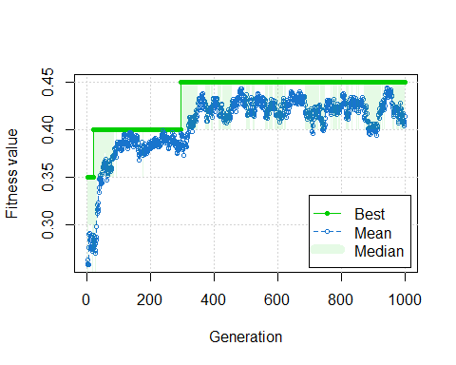
# Run genetic algorithm without recombination:
mad.clonal <- ga(type = "binary", fitness = epi.fit, nBits = len.seq * num.alle, maxiter = 1000, pcrossover = 0)
plot(mad.clonal)
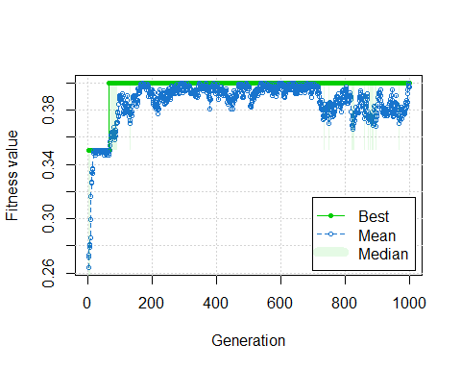
top.pop = mad.ga@solution[1,]
top.clonal = mad.clonal@solution[1,]
# Split into 20-bit strings & get consensus
x.list <- split(top.pop, rep(1:num.alle, each=len.seq))
mad.alleles <- t(as.data.frame(x.list))
x.clonal <- split(top.clonal, rep(1:num.alle, each=len.seq))
clonal.alleles <- t(as.data.frame(x.clonal))
# Obtain majority-rule consensus sequences
consense <- apply(mad.alleles,2, function(x) {table(x)} %>% which.max()-1)

Part 2. Validate seq separation
Compare among variants with crossing-over, without crossing-over, and randomly permuted (with crossing-over). Recombination creates more optimal separation (higher median with low variance).
dist.optimal <- seq_distmatrix(x.list, method = "hamming")/len.seq
dist.clonal <- seq_distmatrix(x.clonal, method = "hamming")/len.seq
mad.shuffled <- apply(mad.alleles, 2, sample) # permute by column
xy.list <- split(mad.shuffled, seq(nrow(mad.shuffled)))
dist.shuffled <- seq_distmatrix(xy.list, method = "hamming")/len.seq
three.dist <- tibble(dist = c(dist.optimal, dist.shuffled, dist.clonal), class = c(rep("mad", size.pair), rep("permuted",size.pair), c(rep("clonal", size.pair))))
two.dist <- three.dist %>% filter(class != "permuted")
med <- two.dist %>% group_by(class) %>% summarise(med = median(dist))
two.dist %>% ggplot(aes(x=dist, fill = class)) + geom_density(alpha=0.5) + theme_bw() + geom_vline(data=med, aes(xintercept = med, color=class), size=2)
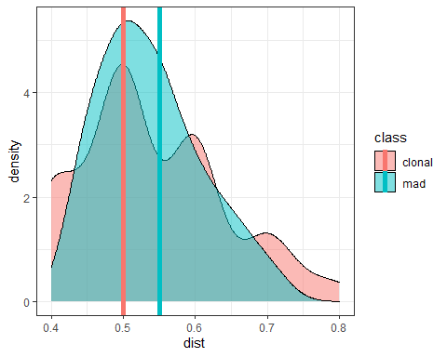
two.dist %>% ggplot(aes(x = class, y = dist)) + geom_boxplot() + geom_jitter(shape=1) + theme_bw() + geom_hline(yintercept = 0.5, linetype = 2)
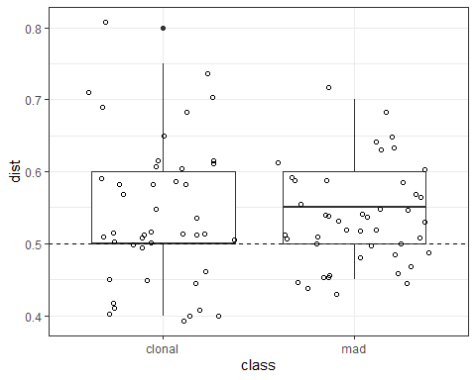
t.test(data = two.dist, dist ~ class)
##
## Welch Two Sample t-test
##
## data: dist by class
## t = 0.060392, df = 78.097, p-value = 0.952
## alternative hypothesis: true difference in means is not equal to 0
## 95 percent confidence interval:
## -0.03551630 0.03773852
## sample estimates:
## mean in group clonal mean in group mad
## 0.5388889 0.5377778

Part 3. Obtain centroids
Find broadly cross-reactive centroids, again using genetic algorithm:
# Fitness function, minimize max distance
center.fit <- function(x) {
ref.alleles <- split(top.pop, rep(1:num.alle, each=len.seq));
-1 * max(seq_dist(x, ref.alleles, method = "hamming")/len.seq);
}
center.ga <- ga(type = "binary", fitness = center.fit, nBits = len.seq, popSize = 100, maxiter = 200);
plot(center.ga)
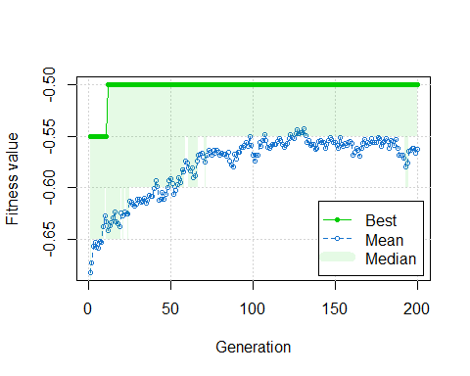
centroid <- center.ga@solution[1,]

Part 4. Validation with tree
x.list[[11]] <- consense
x.list[[12]] <- centroid
names(x.list) <- c("A01", "A02", "A03", "A04", "A05", "A06", "A07", "A08", "A09", "A10", "Consense", "Centroid")
# distance matrix
x.dist <- seq_distmatrix(x.list, method = "hamming")
x.dist
## A01 A02 A03 A04 A05 A06 A07 A08 A09 A10 Consense
## A02 11
## A03 10 11
## A04 11 10 11
## A05 13 12 13 10
## A06 11 10 11 12 10
## A07 14 9 12 13 11 9
## A08 11 10 11 10 12 12 11
## A09 10 9 12 13 9 9 10 9
## A10 9 10 9 14 10 10 11 10 9
## Consense 9 6 9 12 12 6 11 10 7 4
## Centroid 9 10 9 10 10 8 9 10 9 8 6
# show varints
t(as.data.frame(x.list))
## x1 x2 x3 x4 x5 x6 x7 x8 x9 x10 x11 x12 x13 x14 x15 x16 x17 x18 x19 x20
## A01 0 0 1 0 1 0 0 1 1 0 0 0 0 1 1 1 0 0 0 0
## A02 1 1 0 1 1 1 0 1 0 1 1 1 0 1 1 1 0 0 1 1
## A03 0 1 0 0 1 1 0 0 0 0 0 1 1 0 0 1 0 1 0 0
## A04 1 0 1 1 1 1 0 0 1 1 0 1 1 1 0 0 1 0 0 1
## A05 1 0 0 1 0 0 1 1 1 1 0 1 1 0 1 0 1 1 1 0
## A06 0 1 0 1 0 0 1 0 0 0 1 1 0 1 1 0 1 0 0 0
## A07 0 1 0 0 0 1 1 1 0 1 1 0 0 1 0 0 1 1 1 1
## A08 1 1 1 0 0 1 0 0 1 0 1 0 1 0 1 1 1 0 1 1
## A09 0 1 1 1 0 0 1 1 1 0 1 1 1 1 1 1 0 1 1 1
## A10 0 0 0 1 0 0 0 0 0 0 0 0 0 0 1 1 0 1 1 1
## Consense 0 1 0 1 0 0 0 0 0 0 0 1 0 1 1 1 0 0 1 1
## Centroid 0 1 0 0 0 0 0 0 1 1 0 1 0 1 1 1 1 1 0 1
# tree
plot(bionj(x.dist), type = "u", no.margin = T, edge.width = 2)
add.scale.bar()
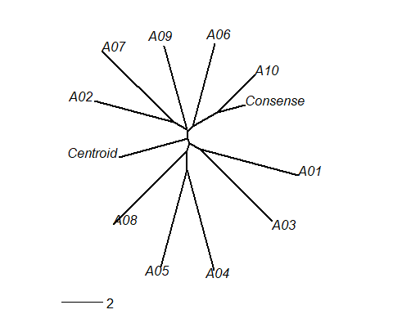

Part 5. Show session info
sessionInfo()
## R version 4.0.5 (2021-03-31)
## Platform: x86_64-w64-mingw32/x64 (64-bit)
## Running under: Windows 10 x64 (build 19041)
##
## Matrix products: default
##
## locale:
## [1] LC_COLLATE=English_United States.1252
## [2] LC_CTYPE=English_United States.1252
## [3] LC_MONETARY=English_United States.1252
## [4] LC_NUMERIC=C
## [5] LC_TIME=English_United States.1252
##
## attached base packages:
## [1] stats graphics grDevices utils datasets methods base
##
## other attached packages:
## [1] ape_5.4-1 forcats_0.5.1 stringr_1.4.0 dplyr_1.0.5
## [5] purrr_0.3.4 readr_1.4.0 tidyr_1.1.3 tibble_3.1.0
## [9] ggplot2_3.3.3 tidyverse_1.3.1 stringdist_0.9.6.3 GA_3.2.1
## [13] iterators_1.0.13 foreach_1.5.1
##
## loaded via a namespace (and not attached):
## [1] Rcpp_1.0.6 lubridate_1.7.10 lattice_0.20-41 assertthat_0.2.1
## [5] digest_0.6.27 utf8_1.2.1 R6_2.5.0 cellranger_1.1.0
## [9] backports_1.2.1 reprex_2.0.0 evaluate_0.14 highr_0.8
## [13] httr_1.4.2 pillar_1.6.0 rlang_0.4.10 readxl_1.3.1
## [17] rstudioapi_0.13 rmarkdown_2.7 labeling_0.4.2 munsell_0.5.0
## [21] broom_0.7.6 compiler_4.0.5 modelr_0.1.8 xfun_0.22
## [25] pkgconfig_2.0.3 htmltools_0.5.1.1 tidyselect_1.1.0 codetools_0.2-18
## [29] fansi_0.4.2 crayon_1.4.1 dbplyr_2.1.1 withr_2.4.1
## [33] grid_4.0.5 nlme_3.1-152 jsonlite_1.7.2 gtable_0.3.0
## [37] lifecycle_1.0.0 DBI_1.1.1 magrittr_2.0.1 scales_1.1.1
## [41] cli_2.4.0 stringi_1.5.3 farver_2.1.0 fs_1.5.0
## [45] xml2_1.3.2 ellipsis_0.3.1 generics_0.1.0 vctrs_0.3.7
## [49] tools_4.0.5 glue_1.4.2 hms_1.0.0 parallel_4.0.5
## [53] yaml_2.2.1 colorspace_2.0-0 rvest_1.0.0 knitr_1.32
## [57] haven_2.3.1

Fig S1. SDS-PAGE images of purified recombinant OspC proteins
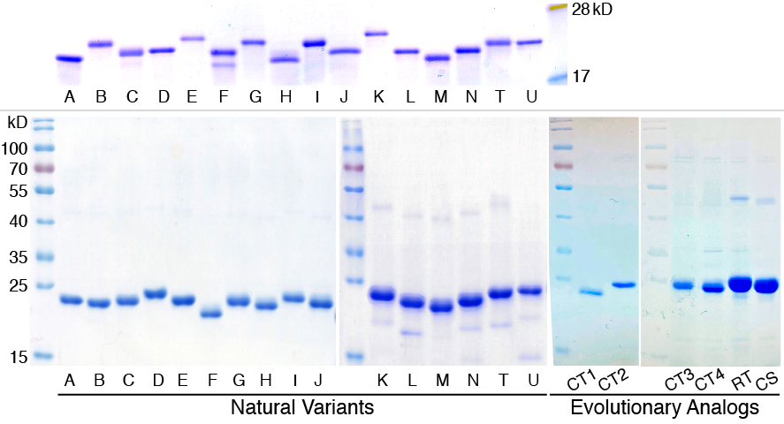
(Top) Purified 16 recombinant natural OspC variants used in ELISA and immunoblot assays with sera from immunized C3H and P. leucopus mice.
(Bottom) Purified 16 recombinant natural OspC variants (“A” through “U”) and six evolutionary analogs used in ELISA including four centroids (“CT1” through “CT4”), one phylogenetically reconstructed root sequence (“RT”), and one consensus sequence (“CS”). Purified rOspCs show as bands near the 25 kD molecular weight marker. Purified OspC molecules tend to form dimers due to the presence of two cysteine residues, producing faint bands between the 40 kD and 55 kD markers.

Fig S2. ELISA results of natural OspC variants and evolutionary analogs with human sera
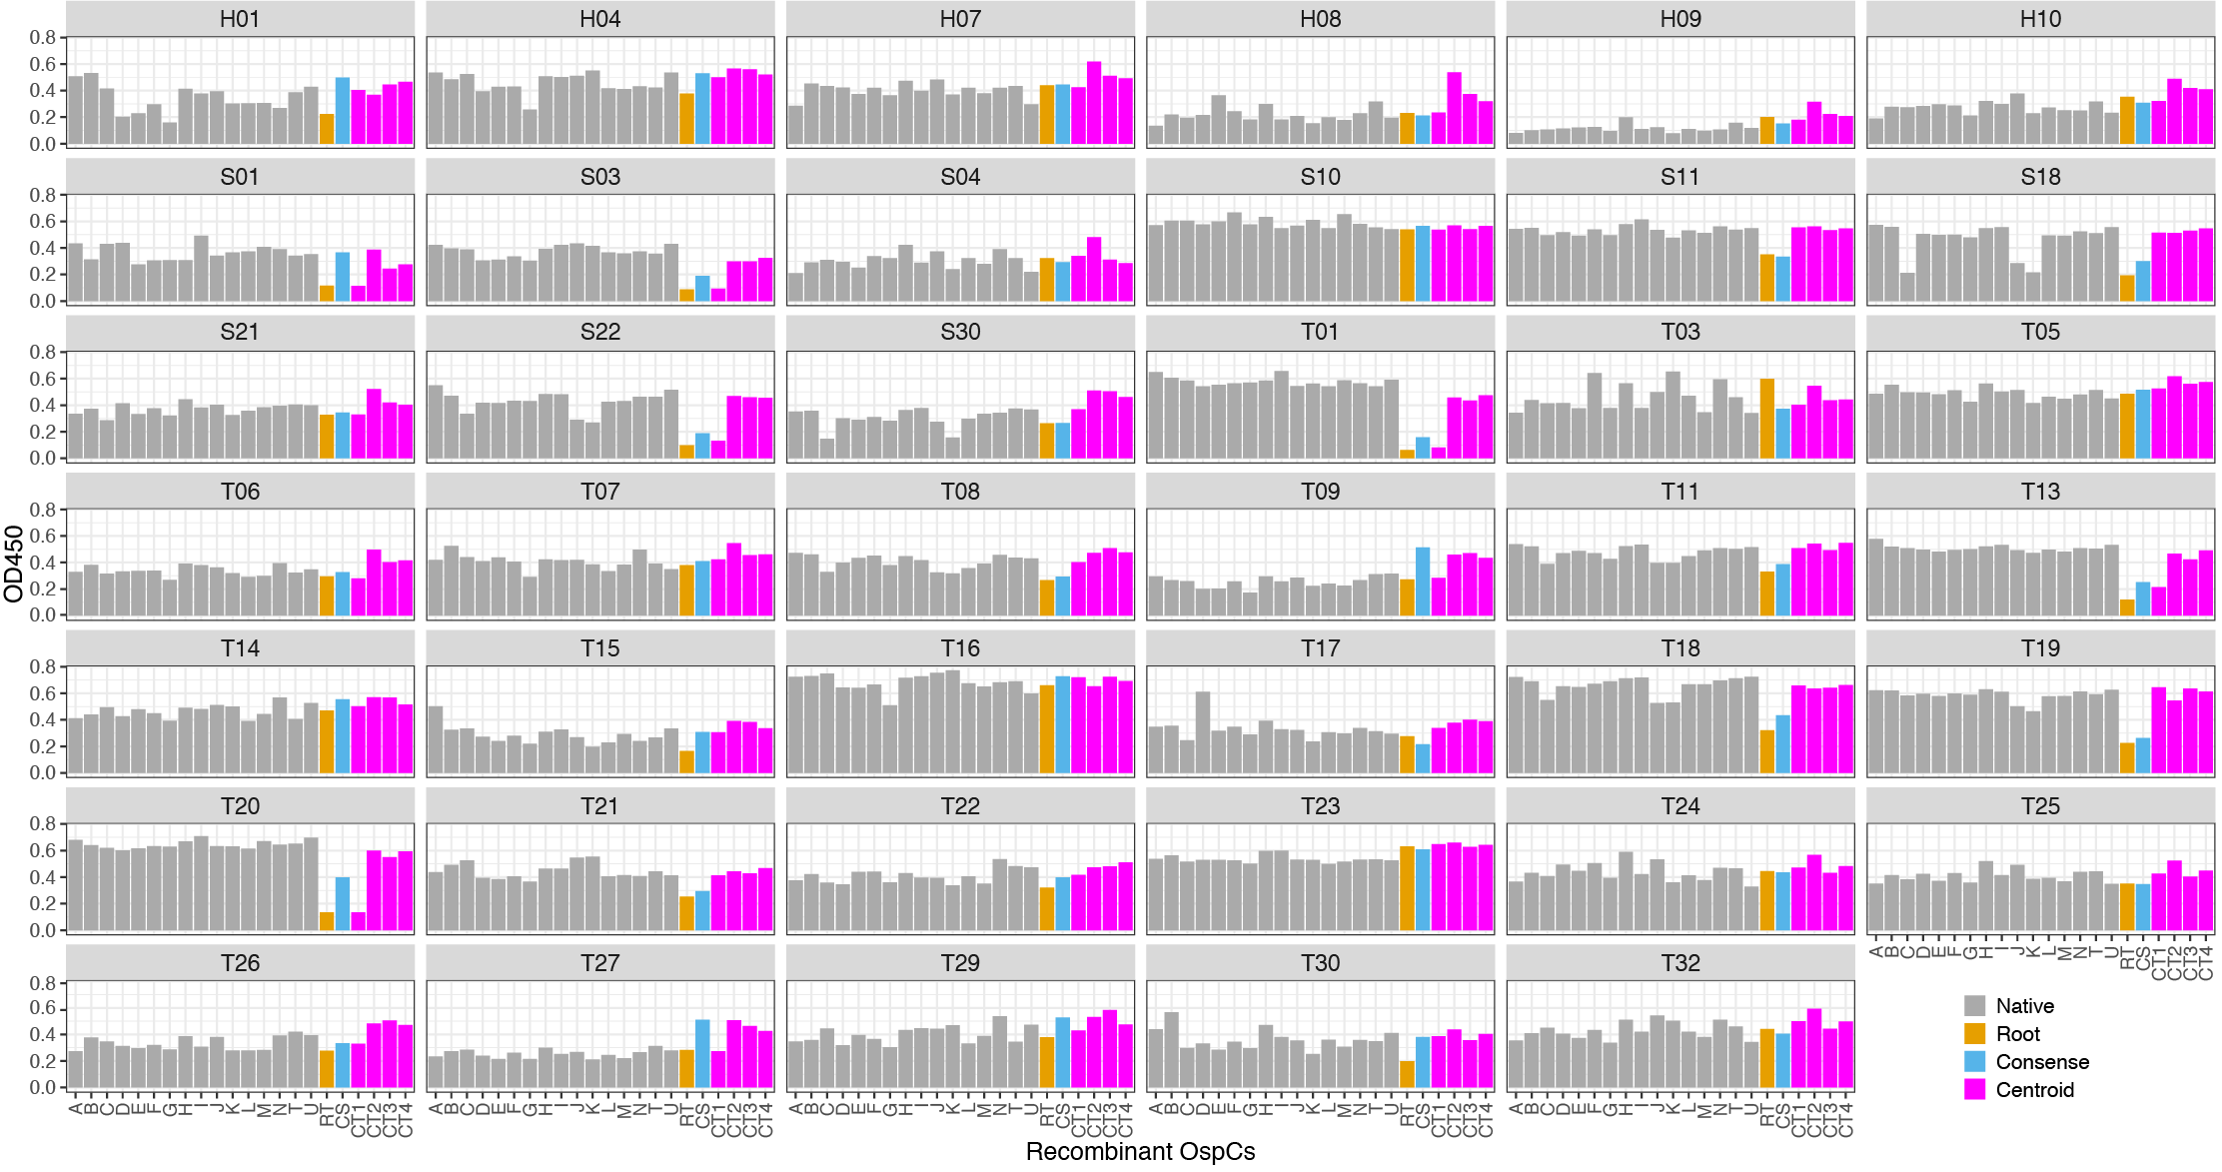
Each panel shows OD450 readings (y-axis) of a serum sample (n=41, listed in Table 1) against a panel of recombinant OspCs (x-axis). The recombinant OspCs included the 16 natural variants, the root sequence (“RT”), the consensus sequence (“CS”), and four centroid sequences (“CT1”, “CT2”, “CT3”, and “CT4”). Human sera provided by CDC (n=35, with labels starting with “S” or “T”) were chosen for the presence of the 23 kD band (OspC) in either IgG, IgM, or both types of Westernblot assays. The EIA and Westernblot results were provided by CDC [3].

Fig S3. ELISA results with P. leucopus mouse sera
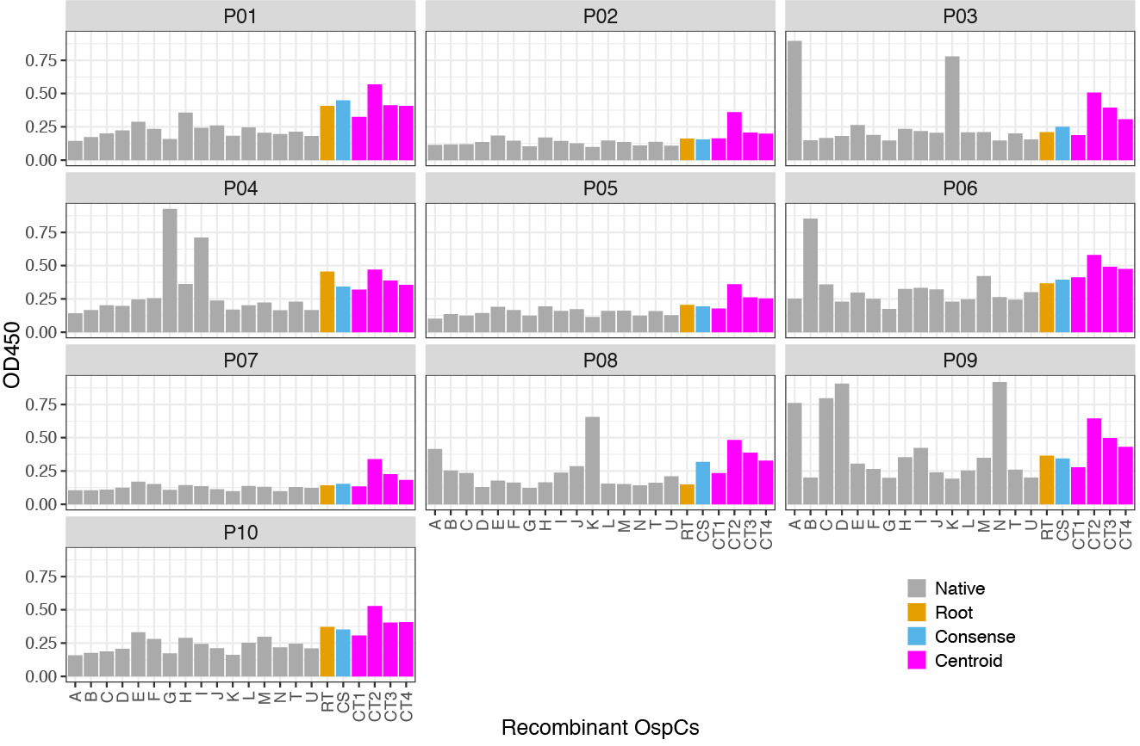
Each panel shows OD450 readings (y-axis) of a P.leucopus serum sample (n=10, listed in Table 1) against a panel of recombinant OspCs (x-axis).

Fig S4. Heatmap of ELISA readings of OspC natural variants and evolutionary analogs with naturally infected human and P. leucopus sera
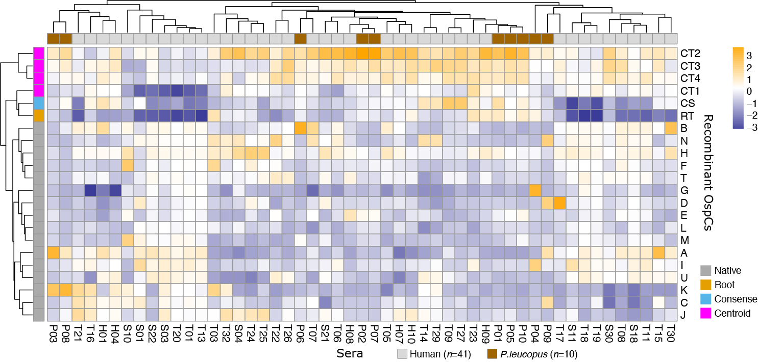
A heat map representation of the ELISA results of purified recombinant OspC variants (n=22, in rows) reacting with the naturally infected human (n=41) and P. leucopus (n=10) sera (in columns). Color intensities represent the serum-scaled OD₄₅₀ values (z-scores).

Fig S5. Structural superimposition of evolutionary analogs with a solved OspC template
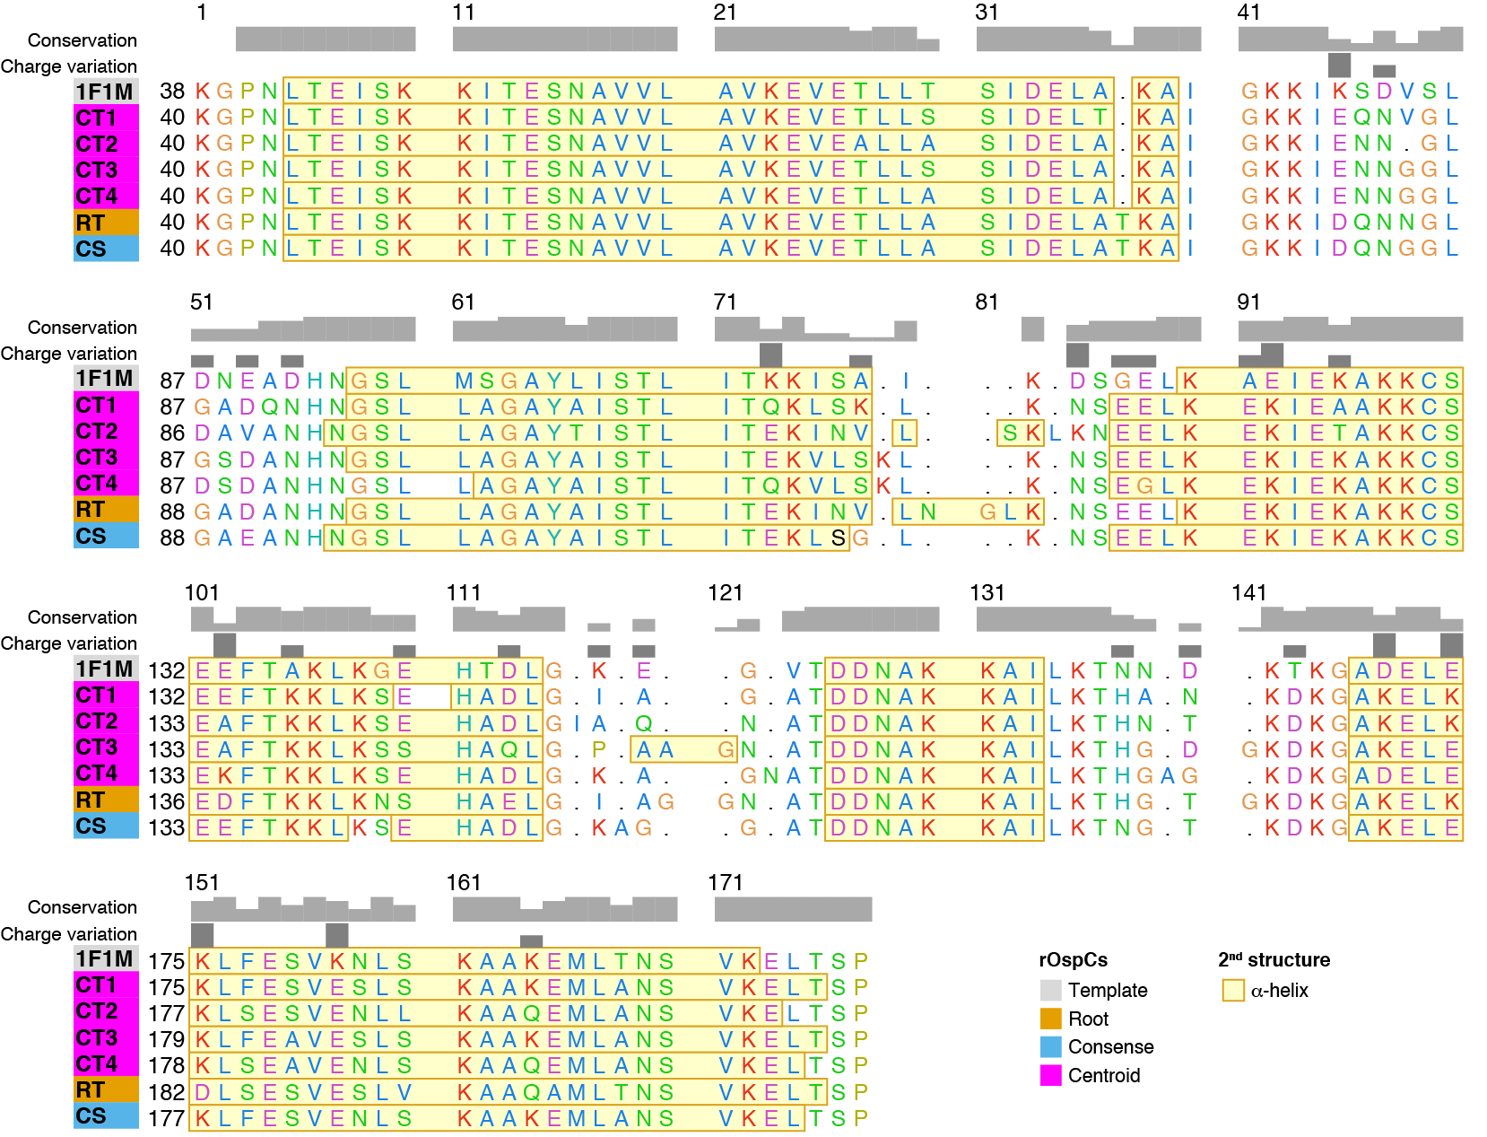
Methods:
The 3D structures of the evolutionary analogs were predicted using the I-TASSER Protein Structure Prediction server [4] with the crystal structure of OspC (PDB ID: 1F1M) [5] as the template.
The sequence alignment from structural superimposition of proteins was created using the UCSF Chimera (version 1.14) [6]. The template structure, 1F1M, was used as a reference. The reference structure and evolutionary analogs were modified before performing superimposition. Duplicated chains (B, C, D), zinc ions, and water molecules were removed from the reference protein. To account for missing N-terminus and C-terminus residues in the reference structure, the N-terminus and C-terminus of evolutionary analogs were truncated at residue positions 1-39 (for all constructs), 202-210 (CT1), 204-212 (CT2), 206-214 (CT3), 205-213 (CT4), 209-219 (RT), and 204-214 (CS).
Protein structure superimposition was obtained using Chimera’s MatchMaker tool. Chain pairing option was set to the best-aligning pair of chains between the reference and match structures. The Needleman-Wunsch algorithm was used as the alignment algorithm and BLOSUM-62 matrix was used as the substitution matrix.
The sequence alignment from structural superimposition of proteins was then generated using Chimera’s Match & Align tool. Residue-residue distance cutoff was set to 5Å. Residues were aligned in a column if they were within the cutoff distance. Cycles of refitting the structures using the sequence alignment and generating a new sequence alignment from the modified superimposition were performed until convergence. Structures were refitted using only the fully populated columns in stretches of at least three consecutive columns.
The alignment and calculated measures of structural similarity showed that evolutionary analogs were structurally similar to the native protein. The overall root mean square deviation (RMSD = 0.565Å) was less than 2Å and the mean alignment quality score (Q-score = 0.829) was close to 1, indicating strong structural similarities of the evolutionary analogs with the template.

Reference cited
1. Wang I-N, Dykhuizen DE, Qiu W, Dunn JJ, Bosler EM, Luft BJ. Genetic Diversity of ospC in a Local Population of Borrelia burgdorferi sensu stricto. Genetics 1999; 151: 15–30.
2. Di L, Wan Z, Akther S, Ying C, Larracuente A, Li L, et al. Genotyping and Quantifying Lyme Pathogen Strains by Deep Sequencing of the Outer Surface Protein C (ospC) Locus. J Clin Microbiol 2018; 56.
3. Molins CR, Sexton C, Young JW, Ashton LV, Pappert R, Beard CB, et al. Collection and characterization of samples for establishment of a serum repository for lyme disease diagnostic test development and evaluation. J Clin Microbiol 2014; 52: 3755–3762.
4. Yang J, Yan R, Roy A, Xu D, Poisson J, Zhang Y. The I-TASSER Suite: protein structure and function prediction. Nat Methods 2015; 12: 7–8.
5. Kumaran D, Eswaramoorthy S, Luft BJ, Koide S, Dunn JJ, Lawson CL, et al. Crystal structure of outer surface protein C (OspC) from the Lyme disease spirochete, Borrelia burgdorferi. EMBO J 2001; 20: 971–978.
6. Goddard TD, Huang CC, Meng EC, Pettersen EF, Couch GS, Morris JH, et al. UCSF ChimeraX: Meeting modern challenges in visualization and analysis. Protein Sci Publ Protein Soc 2018; 27: 14–25.

