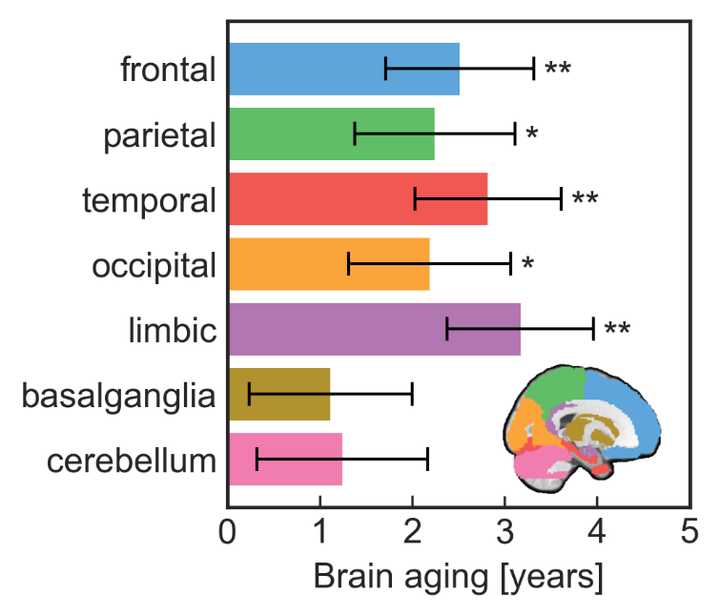
Supplementary Figure S1. Brain aging in patients for different regions of the brain. Error bars indicate standard error of the mean. Asterisks indicate statistical significance based on a one-sample t-test. * p < 0.05, uncorrected; ** p < 0.05, Bonferroni-corrected for 7 regions.

