DNA methylome variation in a perinatal nurse-visitation program that reduces child maltreatment: a 27-year follow-up.

Supplementary Material

Table S1: Enrichr analysis (biological processes) of vCpGs associated with PC10 and maternal participation in the nurse-family partnership (NFP).

Table S2: Enrichr analysis (biological processes) of vCpGs associated with PC1 or PC2 and history of child abuse/neglect (CAN).

Table S3: Child abuse/Neglect Associated vCpGs. The top 100 vCpGs from a linear regression analysis are provided. The model adjusted for cell-counts, gender, age at time of biosampling, population stratification, maternal education, psychiatric disorders and a polygenic risk score for psychiatric disorders. All p-values are unadjusted.

Table S4: Enrichr transcription factor enrichment analysis. Chromatin Immunoprecipitation sequencing datasets were accessed through Enrichr and enrichment for transcription factor binding examined within genes containing child abuse and neglect-associated vCpGs. Steroid-associated nuclear receptors are highlighted in bold.
Table S5: Metacore transcription factor enrichment analysis of variably methylated CpGs associated with child abuse/neglect. Bold text denotes steroid hormone receptors.

Table S6: Treatment group-associated vCpGs. The top 100 vCpGs from a linear regression analysis of maternal nurse family partnership treatment group and variably methylated CpGs are provided. The model adjusted for cell-counts, gender, age at time of biosampling, population stratification, maternal education, psychiatric disorders and a polygenic risk score for psychiatric disorders. All p-values are unadjusted.

Table S7: Effects size estimate and power calculation for detecting genome-wide significant associations between nurse family partnership participation and variation in DNA methylation.

Figure S1: Principal component analysis of genetic data. Scree plot (left) shows the proportion of variance accounted for by each component. Principal component one (PC1) and PC2 best described the population structure in this cohort (markers are colour coded by self reported ethnicity).

Figure S2: Technical validation of AHRR DNA methylation. DNA methylation of AHRR as determined by the 450K array and pyrosequencing was highly correlated (left panel) and reproducible (right panel) across methods. Blue line (left panel) represents regression line, purple lines (right panel) represent the mean difference (solid line) and limits of agreement (dashed lines).

Figure S3: AHRR DNA methylation associates with child abuse/neglect (CAN) and smoking. The 204bp amplicon interrogated by pyrosequencing contained two additional CpGs 25bp and 23bp upstream of cg05575921 one of the top ranked variably methylated CpGs associated with CAN, respectively. All three CpGs showed a similar pattern of association with a history of CAN (a-c) and smoking (d-f). All p≤2.00E-06.

Figure S4: A polygenic risk score (PRS) for major psychiatric disorders associates with DNA methylation. Linear regression analysis of a cross-disorder PRS at p-value threshold <0.20 (Cross-PRS_{0.20}) and DNA methylation of variable CpGs revealed a significantly skewed p-value distribution. Models was adjusted for population stratification, cell counts, gender, age at time of biosampling, maternal education and smoking. P-value from a pkstest.

Figure S5: Variable CpGs (vCpGs) that associate with the Cross-Disorder PRS (black circle) do not significantly overlap with vCpGs that associate with child abuse/neglect (grey circle). P-value is derived from a one-tailed Fisher exact test, numbers represent vCpGs associated with Cross-Disorder PRS child abuse/neglect.

Table S1:
PC10 and NFP treatment-associated vCpGs | p-value | Adj p-value
synapse assembly | 4.70E-17 | 2.21E-13
neurogenesis | 4.49E-16 | 5.49E-13
peripheral nervous system development | 4.02E-16 | 5.49E-13
determination of left/right asymmetry in nervous system | 2.31E-15 | 1.36E-12
autonomic nervous system development | 8.16E-16 | 5.49E-13
ganglion development | 7.21E-16 | 5.49E-13
stomatogastric nervous system development | 7.21E-16 | 5.49E-13
nervous system development | 7.21E-16 | 5.49E-13
neural tube development | 4.26E-15 | 2.23E-12
central nervous system development | 2.16E-13 | 1.01E-10

PC1 and CAN-associated vCpGs | p-value | Adj p-value
protein phosphorylation | 7.06E-05 | 0.10
positive regulation of T cell differentiation | 0.000155847 | 0.10
Hemopoiesis | 0.000184287 | 0.10
T cell differentiation | 0.000242553 | 0.10
inflammatory response | 0.00096767 | 0.19
liver development | 0.0006642 | 0.19
positive regulation of protein ubiquitination | 0.000833824 | 0.19
neutrophil degranulation | 0.002479537 | 0.28
nuclear-transcribed mRNA catabolism | 0.002271739 | 0.28
regulation of transcription from RNA polymerase II promoter | 0.013689801 | 0.49
PC2 and CAN-associated vCpGs | p-value | Adj p-value
regulation of transcription by transcription factor localization | 9.96E-05 | 0.044
regulation of transcription involved in exit from mitosis | 1.21E-04 | 0.044
regulation of antisense RNA transcription | 1.27E-04 | 0.044
regulation of DNA-templated transcription, termination | 1.47E-04 | 0.044
regulation of transcription from RNA polymerase III promoter | 1.48E-04 | 0.044
regulation of transcription involved in G1/S transition of mitotic cell cycle | 1.63E-04 | 0.044
Table S2:
Table S3:
Rank | CpG Identifier | Unadjusted p-value
1 | cg03440944 | 1.47776E-06
2 | cg00115288 | 3.82537E-06
3 | cg16204559 | 8.35849E-06
4 | cg04702509 | 1.38023E-05
5 | cg21161138 | 1.60793E-05
6 | cg01498249 | 1.72501E-05
7 | cg04194840 | 2.74992E-05
8 | cg07784872 | 3.18013E-05
9 | cg11497458 | 3.30141E-05
10 | cg04718853 | 3.35668E-05
11 | cg09501047 | 3.55598E-05
12 | cg08889930 | 3.82525E-05
13 | cg12218389 | 4.55083E-05
14 | cg26364091 | 4.88963E-05
15 | cg18246298 | 5.04457E-05
16 | cg04453471 | 5.22257E-05
17 | cg27057329 | 5.50795E-05
18 | cg17166262 | 6.14106E-05
19 | cg16310491 | 6.24185E-05
20 | cg16911214 | 6.48386E-05
21 | cg07696699 | 6.60701E-05
22 | cg11796827 | 6.62743E-05
23 | cg25350097 | 6.76811E-05
24 | cg14072027 | 6.8371E-05
25 | cg05158854 | 6.8955E-05
26 | cg00806319 | 7.08339E-05
27 | cg24090911 | 7.18812E-05
28 | cg18984103 | 7.32025E-05
29 | cg03445800 | 7.43317E-05
30 | cg02556649 | 7.57178E-05
31 | cg04739149 | 7.61563E-05
32 | cg08677488 | 8.10427E-05
33 | cg13276570 | 9.20088E-05
34 | cg07423149 | 9.41225E-05
35 | cg00035316 | 9.42495E-05
36 | cg18669186 | 9.51754E-05
37 | cg06178299 | 9.98219E-05
38 | cg05713486 | 0.000103396
39 | cg03003394 | 0.000107179
40 | cg06096677 | 0.000112694
41 | cg07576363 | 0.000117276
42 | cg13291296 | 0.000126653
43 | cg09859659 | 0.000130248
44 | cg07519229 | 0.000131523
45 | cg14580211 | 0.000136013
46 | cg26099045 | 0.00014577
47 | cg24124079 | 0.000147495
48 | cg02577773 | 0.000147599
49 | cg15484808 | 0.000152556
50 | cg26946769 | 0.000153118
51 | cg10458392 | 0.000153197
52 | cg00155846 | 0.000155878
53 | cg17115737 | 0.000159982
54 | cg13491139 | 0.000170223
55 | cg22737154 | 0.000171657
56 | cg24251035 | 0.000172405
57 | cg08396193 | 0.000175419
58 | cg00164678 | 0.000176437
59 | cg13268603 | 0.000178265
60 | cg21451906 | 0.00018763
61 | cg19399532 | 0.00018979
62 | cg22228988 | 0.000206791
63 | cg13519452 | 0.000207447
64 | cg06938101 | 0.000211511
65 | cg20600845 | 0.000213477
66 | cg02229607 | 0.000214598
67 | cg15500259 | 0.000218136
68 | cg06123807 | 0.000225231
69 | cg27451610 | 0.000227605
70 | cg26881591 | 0.000238522
71 | cg18190861 | 0.000240368
72 | cg01062116 | 0.000245058
73 | cg23907053 | 0.000252962
74 | cg15252429 | 0.000260863
75 | cg16467775 | 0.000270673
76 | cg02308712 | 0.000283958
77 | cg24046474 | 0.000298069
78 | cg26153954 | 0.000304944
79 | cg11073381 | 0.000311493
80 | cg12119029 | 0.000321482
81 | cg12745160 | 0.000321746
82 | cg05650559 | 0.000329552
83 | cg23912266 | 0.000340073
84 | cg06369785 | 0.000340683
85 | cg01934638 | 0.000342554
86 | cg18099070 | 0.000347044
87 | cg02800810 | 0.000357537
88 | cg01384290 | 0.000358305
89 | cg13844248 | 0.000363727
90 | cg01069451 | 0.000363922
91 | cg12572827 | 0.00037276
92 | cg13008492 | 0.000374201
93 | cg24727216 | 0.000381804
94 | cg03625911 | 0.000394407
95 | cg01058070 | 0.000397203
96 | cg06615840 | 0.000397849
97 | cg10868715 | 0.000401632
98 | cg15065877 | 0.000406072
99 | cg26518580 | 0.000413804
100 | cg08129331 | 0.000416546

Table S4:
Transcription Factor | Cell type/Cell Line | P-value for enrichment | Adjusted P-value
MITF | MELANOMA | 7.53634E-33 | 4.86094E-30
ZNF217 | MCF-7 | 6.2387E-30 | 2.01198E-27
FOXA2 | HepG2 | 6.2357E-25 | 1.00551E-22
TFAP2C | MCF-7 | 8.61187E-25 | 1.11093E-22
EGR1 | ERYTHROLEUKEMIA | 5.30676E-23 | 5.70477E-21
TCF4 | U87 | 3.68498E-21 | 2.6409E-19
HNF4A | HepG2 | 1.14496E-19 | 6.15418E-18
PAX3-FKHR | RHABDOMYOSARCOMA | 2.97527E-18 | 1.27936E-16
STAT3 | U87 | 6.01195E-18 | 2.42357E-16
DROSHA | HELA | 1.03076E-17 | 3.91083E-16
SCL | MEGAKARYOCYTES | 1.28665E-17 | 4.6105E-16
KDM2B | K562 | 3.17287E-16 | 9.74524E-15
AR | PC3 | 2.10956E-15 | 6.18483E-14
KDM2B | SUP-B15 | 2.63747E-15 | 7.0882E-14
CTNNB1 | HCT116 | 3.67022E-15 | 9.46916E-14
AHR | MCF-7 | 5.41114E-15 | 1.34238E-13
ARNT | MCF-7 | 2.8734E-14 | 6.46781E-13
LXR | THP-1 | 4.58589E-14 | 9.85966E-13
GATA1 | MEGAKARYOCYTES | 1.95371E-13 | 4.06497E-12
SMAD4 | A2780 | 5.38882E-13 | 1.05327E-11
TP63 | HFKS | 2.84547E-11 | 5.2438E-10
KDM2B | JURKAT | 3.93844E-11 | 6.86565E-10
CTCF | Bcells | 4.32963E-10 | 7.34897E-09
UBF1/2 | HMEC-DERIVED | 8.38687E-10 | 1.38706E-08
RACK7 | MCF-7 | 1.60752E-09 | 2.52891E-08
RUNX2 | PCA | 2.02885E-09 | 3.11573E-08
GATA2 | MEGAKARYOCYTES | 2.3131E-09 | 3.46966E-08
SPI1 | K562 | 2.72997E-09 | 4.00189E-08
CREB1 | LNCaP-abl | 3.04872E-09 | 4.36984E-08
KDM2B | DND41 | 5.72108E-09 | 8.02195E-08
AR | PROSTATE CANCER | 6.52203E-09 | 8.95045E-08
SMAD3 | EPCs | 1.06559E-08 | 1.43189E-07
KLF4 | ESCs | 1.44173E-08 | 1.85983E-07
TP63 | EP156T | 3.94787E-08 | 4.71551E-07
PPAR | NCI-H1993 | 5.38568E-08 | 6.31594E-07
SMAD2/3 | EPCs | 1.13536E-07 | 1.30769E-06
WT1 | PODOCYTE | 1.39651E-07 | 1.58026E-06
TCF21 | SMOOTH MUSCLE | 1.50852E-07 | 1.64914E-06
ELK3 | HUVEC | 1.50852E-07 | 1.64914E-06
PIAS1 | VCAP | 2.83214E-07 | 3.04455E-06
VDR | THP-1 | 5.21149E-07 | 5.33557E-06
VDR | THP-1 | 7.59108E-07 | 7.65039E-06
SA1 | ERYTHROID | 7.84814E-07 | 7.78777E-06
SMAD3 | ESCs | 1.72682E-06 | 1.68758E-05
PRDM14 | ESCs | 1.84822E-06 | 1.77926E-05
KDM2B | SIL-ALL | 2.23404E-06 | 2.11905E-05
KLF6 | PDAC-Cell Line | 4.76066E-06 | 4.38661E-05
VDR | LCL-AND-THP1 | 5.2344E-06 | 4.7552E-05
EZH2 | EOC | 5.60433E-06 | 5.02055E-05
P300 | ESCs | 6.0936E-06 | 5.2405E-05
KLF5 | YYC3 | 6.0936E-06 | 5.2405E-05
RUNX | JUKART | 9.28448E-06 | 7.87959E-05
CTCF | ERYTHROID | 9.90397E-06 | 8.29618E-05
TCF3/E2A | JUKARTE6-1 | 1.02346E-05 | 8.46326E-05
PPARD | MYOFIBROBLAST | 1.30486E-05 | 0.000106536
FOXM1 | Hek293 flp-in | 1.62329E-05 | 0.000130878
AR | VCAP | 1.97108E-05 | 0.000154453
OCT4 | ESCs | 2.01147E-05 | 0.000154453
KLF4 | PDAC-Cell Line | 2.01147E-05 | 0.000154453
P300 | ZR-75-30cells | 2.01147E-05 | 0.000154453
SA1 | Bcells | 3.18312E-05 | 0.000238734
OCT4 | PROSTATE | 7.71993E-05 | 0.000559478
E2A | RAMOS-Cell line | 9.56986E-05 | 0.00068584
NR3C1 | MCF10A | 0.000113733 | 0.000806126
TBL1 | 293T | 0.000118315 | 0.000829489
VDR | THP-1 | 0.000160207 | 0.001099295
ESR2 | MCF-7 | 0.000178417 | 0.001192936
FOXM1 | MCF-7 | 0.000179403 | 0.001192936
TP53 | IMR90 | 0.000195835 | 0.001288912
TP53 | U2OS | 0.000270621 | 0.001745507
CREB1 | LNCaP | 0.000269146 | 0.001745507
ERG | JURKAT | 0.000334831 | 0.002138274
SMAD4 | EPCs | 0.000399502 | 0.002526261
TRIM28 | HEK293 | 0.00052148 | 0.003265579
TOP2B | MCF-7 | 0.000586712 | 0.003604088
TCF12/HEB | JUKARTE6-1 | 0.000708183 | 0.004309227
CSB | FIBROBLAST | 0.001023588 | 0.006170226
RELA | FIBROSARCOMA | 0.001060229 | 0.006331922
MYCN | NEUROBLASTOMA | 0.001225704 | 0.007253021
ESR1 | MCF-7 | 0.002110707 | 0.012376416
KDM2B | HPB-ALL | 0.002454266 | 0.014133944
CJUN | BT549 | 0.002900243 | 0.016409271
NCOR1 | K562 | 0.002900243 | 0.016409271
GBX2 | PC3 | 0.003259678 | 0.018282541
NFYA | K562 | 0.003418228 | 0.019006528
AR | LNCaP-1F5 | 0.004018121 | 0.022058609
EWS-FLI1 | SK-N-MC | 0.004223164 | 0.022890261
FOXA1 | LNCaP-1F5 | 0.004710875 | 0.025111689
WDR5 | LNCAP | 0.004925376 | 0.026039898
SMRT | Bcells | 0.005508564 | 0.028886372
SCL | HPC-7 | 0.006471646 | 0.033662995
RXR | LS180 | 0.007391659 | 0.037381034
ERA | ENDOMETRIOID-ADENOCARCINOMA | 0.007476207 | 0.037381034
UBF1/2 | HMECs | 0.00747297 | 0.037381034
SMC4 | HELA | 0.008669916 | 0.042045832
NFYB | K562 | 0.008669916 | 0.042045832
ELF3 | PDAC-Cell Line | 0.008669916 | 0.042045832

Table S5:
Gene ID | Transcription factor | Z score | p-value
NR3C1 | GCR-alpha | 7.961 | 1.071E-14
SP1 | SP1 | 7.606 | 9.728E-14
ESR1 | ESR1 (nuclear) | 6.449 | 2.383E-10
POU5F1 | Oct-3/4 | 6.323 | 5.208E-10
STAT3 | STAT3 | 5.868 | 1.073E-08
GLI1 | GLI-1 | 4.53 | 0.00002036
RUNX2 | RUNX2 | 4.392 | 0.00002171
GLI3 | GLI-3 | 4.662 | 0.00002414
GATA4 | GATA-4 | 4.202 | 0.00004515
TCF7L2 | TCF7L2 (TCF4) | 4.003 | 0.00006994
DLX5 | DLX5 | 4.342 | 0.00008337
PGR | PR (nuclear) | 3.984 | 0.00008371
ETS1 | ETS1 | 3.665 | 0.0002374
RARA | RARalpha | 3.722 | 0.0002724
TFAP2A | AP-2A | 3.583 | 0.0003523
LHX2 | LHX2 | 3.538 | 0.0003667
FOXA2 | HNF3-beta | 3.471 | 0.0004949
ZBTB20 | ZNF288 | 3.865 | 0.000503
NKX3-2 | BAPX1 | 3.609 | 0.0005444
NANOG | NANOG | 3.303 | 0.0007122
FOXP2 | FOXP2 | 3.371 | 0.0007551
SMAD1 | SMAD1 | 3.338 | 0.001019
TAL1 | TAL1 | 3.221 | 0.001205
HNF4A | HNF4-alpha | 3.082 | 0.001526
HOXA2 | HOXA2 | 3.368 | 0.001535
MEIS2 | MEIS2 | 3.329 | 0.003724
NR3C1 | GCR-beta | 3.097 | 0.003779
ONECUT2 | OC-2 | 3.358 | 0.004158
RXRA | RXRA | 2.795 | 0.004297

Table S6:
Rank | CpG Identifier | Unadjusted p-value
1 | cg01201279 | 1.85177E-05
2 | cg13775306 | 7.49203E-05
3 | cg03938110 | 7.86255E-05
4 | cg00281725 | 7.94661E-05
5 | cg20107346 | 8.0591E-05
6 | cg06458106 | 9.94869E-05
7 | cg13333304 | 0.000106192
8 | cg09423126 | 0.000111367
9 | cg03088958 | 0.000116695
10 | cg20956390 | 0.000121238
11 | cg14338345 | 0.000131267
12 | cg00777271 | 0.000136609
13 | cg00667751 | 0.000148734
14 | cg09427644 | 0.000151769
15 | cg11083807 | 0.000180456
16 | cg13172549 | 0.000204556
17 | cg16652855 | 0.000211533
18 | cg01997606 | 0.000217833
19 | cg05543520 | 0.000237678
20 | cg03277049 | 0.000244661
21 | cg21077957 | 0.000248077
22 | cg00632007 | 0.000250607
23 | cg20562823 | 0.000252237
24 | cg14751481 | 0.000257852
25 | cg16471600 | 0.000258678
26 | cg21249371 | 0.000265321
27 | cg07168232 | 0.00027417
28 | cg23022785 | 0.000276121
29 | cg14291663 | 0.000280943
30 | cg23867562 | 0.000290301
31 | cg03660034 | 0.000317599
32 | cg11553116 | 0.000327577
33 | cg00011482 | 0.000329631
34 | cg08578216 | 0.000330032
35 | cg10131075 | 0.000342324
36 | cg09143195 | 0.000348391
37 | cg04714638 | 0.000348814
38 | cg09244436 | 0.000352208
39 | cg21004633 | 0.000363643
40 | cg01417849 | 0.000368046
41 | cg24057218 | 0.000375504
42 | cg03236328 | 0.000380163
43 | cg13571479 | 0.000384258
44 | cg10862354 | 0.00039589
45 | cg05485062 | 0.000411338
46 | cg26037602 | 0.000423361
47 | cg16858587 | 0.000457638
48 | cg01298758 | 0.000458552
49 | cg20769177 | 0.000462615
50 | cg26112999 | 0.00046384
51 | cg04699104 | 0.000477363
52 | cg05581802 | 0.000490227
53 | cg17204337 | 0.000494513
54 | cg27606002 | 0.000517964
55 | cg17298543 | 0.000550906
56 | cg04439374 | 0.000558338
57 | cg04605681 | 0.000564777
58 | cg05202300 | 0.000574847
59 | cg19868364 | 0.000575247
60 | cg06048750 | 0.000583634
61 | cg05246645 | 0.00060064
62 | cg00244776 | 0.00063378
63 | cg19815271 | 0.000657705
64 | cg15727708 | 0.000673784
65 | cg16240816 | 0.000706387
66 | cg08126542 | 0.000716952
67 | cg06962918 | 0.000722523
68 | cg06829788 | 0.000738653
69 | cg11300809 | 0.000755915
70 | cg00945507 | 0.000779178
71 | cg04945457 | 0.000802867
72 | cg00159439 | 0.000813909
73 | cg27541691 | 0.000852186
74 | cg00014754 | 0.000859371
75 | cg01591025 | 0.000882423
76 | cg19155735 | 0.000924979
77 | cg11019771 | 0.000927539
78 | cg27404351 | 0.000945513
79 | cg00950244 | 0.000965801
80 | cg02678305 | 0.00098052
81 | cg05775862 | 0.001011131
82 | cg14545253 | 0.001026339
83 | cg02821464 | 0.001029927
84 | cg17216737 | 0.001033354
85 | cg04774364 | 0.001042505
86 | cg16622920 | 0.001071586
87 | cg17545652 | 0.001074396
88 | cg26924247 | 0.00111758
89 | cg21020871 | 0.001122875
90 | cg20490088 | 0.001125583
91 | cg13178170 | 0.001151416
92 | cg21668832 | 0.001155587
93 | cg20026346 | 0.001158403
94 | cg05503062 | 0.001163619
95 | cg06521145 | 0.001165808
96 | cg11557932 | 0.001175565
97 | cg01317029 | 0.001181574
98 | cg24773532 | 0.001182406
99 | cg15890794 | 0.001184712
100 | cg06190807 | 0.00118725

Table S7:
 | Control (n=98) | Nurse-visited (N=88)
CpG Identifier (gene name) | Beta (SD) | Beta (SD)
cg01201279 (LEKR1) | 0.73 (0.082) | 0.67 (0.09)
Cohen's D | 0.71
 | Power calculation
Alpha (p) | 10E-7
Beta | 0.95
Sample allocation ratio | 1.1
Tails | 2
Estimated sample size | N=168 |  | N=184

Linear regression analyses identified cg01201279 as the top ranked variably methylated CpG associated with maternal participation in the nurse family partnership (p=3.47E-05), independent of cell-counts, population stratification, smoking, current mental health, age at time of biosampling and a polygenic risk indicator for psychiatric diagnoses. We estimated Cohen’s D (Table S5) and used G*Power¹ to calculate the projected sample size required to detect a genome-wide significant group difference between controls and nurse-visited participants.
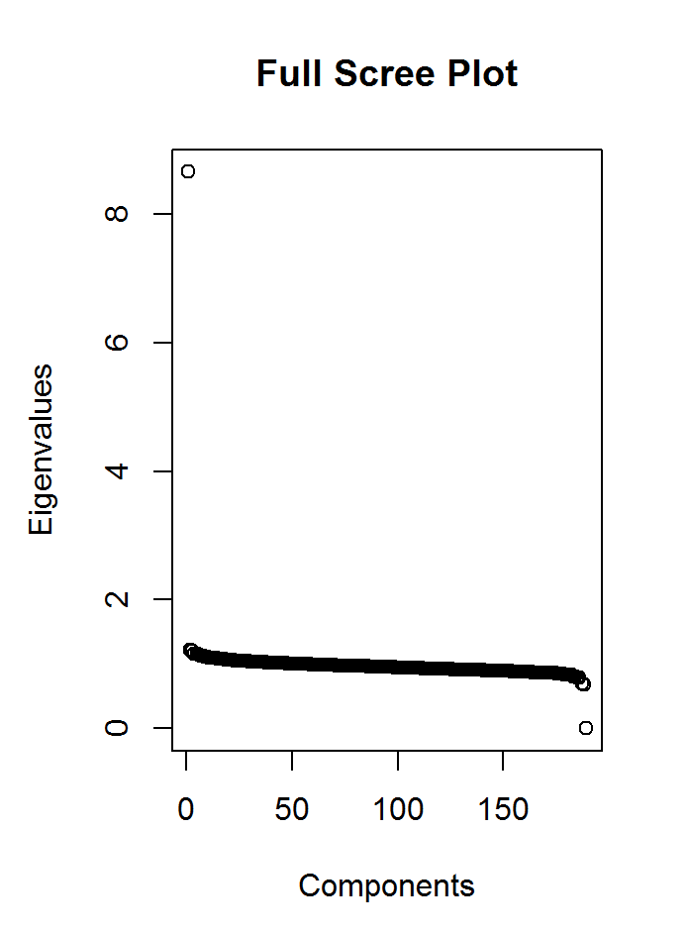
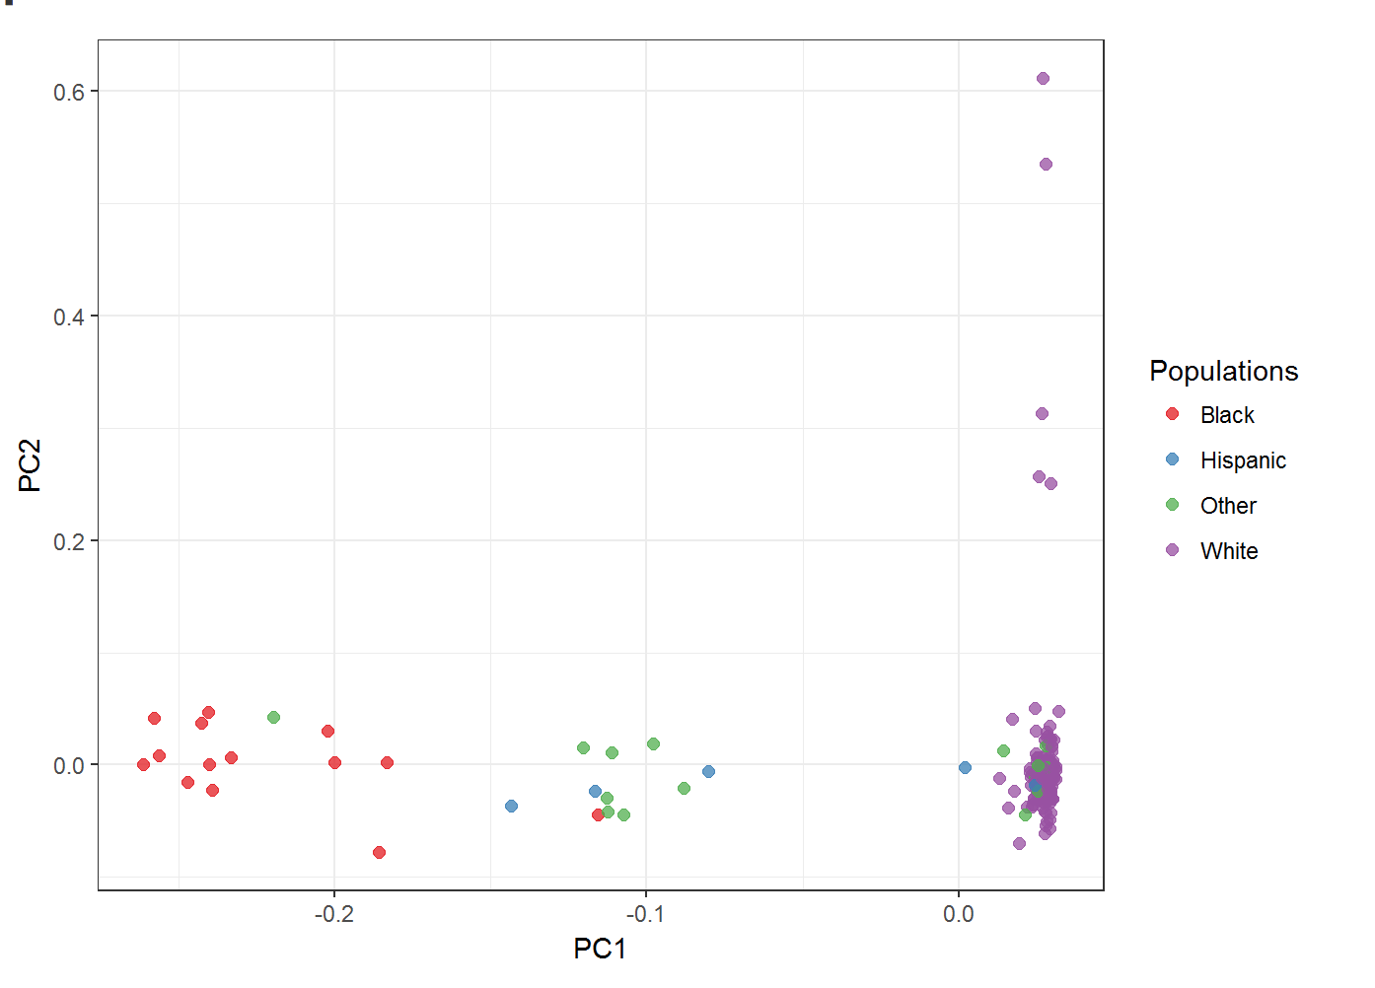
Figure S1:

Figure S2:
a.
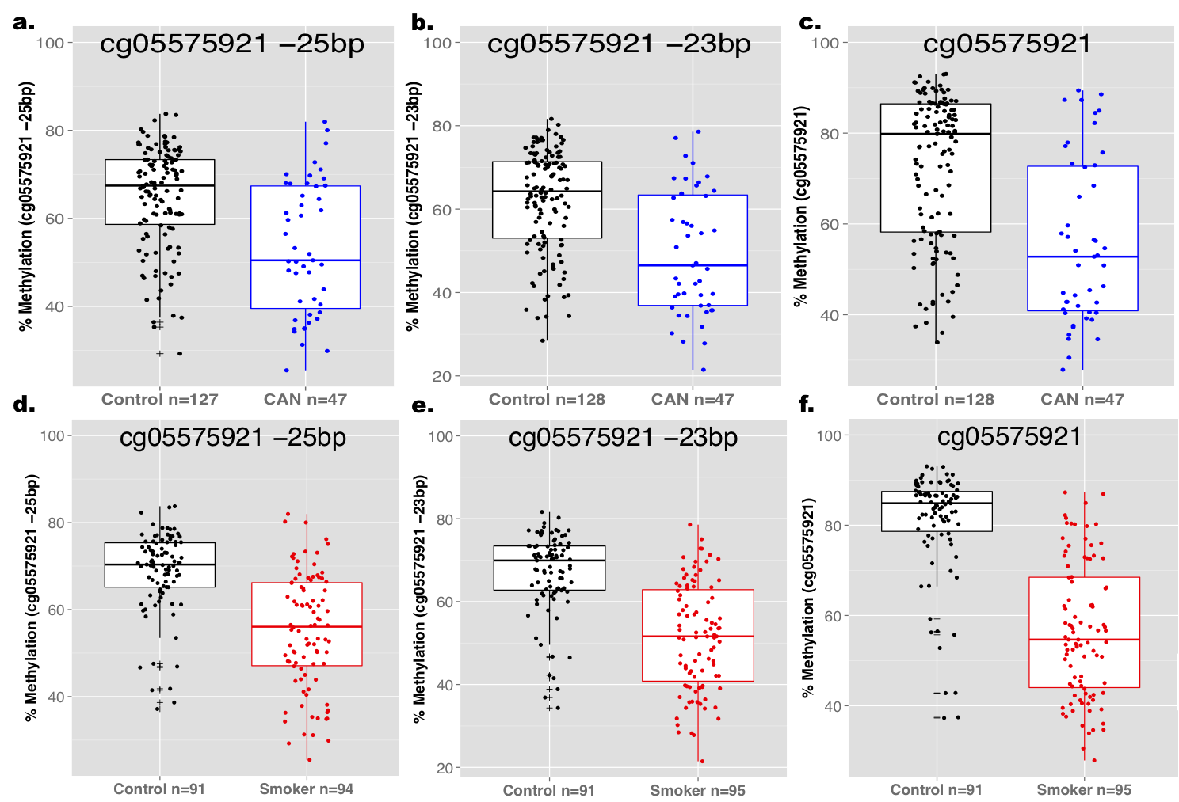
Figure S3:

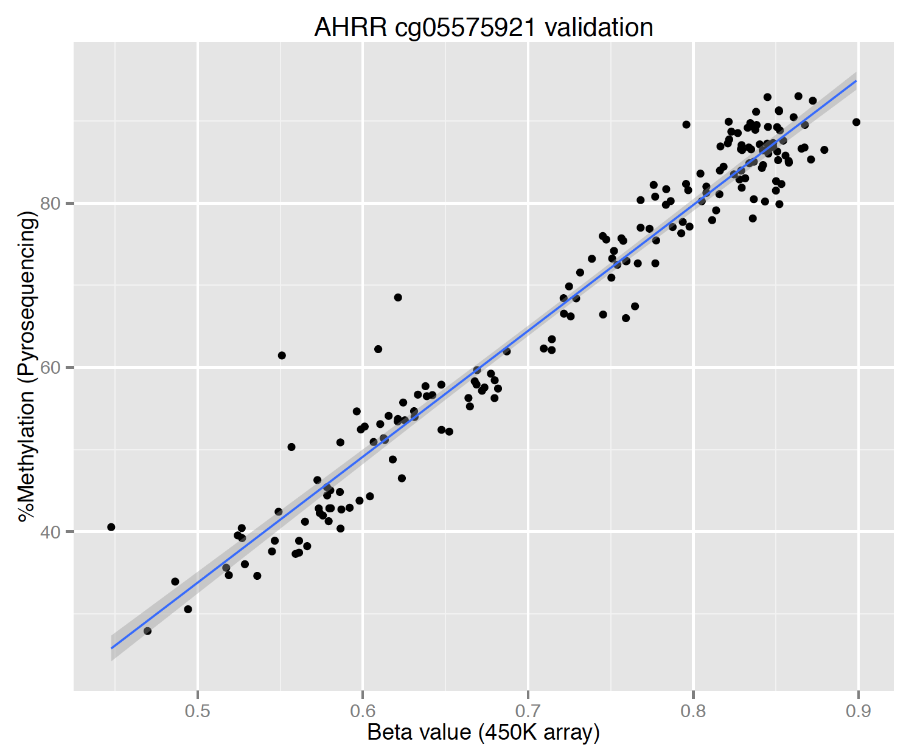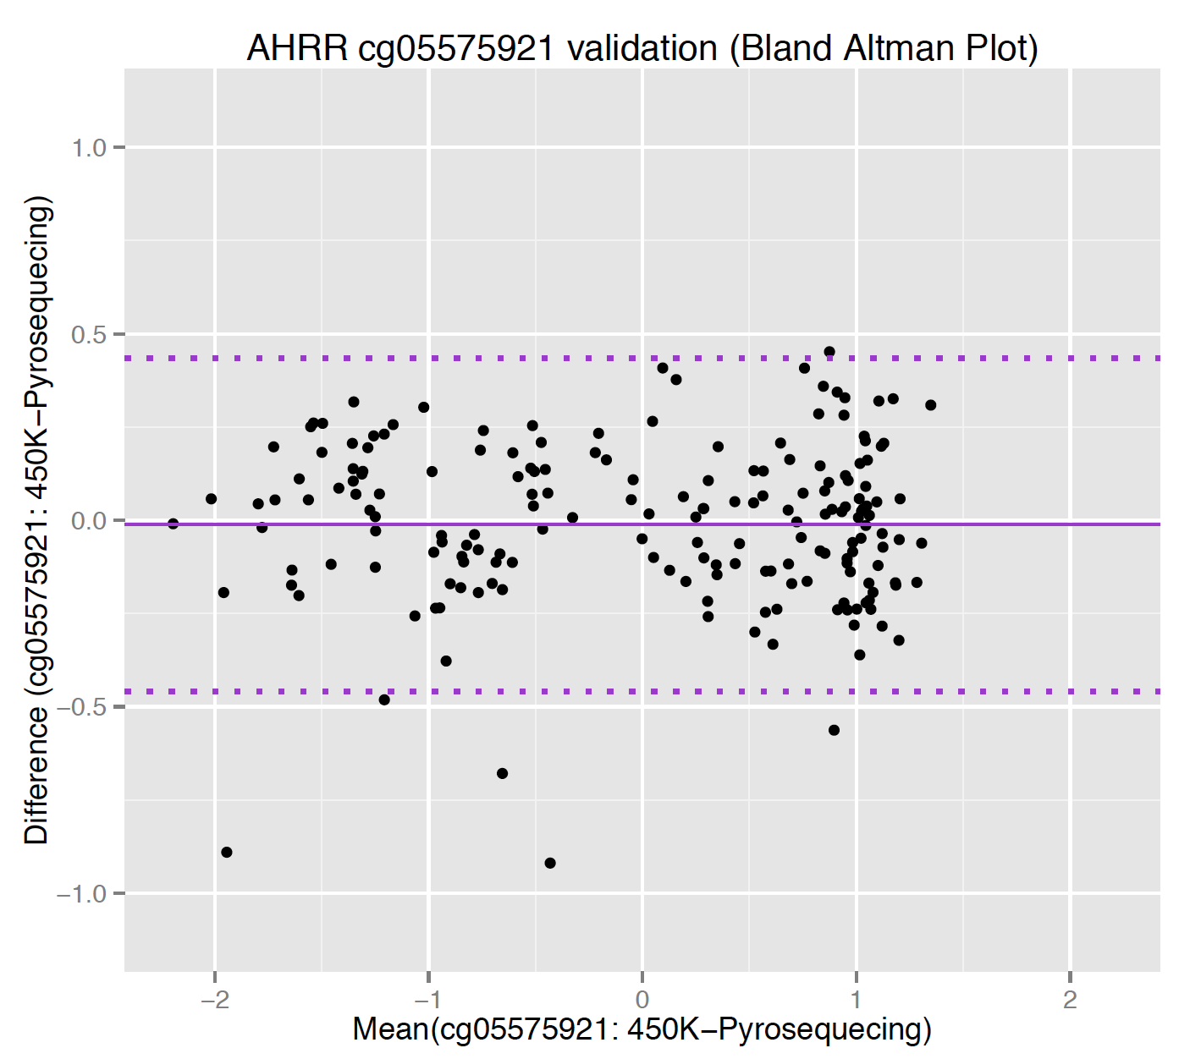
r=0.974, p=3.87E-121

Figure S4:

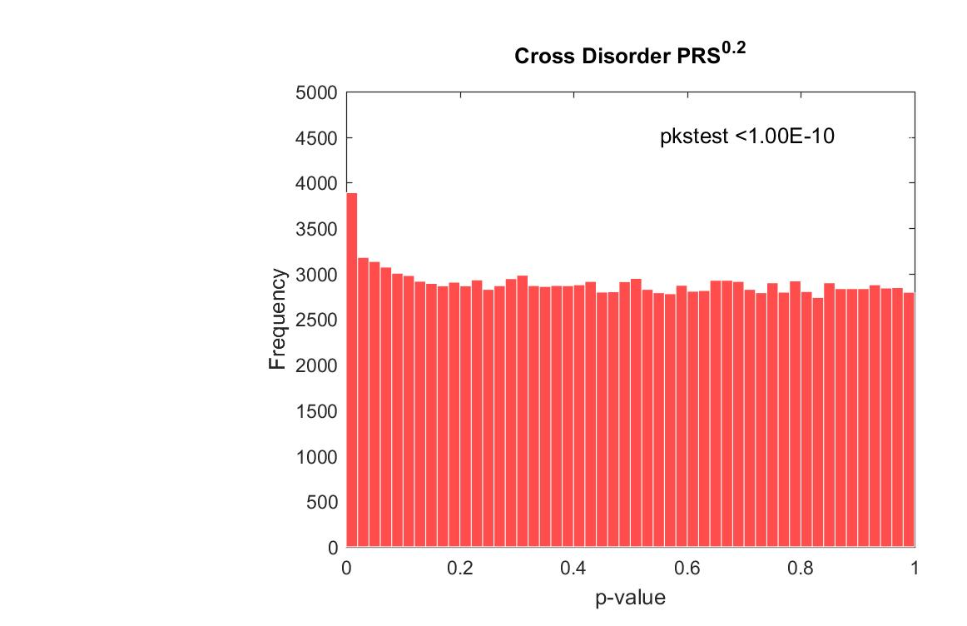

Figure S5

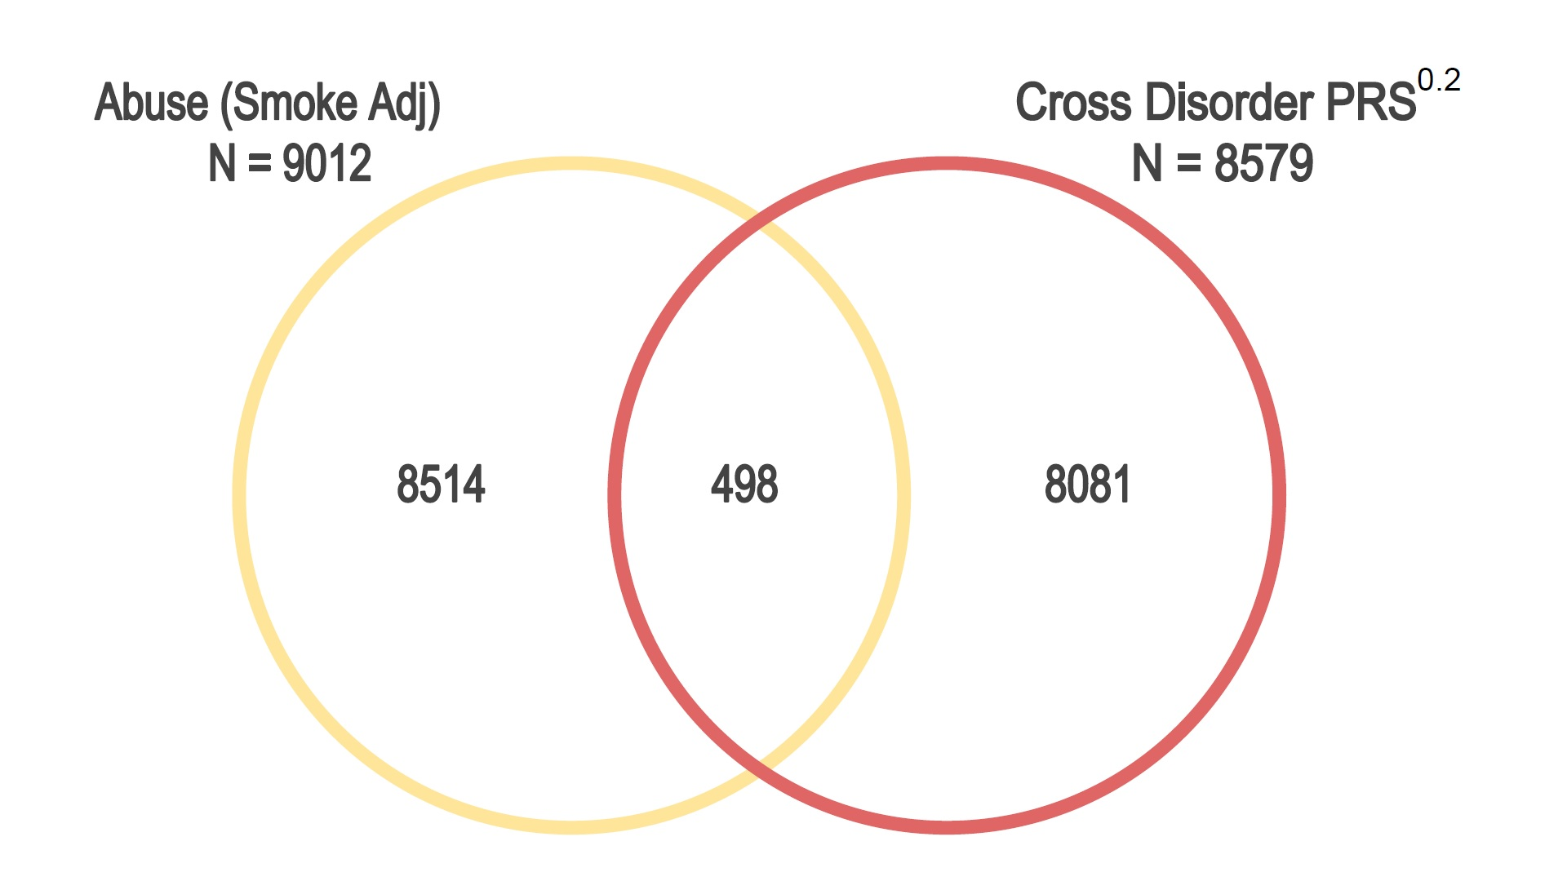
P for overlap=0.117

Supplemental References:

1. Faul F, Erdfelder E, Lang AG, Buchner A. G*Power 3: a flexible statistical power analysis program for the social, behavioral, and biomedical sciences. Behavior research methods. 2007;39(2):175-91.

