Supplemental Material

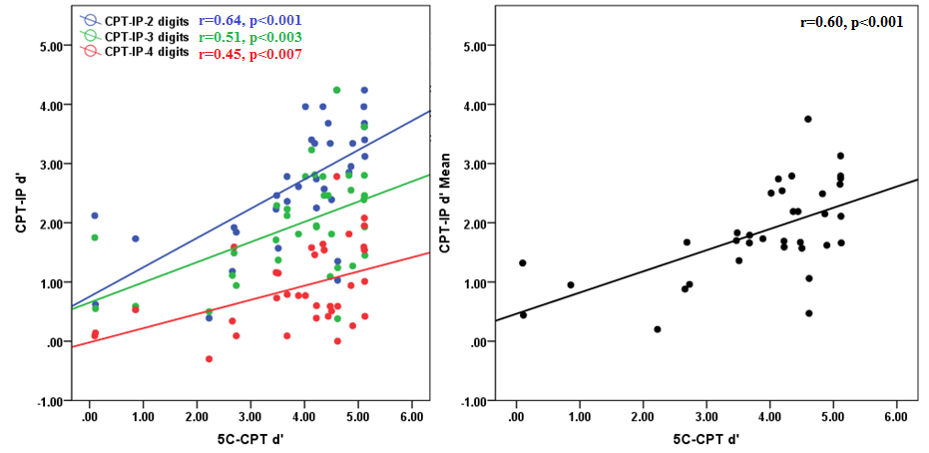
Supplemental figure S1. Scatter plots and correlations between 5C-CPT d' and CPT-IP d' for the (left pane) two-, three-, and four-digit conditions, and the (right pane) collapsed average CPT-IP d'.

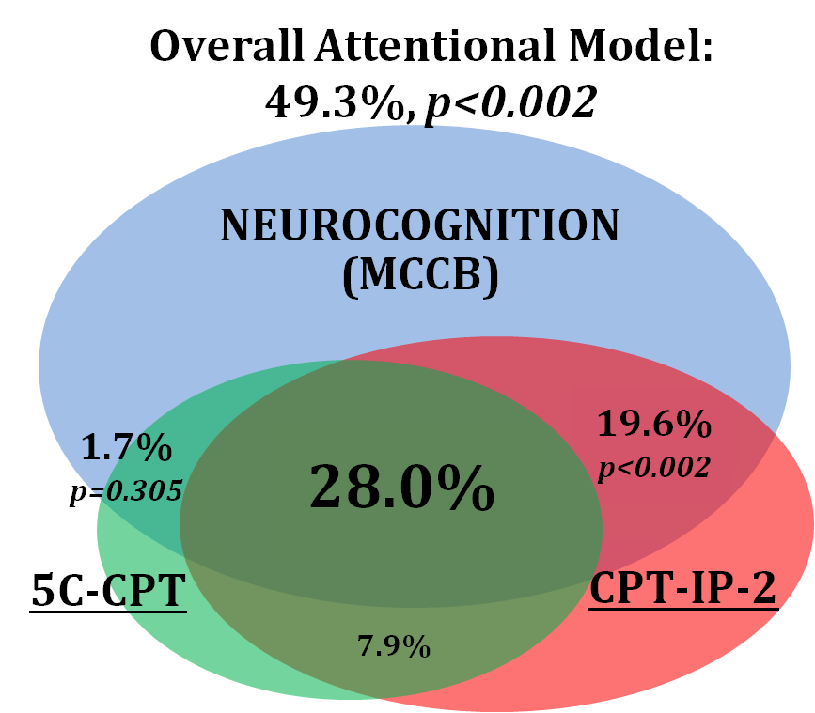
Supplemental Figure 2. Behavioral measure variance components predicting cognition. Total model variance in cognition (MCCB Total score) accounted for was 49.3%. Outer circles depict the unique variance proportions for each predictor. The CPT-IP-2 accounted for 19.6% of the variance, while the 5C-CPT uniquely accounted for only 1.7%. The variance shared between the 5C-CPT and the CPT-IP-2 accounted for 28.0 % of the variance in cognition.

Supplemental Table 1: Behavioral Task Descriptive Statistics
Task/Measure | Mean (SEM)
 | 5C-CPT | CPT-IP-2
d' | 3.85 (0.23) | 2.66 (0.17)*
Hit Rate (HR) | 0.90 (0.35) | 0.79 (0.02)*
False Alarm Rate (FAR) | 0.03 (0.01) | 0.07 (0.01)
Responsivity Index (RI) | -0.23 (0.07) | -0.71 (0.03)*
MCCB (T-Scores) | Mean (SEM) | Range
Composite Score | 34.29 (1.2) | 18.8-49.4
Speed of Processing | 30.8 (1.8) | 8-55
Visual Learning | 31.5 (1.9) | 14-59
Verbal Learning | 34.1 (0.9) | 21-46
Working Memory | 33.3 (2.2) | 5-55
Reasoning & Problem Solving | 41.7 (1.4) | 28-59
Behavioral task performance and MCCB composite and subscale means, standard errors and response ranges. * indicates p<0.01.

Supplemental Table 2: Attention – Cognition Correlations
 | 5C-CPT | CPT-IP-2 | Fisher’s z
5C-CPT |  | 0.64* | p-values
MCCB Composite | 0.54* | 0.69* | ns
Speed of Processing | 0.33 | 0.57* | 0.01*
Working Memory | 0.54* | 0.64* | ns
Verbal Learning | 0.44+ | 0.40 | ns
Visual Learning | 0.26 | 0.43 | 0.01*
Reasoning & Problem Solving | 0.51* | 0.50* | ns
SANS Total Score | -0.30 | -0.14 | ns
SAPS Total Score | -0.28 | -0.23 | ns
Pearson correlations between 5C-CPT and CPT-IP-2 d's, MCCB composite (without the CPT-IP included), subscale T-Scores, and SANS and SAPS total scores. Statistical significance (*) was determined based on a Bonnferoni correction, which required p<0.004. Plus symbol (+) indicates corrected trend-level significance p<0.01. Right column depicts p-values for Fisher-z correlation comparisons between left and middle columns using single-sided testing.

