Association study and mutation sequencing in chromosome 15q11-q13 identified GABRG3 as a susceptibility gene for autism in Chinese Han population

Linyan Wang^{1,2,3,4#}, Jun Li^{1,2,3,4#}, Mei Shuang^{1,2,3,4#}, Tianlan Lu^{1,2,3,4}, Ziqi Wang^{1,2,3,4}, Tian Zhang^{1,2,3,4}, Weihua Yue^{1,2,3,4}, Meixiang Jia^{1,2,3,4}, Yanyan Ruan^{1,2,3,4}, Jing Liu^{1,2,3,4}，Zhiliu Wu^{1,2,3,4,5}, Dai Zhang^{1,2,3,4,6,7}, Lifang Wang^{1,2,3,4}

¹ Peking University Sixth Hospital, Beijing 100191, China.
² Peking University Institute of Mental Health, Beijing 100191, China.
³ Key Laboratory of Mental Health, Ministry of Health (Peking University), Beijing 100191, China.
⁴ National Clinical Research Center for Mental Disorders, (Peking University Sixth Hospital), Beijing 100191, China.
⁵ The Affiliated Brain Hospital of Guangzhou Medical University (Guangzhou Huiai Hospital), Guangzhou, 510370, China.
⁶ Peking-Tsinghua Center for Life Sciences, Peking University, Beijing, 100871, China.
⁷ PKU-IDG/McGovern Institute for Brain Research, Peking University, Beijing 100871, China.
#These authors contributed equally to this work.
Correspondence author: Jing Liu (ljyuch@bjmu.edu.cn), Zhiliu Wu (email: zhiliu_wu@bjmu.edu.cn), Lifang Wang (email: lifangwang@bjmu.edu.cn)
Fax: 86-010-82021960

Supplementary Materials
Figure S1. Schematic of sample processing by targeted sequencing.
Figure S2. Schematic of data analysis by targeted sequencing.
Figure S3. Six rare variants in GABRB3 validated by Sanger sequencing.
Figure S4. eQTL effects of rs4906771 in ATP10A on 10 brain regions in the Braineac database.
Figure S5. Dynamic expression of GABRG3 in human brain and 11 areas of neocortex.
Figure S1. Schematic of sample processing by targeted sequencing.
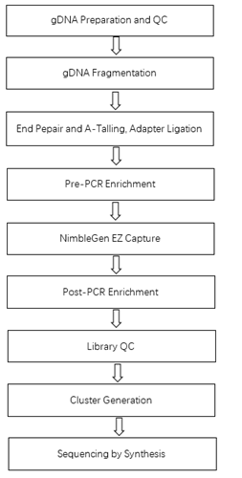
Abbreviations: QC: Quality controls; PCR: polymerase chain reaction.

Figure S2. Schematic of data analysis by targeted sequencing.
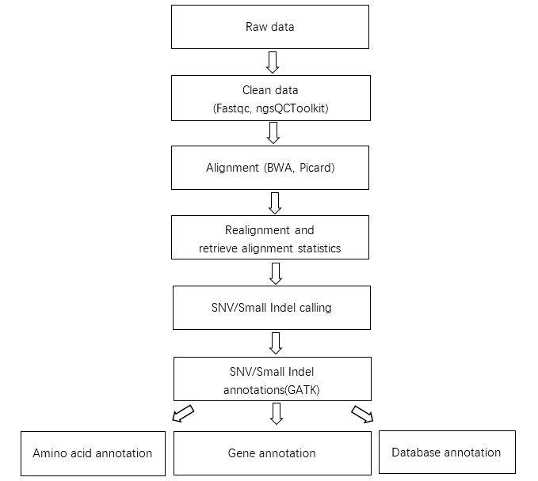
Abbreviations: QC: Quality controls; ngs: next generation sequencing; BWA: Burrows-Wheeler Aligner; GATK: Genome Analysis Toolkit.
Figure S3. Six rare variants in GABRB3 validated by Sanger sequencing.

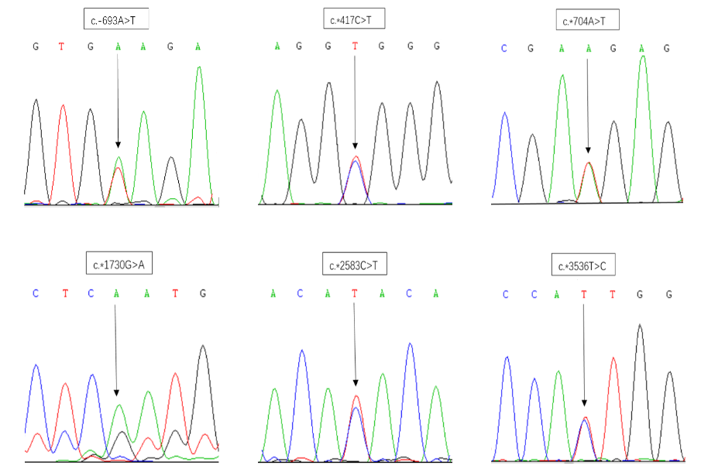

The position and alleles of each SNP are indicated with an arrow.
Figure S4. eQTL effects of rs4906771 in ATP10A on 10 brain regions in the Braineac database.
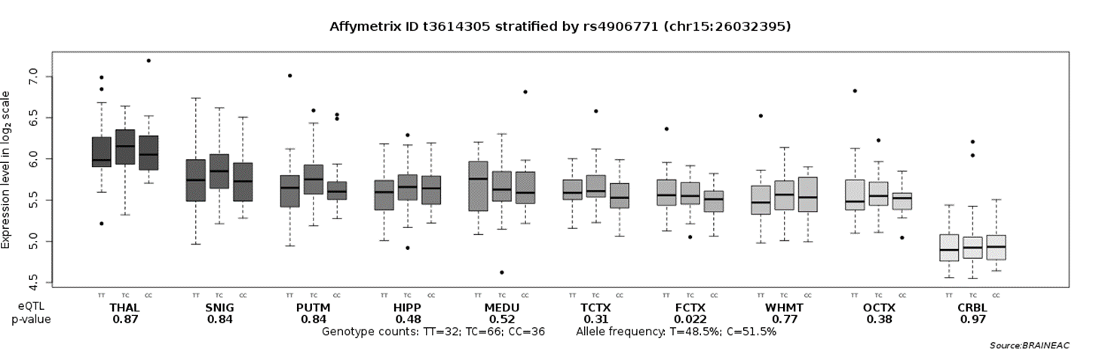
Abbreviations: WHMT: white matter; MEDU: medulla; PUTM: putamen; THAL: thalamus; SNIG: substantia nigra; HIPP: hippocampus; FCTX: frontal cortex; TCTX: temporal cortex; OCTX: occipital cortex; CRBL: cerebellum.

Figure S5. Dynamic expression of GABRG3 in human brain and 11 areas of neocortex.

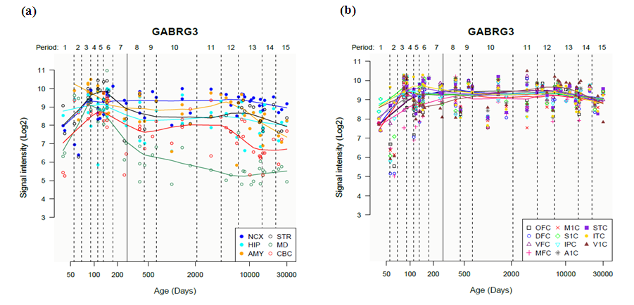
Dynamic expression of GABRG3 in 6 brain regions (a) and 11 area of neocortex (b).
Abbreviation: NCX: neocortex; STR: striatum; HIP: hippocampus; MD: mediodorsal nucleus; AMY: amygdala; CBC: cerebellar cortex; OFC: the orbital cortices; M1C: the primary motor cortices; STC: the posterior superior cortices; DFC: the dorsolateral cortices; S1C: the primary somatosensory cortices; ITC: the anterior inferior cortices; VFC: the ventrolateral cortices; IPC: the posterior inferior cortices; V1C: the primary visual cortex; MFC: the media cortices; A1C: the primary auditory cortic.

