Supplementary Table S1. Five-factor model validated by Higuchi et al. 2014.
Five-Factor Model | ITEMS | Question
NEGATIVE | Poor rapport | N3
NEGATIVE | Lack of spontaneity | N6
NEGATIVE | Emotional withdrawal | N2
NEGATIVE | Passive/apathetic social withdrawal | N4
NEGATIVE | Blunted affect | N1
NEGATIVE | Motor retardation | G7
DISORGANIZATION / COGNITION | Conceptual disorganization | P2
DISORGANIZATION / COGNITION | Poor attention | G11
DISORGANIZATION / COGNITION | Disorientation | G10
DISORGANIZATION / COGNITION | Disturbance of volition | G13
DISORGANIZATION / COGNITION | Difficulty in abstract thinking | N5
DISORGANIZATION / COGNITION | Stereotyped thinking | N7
DISORGANIZATION / COGNITION | Mannerisms/posturing | G5
EXCITEMENT | Uncooperativeness | G8
EXCITEMENT | Poor impulse control | G14
EXCITEMENT | Hostility | P7
EXCITEMENT | Excitement | P4
POSITIVE | Delusions | P1
POSITIVE | Unusual thought content | G9
POSITIVE | Hallucinatory behavior | P3
POSITIVE | Suspiciousness/persecution | P6
POSITIVE | Grandiosity | P5
DEPRESSION / ANXIETY | Anxiety | G2
DEPRESSION / ANXIETY | Guilt feelings | G3
DEPRESSION / ANXIETY | Depression | G6
DEPRESSION / ANXIETY | Tension | G4

Supplemental Table S2. Demographics association with the best p-threshold PRS. The demographics were available only for patients.
 | N | B | p-value
Familial Income (US$) | 48 | 1050797.9 | 0.1027
Other Drugs | 41 | 426.4 | 0.3833
Cannabis | 25 | 616 | 0.2417
BMI | 34 | 8929.5 | 0.0569
Familial History | 46 | -274.4 | 0.524

Supplemental Table S3. Demographics association with the clinical variables. We used t.test() function for Other drugs and Cannabis and cor.test() for Familial income and BMI.
Clinical variables | Other drugs |  |  | Cannabis |  |  | Familial income |  |  | BMI
Clinical variables | t | df | p-value | t | df | p-value | t | df | p-value | t | df | p-value
PANSStot_1 | -0.27 | 23 | 0.791 | -0.28 | 30 | 0.779 | -0.46 | 46 | 0.650 | -0.30 | 21 | 0.769
PANSStot_2 | -0.39 | 20 | 0.703 | 0.51 | 29 | 0.614 | 1.81 | 44 | 0.077 | 0.34 | 20 | 0.735
CGI_total_1 | 0.56 | 24 | 0.582 | 0.85 | 27 | 0.403 | 0.40 | 45 | 0.690 | 0.26 | 20 | 0.800
GAF_1 | 0.12 | 23 | 0.905 | 0.11 | 24 | 0.915 | -0.04 | 43 | 0.972 | -0.88 | 20 | 0.389
CGI_total_2 | 0.91 | 19 | 0.374 | 1.25 | 27 | 0.223 | -0.76 | 42 | 0.452 | 0.53 | 20 | 0.600
GAF_2 | -0.19 | 18 | 0.855 | -0.60 | 28 | 0.552 | 0.03 | 43 | 0.973 | -0.21 | 21 | 0.835
calgarytot_1 | 0.60 | 24 | 0.555 | 0.86 | 18 | 0.399 | 0.30 | 44 | 0.767 | 1.47 | 21 | 0.155
calgarytot_2 | -0.43 | 25 | 0.669 | -0.23 | 27 | 0.823 | 0.25 | 44 | 0.807 | 1.18 | 20 | 0.251
PANSS_Neg_1 | -0.12 | 24 | 0.903 | -0.03 | 24 | 0.976 | -0.41 | 43 | 0.688 | -1.08 | 19 | 0.295
PANSS_Neg_2 | 0.22 | 19 | 0.825 | 0.88 | 27 | 0.385 | 1.63 | 42 | 0.112 | -0.62 | 19 | 0.542
PANSS_Pos_1 | -1.05 | 21 | 0.307 | -1.68 | 28 | 0.105 | 0.11 | 43 | 0.912 | 0.35 | 19 | 0.732
PANSS_Pos_2 | -0.54 | 24 | 0.596 | -0.22 | 20 | 0.829 | 0.11 | 42 | 0.912 | -0.19 | 19 | 0.854
5F-PANSS_neg1 | -0.37 | 25 | 0.714 | -0.19 | 28 | 0.849 | -0.30 | 46 | 0.764 | 0.02 | 21 | 0.981
5F-PANSS_dis1 | 0.12 | 24 | 0.904 | 0.21 | 27 | 0.834 | -0.24 | 46 | 0.809 | -0.99 | 21 | 0.332
5F-PANSS_exc1 | -1.15 | 23 | 0.261 | -1.57 | 29 | 0.128 | -0.13 | 46 | 0.899 | 0.56 | 21 | 0.579
5F-PANSS_pos1 | 0.23 | 21 | 0.822 | -0.48 | 30 | 0.632 | -0.09 | 46 | 0.933 | 0.34 | 21 | 0.734
5F-PANSS_dep1 | -0.63 | 23 | 0.538 | -0.31 | 30 | 0.756 | -0.76 | 46 | 0.453 | -0.22 | 21 | 0.826
5F-PANSS_neg2 | -0.05 | 19 | 0.963 | 0.56 | 29 | 0.582 | 2.50 | 46 | 0.016 | 0.17 | 21 | 0.866
5F-PANSS_dis2 | -0.73 | 19 | 0.475 | 0.19 | 29 | 0.852 | 2.05 | 46 | 0.046 | -0.07 | 21 | 0.948
5F-PANSS_exc2 | -0.82 | 25 | 0.420 | -0.34 | 27 | 0.734 | 0.36 | 46 | 0.720 | 0.47 | 21 | 0.640
5F-PANSS_pos2 | 0.71 | 27 | 0.482 | 0.96 | 21 | 0.348 | -0.24 | 46 | 0.812 | 0.22 | 21 | 0.830
5F-PANSS_dep2 | -0.42 | 21 | 0.681 | -0.01 | 30 | 0.995 | 1.28 | 45 | 0.208 | 0.15 | 21 | 0.879
*1 = baseline; *2 = follow-up; *tot* = total score ; 5F-PANSS* = Five- factor PANSS (Higuchi et al.,); *Neg* = negative symptoms; *pos* = positive symptoms; *exc* = excitement symptoms; *dep* = depressive symptoms; *dis* = disorganization / cognition symptoms

Supplementary Table S4. PRSice results, explained variability and number of SNPs for each threshold.
Threshold | p.out (Naegelkerke’s) | r2.out | Nsnps
0.001 | 0.0032 | 0.10 | 5533
0.01 | 0.0003 | 0.16 | 20223
0.0112 | 0.0001 | 0.19 | 21622
0.05 | 0.0004 | 0.15 | 53790
0.1 | 0.0004 | 0.15 | 82978
0.2 | 0.0007 | 0.14 | 126514
0.3 | 0.0011 | 0.13 | 160713
0.4 | 0.0018 | 0.12 | 188576
0.5 | 0.002 | 0.12 | 211371

Supplementary Table S5. Comparison between Caucasian only analysis and all individuals
 | estimate_caucasians | pvals_caucasians | N_caucasians | Estimate_all | pvals_all | N_all
GAF_1 | -859.90 | 2x10⁻⁰⁶** | 32 | -436.13 | 0.0029* | 48
GAF_2 | 54.55 | 0.7174 | 33 | 132.82 | 0.2281 | 53
calgarytot_1 | 674.45 | 0.1579 | 35 | 1042.25 | 0.0039* | 51
calgarytot_2 | -1354.06 | 0.039* | 34 | -1800.15 | 0.0004** | 53
panss_exc1 | 639.27 | 0.0018* | 35 | 566.67 | 0.0003** | 53
panss_depa2 | -206.09 | 0.3767 | 35 | -575.02 | 0.0013* | 55

Supplementary Figure S1. Ten Principal components for cases and controls separately.
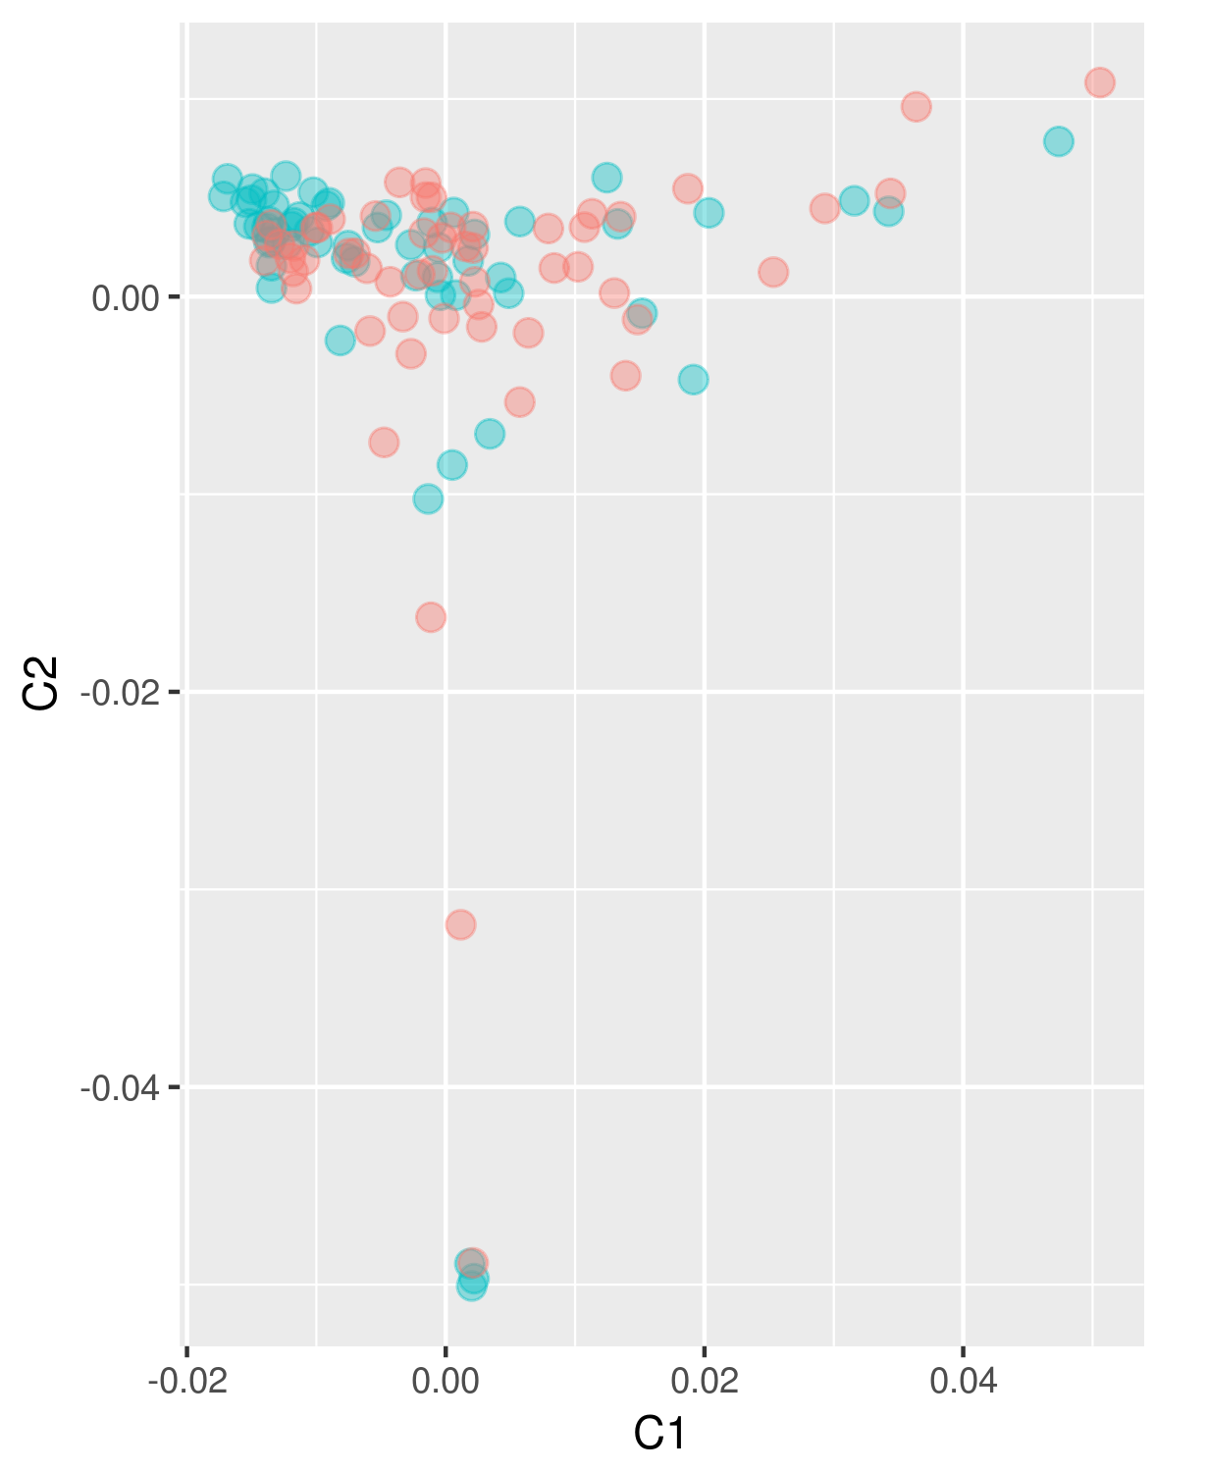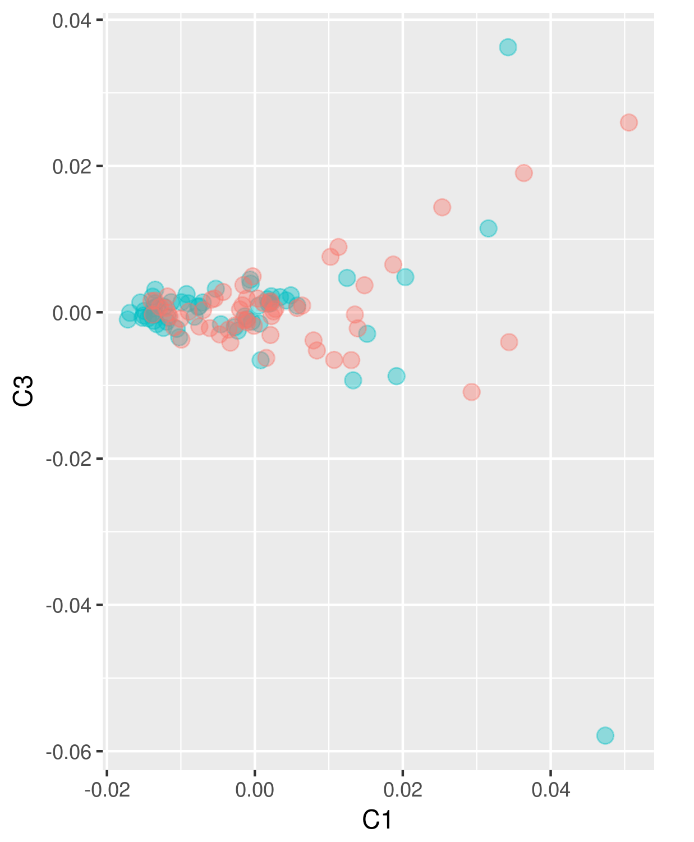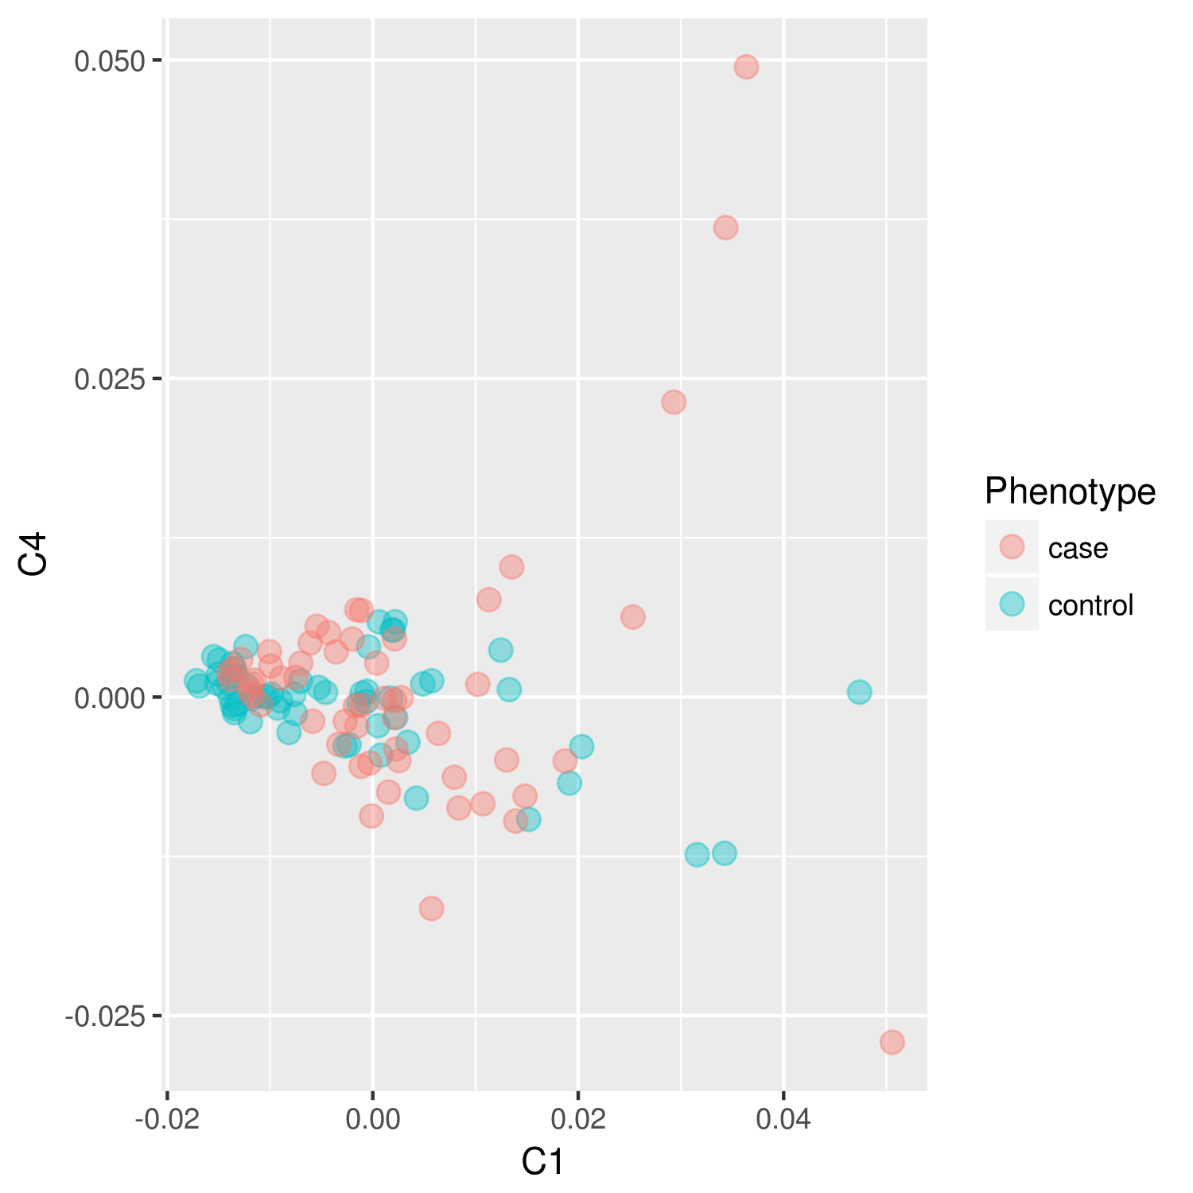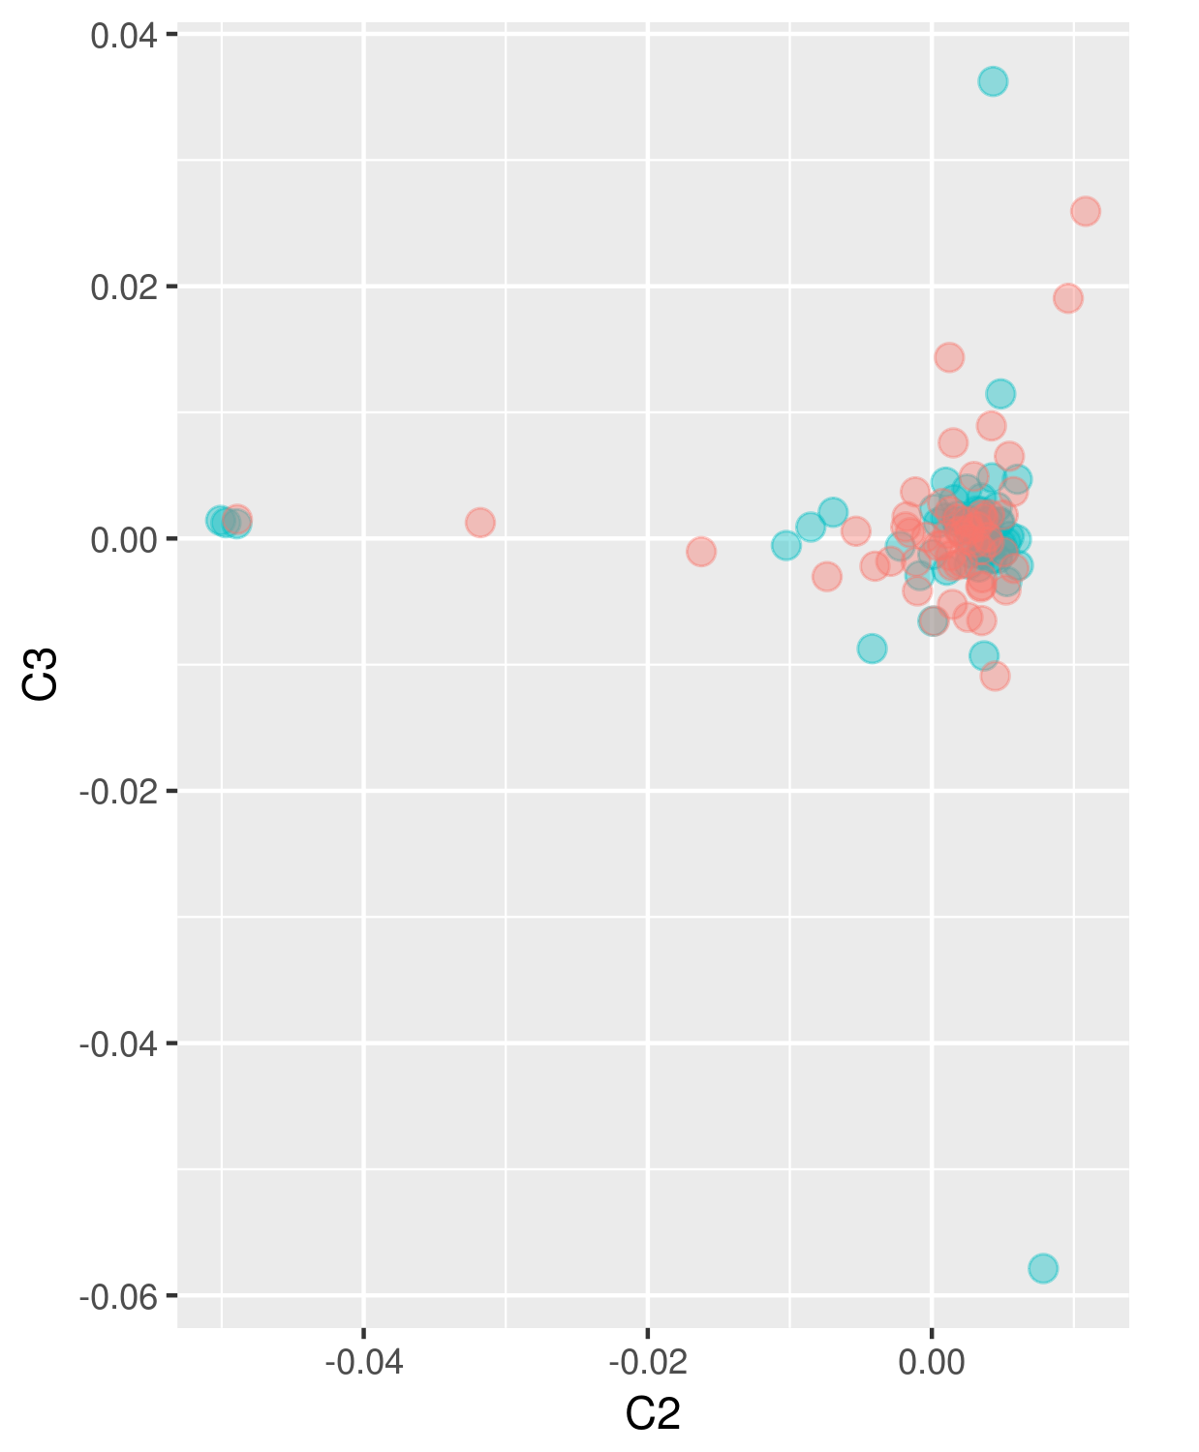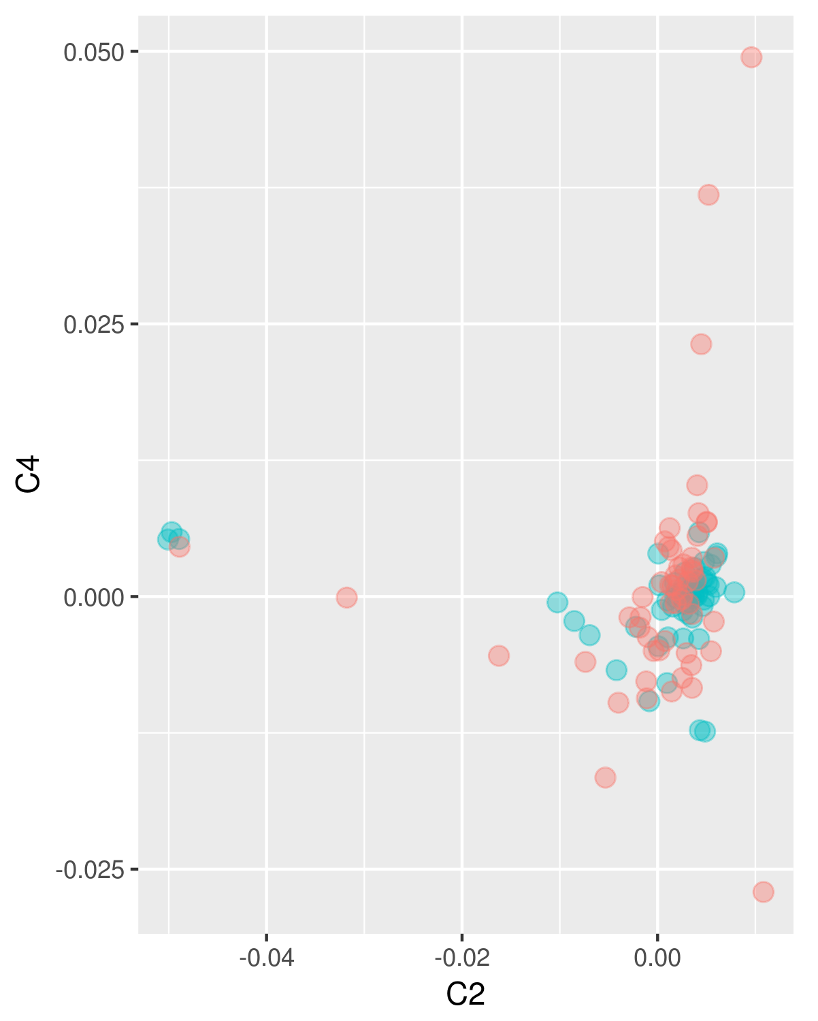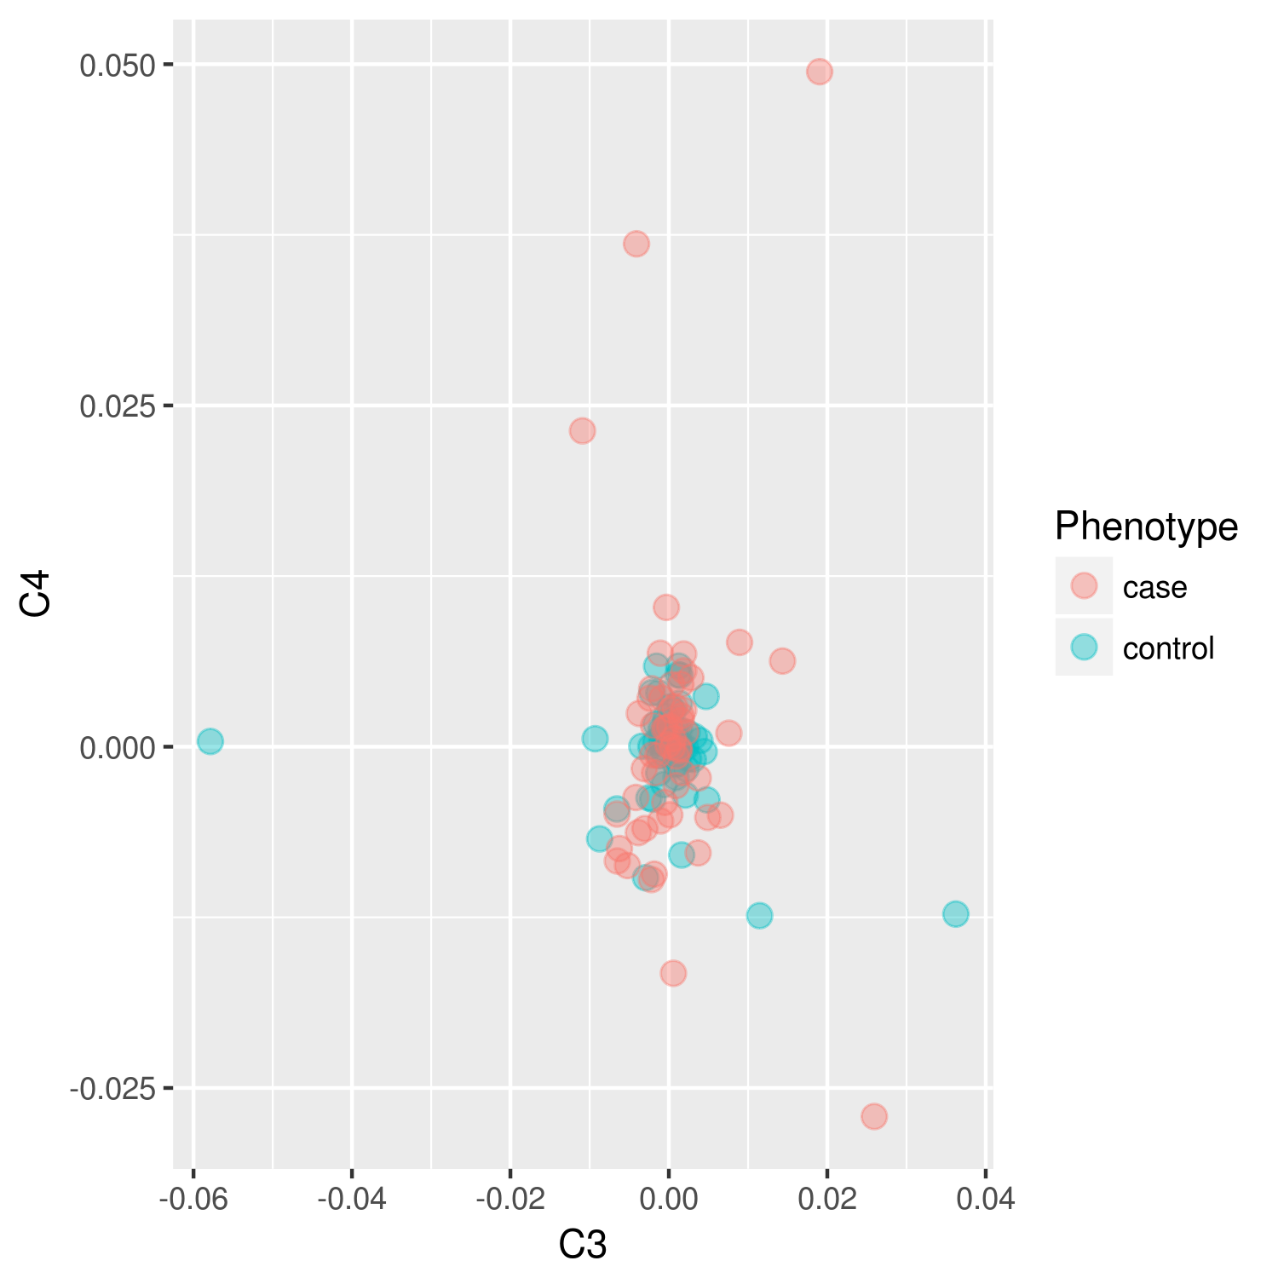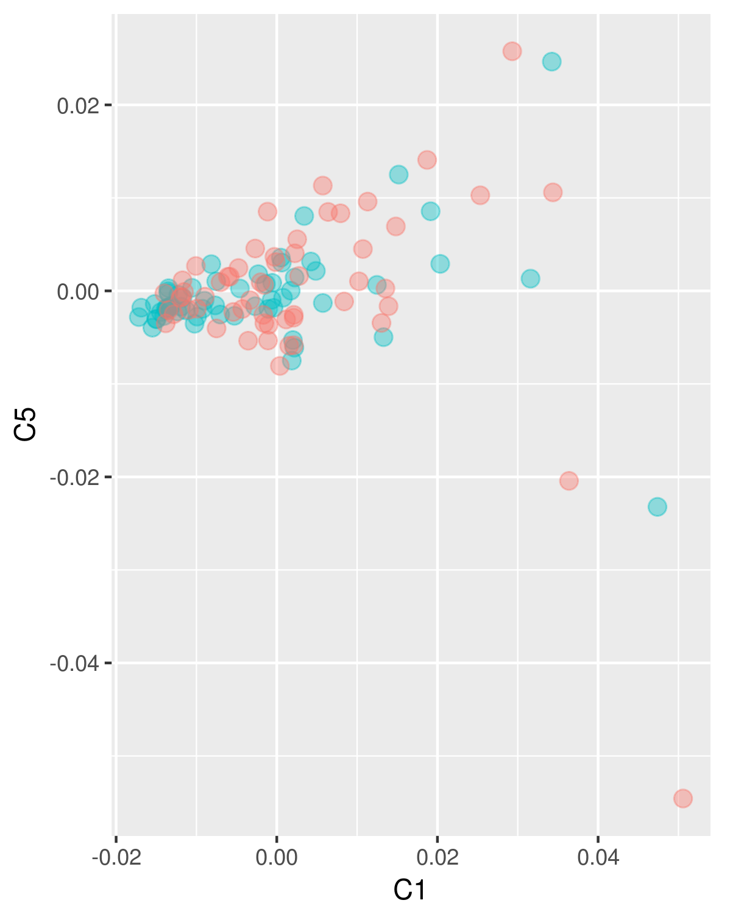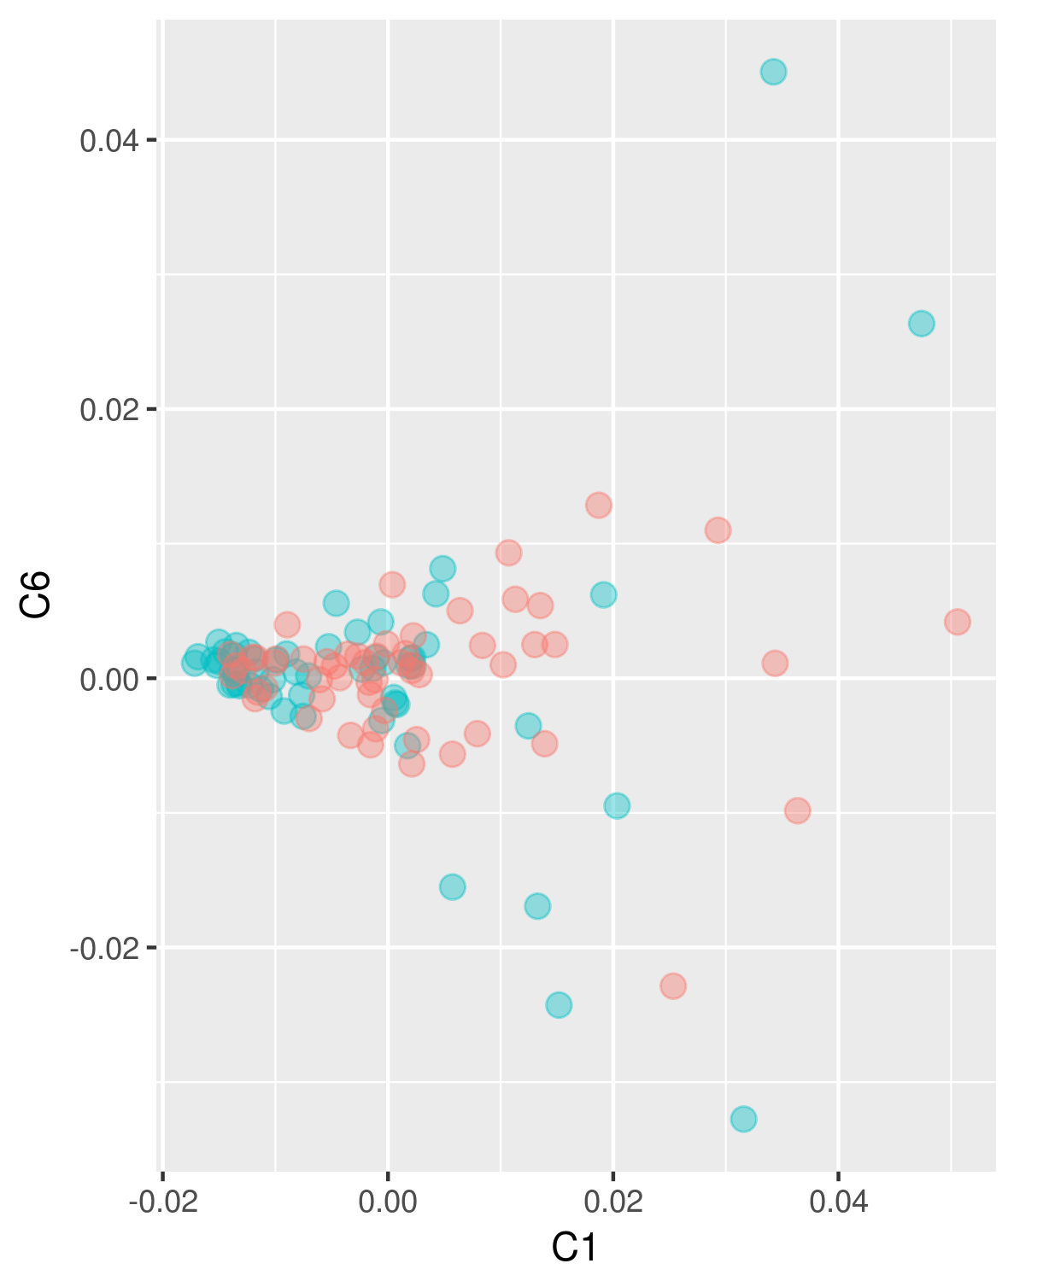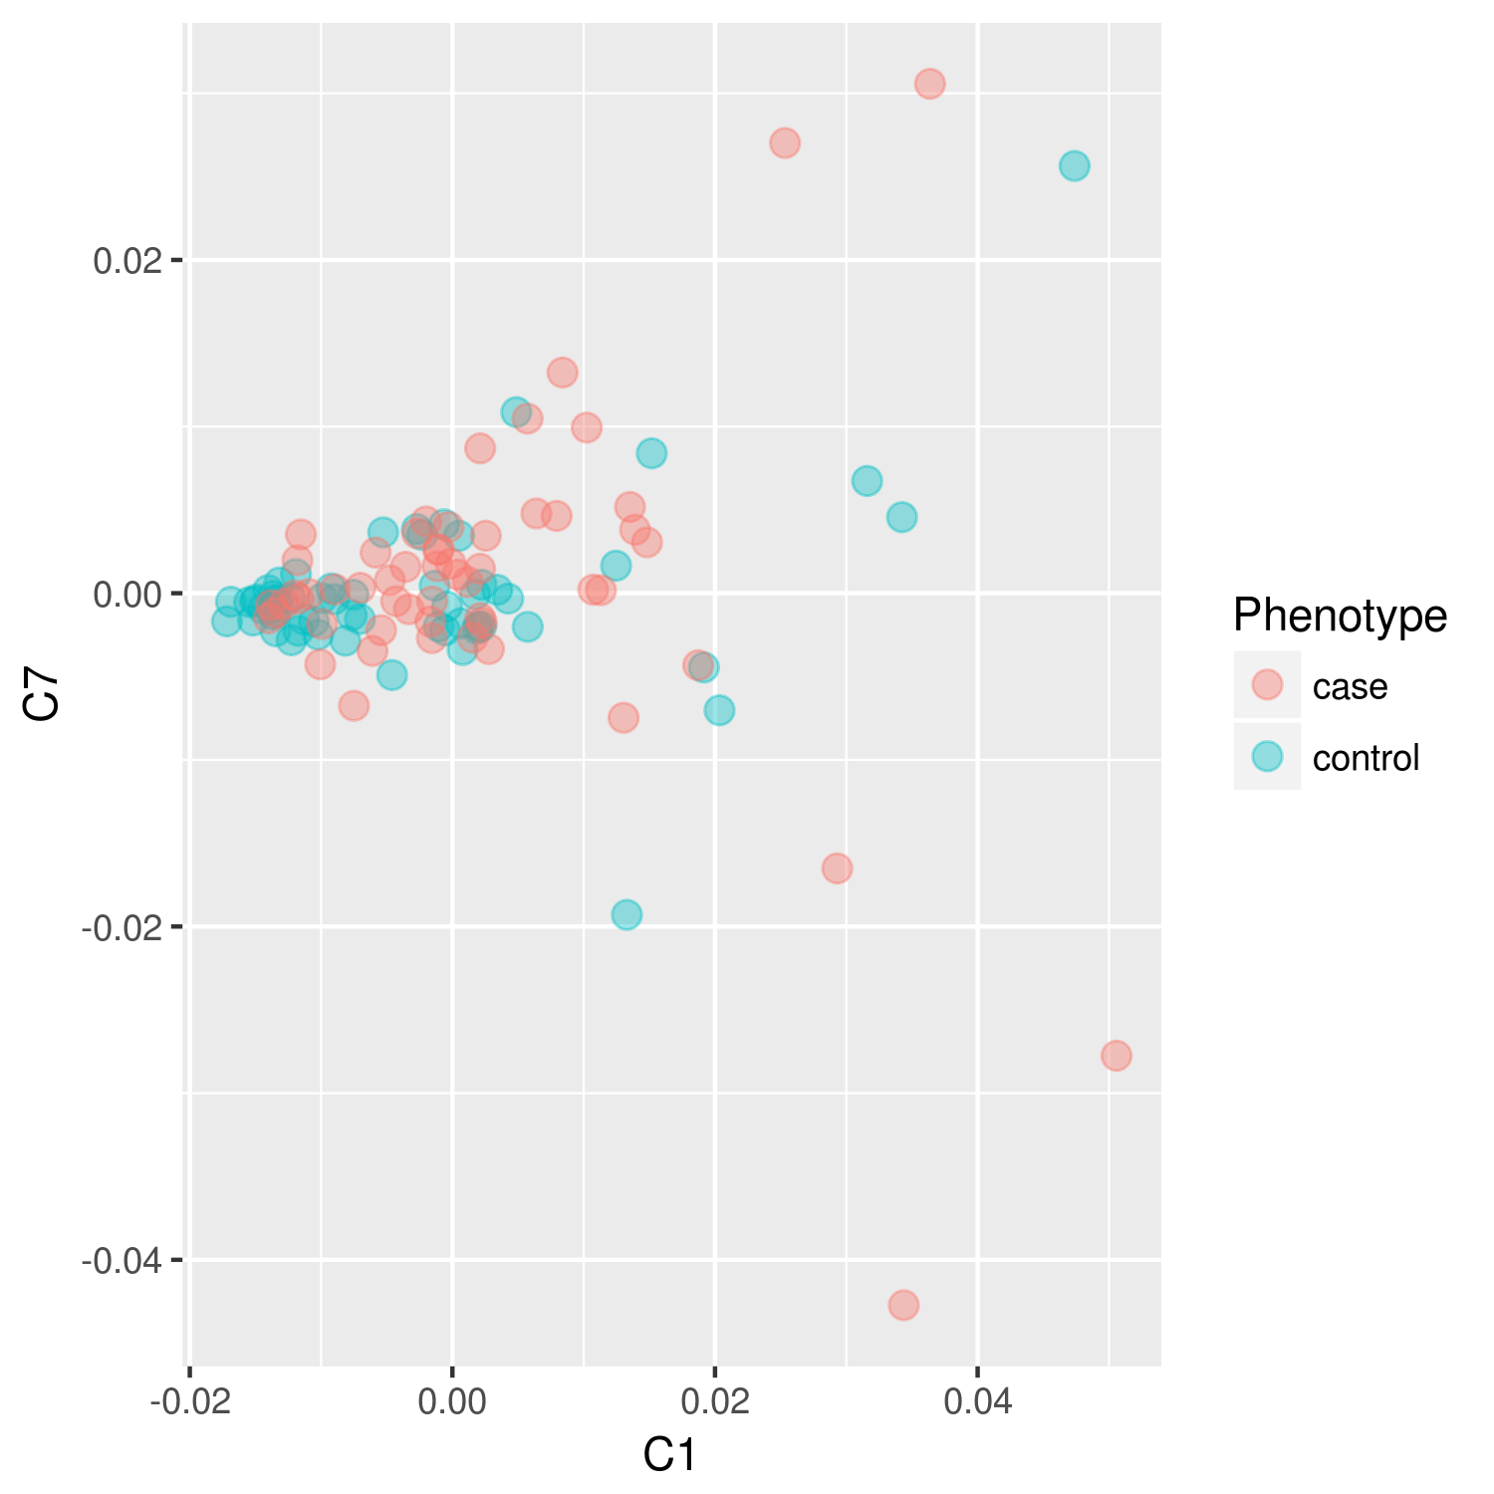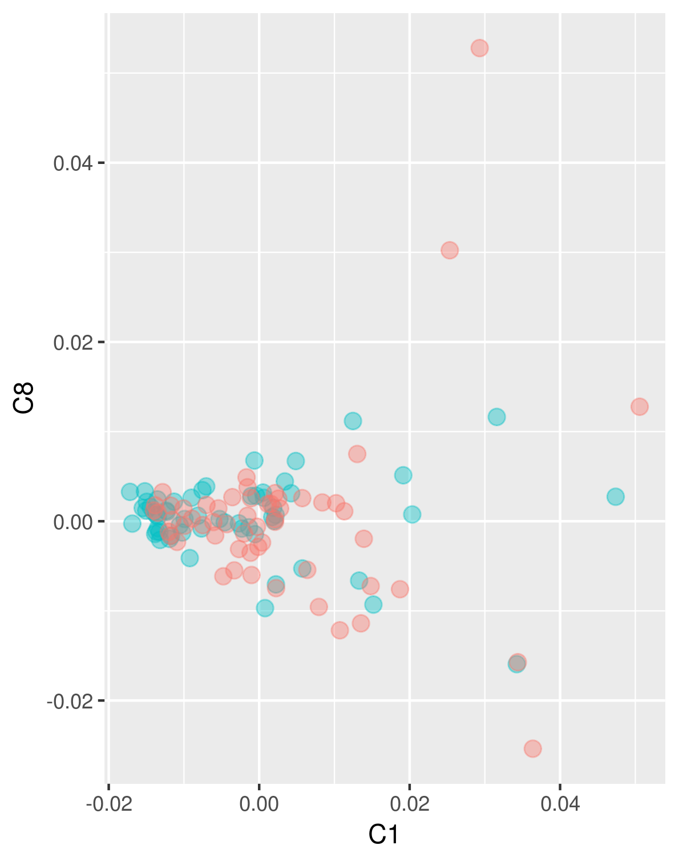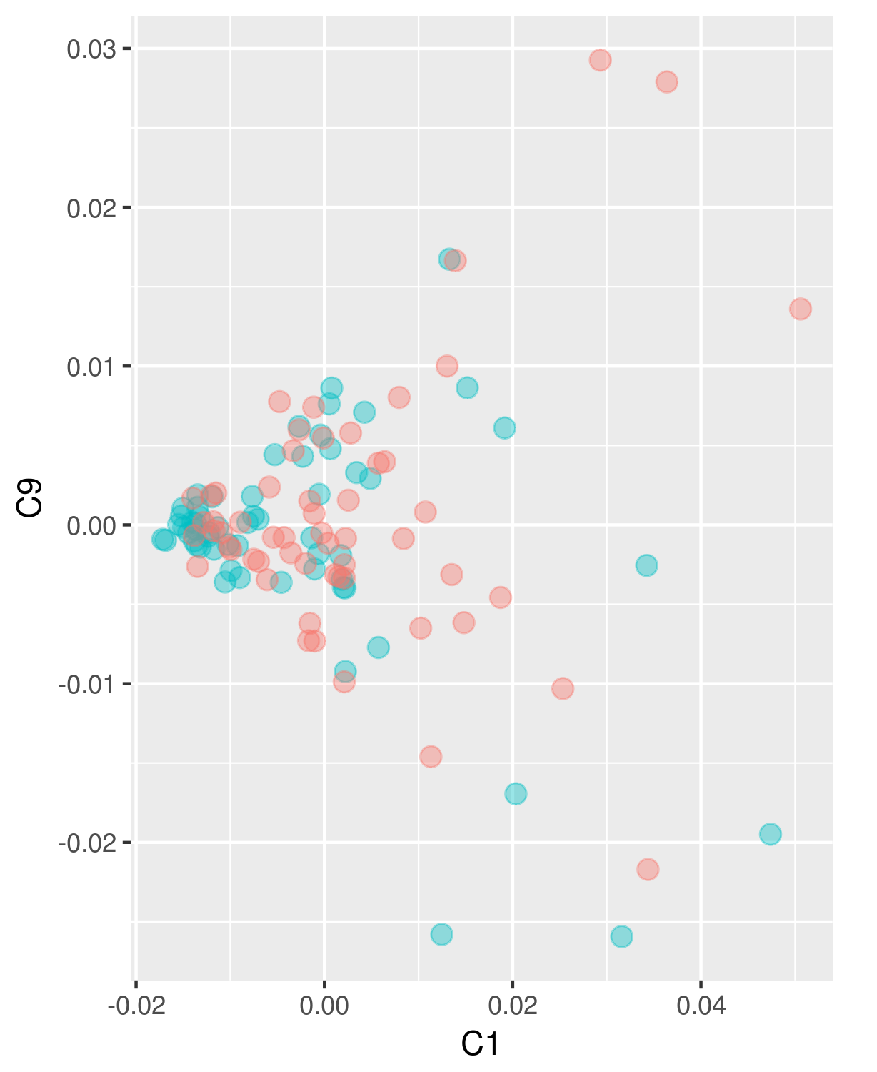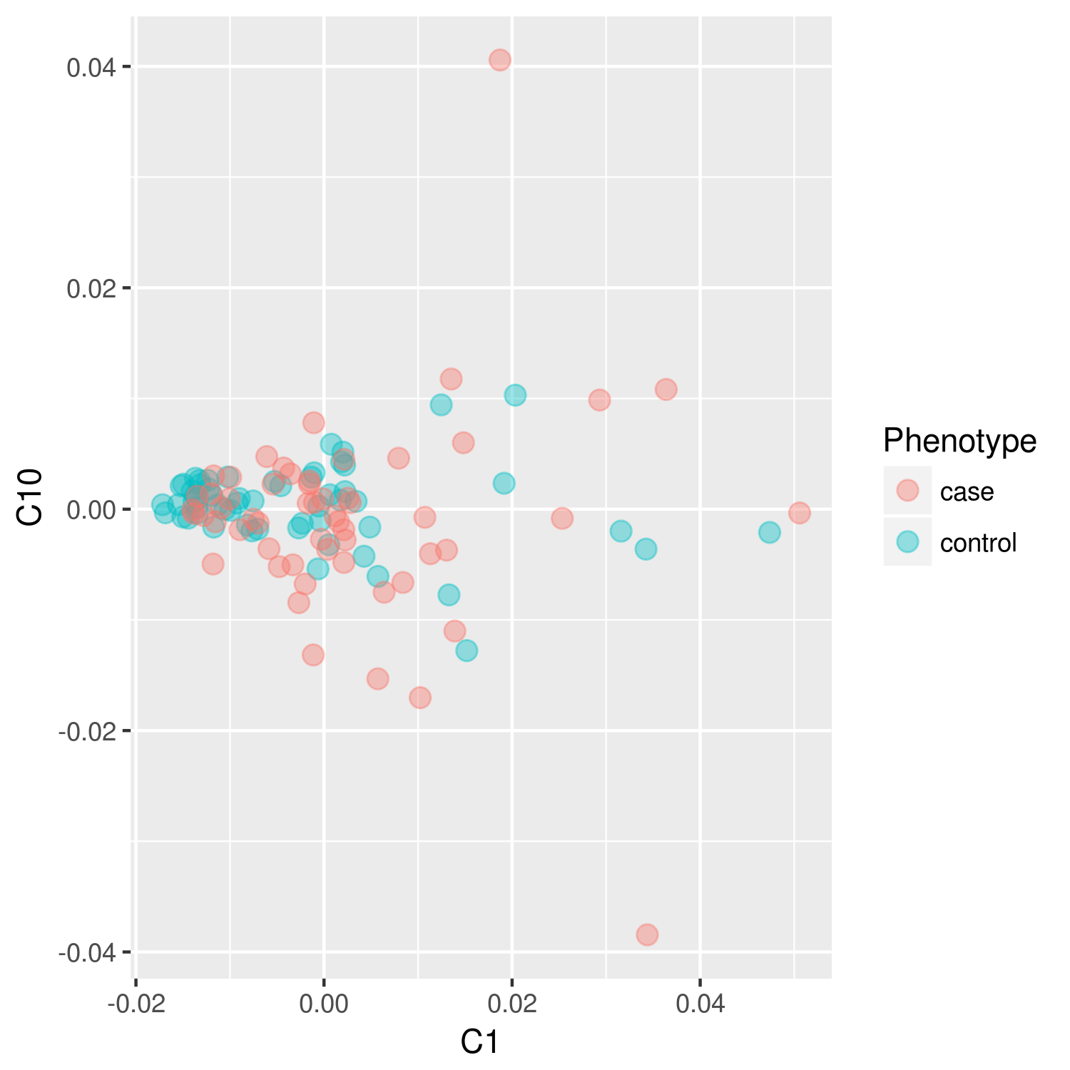

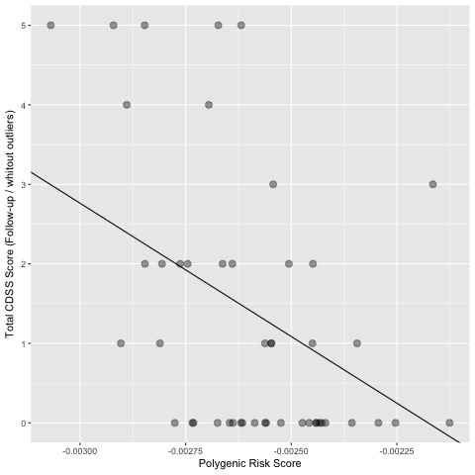
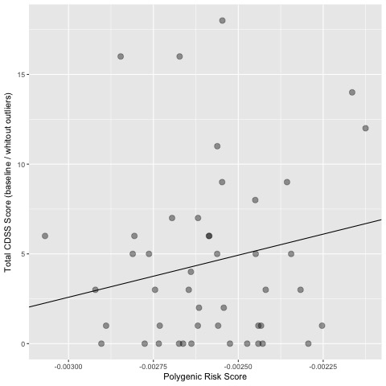
Supplementary Figure S2. Polygenic Risk Scores and CDSS measurements plots for both time points and Delta CDSS excluding outlier individuals for CDSS (6 patients).
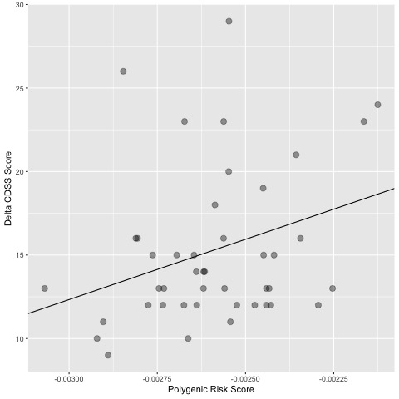

Supplementary Figure S3. Polygenic Risk Scores and baseline PANSS excitement factor measurement plot.
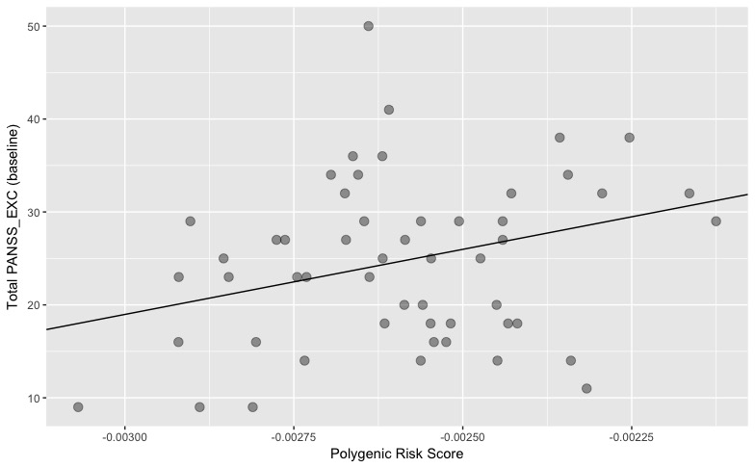

Supplementary Figure S4. Polygenic Risk Scores and Delta PANSS total plot.
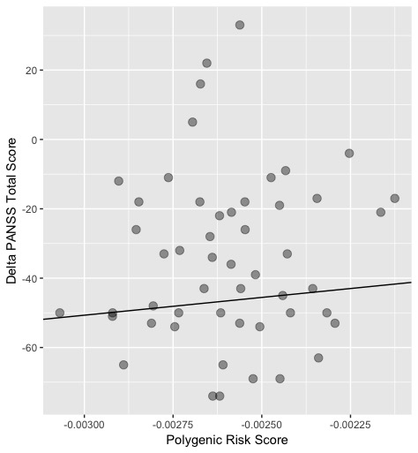

Supplementary Figure S5. Polygenic Risk Score and statistical significant measures, confirmatory analysis selecting only schizophreniform patients.

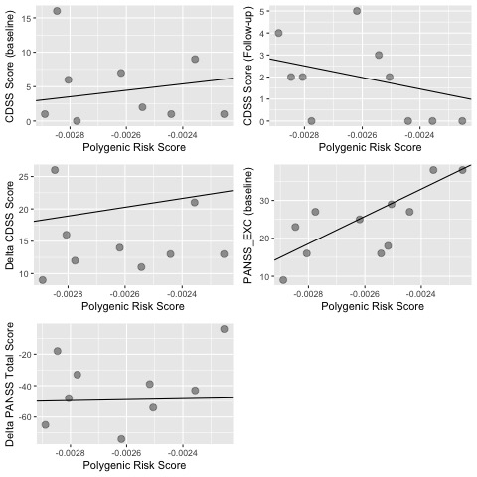

Supplementary Figure S6. Polygenic Risk Score and statistical significant measures, confirmatory analysis selecting only schizophrenia patients.
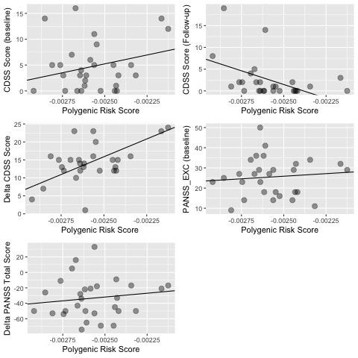

Supplementary Figure S7. Polygenic Risk Scores distribution for all cases, Caucasian cases (self-declared) and all controls.

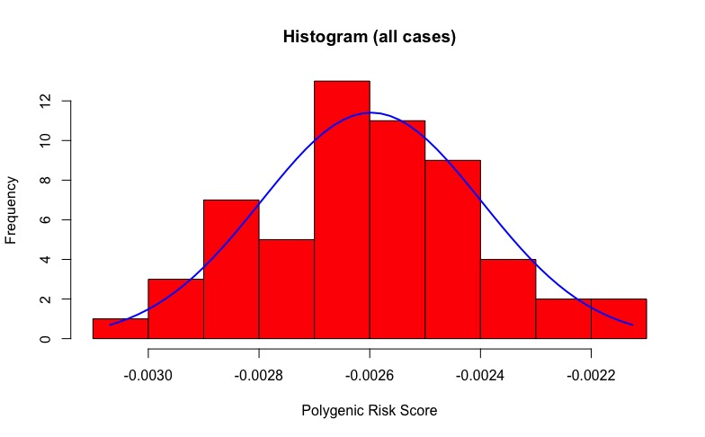
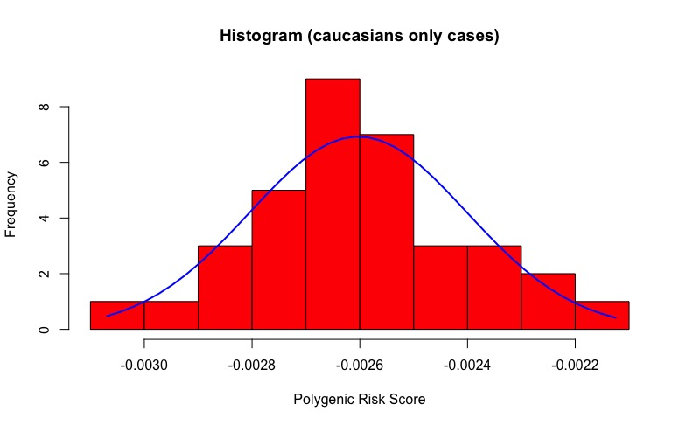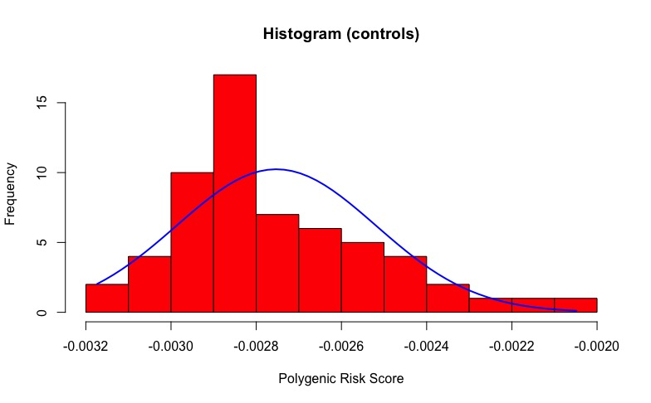
Supplementary Figure S8. Heatmap correlation plot for all clinical measurements for both time points.
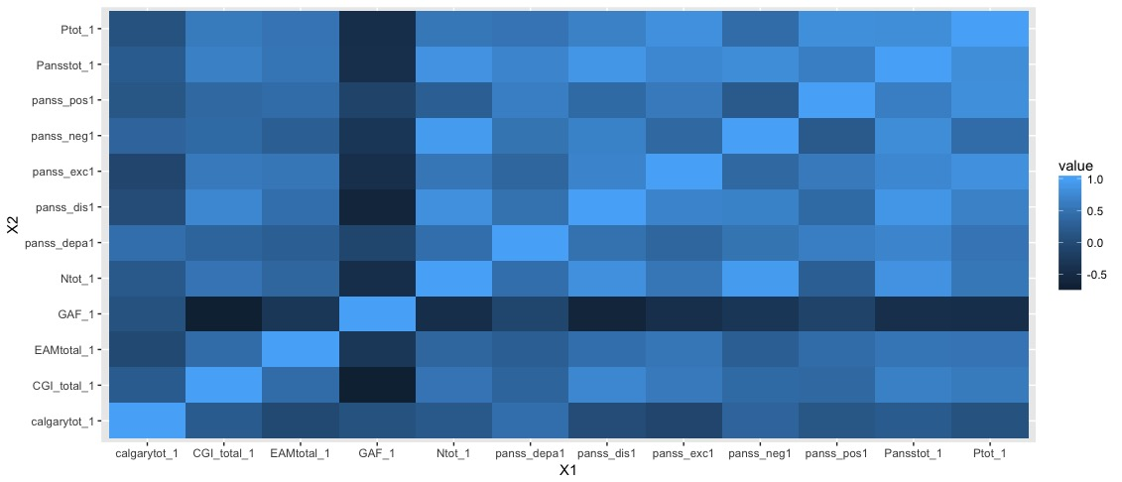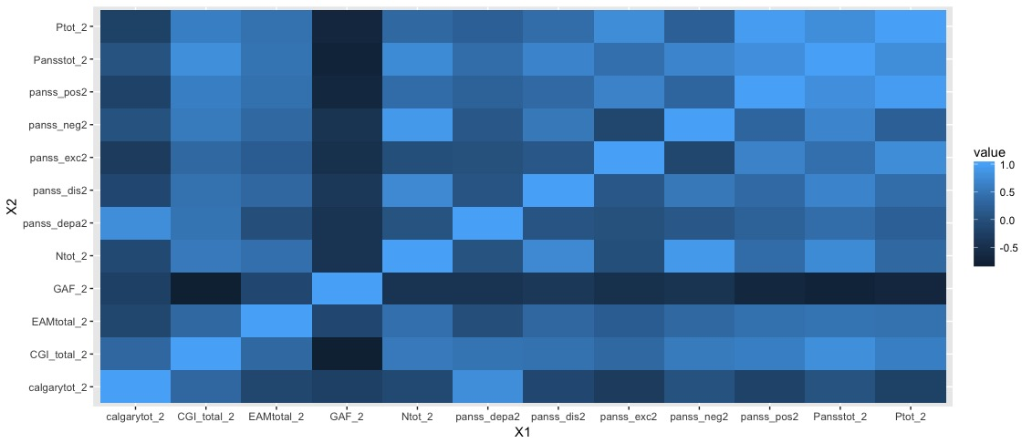

Supplementary Figure S9. CDSS trajectory of each individual from baseline to follow-up and their PRS.
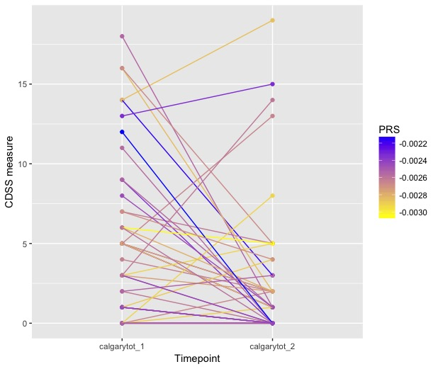

Supplementary Figure S10. Odds ratios (ORs) of psychosis at different levels of polygenic risk score (PRS). For more information on how the OR were calculated please see Vassos et al.,2017.
