Ventral Striatal Dopamine Transporter Availability is Associated with Lower Trait Motor Impulsivity in Healthy Adults
Smith et al.
Supplementary Analyses
Relationship between mesolimbic dopamine system gray matter volume and FE-PE2I BP_{ND}
Relationships have previously been reported between striatal gray matter volume and behavioral^{1,2} as well as trait³ impulsivity in human subjects. Thus, it is possible that gray matter volume of the ventral striatum or the ventral tegmental area (VTA) that projects to it could be driving our observed relationship between FE-PE2I BP_{ND} and BIS-11. This may be especially true if DAT availability indexed by FE-PE2I BP_{ND} reflects overall DA system integrity (the alternative hypothesis to the regulatory hypothesis we propose for our observed DAT effect). If that was the case, one might expect the gray matter volume in the ventral striatum or VTA (a rough index of DA neuron numbers/density) to relate positively to DAT availability. We tested for these possibilities.
We used FSL FIRST⁴ to segment the striatum in our participants, obtained gray matter volume (mm³) for the FIRST caudate, putamen, and VS outputs, and converted them into ROIs for extraction of FE-PE2I BP_{ND} values in our BP_{ND} maps registered to structural MRI (T1) space.
Importantly, we found no relationship between any striatal ROI volume and BIS-11 total or subscale scores (max r=-0.24, min p=0.11 for BIS Nonplanning and Putamen Vol correlation, Supplementary Table 2). The relationship between VS volume and BIS-11 total score (r=-0.011, p=0.94) and BIS Motor subscale (r=0.11, p=0.45) were minimal.
In addition, the relationship between VS volume and FE-PE2I BP_{ND} (r=-0.13, p=0.38) did not support the interpretation that FE-PE2I BP_{ND} is indexing mesolimbic DA system integrity as expressed in the size of VS.
Finally, to further explore whether VS FE-PE2I BP_{ND} was related to overall DA system integrity, we traced the VTA in co-registered T1 and T2-FLAIR-weighted images for these subjects as per guidelines from Murty et al.⁵ and extracted its volume in mm³. There was no significant relationship between VTA volume and VS FE-PE2I BP_{ND} (r=0.26, p=0.082). Furthermore, there was no relationship between VTA volume and BIS-11 total (r=-0.10, p=0.49) or any of its subscales (max r=-0.21, min p=0.15 for BIS Nonplanning).
In summary, these additional analyses lend support to our measure of VS FE-PE2I BP_{ND} not being a simple measure of overall DA system integrity and suggests our interpretation of the relationship between low DAT availability and high trait impulsivity as due to reduced DA regulatory capacity is plausible, if needing further study and validation.

References
1. Cho SS, Pellecchia G, Aminian K, Ray N, Segura B, Obeso I, et al. Morphometric correlation of impulsivity in medial prefrontal cortex. Brain Topogr 2013; 26(3): 479-487.

2. Tschernegg M, Pletzer B, Schwartenbeck P, Ludersdorfer P, Hoffmann U, Kronbichler M. Impulsivity relates to striatal gray matter volumes in humans: evidence from a delay discounting paradigm. Frontiers in human neuroscience 2015; 9: 384.

3. Caravaggio F, Plitman E, Chung JK, Gerretsen P, Kim J, Iwata Y, et al. Trait impulsiveness is related to smaller post-commissural putamen volumes in males but not females. The European journal of neuroscience 2017; 46(7): 2253-2264.

4. Patenaude B, Smith SM, Kennedy DN, Jenkinson M. A Bayesian model of shape and appearance for subcortical brain segmentation. NeuroImage 2011; 56(3): 907-922.

5. Murty VP, Shermohammed M, Smith DV, Carter RM, Huettel SA, Adcock RA. Resting state networks distinguish human ventral tegmental area from substantia nigra. NeuroImage 2014; 100: 580-589.

Supplementary Tables & Figures

PE2I PET Frame
Acquisition Times (secs)
0-15
15-30
30-45
45-60
60-75
75-90
90-105
105-120
120-150
150-180
180-210
210-240
240-270
270-300
300-360
360-420
420-480
480-540
540-600
600-660
660-810
810-960
960-1260
1260-1560
1560-2010
2010-2460
2460-3060
3060-3660
Table S1. Acquisition times for PE2I PET data.

Striatal Region  mean (SD) volume in mm³ | BIS-11 Total  r, p | BIS Attention  r, p | BIS Motor  r, p | BIS Nonplanning  r, p
Caudate  7295 (1165) mm³ | -0.127, 0.395 | -0.126, 0.398 | 0.017, 0.908 | -0.202, 0.174
Putamen  9425 (1054) mm³ | -0.137, 0.358 | -0.175, 0.241 | 0.083, 0.580 | -0.238, 0.107
Ventral Striatum  891 (207) mm³ | -0.011, 0.941 | -0.106, 0.477 | 0.113, 0.451 | -0.030, 0.844

Table S2. Correlation table between BIS-11 total and subscale scores and volume of striatal regions of interest. We correlated FIRST caudate, putamen, and ventral striatum gray matter volume measures against BIS-11 scores, finding no significant relationships.

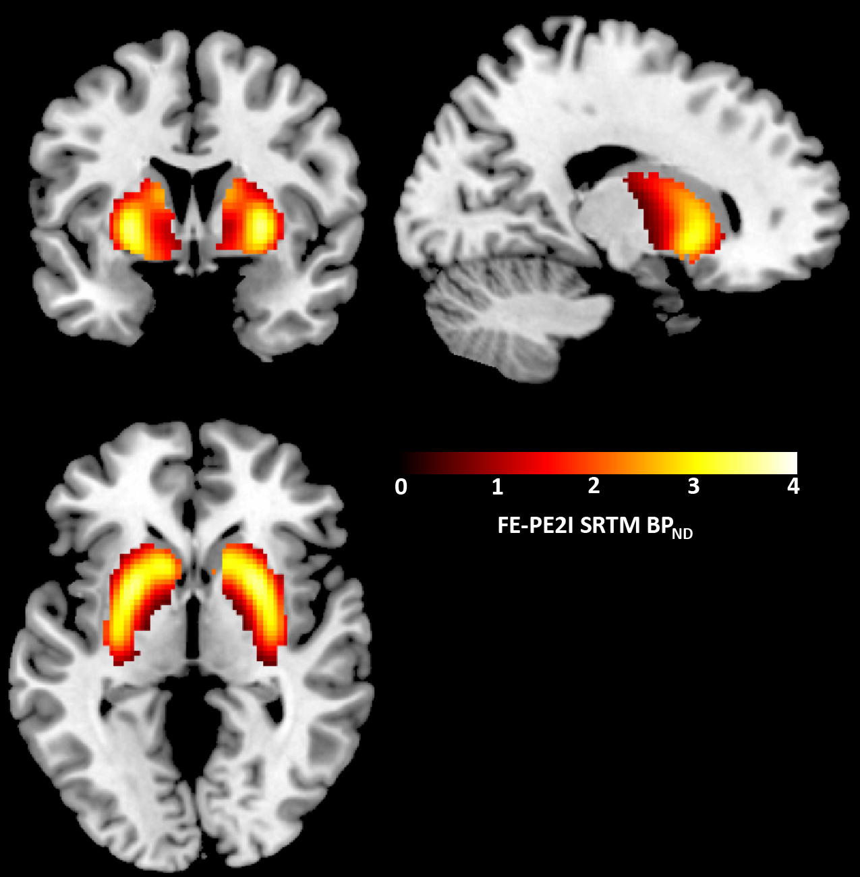

Figure S1. Average FE-PE2I BP_{ND} map from the full dataset.

Mean FE-PE2I SRTM BP_{ND} for the 47 healthy adults analyzed is displayed in MNI space. Coordinates: 17, 4, -2. Data masked to show signal in brain and remove that found in skull given that dosimetry work (Lizana et al., 2018) shows significant uptake of FE-PE2I in red bone marrow and this is of no interest to the present set of analyses.
Lizana H, Johansson L, Axelsson JE, Larsson Stromvall A, Ogren M, Linder J, et al (2018). Whole-body biodistribution and dosimetry of the dopamine transporter radioligand (18)F-FE-PE2I in human subjects. J Nucl Med.

