Supplementary Material
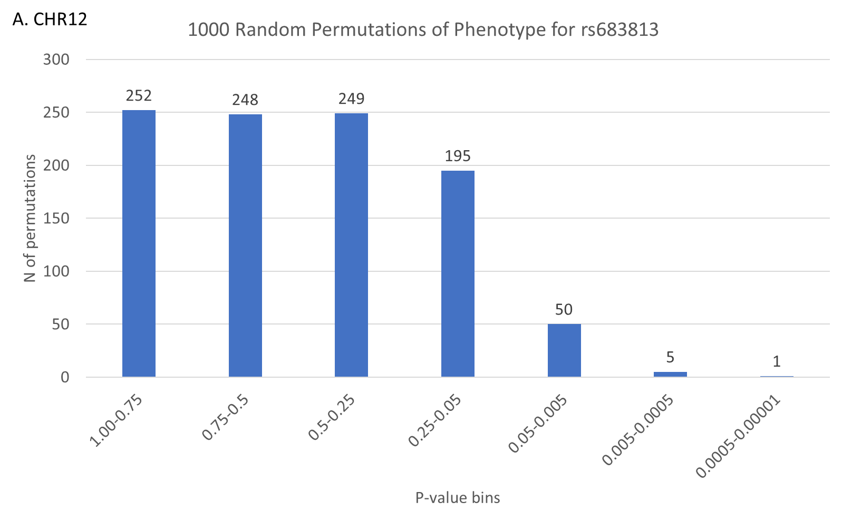
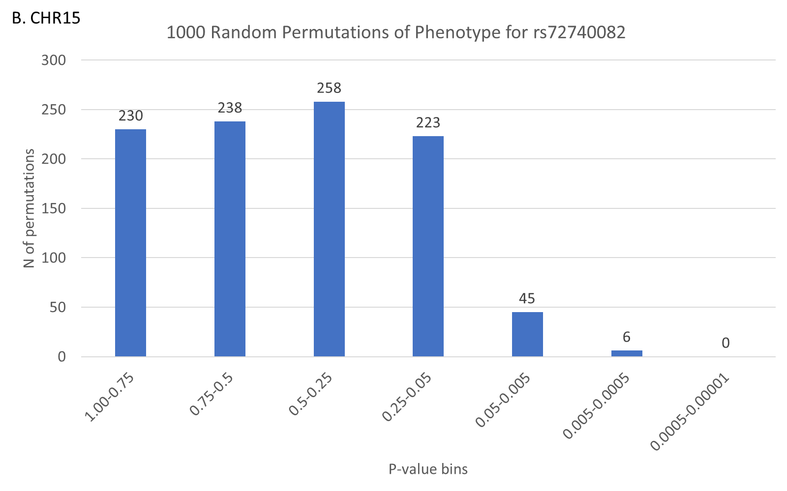
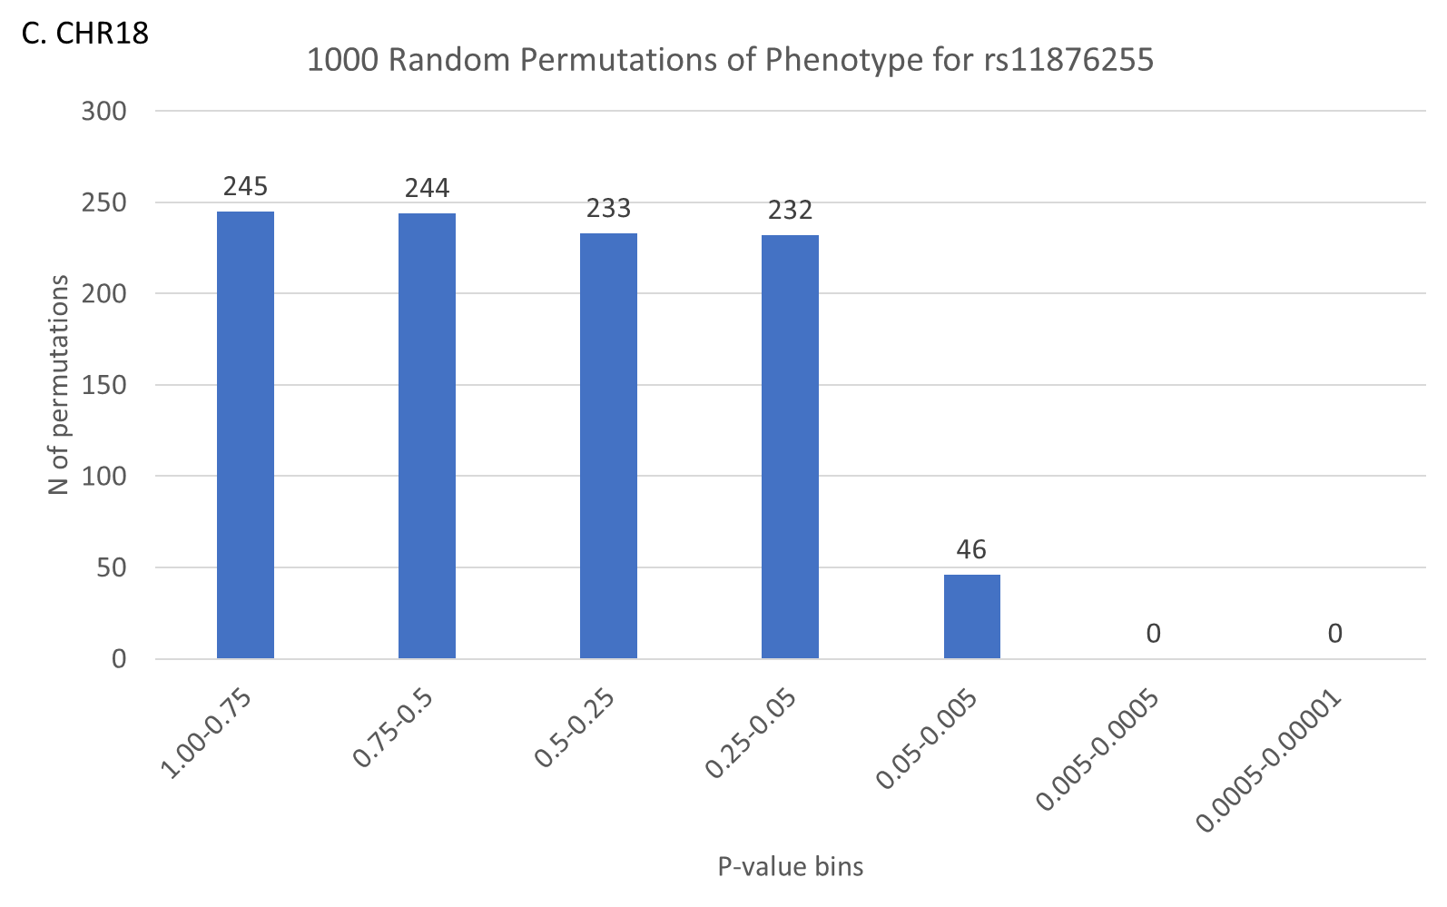
Supplementary Figure S1. Random Permutations of Phenotype Distribution Produce no More Significant Hits Than Expected By Chance.

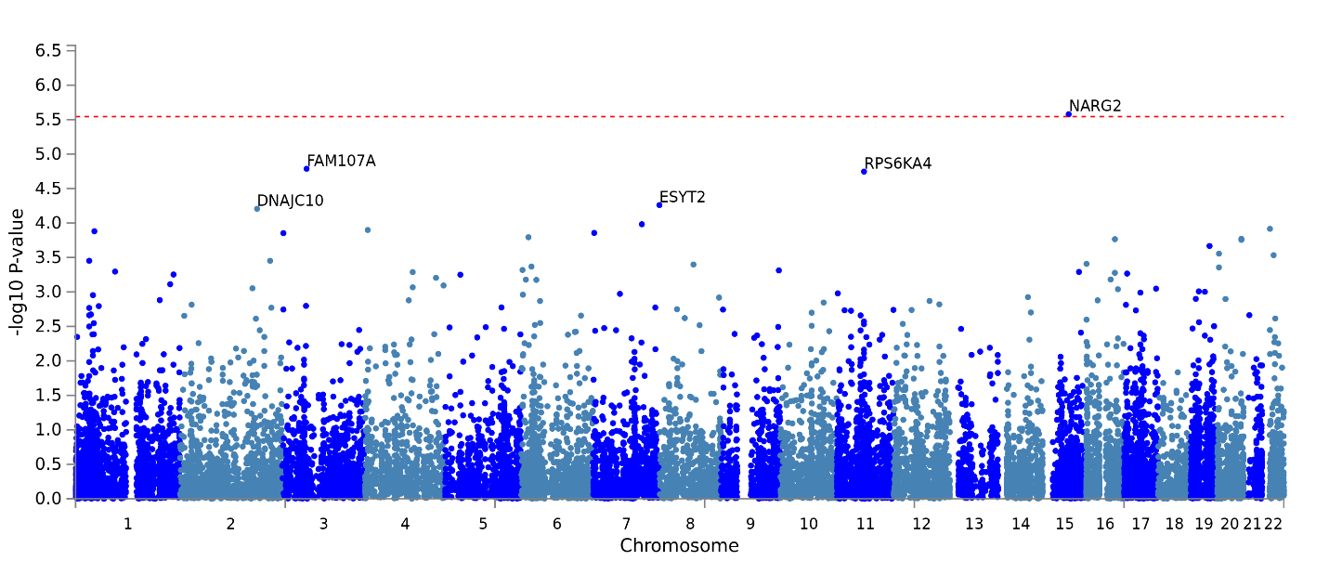
Supplementary Figure 2. FUMA Gene-Based Analysis of AAs Suicide Attempt Severity
European Americans Suicide Attempt Severity
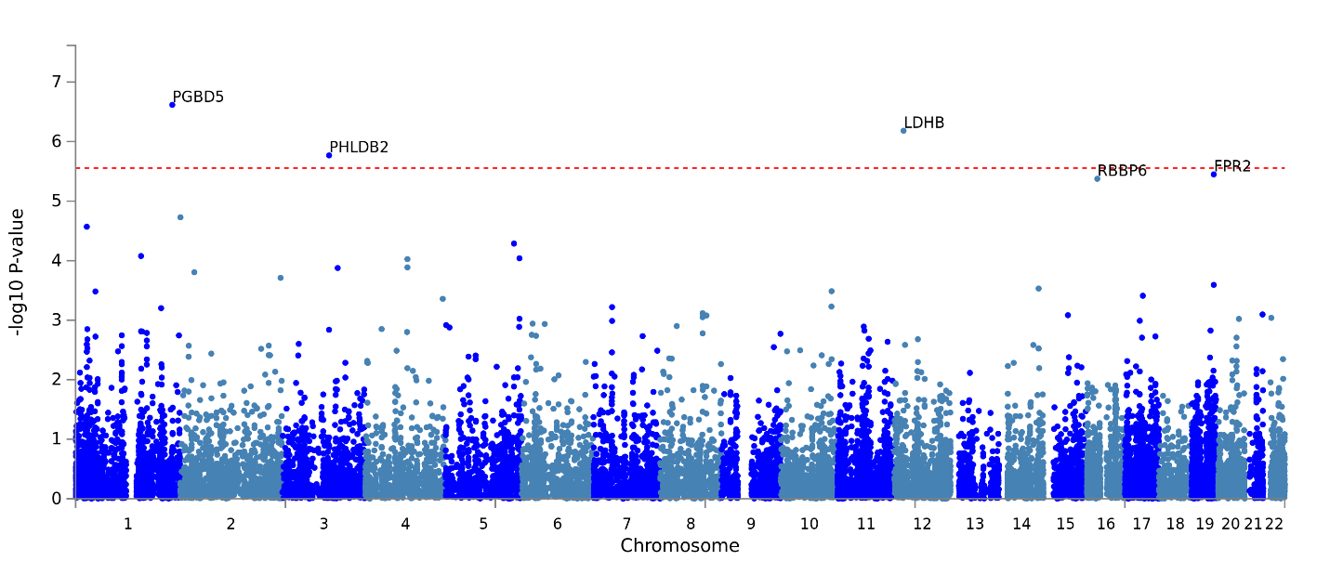
Supplementary Figure S3. FUMA Gene-Based Analysis of EAs Suicide Attempt Severity
Sensitivity Analyses:
EA

Supplementary Figure S4. Affected allele frequency at each level of the scale in EAs.
AA

Supplementary Figure S5. Affected allele frequency at each level of the scale in AAs.

 | Subjects
 | AAYP1 | AAYP2 | EAYP1 | EAYP2 | Total
Total Subjects with Complete Phenotype and Genotype Data | 3191 | 1707 | 1725 | 1696 | 8318
Final Cohort with Suicidal Ideation Removed | 2530 | 1351 | 1225 | 1214 | 6320
% Excluded due to Ideation without Attempt | 20.7% | 20.9% | 29.0% | 28.4% | 24.0%
Supplementary Table S1. Breakdown of the Yale-Penn total sample accounting for number of excluded individuals with suicidal ideation.

Supplementary Table S2. Top findings in meta-analysis of Yale-Penn EA Attempts.
Marker Name | rsid | BP | Allele1 | Allele2 | n | Zscore | P.value | Direction
CHR12:21780851 | rs1677091 | 21780851 | a | c | 2439 | 5.719 | 1.07E-08 | ++
CHR12:21810646 | rs11046147 | 21810646 | t | c | 2439 | 5.717 | 1.09E-08 | ++
CHR12:21774268 | rs255447 | 21774268 | t | c | 2439 | -5.69 | 1.27E-08 | --
CHR12:21815979 | rs12825320 | 21815979 | c | g | 2439 | 5.641 | 1.69E-08 | ++
CHR12:21784608 | rs4762855 | 21784608 | t | c | 2439 | 5.614 | 1.97E-08 | ++
CHR12:21816195 | rs7302534 | 21816195 | a | g | 2439 | -5.576 | 2.47E-08 | --
CHR12:21815425 | rs56125867 | 21815425 | t | c | 2439 | -5.552 | 2.83E-08 | --
CHR12:21784041 | rs10841869 | 21784041 | t | c | 2439 | -5.551 | 2.84E-08 | --
CHR12:21816563 | rs7303185 | 21816563 | a | c | 2439 | 5.541 | 3.01E-08 | ++
CHR12:21787008 | rs1677137 | 21787008 | a | t | 2439 | -5.535 | 3.11E-08 | --
CHR12:21816831 | rs7303612 | 21816831 | t | c | 2439 | 5.531 | 3.18E-08 | ++
CHR12:21817453 | rs58134911 | 21817453 | a | t | 2439 | 5.531 | 3.18E-08 | ++
CHR12:21817542 | rs11046156 | 21817542 | t | c | 2439 | -5.531 | 3.18E-08 | --
CHR12:21816004 | rs12824993 | 21816004 | t | c | 2439 | 5.521 | 3.37E-08 | ++
CHR12:21816005 | rs12824994 | 21816005 | a | c | 2439 | 5.521 | 3.37E-08 | ++
CHR12:21779355 | rs10841862 | 21779355 | t | c | 2439 | -5.497 | 3.86E-08 | --
CHR12:21813860 | rs34438801 | 21813860 | g | ga | 2439 | 5.488 | 4.07E-08 | ++
CHR12:21818102 | rs34313697 | 21818102 | g | ga | 2439 | -5.481 | 4.24E-08 | --
CHR12:21818267 | rs7297042 | 21818267 | a | t | 2439 | 5.473 | 4.41E-08 | ++
CHR12:21814496 | rs10841873 | 21814496 | a | t | 2439 | -5.472 | 4.45E-08 | --
CHR12:21814529 | rs11836830 | 21814529 | a | c | 2439 | -5.472 | 4.45E-08 | --
CHR12:21814566 | rs11832180 | 21814566 | a | c | 2439 | 5.472 | 4.45E-08 | ++
CHR12:21814568 | rs11832211 | 21814568 | t | g | 2439 | 5.472 | 4.45E-08 | ++
CHR12:21814574 | rs11834600 | 21814574 | t | c | 2439 | -5.472 | 4.45E-08 | --
CHR12:21815564 | rs74184609 | 21815564 | t | c | 2439 | -5.465 | 4.62E-08 | --
CHR12:21815580 | rs73077300 | 21815580 | t | c | 2439 | -5.465 | 4.62E-08 | --
CHR12:21815612 | rs78929102 | 21815612 | c | g | 2439 | 5.465 | 4.62E-08 | ++
CHR12:21815650 | rs76654229 | 21815650 | a | c | 2439 | -5.465 | 4.62E-08 | --
CHR12:21815665 | rs80042173 | 21815665 | a | c | 2439 | -5.465 | 4.62E-08 | --
CHR12:21815725 | rs66978947 | 21815725 | a | g | 2439 | 5.465 | 4.62E-08 | ++
CHR12:21813877 | rs7135965 | 21813877 | a | g | 2439 | 5.465 | 4.64E-08 | ++
CHR12:21816351 | rs7302889 | 21816351 | t | c | 2439 | 5.457 | 4.83E-08 | ++
CHR12:21816357 | rs7133707 | 21816357 | t | c | 2439 | -5.457 | 4.83E-08 | --
CHR12:21815874 | rs72276276 | 21815874 | ccccactt | c | 2439 | -5.456 | 4.88E-08 | --
CHR12:21814682 | rs11046148 | 21814682 | a | g | 2439 | -5.451 | 5.02E-08 | --
CHR12:21814745 | rs10841874 | 21814745 | t | c | 2439 | -5.451 | 5.02E-08 | --
CHR12:21814783 | rs11046149 | 21814783 | c | g | 2439 | -5.451 | 5.02E-08 | --
CHR12:21814852 | rs11046150 | 21814852 | a | c | 2439 | 5.451 | 5.02E-08 | ++
CHR12:21814908 | rs11046151 | 21814908 | a | g | 2439 | -5.451 | 5.02E-08 | --
CHR12:21815104 | rs12824571 | 21815104 | t | c | 2439 | -5.451 | 5.02E-08 | --
CHR12:21815232 | rs12823853 | 21815232 | c | g | 2439 | 5.451 | 5.02E-08 | ++
CHR12:21815343 | rs67247140 | 21815343 | t | c | 2439 | -5.451 | 5.02E-08 | --
CHR12:21815668 | rs146857244 | 21815668 | a | ac | 2439 | 5.451 | 5.02E-08 | ++
CHR12:21815800 | rs12826014 | 21815800 | t | c | 2439 | -5.451 | 5.02E-08 | --
CHR12:21815820 | rs12824936 | 21815820 | c | g | 2439 | 5.451 | 5.02E-08 | ++
CHR12:21815898 | rs12824788 | 21815898 | a | c | 2439 | 5.451 | 5.02E-08 | ++
CHR12:21816031 | rs12829701 | 21816031 | a | c | 2439 | -5.451 | 5.02E-08 | --
CHR12:21816082 | rs12830306 | 21816082 | c | g | 2439 | 5.451 | 5.02E-08 | ++
CHR12:21816205 | rs7302639 | 21816205 | t | c | 2439 | 5.451 | 5.02E-08 | ++
CHR12:21816889 | rs7303644 | 21816889 | c | g | 2439 | -5.451 | 5.02E-08 | --
CHR12:21816920 | rs7303528 | 21816920 | a | t | 2439 | -5.451 | 5.02E-08 | --
CHR12:21817003 | rs11046153 | 21817003 | a | g | 2439 | 5.451 | 5.02E-08 | ++
CHR12:21817261 | rs11046154 | 21817261 | a | g | 2439 | 5.451 | 5.02E-08 | ++
CHR12:21816349 | rs7133704 | 21816349 | t | c | 2439 | -5.448 | 5.09E-08 | --
CHR12:21816335 | rs7303126 | 21816335 | a | g | 2439 | 5.432 | 5.57E-08 | ++
CHR12:21815421 | rs71436855 | 21815421 | a | g | 2439 | -5.43 | 5.65E-08 | --
CHR12:21815427 | rs71436857 | 21815427 | a | g | 2439 | -5.43 | 5.65E-08 | --
CHR12:21815440 | rs79594593 | 21815440 | a | c | 2439 | -5.43 | 5.65E-08 | --
CHR12:21815389 | rs67286733 | 21815389 | a | c | 2439 | 5.426 | 5.76E-08 | ++
CHR12:21778904 | rs10841860 | 21778904 | a | g | 2439 | 5.419 | 5.98E-08 | ++
CHR12:21814162 | rs10841872 | 21814162 | c | g | 2439 | 5.414 | 6.17E-08 | ++
CHR12:21815488 | rs74184947 | 21815488 | c | g | 2439 | 5.405 | 6.48E-08 | ++
CHR12:21815491 | rs74207710 | 21815491 | a | t | 2439 | 5.405 | 6.48E-08 | ++
CHR12:21815504 | rs74219429 | 21815504 | t | c | 2439 | -5.405 | 6.48E-08 | --
CHR12:21760286 | rs34600045 | 21760286 | t | c | 2439 | 5.327 | 1.00E-07 | ++
CHR12:21781246 | rs10841868 | 21781246 | t | g | 2439 | 5.276 | 1.32E-07 | ++
CHR12:21807687 | rs7953579 | 21807687 | c | g | 2439 | 5.271 | 1.36E-07 | ++
CHR12:21781181 | rs10841867 | 21781181 | a | g | 2439 | -5.262 | 1.43E-07 | --
CHR12:21816621 | rs368907914 | 21816621 | caaaaaaaa | c | 2439 | -5.251 | 1.51E-07 | --
CHR12:21825201 | rs7133519 | 21825201 | t | g | 2439 | 5.234 | 1.66E-07 | ++
CHR12:21826222 | rs34031159 | 21826222 | a | g | 2439 | -5.234 | 1.66E-07 | --
CHR12:21819568 | rs11046161 | 21819568 | a | t | 2439 | 5.211 | 1.88E-07 | ++
CHR12:21819404 | rs11046159 | 21819404 | c | g | 2439 | 5.203 | 1.96E-07 | ++
CHR12:21842821 | rs7975931 | 21842821 | t | g | 2439 | -5.168 | 2.36E-07 | --
CHR12:21819535 | rs11046160 | 21819535 | t | c | 2439 | -5.163 | 2.43E-07 | --
CHR12:21819641 | rs7301852 | 21819641 | t | c | 2439 | -5.163 | 2.43E-07 | --
CHR12:21819667 | rs7316427 | 21819667 | a | g | 2439 | 5.163 | 2.43E-07 | ++
CHR12:21819702 | rs7301883 | 21819702 | a | t | 2439 | 5.163 | 2.43E-07 | ++
CHR12:21819842 | rs7316669 | 21819842 | a | g | 2439 | 5.163 | 2.43E-07 | ++
CHR12:21819903 | rs7316475 | 21819903 | t | c | 2439 | 5.163 | 2.43E-07 | ++
CHR12:21820070 | rs7305475 | 21820070 | t | c | 2439 | -5.163 | 2.43E-07 | --
CHR12:21803685 | rs1677084 | 21803685 | c | g | 2439 | -5.157 | 2.50E-07 | --
CHR12:21803770 | rs1650307 | 21803770 | t | c | 2439 | -5.157 | 2.50E-07 | --
CHR12:21820146 | rs10686695 | 21820146 | cagag | c | 2439 | 5.154 | 2.55E-07 | ++
CHR12:21838885 | rs34084105 | 21838885 | a | g | 2439 | 5.154 | 2.55E-07 | ++
CHR12:21839397 | rs10841878 | 21839397 | c | g | 2439 | -5.154 | 2.55E-07 | --
CHR12:21827614 | rs12426826 | 21827614 | t | c | 2439 | 5.148 | 2.64E-07 | ++
CHR12:21820578 | rs17629491 | 21820578 | a | g | 2439 | -5.142 | 2.72E-07 | --
CHR12:21831069 | rs12426310 | 21831069 | t | g | 2439 | 5.142 | 2.72E-07 | ++
CHR12:21834560 | rs66592830 | 21834560 | a | c | 2439 | 5.142 | 2.72E-07 | ++
CHR12:21834822 | rs34015001 | 21834822 | a | c | 2439 | 5.142 | 2.72E-07 | ++
CHR12:21826254 | rs34822889 | 21826254 | c | g | 2439 | 5.137 | 2.79E-07 | ++
CHR12:21823036 | rs10770848 | 21823036 | a | g | 2439 | 5.127 | 2.94E-07 | ++
CHR12:21839933 | rs2077105 | 21839933 | a | g | 2439 | -5.127 | 2.94E-07 | --
CHR12:21819125 | rs11046157 | 21819125 | t | c | 2439 | 5.123 | 3.00E-07 | ++
CHR12:21815235 | rs12823507 | 21815235 | c | g | 2439 | -5.12 | 3.06E-07 | --
CHR12:21817385 | rs187647634 | 21817385 | c | g | 2439 | -5.111 | 3.21E-07 | --
CHR12:21819137 | rs11046158 | 21819137 | a | t | 2439 | 5.109 | 3.24E-07 | ++
CHR12:21815454 | rs201502983 | 21815454 | a | aagag | 2439 | 5.101 | 3.38E-07 | ++
CHR12:21815463 | rs143849831 | 21815463 | a | t | 2439 | -5.101 | 3.38E-07 | --
CHR12:21815467 | rs148611933 | 21815467 | t | c | 2439 | 5.101 | 3.38E-07 | ++
CHR12:21815472 | rs77765937 | 21815472 | c | g | 2439 | -5.101 | 3.38E-07 | --
CHR12:21843576 | rs11046164 | 21843576 | t | c | 2439 | 5.083 | 3.72E-07 | ++
CHR12:21845290 | rs10770851 | 21845290 | c | g | 2439 | 5.077 | 3.84E-07 | ++
CHR12:21841978 | rs10841880 | 21841978 | a | t | 2439 | -5.063 | 4.13E-07 | --
CHR12:21849348 | rs852816 | 21849348 | t | c | 2439 | -5.062 | 4.15E-07 | --
CHR12:21850983 | rs852817 | 21850983 | t | c | 2439 | -5.045 | 4.53E-07 | --
CHR12:21858180 | rs860447 | 21858180 | t | c | 2439 | 4.988 | 6.10E-07 | ++
CHR12:21853012 | rs11046166 | 21853012 | a | g | 2439 | 4.986 | 6.16E-07 | ++
CHR16:24558653 | rs9927702 | 24558653 | a | g | 2439 | -4.953 | 7.32E-07 | --
CHR12:21857409 | rs11046170 | 21857409 | t | g | 2439 | 4.943 | 7.70E-07 | ++
CHR10:71788611 | rs111394656 | 71788611 | t | c | 2439 | 4.938 | 7.91E-07 | ++
CHR16:24570381 | rs7200560 | 24570381 | a | t | 2439 | 4.928 | 8.30E-07 | ++

Supplementary Table S3. Top findings in meta-analysis of Yale-Penn AA Attempts.
Marker Name | rsid | BP | Allele1 | Allele2 | n | Zscore | P.value | Direction
CHR12:27600331 | rs683813 | 27600331 | t | c | 3881 | -5.606 | 2.07E-08 | --
CHR15:80508139 | rs72740082 | 80508139 | a | t | 3881 | -5.583 | 2.36E-08 | --
CHR18:35911354 | rs11876255 | 35911354 | a | g | 3881 | -5.466 | 4.61E-08 | --
CHR15:80512515 | rs72740088 | 80512515 | t | c | 3881 | -5.379 | 7.49E-08 | --
CHR3:158144979 | rs61537580 | 1.58E+08 | a | ac | 3881 | 5.233 | 1.67E-07 | ++
CHR3:157675069 | rs9290009 | 1.58E+08 | a | g | 3881 | 5.221 | 1.78E-07 | ++
CHR3:185622421 | rs6795254 | 1.86E+08 | t | c | 3881 | -5.218 | 1.81E-07 | --
CHR18:35912717 | rs7240979 | 35912717 | t | c | 3881 | -5.171 | 2.33E-07 | --
CHR11:96032273 | rs76182109 | 96032273 | a | g | 3881 | -5.167 | 2.38E-07 | --
CHR13:50967576 | rs113498843 | 50967576 | a | g | 3881 | 5.123 | 3.01E-07 | ++
CHR13:51015161 | rs56155205 | 51015161 | c | g | 3881 | 5.112 | 3.19E-07 | ++
CHR13:51020490 | rs75389317 | 51020490 | a | t | 3881 | -5.112 | 3.19E-07 | --
CHR18:35954120 | rs8092042 | 35954120 | t | c | 3881 | 5.105 | 3.32E-07 | ++
CHR18:35955209 | rs144723193 | 35955209 | a | c | 3881 | -5.105 | 3.32E-07 | --
CHR2:173351176 | rs16860543 | 1.73E+08 | a | g | 3881 | 5.048 | 4.48E-07 | ++
CHR2:173355907 | rs56084828 | 1.73E+08 | a | c | 3881 | -5.048 | 4.48E-07 | --
CHR9:83116342 | rs12683724 | 83116342 | a | g | 3881 | -5.037 | 4.73E-07 | --
CHR9:83117229 | rs10867557 | 83117229 | a | t | 3881 | -5.037 | 4.73E-07 | --
CHR18:35960620 | rs151078736 | 35960620 | t | c | 3881 | -5.035 | 4.78E-07 | --
CHR18:35961612 | rs75346662 | 35961612 | t | g | 3881 | 5.008 | 5.51E-07 | ++
CHR18:35961928 | rs75158723 | 35961928 | t | g | 3881 | -5.008 | 5.51E-07 | --
CHR18:35962020 | rs77672600 | 35962020 | a | g | 3881 | 5.008 | 5.51E-07 | ++
CHR13:51007824 | rs76886430 | 51007824 | t | c | 3881 | -4.976 | 6.49E-07 | --
CHR18:35962676 | rs11873140 | 35962676 | a | g | 3881 | -4.975 | 6.54E-07 | --
CHR18:35967146 | rs150919601 | 35967146 | t | c | 3881 | 4.953 | 7.30E-07 | ++
CHR5:35868562 | rs11567739 | 35868562 | a | c | 3881 | 4.949 | 7.45E-07 | ++
CHR5:35869044 | rs9282748 | 35869044 | t | c | 3881 | 4.949 | 7.45E-07 | ++
CHR1:214879192 | rs61520094 | 2.15E+08 | t | c | 3881 | 4.932 | 8.14E-07 | ++
CHR9:105349079 | rs76477759 | 1.05E+08 | c | g | 3881 | -4.923 | 8.53E-07 | --
CHR13:50988880 | rs55810037 | 50988880 | t | c | 3881 | -4.901 | 9.51E-07 | --

Supplementary Table S4. Army-STARRS phenotype
Cohort | Total Participants | Army-STARRS Participants with severity score
Cohort | Total Participants | 0 | 1 | 2
Cohort | Total Participants | No Suicidal Ideation/thoughts | Suicide Attempt | Violent Suicide Attempt
AFR | 1488 | 1405 | 48 | 35
EUR | 9382 | 8977 | 230 | 175
LAT | 2963 | 2854 | 66 | 43

Supplementary Table S5. Age and sex in the discovery (Yale-Penn) and replication (Army-STARRS) cohorts.
Cohort | % Female | Age(Mean(SD))
EA Yale-Penn 1 | 41.4% | 37.907(10.901)
EA Yale-Penn 2 | 41.6% | 39.168(12.811)
EA Army-STARRS NSS1 | 14.1% | 21.117(3.375)
EA Army-STARRS NSS2 | 19.0% | 20.311(3.273)
EA Army-STARRS PPDS | 5.3% | 25.796(5.858)
LAT Army-STARRS NSS1 | 17.6% | 21.035(3.266)
LAT Army-STARRS NSS2 | 24.8% | 20.103(2.983)
LAT Army-STARRS PPDS | 8.2% | 25.171(5.566)
AA Yale-Penn 1 | 48.5% | 41.126(9.068)
AA Yale-Penn 2 | 42.3% | 40.89(11.028)
AA Army-STARRS NSS1 | 30.2% | 21.045(3.156)
AA Army-STARRS NSS2 | 36.0% | 20.628(3.159)

Supplementary Table S6. Comorbidity in the Yale-Penn cohort

Trans-population Meta-analysis
Two independent GWS associations were identified in the trans-population analysis of the Yale-Penn sample, with six GWS SNPs. The top signal was found on chromosome 5 (rs201402387, MAF=0.04, p=1.54×10⁻⁸) ~8kb from a small noncoding RNA pseudogene. This SNP was nominally significant in both AAs and EAs (AA p= 3.12×10⁻⁶, EA p= 1.26×10⁻³) with MAF ranging between 0.03 and 0.04. The other signal was near CTXND1 and LINC01314, with a similar association strength (rs72740082, MAF=0.06, p=2.43×10⁻⁸). This SNP is the same that was identified GWS in Yale-Penn AAs (MAF=0.03, p=2.36×10⁻⁸) and was nearly nominally significant in EAs with the same effect direction (MAF=0.08, p=0.053).

