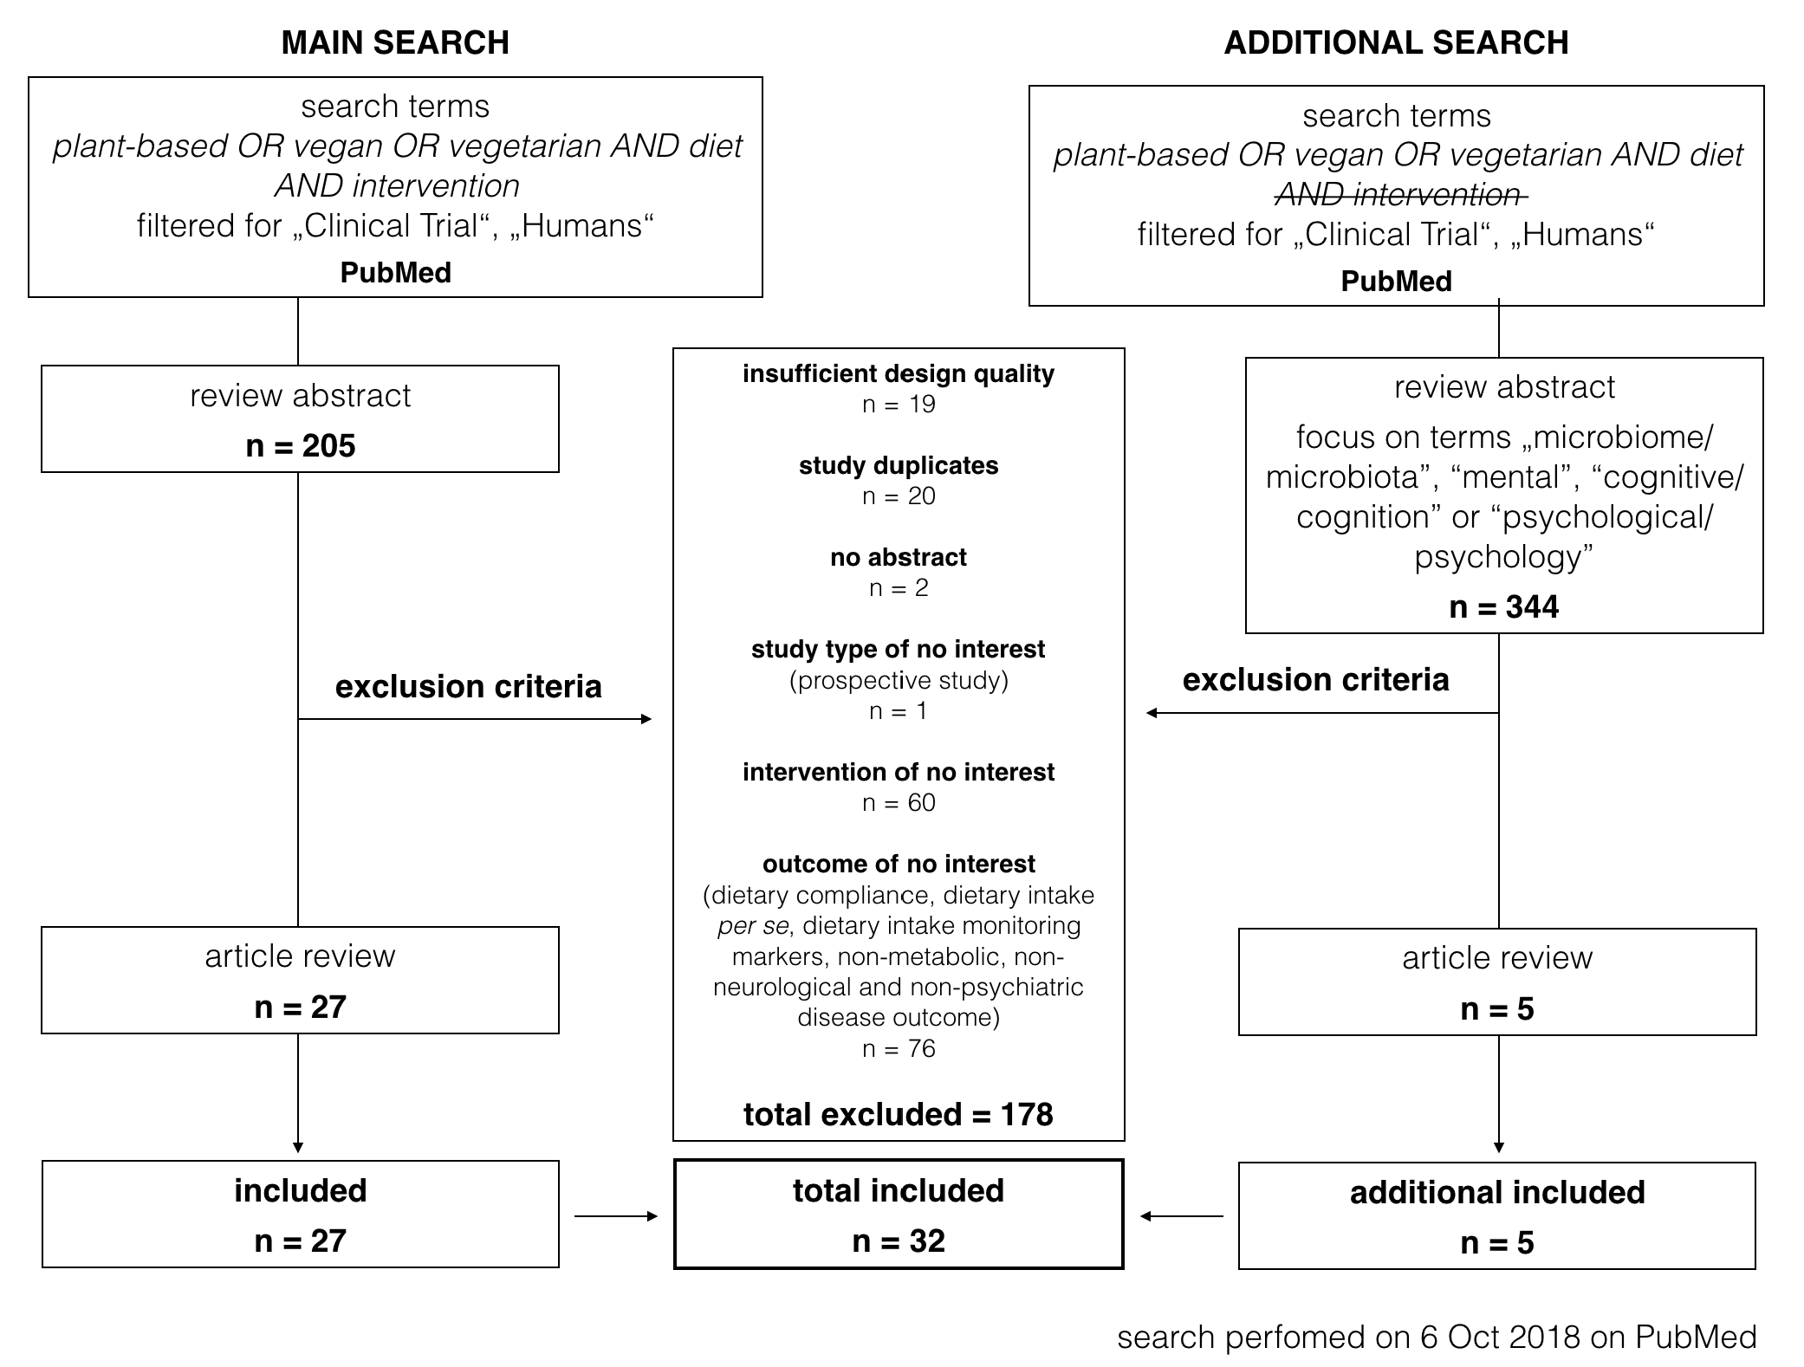
Suppl. Figure 1: Flowchart of literature search performed on 6 Oct 2018 on PubMed.

