Serotonin depletion amplifies distinct human social emotions as a function of individual differences in personality

Jonathan W Kanen, BA^{1,2}, Fréderique E Arntz, MSc^{1,2,3}, Robyn Yellowlees, MSc^{1,2,4}, Rudolf N Cardinal, MD PhD^{2,5,6}, Annabel Price, MBBS PhD^{5,6}, David M Christmas, MD PhD ^{5,6}, Annemieke M Apergis-Schoute, PhD^{2,7}, Barbara J Sahakian, DSc^{2,5}, Trevor W Robbins, PhD^{1,2}
¹Department of Psychology, University of Cambridge, Cambridge, UK
²Behavioural and Clinical Neuroscience Institute, University of Cambridge, Cambridge, UK
³Department of Psychology, Leiden University, Leiden, The Netherlands
⁴Section of Eating Disorders, Department of Psychological Medicine, Institute of Psychiatry, Psychology and Neuroscience, King’s College London, London, UK
⁵Department of Psychiatry, University of Cambridge, Cambridge, UK
⁶Cambridgeshire and Peterborough NHS Foundation Trust, UK
⁷Department of Neuroscience, Psychology, and Behaviour, University of Leicester, Leicester, UK

Corresponding author:
Jonathan Kanen
Department of Psychology, University of Cambridge, Downing Street, Cambridge, CB2 3EB, UK.
Phone: +44 7907922096
Fax: +44 1223 333564
Email: jonathan.kanen@gmail.com

Supplementary Material

Methods
Further exclusion criteria
Further exclusion criteria: history of taking endocrine medication, use of St. John’s Wort, pregnancy, regular consumption of over 38 units of alcohol per week, consumption of more than five cigarettes per day, use of cannabis more than once per month, use of other recreational drugs besides cannabis more than five times in the lifespan, cardiac or circulation problems, respiratory issues including asthma, gastrointestinal disorders, kidney disorders, thyroid problems, head injury, a bleeding disorder, and diabetes.

Individual characteristics
We assessed several personality traits and psychological symptoms primarily to ensure the placebo and depletion groups were matched: trait anxiety (t₍₇₁₎ = -0.872, p = .386) using the Spielberger Trait Anxiety Inventory (STAI; Spielberger et al., 1983); autistic characteristics (t₍₇₁₎ = -0.112 , p = .911) using the Adult Autism Spectrum Quotient (AQ; Baron-Cohen et al., 2001); Participants in each group, additionally, did not differ in their years of education (t₍₇₁₎ = 0.634, p = .528).

Principal Components Analysis Supplementary Information
Our principal components analysis (PCA) was performed with oblique rotation (direct oblimin). The Kaiser-Meyer-Olkin (KMO) measure verified the sampling adequacy for the analysis, KMO = .719 (“good” according to Hutcheson & Sofroniou, 1999). Bartlett’s test of sphericity indicated correlations between items were sufficiently large for PCA (χ² (120) = 700.731, p = 7.9941 x 10⁻⁸³). We obtained eigenvalues for each component in the data and extracted components with eigenvalues over Kaiser’s criterion of one. This resulted in 4 components, which explained 72.354% of the variance. The scree plot showed an inflexion that justified retaining these 4 components, which were then used in the remainder of the analysis. The pattern matrix (Supplementary Table 1) shows the factor loadings after rotation.
Figures and Tables
Supplementary Figure 1. Effects of ATD on emotion: serotonin depletion enhanced emotion non-specifically overall (see main text). Each bar represents the average emotion ratings per group, collapsed across agency and intentionality. Error bars indicate 1 standard error. Asterisk indicates main effect, p < .05.

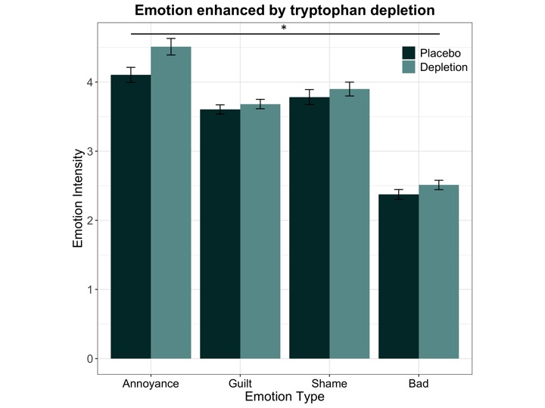

Supplementary Figure 2. ANOVA on four principal components from principal components analysis. Measures contained in components 2 and 4 were significantly increased by ATD (acute tryptophan depletion). Error bars indicate 1 standard error. # indicates interaction at p < .05; asterisk indicates significant follow-up t-test at p < .05.

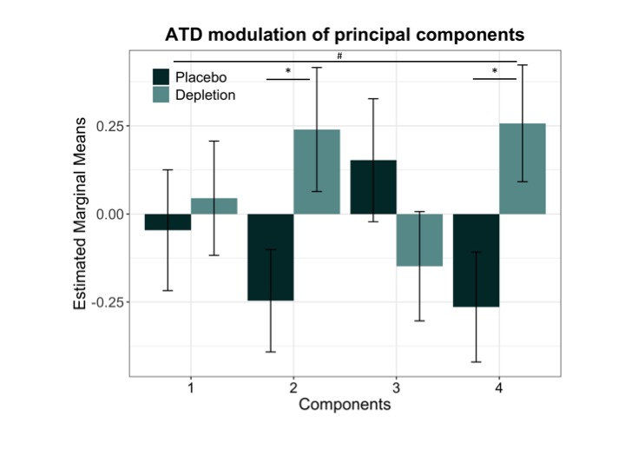

Supplementary Table 1. Principal Components Pattern Matrix. Rotation Method: Oblimin with Kaiser Normalisation. Rotation converged in 19 iterations. Intended = intentional harm. Unintended = unintentional harm.

 | Component
Raw Variable | 1 | 2 | 3 | 4
Annoyed-unintended-victim | .819
Annoyed-intended-victim | .791 | .317
Bad-unintended-victim | -.736
Bad-unintended-agent | -.617 |  | -.351
Bad-intended-victim | -.604
Guilty-unintended-agent | .587 |  | .403
Annoyed-unintended-agent |  | .921
Annoyed-intended-agent |  | .897
Ashamed-intended-agent |  |  | .923
Guilty-intended-agent |  |  | .922
Bad-intended-agent |  |  | -.892
Ashamed-unintended-agent | .396 |  | .455 | .417
Ashamed-unintended-victim |  |  |  | .830
Ashamed-intended-victim |  |  |  | .750
Guilty-unintended-victim |  | .408 |  | .541
Guilty-intended-victim |  | .504 |  | .521

Supplementary Table 2.

 | Guilt | Shame | Bad
Annoyance | r = .481, p = 1.7x10⁻⁵ | r = .403, p = 4.08x10⁻⁴ | r = -.145, p = .220
Guilt |  | r = .779, p = 5.16x10⁻¹⁶ | r = -.527, p = 2.0x10⁻⁶
Shame |  |  | r = -.451, p = 6.2x10⁻⁵

Supplementary references
Hutcheson, G. D. and Sofroniou, N. (1999). The multivariate social scientist: Introductory statistics using generalized linear models. Sage Publications.

