a) EthOH vs Cortisol
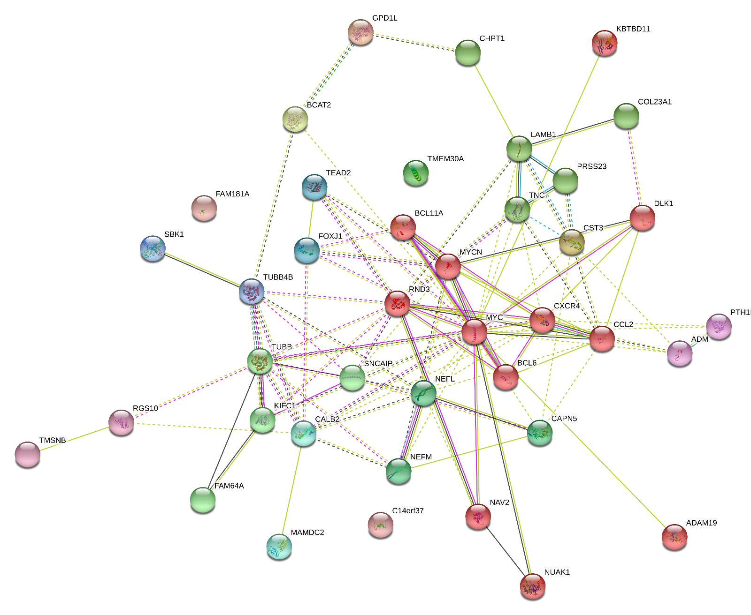

b) EE vs EC

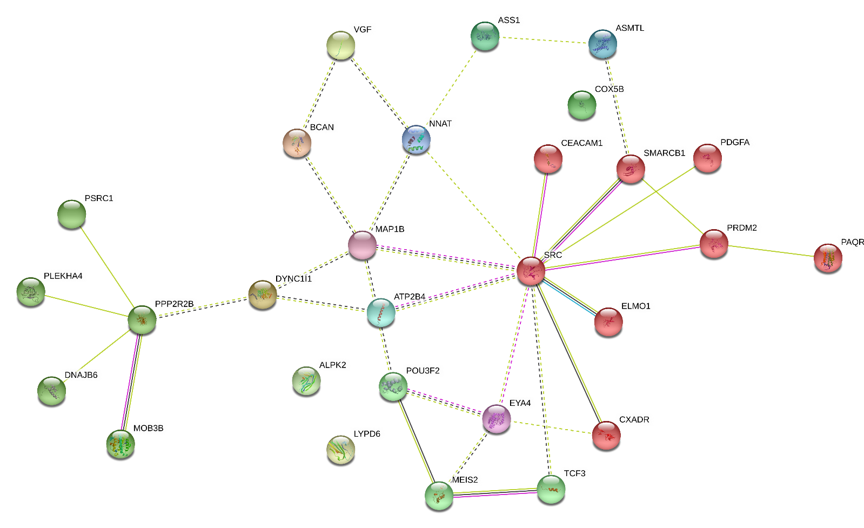

c) EE vs EEC
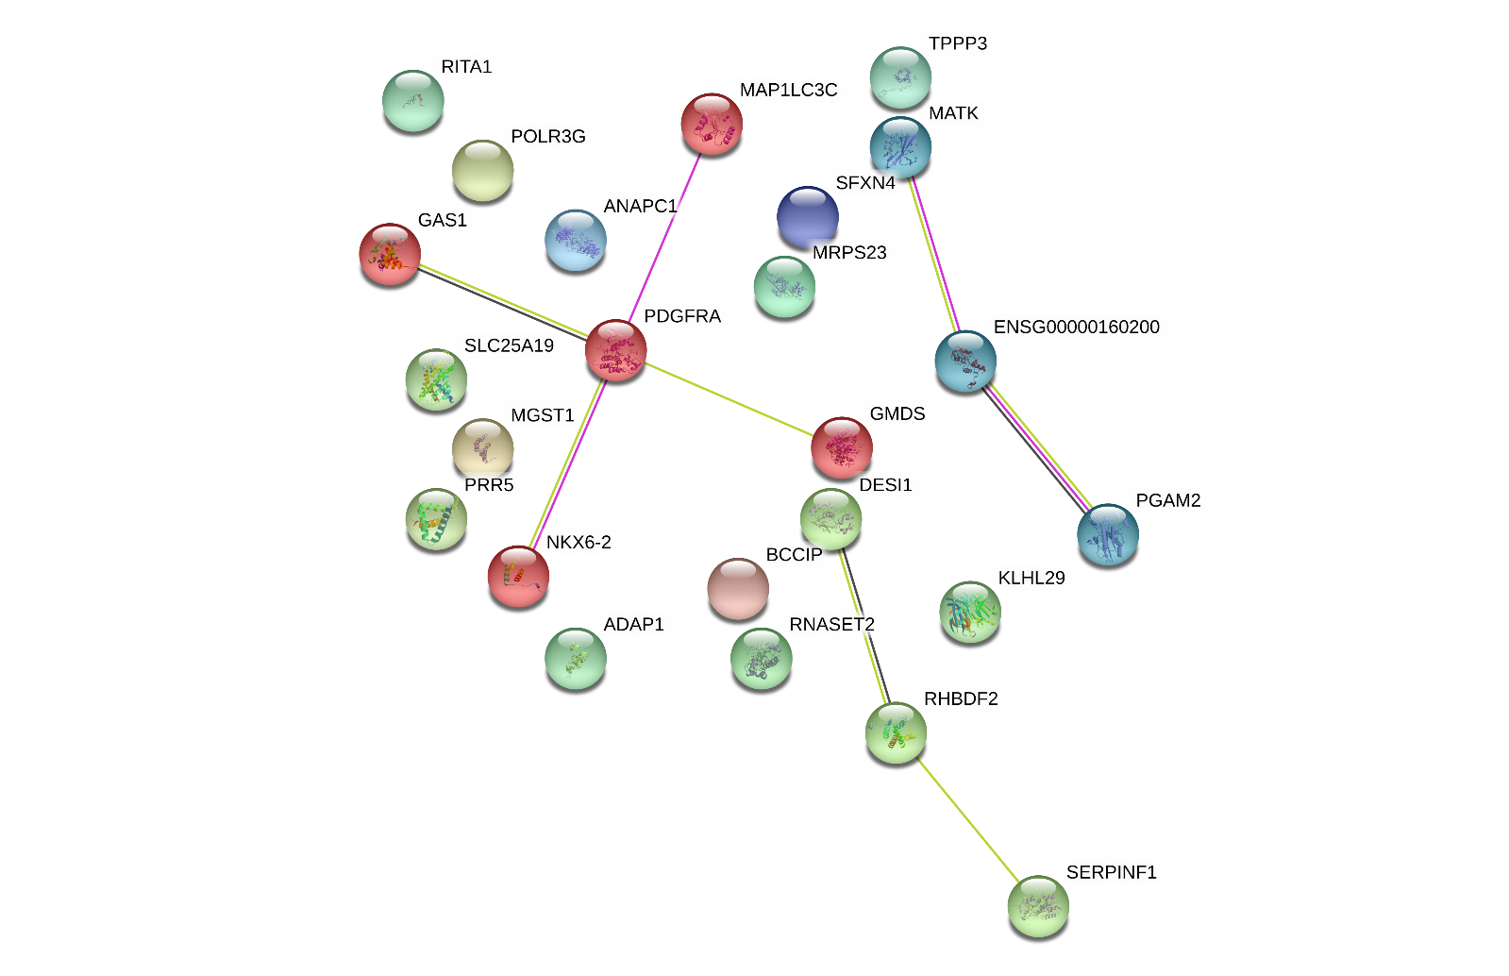
d) EtOH vs EE


e) EthOH vs Cortisol_EE vs EC
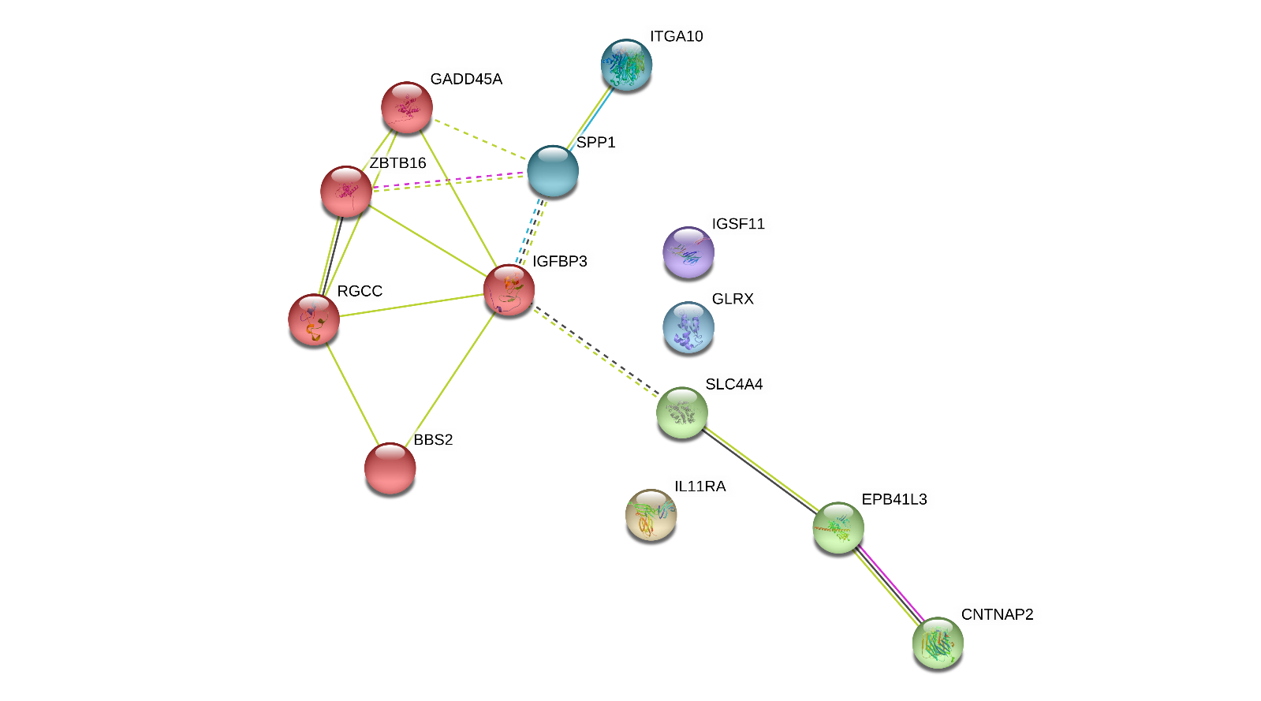

f) EthOH vs Cortisol_EE vs EEC



g) EE vs EC_ EE vs EEC
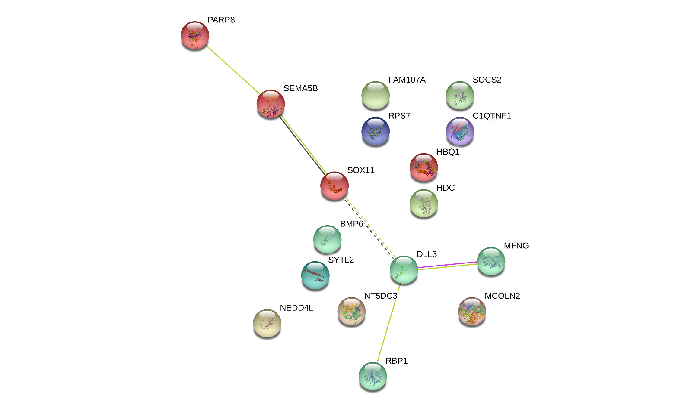

h) All conditions
