Supplementary Tables and Figures
Table of Contents
Supplementary Table 1 2
Supplementary Figure 1 3
Supplementary Figure 2 4
Supplementary Figure 3 5
Supplementary Figure 4 6
Supplementary Figure 5 7
Supplementary Figure 6 8

Supplementary Table 1. Average scores for eight Child Behavior Checklist (CBCL) syndrome scale across 95 probands grouped by gender and affection status.
 |  |  | Female (n = 50) |  | Male (n = 45) |  |  | Typical developing (n = 48) |  | Cases (n = 47)
CBCL syndrome scales | Mean | SD | Mean | SD | Mean | SD | p-value | Mean | SD | Mean | SD | p-value
Anxious/depressed | 105.36 | 7.11 | 106.04 | 8.37 | 104.60 | 5.36 | 0.32 | 102.58 | 3.87 | 108.19 | 8.46 | 1.04×10⁻⁰⁴
Withdrawn/depressed | 106.92 | 7.74 | 106.86 | 8.63 | 106.98 | 6.71 | 0.94 | 104.81 | 5.86 | 109.06 | 8.83 | 7.21×10⁻⁰³
Somatic complaints | 104.31 | 6.11 | 104.66 | 6.80 | 103.91 | 5.30 | 0.55 | 103.58 | 5.75 | 105.04 | 6.44 | 0.25
Social problems | 107.73 | 8.20 | 108.26 | 9.40 | 107.13 | 6.67 | 0.50 | 104.35 | 5.94 | 111.17 | 8.79 | 3.07×10⁻⁰⁵
Thought problems | 108.11 | 8.09 | 107.98 | 8.73 | 108.24 | 7.42 | 0.87 | 104.85 | 5.66 | 111.43 | 8.88 | 5.06×10⁻⁰⁵
Attention problems | 109.11 | 9.17 | 109.48 | 10.67 | 108.69 | 7.24 | 0.67 | 104.02 | 5.06 | 114.30 | 9.54 | 8.75×10⁻⁰⁹
Rule-breaking behavior | 106.88 | 7.47 | 107.28 | 7.80 | 106.44 | 7.14 | 0.59 | 104.60 | 6.82 | 109.21 | 7.45 | 2.24×10⁻⁰³
Aggression | 107.34 | 8.60 | 108.12 | 9.94 | 106.47 | 6.82 | 0.34 | 103.94 | 5.42 | 110.81 | 9.84 | 7.50×10⁻⁰⁵
SD – standard deviation, CBCL – Child Behavior Checklist. “Cases” refer to children with a parent report of a psychiatric diagnosis.

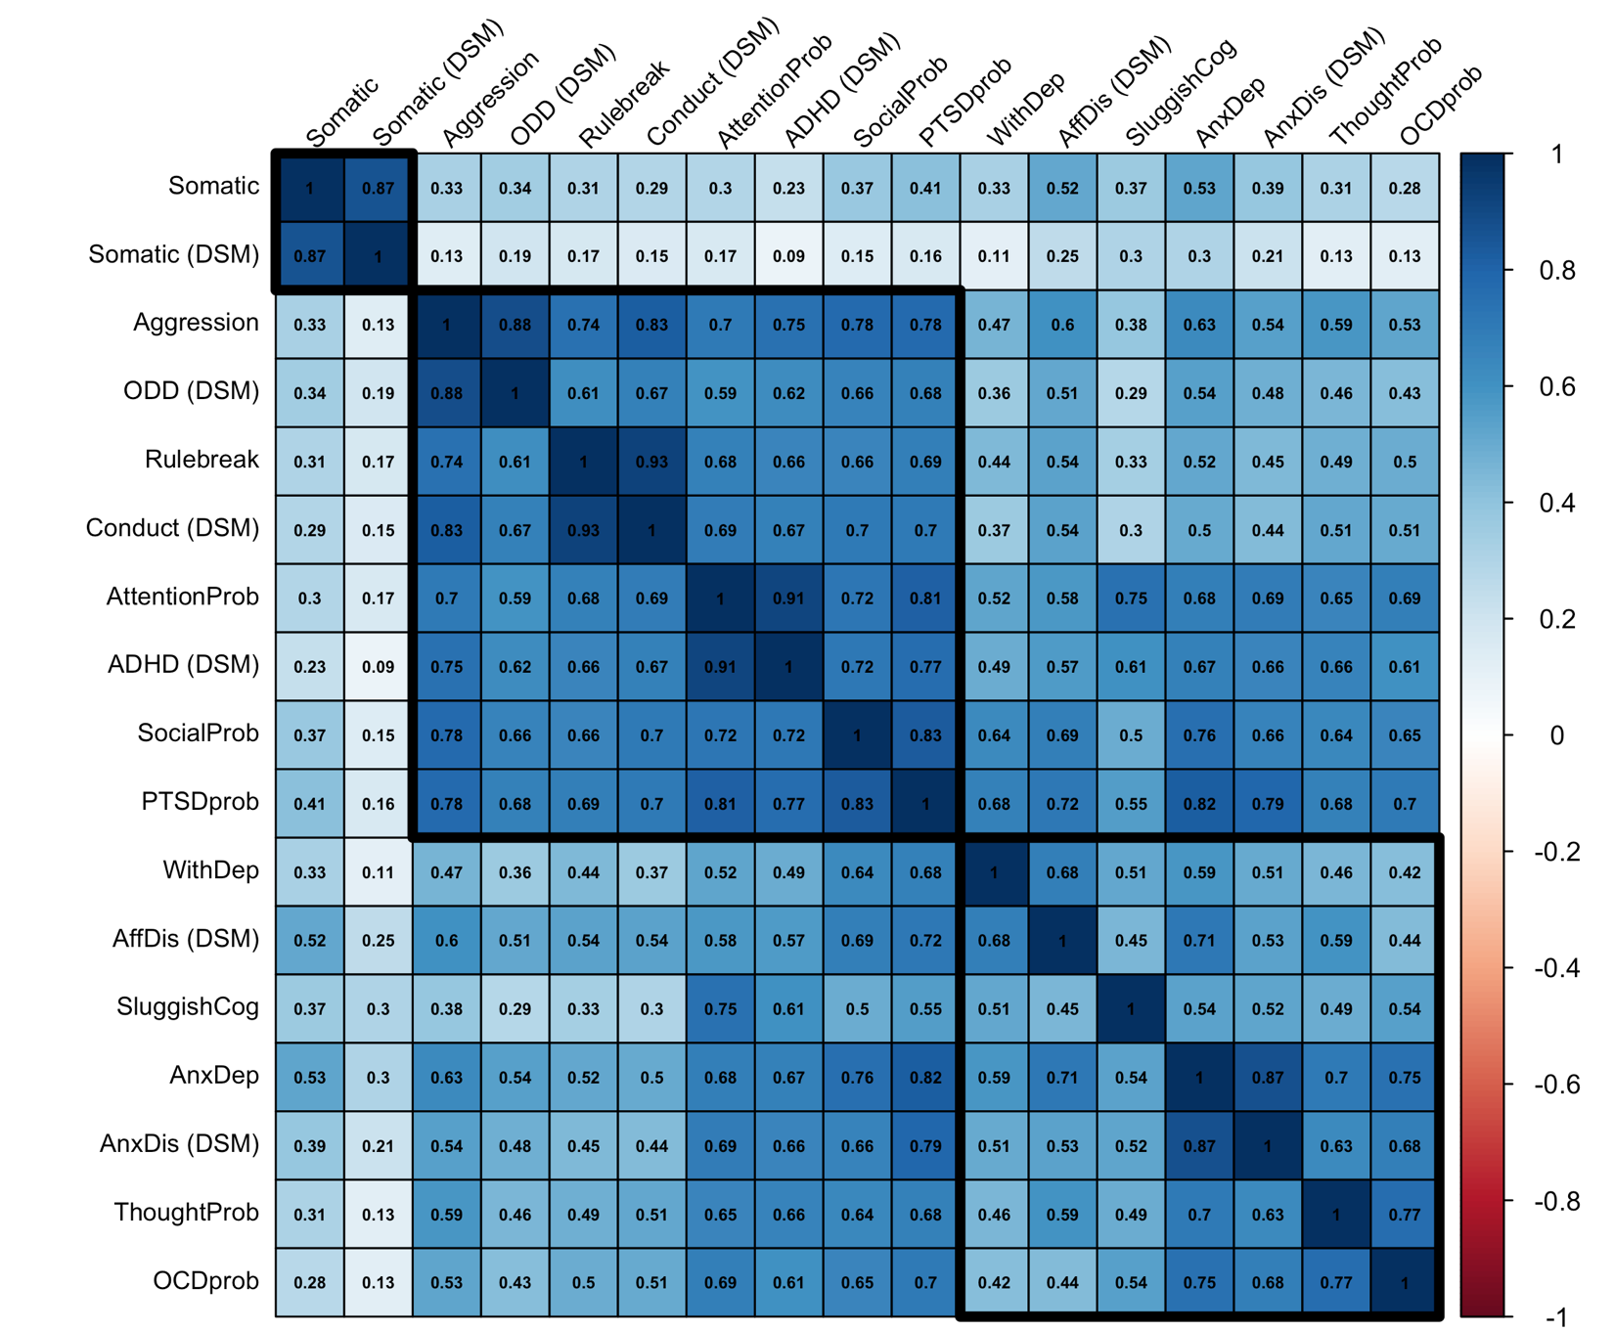
Supplementary Figure 1. Pair-wise Pearson’s correlation coefficients estimated between Child Behavior Checklist (CBCL) scales. Rows and columns were ordered using hierarchical clustering based on Euclidean distances. Boxes were drawn around three distinct clusters.

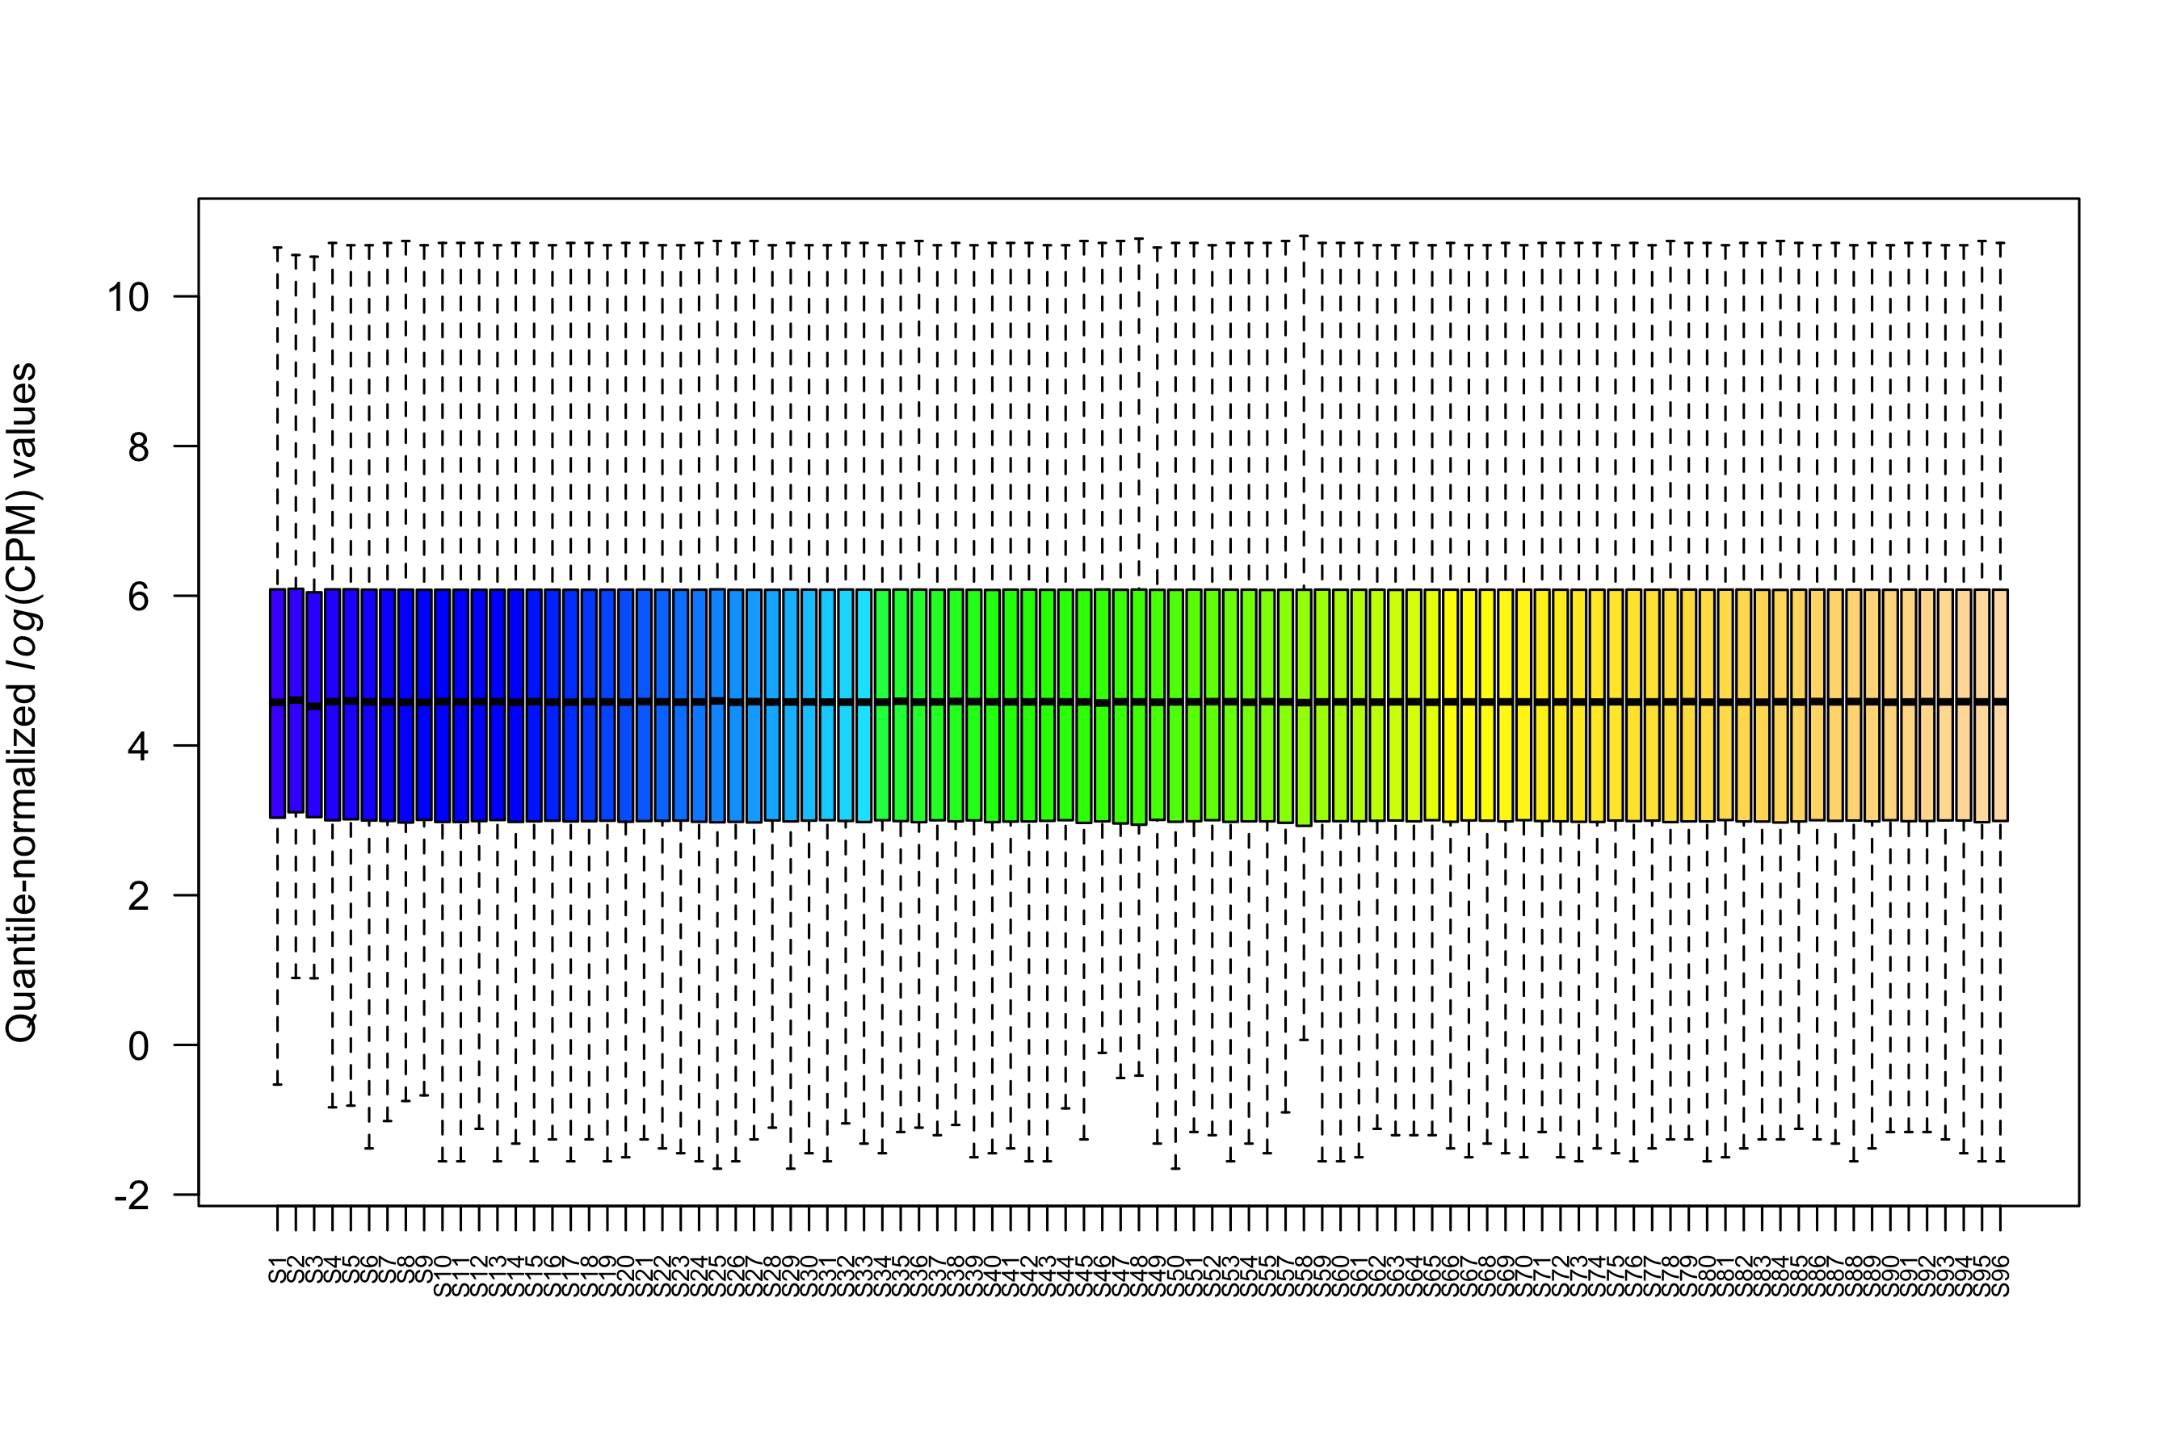

Supplementary Figure 2. Box-and-whisker plots showing normalized RNA-sequencing read count distributions for 95 samples (excluded one sample with an insufficient number of reads).

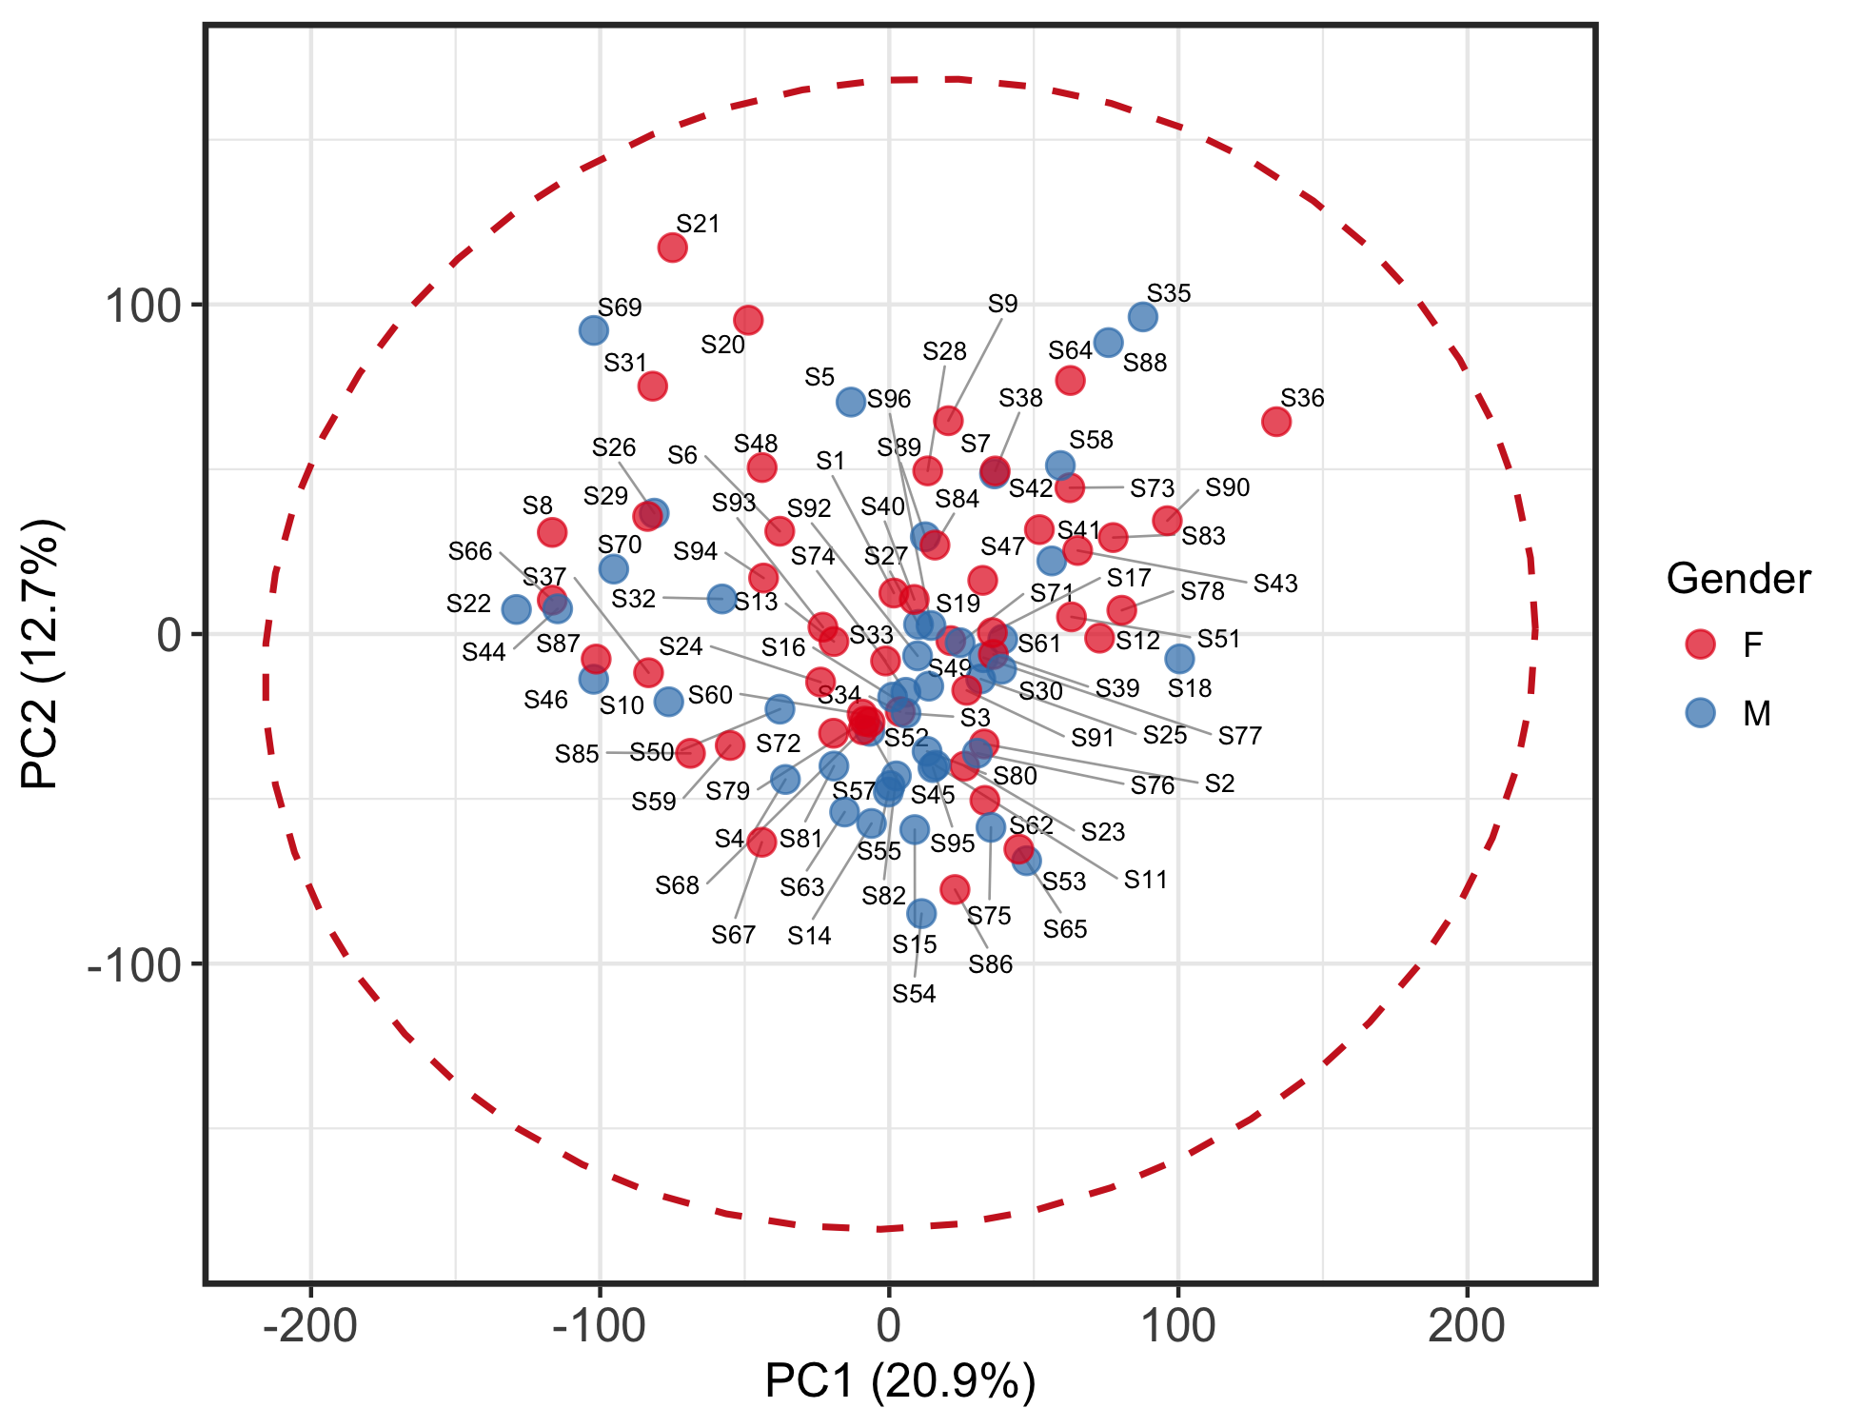
Supplementary Figure 3. Scatterplot of first two components from principal component analysis supplied with normalized read counts from 14,318 genes from 95 samples. A red dashed ellipse was drawn 4 standard deviations out from the center of the group.

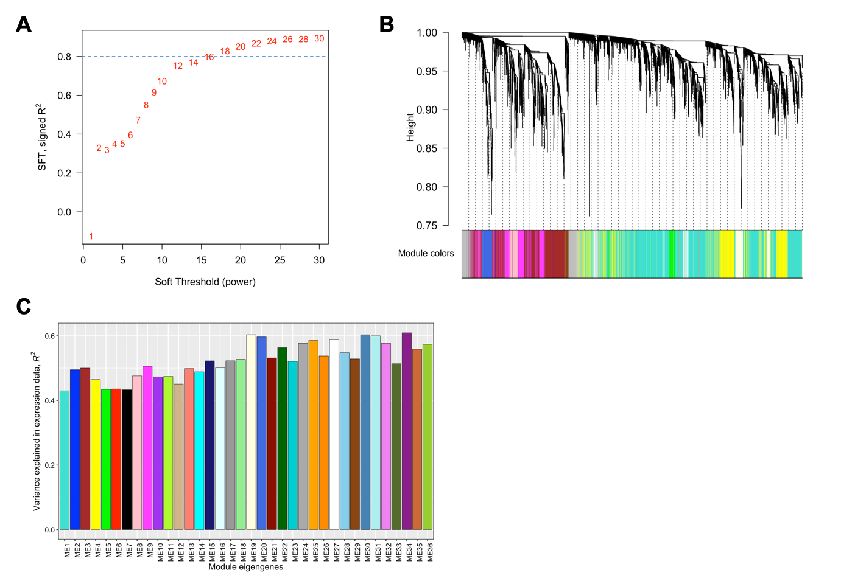
Supplementary Figure 4. (A) Twenty possible soft-threshold power options were evaluated. A power of 20 was selected as this approximated scale-free-topology for a signed network. (B) A dendrogram plot showing 36 gene co-expression modules that were detected from normalized RNA-sequencing reads counts in our sample of 95 probands. (C) Proportion of variance in gene expression levels captured by module eigengenes.
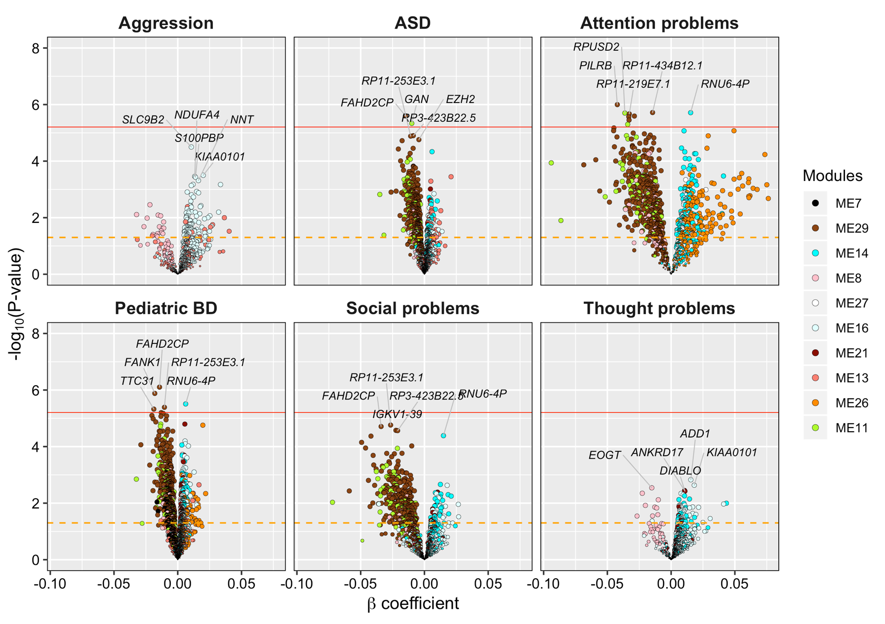
Supplementary Figure 5. Six volcano plots are presented which summarize the associations between six CBCL scales a total of 2,256 across 10 WGCNA modules found to be significantly associated with at least one of the six CBCL scales. The orange dotted line in each panel denotes a nominal significance threshold of p = 0.05, whereas the solid red line represents the Bonferroni-adjusted significance threshold of p = 6.22×10⁻⁶ which accounts for the total number of tests performed (No. of tests = 8,040). The five most significant genes associated with each CBCL scale are labeled.

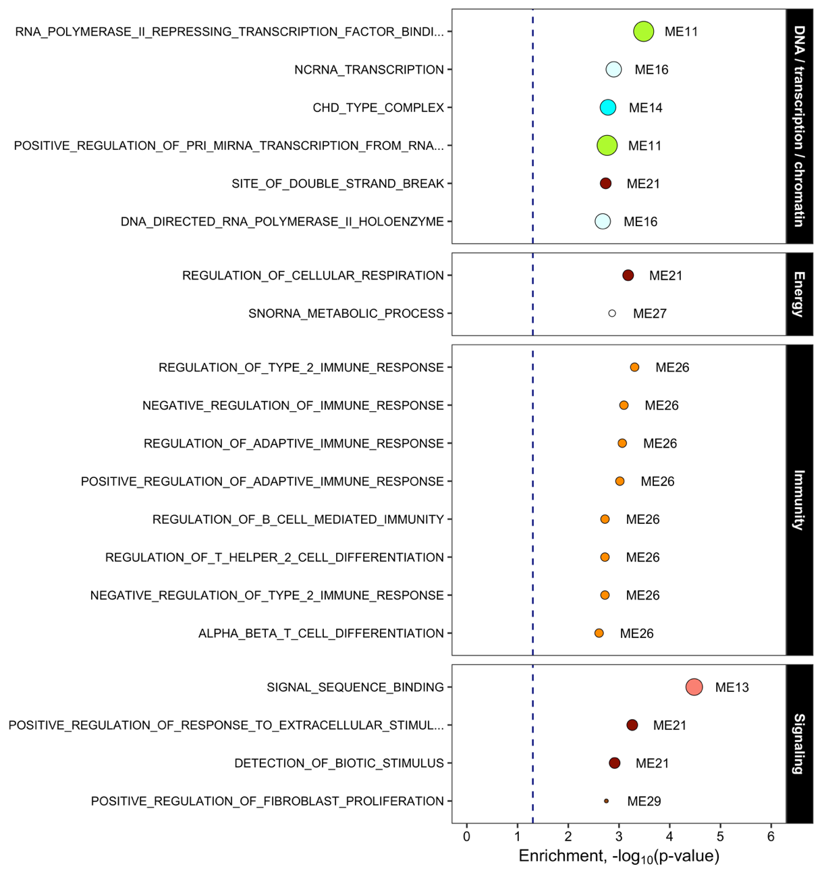
Supplementary Figure 6. The top 20 Gene Ontology (GO) terms from the Molecular Signatures Database that showed a nominally significant (p<0.05) enrichment among WGCNA module eigengenes that showed a significant association with CBCL scales. None of these gene sets survived multiple testing correction (Benjamin-Hochberg false-discovery rate adjustment). The size of each dot represents the number of genes contained in each module eigengene.

