Supplemental Information to “Default Mode and Salience Network Alterations in Suicidal Ideation and Non-Suicidal Self-Injury in Adolescents with Depression”
Clinical Assessments
We interviewed participants at an initial behavioral session to assess study eligibility using the Kiddie Schedule for Affective Disorders and Schizophrenia–Present and Lifetime (K-SADS-PL)^{1,2}, Children’s Depressive Rating Scale–Revised (CDRS-R)³, and Family Interview for Genetics Studies⁴. For the present study, we administered Screening Interviews and Supplements from the K-SADS-PL for the following modules to determine study inclusion: Major Depressive Disorder, Mania, Psychosis, Cigarette/Tobacco Use, Alcohol Abuse, and Substance Use Disorder^{1,2,5}. CDRS-R scores were also used for determining study inclusion; both child- and parent-report were integrated and reviewed by a clinically trained research team and integrated to generate a single summary score. Standardized t-scores ≥ 55 indicate that the presence of a depressive disorder is likely to be confirmed in a comprehensive diagnostic evaluation and, thus, was used as a cut-off for study eligibility for those who did not meet full criteria for MDD or Dysthymia in the K-SADS-PL screening, provided that the participant also endorsed at least 2 symptoms of MDD or Dysthymia in the K-SADS-PL screening.

Inclusion/Exclusion Criteria
Inclusion criteria for potentially non-depressed adolescents included no current or lifetime diagnosis of any DSM-IV disorder or first-degree relative with history of suicide or known suicide attempt, or a suspected diagnosis of depression, bipolar disorder, or schizophrenia using the Family Interview for Genetics Study⁴. Exclusion criteria were premenarchal status (for females), history of concussion within the past 6 weeks or history of any concussion with loss of consciousness, contraindications to MRI scanning (e.g. braces, metal implants, or claustrophobia), and any serious neurological or intellectual disorders that could interfere with the participant’s ability to complete study components; for potentially depressed adolescents, exclusion criteria also included meeting for lifetime or current criteria for Mania, Psychosis, or Alcohol Dependence (based on DSM-IV) or Moderate Substance Use Disorder with substance-specific threshold for withdrawal (based on DSM-V). One CTL participant met for a past episode of clinically significant SI but did not meet criteria for any DSM-IV diagnosis. We therefore conservatively included this participant in our analyses; as expected, removing them did not change the significance of any of our findings.

MRI Scanning Acquisition
All MRI scans were acquired at the Stanford Center for Cognitive and Neurobiological Imaging (CNI) with a 3T GE Discovery MR750 (General Electric Healthcare, Milwaukee, WI, USA) and Nova 32-channel head coil (Nova Medical, Wilmington, MA, USA). Participants completed a T2*weighted resting-state scan obtained using an echo planar image (EPI) sequence: 240 volumes, TR/TE=2000/30 ms; flip angle=77°; 42 oblique slices; FOV=240 mm; matrix=80 mm x 80 mm, voxel resolution=3x3x3 mm³; total scan time=8 min. During this scan, participants were instructed to close their eyes but remain awake. Participants also completed a T1-weighted anatomical scan obtained using a spoiled gradient (SPGR) sequence: TR/TE/TI=8.2/3.2/600 ms; flip angle=12°; 156 axial slices; FOV=256 mm; matrix=256 mm x 256 mm, voxel resolution=1x1x1 mm³; total scan time=3 min 40 sec. Physiological signal (i.e., respiration and heart rate) was collected via a photoplethysmograph attached to the toe and used for preprocessing the fMRI data (see next section).

Resting-State fMRI Preprocessing
All data were visually inspected prior to preprocessing to assess for magnetic field inhomogeneities or disruptions in the scanner signal. The SPGR images were skull-stripped and white matter (WM) and cerebrospinal fluid (CSF) were parcellated and eroded using Freesurfer’s recon-all routine (v. 6.0) before being registered to the MNI 2 mm³ standardized atlas using linear transformations in FSL (FLIRT). The appropriate WM and CSF erosion mask (1 voxel, 2 voxels, or 3 voxels) was selected for each participant based on visual inspection. The first six volumes of the functional time series were removed, leaving 234 volumes for subsequent preprocessing. Functional data were de-spiked (3dDespike) and physiological correction was applied (RETROICOR; 6, 7) before being slice-time corrected and spatially normalized to the MNI 2 mm³ standardized atlas (3dAllineate) and spatially smoothed using a 5 mm full width at half maximum Gaussian kernel (3dBlurInMask). Preprocessed data were then entered into a voxel-wise generalized least squares regression (3dREMLfit) in order to regress out spurious activation related to physiology and motion by including the mean WM timeseries, mean CSF timeseries and 24 motion parameters (3 translational, 3 rotational at each time point and the prior time point, and each of these 12 motion parameters squared) as covariates of non-interest. The resulting residuals were bandpass filtered (0.009 < f < 0.08 Hz; 3dBandpass), de-meaned (3dcalc) and used for subsequent analyses (see “Defining Functional Networks Using Group Independent Component Analysis” in the Methods section of the main manuscript for more details). For each subject, we computed mean relative displacement (MRD, also known as framewise displacement). Our criterion for excessive movement was defined as having more than 20 volumes with a MRD > 0.25 mm or a mean MRD > 0.2 mm (8, 9). No participants moved excessively based on these thresholds; however, 7 participants (2 CTL) did not complete the full scan due to discomfort and 2 participants (1 CTL) did not have physiological signal properly recorded. Participants who were included in our final analyses did not differ from these 9 participants on any demographic characteristics (all ps>0.259).

Between-Network Connectivity Results
To complement our primary investigation examining network coherence (i.e., within-network connectivity), we tested whether groups differed in between-network connectivity in the CEN and SN-ACC, which were the networks where we did not find significant group differences in network coherence. SI+ did not differ from the other two groups in CEN or SN-ACC with one another or with the three DMN networks. In contrast, NSSI+ had significantly higher connectivity between CEN-L and DMN-P compared to both NSSI- (B=0.141±0.066, t(63)=2.124, p=0.038) and CTL (B=0.165±0.074, t(63)=2.245, p=0.028); NSSI+ also exhibited significantly higher connectivity between CEN-R and DMN-P compared to both NSSI- (B=0.210±0.071, t(63)=2.946, p=0.0045) and CTL (B=0.168±0.079, t(63)=2.118, p=0.038). The NSSI- group, however, did not differ from CTL in connectivity between CEN and DMN-P (all ps>0.631). Finally, the NSSI+ group also exhibited significantly higher CEN-R connectivity with DMN-V compared to NSSI- (B=0.255±0.415, t(63)=3.401, p=0.001) but did not differ from CTL (p=0.167). See Figure 4 in the main text for more details.

Correlations Between Network Coherence and Behavior
Given the skewed distributions of the SIQ scores and NSSI frequency in the past month (see Figure S1), we conducted Poisson log-linear regressions to estimate the associations between coherence of DMN-A, DMN-V, DMN-P, and SN-Ins with SIQ scores and NSSI frequency in the past month. All statistical models included age, sex, motion, and medication usage as covariates. We found that higher SIQ scores were significantly associated with lower coherence in the DMN-A (B=-0.216±0.055, z(43)=-3.941, p=0.00008), DMN-P (B=-0.159±0.039, z(43)=-4.107, p=0.00004), DMN-V (B=-0.468±0.046, z(43)=-10.216, p=2x10⁻¹⁶), and SN-Ins (B=-0.295±0.043, z(43)=-6.808, p=1x10⁻¹¹). See Figure S2 for more details. Importantly, including current depression severity, as measured by CDRS-R t-scores, as a covariate in these models, did not alter the significance of DMN-A, DMN-V, or SN-Ins (all ps<0.003). However, controlling for current depression severity reduced the significance of the association of higher SIQ scores with lower DMN-P coherence (p>0.059). We also found that higher NSSI frequency in the past month was significantly associated with lower coherence in the DMN-A (B=-0.812±0.144, z(42)=-5.614, p=2x10⁻⁸), DMN-P (B=-0.314±0.095, z(42)=-3.302, p=0.001), DMN-V (B=-1.423±0.162, z(42)=-8.769, p<2x10⁻¹⁶), and SN-Ins (B=-1.227±0.139, z(42)=-8.851, p<2x10⁻¹⁶). Including current depression severity as a covariate in these models did not alter the significance of any of these associations (all ps<0.013). See Figure S3 for more details.

Table S1. Full model results with covariates for each model with a significant effect of group (SI+, SI-, CTL) on network coherence. Sex and current medication were coded as binary factors. All covariates were mean-centered. See Table 2 in the main text for a summary of the group effect and linear contrast test results. *p<0.05, **p<0.01.
Model | Statistic | p | B±SE | Δ R² | Adj. R²
DMN-V Coherence
Overall Model | F(6,63)=3.221 | 0.008** |  |  | 0.162
Age | t(63)=0.511 | 0.611 | 0.034±0.067 | 0.004
Sex | t(63)=-3.008 | 0.004** | -0.497±0.165 | 0.126
Motion | t(63)=-1.963 | 0.054 | -8.195±4.175 | 0.058
Current Meds | t(63)=-0.902 | 0.371 | -0.172±0.190 | 0.013
DMN-A Coherence
Overall Model | F(6,63)=3.262 | 0.007** |  |  | 0.164
Age | t(63)=1.195 | 0.236 | 0.070±0.059 | 0.022
Sex | t(63)=-2.563 | 0.013* | -0.372±0.145 | 0.094
Motion | t(63)=-1.302 | 0.198 | -4.774±3.667 | 0.026
Current Meds | t(63)=0.450 | 0.654 | 0.075±0.167 | 0.003
DMN-P Coherence
Overall Model | F(6,63)=2.854 | 0.016* |  |  | 0.139
Age | t(63)=-1.425 | 0.159 | -0.117±0.082 | 0.031
Sex | t(63)=-1.869 | 0.066 | -0.378±0.202 | 0.053
Motion | t(63)=-2.069 | 0.043* | -10.567±5.108 | 0.064
Current Meds | t(63)=-2.852 | 0.006** | -0.665±0.233 | 0.114
SN-Ins Coherence
Overall Model | F(6,63)=2.584 | 0.027* |  |  | 0.121
Age | t(63)=-1.072 | 0.288 | -0.090±0.084 | 0.018
Sex | t(63)=-0.734 | 0.465 | -0.152±0.207 | 0.008
Motion | t(63)=1.357 | 0.180 | 7.073±5.213 | 0.028
Current Meds | t(63)=-0.877 | 0.384 | -0.209±0.238 | 0.012

Table S2. Full model results with covariates for each model with a significant effect of group (NSSI+, NSSI-, CTL) on network coherence. Sex and current medication were coded as binary factors. All covariates were mean-centered. See Table 3 in the main text for a summary of the group effect and linear contrast test results. *p<0.05, **p<0.01, ***p<0.001.
Model | Statistic | p | B±SE | Δ R² | Adj. R²
DMN-A Coherence
Overall Model | F(6,63)=4.569 | 0.0007*** |  |  | 0.237
Age | t(63)=1.270 | 0.209 | 0.072±0.056 | 0.025
Sex | t(63)=-2.758 | 0.008** | -0.384±0.139 | 0.108
Motion | t(63)=-1.174 | 0.245 | -4.065±3.462 | 0.021
Current Meds | t(63)=0.354 | 0.725 | 0.057±0.162 | 0.002
DMN-V Coherence
Overall Model | F(6,63)=3.389 | 0.006** |  |  | 0.172
Age | t(63)=0.549 | 0.585 | 0.037±0.067 | 0.005
Sex | t(63)=-2.898 | 0.005** | -0.478±0.165 | 0.118
Motion | t(63)=-1.510 | 0.136 | -6.189±4.099 | 0.035
Current Meds | t(63)=-0.660 | 0.512 | -0.126±0.192 | 0.007
SN-Ins Coherence
Overall Model | F(6,63)=4.269 | 0.001** |  |  | 0.221
Age | t(63)=-0.970 | 0.336 | -0.077±0.079 | 0.015
Sex | t(63)=-0.765 | 0.447 | -0.149±0.195 | 0.009
Motion | t(63)=1.810 | 0.075 | 8.776±4.848 | 0.049
Current Meds | t(63)=-0.692 | 0.491 | -0.157±0.227 | 0.008
DMN-P Coherence
Overall Model | F(6,63)=3.53 | 0.004** |  |  | 0.180
Age | t(63)=-1.510 | 0.136 | -0.121±0.080 | 0.035
Sex | t(63)=-2.064 | 0.043* | -0.409±0.198 | 0.063
Motion | t(63)=-2.113 | 0.039* | -10.404±4.924 | 0.066
Current Meds | t(63)=-3.115 | 0.003** | -0.717±0.230 | 0.133

Figure S1. Histograms of SIQ scores and frequency of NSSI (thoughts and actions) in the past month. SIQ scores and past month NSSI frequency are from all depressed participants (n=49). SI=suicidal ideation; NSSI=non-suicidal self-injury; SIQ=Suicidal Ideation Questionnaire-Junior High; SITBI=Self-Injurious Thoughts and Behaviors Interview.
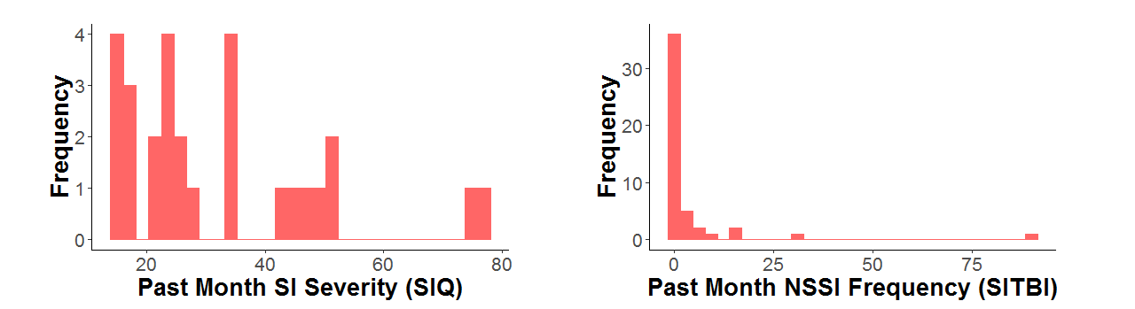
Figure S2. Scatterplots of network coherence with SIQ scores. Poisson log-linear regression models were used to examine associations between network coherence and past month suicidal ideation severity, as measured by SIQ scores. Lower coherence in the DMN-A, DMN-P, DMN-V, and SN-Ins were significantly associated with higher SIQ scores. Raw values are plotted below for visualization only. DMN-A=anterior Default Mode Network; DMN-P=posterior Default Mode Network; DMN-V=ventral Default Mode Network; SN-Ins=insula-based Salience Network; SIQ=Suicidal Ideation Questionnaire-Junior High.
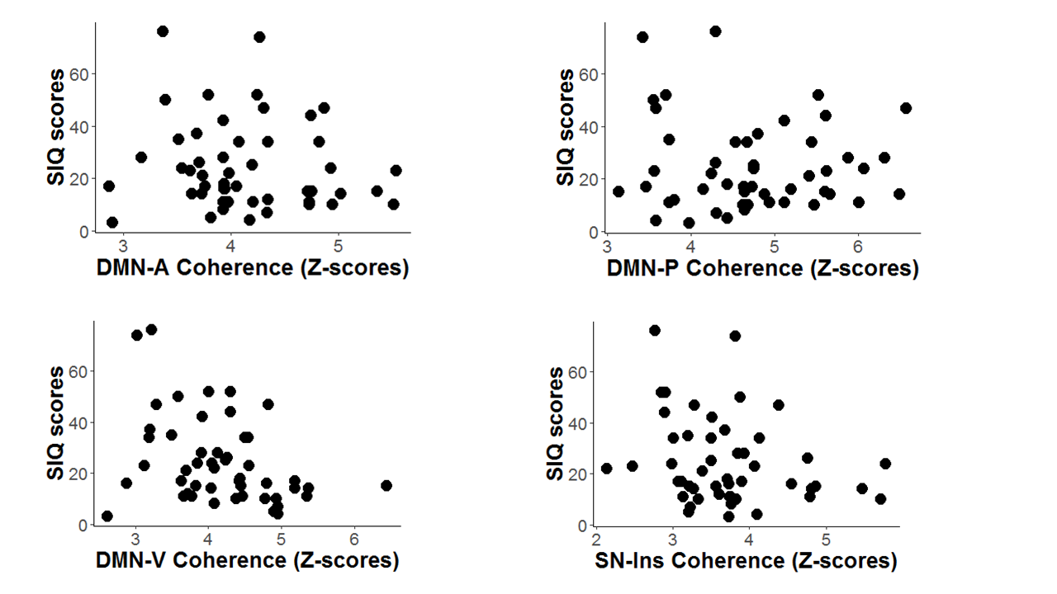

Figure S3. Scatterplots of network coherence with past month frequency of NSSI scores. Poisson log-linear regression models were used to examine associations between network coherence and past month NSSI frequency of thoughts and behaviors, as measured by the SITBI. Lower coherence in the DMN-A, DMN-P, and SN-Ins were significantly associated with higher NSSI. Raw values are plotted below for visualization only. DMN-A=anterior Default Mode Network; DMN-P=posterior Default Mode Network; DMN-V=ventral Default Mode Network; NSSI=Non-suicidal self-injury; SITBI=Self-Injurious Thoughts and Behaviors Interview; SN-Ins=insula-based Salience Network
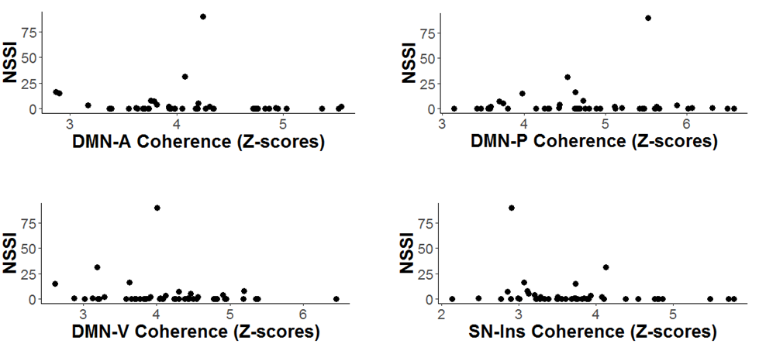
Supplemental References

- Kaufman J, Birmaher B, Brent DA, Rao U, Flynn C, Moreci P, et al. (1997): Schedule for Affective Disorders and Schizophrenia for School-Age Children-Present and Lifetime Version (K-SADS-PL): Initial Reliability and Validity Data. Journal of the American Academy of Child & Adolescent Psychiatry, 36: 980–988.
- Kaufman J, Birmaher B, Brent DA, Ryan, ND, & Rao U (2000). K-SADS-PL. Journal of the American Academy of Child & Adolescent Psychiatry, 39(10): 1208. https://doi.org/10.1097/00004583-200010000-00002
- Poznanski EO, & Mokros HB (1996) Children's Depression Rating Scale, Revised (CDRS-R). Los Angeles: Western Psychological Services.
- Maxwell ME (1992). Family Interview for Genetic Studies (FIGS): a manual for FIGS. Bethesda, MD: Clinical Neurogenetics Branch, Intramural Research Program, National Institute of Mental Health.
- Birmaher B, Axelson D, Perepletchikova F, Brent DA, & Ryan N (2016) K-SADS-PL DSM-5. Pittsburgh: Western Psychiatric Institute and Clinic.
- Chang C, Cunningham JP, & Glover GH (2009) Influence of heart rate on the BOLD signal: the cardiac response function, Neuroimage, 44(3):857–869.
- Jo HJ, Saad ZS, Simmons WK, Milbury LA & Cox RW (2010) Mapping sources of correlation in resting state FMRI, with artifact detection and removal, Neuroimage, 52(2):571–582.
- Satterthwaite TD, Elliott MA, Gerraty RT, Ruparel K, Loughead J, Calkins M, et al. (2013) An improved framework for confound regression and filtering for control of motion artifact in the preprocessing of resting-state functional connectivity data, Neuroimage, 64:240–256.
- Power JD, Barnes KA, Snyder AZ, Schlaggar BL, & Petersen SE (2013) Steps toward optimizing motion artifact removal in functional connectivity MRI; a reply to Carp, Neuroimage, 76:439–441.

