Supplementary Materials

Supplementary table 1: TRIPOD Checklist: Prediction Model Development and Validation
Section/Topic | Item |  | Checklist Item | Page
Title and abstract
Title | 1 | D;V | Identify the study as developing and/or validating a multivariable prediction model, the target population, and the outcome to be predicted. | 1
Abstract | 2 | D;V | Provide a summary of objectives, study design, setting, participants, sample size, predictors, outcome, statistical analysis, results, and conclusions. | 2
Introduction
Background and objectives | 3a | D;V | - Explain the medical context (including whether diagnostic or prognostic) and rationale for developing or validating the multivariable prediction model, including references to existing models. | 3,4
Background and objectives | 3b | D;V | - Specify the objectives, including whether the study describes the development or validation of the model or both. | 4
Methods
Source of data | 4a | D;V | - Describe the study design or source of data (e.g., randomized trial, cohort, or registry data), separately for the development and validation data sets, if applicable. | 4
Source of data | 4b | D;V | - Specify the key study dates, including start of accrual; end of accrual; and, if applicable, end of follow-up. | 5,6
Participants | 5a | D;V | - Specify key elements of the study setting (e.g., primary care, secondary care, general population) including number and location of centres. | 4,5,6
Participants | 5b | D;V | - Describe eligibility criteria for participants. | 5,6
Participants | 5c | D;V | - Give details of treatments received, if relevant. | n/a
Outcome | 6a | D;V | - Clearly define the outcome that is predicted by the prediction model, including how and when assessed. | 5
Outcome | 6b | D;V | - Report any actions to blind assessment of the outcome to be predicted. | n/a
Predictors | 7a | D;V | - Clearly define all predictors used in developing or validating the multivariable prediction model, including how and when they were measured. | 5
Predictors | 7b | D;V | - Report any actions to blind assessment of predictors for the outcome and other predictors. | n/a
Sample size | 8 | D;V | - Explain how the study size was arrived at. | 4
Missing data | 9 | D;V | - Describe how missing data were handled (e.g., complete-case analysis, single imputation, multiple imputation) with details of any imputation method. | 5,6
Statistical analysis methods | 10a | D | - Describe how predictors were handled in the analyses. | 5,6
Statistical analysis methods | 10b | D | - Specify type of model, all model-building procedures (including any predictor selection), and method for internal validation. | 5,6
Statistical analysis methods | 10c | V | - For validation, describe how the predictions were calculated. | 6
Statistical analysis methods | 10d | D;V | - Specify all measures used to assess model performance and, if relevant, to compare multiple models. | 6
Statistical analysis methods | 10e | V | - Describe any model updating (e.g., recalibration) arising from the validation, if done. | 6
Risk groups | 11 | D;V | Provide details on how risk groups were created, if done. | n/a
Development vs. validation | 12 | V | For validation, identify any differences from the development data in setting, eligibility criteria, outcome, and predictors. | 6
Results
Participants | 13a | D;V | - Describe the flow of participants through the study, including the number of participants with and without the outcome and, if applicable, a summary of the follow-up time. A diagram may be helpful. | SF1
Participants | 13b | D;V | - Describe the characteristics of the participants (basic demographics, clinical features, available predictors), including the number of participants with missing data for predictors and outcome. | T1
Participants | 13c | V | - For validation, show a comparison with the development data of the distribution of important variables (demographics, predictors and outcome). | T1
Model development | 14a | D | - Specify the number of participants and outcome events in each analysis. | 7
Model development | 14b | D | - If done, report the unadjusted association between each candidate predictor and outcome. | n/a
Model specification | 15a | D | - Present the full prediction model to allow predictions for individuals (i.e., all regression coefficients, and model intercept or baseline survival at a given time point). | n/a
Model specification | 15b | D | - Explain how to the use the prediction model. | ST2
Model performance | 16 | D;V | - Report performance measures (with CIs) for the prediction model. | 7
Model-updating | 17 | V | If done, report the results from any model updating (i.e., model specification, model performance). | 7
Limitations | 18 | D;V | Discuss any limitations of the study (such as nonrepresentative sample, few events per predictor, missing data). | 8
Interpretation | 19a | V | - For validation, discuss the results with reference to performance in the development data, and any other validation data. | 8
Interpretation | 19b | D;V | - Give an overall interpretation of the results, considering objectives, limitations, results from similar studies, and other relevant evidence. | 9
Implications | 20 | D;V | Discuss the potential clinical use of the model and implications for future research. | 9
Other information
Supplementary information | 21 | D;V | Provide information about the availability of supplementary resources, such as study protocol, Web calculator, and data sets. | SFs
Funding | 22 | D;V | Give the source of funding and the role of the funders for the present study. | 10

Supplementary Figure 1: Flow diagram of participant eligibility
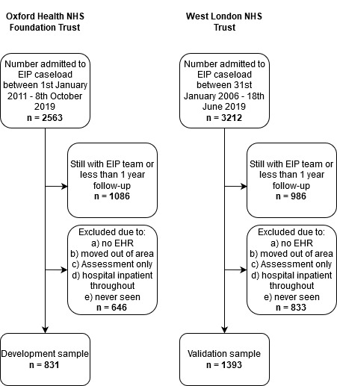

Supplementary Table 2: Complete case (n = 664) sensitivity analysis of logistic model performance of the development dataset

Predictor | OR | 95% CI | P-value
Gender, male | 0.561 | 0.314; 1.001 | 0.050
Age | 0.996 | 0.960; 1.033 | 0.821
Ethnicity, white | 1.240 | 0.652; 2.359 | 0.512
LSOA¹ | 0.966 | 0.873; 1.069 | 0.504
Diagnosis, schizophrenia | 2.537 | 1.364; 4.719 | 0.003
Duration of EIP, days | 1.000 | 1.000; 1.001 | 0.405
Number of admissions prior to EIP discharge | 1.246 | 0.989; 1.571 | 0.062
Substance misuse diagnosis | 3.507 | 1.899; 6.478 | < 0.001
1. Lower super output area, a measure of local area deprivation

Supplementary Table 3: Bootstrap adjusted coefficients derived from logistic model
Predictor | Coefficient
Intercept | -3.311272473
Gender, male | 0.576210412
Age | -0.002234690
Ethnicity, white | -0.262593105
LSOA | -0.027267330
Diagnosis, schizophrenia | 0.944245707
Duration of EIP, days | 0.000525936
Number of admissions prior to EIP discharge | 0.257462073
Substance misuse diagnosis | 1.176060434

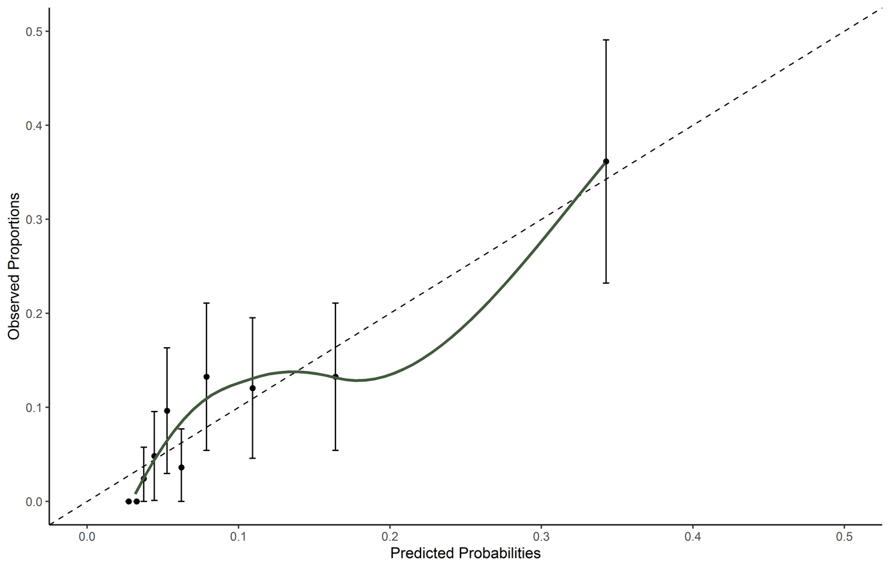
Supplementary Figure 2. Calibration plot of 1st imputation of development dataset (as an example), showing fitted calibration lines across predicted probabilities categorized into 10 risk groups with confidence intervals.

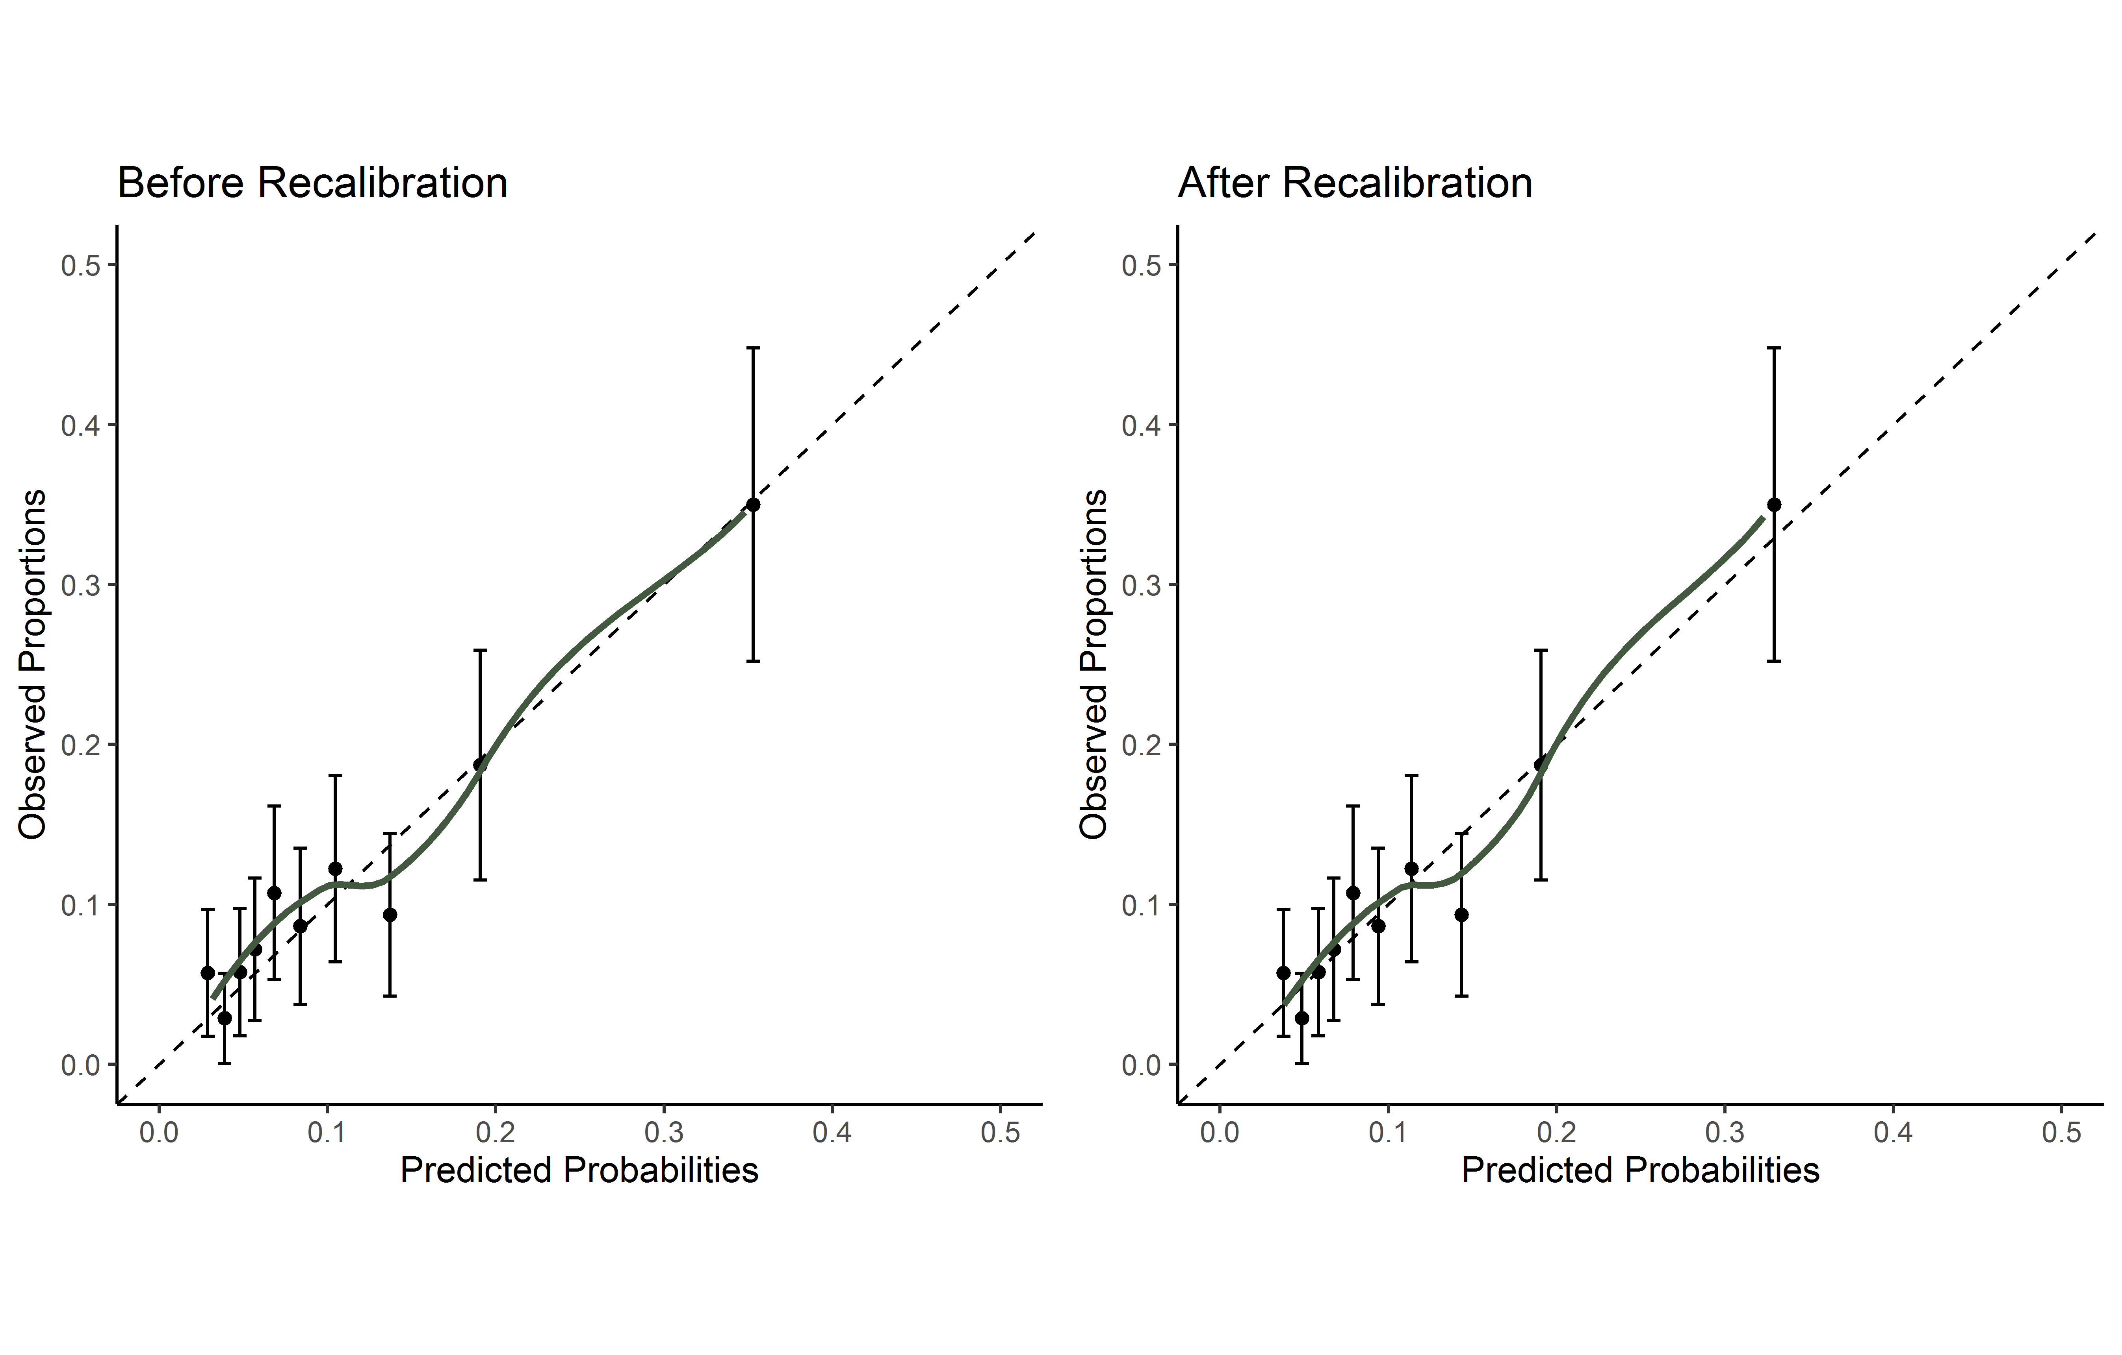
Supplementary Figure 3. Calibration plot of 1st imputation of validation dataset (used as an example), before and after calibration showing fitted calibration lines across predicted probabilities categorized into 10 risk groups with confidence intervals.

