Supplementary 1: Suicide attempt case distribution in different mental illness

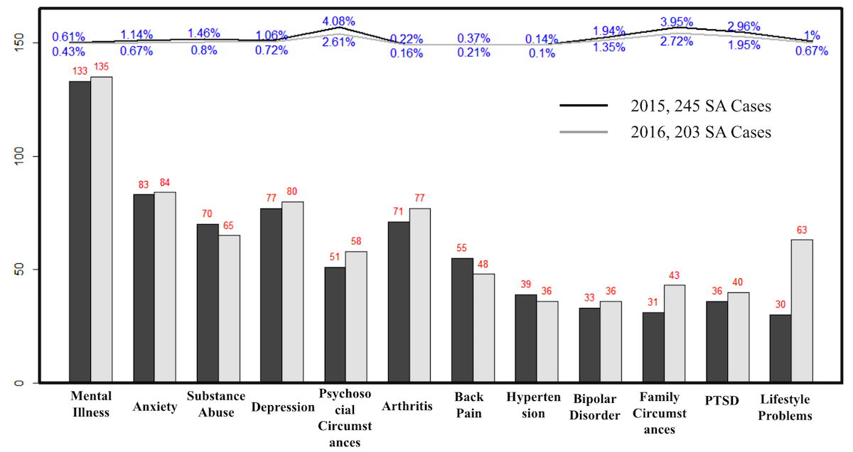
Supplementary Figure 1. Sub-cohort enrichment of incidence rate with different disease burden in 2015 and 2016, respectively

Supplementary 2: Baseline characteristics of the training and testing cohorts

Supplementary Table 1 Baseline characteristics of the cohorts
Characteristic | Retrospective cohort | Training  cohort | Validation  cohort
n(%) | (N=118,252) | (N=21,013) | (N=118,095)
Age
<=18 | 16,960 (14.34%) | 1,424 (6.78%) | 16,614 (14.07%)
19-40 | 28,104 (23.76%) | 6,177 (29.40%) | 28,121 (23.81%)
41-65 | 44,860 (37.94%) | 8,255 (39.28%) | 44,524 (37.70%)
>=66 | 28,328 (23.96%) | 5,157 (24.54%) | 28,836 (24.42%)
Gender
Male | 53,416 (45.17%) | 9,781 (46.55%) | 53,287 (45.12%)
Female | 64,836 (54.83%) | 11,232 (53.45%) | 64,808 (54.88%)
Suicide attempt | 245 (0.21%) | 133 (0.61%) | 233 (0.20%)

Supplementary 3: Missing data handling

Before constructing the deep learning model, all the missing data were preprocessed. Missing data was a data integrity problem that existed widely throughout the EHR. For example, there were 3.7% of encounters with missing geographic information, 0.56% with missing gender or age, and 0.33% with missing admission or discharge date. In deep learning techniques, deep denoising autoencoder is designed to recover clean output from noisy input [1]. Since missing data is a special kind of noisy input, we used a four-layer deep denoising autoencoder to impute the missing demographic data [2, 3]. There were also possibly some longitudinal data of medical histories missing. It is a study limitation. However, from a deep learning point of view, if we assumed that the missing medical histories were totally random and replaced them with zeros, they behaved in a way similar to dropout mechanism, which could provide regularization to the deep neural network and avoid overfitting [4].

Supplementary 4: Risk stratification by the SSLR method

Supplementary Table 2. Model performance by risk groups in the prospective cohort. SSLR: stratum-specific likelihood-ratio.
Risk Group | Abnormal | Normal | SSLR  (95% CI) | PPV% | Relative Risk
Low | 119 | 109,674 | 0.63  (0.56-0.71) | 0.11 | 0.63
Medium | 47 | 6,686 | 4.08  (3.17-5.25) | 0.70 | 4.06
High | 23 | 1,408 | 9.49  (6.43-13.99) | 1.61 | 9.35
Very High | 14 | 124 | 65.57  (38.39-111.98) | 10.14 | 59.02

Supplementary 5: Categories of significant features

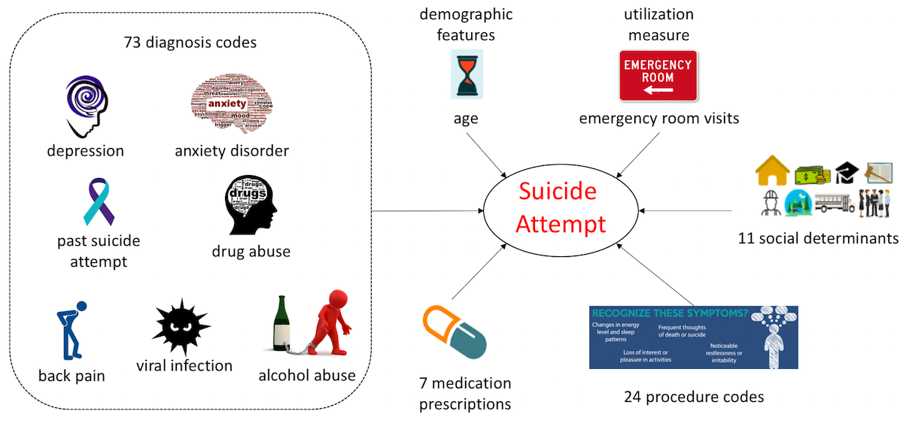

Supplementary Figure 2. Six categories of the 117 EHR-based significant features used in the risk model.

Supplementary 6: Examples of model interpretation

We demonstrated the decision interpretations for three representative individuals from the prospective cohort, i.e. a true positive (Supplementary Table 3), a false positive (Supplementary Table 4), and a false negative (Supplementary Table 5), to illustrate the effect of the interpretation method. The influences were the coefficients computed from equation (1) in the main text. And features =1 denoted the individual had the feature in the past one year whereas features =0 indicated that the individual did not have the feature. The main findings are:
- For the true positive, the interpretations indicated that making a suicide attempt, suffering from borderline personality disorder, and prescribed a bronchodilator were the driving features to make the prediction. Bronchodilator is a medication to treat or prevent bronchospasm, which often affects people with asthma and allergies, and contributes to asthma symptoms like wheezing and shortness of breath. Thus, the interpretation indicated that asthma could also increase the risk of suicide, which was consistent with previous studies [5].
- For the false positive, the driving features were past suicide attempt in past 1 year and 3 years, suicidal ideation, and symptoms involving digestive systems. Though this patient did not commit suicide in the next one year, attention should be paid to this patient and certain interventions should be applied to mitigate the event in the following years.
- For the false negative, the interpretations showed that the patient was predicted as low risk because the patient did not have several key features of suicide attempt. In fact, over 20% (48/203) of the true cases had no admission until they were admitted due to the suicide attempt event. This was a limitation of our study since those patients were all assigned to the low risk group. A broader range of data, like the social media data [6], could be included and help build a better prediction model.

Supplementary Table 3 Decision interpretations of a true positive with risk score 0.89
 | Influence | Description
Positive | 0.11 | Diagnosis: Suicide and self-inflicted injury by cutting and piercing instrument
Positive | 0.11 | Diagnosis: Open wound of wrist
Positive | 0.10 | Medication: Treat or prevent bronchospasm
Positive | 0.07 | Diagnosis: Borderline personality disorder
Positive | 0.06 | Diagnosis: Other specified family circumstances
Negative | -0.03 | Diagnosis: Open wound of forearm

Supplementary Table 4 Decision interpretations of a false positive with risk score 0.65
 | Influence | Description
Positive | 0.08 | Diagnosis: Open wound of forearm
Positive | 0.07 | Diagnosis: Suicide and self-inflicted injury by cutting and piercing instrument
Positive | 0.06 | Diagnosis: Suicide ideation
Positive | 0.06 | Diagnosis history: Past suicide attempt in past 3 years
Positive | 0.03 | Diagnosis: Nausea
Negative | -0.05 | Diagnosis: Episodic mood disorder

Supplementary Table 5 Decision interpretations of a false negative with risk score 0.02
 | Influence | Description
Positive | 0.01 | Diagnosis: Suicide ideation
Negative | -0.03 | Utilization: Emergency room visit > 5 times in past one year
Negative | -0.04 | Diagnosis: Alcohol-induced mental disorders
Negative | -0.04 | Diagnosis: Episodic mood disorder
Negative | -0.05 | Diagnosis: Acute alcoholic intoxication in alcoholism
Negative | -0.06 | Diagnosis: Depressive disorder

Supplementary 7: Survival analyses

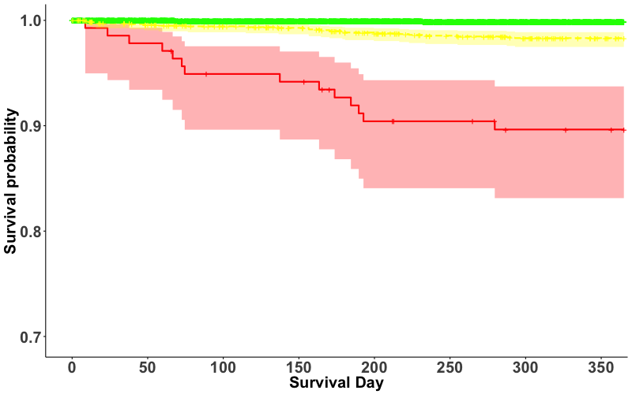
Supplementary Figure 3. Survival curves of the low (green)-, medium (yellow)-, and high/very high (red)-risk groups in the prospective cohort. The differences between the three risk groups within a 1-month, 3-month, and 1-year period are all significant (P < 0.001).

Supplementary 8: Time decay analyses

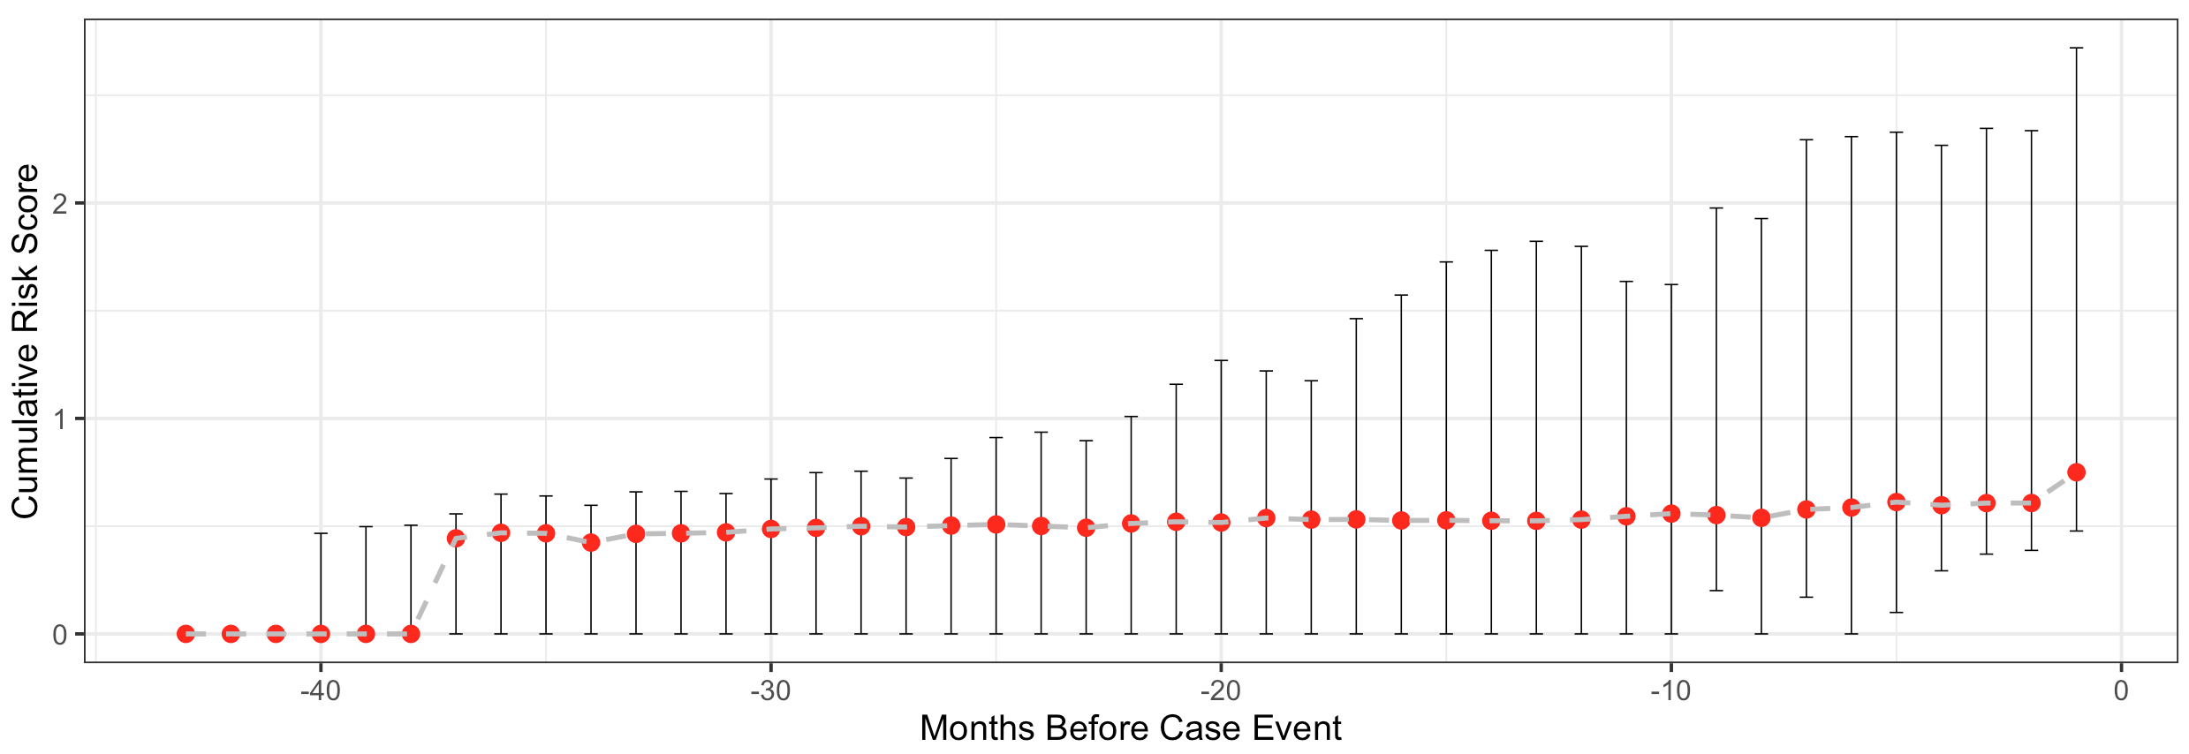
Supplementary Figure 4. Cumulative risk scores of prospective patients with suicide attempts as a function of months to the attempts occurred.

Supplementary 9: Risk distribution in different age groups

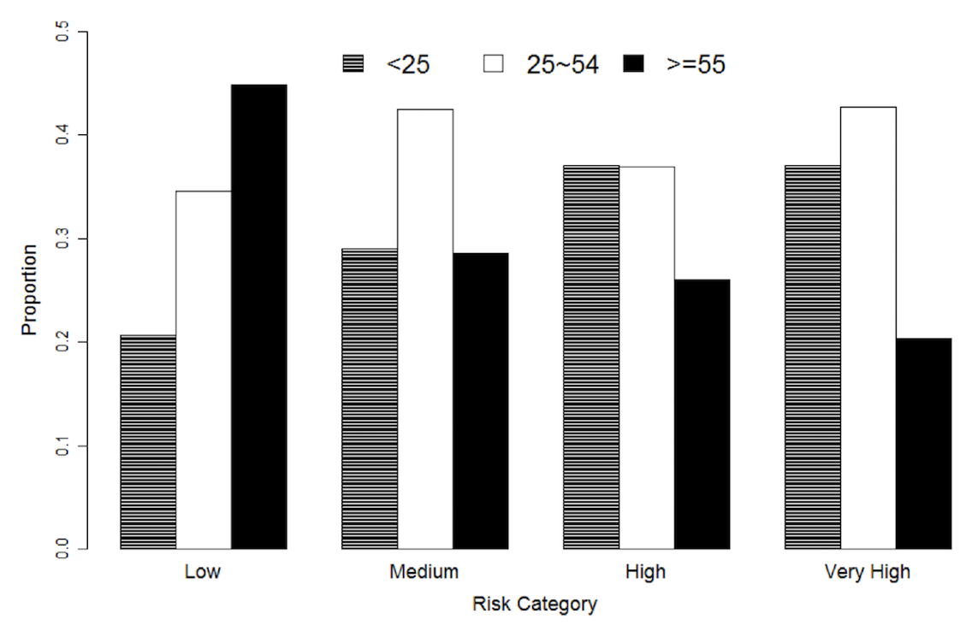

Supplementary Figure 5. Constituent ratios of age subgroups across the identified four risk categories. Age groups: <25, 25-54, and ≥55

Supplementary 10: Model Interpretation via Mimic Model Method

In addition to FDR and odds ratios, we also evaluate the importance of the features using a decision tree model (XGBoost). XGBoost identified past suicide attempt, substance abuse, arthritis excluding back pain, anxiety disorder and back pain as the top-5 strongest predictors of suicide attempt.

Supplementary Table 6 Feature importance values calculated by XGBoost.
Feature Description | Feature Importance
Past suicide attempt | 0.16917
Substance abuse | 0.11553
Arthritis excluding back pain | 0.047
Anxiety disorder | 0.03274
Back pain | 0.03258
Vehicle accidents at home | 0.02932
Headache | 0.02785
Female | 0.02401
PTSD | 0.02205
Unspecified injuries | 0.0215
Other ill-defined and unknown causes of impulsiveness | 0.02067
Esophageal disorders | 0.02056
Depressive disorder | 0.0198
Essential hypertension | 0.0179
Screening and history of mental health and substance abuse codes | 0.01641
Unspecified injuries from unspecified external causes | 0.01616
Unspecified episodic mood disorder | 0.01616
Personal history of noncompliance with medical treatment, presenting hazards to health | 0.01592
Family history of psychiatric condition | 0.01518
Mood disorders | 0.0149
Vehicle accidents at unspecified place | 0.013
Esophageal reflux | 0.01295
Serotonin Reuptake Inhibitor | 0.01292
Health influenced by physical restraints | 0.01228
Anxiety disorders, unspecified | 0.01156
Acute alcoholic intoxication in alcoholism | 0.01109
Alcohol-related disorders | 0.01104
Family problems | 0.0106
Major depressive affective disorder, recurrent episode | 0.00991
Educational circumstances problems | 0.00985
Injury and poisoning activities involving snow and ice | 0.00968
Open wound of wrist | 0.00968
Long term drug use | 0.00922
Knee, leg, ankle, and foot injury | 0.0087
Psychosocial issues | 0.00844
Vehicle accidents, unspecified | 0.00832
Depression, unspecified | 0.00775
Lifestyle problems | 0.007
Anxiety state | 0.00688
Suicide and self-inflicted poisoning by tranquilizers and other psychotropic agents | 0.00622
Pain | 0.00611
Open wound of forearm | 0.00606
Unspecified injuries from other external causes | 0.006
Asthma | 0.00526
Schizophrenia and other psychotic disorders | 0.00523
Unspecified essential hypertension | 0.00522
Joint pain | 0.00477
Tobacco use disorder | 0.00475
Other nervous system disorders | 0.00454
Personal history of other injury | 0.0045
Unemployment | 0.00447
Suicidal ideation | 0.0044
Neuropathy | 0.00423
Generalized anxiety disorder | 0.00409
Bipolar disorder | 0.00394
Developmental disorders | 0.00292
Fibromyalgia | 0.0027
Suicide and self-inflicted injury by cutting and piercing instrument | 0.00259
Impulse control disorders | 0.0021
Bipolar disorder | 0.00209
Suicide and self-inflicted poisoning by other specified drugs and Medicinal substances | 0.00183
Other alcohol-induced mental disorders | 0.00155
Personality disorders | 0.00137
Other endocrine disorders | 0.00122
Pain in joint, forearm | 0.00103
Migraines | 0.00056
Borderline personality disorder | 0.00001

Supplementary 11: Modeling in different age groups

Supplementary Table 7 displays the model performance in two age groups (<25 and 25-54) of the prospective cohort. The model has a higher sensitivity (21.7% vs 16.1%; p-value = 0.4) but a lower PPV (2.7% vs 4.8%; p-value = 0.1) with patients <25. Such differences, however, are not significant. We also explored our modeling in different age groups (Supplementary Table 8). Compared with our population model, the specific models developed within each age group demonstrated a better PPV with patients at 25-54 (3.3% vs 2.7%; p-value = 0.5), but worse sensitivity and PPV with patients <25 (sensitivity: 13.6% vs 16.1%; P = 0.8; PPV: 2.7% vs 4.8%; p-value = 0.2). The reduced performance of the model developed with patients <25 is probably due to the small number of cases (n=13).

Supplementary Table 7 The performance of a single model in different age groups in the prospective cohort
 | Sensitivity | Specificity | PPV | NPV
Age Group <25 | 16.1% | 98.7% | 4.8% | 99.7%
Age Group 25-54 | 21.7% | 98.1% | 2.7% | 99.8%
Age Group >54 | 12.5% | 99.1% | 0.6% | 99.9%

Supplementary Table 8 The performance of models developed within different age groups separately
 | Sensitivity | Specificity | PPV | NPV
Age Group <25 | 13.6% | 98.0% | 2.7% | 99.6%
Age Group 25-54 | 20.6% | 98.5% | 3.3% | 99.8%

Reference

1. Vincent, P., et al. Extracting and composing robust features with denoising autoencoders. in 25th international conference on Machine learning. 2008.
2. Beaulieu-Jones, B.K. and J.H. Moore, MISSING DATA IMPUTATION IN THE ELECTRONIC HEALTH RECORD USING DEEPLY LEARNED AUTOENCODERS. Pac Symp Biocomput, 2017. 22: p. 207-218.
3. Gondara, L. and K. Wang, MIDA: Multiple Imputation using Denoising
Autoencoders. 2017.
4. Srivastava, N., et al., Dropout: A Simple Way to Prevent Neural Networks from
Overfitting. Journal of Machine Learning Research, 2014. 15: p. 1929-1958.
5. Chung, J.H., S.H. Kim, and Y.W. Lee, Suicidal ideation and suicide attempts among asthma. Ann Gen Psychiatry, 2016. 15: p. 35.
6. Choudhury, M., et al., Predicting Depression via Social Media, in The Seventh International AAAI Conference on Weblogs and Social Media. 2013: Cambridge, Massachusetts.

