Supplementary Figures

Supplementary Figure 2. Association of methylation density at PLEKHA7 intronic region with, respectively, childhood adversity score and postpartum depression severity. PLEKHA7 methylation density vs postpartum EPDS score: Pearson correlation = 0.542, p<0.001. PLEKHA7 methylation density vs CTQ score: Pearson correlation = 0.493, p<0.001. (N=54)
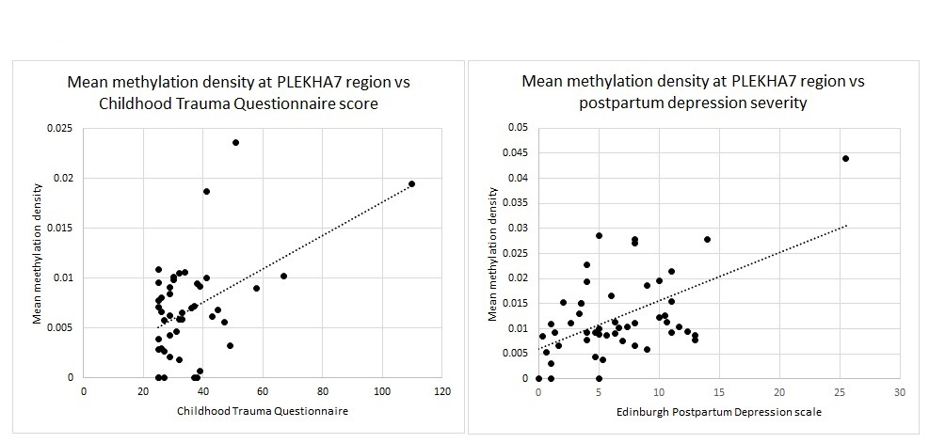

Supplementary Figure 3. Telomere analysis (N=54). Telomere length was significantly negatively associated with history of emotional abuse (ρ = -0.296, p = 0.048) and physical abuse (ρ = -0.297, p = 0.048) in childhood. Trends for shorter telomere length with greater adversity were found for other CTQ subscales and total CTQ, but did not reach statistical significance (top row). Telomere length was also positively associated with educational attainment (p=0.004, data not shown). Telomere length was not associated with attachment insecurity or depressive symptoms (bottom row).
