Supplemental Material
Zhang, et al.
List of abbreviations
ADE Affective Disorder Evaluation
AUDIT Alcohol Use Disorders Identification Test
BMI Body mass index
CRP C-reactive protein
CSF Cerebrospinal fluid
DNA Deoxyribonucleic acid
DUDIT Drug Use Disorders Identification Test
GWAS Genome-wide association studies
GWS Genome-wide significant
IL-8 Interleukin 8
MCP-1 Monocyte chemoattractant protein-1
MDS Multidimensional scaling
M.I.N.I. Mini International Neuropsychiatric Interview
sCD14 Soluble cluster of differentiation
SNP Single nucleotide polymorphism
TIMP Tissue inhibitor of metalloproteinases
YKL-40 Chitinase-3-like protein-1

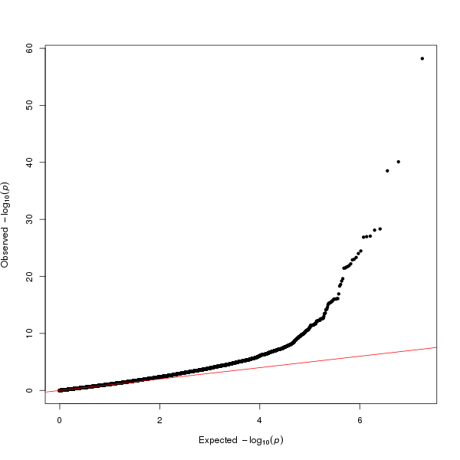
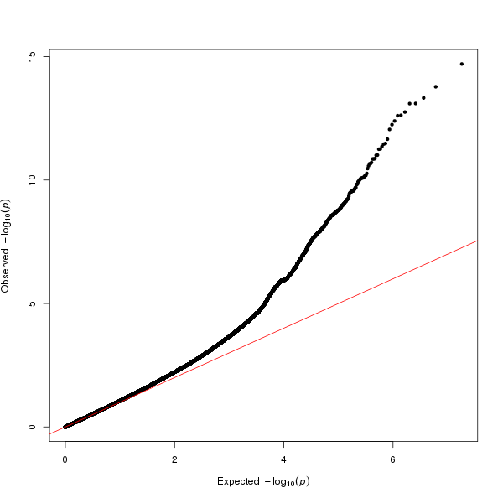
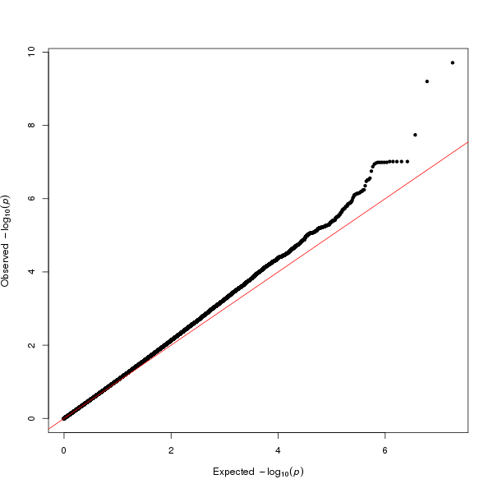
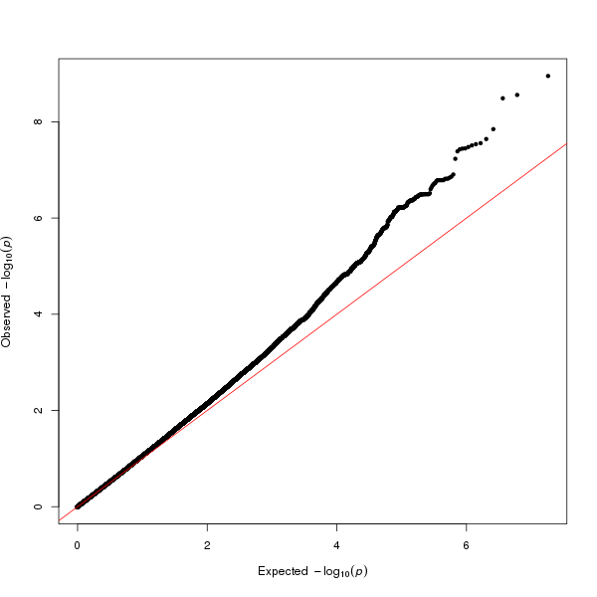
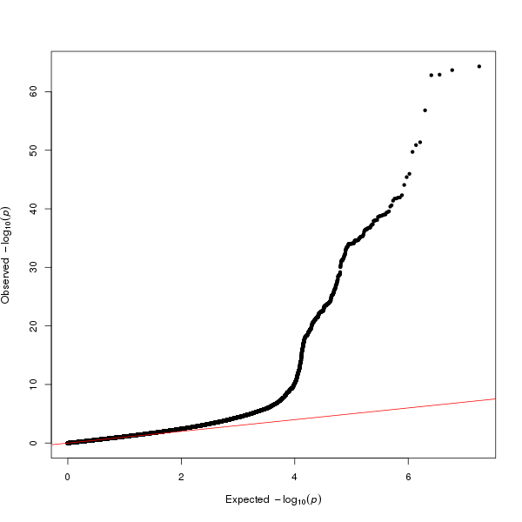
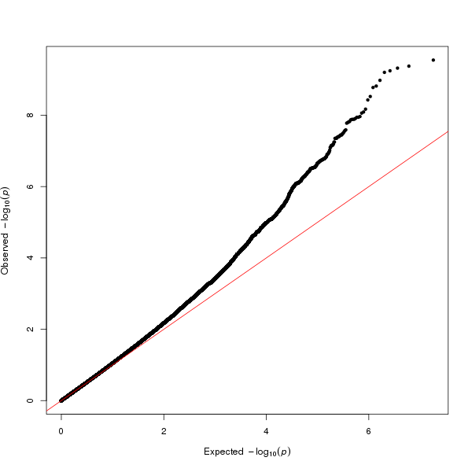
YKL-40
MCP-1
sCD14
TIMP-1
TIMP-2
IL-8
Figure S1. Quantile-quantile plots for six genome-wide scans of CSF immune biomarkers
Quantile-quantile plots for each of the six biomarkers illustrate the relationship of the experimentally observed P-values (vertical axis) with the expected P-values of a null distribution (horizontal axis) for all SNPs that pass the standard quality control filters, have a minor allele frequency >1% and imputation info score >0.6. Each quantile-quantile plot involves around 5 600 000 SNPs.
λ=1.05
λ=1.09
λ=1.06
λ=1.06
λ=1.06
λ=1.11

Figure S2. Expression of CSF immune biomarkers in 30 general tissue types (from GTEx v6)

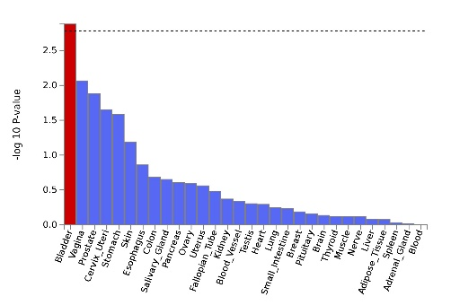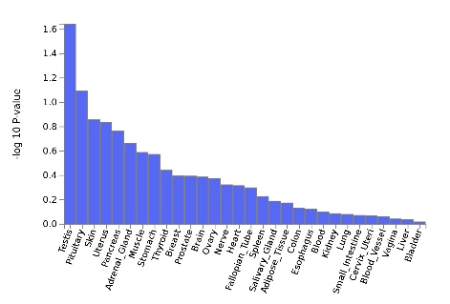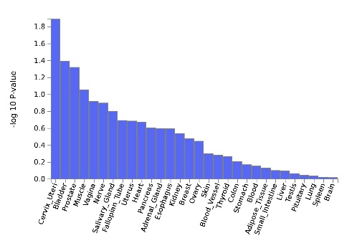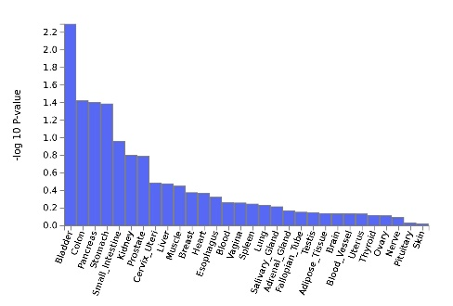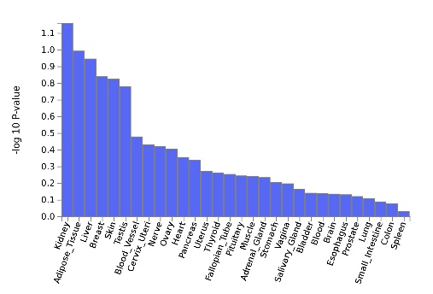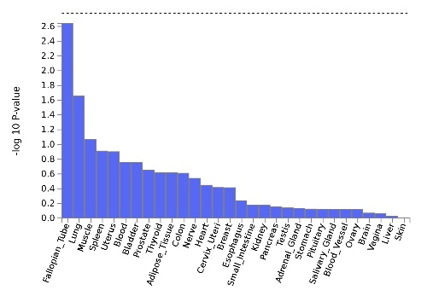
YKL-40
MCP-1
sCD14
TIMP-1
TIMP-2
IL-8

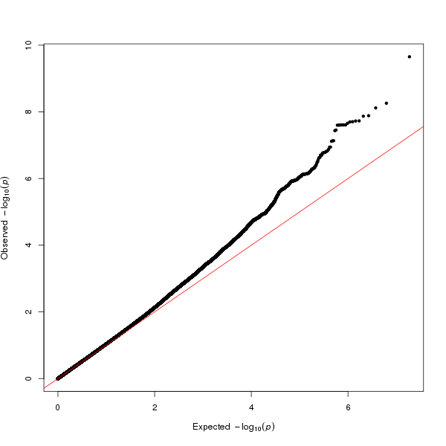
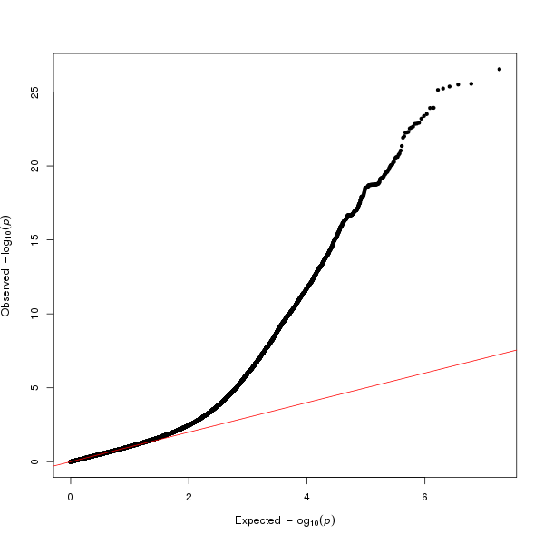
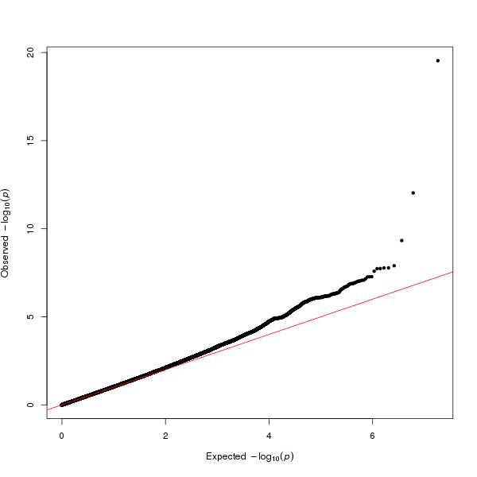
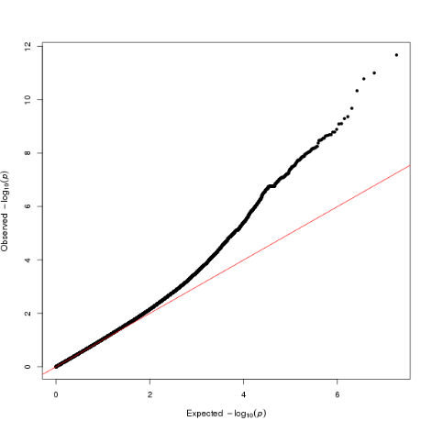
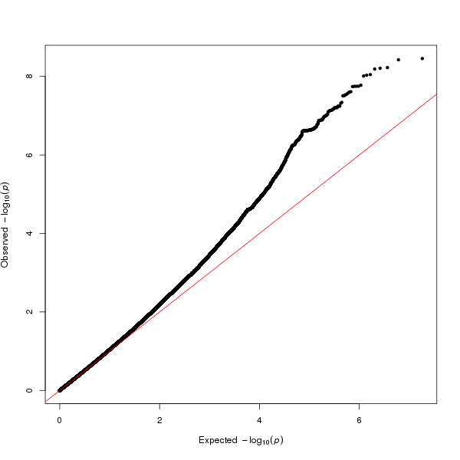
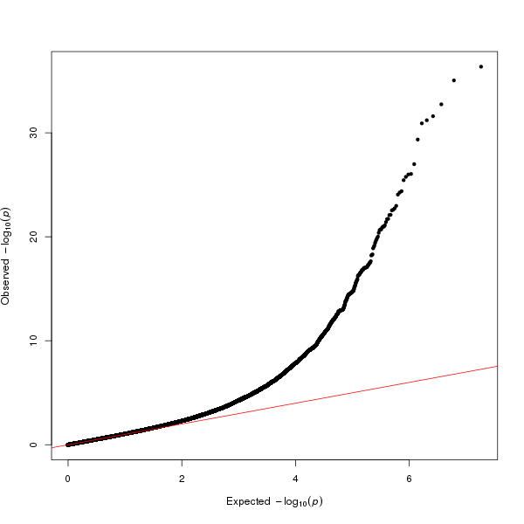
YKL-40
MCP-1
sCD14
TIMP-1
TIMP-2
Log (CRP)
Figure S3. Quantile-quantile plots for six genome-wide scans of serum immune biomarkers
Quantile-quantile plots show the relationship of the experimentally observed P-values (vertical axis) with the expected P-values of a null distribution (horizontal axis) for all SNPs that pass the standard quality control filters, have a minor allele frequency >1% and imputation info score >0.6. Each quantile-quantile plot involves around 5 340 000 SNPs.
λ=1.01
λ=1.04
λ=1.02
λ=1.02
λ=1.04
λ=1.05

Figure S4. Expression of serum immune biomarkers in 30 general tissue types (from GTEx v6)

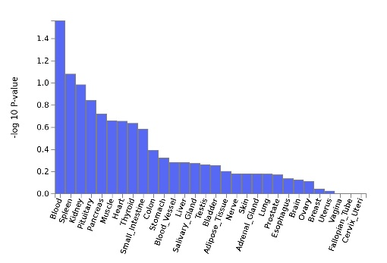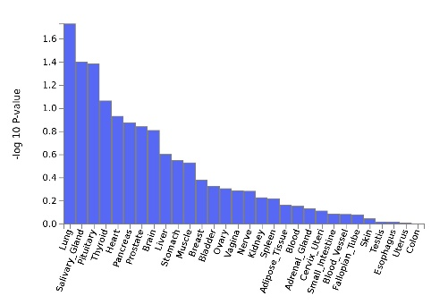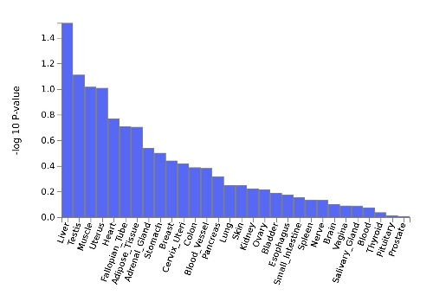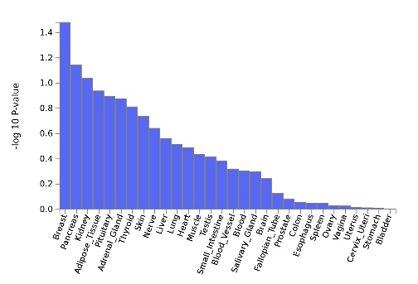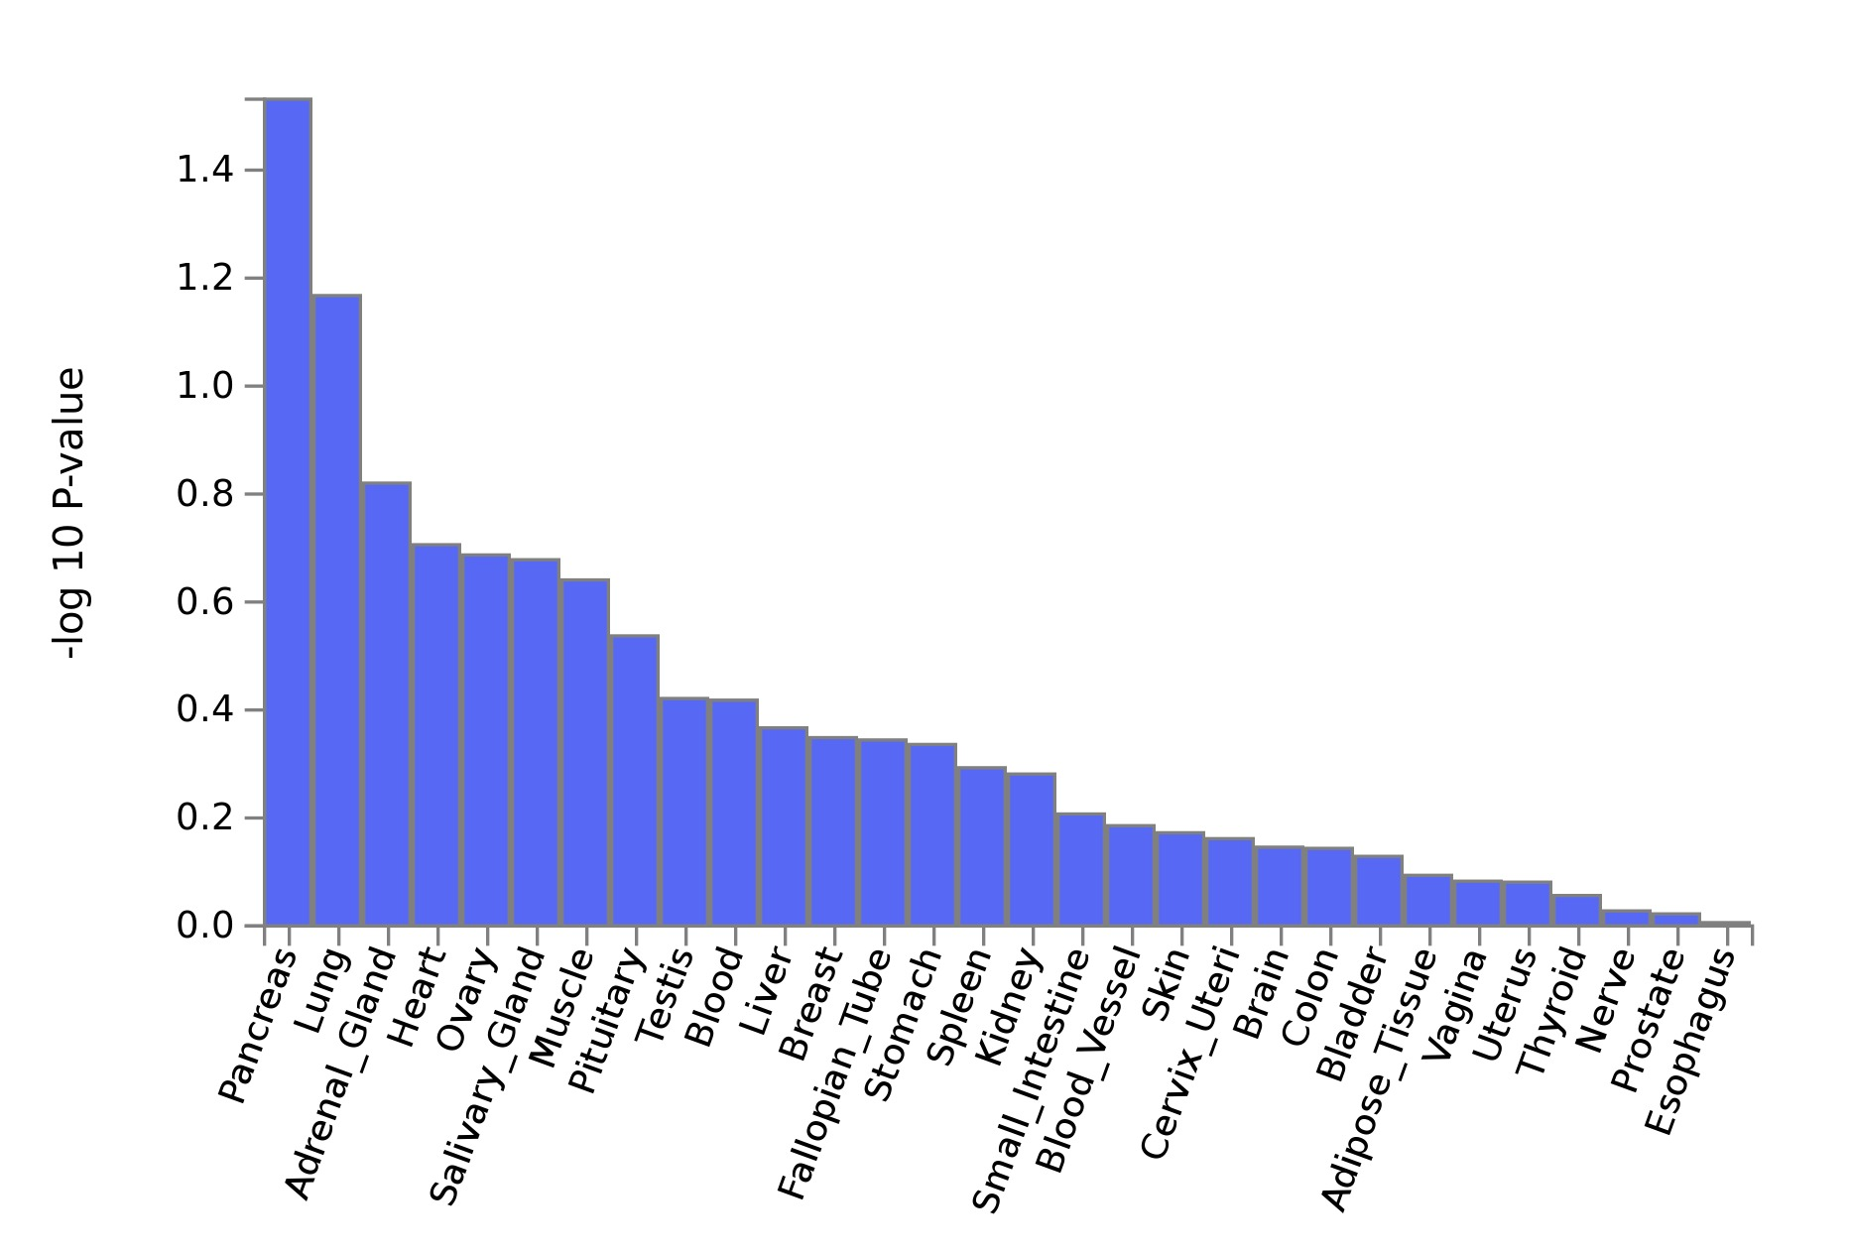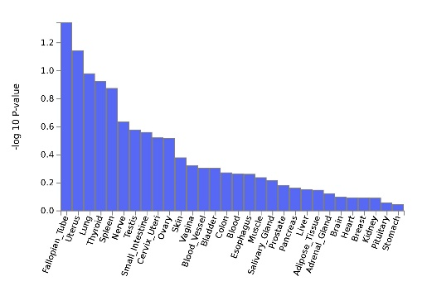
YKL-40
MCP-1
sCD14
TIMP-1
TIMP-2
Log(CPR)

Table S1. Sample sizes by biomarker and wave
 |  | Wave 1 | Wave 2 | Wave 3 | Meta-analysis
CSF | Case:Control | 0:30 | 114:0 | 0:53 | 114:83
CSF | TIMP-1 | 30 | 112 | 53 | 195
CSF | TIMP-2 | 30 | 111 | 53 | 194
CSF | sCD14 | 30 | 112 | 53 | 195
CSF | YKL-40 | 30 | 106 | 53 | 189
CSF | MCP-1 | 16 | 106 | 52 | 174
CSF | IL-8 | 16 | 113 | 52 | 181
Blood serum | Case:Control | 0:54 | 182:0 | 1:53 | 183:107
Blood serum | TIMP-1 | 54 | 182 | 54 | 290
Blood serum | TIMP-2 | 54 | 182 | 54 | 290
Blood serum | sCD14 | 54 | 182 | 54 | 290
Blood serum | YKL-40 | 54 | 182 | 54 | 290
Blood serum | MCP-1 | 54 | 182 | 54 | 290
Blood serum | CRP | 49 | 166 | 48 | 263
Abbreviations: CSF=cerebrospinal fluid; TIMP=tissue inhibitor of
metalloproteinases; sCD14=soluble cluster of differentiation 14;
YKL-40=chitinase-3-like protein-1; MCP-1=monocyte chemoattractant
protein-1; IL-8=interleukin 8; CRP=C-reactive protein.
The numbers are subjects with available biomarker level information
and passed genotyping quality control.

Table S2. Demographic and clinical characteristics of the study population
 | CSF, no.(%) or median [IQR] |  |  | Blood Serum, no.(%) or median [IQR]
Characteristic | Bipolar disorder (n=114) | Control (n=83) | p value | Bipolar disorder (n=184) |  |  | Control (n=107) |  | p value
Sex,male | 44(38.60) | 36(43.37) | 0.60¹ | 67(36.4) |  |  | 46(43.0) |  | 0.32¹
Age,yr | 37[30-51] | 36[27.5-47] | 0.29² | 36.5[30.0-48.0] |  |  | 35.0[27.5-44.0] |  | 0.18²
BMI | 24.8[22.1-27.8] | 23.3[21.6-25.7] | 0.018² | 25.03[22.18-27.75] |  |  | 23.31[21.65-25.58] |  | 0.003²
TIMP-1*(ng/mL) | 34.6ª[29.5-39.7] | 32.0[28.3-32.8] | 0.038² | 203.6^{f}[172.5-231.9] |  |  | 191.6[169.3-218.7] |  | 0.027²
TIMP-2*(ng/mL) | 65.9^{b}[56.5-78.6] | 60.9[51.5-74.3] | 0.090² | 63.8^{f}[56.7-79.2] |  |  | 64.5[57.6-74.2] |  | 0.72²
sCD14*(ng/mL) | 52.8ª[34.0-69.7] | 43.4[28.9-55.1] | 0.021² | 1457.5^{f}[1311.3-1675.1] |  |  | 1360.7[1234.1-1541.4] |  | 0.002²
YKL-40*(ng/mL) | 81.6^{c}[55.1-109.4] | 61.7[49.2-90.6] | 0.025² | 24.1^{f}[18.8-32.2] |  |  | 20.8[15.8-26.9] |  | <0.001²
MCP-1*(pg/mL) | 491.0^{d}[418.0-601.0] | 440.5e[379.2-522.2] | 0.004² | 592.0^{f}[489.0-715.5] |  |  | 561.0[455.5-687.0] |  | 0.074²
IL-8*(pg/mL) | 33.1^{f}[27.6-39.7] | 27.9e[24.4-35.4] | <0.001² | - |  |  | - |  | -
CRP*(mg/L) | - | - | - | 0.8^{g}[0.2-2.5] |  |  | 0.7^{h}[0.4-1.8] |  | 0.98²
Log*(CRP) | - | - | - | -0.2^{g}[-1.4-0.9] |  |  | -0.3^{h}[-1.0-0.6] |  | 0.98²
Bold p values are significant at the 0.05 level
¹ Analyzed by Fisher's exact test.
² Analyzed by Mann-Whitney U test.
*Missing data: ªN=2, ^{b}N=3 , ^{c}N=8, ^{d}N=8, ^{e}N=15, ^{f}N=1, ^{g}N=17, ^{h}N=11

Table S3. MAGMA Gene-Set Analysis for biomarkers with GWS SNPs
Biomarker | Gene Set | N genes | Beta | Beta STD | SE | P | P_{bon}
sCD14_serum | Curated_gene_sets:zwang_class_1_transiently_induced_by_egf | 458 | 0.175 | 0.027 | 0.037 | 1.0035e-06 | 0.011*
sCD14_serum | GO_mf:go_apolipoprotein_binding | 15 | 0.919 | 0.026 | 0.208 | 5.2139e-06 | 0.056
sCD14_serum | GO_bp:go_negative_chemotaxis | 37 | 0.516 | 0.023 | 0.131 | 4.1377e-05 | 0.442
sCD14_serum | GO_bp:go_epiboly | 20 | 0.623 | 0.021 | 0.159 | 4.439e-05 | 0.474
sCD14_serum | Curated_gene_sets:kegg_proximal_tubule_bicarbonate_reclamation | 22 | 0.580 | 0.020 | 0.154 | 8.6334e-05 | 0.921
sCD14_serum | Curated_gene_sets:pid_ecadherin_stabilization_pathway | 42 | 0.432 | 0.021 | 0.116 | 9.2164e-05 | 0.983
YKL40_serum | GO_bp:go_regulation_of_transcription_involved_in_cell_fate_commitment | 19 | 0.861 | 0.028 | 0.206 | 1.5003e-05 | 0.160
YKL40_serum | GO_mf:go_protein_kinase_c_binding | 50 | 0.393 | 0.021 | 0.102 | 5.9141e-05 | 0.631
YKL40_serum | GO_mf:go_protein_complex_scaffold | 66 | 0.329 | 0.020 | 0.088 | 9.0723e-05 | 0.968
Log(CPR)_serum | GO_mf:go_s100_protein_binding | 12 | 0.977 | 0.025 | 0.250 | 4.5929e-05 | 0.490
Log(CPR)_serum | GO_bp:go_regulation_of_voltage_gated_calcium_channel_activity | 22 | 0.689 | 0.024 | 0.182 | 7.9533e-05 | 0.849
TIMP1_serum | GO_bp:go_coenzyme_a_biosynthetic_process | 11 | 0.853 | 0.021 | 0.222 | 5.9567e-05 | 0.636
sCD14_csf | Curated_gene_sets:biocarta_gh_pathway | 28 | 0.597 | 0.023 | 0.156 | 6.3259e-05 | 0.675
IL8_csf | Curated_gene_sets:elvidge_hif1a_targets_up | 61 | 0.381 | 0.022 | 0.100 | 6.7781e-05 | 0.723
IL8_csf | Curated_gene_sets:reactome_generic_transcription_pathway | 328 | 0.177 | 0.024 | 0.047 | 8.9076e-05 | 0.951
P_{bon} is the p value after Bonferroni correction.
*significant gene sets after Bonferroni correction.
The table displays gene sets with P_{bon} < 1.

