SUPPLEMENTARY

- Propensity Score Matching Analysis:
MDD-SUD (n = 2 672) to MDD-NSUD (n = 8 603 n = 2 672)

  - Percent Balance Improvement
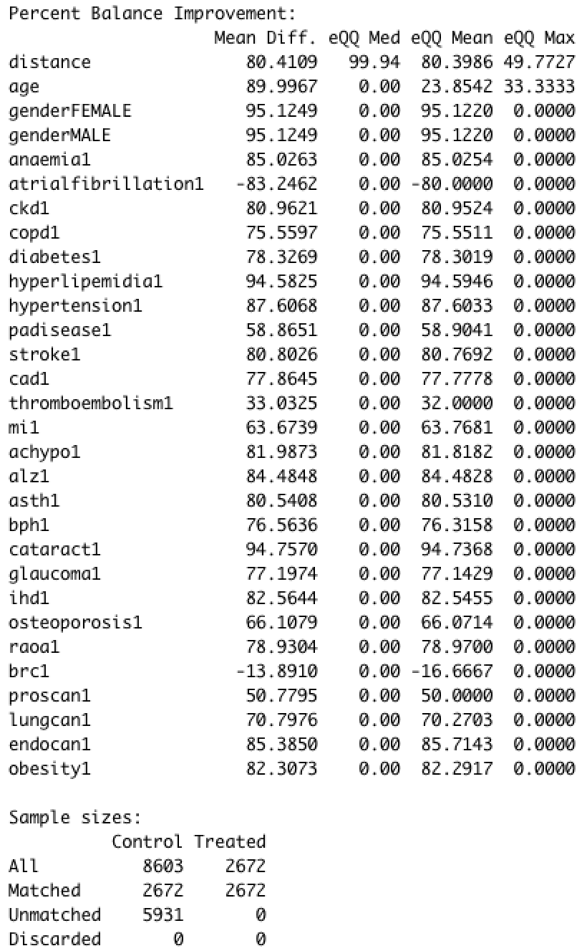

  - Distribution of Propensity Scores (Jitter Plot)
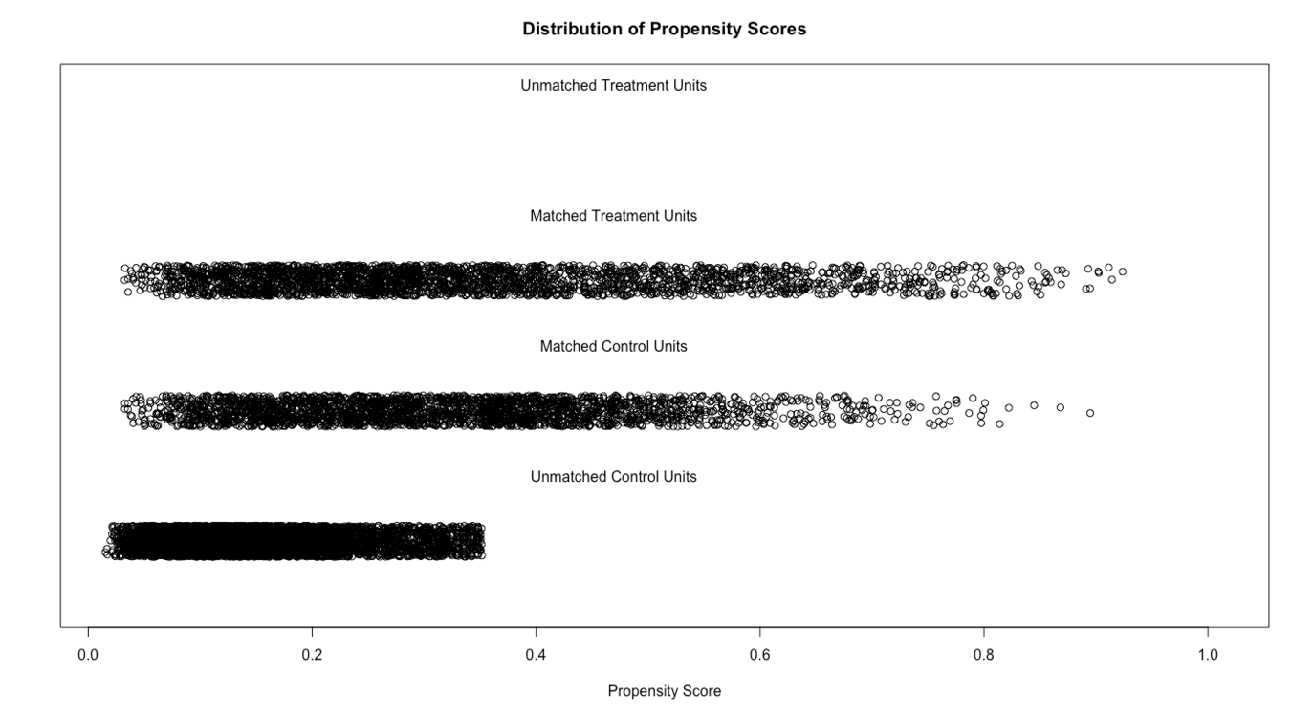

  - Summary of Balance for All Data
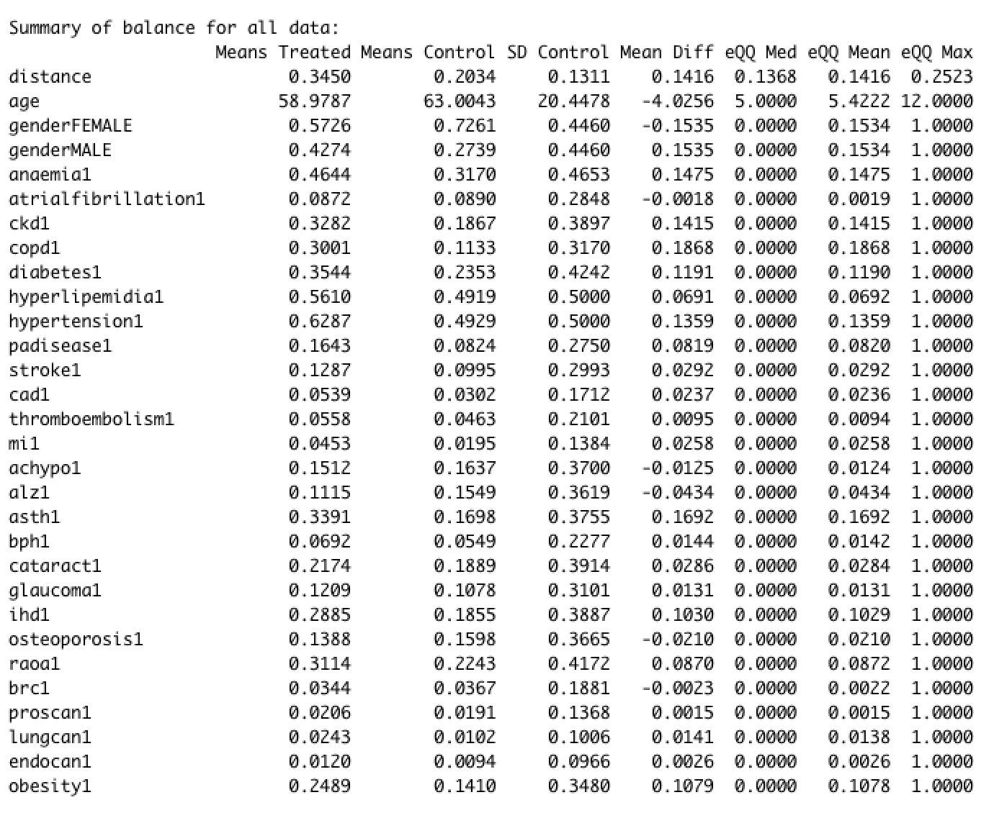
  - Summary of Balance for Matched Data
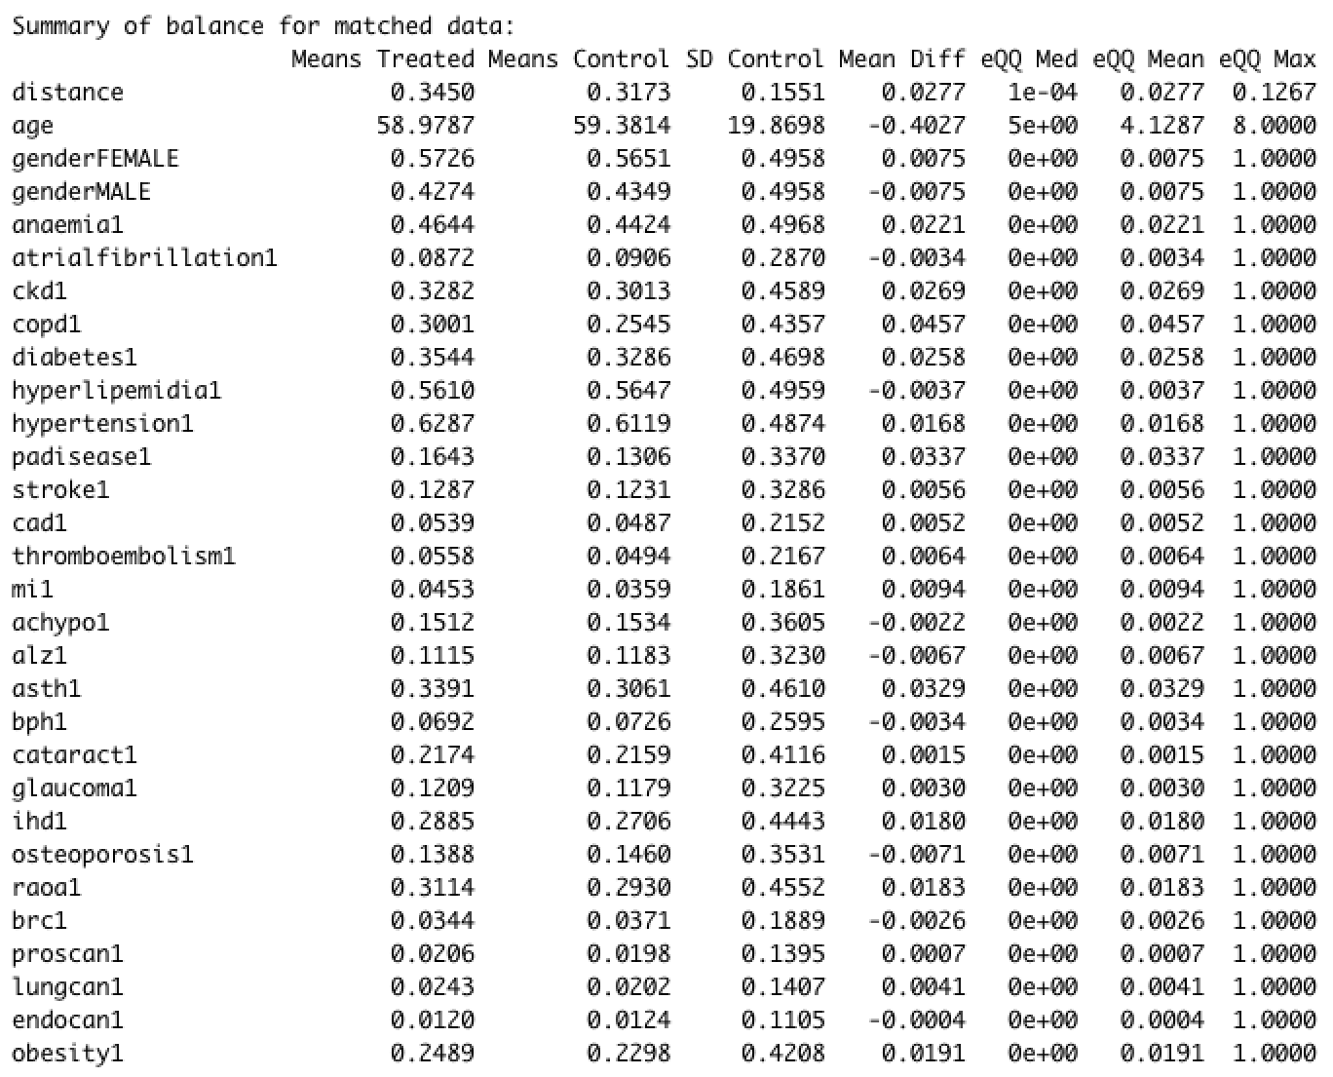

- Propensity Score Matching Analysis:
MDD-OUD (n = 424) to MDD-NOUD (n = 2 248 n = 424)

  - Percent Balance Improvement
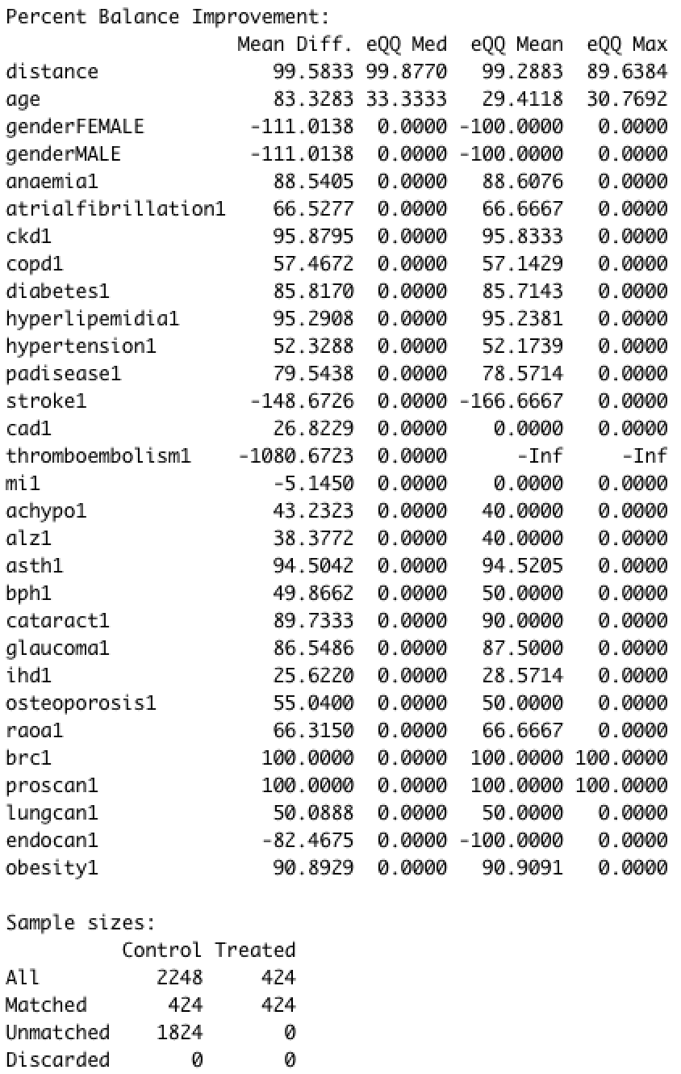

  - Distribution of Propensity Scores (Jitter Plot)
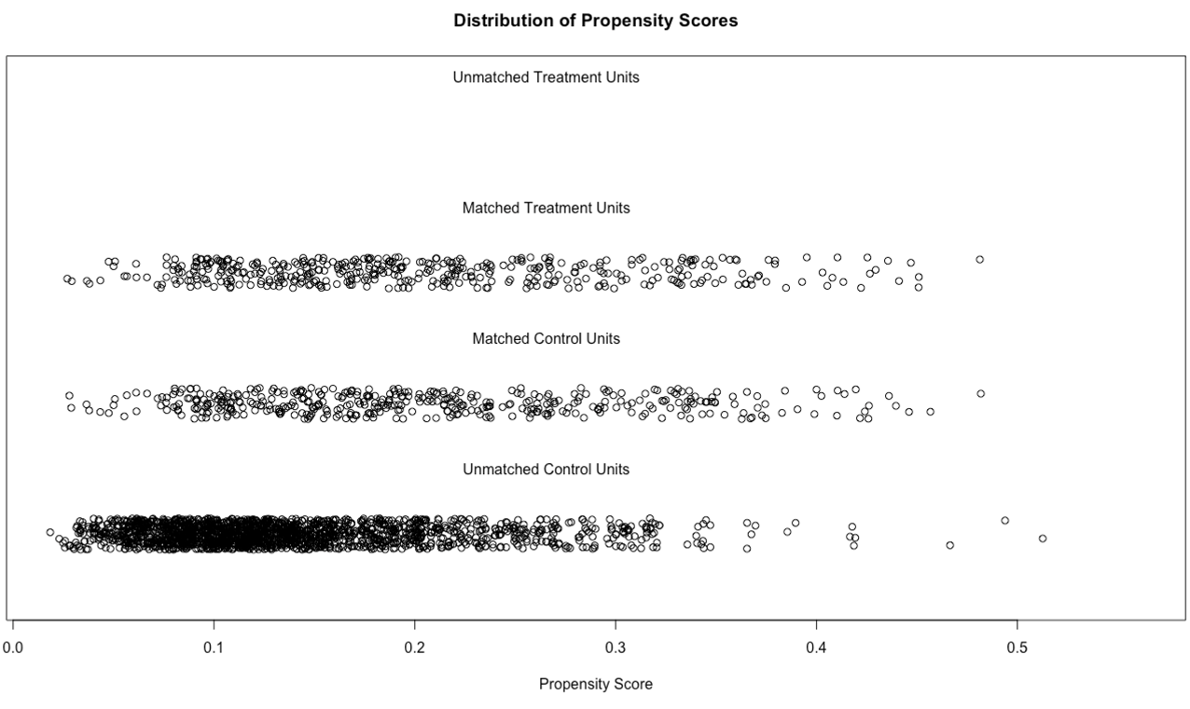

  - Summary of Balance for All Data
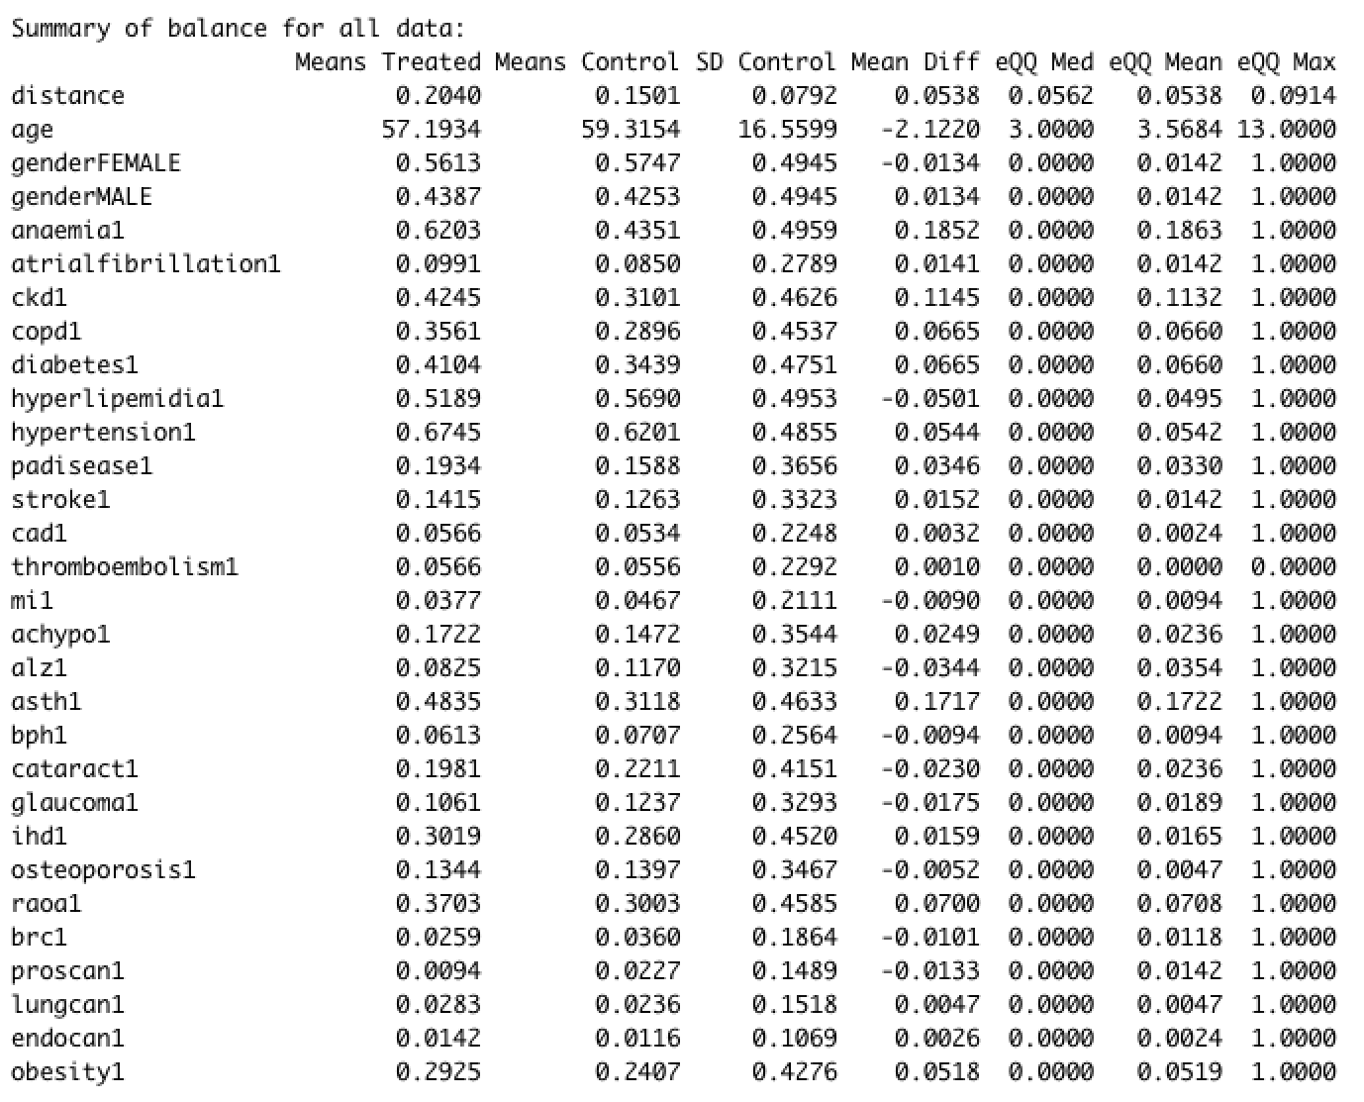

  - Summary of Balance for Matched Data
