Supplementary Appendix
This appendix has been provided by the authors to give readers additional information about their work.
Supplement to: Hjorth OR, Frick A, Gingnell M, et al. Expectancy effects on serotonin and dopamine transporters during SSRI treatment of social anxiety disorder: A randomized clinical trial.
SUPPLEMENTARY APPENDIX
TABLE OF CONTENT | Page
SUPPLEMENTARY RESULTS | 3
Descriptive characteristics | 3
Serotonin transporter occupancy across regions | 3
Compliance with escitalopram | 3
Table S1 | 4
Table S2 | 5
Figure S1 | 6

SUPPLEMENTARY RESULTS

Descriptive characteristics
Descriptive data for the overt and covert SSRI groups are listed in Table S1, and the CONSORT flow diagram is shown in Figure S1.

Serotonin transporter occupancy across regions
Levels of SERT occupancy following treatment with escitalopram are listed in in Table S2.

Compliance with escitalopram
At post-treatment, the overt and covert SSRI groups did not differ in blood serum concentrations (nMol/l) of escitalopram (overt M±SD: 84.4±51.3; covert: 101.0±58.3; t=-0.78, P=.44) or S-desmethylcitalopram (overt M ±SD: 47.1±19.6; covert: 43.5±15.1; t=0.55, P=.59). There was no correlation (R=.13, P=.51) or group difference in the correlations (R difference = .18, P=.54) between escitalopram concentration and symptom improvement. A trend-level positive relationship between S-desmethylcitalopram concentration and symptom improvement was found (R=.35, P=.07) but groups did not differ (R difference = .10, P=.78).

Table S1. Descriptive statistics.
 | Overt SSRI | Covert SSRI
N | 14 | 13
Mean (SD) age | 31.7 (11) | 30.4 (10)
Sex, n (%)
Male | 9 (64) | 8 (62)
Female | 5 (36) | 5 (39)
Other | 0 | 0
Comorbidity, n (%)
Anxiety disorders | 9 (64) | 4 (31)
Depression, mild | 4 (19) | 3 (23)
Other | 1 (7) | 1 (8)
Previous SSRI treatment | 3 (21) | 2 (15)
Education, n (%)
At least college degree | 10 (71) | 7 (54)

Table S2. Percent intraregional serotonin transporter occupancy [mean (SD)] by escitalopram in the overt and covert treatment groups.
Region | Overt | Covert | Total¹
Amygdala | 87 (11) | 94 (12) | 90 (12)
Hippocampus | 91 (13) | 94 (11) | 92 (13)
NAcc | 85 (9) | 87 (8) | 86 (9)
Caudate | 94 (15) | 96 (13) | 95 (14)
Putamen | 73 (7) | 74 (7) | 73 (7)
Pallidum | 71 (8) | 72 (9) | 71 (8)
Thalamus | 73 (9) | 75 (6) | 74 (8)
Insula | 78 (12) | 80 (9) | 79 (10)
ACC | 80 (20) | 79 (15) | 80 (18)
Raphe nuclei | 85 (12) | 89 (9) | 87 (11)
¹Total occupancy = 78% when accounting for total volume; NAcc = Nucleus Accumbens; ACC = Anterior Cingulate Cortex
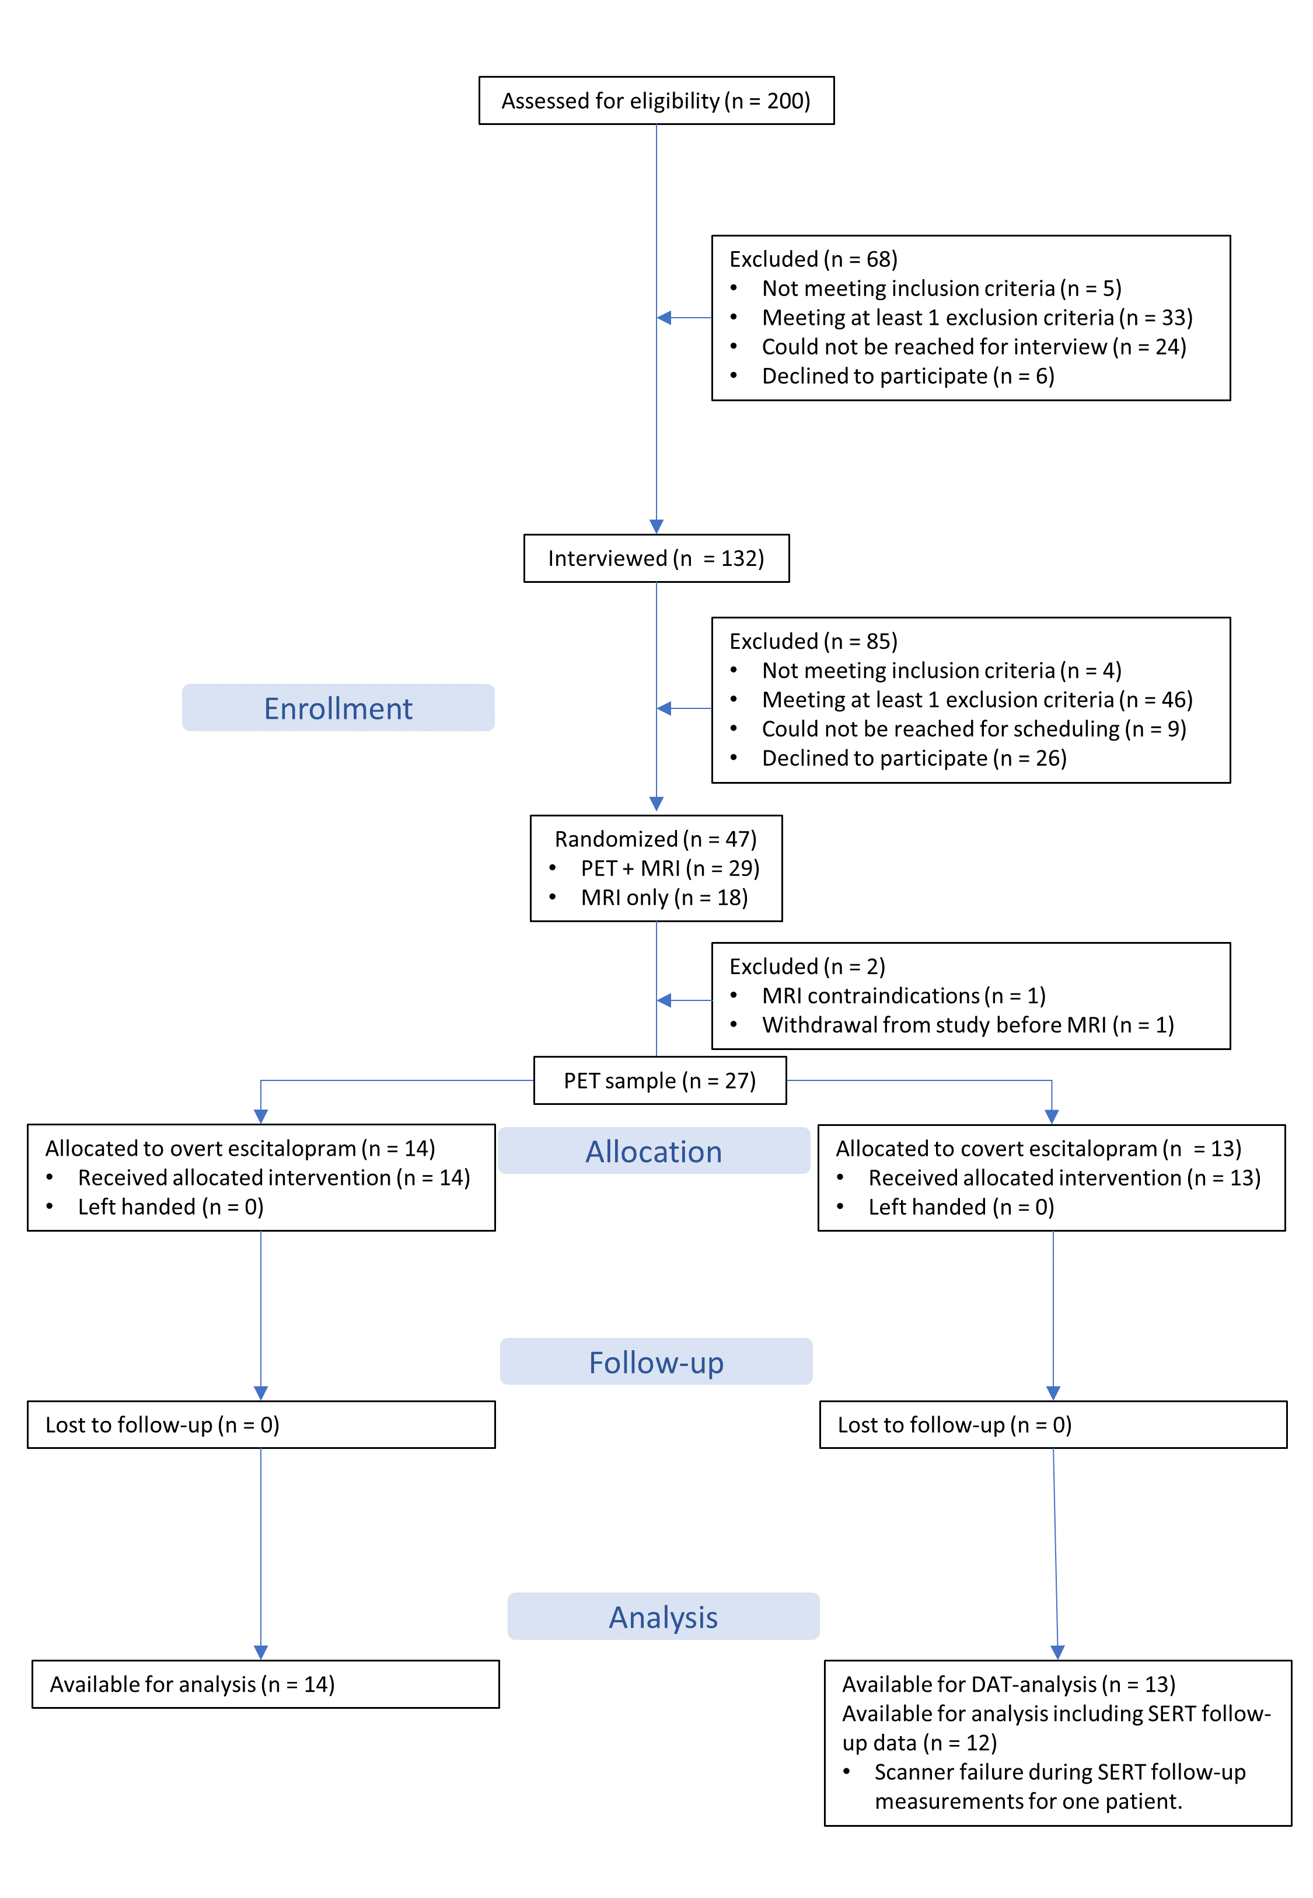
Figure S1. CONSORT flow diagram.

