Supplementary Table S1. Statistical analysis results using multiple regression for each EPIC probe

CPG.Labels | T.statistic | P.value | FDR (BH) | CHR | MAPINFO | UCSC_RefGene_Group | Relation_to_UCSC_CpG_Island
cg09129163 | 1.06 | 0.29 | 0.29 | 20 | 3050786 | TSS1500 | N_Shore
cg07597882 | 2.18 | 0.03 | 0.06 | 20 | 3051493 | TSS1500 | N_Shore
cg04528380 | 1.31 | 0.20 | 0.21 | 20 | 3051528 | TSS1500 | N_Shore
cg04731988 | 1.87 | 0.07 | 0.10 | 20 | 3051954 | TSS1500 | N_Shore
cg19776589 | 2.08 | 0.04 | 0.07 | 20 | 3052058 | TSS1500 | N_Shore
cg07747220 | 2.31 | 0.03 | 0.06 | 20 | 3052115 | TSS200 | Island
cg16887334 | 2.42 | 0.02 | 0.06 | 20 | 3052151 | TSS200 | Island
cg13285174 | 2.73 | 0.009 | 0.06 | 20 | 3052221 | TSS200 | Island
cg26267561 | 2.58 | 0.01 | 0.06 | 20 | 3052224 | TSS200 | Island
cg01644611 | 1.78 | 0.08 | 0.11 | 20 | 3052253 | TSS200 | Island
cg13725599 | 2.34 | 0.02 | 0.06 | 20 | 3052262 | TSS200 | Island
cg26955850 | 1.69 | 0.10 | 0.12 | 20 | 3052345 | 1stExon | Island
cg09774842 | 2.23 | 0.03 | 0.06 | 20 | 3052483 | Body | Island
cg06404175 | 2.72 | 0.009 | 0.06 | 20 | 3052692 | Body | Island
cg12099952 | 1.46 | 0.15 | 0.17 | 20 | 3053037 | Body | Island
The statistical threshold was set at corrected FDR < 0.05 with the Benjamini-Hochberg (BH) adjustment for multiple comparisons

Supplementary Table S2. Statistical analysis results using multiple regression for each CpG fragment

CPG.Labels | T.statistic | P.value | FDR (BH) | CHR | MAPINFO | EPIC probe
CpG_3,4 | 2.79 | 0.008 | 0.04 | 20 | 3052098/3052100
CpG_5 | 2.47 | 0.02 | 0.06 | 20 | 3052115 | cg07747220
CpG_6 | 1.29 | 0.20 | 0.26 | 20 | 3052147
CpG_8 | 1.92 | 0.06 | 0.12 | 20 | 3052157
CpG_9,10 | 2.91 | 0.006 | 0.04 | 20 | 3052169/3052172
CpG_13 | 2.17 | 0.03 | 0.09 | 20 | 3052253 | cg01644611
CpG_14,17 | 0.90 | 0.37 | 0.41 | 20 | 3052262/3052296 | cg13725599/
CpG_16 | 1.70 | 0.10 | 0.16 | 20 | 3052290
CpG_18 | -0.05 | 0.96 | 0.96 | 20 | 3052307
CpG_22 | 1.34 | 0.19 | 0.26 | 20 | 3052355
The statistical threshold was set at corrected FDR < 0.05 with the Benjamini-Hochberg (BH) adjustment for multiple comparisons

Supplementary Figure S1. Correlation between EPIC probes (cg07747220, cg01644611, and partially cg13725599) and EpiTYPER fragments (CpG 5, 13, and 14). CpG14, 17 was an averaged methylation from both the sites, and we were not able to separate CpG14 from CpG17 by EpiTYPER due to a technical limitation.

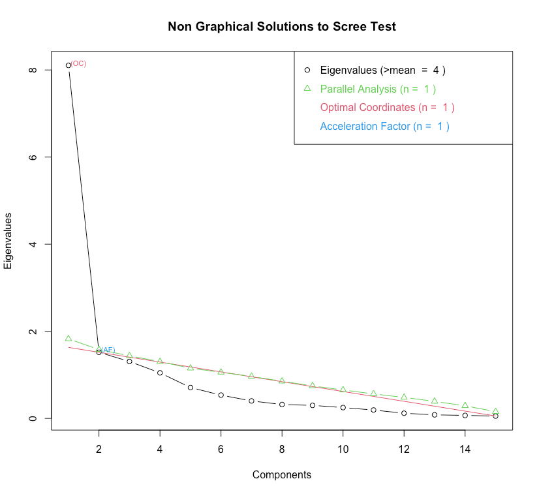
Supplementary Figure S2. Scree plot for the eigenvalues.

Supplementary Table S3. Maximum likelihood factor analysis (MLFA) using varimax rotation for EPIC probes

 | Factor1 | Factor2 | Factor3 | Factor4
cg09129163
cg07597882 |  | 0.622
cg04528380 |  | 0.682
cg04731988 | 0.606
cg19776589 | 0.822
cg07747220 | 0.727
cg16887334 | 0.874
cg13285174 | 0.777
cg26267561 | 0.606 | 0.567
cg01644611 | 0.844
cg13725599 | 0.881
cg26955850 | 0.679
cg09774842 |  |  | 0.702
cg06404175
cg12099952 |  | 0.538
Factor 1 (Eigenvalue 8.15, loadings 0.606–0.881, cutoff = 0.500) that explained 36.6% of the variance.
Supplementary Figure S3. Correlation matrices between each pair of (A) fifteen EPIC probe methylation and (B) ten EpiTYPER fragments methylation. The size and color of the circles reflect correlation coefficients for each pair of the Pearson’s correlation analysis.

Supplementary Table S4. Background of CM subgroups
 | PA+ (n = 16) | PA- (n = 8) | Statistics | P
Male participants, n (%) | 13 (81.3) | 3 (37.5) | χ²(1) = 4.1 | 0.04
Age (years), Mean (SD) | 12.7 (1.8) | 13.9 (3.0) | t(22) = -1.2 | 0.26
Types of maltreatment, n (%)  Physical abuse  Emotional abuse  Neglect  Sexual abuse | 16 (100.0)  16 (100.0)  14 (87.5)  2 (12.5) | 0 (0.0)  2 (25.0)  7 (87.5)  0 (0.0) | NA  NA  χ²(1) = 0  NA | NA  NA  1  NA
#Types of maltreatment | 3.0 (0.5) | 1.1 (0.4) | t(22) = 9.2 | 5.4E-09
Perpetrators, n (%)  Biological mother / father  Others | 13 (81.3) / 9 (56.3)  7 (43.8) | 5 (62.5) / 7 (87.5)  0 (0.0) | χ²(1) = 1.0 / χ²(1) = 2.3  NA | 0.32 / 0.13  NA
Duration of maltreatment
Years / %years of their lives | 9.1 (3.6) / 71.4 (26.0) | 3.9 (1.8) / 30.6 (19.4) | t(22) = 3.8 / t(22) = 3.9 | 8.8E-04 / 7.9E-04
Duration elapsed from maltreatment
Years / %years of their lives | 3.5 (3.2) / 27.8 (25.6) | 10.0 (4.8) / 68.7 (25.6) | t(22) = -4.0 / t(22) = -3.7 | 6.4E-04 / 1.3E-03
WISC-IV (FSIQ) | 87.7 (10.5) | 91.6 (10.9) | t(22) = -0.9 | 0.40
CATS total | 41.8 (21.0) | 20.4 (11.5) | t(20) = 2.5 | 0.02
SDQ total | 12.1 (8.1) | 9.6 (6.3) | t(22) = 0.8 | 0.45
CBCL total | 61.8 (8.1) | 58.9 (8.0) | t(22) = 0.8 | 0.41
DSRSC | 13.1 (7.4) | 11.5 (5.1) | t(21) = 0.6 | 0.59
IWMS
Secure | 20.5 (7.8) | 22.1 (4.6) | t(20) = -0.5 | 0.61
Avoidant | 14.9 (5.0) | 12.4 (3.8) | t(20) = 1.1 | 0.27
Ambivalent | 16.3 (7.1) | 16.9 (3.4) | t(20) = -0.2 | 0.86
Insecure | 31.2 (11.2) | 29.3 (6.4) | t(20) = 0.4 | 0.68

Supplementary Figure S4. Comparison of the OXTmi between PA+, PA-, and non-CM. Left: exact plot reflected the statistical result of the partial correlation analysis adjusted for age, gender, FSIQ, and proportion of buccal epithelium cells. Right: semi-partial plot using unadjusted “Group” for visually better understanding.

Supplementary Figure S5. Gene expression of OXT in the developing human brain. The figure shows the OXT gene expression measured via RNA-seq in BrainSpan (http://www.brainspan.org) datasets (n = 15; mean age: 11.9 ± 8.9; age range: 1-30 years). Dashed line represents mean expression level across all the regions (0.13). Error bars represent standard errors of the mean.

Supplementary Table S5. OXT methylation correlations between brain and saliva from the IMAGE-CpG database (Braun PR et al., 2019)
 |  | EPIC |  | 450K
Probe ID | Chr:MAPINFO | rho | P | rho | P
cg09129163 | Chr20:3050786 | -0.12 | 0.60 | NA | NA
cg07597882 | Chr20:3051493 | -0.34 | 0.13 | NA | NA
cg04528380 | Chr20:3051528 | -0.21 | 0.36 | NA | NA
cg04731988 | Chr20:3051954 | -0.43 | 0.05 | 0.16 | 0.66
cg19776589 | Chr20:3052058 | -0.20 | 0.39 | -0.10 | 0.79
cg07747220 | Chr20:3052115 | -0.44 | 0.05 | -0.22 | 0.54
cg16887334 | Chr20:3052151 | -0.19 | 0.42 | 0.08 | 0.84
cg13285174 | Chr20:3052221 | -0.10 | 0.67 | 0.03 | 0.95
cg26267561 | Chr20:3052224 | -0.21 | 0.36 | 0.10 | 0.79
cg01644611 | Chr20:3052253 | -0.12 | 0.59 | -0.03 | 0.95
cg13725599 | Chr20:3052262 | -0.05 | 0.83 | -0.05 | 0.89
cg19592472* | Chr20:3052274 | -0.40 | 0.07 | 0.15 | 0.68
cg26955850 | Chr20:3052345 | 0.07 | 0.77 | 0.84 | 0.00
cg09774842 | Chr20:3052483 | 0.14 | 0.53 | 0.47 | 0.18
cg06404175 | Chr20:3052692 | 0.54 | 0.01 | 0.28 | 0.43
cg12099952 | Chr20:3053037 | 0.10 | 0.65 | 0.16 | 0.66
Bold: probes constructed OXTmi
*: removed by quality control process

Supplementary Table S6. Numbers of participants in each brain imaging data
N | T1 | DTI | fMRI | rs-fMRI
CM | 24 | 22 | 14 | 11 (PA+: 7, PA-: 4)
non-CM | 31 | 31 | 19 | 0
Total | 55 | 53 | 33 | 11

