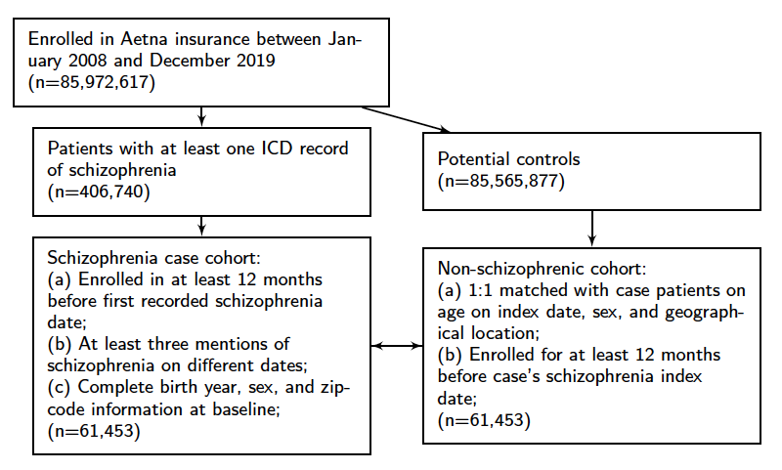

Supplemental Figure 1. Study flowchart.
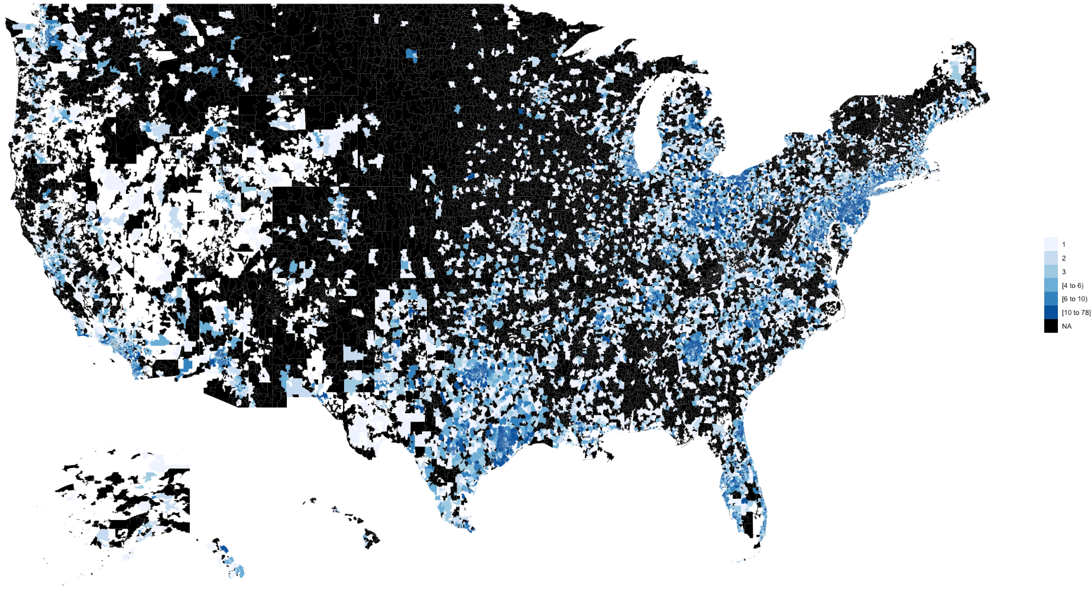
Supplemental Figure 2. Geographical distribution of patients included in this study.

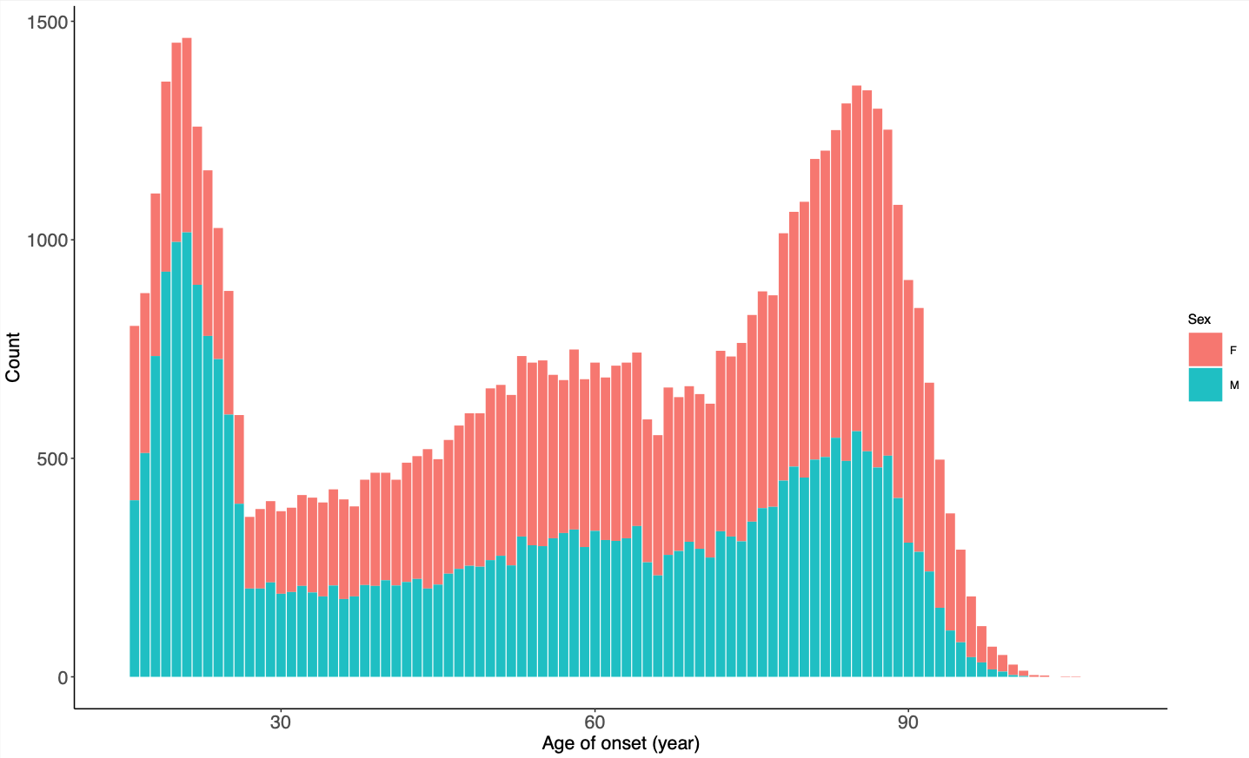
Supplemental Figure 3. Distribution of age at schizophrenia index date by sex.

Supplemental Table 1. Patient characteristics of the study cohort.

Characteristics | Value (%)
Total patients | 61,453
Males | 29,001 (47.2)
Females | 32,452 (52.8)
Days Enrolled
Average | 2177.6
Minimum | 392
Maximum | 4,382
Age (in years)
Mean | 57.2
Median | 60
Geographic Region
East North Central | 10,232 (16.7)
East South Central | 11,008 (17.9)
Mid Atlantic | 12,334 (20.1)
Mountain | 2,882 (4.7)
New England | 2,885 (4.7)
Pacific | 5,405 (8.8)
South Atlantic | 12,418 (20.2)
West North Central | 2,057 (3.4)
West South Central | 11,008 (17.9)

Supplemental Table 2. Top 10 phenotypes preceding schizophrenia in women but not in men between ages 15 and 29 (number of schizophrenia patients in this age group = 13,828).

Phecode | Phecode Description | Number of Female Schizophrenia Patients | Number of Female Non-Schizophrenic Participants | Odds Ratio | 95% Confidence Interval | P-value
301.2 | Antisocial/borderline personality disorder | 156 | 10 | 16.1 | (8.5, 34.2) | $$3×{10}^{-35}$$
297.2 | Suicide or self-inflicted injury | 61 | 5 | 12.3 | (5.0, 39.4) | $$2×{10}^{-13}$$
250.2 | Type 2 diabetes | 85 | 7 | 12.3 | (5.7, 31.6) | $$3×{10}^{-18}$$
327.32 | Obstructive sleep apnea | 43 | 5 | 8.7 | (3.4, 28.0) | $$1×{10}^{-8}$$
790.6 | Other abnormal blood chemistry | 40 | 5 | 8.1 | (3.2, 26.2) | $$7×{10}^{-8}$$
305.2 | Eating disorder | 185 | 24 | 8.0 | (5.2, 12.8) | $$1×{10}^{-32}$$
305.21 | Anorexia nervosa | 84 | 12 | 7.1 | (3.9, 14.3) | $$1×{10}^{-14}$$
599.4 | Urinary incontinence | 40 | 6 | 6.7 | (2.8, 19.4) | $$3×{10}^{-7}$$
350.1 | Abnormal involuntary movements | 36 | 6 | 6.0 | (2.5, 17.5) | $$3×{10}^{-6}$$
327.3 | Sleep apnea | 27 | 5 | 5.4 | (2.1, 18.1) | $$1×{10}^{-4}$$

Supplemental Table 3. Top 10 phenotypes preceding schizophrenia in men but not in women between ages 15 and 29 (number of schizophrenia patients in this age group = 13,828).

Phecode | Phecode Description | Number of Male Schizophrenia Patients | Number of Male Non-Schizophrenic Participants | Odds Ratio | 95% Confidence Interval | P-value
301 | Personality disorders | 75 | 7 | 10.8 | (5.0, 27.8) | $$2×{10}^{-15}$$
1005 | Other symptoms | 38 | 5 | 7.6 | (3.0, 24.8) | $$2×{10}^{-7}$$
315.1 | Learning disorder | 43 | 7 | 6.2 | (2.8, 16.3) | $$2×{10}^{-7}$$
585.1 | Acute renal failure | 61 | 10 | 6.1 | (3.1, 13.4) | $$4×{10}^{-10}$$
772.4 | Rhabdomyolysis | 40 | 7 | 5.7 | (2.5, 15.2) | $$1×{10}^{-6}$$
315.3 | Intellectual disabilities | 74 | 13 | 5.7 | (3.2, 11.3) | $$1×{10}^{-11}$$
315 | Developmental delays and disorders | 94 | 17 | 5.5 | (3.3, 10.0) | $$4×{10}^{-14}$$
1008 | Internal injury to organs | 60 | 11 | 5.5 | (2.9, 11.6) | $$2×{10}^{-9}$$
509.1 | Respiratory failure | 63 | 12 | 5.3 | (2.8, 10.8) | $$2×{10}^{-9}$$
313.2 | Tics and stuttering | 74 | 16 | 4.7 | (2.7, 8.6) | $$4×{10}^{-10}$$

Supplemental Table 4. Top 10 phenotypes succeeding schizophrenia in women but not in men (total number of schizophrenia patients = 61,453).

Phecode | Phecode Description | Number of Female Schizophrenia Patients | Number of Female Non-Schizophrenic Participants | Hazard Ratio | 95% Confidence Interval | P-value
348.1 | Coma; stupor; and brain damage | 534 | 8 | 68.5 | (34.1, 137.8) | $$2×{10}^{-32}$$
290.2 | Delirium due to conditions classified elsewhere | 279 | 5 | 57.4 | (26.7, 138.9) | $$3×{10}^{-19}$$
305.2 | Eating disorder | 170 | 8 | 21.4 | (10.5, 43.5) | $$3×{10}^{-17}$$
348.8 | Encephalopathy, not elsewhere classified | 103 | 5 | 20.8 | (8.5, 51.0) | $$3×{10}^{-11}$$
198.5 | Secondary malignancy of brain/spine | 120 | 6 | 20.0 | (8.8, 45.5) | $$8×{10}^{-13}$$
345.1 | Epilepsy | 106 | 6 | 17.9 | (7.9, 40.7) | $$6×{10}^{-12}$$
276.11 | Hyperosmolality and/or hypernatremia | 101 | 6 | 17.1 | (7.5, 38.9) | $$1×{10}^{-11}$$
376.6 | Fluid overload | 98 | 6 | 16.6 | (7.3, 37.9) | $$2×{10}^{-11}$$
979 | Adverse drug events and drug allergies | 179 | 14 | 13.1 | (7.6, 22.6) | $$2×{10}^{-20}$$
290.12 | Dementia with cerebral degenerations | 130 | 10 | 13.1 | (6.9, 25.0) | $$4×{10}^{-15}$$

Supplemental Table 5. Top 10 phenotypes succeeding schizophrenia in men but not in women (total number of schizophrenia patients = 61,453).

Phecode | Phecode Description | Number of Male Schizophrenia Patients | Number of Male Non-Schizophrenic Participants | Hazard Ratio | 95% Confidence Interval | P-value
038.3 | Bacteremia | 142 | 7 | 20.7 | (9.7, 44.2) | $$5×{10}^{-15}$$
312.3 | Impulse control disorder | 88 | 5 | 18.0 | (7.3, 44.3) | $$3×{10}^{-10}$$
313.3 | Autism | 389 | 24 | 16.6 | (11.0, 25.0) | $$1×{10}^{-40}$$
315.3 | Intellectual Disabilities | 90 | 6 | 15.2 | (6.6, 34.7) | $$1×{10}^{-10}$$
530.2 | Esophageal bleeding | 75 | 6 | 12.9 | (5.6, 29.5) | $$2×{10}^{-9}$$
791 | Gangrene | 53 | 5 | 11.0 | (4.4, 27.6) | $$3×{10}^{-7}$$
264.2 | Failure to thrive | 71 | 7 | 10.3 | (4.7, 22.4) | $$4×{10}^{-9}$$
560.1 | Paralytic ileus | 48 | 5 | 9.9 | (3.9, 24.8) | $$1×{10}^{-6}$$
710.11 | Acute osteomyelitis | 61 | 7 | 9.0 | (4.1, 19.7) | $$4×{10}^{-8}$$
722.9 | Other and unspecified disc disorder | 50 | 7 | 7.3 | (3.3, 16.1) | $$8×{10}^{-7}$$

Supplemental Table 6. Top 10 phenotypes succeeding schizophrenia diagnoses in patients age between 15 and 29 (number of schizophrenia patients in this age group = 13,828).

Phecode | Phecode Description | Number of Schizophrenia Patients | Number of Non-Schizophrenic Participants | Hazard Ratio | 95% Confidence Interval | P-value
297.1 | Suicidal Ideation | 523 | 3 | 178.5 | (57.4, 555.4) | $$3×{10}^{-19}$$
296.1 | Bipolar | 2,039 | 34 | 110.2 | (71.7, 169.3) | $$6×{10}^{-102}$$
312 | Conduct Disorders | 219 | 3 | 73.1 | (23.4, 228.3) | $$2×{10}^{-13}$$
300.9 | Posttraumatic stress disorder | 404 | 6 | 67.9 | (30.3, 152.1) | $$1×{10}^{-24}$$
316 | Substance addiction and disorders | 1,970 | 36 | 61.5 | (44.3, 85.6) | $$2×{10}^{-132}$$
327.4 | Insomnia | 161 | 3 | 53.8 | (17.2, 168.7) | $$8×{10}^{-12}$$
301.2 | Antisocial/borderline personality disorder | 146 | 3 | 48.5 | (15.5, 152.2) | $$3×{10}^{-11}$$
317.1 | Alcoholism | 270 | 6 | 45.2 | (20.1, 101.5) | $$3×{10}^{-20}$$
296 | Mood disorders | 760 | 18 | 43.9 | (27.5, 70) | $$1×{10}^{-56}$$
305.2 | Eating disorder | 128 | 3 | 42.5 | (13.5, 133.5) | $$1×{10}^{-10}$$

Supplemental Table 7. Top 10 phenotypes succeeding schizophrenia diagnoses in patients age between 30 and 59 (number of schizophrenia patients in this age group = 16,339).

Phecode | Phecode Description | Number of Schizophrenia Patients | Number of Non-Schizophrenic Participants | Hazard Ratio | 95% Confidence Interval | P-value
317.1 | Alcoholism | 557 | 7 | 82.2 | (39, 172.3) | $$4×{10}^{-31}$$
509.1 | Respiratory failure | 298 | 4 | 76.9 | (28.7, 206.2) | $$6×{10}^{-18}$$
296.1 | Bipolar | 2,618 | 51 | 58.7 | (44.5, 77.5) | 2$×{10}^{-182}$
317 | Alcohol-related disorders | 608 | 12 | 52.3 | (29.5, 92.6) | $$6×{10}^{-42}$$
994.2 | Sepsis | 133 | 3 | 45.8 | (14.6, 143.8) | $$6×{10}^{-11}$$
316 | Substance addiction and disorders | 989 | 23 | 45.3 | (30, 68.5) | $$5×{10}^{-73}$$
585.1 | Acute renal failure | 345 | 9 | 39.5 | (20.3, 76.6) | $$1×{10}^{-27}$$
345.3 | Convulsions | 515 | 14 | 37.9 | (22.3, 64.5) | $$5×{10}^{-41}$$
480 | Pneumonia | 320 | 9 | 36.9 | (19, 71.5) | $$1×{10}^{-26}$$
191.11 | Brain cancer | 96 | 3 | 32.2 | (10.2, 101.6) | $$3×{10}^{-44}$$

Supplemental Table 8. Top 10 phenotypes succeeding schizophrenia diagnoses in patients older than 60 years old (number of schizophrenia patients in this age group = 31,286).

Phecode | Phecode Description | Number of Schizophrenia Patients | Number of Non-Schizophrenic Participants | Hazard Ratio | 95% Confidence Interval | P-value
292.4 | Altered mental status | 3,621 | 53 | 84.2 | (64.2, 110.5) | $$4×{10}^{-225}$$
348 | Other conditions of brain | 1211 | 17 | 75.2 | (46.6, 121.4) | $$5×{10}^{-70}$$
348.1 | Coma; stupor; and brain damage | 810 | 12 | 71.6 | (40.5, 126.7) | $$8×{10}^{-49}$$
290.2 | Delirium due to conditions classified elsewhere | 469 | 7 | 70.9 | (33.6, 150) | $$5×{10}^{-29}$$
296.1 | Bipolar | 1,351 | 377 | 38 | (27.4, 52.7) | $$1×{10}^{-105}$$
292.5 | Transient alteration of awareness | 174 | 5 | 36.9 | (15.2, 89.7) | $$2×{10}^{-15}$$
430.3 | Subdural hemorrhage | 159 | 5 | 32.4 | (13.3, 79.9) | $$2×{10}^{-14}$$
290 | Delirium dementia and amnestic disorders | 1,706 | 59 | 31.3 | (24.1, 40.5) | $$6×{10}^{-149}$$
317.1 | Alcoholism | 325 | 12 | 27.9 | (15.7, 49.6) | $$1×{10}^{-29}$$
819 | Intercranial injury | 132 | 5 | 27 | (11, 66) | $$5×{10}^{-13}$$

Supplemental Table 9. Top 10 significantly enriched phenotypes after the diagnoses of schizoaffective disorders compared with other types of schizophrenia (number of patients with schizoaffective disorder after matching = 3,096).

Phecode | Phecode Description | Number of Patients with Schizoaffective Disorder | Number of Patients with Other Schizophrenia | Hazard Ratio | 95% Confidence Interval | P-value
216.1 | Screening for malignant neoplasms of the skin | 90 | 7 | 15.8 | (7.3, 34.2) | $$3×{10}^{-12}$$
244.4 | Hypothyroidism NOS | 184 | 17 | 11.5 | (7, 19) | $$5×{10}^{22}$$
338.2 | Chronic pain | 54 | 8 | 7.4 | (3.5, 15.5) | $$1×{10}^{-7}$$
285 | Other anemias | 69 | 11 | 7.3 | (3.7, 14.1) | $$5×{10}^{-9}$$
300.11 | Generalized anxiety disorder | 309 | 96 | 3.6 | (2.9, 4.6) | $$7×{10}^{-28}$$
290.1 | Dementias | 118 | 37 | 3.4 | (2.3, 4.9) | $$1×{10}^{-10}$$
306 | Other mental disorder | 72 | 27 | 3.1 | (2, 4.9) | $$5×{10}^{-7}$$
296.1 | Bipolar | 602 | 245 | 2.9 | (2.5, 3.3) | $$6×{10}^{-43}$$
278.11 | Morbid obesity | 98 | 47 | 2.3 | (1.6, 3.3) | $$2×{10}^{-6}$$
278.1 | Obesity | 96 | 49 | 2.2 | (1.6, 3.1) | $$7×{10}^{-6}$$

Supplemental Table 10. Top 5 significantly depleted phenotypes after the diagnoses of schizoaffective disorder compared with other types of schizophrenia (number of patients with schizoaffective disorder after matching = 3,096).

Phecode | Phecode Description | Number of Patients with Schizoaffective Disorder | Number of Patients with Other Schizophrenia | Hazard Ratio | 95% Confidence Interval | P-value
1019 | Other causes of morbidity & mortality | 57 | 240 | 0.24 | (0.18, 0.32) | $$6×{10}^{-22}$$
345.3 | Convulsions | 23 | 76 | 0.32 | (0.20, 0.50) | $$1×{10}^{-6}$$
339 | Other headache syndromes | 31 | 89 | 0.37 | (0.25, 0.56) | $$2×{10}^{-6}$$
292.4 | Altered mental status | 39 | 94 | 0.45 | (0.31, 0.65) | $$2×{10}^{-5}$$
296 | Mood disorders | 49 | 111 | 0.45 | (0.32, 0.63) | $$4×{10}^{-6}$$

