Supplemental Figure 1. Flowchart of Study Participants.
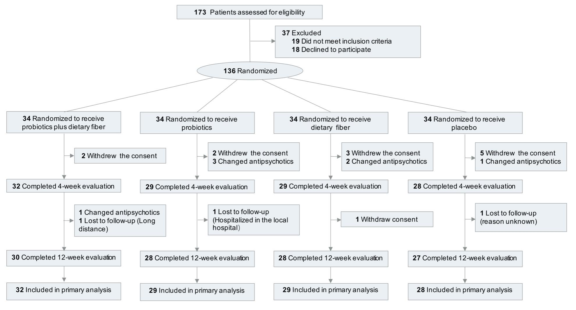

Supplemental Figure 2. Relative Abundance of Significantly Changed Species Across Four Treatment Groups.
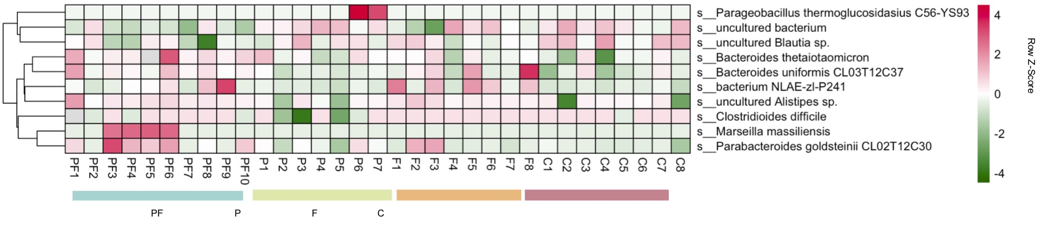
PF represented the probiotics plus dietary fiber group, N=10.
P represented the probiotics group, N=7.
F represented the dietary fiber group, N=8.
C represented the placebo group, N=8.

Supplemental Table 1. Adverse Effects by Treatment Groups.
 |  | No. (%) of Participants
Adverse Effect | Probiotics + Dietary fiber (n=34) |  | Probiotics  (n=34) | Dietary fiber  (n=34) | Placebo (n=34) | χ² Testª | P value
Hypoactivity | 4 (11.8) |  | 4 (11.8) | 4 (11.8) | 2 (5.9) | 0.96 | 0.81
Somnolence | 3 (8.8) |  | 6 (17.6) | 4 (11.8) | 6 (17.6) | 1.24 | 0.74
Abnormal liver function | 1 (2.9) |  | 1 (2.9) | 1 (2.9) | 0 (0.0) | 1.02 | 0.8
Constipation | 3 (8.8) |  | 2 (5.9) | 3 (8.8) | 10 (29.4) | 10.50 | 0.02
Nausea //Vomiting | 1 (2.9) |  | 2 (5.9) | 0 (0.0) | 2 (5.9) | 2.28 | 0.52
Headache | 1 (2.9) |  | 0 (0.0) | 0 (0.0) | 0 (0.0) | 3.02 | 0.39
ªχ² Test among four treatment groups.

Supplemental Table 2. Comparison of α-diversity in Four Treatment Groups Between Baseline and Week 12.
 | Probiotics plus dietary fiber (PF)  N=10 |  |  |  | Probiotics (P)  N=7 |  | Dietary fiber (D)  N=8 |  |  |  | Placebo (C)  N=8
α-diversity | t P |  |  | t |  | P |  | t | P | t |  | P
ACE | -3.649 | 0.002 |  | 0.590 |  | 0.566 |  | 1.205 | 0.248 | 0.337 |  | 0.741
Chao 1 | -3.599 | 0.002 |  | 0.641 |  | 0.534 |  | 1.040 | 0.316 | -0.069 |  | 0.946
Observed Species | -3.812 | 0.001 |  | -0.131 |  | 0.898 |  | 0.253 | 0.804 | 0.410 |  | 0.688
Simpson | -0.746 | 0.465 |  | -1.024 |  | 0.326 |  | -1.326 | 0.221 | 0.435 |  | 0.670
Shannon | 0.958 | 0.226 |  | -0.627 |  | 0.542 |  | -0.697 | 0.497 | 0.451 |  | 0.659
P values represented the differences of gut bacteria between week 12 and baseline within the treatment group.
Supplemental Table 3. Comparison of α-diversity Across Treatment Groups.
α-diversity  (Pª value) | Probiotics +  dietary fiber  vs  Dietary Fiber | Probiotics +  dietary fiber  vs  Probiotics | Probiotics +  dietary fiber  vs  Placebo | Dietary fiber  vs  Probiotics | Dietary fiber  vs  Placebo | Probiotics  vs  Placebo | P^{b}
ACE | 0.002 | <0.001 | <0.001 | 0.804 | 0.586 | 0.438 | <0.001
Chao 1 | 0.004 | <0.001 | <0.001 | 0.957 | 0.78 | 0.824 | 0.003
Observed Species | 0.049 | 0.202 | 0.007 | 0.52 | 0.432 | 0.168 | 0.046
Simpson | 0.696 | 0.552 | 0.552 | 0.666 | 0.366 | 0.178 | 0.565
Shannon | 0.654 | 0.763 | 0.287 | 0.491 | 0.546 | 0.200 | 0.572
Pª represents the differences from the baseline to week 12 between groups.
P^{b} represents the overall differences across four treatment groups.

Supplemental Table 4. Median Relative Abundance of Top 10 Phylum and Families in Fecal Microbiota of Patients in Four Treatment Groups.
Phylum | Probiotics plus dietary fiber (PF)  N=10 |  |  |  | Probiotics (P)  N=7 |  | Dietary fiber (D)  N=8 |  |  |  | Placebo (C)  N=8
Family | Mann-Whitney U P |  |  | Mann-Whitney U |  | P |  | Mann-Whitney U | P | Mann-Whitney U |  | P
Firmicutes | 9 | 0.005 |  | 29 |  | 0.565 |  | 17 | 0.115 | 42 |  | 0.294
Ruminococcaceae | 36 | 0.290 |  | 24 |  | 0.949 |  | 26 | 0.529 | 43 |  | 0.248
Lachnospiraceae | 36 | 0.290 |  | 27 |  | 0.749 |  | 26 | 0.529 | 34 |  | 0.834
Veillonellaceae | 52 | 0.880 |  | 23 |  | 0.848 |  | 33 | 0.916 | 47 |  | 0.115
Peptostreptococcaceae | 15 | 0.008 |  | 23 |  | 0.848 |  | 22 | 0.294 | 23 |  | 0.345
Bacteroidetes | 92 | 0.001 |  | 27 |  | 0.749 |  | 55 | 0.016 | 25 |  | 0.462
Bacteroidaceae | 90 | 0.002 |  | 24 |  | 0.949 |  | 35 | 0.753 | 17 |  | 0.338
Prevotellaceae | 62 | 0.364 |  | 29 |  | 0.565 |  | 41 | 0.345 | 28 |  | 0.674
Tannerellaceae | 66 | 0.021 |  | 29 |  | 0.565 |  | 57 | 0.009 | 28 |  | 0.674
Rikenellaceae | 73 | 0.082 |  | 19 |  | 0.482 |  | 28 | 0.674 | 15 |  | 0.074
Proteobacteria | 35 | 0.257 |  | 25 |  | 0.949 |  | 27 | 0.600 | 28 |  | 0.674
Enterobacteriaceae | 44 | 0.650 |  | 21 |  | 0.655 |  | 30 | 0.834 | 30 |  | 0.834
Fusobacteria | 43 | 0.595 |  | 16 |  | 0.277 |  | 21 | 0.248 | 24 |  | 0.401
Fusobacteriaceae | 43 | 0.595 |  | 16 |  | 0.277 |  | 21 | 0.248 | 24 |  | 0.401
Actinobacteria | 38 | 0.364 |  | 29 |  | 0.565 |  | 43 | 0.248 | 44 |  | 0.208
Tenericutes | 37 | 0.326 |  | 31 |  | 0.406 |  | 28 | 0.610 | 37 |  | 0.6
Verrucomicrobia | 51 | 0.940 |  | 29 |  | 0.503 |  | 31 | 0.872 | 30 |  | 0.834
Patescibacteria | 39 | 0.402 |  | 25 |  | 0.949 |  | 23 | 0.341 | 47 |  | 0.112
Synergistetes | 41 | 0.495 |  | 19 |  | 0.482 |  | 33 | 0.916 | 31 |  | 0.916
Euryarchaeota | 45 | 0.67 |  | 25 |  | 0.917 |  | 40 | 0.144 | 34 |  | 0.783
Wilcoxon matched-pairs signed rank test
P values represented the differences of gut bacteria between week 12 and baseline within the treatment group.
Supplemental Table 5. Comparison of Top 10 Phylum and Families in Fecal Microbiota of Patients across Four Treatment Groups.
Phylum  Family  (Pairwise pFDR) | Overall  pFDR | Probiotics +  dietary fiber  vs  Dietary fiber | Probiotics +  dietary fiber  vs  Probiotics | Probiotics +  dietary fiber  vs  Placebo | Dietary fiber  vs  Probiotics | Dietary fiber  vs  Placebo | Probiotics  vs  Placebo
Firmicutes | 0.033 | 0.452 | 0.028 | 0.010 | 0.150 | 0.079 | 0.794
Ruminococcaceae | 0.390 | - | - | - | - | - | -
Lachnospiraceae | 0.811 | - | - | - | - | - | -
Veillonellaceae | 0.220 | - | - | - | - | - | -
Peptostreptococcaceae | 0.442 | - | - | - | - | - | -
Bacteroidetes | 0.017 | 0.316 | 0.028 | 0.003 | 0.242 | 0.066 | 0.546
Bacteroidaceae | 0.019 | 0.095 | 0.073 | 0.002 | 0.857 | 0.157 | 0.231
Prevotellaceae | 0.338 | - | - | - | - | - | -
Tannerellaceae | 0.029 | 0.901 | 0.037 | 0.020 | 0.055 | 0.033 | 0.886
Rikenellaceae | 0.004 | 0.128 | 0.007 | 0.001 | 0.232 | 0.093 | 0.669
Proteobacteria | 0.950 | - | - | - | - | - | -
Enterobacteriaceae | 0.983 | - | - | - | - | - | -
Fusobacteria | 0.147 | - | - | - | - | - | -
Fusobacteriaceae | 0.147 | - | - | - | - | - | -
Actinobacteria | 0.118 | - | - | - | - | - | -
Tenericutes | 0.112 | - | - | - | - | - | -
Verrucomicrobia | 0.925 | - | - | - | - | - | -
Patescibacteria | 0.258 | - | - | - | - | - | -
Synergistetes | 0.537 | - | - | - | - | - | -
Euryarchaeota | 0.662 | - | - | - | - | - | -

The rank-based nonparametric Kruskal–Wallis test with FDR correction was used for the overall comparisons of four treatment groups; when the overall pFDR was <0.05, further pairwise comparisons by Dunn’s post-hoc tests for multiple comparisons were performed to compare the differences between two specific groups.

Supplemental Table 6. Association of Metabolic Indexes and Key Microbiota Measures
 | Weight | BMI | IRI | Insulin | Glucose | Cholesterol | HDL-C
Microbiota Measures | OR (95%CI) | OR (95%CI) | OR (95%CI) | OR (95%CI) | OR (95%CI) | OR (95%CI) | OR (95%CI)
Chao1  (per quartile increase) | 0.37 (0.15-0.87) | 0.37 (0.15-0.87) | 0.47 (0.21-1.06) | 0.78 (0.34-1.78) | 0.72 (0.33-1.56) | 0.25 (0.09-0.75) | 1.37 (0.71-2.68)
ACE  (per quartile increase) | 0.45 (0.20-0.98) | 0.45 (0.20-0.98) | 0.60 (0.27-1.29) | 1.06 (0.48-2.34) | 0.71 (0.33-1.55) | 0.30 (0.11-0.82) | 1.11 (0.58-2.14)
Observed_species  (per quartile increase) | 0.61 (0.30-1.26) | 0.61 (0.30-1.26) | 0.55 (0.25-1.21) | 0.65 (0.28-1.54) | 0.87 (0.40-1.88) | 0.50 (0.22-1.12) | 1.57 (0.79-3.13)
dFirmicutes | 0.99 (0.21-4.55) | 0.99 (0.21-4.55) | 4.91 (0.87-27.52) | 4.22 (0.58-30.66) | 10.95 (1.26-94.95) | 1.62 (0.34-7.86) | 3.62 (0.77-17.02)
dBacteroidetes | 0.39 (0.08-1.91) | 0.39 (0.08-1.91) | 0.25 (0.04-1.41) | 0.14 (0.02-1.18) | 0.30 (0.05-1.92) | 0.46 (0.09-2.31) | 1.16 (0.27-5.01)
Parabacteroides goldsteinii  (above median) | 0.20 (0.03-1.34) | 0.20 (0.03-1.34) | 0.04 (0.002-0.85) | 0.06 (0.004-1.15) | 0.12 (0.01-1.14) | 0.05 (0.003-0.74) | 1.47 (0.30-7.23)
Bacteroides uniformis  (above median) | 0.72 (0.15-3.49) | 0.72 (0.15-3.49) | 0.59 (0.11-3.27) | 0.75 (0.12-4.84) | 0.09 (0.007-1.16) | 0.53 (0.10-2.99) | 1.26 (0.28-5.73)
Bacteroides thetaiotaomicron  (above median) | 0.33 (0.07-1.63) | 0.33 (0.07-1.63) | 0.15 (0.02-1.09) | 0.14 (0.02-1.24) | 0.27 (0.04-1.93) | 0.31 (0.05-1.84) | 1.54 (0.35-6.90)
Abbreviations:OR, odds ratio.
Candidate microbiota measures (ACE, Chao1, Observed species) were classified in quartiles.
High species ((above vs below median) presented high relative abundance of the specific species.

