Supplement Materials

Supplement tables (1-6) are in supplement_table.xlsx

Supplementary Table 1. Basic characteristics in FHS and ADNI

Supplementary Table 2. Information for 10 inflammatory & AD-related SNPs¹⁻¹¹

Supplementary Table 3. Power analysis for the stratified genotype analysis

Supplementary Table 4. Interaction effect between high CRP cutoff and SNPs genotypes (dominant) on AD risk, adjusted for age, sex, years of education, APOE4 and PCs, for 5 SNPs in UKBB, FHS and meta-analysis

Supplementary Table 5. Number of AD cases (percentage) under different CRP level cutoff for 3 significant SNPs in UKBB

Supplementary Table 6. Interaction of CRP and SPI1 rs1057233/CD33 rs3865444 on MCI-AD conversion, adjusted by age, sex, years of education and APOE4 in ADNI MCI patients

Supplement Figure 1. Trends of cumulative AD incidence rates across CRP level cutoff (1-12 mg/L) among 3 SNPs genotypes in UKBB.

Supplement Figure 2. Forest plot for the stratified genotype analysis of 3 SNPs for the effect of CRP levels cutoffs (all 3-12 mg/L) on AD incidence in Cox proportional hazard regression models.

Supplement Figure 3. CSF AD biomarkers based on elevated serum CRP and different genotypes of SPI1 and CD33.

Supplement Figure 1. Trends of cumulative AD incidence rates across CRP level cutoff (1-12 mg/L) among 3 SNPs genotypes in UKBB.

- CLU

- SPI1

- CD33

Supplement Figure 2. Forest plot for the stratified genotype analysis of 3 SNPs for the effect of CRP levels cutoffs (all 3-12 mg/L) on AD incidence in Cox proportional hazard regression models.

Supplement Figure 3. CSF AD biomarkers based on elevated serum CRP and different genotypes of SPI1 and CD33. ADNI participants with measured CSF AD biomarkers were divided into SPI1 AA/GG+GA and CD33 CC/AA+AC genotypes. Different CRP cutoff level (3-10mg/L) were used to further divide participants into two genotype groups. Prevalent AD cases were excluded. t-Tau and p-Tau at each participants’ last exam were used. Level of t-Tau and p-Tau were log transformed. Boxplots of t-Tau and p-Tau for different SNP-CRP groups with p-values of interaction between CRP cutoffs and SNPs genotypes from linear regression analysis, adjusted for age, sex, education and APOE ε4, were shown for SPI1 (a-b) and CD33 (c-d).

- SPI1 vs. t-Tau

- SPI1 vs. p-Tau
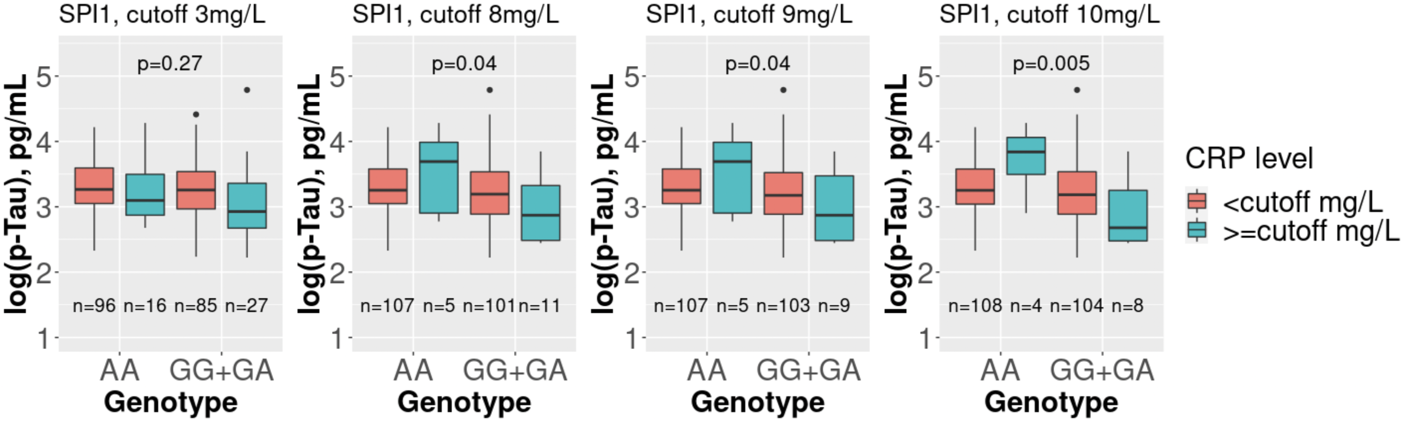
- CD33 vs. t-Tau
CRP

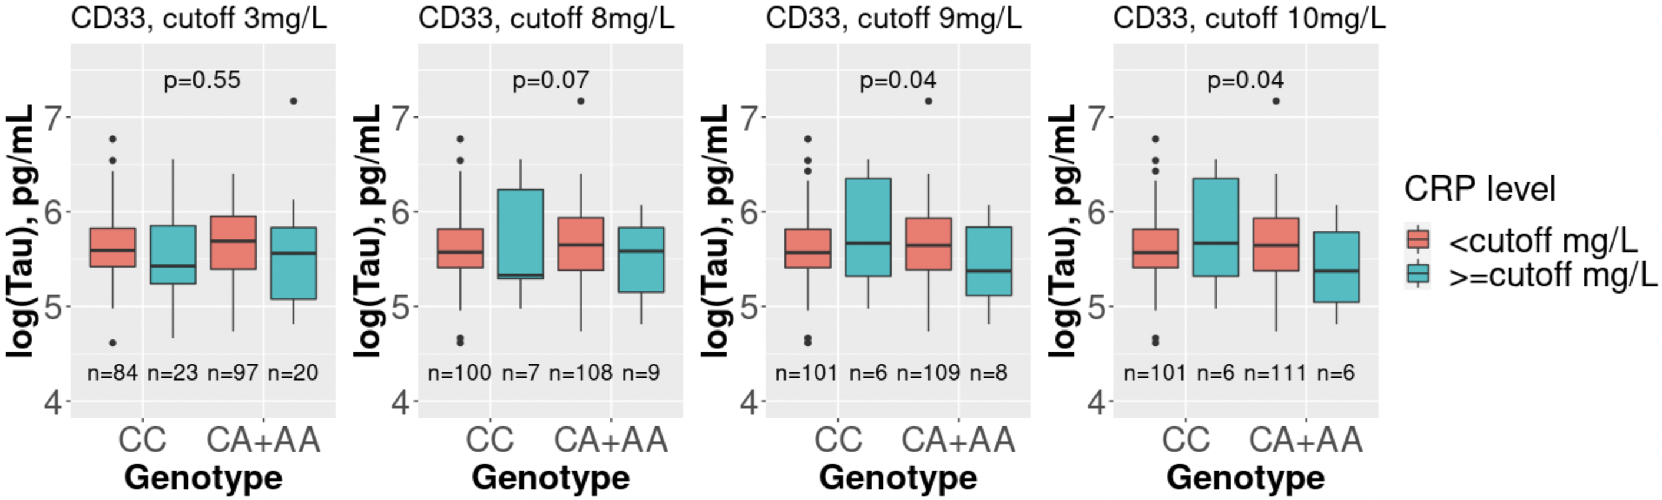

- CD33 vs. p-Tau

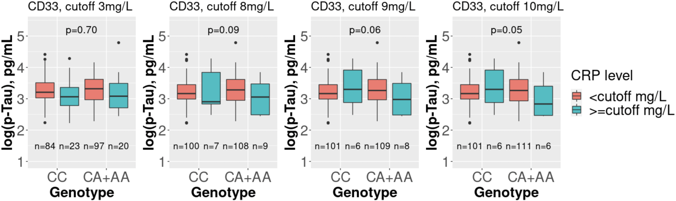

Reference

1. Hollingworth P, Harold D, Sims R, et al. Common variants at ABCA7, MS4A6A/MS4A4E, EPHA1, CD33 and CD2AP are associated with Alzheimer's disease. Nat Genet. May 2011;43(5):429-35. doi:10.1038/ng.803
2. Lambert JC, Ibrahim-Verbaas CA, Harold D, et al. Meta-analysis of 74,046 individuals identifies 11 new susceptibility loci for Alzheimer's disease. Nat Genet. Dec 2013;45(12):1452-8. doi:10.1038/ng.2802
3. Malik M, Parikh I, Vasquez JB, et al. Genetics ignite focus on microglial inflammation in Alzheimer's disease. Mol Neurodegener. Oct 5 2015;10:52. doi:10.1186/s13024-015-0048-1
4. Villegas-Llerena C, Phillips A, Garcia-Reitboeck P, Hardy J, Pocock JM. Microglial genes regulating neuroinflammation in the progression of Alzheimer's disease. Curr Opin Neurobiol. Feb 2016;36:74-81. doi:10.1016/j.conb.2015.10.004
5. Naj AC, Jun G, Beecham GW, et al. Common variants at MS4A4/MS4A6E, CD2AP, CD33 and EPHA1 are associated with late-onset Alzheimer's disease. Nat Genet. May 2011;43(5):436-41. doi:10.1038/ng.801
6. Kunkle BW, Grenier-Boley B, Sims R, et al. Genetic meta-analysis of diagnosed Alzheimer's disease identifies new risk loci and implicates Abeta, tau, immunity and lipid processing. Nat Genet. Mar 2019;51(3):414-430. doi:10.1038/s41588-019-0358-2
7. Dries JL, Kent SD, Virag JA. Intramyocardial administration of chimeric ephrinA1-Fc promotes tissue salvage following myocardial infarction in mice. J Physiol. Apr 1 2011;589(Pt 7):1725-40. doi:10.1113/jphysiol.2010.202366
8. Kim M, Suh J, Romano D, et al. Potential late-onset Alzheimer's disease-associated mutations in the ADAM10 gene attenuate {alpha}-secretase activity. Hum Mol Genet. Oct 15 2009;18(20):3987-96. doi:10.1093/hmg/ddp323
9. Gerhardt S, Hassall G, Hawtin P, et al. Crystal structures of human ADAMTS-1 reveal a conserved catalytic domain and a disintegrin-like domain with a fold homologous to cysteine-rich domains. J Mol Biol. Nov 2 2007;373(4):891-902. doi:10.1016/j.jmb.2007.07.047
10. Huang KL, Marcora E, Pimenova AA, et al. A common haplotype lowers PU.1 expression in myeloid cells and delays onset of Alzheimer's disease. Nat Neurosci. Aug 2017;20(8):1052-1061. doi:10.1038/nn.4587
11. Fagan V, Johansson C, Gileadi C, et al. A Chemical Probe for Tudor Domain Protein Spindlin1 to Investigate Chromatin Function. J Med Chem. Oct 24 2019;62(20):9008-9025. doi:10.1021/acs.jmedchem.9b00562

