SUPPLEMENTAL MATERIAL

Supplemental Figure 1. Log Estradiol and Progesterone Values Across Days Since Positive LH Test, by Condition (EP vs. PBO).

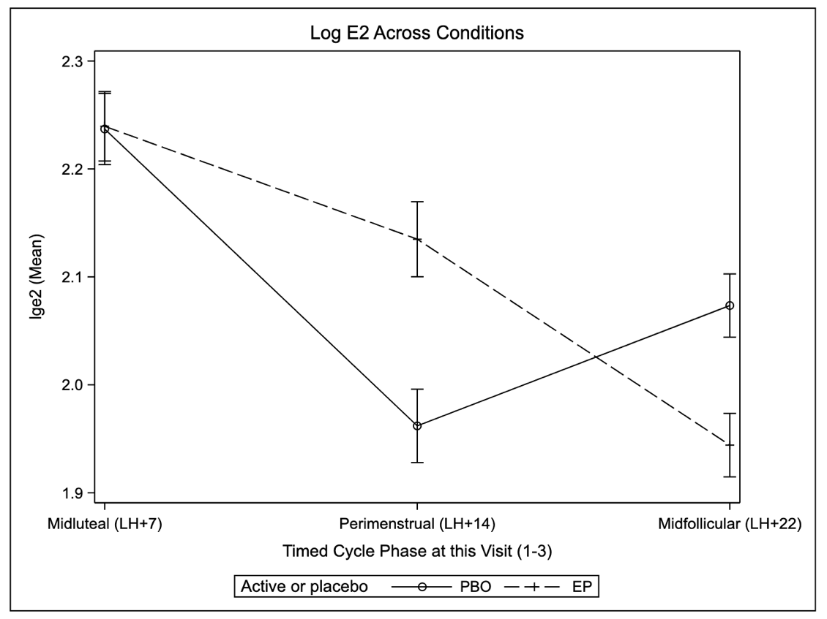

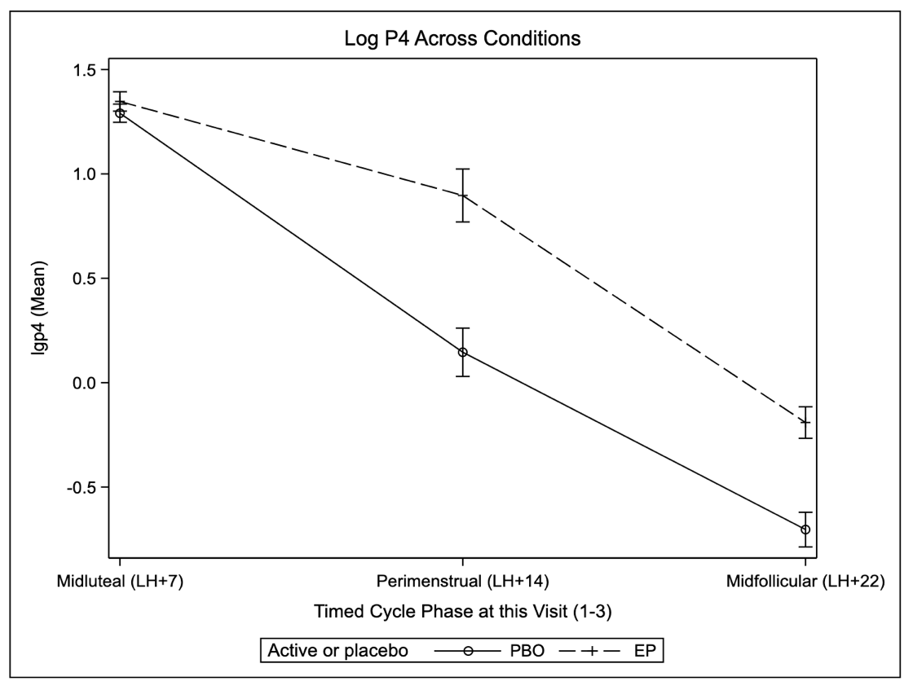

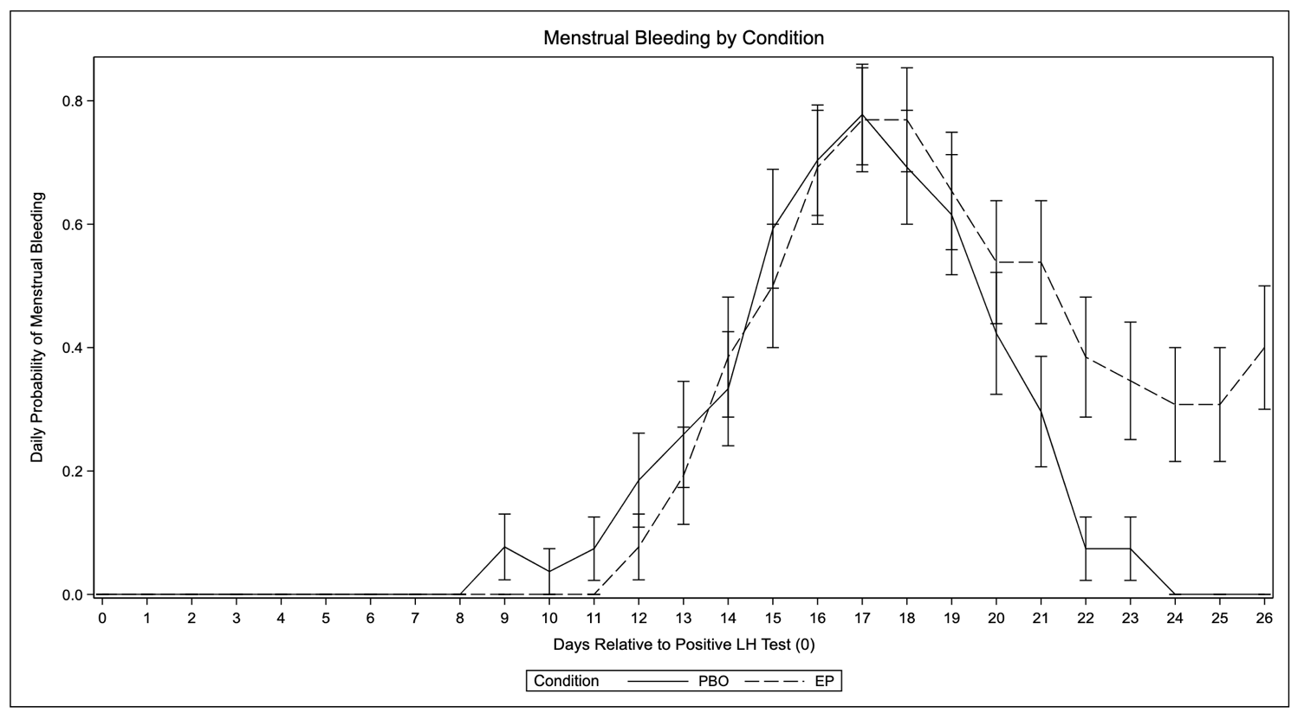
Supplemental Figure 2. Probability of Menstrual Bleeding Values Across Days Since Positive LH Test, by Condition (EP vs. PBO).

Supplemental Figures 3. Graphical Depictions of Secondary and Exploratory Outcomes by Condition and Phase. Note: Asterisks indicate significant Condition × Phase interaction effects.

