Supplementary Figures for Honorato-Mauer et al.

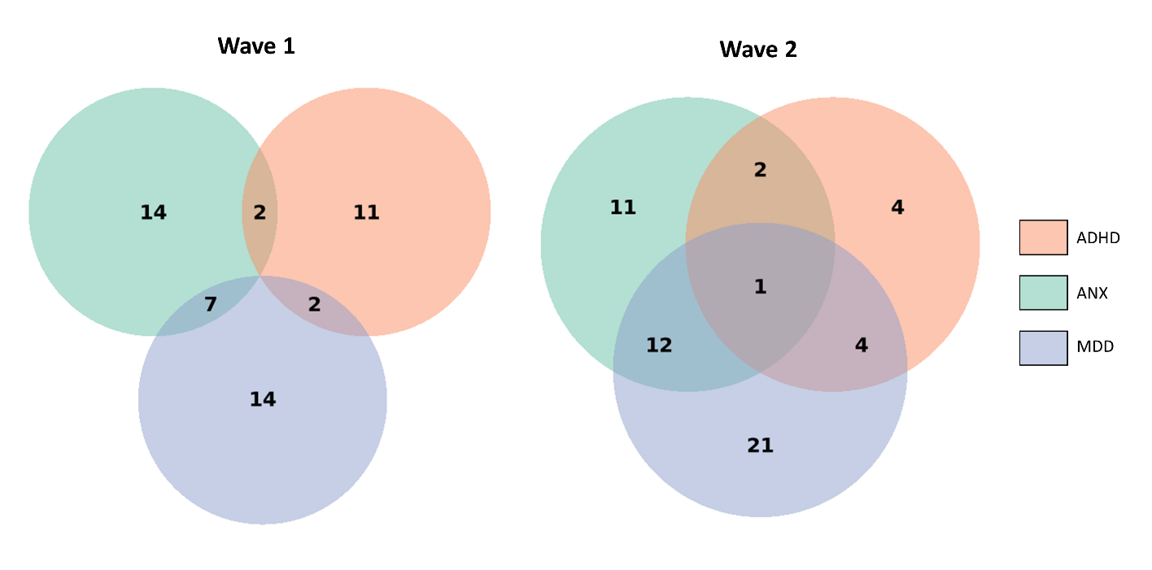
Supplementary figure 1. Number of participants of the study that were diagnosed with ADHD, ANX and/or MDD, separated by time point (Wave 1 - w1 and Wave 2 – w2).
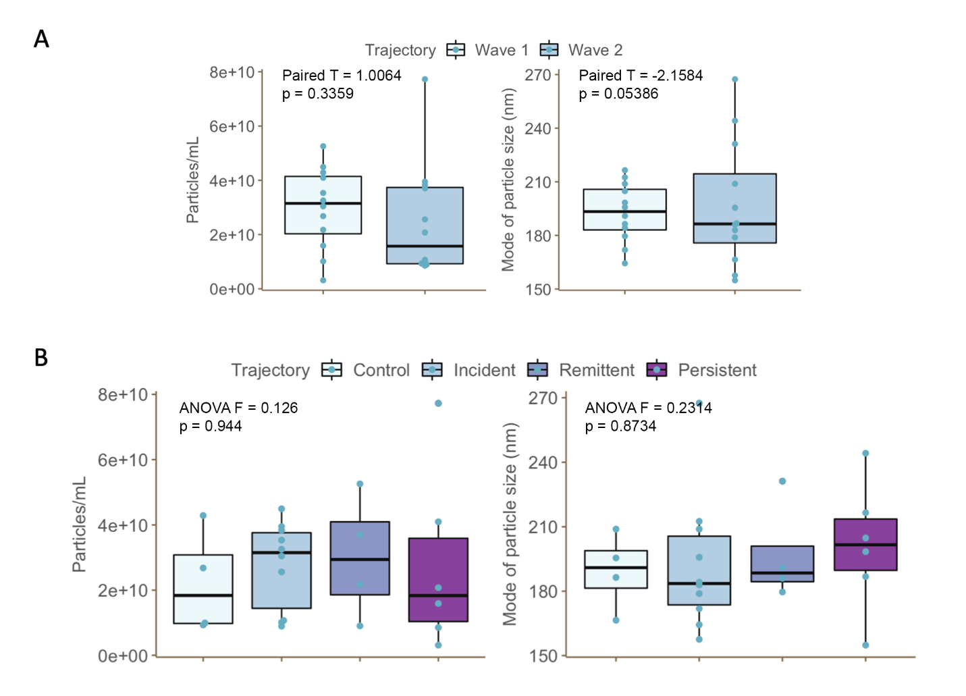
Supplementary Figure 2: Boxplots of concentration and mode of particle size between A) Waves and B) Trajectories, and values of comparisons of mean size in nm (Wave: Paired T-test T = -2.1584, p-value = 0.05386; Trajectory: ANOVA F = 0.2314, p = 0.8734), and concentration in particles/mL (Wave: Paired T-test T = 1.0064, p-value = 0.3359; Trajectory: ANOVA F = 0.126, p = 0.944).

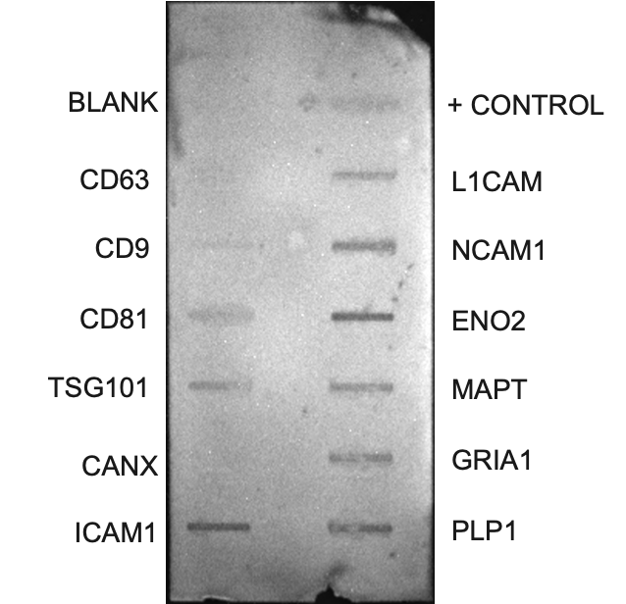
Supplementary Figure 3: Revealed image of protein antibody array membrane indicating presence of general (left) and brain-associated (right) EV membrane markers present in our samples.

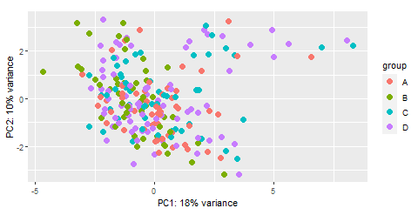
Supplementary Figure 4. Principal Component Analysis plot (PC1 x PC2). Dots are labeled according to trajectory group. A = Control, B = Incident, C = Remitting, D = Persistent.
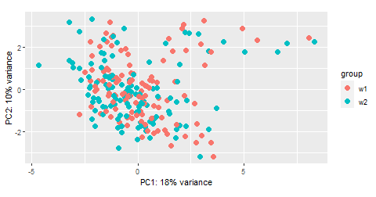
Supplementary Figure 5. Principal Component Analysis plot (PC1 x PC2). Dots are labeled according to time point. w1 = Wave 1, w2 = Wave 2.
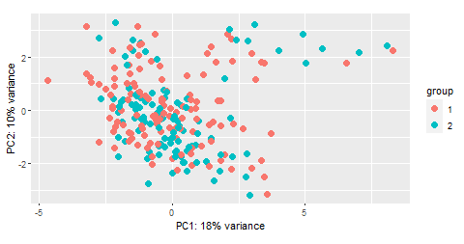
Supplementary Figure 6. Principal Component Analysis plot (PC1 x PC2). Dots are labeled according to sex. 1 = male, 2 = female.
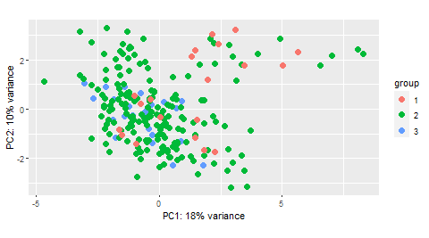
Supplementary Figure 7. Principal Component Analysis plot (PC1 x PC2). Dots are labeled according to 1st, 2nd or 3rd miRNA sequencing batch.

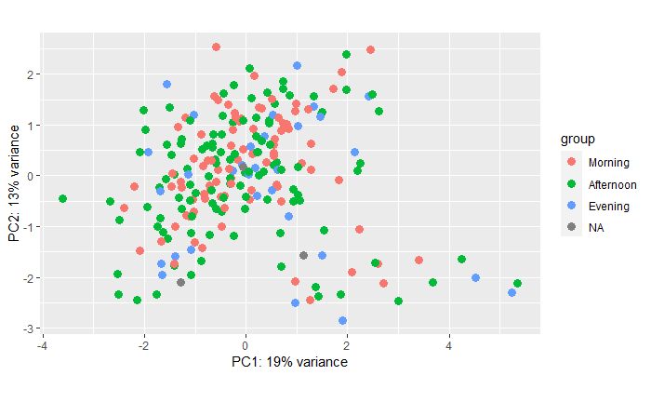
Supplementary Figure 8. Principal Component Analysis plot (PC1 x PC2). Dots are labeled according to period in which the participants had their blood samples collected (morning, afternoon, Evening). NA = data not available.

