Maternal preconception circulating blood biomarker mixtures, child behavioural symptom scores and the potential mediating role of neonatal brain microstructure: the S-PRESTO cohort
Supplementary Figure

Figure 1 Exposure-outcome relationships using Bayesian kernel machine regression (BKMR) simultaneously accounting for 67 biomarkers (11 clusters), stratified by household income (Model 1, N=89 for lower household income group and N=110 for higher household income group). Biomarker levels and CBCL scores were in standard deviation unit. Grey areas indicate 95% credible interval.
Figure 2 Associations of preconception thiamine and neonatal orientation dispersion index at 49 brain structures (n=56).
Figure 3 Associations of preconception thiamine monophosphate and neonatal orientation dispersion index at 49 brain structures (n=56).
Figure 4 Regression-based causal mediation analysis for preconception thiamine neonatal ODI at the right subthalamic nucleus CBCL scores (Child Behavior Checklist (CBCL), orientation dispersion index (ODI), n=62).

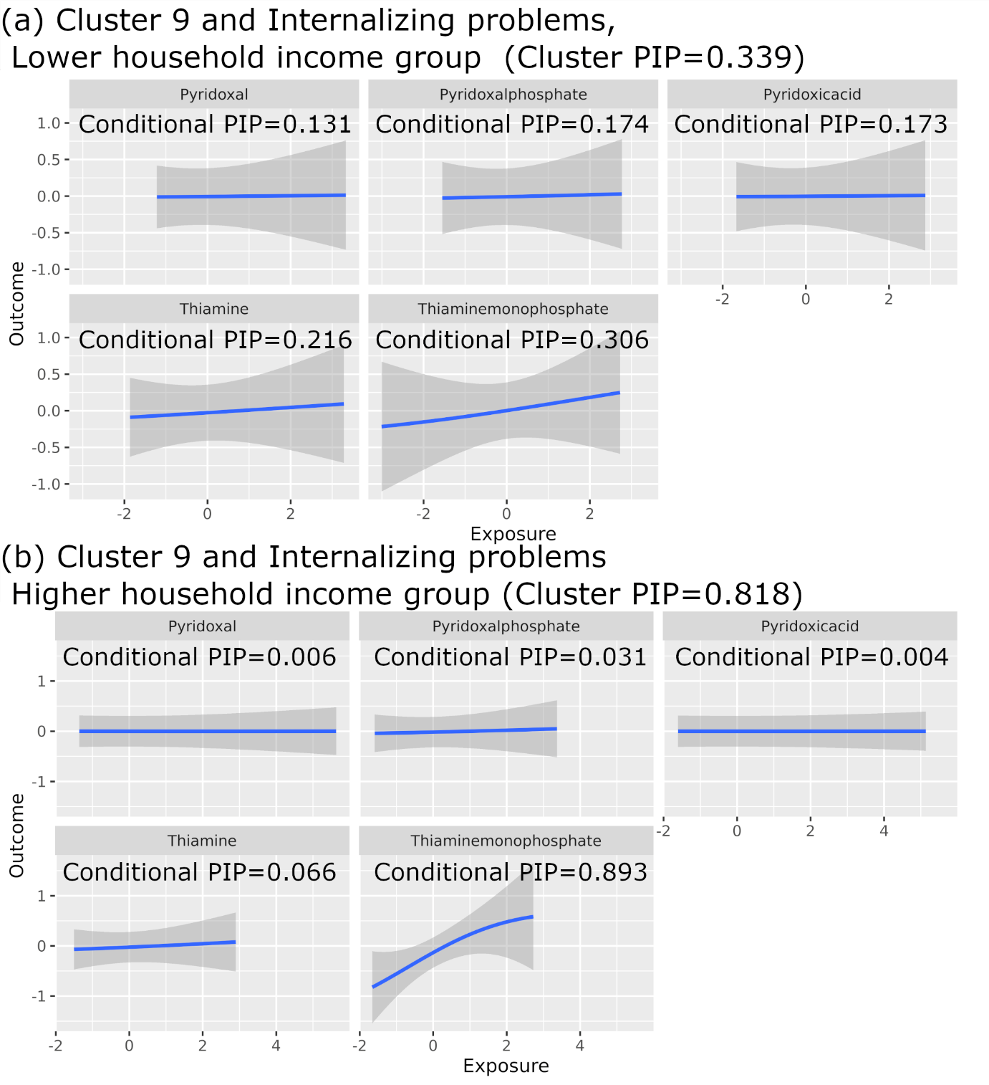
Figure 1 Exposure-outcome relationships using Bayesian kernel machine regression (BKMR) simultaneously accounting for 67 biomarkers (11 clusters), stratified by household income (Model 1, N=89 for lower household income group and N=110 for higher household income group). Biomarker levels and CBCL scores were in standard deviation unit. Grey areas indicate 95% credible interval.

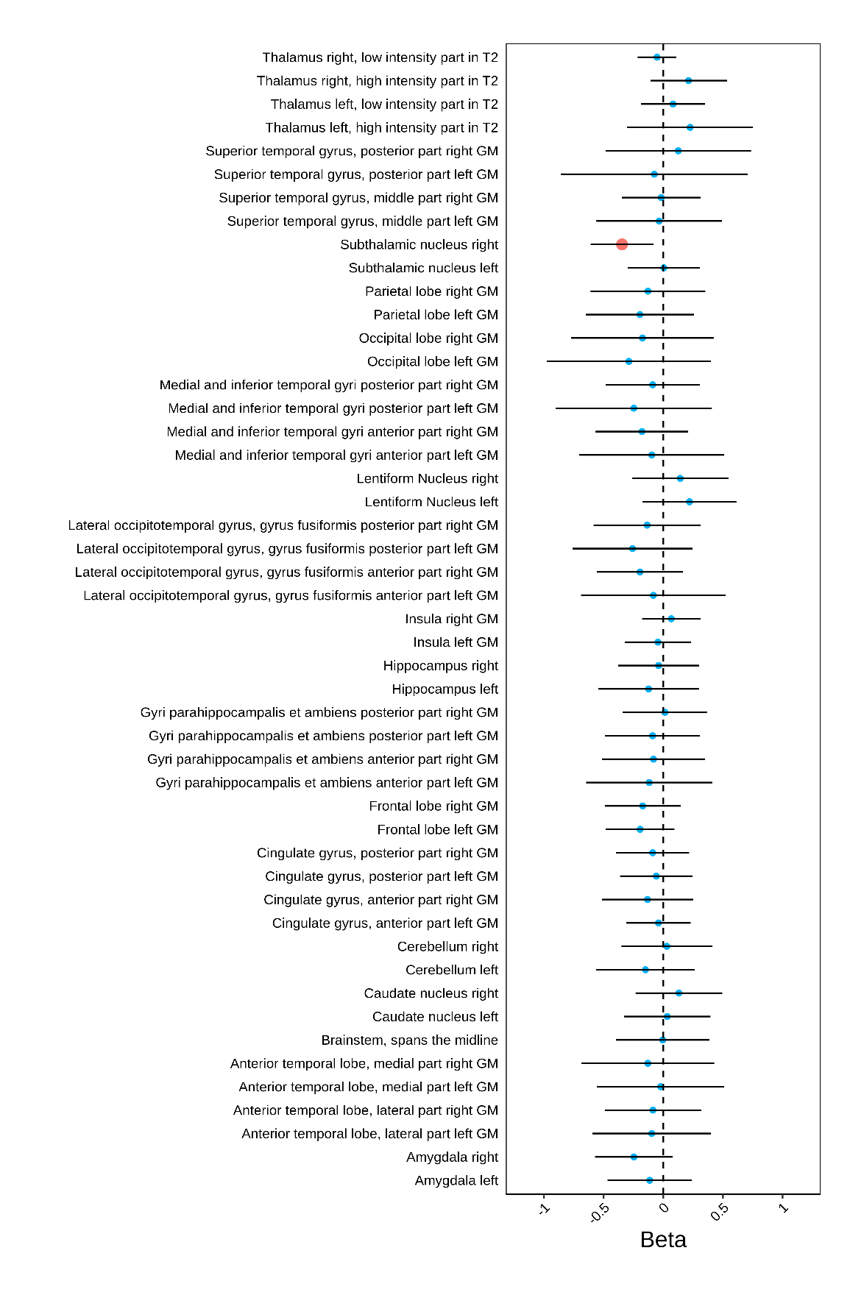
Figure 2 Associations of preconception thiamine and neonatal orientation dispersion index at 49 brain structures (n=56).

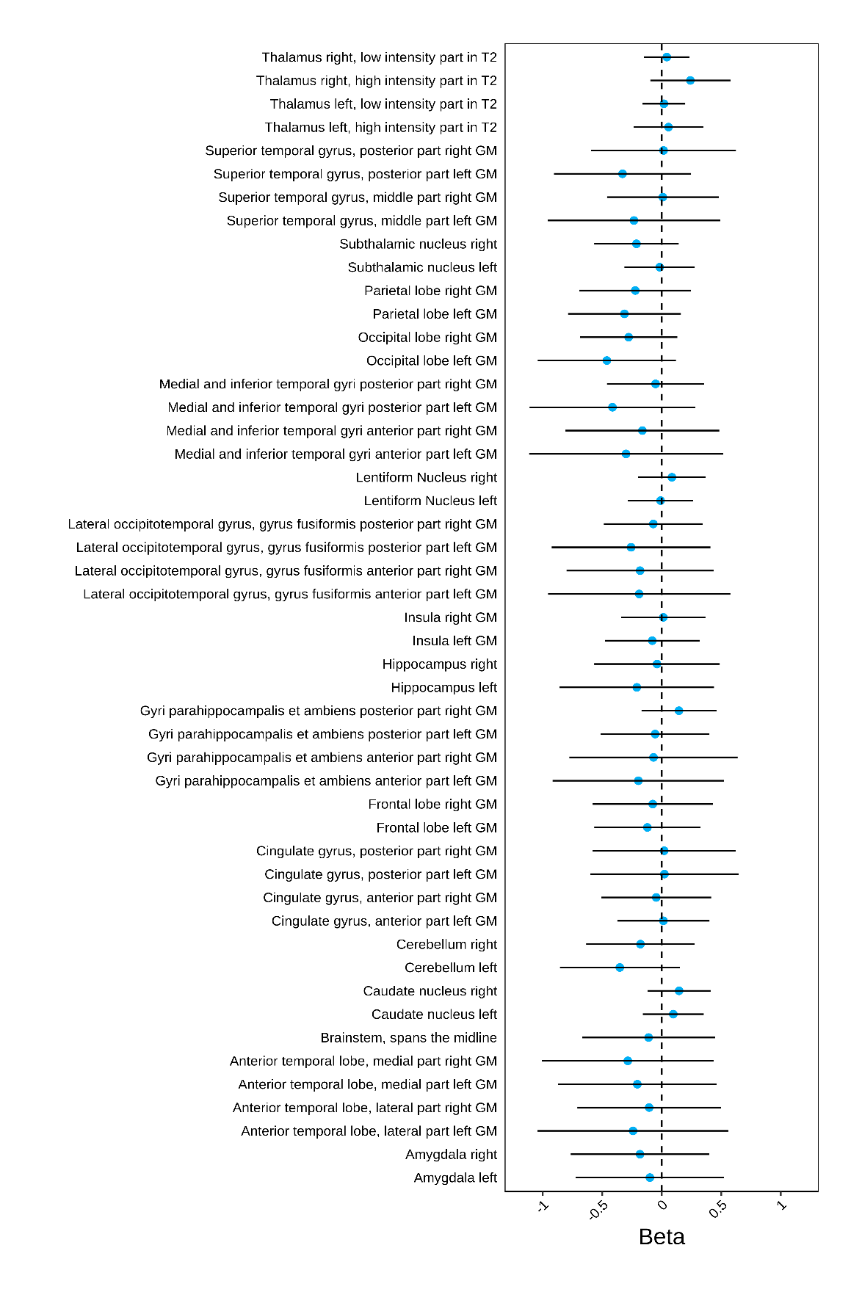
Figure 3 Associations of preconception thiamine monophosphate and neonatal orientation dispersion index at 49 brain structures (n=56).

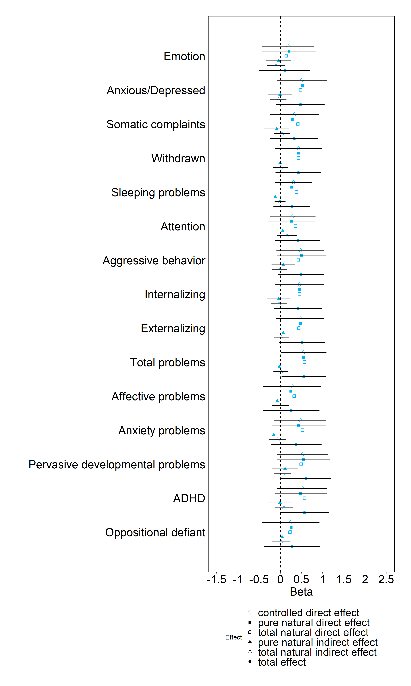
Figure 4 Regression-based causal mediation analysis for preconception thiamine neonatal ODI at the right subthalamic nucleus CBCL scores (Child Behavior Checklist (CBCL), orientation dispersion index (ODI), n=62).

