Supplement materials
Supplementary Methods
Collection of information on outdoor light
Participants wrote a number using a touch–screen pad or selected integers that included “less than an hour a day”, “do not know”, or “prefer not to answer” in several options set in advance. If participants spent a lot of time outdoors, they should report the average time they spent outdoors. We excluded 30,232 participants who reported “do not know” or “prefer not to answer”. And we redefined “less than an hour a day” as 0. We also excluded extreme values >16 hours on summer typical day and >8 hours on winter typical day (N = 4,647).(1) To unify outdoor light time standard, the duration reported in winter and summer was averaged.

Source of hospital inpatient records of depression
Participants joined the UK Biobank study from 2006 to 2010. Depression was ascertained using hospital inpatient records containing data on admissions and diagnoses obtained from the Hospital Episode Statistics for England, Scottish Morbidity Record data for Scotland, and the Patient Episode Database for Wales.
Hospital inpatient records | ICD-10 code of depression
The Hospital Episode Statistics for England | F32, F33, F34, F38, F39
The Scottish Morbidity Record data for Scotland | F32, F33, F34, F39
The Patient Episode Database for Wales | F32, F33, F39

Table S1. Interaction between the genetic risk and outdoor light time for depression.
 | HR (95% CI) | P value
Summer ª
Intermediate genetic risk × below 2 hours | 1.05 (0.90, 1.22) | 0.532
Intermediate genetic risk × above 2 hours | 0.88 (0.79, 0.98) | 0.024
High genetic risk × below 2 hours | 0.96 (0.82, 1.11) | 0.565
High genetic risk × above 2 hours | 0.91 (0.81, 1.01) | 0.074
Winter b
Intermediate genetic risk × below 1 hour | 1.04 (0.92, 1.18) | 0.515
Intermediate genetic risk × above 1 hour | 0.88 (0.80, 0.97) | 0.013
High genetic risk × below 1 hour | 0.98 (0.87, 1.11) | 0.806
High genetic risk × above 1 hour | 0.99 (0.90, 1.09) | 0.874
Average c
Intermediate genetic risk × below 1.5 hours | 0.97 (0.83, 1.14) | 0.724
Intermediate genetic risk × above 1.5 hours | 0.82 (0.72, 0.94) | 0.005
High genetic risk × below 1.5 hours | 0.94 (0.80, 1.11) | 0.482
High genetic risk × above 1.5 hours | 0.89 (0.78, 1.02) | 0.094
Abbreviation: HR, hazard ratio; 95% CI, 95% confidence interval.
Shown are the interaction effects between intermediate or high genetic risk and different outdoor light time, ª compared to low genetic risk and 2 hours in summer, ^{b} compared to low genetic risk and 1 hour in winter, ^{c} compared to low genetic risk and 1.5 hours average.

Table S2. Hazard ratios (95% confidence interval) of incident depression according to genetic risk and outdoor light time stratified by age.
Subgroup | Age <60 |  | Age ≥60
Subgroup | HR (95% CI) | P Value | HR (95% CI) | P Value
Summer
Low genetic risk
2 hours | 1 (Ref.) |  | 1 (Ref.)
below 2 hours | 1.07 (0.93, 1.23) | 0.324 | 1.24 (1.02, 1.50) | 0.033
above 2 hours | 1.18 (1.06, 1.31) | 0.002 | 1.21 (1.06, 1.38) | 0.005
Intermediate genetic risk
2 hours | 1.19 (1.06, 1.34) | 0.004 | 1.25 (1.07, 1.47) | 0.006
below 2 hours | 1.33 (1.17, 1.51) | <0.001 | 1.67 (1.40, 2.00) | <0.001
above 2 hours | 1.22 (1.10, 1.35) | <0.001 | 1.34 (1.17, 1.52) | <0.001
High genetic risk
2 hours | 1.20 (1.06, 1.35) | 0.003 | 1.33 (1.14, 1.56) | <0.001
below 2 hours | 1.22 (1.07, 1.40) | 0.002 | 1.60 (1.34, 1.91) | <0.001
above 2 hours | 1.33 (1.20, 1.47) | <0.001 | 1.37 (1.20, 1.56) | <0.001
Winter
Low genetic risk
1 hour | 1 (Ref.) |  | 1 (Ref.)
below 1 hour | 1.06 (0.94, 1.18) | 0.364 | 1.14 (0.98, 1.31) | 0.084
above 1 hour | 1.19 (1.08, 1.31) | <0.001 | 1.08 (0.97, 1.20) | 0.169
Intermediate genetic risk
1 hour | 1.21 (1.09, 1.33) | <0.001 | 1.15 (1.02, 1.29) | 0.019
below 1 hour | 1.32 (1.19, 1.47) | <0.001 | 1.36 (1.19, 1.56) | <0.001
above 1 hour | 1.14 (1.03, 1.26) | 0.009 | 1.21 (1.10, 1.35) | <0.001
High genetic risk
1 hour | 1.13 (1.02, 1.24) | 0.023 | 1.22 (1.09, 1.37) | 0.001
below 1 hour | 1.23 (1.10, 1.37) | <0.001 | 1.27 (1.11, 1.46) | <0.001
above 1 hour | 1.36 (1.24, 1.50) | <0.001 | 1.26 (1.14, 1.39) | <0.001
Average
Low genetic risk
1.5 hours | 1 (Ref.) |  | 1 (Ref.)
below 1.5 hours | 1.08 (0.93, 1.26) | 0.293 | 1.25 (1.02, 1.54) | 0.034
above 1.5 hours | 1.23 (1.08, 1.40) | 0.002 | 1.32 (1.12, 1.56) | 0.001
Intermediate genetic risk
1.5 hours | 1.27 (1.09, 1.49) | 0.003 | 1.34 (1.09, 1.66) | 0.007
below 1.5 hours | 1.33 (1.16, 1.54) | <0.001 | 1.65 (1.35, 2.01) | <0.001
above 1.5 hours | 1.26 (1.11, 1.44) | <0.001 | 1.45 (1.23, 1.72) | <0.001
High genetic risk
1.5 hours | 1.23 (1.05, 1.44) | 0.012 | 1.35 (1.10, 1.67) | 0.005
below 1.5 hours | 1.26 (1.09, 1.45) | 0.002 | 1.60 (1.31, 1.94) | <0.001
above 1.5 hours | 1.38 (1.21, 1.57) | <0.001 | 1.51 (1.28, 1.78) | <0.001
Abbreviation: HR, hazard ratio; 95% CI, 95% confidence interval. Adjusted for sex, education, Townsend deprivation index, smoking status, drinking status, body mass index, total physical activity, sleep duration, fracture history, vitamin D supplement, hearing loss, use of sun/UV protection, PM_{2.5}, hypertension, and hyperglycemia.
Table S3. Hazard ratios (95% confidence interval) of incident depression according to genetic risk and outdoor light time stratified by sex.
Subgroup | Women |  | Men
Subgroup | HR (95% CI) | P Value | HR (95% CI) | P Value
Summer
Low genetic risk
2 hours | 1 (Ref.) |  | 1 (Ref.)
below 2 hours | 1.05 (0.91, 1.20) | 0.531 | 1.27 (1.05, 1.54) | 0.014
above 2 hours | 1.14 (1.04, 1.26) | 0.008 | 1.27 (1.11, 1.46) | 0.001
Intermediate genetic risk
2 hours | 1.21 (1.07, 1.36) | 0.002 | 1.23 (1.03, 1.45) | 0.019
below 2 hours | 1.39 (1.22, 1.58) | <0.001 | 1.50 (1.25, 1.80) | <0.001
above 2 hours | 1.25 (1.13, 1.38) | <0.001 | 1.32 (1.15, 1.52) | <0.001
High genetic risk
2 hours | 1.21 (1.08, 1.36) | 0.001 | 1.31 (1.11, 1.55) | 0.001
below 2 hours | 1.32 (1.16, 1.49) | <0.001 | 1.38 (1.15, 1.66) | 0.001
above 2 hours | 1.31 (1.19, 1.44) | <0.001 | 1.41 (1.23, 1.62) | <0.001
Winter
Low genetic risk
1 hour | 1 (Ref.) |  | 1 (Ref.)
below 1 hour | 1.09 (0.98, 1.22) | 0.125 | 1.06 (0.90, 1.24) | 0.508
above 1 hour | 1.16 (1.06, 1.27) | 0.002 | 1.10 (0.98, 1.23) | 0.123
Intermediate genetic risk
1 hour | 1.18 (1.07, 1.30) | 0.001 | 1.18 (1.04, 1.35) | 0.010
below 1 hour | 1.33 (1.20, 1.48) | <0.001 | 1.33 (1.14, 1.55) | <0.001
above 1 hour | 1.26 (1.15, 1.38) | <0.001 | 1.09 (0.97, 1.22) | 0.148
High genetic risk
1 hour | 1.18 (1.08, 1.30) | 0.001 | 1.14 (1.01, 1.29) | 0.048
below 1 hour | 1.26 (1.14, 1.40) | <0.001 | 1.18 (1.01, 1.38) | 0.032
above 1 hour | 1.35 (1.24, 1.48) | <0.001 | 1.25 (1.12, 1.40) | <0.001
Average
Low genetic risk
1.5 hours | 1 (Ref.) |  | 1 (Ref.)
below 1.5 hours | 1.11 (0.96, 1.29) | 0.159 | 1.19 (0.96, 1.47) | 0.119
above 1.5 hours | 1.24 (1.09, 1.40) | 0.001 | 1.31 (1.10, 1.57) | 0.003
Intermediate genetic risk
1.5 hours | 1.28 (1.10, 1.50) | 0.001 | 1.32 (1.06, 1.65) | 0.014
below 1.5 hours | 1.43 (1.24, 1.64) | <0.001 | 1.43 (1.16, 1.75) | 0.001
above 1.5 hours | 1.34 (1.19, 1.52) | <0.001 | 1.36 (1.13, 1.62) | 0.001
High genetic risk
1.5 hours | 1.23 (1.05, 1.43) | 0.009 | 1.37 (1.10, 1.70) | 0.005
below 1.5 hours | 1.37 (1.19, 1.57) | <0.001 | 1.35 (1.10, 1.67) | 0.004
above 1.5 hours | 1.42 (1.25, 1.60) | <0.001 | 1.46 (1.22, 1.74) | <0.001
Abbreviation: HR, hazard ratio; 95% CI, 95% confidence interval. Adjusted for age, education, Townsend deprivation index, smoking status, drinking status, body mass index, total physical activity, sleep duration, fracture history, vitamin D supplement, hearing loss, use of sun/UV protection, PM_{2.5}, hypertension, and hyperglycemia.

Table S4. Association of genetic risk and sunlight exposure with incident depression excluding the missing information on covariates.
Subgroup | HR (95% CI) | P Value
Summer
Low genetic risk
2 hours | 1 (Ref.)
below 2 hours | 1.11 (0.99, 1.25) | 0.085
above 2 hours | 1.21 (1.11, 1.31) | <0.001
Intermediate genetic risk
2 hours | 1.23 (1.11, 1.36) | <0.001
below 2 hours | 1.36 (1.21, 1.52) | <0.001
above 2 hours | 1.28 (1.18, 1.40) | <0.001
High genetic risk
2 hours | 1.23 (1.11, 1.35) | <0.001
below 2 hours | 1.33 (1.19, 1.49) | <0.001
above 2 hours | 1.36 (1.25, 1.48) | <0.001
Winter
Low genetic risk
1 hour | 1 (Ref.)
below 1 hour | 1.08 (0.98, 1.19) | 0.116
above 1 hour | 1.14 (1.06, 1.23) | 0.001
Intermediate genetic risk
1 hour | 1.18 (1.09, 1.28) | <0.001
below 1 hour | 1.29 (1.18, 1.41) | <0.001
above 1 hour | 1.19 (1.10, 1.28) | <0.001
High genetic risk
1 hour | 1.17 (1.08, 1.26) | <0.001
below 1 hour | 1.21 (1.10, 1.32) | <0.001
above 1 hour | 1.32 (1.23, 1.42) | <0.001
Average
Low genetic risk
1.5 hours | 1 (Ref.)
below 1.5 hours | 1.14 (1.01, 1.30) | 0.038
above 1.5 hours | 1.29 (1.16, 1.44) | <0.001
Intermediate genetic risk
1.5 hours | 1.33 (1.16, 1.52) | <0.001
below 1.5 hours | 1.39 (1.23, 1.58) | <0.001
above 1.5 hours | 1.37 (1.23, 1.52) | <0.001
High genetic risk
1.5 hours | 1.25 (1.09, 1.43) | <0.001
below 1.5 hours | 1.37 (1.22, 1.55) | <0.001
above 1.5 hours | 1.46 (1.31, 1.62) | <0.001
Abbreviation: HR, hazard ratio; 95% CI, 95% confidence interval. Adjusted for age, gender, education, Townsend deprivation index, smoking status, drinking status, body mass index, total physical activity, sleep duration, fracture history, vitamin D supplement, hearing loss, use of sun/UV protection, PM_{2.5}, hypertension, and hyperglycemia.

Table S5. Risk of incident depression according to genetic risk and outdoor light time after excluding the first 2 years of developing depression.
Subgroup | HR (95% CI) | P Value
Summer
Low genetic risk
2 hours | 1 (Ref.)
below 2 hours | 1.09 (0.97, 1.22) | 0.170
above 2 hours | 1.17 (1.08, 1.27) | <0.001
Intermediate genetic risk
2 hours | 1.18 (1.07, 1.31) | 0.001
below 2 hours | 1.39 (1.25, 1.55) | <0.001
above 2 hours | 1.26 (1.16, 1.36) | <0.001
High genetic risk
2 hours | 1.22 (1.10, 1.34) | <0.001
below 2 hours | 1.32 (1.18, 1.47) | <0.001
above 2 hours | 1.34 (1.23, 1.45) | <0.001
Winter
Low genetic risk
1 hour | 1 (Ref.)
below 1 hour | 1.07 (0.98, 1.18) | 0.131
above 1 hour | 1.14 (1.06, 1.22) | 0.001
Intermediate genetic risk
1 hour | 1.17 (1.08, 1.27) | <0.001
below 1 hour | 1.32 (1.21, 1.44) | <0.001
above 1 hour | 1.19 (1.11, 1.28) | <0.001
High genetic risk
1 hour | 1.17 (1.08, 1.27) | <0.001
below 1 hour | 1.24 (1.14, 1.36) | <0.001
above 1 hour | 1.32 (1.23, 1.42) | <0.001
Average
Low genetic risk
1.5 hours | 1 (Ref.)
below 1.5 hours | 1.10 (0.97, 1.25) | 0.122
above 1.5 hours | 1.23 (1.11, 1.37) | <0.001
Intermediate genetic risk
1.5 hours | 1.25 (1.09, 1.42) | 0.001
below 1.5 hours | 1.39 (1.23, 1.56) | <0.001
above 1.5 hours | 1.31 (1.18, 1.46) | <0.001
High genetic risk
1.5 hours | 1.25 (1.10, 1.42) | 0.001
below 1.5 hours | 1.33 (1.19, 1.50) | <0.001
above 1.5 hours | 1.41 (1.27, 1.56) | <0.001
Abbreviation: HR, hazard ratio; 95% CI, 95% confidence interval. Adjusted for age, gender, education, Townsend deprivation index, smoking status, drinking status, body mass index, total physical activity, sleep duration, fracture history, vitamin D supplement, hearing loss, use of sun/UV protection, PM_{2.5}, hypertension, and hyperglycemia.

Table S6. Risk of incident depression according to genetic risk and outdoor light time after excluding participants whose average outdoor light time was over 2-fold of standard deviation.
Subgroup | HR (95% CI) | P Value
Summer
Low genetic risk
2 hours | 1 (Ref.)
below 2 hours | 1.12 (1.01, 1.26) | 0.044
above 2 hours | 1.18 (1.09, 1.28) | <0.001
Intermediate genetic risk
2 hours | 1.21 (1.10, 1.34) | <0.001
below 2 hours | 1.43 (1.28, 1.59) | <0.001
above 2 hours | 1.28 (1.18, 1.38) | <0.001
High genetic risk
2 hours | 1.25 (1.13, 1.37) | <0.001
below 2 hours | 1.34 (1.20, 1.49) | <0.001
above 2 hours | 1.34 (1.24, 1.45) | <0.001
Winter
Low genetic risk
1 hour | 1 (Ref.)
below 1 hour | 1.08 (0.98, 1.18) | 0.108
above 1 hour | 1.12 (1.04, 1.21) | 0.002
Intermediate genetic risk
1 hour | 1.18 (1.10, 1.28) | <0.001
below 1 hour | 1.33 (1.22, 1.45) | <0.001
above 1 hour | 1.19 (1.11, 1.28) | <0.001
High genetic risk
1 hour | 1.17 (1.08, 1.26) | <0.001
below 1 hour | 1.24 (1.14, 1.35) | <0.001
above 1 hour | 1.31 (1.22, 1.41) | <0.001
Average
Low genetic risk
1.5 hours | 1 (Ref.)
below 1.5 hours | 1.14 (1.01, 1.28) | 0.036
above 1.5 hours | 1.25 (1.13, 1.39) | <0.001
Intermediate genetic risk
1.5 hours | 1.30 (1.14, 1.47) | <0.001
below 1.5 hours | 1.43 (1.27, 1.60) | <0.001
above 1.5 hours | 1.35 (1.22, 1.49) | <0.001
High genetic risk
1.5 hours | 1.27 (1.12, 1.44) | <0.001
below 1.5 hours | 1.36 (1.22, 1.53) | <0.001
above 1.5 hours | 1.43 (1.29, 1.58) | <0.001
Abbreviation: HR, hazard ratio; 95% CI, 95% confidence interval. Adjusted for age, gender, education, Townsend deprivation index, smoking status, drinking status, body mass index, total physical activity, sleep duration, fracture history, vitamin D supplement, hearing loss, use of sun/UV protection, PM_{2.5}, hypertension, and hyperglycemia.
Table S7. Risk of incident depression according to genetic risk and outdoor light time after further adjusting for antidepressant use.
Subgroup | HR (95% CI) | P Value
Summer
Low genetic risk
2 hours | 1 (Ref.)
below 2 hours | 1.12 (1.00, 1.25) | 0.058
above 2 hours | 1.19 (1.10, 1.29) | <0.001
Intermediate genetic risk
2 hours | 1.22 (1.11, 1.35) | <0.001
below 2 hours | 1.41 (1.27, 1.57) | <0.001
above 2 hours | 1.27 (1.17, 1.37) | <0.001
High genetic risk
2 hours | 1.24 (1.13, 1.36) | <0.001
below 2 hours | 1.31 (1.18, 1.45) | <0.001
above 2 hours | 1.33 (1.23, 1.44) | <0.001
Winter
Low genetic risk
1 hour | 1 (Ref.)
below 1 hour | 1.05 (0.96, 1.15) | 0.313
above 1 hour | 1.13 (1.06, 1.22) | 0.001
Intermediate genetic risk
1 hour | 1.18 (1.09, 1.27) | <0.001
below 1 hour | 1.28 (1.18, 1.40) | <0.001
above 1 hour | 1.18 (1.10, 1.26) | <0.001
High genetic risk
1 hour | 1.15 (1.07, 1.24) | <0.001
below 1 hour | 1.19 (1.09, 1.29) | <0.001
above 1 hour | 1.30 (1.21, 1.39) | <0.001
Average
Low genetic risk
1.5 hours | 1 (Ref.)
below 1.5 hours | 1.13 (1.00, 1.27) | 0.049
above 1.5 hours | 1.27 (1.15, 1.41) | <0.001
Intermediate genetic risk
1.5 hours | 1.30 (1.15, 1.48) | <0.001
below 1.5 hours | 1.42 (1.26, 1.59) | <0.001
above 1.5 hours | 1.34 (1.21, 1.49) | <0.001
High genetic risk
1.5 hours | 1.27 (1.12, 1.44) | <0.001
below 1.5 hours | 1.34 (1.20, 1.51) | <0.001
above 1.5 hours | 1.42 (1.28, 1.57) | <0.001
Abbreviation: HR, hazard ratio; 95% CI, 95% confidence interval. Adjusted for age, gender, education, Townsend deprivation index, smoking status, drinking status, body mass index, total physical activity, sleep duration, fracture history, vitamin D supplement, hearing loss, use of sun/UV protection, PM2.5, hypertension, hyperglycemia, and antidepressant use.

Table S8. Risk of incident depression according to time spent in outdoor light based on individuals with or without sun/UV protection.
Time spent  in outdoor light | Sun/UV protection
Time spent  in outdoor light | No or occasionally |  | Yes
Time spent  in outdoor light | HR (95% CI) | P Value | HR (95% CI) | P Value
Summer
2 hours | 1 (Ref.) |  | 1 (Ref.)
below 2 hours | 1.20 (1.10, 1.32) | <0.001 | 1.04 (0.96, 1.13) | 0.320
above 2 hours | 1.16 (1.08, 1.24) | <0.001 | 1.07 (1.01, 1.13) | 0.025
Winter
1 hour | 1 (Ref.) |  | 1 (Ref.)
below 1 hour | 1.14 (1.06, 1.23) | 0.001 | 1.06 (0.99, 1.13) | 0.080
above 1 hour | 1.11 (1.05, 1.18) | 0.001 | 1.10 (1.04, 1.15) | 0.001
Average
1.5 hours | 1 (Ref.) |  | 1 (Ref.)
below 1.5 hours | 1.16 (1.05, 1.28) | 0.003 | 1.05 (0.97, 1.15) | 0.239
above 1.5 hours | 1.19 (1.09, 1.30) | <0.001 | 1.12 (1.04, 1.20) | 0.002
Abbreviation: HR, hazard ratio; 95% CI, 95% confidence interval. Adjusted for age, gender, education, Townsend deprivation index, smoking status, drinking status, body mass index, total physical activity, sleep duration, fracture history, vitamin D supplement, hearing loss, PM2.5, hypertension, hyperglycemia, and genetic risk.

Table S9. Risk of incident depression according to time spent in outdoor light based on individuals who used or did not vitamin D supplements.
Time spent  in outdoor light | Without vitamin D supplements |  | Vitamin D supplements
Time spent  in outdoor light | HR (95% CI) | P Value | HR (95% CI) | P Value
Summer
2 hours | 1 (Ref.) |  | 1 (Ref.)
below 2 hours | 1.11 (1.04, 1.18) | 0.002 | 1.09 (0.84, 1.41) | 0.530
above 2 hours | 1.11 (1.06, 1.17) | <0.001 | 0.96 (0.78, 1.17) | 0.673
Winter
1 hour | 1 (Ref.) |  | 1 (Ref.)
below 1 hour | 1.08 (1.03, 1.14) | 0.002 | 1.21 (0.97, 1.51) | 0.098
above 1 hour | 1.10 (1.05, 1.14) | <0.001 | 1.14 (0.95, 1.38) | 0.166
Average
1.5 hours | 1 (Ref.) |  | 1 (Ref.)
below 1.5 hours | 1.09 (1.02, 1.16) | 0.012 | 1.27 (0.95, 1.71) | 0.111
above 1.5 hours | 1.14 (1.08, 1.21) | <0.001 | 1.22 (0.94, 1.58) | 0.143
Abbreviation: HR, hazard ratio; 95% CI, 95% confidence interval. Adjusted for age, gender, education, Townsend deprivation index, smoking status, drinking status, body mass index, total physical activity, sleep duration, fracture history, sun/UV protection, hearing loss, PM2.5, hypertension, hyperglycemia, and genetic risk.

Table S10. Risk of incident depression according to time spent in outdoor light after further adjusting for UK Biobank assessment centers.
Time spent  in outdoor light | Model 1 |  | Model 2
Time spent  in outdoor light | HR (95% CI) | P Value | HR (95% CI) | P Value
Summer
2 hours | 1 (Ref.) |  | 1 (Ref.)
below 2 hours | 1.14 (1.08, 1.21) | <0.001 | 1.11 (1.04, 1.18) | 0.001
above 2 hours | 1.19 (1.14, 1.24) | <0.001 | 1.12 (1.07, 1.17) | <0.001
Winter
1 hour | 1 (Ref.) |  | 1 (Ref.)
below 1 hour | 1.14 (1.08, 1.20) | <0.001 | 1.10 (1.04, 1.15) | <0.001
above 1 hour | 1.19 (1.14, 1.23) | <0.001 | 1.09 (1.05, 1.14) | <0.001
Average
1.5 hours | 1 (Ref.) |  | 1 (Ref.)
below 1.5 hours | 1.13 (1.06, 1.21) | <0.001 | 1.08 (1.01, 1.15) | 0.020
above 1.5 hours | 1.24 (1.18, 1.31) | <0.001 | 1.13 (1.08, 1.20) | <0.001
Model 1 was unadjusted; Model 2 adjusted for age, gender, education, Townsend deprivation index, smoking status, drinking status, body mass index, total physical activity, sleep duration, fracture history, vitamin D supplement, hearing loss, use of sun/UV protection, PM2.5, hypertension, hyperglycemia, genetic risk, and UK Biobank assessment centers.

Table S11. Risk of incident depression according to genetic risk and time spent in outdoor light after further adjusting for UK Biobank assessment centers.
Subgroup | HR (95% CI) | P Value
Summer
Low genetic risk
2 hours | 1 (Ref.)
below 2 hours | 1.11 (0.99, 1.24) | 0.074
above 2 hours | 1.22 (1.12, 1.32) | <0.001
Intermediate genetic risk
2 hours | 1.21 (1.10, 1.34) | <0.001
below 2 hours | 1.41 (1.27, 1.56) | <0.001
above 2 hours | 1.29 (1.19, 1.40) | <0.001
High genetic risk
2 hours | 1.23 (1.12, 1.36) | <0.001
below 2 hours | 1.31 (1.18, 1.46) | <0.001
above 2 hours | 1.36 (1.25, 1.47) | <0.001
Winter
Low genetic risk
1 hour | 1 (Ref.)
below 1 hour | 1.09 (0.99, 1.19) | 0.071
above 1 hour | 1.14 (1.06, 1.23) | <0.001
Intermediate genetic risk
1 hour | 1.18 (1.09, 1.27) | <0.001
below 1 hour | 1.33 (1.22, 1.45) | <0.001
above 1 hour | 1.19 (1.11, 1.27) | <0.001
High genetic risk
1 hour | 1.15 (1.07, 1.25) | <0.001
below 1 hour | 1.23 (1.13, 1.34) | <0.001
above 1 hour | 1.31 (1.22, 1.40) | <0.001
Average
Low genetic risk
1.5 hours | 1 (Ref.)
below 1.5 hours | 1.12 (0.99, 1.26) | 0.077
above 1.5 hours | 1.27 (1.15, 1.41) | <0.001
Intermediate genetic risk
1.5 hours | 1.29 (1.14, 1.47) | <0.001
below 1.5 hours | 1.40 (1.24, 1.57) | <0.001
above 1.5 hours | 1.35 (1.22, 1.49) | <0.001
High genetic risk
1.5 hours | 1.26 (1.11, 1.43) | <0.001
below 1.5 hours | 1.32 (1.18, 1.48) | <0.001
above 1.5 hours | 1.43 (1.29, 1.58) | <0.001
Adjusted for age, gender, education, Townsend deprivation index, smoking status, drinking status, body mass index, total physical activity, sleep duration, fracture history, vitamin D supplement, hearing loss, use of sun/UV protection, PM2.5, hypertension, hyperglycemia, and UK Biobank assessment centers.

Table S12. Risk of incident depression according to genetic risk and time spent in outdoor light after further adjusting for employment.
Subgroup | HR (95% CI) | P Value
Summer
Low genetic risk
2 hours | 1 (Ref.)
below 2 hours | 1.13 (1.01, 1.26) | 0.038
above 2 hours | 1.14 (1.05, 1.24) | 0.001
Intermediate genetic risk
2 hours | 1.22 (1.11, 1.35) | <0.001
below 2 hours | 1.43 (1.29, 1.59) | <0.001
above 2 hours | 1.22 (1.13, 1.32) | <0.001
High genetic risk
2 hours | 1.24 (1.13, 1.37) | <0.001
below 2 hours | 1.33 (1.20, 1.48) | <0.001
above 2 hours | 1.29 (1.19, 1.39) | <0.001
Winter
Low genetic risk
1 hour | 1 (Ref.)
below 1 hour | 1.07 (0.97, 1.17) | 0.159
above 1 hour | 1.11 (1.03, 1.19) | 0.004
Intermediate genetic risk
1 hour | 1.18 (1.10, 1.28) | <0.001
below 1 hour | 1.31 (1.20, 1.43) | <0.001
above 1 hour | 1.16 (1.08, 1.24) | <0.001
High genetic risk
1 hour | 1.17 (1.08, 1.26) | <0.001
below 1 hour | 1.22 (1.12, 1.32) | <0.001
above 1 hour | 1.28 (1.20, 1.37) | <0.001
Average
Low genetic risk
1.5 hours | 1 (Ref.)
below 1.5 hours | 1.13 (1.01, 1.28) | 0.041
above 1.5 hours | 1.22 (1.10, 1.35) | <0.001
Intermediate genetic risk
1.5 hours | 1.30 (1.14, 1.47) | <0.001
below 1.5 hours | 1.42 (1.27, 1.60) | <0.001
above 1.5 hours | 1.30 (1.17, 1.43) | <0.001
High genetic risk
1.5 hours | 1.27 (1.12, 1.44) | <0.001
below 1.5 hours | 1.35 (1.20, 1.52) | <0.001
above 1.5 hours | 1.38 (1.25, 1.52) | <0.001
Abbreviation: HR, hazard ratio; 95% CI, 95% confidence interval. Adjusted for age, gender, education, Townsend deprivation index, smoking status, drinking status, body mass index, total physical activity, sleep duration, fracture history, vitamin D supplement, hearing loss, use of sun/UV protection, PM2.5, hypertension, hyperglycemia, and employment.

Table S13. Risk of incident depression according to genetic risk and time spent in outdoor light after further adjusting for living environment (urban and rural areas).
Subgroup | HR (95% CI) | P Value
Summer
Low genetic risk
2 hours | 1 (Ref.)
below 2 hours | 1.12 (1.00, 1.25) | 0.057
above 2 hours | 1.19 (1.10, 1.30) | <0.001
Intermediate genetic risk
2 hours | 1.21 (1.10, 1.34) | <0.001
below 2 hours | 1.42 (1.28, 1.58) | <0.001
above 2 hours | 1.28 (1.18, 1.39) | <0.001
High genetic risk
2 hours | 1.24 (1.13, 1.37) | <0.001
below 2 hours | 1.33 (1.20, 1.48) | <0.001
above 2 hours | 1.35 (1.24, 1.46) | <0.001
Winter
Low genetic risk
1 hour | 1 (Ref.)
below 1 hour | 1.08 (0.98, 1.18) | 0.107
above 1 hour | 1.13 (1.06, 1.22) | 0.001
Intermediate genetic risk
1 hour | 1.18 (1.10, 1.28) | <0.001
below 1 hour | 1.33 (1.22, 1.44) | <0.001
above 1 hour | 1.19 (1.11, 1.27) | <0.001
High genetic risk
1 hour | 1.16 (1.08, 1.26) | <0.001
below 1 hour | 1.24 (1.13, 1.35) | <0.001
above 1 hour | 1.31 (1.22, 1.41) | <0.001
Average
Low genetic risk
1.5 hours | 1 (Ref.)
below 1.5 hours | 1.12 (0.99, 1.26) | 0.066
above 1.5 hours | 1.26 (1.14, 1.40) | <0.001
Intermediate genetic risk
1.5 hours | 1.30 (1.14, 1.47) | <0.001
below 1.5 hours | 1.41 (1.25, 1.58) | <0.001
above 1.5 hours | 1.34 (1.21, 1.49) | <0.001
High genetic risk
1.5 hours | 1.27 (1.12, 1.44) | <0.001
below 1.5 hours | 1.34 (1.19, 1.50) | <0.001
above 1.5 hours | 1.43 (1.29, 1.58) | <0.001
Abbreviation: HR, hazard ratio; 95% CI, 95% confidence interval. Adjusted for age, gender, education, Townsend deprivation index, smoking status, drinking status, body mass index, total physical activity, sleep duration, fracture history, vitamin D supplement, hearing loss, use of sun/UV protection, PM2.5, hypertension, hyperglycemia, and living environment.

Table S14. Risk of incident depression according to time spent in outdoor light after including extreme hours spent in outdoor light.
Time spent  in outdoor light | Model 1 |  | Model 2
Time spent  in outdoor light | HR (95% CI) | P Value | HR (95% CI) | P Value
Summer
2 hours | 1 (Ref.) |  | 1 (Ref.)
< 2 hours | 1.14 (1.08, 1.21) | <0.001 | 1.12 (1.05, 1.19) | <0.001
> 2 and ≤ 16 hours | 1.19 (1.14, 1.24) | <0.001 | 1.10 (1.06, 1.15) | <0.001
> 16 hours | 2.32 (1.34, 4.00) | 0.003 | 1.83 (1.06, 3.15) | 0.030
Winter
1 hour | 1 (Ref.) |  | 1 (Ref.)
< 1 hour | 1.14 (1.09, 1.20) | <0.001 | 1.07 (1.02, 1.13) | 0.004
> 1 and ≤ 8 hours | 1.19 (1.14, 1.23) | <0.001 | 1.09 (1.04, 1.13) | <0.001
> 8 hours | 1.30 (1.12, 1.51) | <0.001 | 1.06 (0.91, 1.23) | 0.478
Average
1.5 hours | 1 (Ref.) |  | 1 (Ref.)
< 1.5 hours | 1.13 (1.06, 1.21) | <0.001 | 1.08 (1.02, 1.16) | 0.013
> 1.5 and ≤ 12 hours | 1.25 (1.18, 1.32) | <0.001 | 1.13 (1.07, 1.19) | <0.001
> 12 hours | 1.66 (1.14, 2.41) | 0.008 | 1.28 (0.88, 1.87) | 0.195
Abbreviation: HR, hazard ratio; 95% CI, 95% confidence interval. Model 1 was unadjusted; Model 2 adjusted for age, gender, education, Townsend deprivation index, smoking status, drinking status, body mass index, total physical activity, sleep duration, fracture history, vitamin D supplement, hearing loss, use of sun/UV protection, PM2.5, hypertension, hyperglycemia, and genetic risk.

Table S15. Association between covariates and the risk of depression.
Covariates | HR (95% CI) | P value
Age | 1.00 (1.00, 1.00) | 0.677
Gender
Female | 1.00 (Ref.)
Male | 0.62 (0.60, 0.65) | <0.001
Townsend deprivation index, mean (SD) | 1.05 (1.05, 1.06) | <0.001
Education
College or University degree | 1.00 (Ref.)
Upper secondary | 1.19 (1.12, 1.27) | <0.001
Lower secondary | 1.36 (1.29, 1.42) | <0.001
Vocational | 1.48 (1.38, 1.59) | <0.001
Other | 1.56 (1.48, 1.64) | <0.001
Smoking status
Never | 1.00 (Ref.)
Previous | 1.23 (1.18, 1.28) | <0.001
Current | 1.85 (1.76, 1.94) | <0.001
Drinking status
Never | 1.00 (Ref.)
Previous | 1.78 (1.66, 1.91) | <0.001
Current | 1.17 (1.08, 1.27) | <0.001
Body mass index (kg/m²), mean (SD) | 1.32 (1.27, 1.37) | <0.001
Total physical activity, MET-min/week, mean (SD) | 1.00 (1.00, 1.00) | 0.045
Sleep duration, hours/day, mean (SD) | 0.98 (0.96, 0.99) | 0.003
PM_{2.5}, ug/m³, mean (SD) | 1.02 (1.00, 1.04) | 0.023
Vitamin D supplement
No | 1.00 (Ref.)
Yes | 1.16 (1.07, 1.26) | <0.001
Use of sun/UV protection
No or occasionally | 1.00 (Ref.)
Yes | 0.80 (0.76, 0.85) | <0.001
Do not go out in the sunshine | 1.29 (1.08, 1.54) | 0.005
Fracture history
No | 1.00 (Ref.)
Yes | 1.32 (1.25, 1.38) | <0.001
Hearing loss
No | 1.00 (Ref.)
Yes | 1.43 (1.38, 1.48) | <0.001
Hypertension
No | 1.00 (Ref.)
Yes | 0.98 (0.94, 1.01) | 0.212
Hyperglycemia
No | 1.00 (Ref.)
Yes | 1.32 (1.25, 1.39) | <0.001

Figure S1. Flowchart for the selection of the analyzed study population from UK Biobank.
- 1,347 with losing follow–up information.
453,255 White Participants
- 12,881 with the missing data on genetic risk.
- 30,232 participants who reported “do not know” or “prefer not to answer” of the information on outdoor light.
- 4,647 with the extreme values on outdoor light.
- 24,519 with the history of depression
502,507 Baseline participants with available data
380,976 Participants were included
- 13,636 depression cases
- 367,340 depression–free participants

.

Figure S2. Percentage of genetic risk according to outdoor light categories.
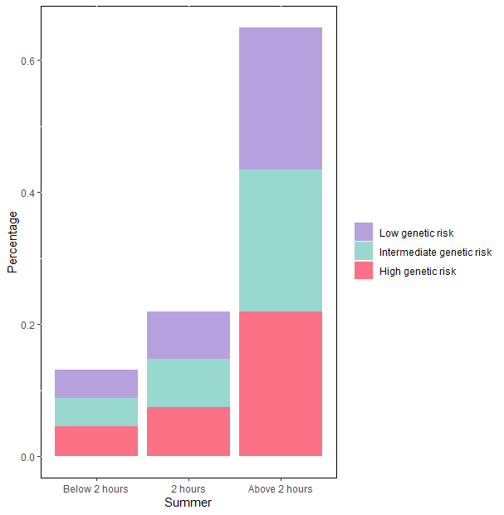
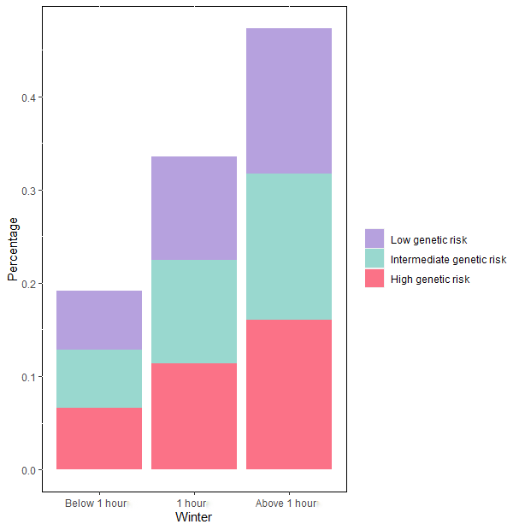
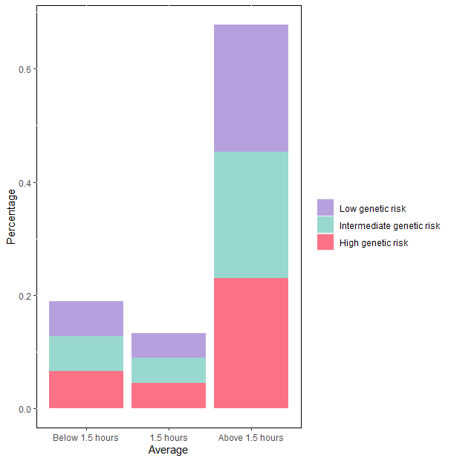

Figure S3. The correlation between gene risk and incident depression during follow-up.
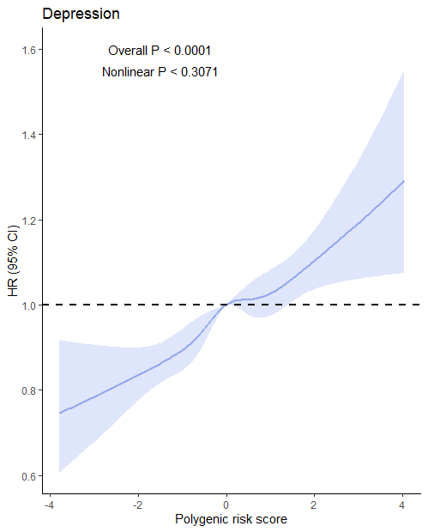
Abbreviation: HR, hazard ratio; 95% CI, 95% confidence interval.
Adjusted for age, gender, education, Townsend deprivation index, smoking status, drinking status, body mass index, total physical activity, sleep duration, fracture history, vitamin D supplement, hearing loss, use of sun/UV protection, PM_{2.5}, hypertension, and hyperglycemia.

Figure S4. The dose-response association between time spent in outdoor light in winter and depression risk after dividing individuals spent less 1 hour into a group.
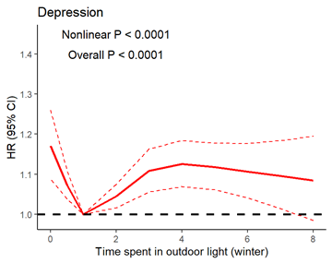
Figure S5. Dose-response association between time spent in outdoor light and the risk of depression after including extreme hours spent in outdoor light.

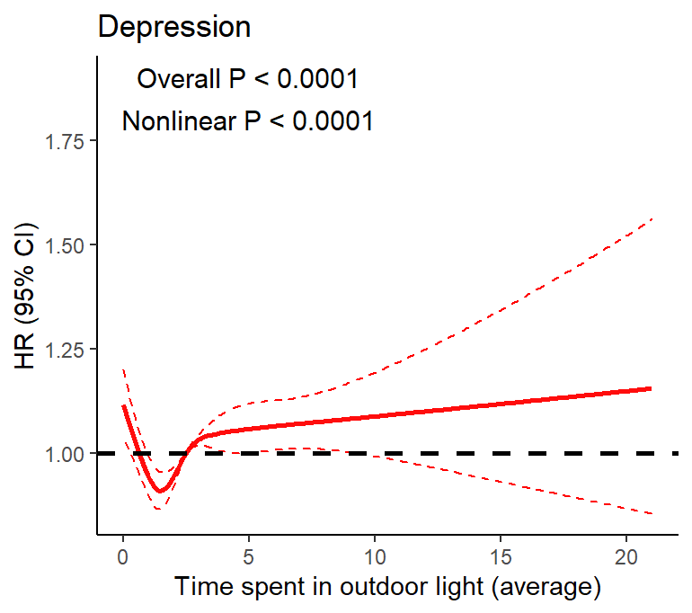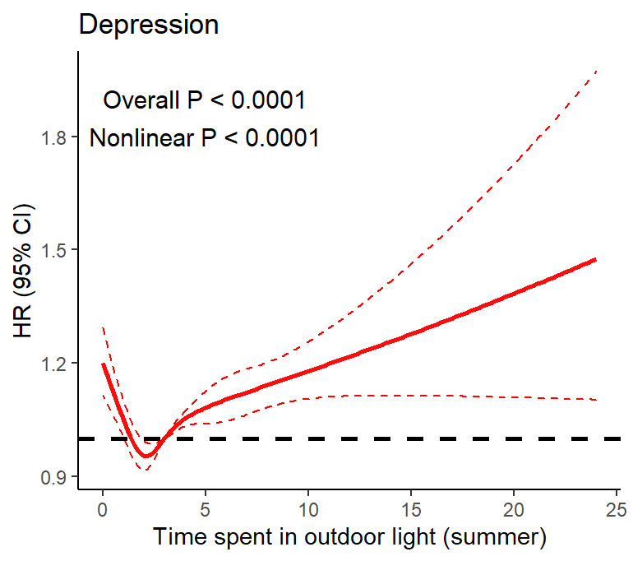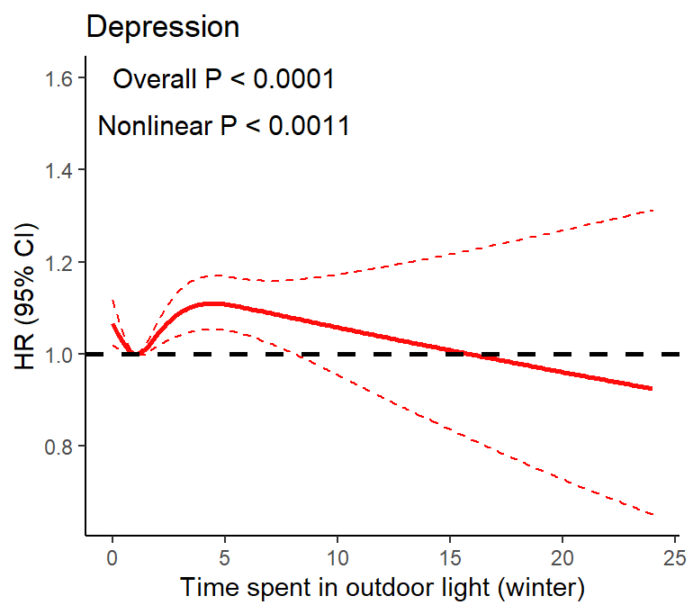

References:
1. Ma LZ, Ma YH, Ou YN, Chen SD, Yang L, Dong Q et al.. Time spent in outdoor light is associated with the risk of dementia: a prospective cohort study of 362094 participants. BMC MED 2022 2022-4-25; 20(1): 132.

