BMI and Well-being in people of East Asian and European Ancestry: A Mendelian Randomisation Study

Jessica O’Loughlin¹, Francesco Casanova¹, Amanda Hughes², Zammy Fairhurst-Hunter³, Liming Li⁴, Zhengming Chen^{3,5}, China Kadoorie Biobank Collaborative Group, Jack Bowden¹, Ed Watkins⁶, Rachel M. Freathy¹, Laura D Howe², Robin G Walters³, and Jessica Tyrrell¹

¹College of Biomedical and Clinical Sciences, Faculty of Health and Life Sciences, University of Exeter, United Kingdom

²MRC Integrative Epidemiology Unit (IEU), Population Health Sciences, Bristol Medical School, University of Bristol, United Kingdom

³Clinical Trial Service Unit and Epidemiological Studies Unit (CTSU), Nuffield Department of Population Health, University of Oxford, United Kingdom

⁴Department of Epidemiology and Biostatistics, School of Public Health, Peking University, Beijing

⁵MRC Population Health Research Unit, Nuffield Department of Population Health, University of Oxford, United Kingdom

⁶Department of Psychology, University of Exeter, United Kingdom

Corresponding Author: Dr Jessica Tyrrell (j.tyrrell@exeter.ac.uk)

Supplementary table 1: The BMI variants that reach P<1x10-8 in independent genome wide association studies in European ancestries that were extracted from the imputed CKB data.
chr | pos | SNP | Trait-raising allele | Other allele
1 | 167280354 | rs10733051 | A | G
1 | 197012111 | rs10754210 | G | A
1 | 11284336 | rs10779751 | A | G
1 | 225668524 | rs10915840 | A | G
1 | 190239907 | rs10920678 | A | G
1 | 119546842 | rs10923724 | C | T
1 | 219633869 | rs11118308 | G | A
1 | 65987164 | rs11208662 | C | G
1 | 155983710 | rs11577179 | G | A
1 | 101024370 | rs1158103 | G | A
1 | 112318484 | rs12033257 | A | G
1 | 107885018 | rs12035149 | G | C
1 | 77557339 | rs12035349 | G | A
1 | 173549827 | rs12039524 | A | G
1 | 195047936 | rs12041258 | T | C
1 | 74997762 | rs12042908 | A | G
1 | 243533273 | rs12042959 | A | G
1 | 1708801 | rs12044597 | G | A
1 | 174478100 | rs12564992 | G | A
1 | 118852975 | rs12731372 | T | C
1 | 209543560 | rs17014375 | G | T
1 | 107617707 | rs1730859 | G | A
1 | 15966713 | rs17448682 | C | T
1 | 107977075 | rs17531363 | A | C
1 | 96943994 | rs1973993 | T | C
1 | 97388226 | rs2030342 | T | C
1 | 80791708 | rs2154297 | T | C
1 | 46487552 | rs2275426 | A | G
1 | 39569571 | rs2282231 | T | C
1 | 62594677 | rs2481665 | C | T
1 | 242986063 | rs2491864 | A | G
1 | 72885281 | rs2590942 | T | G
1 | 201841476 | rs2820311 | G | A
1 | 82379446 | rs284227 | C | T
1 | 45620134 | rs346722 | C | T
1 | 243722892 | rs3753549 | C | T
1 | 19510394 | rs3762396 | A | G
1 | 110123971 | rs3768486 | G | A
1 | 98320492 | rs4372296 | A | C
1 | 33776728 | rs4653017 | T | C
1 | 177889480 | rs543874 | G | A
1 | 6715390 | rs6577584 | G | T
1 | 151018861 | rs6587552 | A | G
1 | 92976590 | rs6690764 | G | A
1 | 47700027 | rs6700838 | C | T
1 | 16828640 | rs696606 | A | G
1 | 72837239 | rs7531118 | C | T
1 | 49828663 | rs7531656 | A | G
1 | 2444414 | rs7535528 | G | A
1 | 8741401 | rs7556169 | G | A
1 | 17301672 | rs761423 | T | C
1 | 33307987 | rs785278 | T | A
1 | 154991389 | rs905938 | C | T
1 | 202116238 | rs9077 | G | A
1 | 173473713 | rs912768 | C | G
1 | 34602870 | rs9426003 | G | A
1 | 23399932 | rs967605 | C | T
2 | 51834839 | rs10168197 | G | C
2 | 25150296 | rs10182181 | G | A
2 | 61619267 | rs10190332 | G | T
2 | 103496700 | rs10203277 | A | G
2 | 229016917 | rs10211055 | C | T
2 | 198585087 | rs10497807 | G | C
2 | 6155557 | rs10929925 | C | A
2 | 175000711 | rs10930641 | A | G
2 | 220163543 | rs11889536 | A | G
2 | 228891702 | rs12479233 | T | A
2 | 102436738 | rs12615778 | A | G
2 | 206084372 | rs12694021 | C | A
2 | 61307982 | rs12713433 | T | C
2 | 199169278 | rs12991989 | C | G
2 | 632348 | rs13021737 | G | A
2 | 62848319 | rs13417156 | C | T
2 | 56603985 | rs13432055 | C | T
2 | 81816251 | rs1371108 | A | C
2 | 211983316 | rs1437929 | A | G
2 | 105466005 | rs1451533 | A | G
2 | 151198990 | rs16828086 | C | G
2 | 46878616 | rs17035438 | G | A
2 | 208255518 | rs17203016 | G | A
2 | 35512183 | rs17327461 | C | T
2 | 142293146 | rs17551974 | C | A
2 | 50865334 | rs2194385 | A | C
2 | 471514 | rs2724861 | G | A
2 | 67825685 | rs2902021 | C | T
2 | 5830599 | rs3922853 | C | A
2 | 100830040 | rs4303732 | C | T
2 | 28973883 | rs4372836 | T | C
2 | 147907202 | rs453520 | C | T
2 | 416815 | rs4639527 | G | A
2 | 37046657 | rs4670626 | C | T
2 | 58935282 | rs4671328 | T | G
2 | 60164634 | rs4671358 | A | T
2 | 211608379 | rs4673553 | G | T
2 | 110010962 | rs4676084 | G | A
2 | 603088 | rs4854326 | A | G
2 | 59307725 | rs6545714 | A | G
2 | 295255 | rs6548221 | A | G
2 | 143960593 | rs6710871 | A | G
2 | 40291940 | rs6713781 | C | G
2 | 230663576 | rs6720868 | C | T
2 | 172599615 | rs6738445 | T | C
2 | 58481863 | rs6753170 | T | C
2 | 512490 | rs7425440 | C | T
2 | 86766153 | rs7557796 | T | C
2 | 48954905 | rs7561278 | T | C
2 | 204012790 | rs7564679 | G | A
2 | 50735943 | rs7598402 | G | C
2 | 213413231 | rs7599312 | G | A
2 | 156018263 | rs7600699 | C | G
2 | 55281901 | rs7601895 | C | G
2 | 69562127 | rs7607351 | T | C
2 | 219279097 | rs7607369 | A | G
2 | 113955074 | rs902695 | G | A
2 | 198166565 | rs919433 | A | G
2 | 58792377 | rs929641 | A | G
2 | 50233352 | rs930295 | A | C
2 | 79482643 | rs934515 | A | G
2 | 181607676 | rs9630985 | C | A
2 | 51171962 | rs968972 | A | G
2 | 207244783 | rs972540 | G | A
2 | 60285100 | rs980329 | C | T
2 | 188325474 | rs993954 | T | G
3 | 135621417 | rs1014312 | G | C
3 | 42308735 | rs10460960 | A | G
3 | 6009092 | rs10510321 | T | C
3 | 34700713 | rs10865858 | T | C
3 | 134665159 | rs10935143 | A | G
3 | 15873407 | rs11128760 | A | G
3 | 21794904 | rs11711337 | A | T
3 | 70539559 | rs11915371 | A | C
3 | 56114861 | rs12488237 | C | T
3 | 50080174 | rs12631248 | G | C
3 | 49237334 | rs12637576 | C | T
3 | 89331055 | rs12638746 | G | A
3 | 193639623 | rs13072095 | T | C
3 | 171129859 | rs13085472 | T | C
3 | 51243837 | rs13095652 | C | T
3 | 131758077 | rs1320903 | A | G
3 | 85658230 | rs1375561 | T | C
3 | 104606130 | rs1436343 | G | A
3 | 62481063 | rs1452075 | T | C
3 | 176341188 | rs1454148 | C | T
3 | 94038085 | rs1454687 | C | G
3 | 8138801 | rs1554193 | T | A
3 | 136979939 | rs1600136 | C | A
3 | 115071668 | rs16823670 | A | G
3 | 141275436 | rs16851483 | T | G
3 | 48732480 | rs17080319 | C | T
3 | 136744386 | rs181732 | G | T
3 | 12394840 | rs1899951 | T | C
3 | 124687767 | rs1909586 | G | T
3 | 123093541 | rs2124499 | G | C
3 | 49936102 | rs2230590 | T | C
3 | 49343175 | rs2230929 | G | A
3 | 50420554 | rs2236950 | A | C
3 | 184044433 | rs2293605 | C | T
3 | 61236462 | rs2365389 | C | T
3 | 183486117 | rs262956 | T | G
3 | 53777176 | rs2680648 | T | C
3 | 52815905 | rs2710323 | C | T
3 | 42418446 | rs28350 | A | G
3 | 154034950 | rs355777 | C | G
3 | 115417865 | rs3772934 | T | C
3 | 52084040 | rs3821841 | C | T
3 | 81792112 | rs3849570 | C | A
3 | 9514856 | rs3915844 | G | A
3 | 173095123 | rs39654 | G | A
3 | 108119071 | rs4273371 | C | T
3 | 137215820 | rs4342060 | T | C
3 | 119571541 | rs4624596 | T | C
3 | 136907111 | rs4678297 | C | T
3 | 20441050 | rs4858193 | C | T
3 | 170744815 | rs5396 | C | T
3 | 13345450 | rs580438 | T | C
3 | 46742019 | rs6442021 | C | T
3 | 48130893 | rs6442101 | C | T
3 | 89442305 | rs6551410 | T | A
3 | 196088464 | rs6764533 | A | G
3 | 156893782 | rs6767619 | C | G
3 | 28727523 | rs6786125 | G | C
3 | 89443784 | rs6803870 | T | C
3 | 116937546 | rs6804181 | A | T
3 | 25106437 | rs6804842 | G | A
3 | 156299313 | rs7615297 | G | C
3 | 77624784 | rs775731 | C | T
3 | 157985182 | rs827092 | T | C
3 | 62713143 | rs925018 | G | C
3 | 90428286 | rs9714342 | T | C
3 | 41310470 | rs9814633 | A | G
3 | 185834499 | rs9816226 | T | A
3 | 51184893 | rs9827072 | A | G
3 | 89392778 | rs9832305 | C | T
3 | 50820486 | rs9838283 | A | G
3 | 49088112 | rs9846123 | C | T
3 | 136845666 | rs9881036 | G | A
4 | 38692835 | rs1000096 | C | T
4 | 45182527 | rs10938397 | G | A
4 | 147376805 | rs11736228 | A | T
4 | 65700865 | rs11945861 | G | A
4 | 137083193 | rs1296328 | A | C
4 | 162129844 | rs13110266 | A | G
4 | 20263058 | rs1323068 | G | A
4 | 30843533 | rs1345148 | C | T
4 | 119101723 | rs1403846 | T | C
4 | 145986668 | rs1455137 | C | A
4 | 18514827 | rs1477887 | G | A
4 | 55221467 | rs1492767 | C | T
4 | 163038241 | rs17538472 | T | C
4 | 44514468 | rs1866510 | C | T
4 | 91253956 | rs1903579 | C | G
4 | 55505360 | rs2192158 | G | A
4 | 49064487 | rs2768950 | A | G
4 | 102183594 | rs2850969 | T | C
4 | 112713436 | rs326889 | C | T
4 | 143663206 | rs331949 | T | C
4 | 89054667 | rs4148155 | A | G
4 | 6492739 | rs4524456 | G | A
4 | 130731284 | rs4864201 | T | C
4 | 28561990 | rs6448587 | C | A
4 | 16600664 | rs6818414 | T | C
4 | 153075491 | rs6827083 | G | A
4 | 103936001 | rs6843738 | G | A
4 | 52926216 | rs711347 | A | T
4 | 102708997 | rs7377083 | A | C
4 | 80794681 | rs7674623 | T | C
4 | 180167906 | rs7683836 | G | A
4 | 10491040 | rs7692088 | G | C
4 | 115124089 | rs7694732 | A | G
4 | 140881964 | rs769674 | T | A
4 | 60253877 | rs925421 | A | G
4 | 25428296 | rs9291467 | C | T
5 | 153095918 | rs10035289 | A | G
5 | 151254297 | rs10066835 | C | T
5 | 168192944 | rs1014194 | A | C
5 | 80818639 | rs12514473 | T | C
5 | 88858208 | rs12655756 | A | T
5 | 152274478 | rs12659802 | G | A
5 | 136571959 | rs13163306 | G | A
5 | 139080745 | rs13174863 | G | A
5 | 87125578 | rs1423627 | C | T
5 | 94206202 | rs159032 | T | C
5 | 138061341 | rs160401 | C | T
5 | 157516393 | rs1650586 | G | T
5 | 158271680 | rs17056301 | C | T
5 | 86908920 | rs17285919 | T | C
5 | 95933162 | rs174415 | A | T
5 | 167293652 | rs17525725 | G | A
5 | 86420392 | rs17591778 | A | G
5 | 86754835 | rs186543 | G | C
5 | 144484261 | rs2190788 | T | G
5 | 87988733 | rs2304607 | G | A
5 | 75003678 | rs2307111 | T | C
5 | 64168193 | rs2367112 | G | T
5 | 167352783 | rs248139 | A | G
5 | 141777439 | rs254428 | T | G
5 | 66175682 | rs25832 | A | G
5 | 95856501 | rs2611742 | C | T
5 | 133865452 | rs329124 | A | G
5 | 96080883 | rs3822683 | G | A
5 | 140992235 | rs3844598 | A | G
5 | 107439012 | rs40067 | G | A
5 | 27185904 | rs4518345 | G | A
5 | 138372345 | rs4643949 | T | C
5 | 87932809 | rs4916661 | G | T
5 | 95728898 | rs6235 | G | C
5 | 60712212 | rs6449531 | G | A
5 | 119372533 | rs6595205 | G | C
5 | 130356413 | rs6877851 | G | C
5 | 59208302 | rs6879326 | C | T
5 | 63932234 | rs6888159 | C | G
5 | 86727027 | rs7702514 | T | C
5 | 106506697 | rs7710595 | A | C
5 | 122733317 | rs7711753 | G | A
5 | 153537893 | rs7715256 | G | T
5 | 137631073 | rs7716275 | T | G
5 | 165185571 | rs7727781 | T | C
5 | 43191033 | rs7730004 | T | C
5 | 170459675 | rs7730898 | A | G
6 | 154309808 | rs10499276 | T | C
6 | 20705590 | rs11753081 | T | G
6 | 57642076 | rs12207241 | G | A
6 | 34644749 | rs12215331 | T | C
6 | 51822297 | rs1266922 | G | A
6 | 137675541 | rs13201877 | G | A
6 | 97374850 | rs13203153 | G | A
6 | 97753223 | rs13209872 | G | C
6 | 126089285 | rs13209968 | C | G
6 | 93913200 | rs1324110 | G | C
6 | 51825285 | rs1358808 | G | C
6 | 35619554 | rs1475774 | G | A
6 | 54724405 | rs1503139 | G | A
6 | 104799007 | rs156151 | C | G
6 | 27293049 | rs17739298 | C | G
6 | 87606842 | rs1853639 | G | A
6 | 27859568 | rs200968 | T | C
6 | 40348653 | rs2033529 | G | A
6 | 34975415 | rs2140418 | T | C
6 | 153381622 | rs2185027 | C | A
6 | 12124855 | rs2228213 | G | A
6 | 50566383 | rs2295896 | A | G
6 | 120213880 | rs2357760 | A | G
6 | 51638877 | rs2397061 | T | C
6 | 51160682 | rs2504674 | G | C
6 | 50820940 | rs2635727 | C | T
6 | 55169801 | rs2653365 | C | T
6 | 131897278 | rs2781668 | T | C
6 | 34617144 | rs2814992 | G | A
6 | 19078274 | rs2842385 | G | A
6 | 124925032 | rs2875762 | C | G
6 | 28059458 | rs3734572 | C | T
6 | 108996963 | rs3800229 | T | G
6 | 35512955 | rs3807049 | C | T
6 | 31322367 | rs3819299 | T | G
6 | 33554147 | rs419261 | C | T
6 | 53693410 | rs4278019 | A | T
6 | 57964315 | rs4339513 | T | C
6 | 160774459 | rs487060 | T | C
6 | 58060143 | rs6459326 | C | G
6 | 130349119 | rs6569648 | C | T
6 | 23876240 | rs6900723 | T | C
6 | 58705746 | rs6904676 | A | C
6 | 27527205 | rs6908295 | A | C
6 | 104493098 | rs6919443 | G | A
6 | 73742334 | rs6921533 | T | C
6 | 69968484 | rs6922214 | A | G
6 | 51843542 | rs6922855 | G | A
6 | 34683635 | rs6938239 | A | G
6 | 27408181 | rs760880 | T | G
6 | 51874745 | rs765332 | T | G
6 | 41133806 | rs7748777 | A | G
6 | 21919387 | rs7760082 | G | A
6 | 53990465 | rs816364 | G | A
6 | 35033854 | rs820077 | G | A
6 | 40080069 | rs847747 | G | T
6 | 28296863 | rs853679 | A | C
6 | 98539519 | rs901630 | T | C
6 | 58298846 | rs926279 | A | G
6 | 83433228 | rs9294260 | G | A
6 | 42676480 | rs9349239 | G | A
6 | 90296588 | rs9362662 | A | G
6 | 13189275 | rs9367368 | T | C
6 | 51546123 | rs9370042 | G | C
6 | 35672330 | rs9394312 | C | G
6 | 9952059 | rs9396763 | C | A
6 | 19211776 | rs9460306 | T | C
6 | 9510030 | rs9463175 | C | T
6 | 55013291 | rs9475173 | A | G
6 | 73922654 | rs9688431 | T | C
6 | 50803050 | rs987237 | G | A
6 | 43757896 | rs998584 | C | A
7 | 49616203 | rs10269783 | A | G
7 | 1273845 | rs10275044 | T | A
7 | 69598328 | rs1035010 | T | C
7 | 100804430 | rs1048365 | T | C
7 | 109173373 | rs10953620 | C | A
7 | 103417557 | rs11496125 | T | C
7 | 147668180 | rs11773362 | C | T
7 | 26526960 | rs12666574 | G | A
7 | 114349212 | rs12705987 | A | T
7 | 74094721 | rs13227433 | G | T
7 | 99064466 | rs13240600 | A | G
7 | 93232057 | rs13247665 | C | T
7 | 77417584 | rs1544459 | C | T
7 | 131619847 | rs1593304 | G | A
7 | 75101065 | rs17207196 | C | T
7 | 138794149 | rs1814170 | A | T
7 | 77829768 | rs1852006 | G | A
7 | 121964349 | rs1899689 | T | C
7 | 32368524 | rs215632 | G | A
7 | 126721231 | rs2283093 | T | C
7 | 35080931 | rs329277 | G | T
7 | 137424509 | rs3800649 | A | G
7 | 50564204 | rs3807566 | G | T
7 | 21470536 | rs40245 | A | T
7 | 94033031 | rs411717 | C | T
7 | 24354300 | rs4307239 | G | A
7 | 70040558 | rs4718966 | T | C
7 | 3125220 | rs4722398 | T | C
7 | 27231762 | rs4722672 | T | C
7 | 150668514 | rs4725984 | C | T
7 | 2103668 | rs6461115 | A | G
7 | 5542513 | rs6463489 | T | C
7 | 78144371 | rs6963840 | T | C
7 | 17287106 | rs6968554 | G | A
7 | 77055885 | rs740157 | A | G
7 | 73058017 | rs7777102 | G | A
7 | 6418275 | rs7784465 | C | T
7 | 897847 | rs7796608 | A | G
7 | 78121458 | rs7805441 | T | C
7 | 44784697 | rs799449 | T | C
7 | 28196413 | rs849135 | A | G
7 | 131896813 | rs874454 | G | A
7 | 130466854 | rs972283 | A | G
7 | 71888157 | rs993931 | G | A
8 | 14324437 | rs10110727 | G | A
8 | 118946541 | rs10955841 | A | G
8 | 10647823 | rs11250076 | A | G
8 | 23389571 | rs11781222 | C | T
8 | 118863061 | rs11781699 | C | T
8 | 10788875 | rs11783247 | C | T
8 | 15197115 | rs11987383 | A | C
8 | 11617240 | rs12458 | A | T
8 | 132879047 | rs12675063 | T | A
8 | 95582606 | rs12680842 | A | G
8 | 10626280 | rs12682565 | A | G
8 | 14095900 | rs13263601 | A | C
8 | 30856464 | rs1362910 | A | G
8 | 9511654 | rs1394 | A | G
8 | 9785503 | rs1399054 | A | G
8 | 77228222 | rs1405348 | G | A
8 | 73439070 | rs1431659 | A | G
8 | 26334167 | rs1594830 | G | C
8 | 4288577 | rs1658820 | T | G
8 | 138215228 | rs16906845 | G | A
8 | 81375457 | rs16907751 | C | T
8 | 67202787 | rs16932761 | A | G
8 | 89461609 | rs1700137 | C | T
8 | 4137396 | rs17069831 | C | T
8 | 27167942 | rs17446091 | T | C
8 | 28118130 | rs2100814 | A | G
8 | 11060638 | rs2409730 | C | A
8 | 15536311 | rs2543132 | G | C
8 | 85696337 | rs2634047 | G | C
8 | 116662038 | rs2721965 | A | C
8 | 101947453 | rs3134353 | T | A
8 | 116559435 | rs3808434 | A | G
8 | 144910239 | rs4076358 | A | G
8 | 20639811 | rs4366093 | C | T
8 | 64720693 | rs4737183 | G | A
8 | 11828200 | rs4841659 | T | C
8 | 9790041 | rs497417 | A | T
8 | 87519542 | rs7006629 | T | C
8 | 85077686 | rs733594 | T | C
8 | 8380471 | rs7827182 | G | C
8 | 34503776 | rs7844647 | T | C
8 | 38332318 | rs881301 | C | T
8 | 142630782 | rs903959 | A | T
8 | 10864363 | rs9657542 | G | C
9 | 103061366 | rs10118701 | G | A
9 | 92191256 | rs10797115 | C | T
9 | 126096522 | rs10818810 | G | A
9 | 127049237 | rs10818938 | A | G
9 | 81367391 | rs10867256 | C | T
9 | 16719445 | rs10962549 | T | C
9 | 104396304 | rs10989568 | A | G
9 | 14651283 | rs11790280 | C | T
9 | 140646121 | rs11792069 | G | A
9 | 37183628 | rs13290794 | G | A
9 | 129467340 | rs13292976 | T | C
9 | 28410996 | rs1412235 | C | G
9 | 83263089 | rs17351791 | A | C
9 | 8845911 | rs1865341 | T | C
9 | 120378483 | rs1928295 | T | C
9 | 73791849 | rs2174307 | C | G
9 | 129940416 | rs3739555 | T | G
9 | 88897891 | rs3739733 | A | G
9 | 129390800 | rs3829849 | T | C
9 | 129419025 | rs3902840 | A | G
9 | 101481205 | rs450231 | G | A
9 | 128616073 | rs4515655 | T | C
9 | 133783566 | rs4740383 | A | G
9 | 96482633 | rs4744275 | A | G
9 | 27612918 | rs483752 | T | C
9 | 15670492 | rs6474945 | G | T
9 | 111932342 | rs6477694 | C | T
9 | 109072075 | rs7024334 | T | G
9 | 6959840 | rs7042372 | A | G
9 | 122631560 | rs7865157 | C | T
9 | 94180627 | rs7869771 | A | C
9 | 131027982 | rs7871866 | C | G
9 | 27777012 | rs7874154 | C | T
10 | 102635475 | rs10883553 | A | C
10 | 104412049 | rs10883759 | G | A
10 | 118672531 | rs10886017 | A | C
10 | 88096047 | rs10887578 | C | G
10 | 102452136 | rs11190661 | T | C
10 | 2585792 | rs11251352 | A | G
10 | 76047464 | rs12098284 | C | T
10 | 104685299 | rs12411886 | A | C
10 | 19776828 | rs12776880 | A | T
10 | 102395440 | rs17094222 | C | T
10 | 105033015 | rs1712517 | C | T
10 | 126594078 | rs17636031 | C | T
10 | 53680085 | rs1937684 | T | A
10 | 100017453 | rs1983864 | T | G
10 | 65314711 | rs2163188 | C | G
10 | 93032943 | rs2631681 | C | T
10 | 27318776 | rs3781099 | T | C
10 | 33862727 | rs3851083 | G | A
10 | 99769388 | rs577525 | T | C
10 | 103984060 | rs7083450 | T | C
10 | 21821274 | rs7084454 | A | G
10 | 16750129 | rs7893571 | G | T
10 | 114758349 | rs7903146 | C | T
10 | 99032375 | rs793520 | A | G
10 | 125220036 | rs845084 | A | G
10 | 105675946 | rs9419958 | T | C
10 | 103206115 | rs9787495 | G | A
11 | 118913993 | rs1003081 | C | T
11 | 11796727 | rs1037587 | T | C
11 | 55091574 | rs10459012 | C | A
11 | 115044850 | rs1048932 | C | A
11 | 45706453 | rs10769165 | T | C
11 | 89966202 | rs10830452 | G | A
11 | 17394073 | rs10832778 | G | C
11 | 43551416 | rs10838122 | C | T
11 | 48286256 | rs10838852 | C | T
11 | 49994823 | rs10839472 | T | C
11 | 2234690 | rs10840606 | G | A
11 | 28629115 | rs11030385 | G | A
11 | 46895378 | rs11039014 | G | A
11 | 64082807 | rs11600990 | C | T
11 | 134601012 | rs12364470 | G | T
11 | 115623272 | rs12417072 | A | G
11 | 117017530 | rs12420725 | G | A
11 | 46422686 | rs12574668 | C | A
11 | 8694073 | rs12575252 | G | C
11 | 43728534 | rs12577642 | A | T
11 | 86133416 | rs1452134 | T | C
11 | 48901553 | rs1473579 | A | G
11 | 29158495 | rs1552717 | A | T
11 | 131957293 | rs1625427 | T | C
11 | 46520302 | rs17197116 | C | T
11 | 30243868 | rs1782507 | G | T
11 | 69481969 | rs1789165 | A | G
11 | 56973793 | rs1943477 | C | T
11 | 32131303 | rs223051 | T | C
11 | 70563286 | rs2440885 | A | G
11 | 93221105 | rs2605603 | G | A
11 | 122765667 | rs3134438 | A | C
11 | 133827733 | rs3802924 | C | A
11 | 56446833 | rs4542429 | C | T
11 | 132641959 | rs4936175 | C | T
11 | 121942512 | rs4936671 | C | G
11 | 56206141 | rs4939051 | C | G
11 | 65886662 | rs524281 | C | A
11 | 55323307 | rs551137 | T | C
11 | 117267884 | rs573455 | G | A
11 | 69299771 | rs587230 | A | G
11 | 27679916 | rs6265 | C | T
11 | 65594820 | rs7102454 | C | T
11 | 78040259 | rs7117238 | G | A
11 | 49459474 | rs7120873 | C | T
11 | 66662731 | rs7122539 | A | G
11 | 72444583 | rs7123876 | C | T
11 | 27677041 | rs7124442 | C | T
11 | 47529947 | rs7124681 | A | C
11 | 47836302 | rs7131262 | T | A
11 | 113234679 | rs719802 | T | C
11 | 48630323 | rs7478904 | C | T
11 | 49620595 | rs7924371 | C | T
11 | 122522375 | rs7941030 | C | T
11 | 28763321 | rs7948120 | C | T
11 | 13294268 | rs900144 | T | C
12 | 17212881 | rs10744146 | G | A
12 | 97586257 | rs10745785 | C | T
12 | 33379440 | rs10772055 | G | C
12 | 124506631 | rs10773049 | C | T
12 | 17360254 | rs10840674 | G | A
12 | 24060075 | rs10842240 | C | G
12 | 112771063 | rs10850031 | G | T
12 | 39428802 | rs10876418 | C | T
12 | 69642315 | rs10878946 | T | C
12 | 82465797 | rs11115176 | T | C
12 | 39982413 | rs11172702 | G | A
12 | 939480 | rs11611246 | T | G
12 | 38242029 | rs12306932 | C | T
12 | 112019799 | rs12369009 | T | G
12 | 14413931 | rs12422552 | C | G
12 | 111780998 | rs1558236 | C | G
12 | 38529333 | rs17096549 | A | G
12 | 110046698 | rs17608150 | C | T
12 | 68205604 | rs1819844 | A | G
12 | 48180508 | rs2240108 | T | C
12 | 2152655 | rs2429150 | C | A
12 | 23067302 | rs2467110 | T | C
12 | 90595383 | rs2731222 | A | C
12 | 41880909 | rs2733287 | C | A
12 | 111800258 | rs3809272 | A | G
12 | 51593616 | rs4077093 | T | G
12 | 54653258 | rs4759073 | G | A
12 | 56508409 | rs4759228 | G | C
12 | 103658096 | rs4764949 | A | G
12 | 114437708 | rs4766710 | A | G
12 | 18789007 | rs621042 | A | C
12 | 111768973 | rs6490055 | A | G
12 | 99560183 | rs651548 | A | G
12 | 39159190 | rs6580755 | C | T
12 | 124409502 | rs7133378 | A | G
12 | 20473758 | rs7134375 | A | C
12 | 50247468 | rs7138803 | A | G
12 | 89899912 | rs7313924 | C | G
12 | 39329294 | rs7958206 | A | G
12 | 49987929 | rs7965658 | G | A
12 | 133481917 | rs7968230 | G | A
12 | 118409640 | rs7973955 | G | A
12 | 60964108 | rs7975187 | A | G
12 | 117579274 | rs884282 | T | C
13 | 28047269 | rs1006353 | A | G
13 | 31033232 | rs1045411 | C | T
13 | 54694130 | rs10467530 | C | G
13 | 28011963 | rs1218822 | A | G
13 | 54102206 | rs12429545 | A | G
13 | 59425111 | rs1333423 | A | T
13 | 78371890 | rs1668633 | T | C
13 | 96922191 | rs1927790 | C | T
13 | 111984244 | rs2479958 | G | A
13 | 76386075 | rs629443 | T | G
13 | 99120484 | rs7334078 | T | C
13 | 65884191 | rs892261 | C | T
13 | 28620036 | rs9507983 | C | T
13 | 58402479 | rs9527706 | A | G
13 | 79563749 | rs9530843 | C | A
13 | 59178258 | rs9538141 | A | G
13 | 66205704 | rs9540493 | A | G
13 | 36230485 | rs9544915 | T | C
13 | 28681228 | rs9554263 | G | C
13 | 67472713 | rs9571687 | C | A
13 | 33184288 | rs9595908 | T | C
13 | 40783323 | rs9603697 | T | C
14 | 97258752 | rs10131890 | C | A
14 | 25928179 | rs10132280 | C | A
14 | 79499850 | rs10146527 | T | C
14 | 65910844 | rs11844682 | G | C
14 | 72269668 | rs1205106 | A | G
14 | 47272423 | rs12587412 | T | G
14 | 29736838 | rs12885454 | C | A
14 | 77529783 | rs17105272 | T | C
14 | 33302882 | rs17522122 | T | G
14 | 91512339 | rs1951455 | C | T
14 | 40101060 | rs1956151 | A | G
14 | 79903993 | rs2003616 | T | G
14 | 103862322 | rs2010281 | G | A
14 | 92428410 | rs2160077 | A | G
14 | 62360464 | rs217671 | G | A
14 | 65426216 | rs2412107 | G | T
14 | 103246470 | rs3803286 | A | G
14 | 99671788 | rs3850422 | G | A
14 | 69789755 | rs3902951 | T | G
14 | 29680331 | rs4981693 | A | G
14 | 101539384 | rs7147503 | C | T
14 | 82684748 | rs799132 | T | A
15 | 77156899 | rs10519151 | A | T
15 | 84580156 | rs11259933 | G | A
15 | 66741387 | rs11629783 | C | G
15 | 78012618 | rs11855853 | C | T
15 | 92570921 | rs12101393 | C | G
15 | 77254544 | rs12148386 | T | C
15 | 46584787 | rs12439798 | T | G
15 | 81058652 | rs12593036 | G | A
15 | 62316035 | rs12595158 | C | T
15 | 79432359 | rs12595749 | A | G
15 | 68104367 | rs13329567 | C | T
15 | 89928189 | rs150353 | G | T
15 | 57120989 | rs1657930 | G | A
15 | 68103632 | rs16951319 | T | C
15 | 62150364 | rs17238110 | G | A
15 | 76863838 | rs2459359 | G | C
15 | 76150965 | rs2593280 | A | G
15 | 41751678 | rs316611 | T | C
15 | 60908307 | rs340025 | C | T
15 | 51748610 | rs3736485 | A | G
15 | 76755506 | rs403656 | A | G
15 | 31843528 | rs4284600 | T | C
15 | 77207277 | rs4886506 | T | G
15 | 77799657 | rs4886869 | G | A
15 | 27040082 | rs4906908 | G | T
15 | 64849904 | rs6494481 | G | T
15 | 78117685 | rs6495252 | C | T
15 | 73093991 | rs7164727 | T | C
15 | 95271404 | rs7181498 | T | C
15 | 77915282 | rs8024932 | T | G
15 | 61445514 | rs8033510 | T | C
15 | 36402716 | rs8036040 | A | C
16 | 6701400 | rs10083803 | C | T
16 | 69174141 | rs10500548 | T | C
16 | 29833714 | rs1057452 | A | G
16 | 20255123 | rs11074446 | T | C
16 | 62803841 | rs11075489 | C | T
16 | 53805344 | rs11075986 | C | G
16 | 71899586 | rs11642001 | A | G
16 | 387867 | rs11866815 | C | T
16 | 52548037 | rs12443621 | G | A
16 | 3599655 | rs12448257 | A | G
16 | 56489343 | rs12448738 | C | A
16 | 67420603 | rs12920590 | T | C
16 | 82438337 | rs12922346 | C | G
16 | 31141993 | rs1549293 | C | T
16 | 50986308 | rs1564981 | A | G
16 | 53770578 | rs16952479 | T | A
16 | 51926509 | rs17795934 | C | T
16 | 24803620 | rs1862451 | G | A
16 | 54153099 | rs2075205 | A | T
16 | 49062590 | rs2080454 | C | A
16 | 68381978 | rs2307022 | A | G
16 | 2097158 | rs2516739 | G | A
16 | 6509009 | rs2534760 | T | A
16 | 68295598 | rs2863981 | G | A
16 | 53818708 | rs3751813 | G | T
16 | 3730613 | rs3794702 | T | A
16 | 29994922 | rs3814883 | T | C
16 | 82650384 | rs4783241 | G | C
16 | 15129459 | rs4985155 | A | G
16 | 76779612 | rs6564360 | G | A
16 | 28857645 | rs7187776 | G | A
16 | 24578458 | rs7195386 | T | C
16 | 67316600 | rs7200919 | A | G
16 | 82872628 | rs7206608 | G | C
16 | 72996162 | rs756717 | G | A
16 | 70514828 | rs7919 | A | C
16 | 80752293 | rs8046061 | C | T
16 | 53798523 | rs8047395 | A | G
16 | 73606563 | rs825680 | A | T
16 | 20050466 | rs868554 | G | C
16 | 4015729 | rs879620 | T | C
16 | 69556715 | rs889398 | C | T
16 | 54234492 | rs907011 | T | G
16 | 71965915 | rs952159 | A | G
16 | 9724750 | rs977540 | G | A
16 | 53831146 | rs9922708 | T | C
16 | 23833071 | rs9927848 | C | A
16 | 53825238 | rs9931164 | A | G
16 | 20375351 | rs9931967 | T | G
17 | 5283252 | rs1000940 | A | G
17 | 28074563 | rs1038088 | G | T
17 | 79202329 | rs1048775 | C | G
17 | 51923847 | rs10515050 | C | T
17 | 15943910 | rs1075901 | C | T
17 | 34942595 | rs1106908 | G | A
17 | 47090785 | rs11079849 | C | T
17 | 31747629 | rs12453418 | G | A
17 | 65870073 | rs12602912 | T | C
17 | 77796889 | rs1285245 | G | C
17 | 78611724 | rs12939549 | A | G
17 | 39573713 | rs16966801 | A | G
17 | 46252346 | rs208015 | T | C
17 | 65694355 | rs2537847 | G | A
17 | 71754545 | rs2619976 | T | C
17 | 1846831 | rs4516268 | C | A
17 | 35057883 | rs4796243 | G | A
17 | 78640510 | rs4889782 | C | T
17 | 79081724 | rs4969387 | G | C
17 | 21261560 | rs4986044 | C | T
17 | 73759552 | rs7209235 | A | G
17 | 31460899 | rs7211567 | C | T
17 | 2136065 | rs7217226 | G | T
17 | 59497277 | rs757608 | G | A
17 | 29349688 | rs8067737 | T | C
17 | 42935059 | rs8069296 | T | C
17 | 38160754 | rs8070454 | C | T
17 | 55336155 | rs8071182 | A | G
17 | 61728881 | rs8075273 | C | A
17 | 5412361 | rs8079034 | T | C
17 | 46051911 | rs886444 | G | A
17 | 46669430 | rs9299 | T | C
17 | 80052073 | rs9905991 | A | G
18 | 42950629 | rs10438964 | T | C
18 | 73498528 | rs11150911 | A | C
18 | 57726627 | rs12327272 | A | G
18 | 6873954 | rs1241986 | G | A
18 | 21116998 | rs12964689 | G | A
18 | 36182440 | rs1365466 | T | C
18 | 51478026 | rs1498139 | A | C
18 | 947954 | rs1608445 | G | A
18 | 31581247 | rs16965062 | T | C
18 | 76742544 | rs1787267 | G | C
18 | 37103550 | rs1791253 | T | G
18 | 31251276 | rs1941697 | A | G
18 | 57741783 | rs1942866 | C | G
18 | 57677294 | rs2000746 | G | A
18 | 63297672 | rs2012927 | A | G
18 | 58039276 | rs2229616 | C | T
18 | 23178748 | rs273697 | G | A
18 | 40992698 | rs555267 | G | T
18 | 57838401 | rs663129 | A | G
18 | 45921214 | rs7239114 | A | G
18 | 56883319 | rs7243357 | T | G
18 | 58371566 | rs8087550 | A | C
18 | 69224478 | rs8089514 | A | T
18 | 52479487 | rs8092503 | G | A
18 | 57804346 | rs8095404 | T | A
18 | 42598463 | rs954018 | G | A
18 | 57969244 | rs9675376 | A | G
18 | 60739250 | rs9951893 | C | T
18 | 57853056 | rs9961813 | A | C
19 | 33963766 | rs10408013 | T | C
19 | 46180184 | rs11672660 | C | T
19 | 12994140 | rs12609744 | C | T
19 | 18454825 | rs17724992 | A | G
19 | 45395619 | rs2075650 | G | A
19 | 19789528 | rs2304130 | A | G
19 | 18215247 | rs273504 | G | A
19 | 30683879 | rs2866816 | T | C
19 | 34311481 | rs29938 | C | T
19 | 47569003 | rs3810291 | A | G
19 | 42637232 | rs3826705 | C | T
19 | 30296853 | rs8102137 | C | T
20 | 32738612 | rs1015362 | T | C
20 | 32738335 | rs1015363 | A | G
20 | 15801600 | rs12480713 | T | C
20 | 62380542 | rs12625413 | C | T
20 | 32542814 | rs13041173 | G | A
20 | 34025756 | rs143384 | A | G
20 | 32606299 | rs17091470 | G | T
20 | 51107290 | rs17806379 | C | T
20 | 1410582 | rs1884389 | T | C
20 | 6612832 | rs1884897 | G | A
20 | 41987392 | rs2143253 | G | A
20 | 25971327 | rs2386802 | C | A
20 | 44914134 | rs2425857 | A | G
20 | 31097877 | rs293566 | T | C
20 | 62127121 | rs310618 | C | T
20 | 33703607 | rs3746429 | T | C
20 | 16564210 | rs4814512 | A | C
20 | 54157497 | rs559267 | G | A
20 | 61530915 | rs6011457 | T | A
20 | 47495560 | rs6019482 | C | T
20 | 33594226 | rs6060151 | G | T
20 | 33170752 | rs6088529 | A | C
20 | 30785593 | rs6121381 | T | A
20 | 26073030 | rs6132918 | C | T
20 | 25059442 | rs6138482 | T | C
20 | 32686658 | rs6142096 | A | G
20 | 3026069 | rs676749 | A | T
20 | 30504530 | rs8121840 | A | G
20 | 15819495 | rs8123881 | G | A
20 | 62522315 | rs8567 | G | A
21 | 40309436 | rs13047416 | C | G
21 | 40627020 | rs2836961 | C | A
21 | 42653567 | rs2838006 | C | T
21 | 46570896 | rs427943 | C | A
21 | 39238610 | rs762147 | G | A
21 | 34153330 | rs9979651 | G | C
22 | 40604945 | rs4820408 | T | G
22 | 40640285 | rs5750913 | G | A
22 | 48875699 | rs9615905 | T | C

ST2: Genetic variants associated with BMI at genome-wide significance (P<5x10-8) in the GIANT consortium of up to 339,224 people of European ancestry used in the BMI GRS for our UKB analyses
SNP | Trait raising allele | Other allele | Beta | SE
rs1000940 | G | A | 0.0192 | 0.0034
rs10132280 | C | A | 0.023 | 0.0034
rs1016287 | T | C | 0.0229 | 0.0034
rs10182181 | G | A | 0.0307 | 0.0031
rs10733682 | A | G | 0.0174 | 0.0031
rs10938397 | G | A | 0.0402 | 0.0031
rs10968576 | G | A | 0.0249 | 0.0033
rs11057405 | G | A | 0.0307 | 0.0055
rs11126666 | A | G | 0.0207 | 0.0034
rs11165643 | T | C | 0.0218 | 0.0031
rs11191560 | C | T | 0.0308 | 0.0053
rs11583200 | C | T | 0.0177 | 0.0031
rs1167827 | G | A | 0.0202 | 0.0033
rs11688816 | G | A | 0.0172 | 0.0031
rs11727676 | T | C | 0.0358 | 0.0064
rs11847697 | T | C | 0.0492 | 0.0084
rs12286929 | G | A | 0.0217 | 0.0031
rs12401738 | A | G | 0.0211 | 0.0033
rs12429545 | A | G | 0.0334 | 0.0047
rs12446632 | G | A | 0.0403 | 0.0046
rs12566985 | G | A | 0.0242 | 0.0031
rs12885454 | C | A | 0.0207 | 0.0033
rs12940622 | G | A | 0.0182 | 0.0031
rs13021737 | G | A | 0.0601 | 0.004
rs13078960 | G | T | 0.0297 | 0.0039
rs13191362 | A | G | 0.0277 | 0.0048
rs1516725 | C | T | 0.0451 | 0.0046
rs1528435 | T | C | 0.0178 | 0.0031
rs1558902 | A | T | 0.0818 | 0.0031
rs16851483 | T | G | 0.0483 | 0.0077
rs16951275 | T | C | 0.0311 | 0.0037
rs17001654 | G | C | 0.0306 | 0.0053
rs17024393 | C | T | 0.0658 | 0.0088
rs17094222 | C | T | 0.0249 | 0.0038
rs17405819 | T | C | 0.0224 | 0.0033
rs17724992 | A | G | 0.0194 | 0.0035
rs1808579 | C | T | 0.0167 | 0.0031
rs1928295 | T | C | 0.0188 | 0.0031
rs2033529 | G | A | 0.019 | 0.0033
rs2033732 | C | T | 0.0192 | 0.0035
rs205262 | G | A | 0.0221 | 0.0035
rs2075650 | A | G | 0.0258 | 0.0045
rs2112347 | T | G | 0.0261 | 0.0031
rs2121279 | T | C | 0.0245 | 0.0044
rs2176598 | T | C | 0.0198 | 0.0036
rs2207139 | G | A | 0.0447 | 0.004
rs2245368 | C | T | 0.0317 | 0.0057
rs2287019 | C | T | 0.036 | 0.0042
rs2365389 | C | T | 0.02 | 0.0031
rs2650492 | A | G | 0.0207 | 0.0035
rs2820292 | C | A | 0.0195 | 0.0031
rs29941 | G | A | 0.0182 | 0.0033
rs3101336 | C | T | 0.0334 | 0.0031
rs3736485 | A | G | 0.0176 | 0.0031
rs3810291 | A | G | 0.0283 | 0.0036
rs3817334 | T | C | 0.0262 | 0.0031
rs3849570 | A | C | 0.0188 | 0.0034
rs4256980 | G | C | 0.0209 | 0.0031
rs4740619 | T | C | 0.0179 | 0.0031
rs543874 | G | A | 0.0482 | 0.0039
rs6477694 | C | T | 0.0174 | 0.0031
rs6567160 | C | T | 0.0556 | 0.0036
rs657452 | A | G | 0.0227 | 0.0031
rs6804842 | G | A | 0.0185 | 0.0031
rs7138803 | A | G | 0.0315 | 0.0031
rs7141420 | T | C | 0.0235 | 0.0031
rs7243357 | T | G | 0.0217 | 0.004
rs758747 | T | C | 0.0225 | 0.0037
rs7599312 | G | A | 0.022 | 0.0034
rs7899106 | G | A | 0.0395 | 0.0071
rs9581854 | T | C | 0.03 | 0.005
rs9400239 | C | T | 0.0188 | 0.0033
rs9925964 | A | G | 0.0192 | 0.0031

ST3: A table showing our health satisfaction outcome in CKB stratified by sex and region of residence within China.
Region | Urban_Rural | Sex | 0 – Poor | 1 – Fair | 2 – Good | 3 – Excellent
Qingdao | Urban | Female N(%) | 331 (6.7) | 2486 (50.0) | 1162 (23.4) | 995 (20.0)
Qingdao | Urban | Male N(%) | 198 (6.0) | 1,428 (43.4) | 941 (28.6) | 720 (21.9)
Harbin | Urban | Female N(%) | 987 (12.8) | 3303 (42.8) | 1340 (17.3) | 2097 (27.1)
Harbin | Urban | Male N(%) | 530 (9.8) | 2056 (38.1) | 1052 (19.5) | 1756 (32.6)
Haikou | Urban | Female N(%) | 305 (8.5) | 2173 (60.2) | 695 (19.3) | 434 (12.0)
Haikou | Urban | Male N(%) | 165 (7.6) | 1182 (54.2) | 508 (23.3) | 325 (14.9)
Suzhou | Urban | Female N(%) | 593 (12.9) | 1261 (27.5) | 1539 (33.6) | 1194 (26.0)
Suzhou | Urban | Male N(%) | 304 (9.0) | 824 (24.3) | 1138 (33.6) | 1124 (33.2)
Liuzhou | Urban | Female N(%) | 472 (9.3) | 2939 (58.1) | 947 (18.7) | 703 (13.9)
Liuzhou | Urban | Male N(%) | 381 (10.2) | 1977 (53.0) | 730 (19.6) | 644 (17.3)
Sichuan | Rural | Female N(%) | 1701 (26.8) | 2570 (40.5) | 1720 (27.1) | 356 (5.6)
Sichuan | Rural | Male N(%) | 870 (20.3) | 1785 (41.7) | 1298 (30.3) | 331 (7.7)
Gansu | Rural | Female N(%) | 886 (15.0) | 2401 (40.7) | 1674 (28.4) | 932 (15.8)
Gansu | Rural | Male N(%) | 444 (10.7) | 1455 (35.0) | 1192 (28.7) | 1069 (25.7)
Henan | Rural | Female N(%) | 981 (16.3) | 2596 (43.0) | 1807 (30.0) | 650 (10.9)
Henan | Rural | Male N(%) | 686 (12.8) | 2216 (41.2) | 1725 (32.1) | 752 (14.0)
Zhejiang | Rural | Female N(%) | 422 (6.1) | 2567 (37.3) | 3017 (43.8) | 877 (12.7)
Zhejiang | Rural | Male N(%) | 256 (5.0) | 2015 (39.1) | 2108 (40.9) | 771 (15.0)
Hunan | Rural | Female N(%) | 571 (8.8) | 3891 (60.2) | 1275 (19.7) | 723 (11.2)
Hunan | Rural | Male N(%) | 533(8.8) | 3459 (57.2) | 1319 (21.8) | 734 (12.1)

ST4: A table showing our life satisfaction outcome in CKB stratified by sex and region of residence within China.
Region | Urban_Rural | Sex | 0 – Unsatisfied | 1 – Neither | 2 – Satisfied | 3 - Very satisfied
Qingdao | Urban | Female N(%) | 108 (2.2) | 1,445 (29.1) | 2633 (52.9) | 788 (15.8)
Qingdao | Urban | Male N(%) | 127 (3.9) | 954 (29.0) | 1700 (51.7) | 506 (15.4)
Harbin | Urban | Female N(%) | 415 (5.4) | 1213 (5.7) | 5144 (66.6) | 955 (12.4)
Harbin | Urban | Male N(%) | 344(6.4) | 734 (13.6) | 3594 (66.6) | 722 (13.4)
Haikou | Urban | Female N(%) | 250 (6.9) | 1939 (53.8) | 1333 (37.0) | 85 (2.4)
Haikou | Urban | Male N(%) | 157 (7.2) | 1020 (46.8) | 925 (42.4) | 78 (3.6)
Suzhou | Urban | Female N(%) | 449 (9.8) | 1,646 (35.9) | 1,826 (39.8) | 666 (14.5)
Suzhou | Urban | Male N(%) | 269 (7.9) | 1,094 (32.3) | 1,587 (46.8) | 440 (13.0)
Liuzhou | Urban | Female N(%) | 375 (7.4) | 1,868 (36.9) | 2,559 (50.6) | 259 (5.1)
Liuzhou | Urban | Male N(%) | 357 (9.6) | 1,282 (34.4) | 1,916 (51.3) | 177 (4.7)
Sichuan | Rural | Female N(%) | 194 (3.1) | 1,957 (30.8) | 2,981 (47.0) | 1,215 (19.1)
Sichuan | Rural | Male N(%) | 108 (2.5) | 1,033 (24.1) | 2,245 (52.4) | 898 (21.0)
Gansu | Rural | Female N(%) | 133 (2.3) | 484 (8.2) | 2,937 (49.8) | 2,339 (39.7)
Gansu | Rural | Male N(%) | 134 (3.2) | 326 (7.8) | 1,980 (47.6) | 1,720 (41.4)
Henan | Rural | Female N(%) | 193 (3.2) | 1,180 (19.6) | 1,733 (28.7) | 2,928 (48.5)
Henan | Rural | Male N(%) | 239 (4.4) | 881 (16.4) | 1,847 (34.3) | 2,412 (44.8)
Zhejiang | Rural | Female N(%) | 251 (3.7) | 2,486 (36.1) | 3,619 (52.6) | 527 (7.7)
Zhejiang | Rural | Male N(%) | 173 (3.4) | 1,975 (38.4) | 2,685 (52.1) | 317 (6.2)
Hunan | Rural | Female N(%) | 45 (0.7) | 2,276 (35.2) | 3,842 (59.5) | 297 (4.6)
Hunan | Rural | Male N(%) | 55 (0.9) | 2,051 (33.9) | 3,674 (60.8) | 265 (4.4)

ST5: The observational associations between BMI and health and life satisfaction in the CKB and UKB stratified by urban and rural regions further adjusting for measures of socioeconomic status.
 |  |  | CKB |  | UKB
Study | Strata | Region | Beta (95% CI) per SD higher BMI | Pa | Beta (95% CI) per SD higher BMI | Pb
Health satisfaction | All | Both | 0.020 (0.015, 0.026) | 3.30E-12 | -0.162 (-0.164, -0.159) | <1.00E-15
Health satisfaction | Male | Both | 0.028 (0.018, 0.037) | 2.60E-09 | -0.171 (-0.175, -0.167) | <1.00E-15
Health satisfaction | Female | Both | 0.018 (0.010, 0.025) | 2.50E-06 | -0.154 (-0.158, -0.150) | <1.00E-15
Health satisfaction | All | Urban only | 0.011 (0.001, 0.020) | 0.02 | -0.161 (-0.164, -0.158) | <1.00E-15
Health satisfaction | Male | Urban only | 0.012 (-0.003, 0.027) | 0.11 | -0.170 (-0.174, -0.166) | <1.00E-15
Health satisfaction | Female | Urban only | 0.010 (-0.002, 0.022) | 0.09 | -0.154 (-0.158, -0.150) | <1.00E-15
Health satisfaction | All | Rural only | 0.025 (0.017, 0.032) | 4.70E-11 | -0.162 (-0.169, -0.155) | <1.00E-15
Health satisfaction | Male | Rural only | 0.037 (0.026, 0.049) | 2.30E-10 | -0.175 (-0.185, -0.165) | <1.00E-15
Health satisfaction | Female | Rural only | 0.019 (0.009, 0.028) | 1.10E-04 | -0.151 (-0.160, -0.141) | <1.00E-15
Life Satisfaction | All | Both | 0.054 (0.049, 0.059) | <1.00E-15 | -0.008 (-0.013, -0.003) | 3.20E-03
Life Satisfaction | Male | Both | 0.048 (0.040, 0.056) | <1.00E-15 | 0.000 (-0.007, 0.008) | 0.92
Life Satisfaction | Female | Both | 0.060 (0.053, 0.066) | <1.00E-15 | -0.014 (-0.021, -0.006) | 2.30E-04
Life Satisfaction | All | Urban only | 0.031 (0.024, 0.038) | <1.00E-15 | -0.008 (-0.014, -0.002) | 5.60E-03
Life Satisfaction | Male | Urban only | 0.025 (0.014, 0.036) | <1.00E-15 | -0.002 (-0.011, 0.006) | 0.61
Life Satisfaction | Female | Urban only | 0.036 (0.027, 0.045) | 3.80E-15 | -0.012 (-0.020, -0.004) | 3.10E-03
Life Satisfaction | All | Rural only | 0.059 (0.053, 0.066) | <1.00E-15 | -0.008 (-0.022, 0.005) | 0.21
Life Satisfaction | Male | Rural only | 0.060 (0.050, 0.070) | <1.00E-15 | 0.013 (-0.006, 0.032) | 0.18
Life Satisfaction | Female | Rural only | 0.057 (0.049, 0.066) | <1.00E-15 | -0.024 (-0.042, -0.006) | 0.01
Pa adjusted for age, region, sex (all only), SES, smoking, alcohol consumption, education and household income.
Pb adjusted for age, centre, sex (all only), TDI, smoking, alcohol consumption, education and household income.

ST6: The comparison of the 1-sample genetic associations between BMI and health satisfaction in the CKB and the UKB.
 |  | CKB | UKB
Strata | Region | Beta (SE) | Beta (SE) | P_{difference}
All | Both | 0.026 (0.017) | -0.183 (0.009) | <1.00E-15
Male | Both | -0.006 (0.030) | -0.231 (0.012) | 1.75E-12
Female | Both | 0.041 (0.020) | -0.206 (0.012) | 1.24E-04
All | Urban only | 0.022 (0.027) | -0.184 (0.010) | 2.79E-04
Male | Urban only | -0.004 (0.049) | -0.234 (0.013) | 4.98E-06
Female | Urban only | 0.035 (0.033) | -0.203 (0.012) | 1.23E-11
All | Rural only | 0.028 (0.021) | -0.167 (0.023) | 5.37E-10
Male | Rural only | -0.008 (0.037) | -0.173 (0.031) | 6.01E-04
Female | Rural only | 0.045 (0.026) | -0.177 (0.032) | 6.75E-08
P_{difference} calculated using Fishers z-score method.

ST7: The meta-analysed estimates with heterogeneity statistics for genetic 1-sample associations between BMI and health and life satisfaction in individuals with valid genetic data from the China Kadoorie Biobank .
Outcome | Sex | Region | beta (95% CI) | Pª | Cochran's Q | Heterogeneity statistic | P_{het} |  | I²
Health Satisfaction | All | Both | 0.026 (-0.007, 0.059) | 0.117 | 65.76 | 1.860 | <1.00E-15 |  | 71.10%
Health Satisfaction | Male | Both | -0.006 (-0.064, 0.052) | 0.831 | 23.51 | 1.616 | 0.005 |  | 61.70%
Health Satisfaction | Female | Both | 0.041 (0.002, 0.081) | 0.041 | 40.48 | 2.121 | <1.00E-15 |  | 77.80%
Health Satisfaction | All | Urban only | 0.022 (-0.031, 0.076) | 0.412 | 26.81 | 1.726 | 0.002 |  | 66.40%
Health Satisfaction | Male | Urban only | -0.004 (-0.100, 0.091) | 0.932 | 10.49 | 1.619 | 0.033 |  | 61.90%
Health Satisfaction | Female | Urban only | 0.035 (-0.030, 0.099) | 0.295 | 15.89 | 1.993 | 0.003 |  | 74.80%
Health Satisfaction | All | Rural only | 0.028 (-0.013, 0.070) | 0.178 | 38.92 | 2.080 | <1.00E-15 |  | 76.90%
Health Satisfaction | Male | Rural only | -0.008 (-0.080, 0.065) | 0.839 | 13.02 | 1.804 | 0.011 |  | 69.30%
Health Satisfaction | Female | Rural only | 0.045 (-0.005, 0.095) | 0.076 | 24.52 | 2.476 | <1.00E-15 |  | 83.70%
Life Satisfaction | All | Both | -0.028 (-0.055, -0.002) | 0.038 | 43.34 | 1.510 | 0.001 |  | 56.20%
Life Satisfaction | Male | Both | -0.077 (-0.123, -0.030) | 0.001 | 16.37 | 1.349 | 0.060 |  | 45.00%
Life Satisfaction | Female | Both | -0.004 (-0.037, 0.028) | 0.797 | 20.66 | 1.515 | 0.014 |  | 56.40%
Life Satisfaction | All | Urban only | 0.006 (-0.036, 0.048) | 0.784 | 14.95 | 1.289 | 0.092 |  | 39.80%
Life Satisfaction | Male | Urban only | -0.033 (-0.109, 0.042) | 0.388 | 6.24 | 1.249 | 0.182 |  | 35.90%
Life Satisfaction | Female | Urban only | 0.024 (-0.027, 0.075) | 0.360 | 7.20 | 1.341 | 0.126 |  | 44.40%
Life Satisfaction | All | Rural only | -0.051 (-0.085, -0.016) | 0.004 | 24.24 | 1.641 | 0.004 |  | 62.90%
Life Satisfaction | Male | Rural only | -0.103 (-0.162, -0.044) | 0.001 | 8.07 | 1.420 | 0.089 |  | 50.40%
Life Satisfaction | Female | Rural only | -0.023 (-0.066, 0.019) | 0.275 | 11.50 | 1.696 | 0.021 |  | 65.20%
Life satisfaction removing Hunan with prevalence unsatisfied <1% | All | Both | 0.000 (-0.030, 0.029) | 0.974 | 24.93 | 1.211 | 0.096 |  | 31.80%
 | Male | Both | -0.043 (-0.096, 0.010) | 0.114 | 9.64 | 1.098 | 0.291 | 17.00%
 | Female | Both | 0.019 (-0.017, 0.055) | 0.302 | 11.73 | 1.211 | 0.164 | 31.80%
 | All | Urban only | 0.006 (-0.036, 0.048) | 0.784 | 14.95 | 1.289 | 0.092 | 39.80%
 | Male | Urban only | -0.033 (-0.109, 0.042) | 0.388 | 6.24 | 1.249 | 0.182 | 35.90%
 | Female | Urban only | 0.024 (-0.027, 0.075) | 0.360 | 7.20 | 1.341 | 0.126 | 44.40%
 | All | Rural only | -0.007 (-0.048, 0.035) | 0.751 | 9.81 | 1.184 | 0.199 | 28.70%
 | Male | Rural only | -0.052 (-0.126, 0.022) | 0.171 | 3.28 | 1.045 | 0.351 | 8.50%
 | Female | Rural only | 0.014 (-0.036, 0.064) | 0.586 | 4.46 | 1.219 | 0.216 | 32.70%
Pª adjusted for age, regional principal components and chip

ST8: The comparison of the 1-sample genetic associations between BMI and life satisfaction in the CKB and the UKB.
 |  | CKB | UKB
Strata | Region | Beta (SE) | Beta (SE) | P_{difference}
All | Both | -0.028 (0.014) | -0.019 (0.018) | 0.69
Male | Both | -0.077 (0.024) | -0.003 (0.024) | 0.03
Female | Both | -0.004 (0.017) | -0.030 (0.022) | 0.36
All | Urban only | 0.006 (0.021) | -0.027 (0.02) | 0.25
Male | Urban only | -0.033 (0.039) | -0.003 (0.026) | 0.52
Female | Urban only | 0.024 (0.026) | -0.031 (0.024) | 0.12
All | Rural only | -0.051 (0.018) | 0.030 (0.045) | 0.09
Male | Rural only | -0.103 (0.030) | 0.026 (0.057) | 0.04
Female | Rural only | -0.023 (0.022) | 0.010 (0.062) | 0.62
P_{difference} calculated using Fishers z-score method.

ST9: The genetic 1-sample associations between BMI and life satisfaction in the CKB removing Hunan stratified by sex and region.
 |  | Genetic
Strata | Region | beta (95% CI) per SD higher BMI | Pa
All | Both | 0.000 (-0.030, 0.029) | 0.97
Male | Both | -0.043 (-0.096, 0.010) | 0.11
Female | Both | 0.019 (-0.017, 0.055) | 0.30
All | Urban only | 0.006 (-0.036, 0.048) | 0.78
Male | Urban only | -0.033 (-0.109, 0.042) | 0.39
Female | Urban only | 0.024 (-0.027, 0.075) | 0.36
All | Rural only | -0.007 (-0.048, 0.035) | 0.75
Male | Rural only | -0.052 (-0.126, 0.022) | 0.17
Female | Rural only | 0.014 (-0.036, 0.064) | 0.59
Pa adjusted for age, region, sex and principal components
ST10:Linear, Quadratic and Fractional Polynomial models to predict health satisfaction from BMI in the CKB and the UKB. The deviance difference compares the fit with that of a straight line (p=1). Here, we use the AIC to determine which model provides a better fit (lower AIC = better fit).
Study | Region | Strata | FP1 power | Deviance FP1 | FP1 AIC | Pa | FP2 powers | Deviance FP2 | FP2 AIC | Pb | Pc | Quadratic AIC | Linear AIC
UKB | Both | All | 2 | 793873.44 | 793923.4 | <0.001 | -2, -2 | 791515.26 | 791567.3 | <0.001 | <0.001 | 793925.4 | 794533.8
UKB | Both | Male | 2 | 375915.3 | 375963.3 | <0.001 | -2, -2 | 374413.16 | 374463.2 | <0.001 | <0.001 | 375908 | 376425.8
UKB | Both | Female | 2 | 417027.14 | 417075.1 | <0.001 | -2, -2 | 415919.52 | 415919.5 | <0.001 | <0.001 | 417053.3 | 417258.5
CKB | Both | All | -2 | 259512.68 | 259538.7 | <0.001 | -0.5, -0.5 | 259138.13 | 259166.1 | <0.001 | <0.001 | 259246.1 | 259697.3
CKB | Both | Male | -2 | 111518.2 | 111518.2 | <0.001 | -0.5, -0.5 | 111326.15 | 111326.2 | <0.001 | <0.001 | 111377.3 | 111617.2
CKB | Both | Female | -2 | 147647.5 | 147841.7 | <0.001 | -0.5, -0.5 | 147621.55 | 147647.5 | <0.001 | <0.001 | 147691.1 | 147908.6
UKB | Urban only | All | 2 | 672920.81 | 672970.8 | <0.001 | -2, -2 | 670860.74 | 670912.7 | <0.001 | <0.001 | 672972.5 | 673507.2
UKB | Urban only | Male | 2 | 319130.8 | 319178.8 | <0.001 | -2, -2 | 317838.37 | 317888.4 | <0.001 | <0.001 | 319119.8 | 319597.3
UKB | Urban only | Female | 2 | 352961.87 | 353009.9 | <0.001 | -2, -2 | 351981.55 | 352031.6 | <0.001 | <0.001 | 352991.1 | 353161.2
CKB | Urban only | All | -2 | 117850.54 | 117866.5 | <0.001 | -1, -0.5 | 117682.41 | 117700.4 | <0.001 | <0.001 | 117739.1 | 117904
CKB | Urban only | Male | -2 | 48514.17 | 48528.17 | <0.001 | -0.5, 0 | 48445.38 | 48461.38 | <0.001 | <0.001 | 48468.99 | 48552.08
CKB | Urban only | Female | -2 | 69295.98 | 69309.98 | <0.001 | -1, -1 | 69196.74 | 69212.74 | <0.001 | <0.001 | 69240.05 | 69324.53
UKB | Rural only | All | 2 | 112250.31 | 112300.3 | <0.001 | -2, -2 | 112025.04 | 112077 | <0.001 | <0.001 | 112301.3 | 112362.8
UKB | Rural only | Male | 2 | 52237.77 | 52283.77 | <0.001 | -2, -2 | 52071.38 | 52119.38 | <0.001 | <0.001 | 52285.77 | 52313.86
UKB | Rural only | Female | 2 | 59894.59 | 59942.59 | <0.001 | -2, -1 | 59809.46 | 59859.46 | <0.001 | <0.001 | 59943.07 | 59975.16
CKB | Rural only | All | -2 | 141168.31 | 141184.3 | <0.001 | -0.5, -0.5 | 140971.53 | 140989.5 | <0.001 | <0.001 | 141028.2 | 141293.4
CKB | Rural only | Male | -2 | 62773.49 | 62787.49 | <0.001 | -1, -0.5 | 62682.13 | 62698.13 | <0.001 | <0.001 | 62714.69 | 62855.62
CKB | Rural only | Female | -2 | 78215.81 | 78229.81 | <0.001 | -0.5, -0.5 | 78120.72 | 78136.72 | <0.001 | <0.001 | 78153.86 | 78274.15
Pa comparison of FP1 to linear
Pb comparison of FP2 to linear
Pc comparison of FP2 to FP1
Bold values identify the lowest AIC value and therefore the best fitting model

ST11:Linear, Quadratic and Fractional Polynomial models to predict life satisfaction from BMI in the CKB and the UKB. The deviance difference compares the fit with that of a straight line (p=1). Here, we use the AIC to determine which model provides a better fit (lower AIC = better fit).
Study | Region | Strata | FP1 power | Deviance FP1 | FP1 AIC | Pa | FP2 powers | Deviance FP2 | FP2 AIC | Pb | Pc | Quadratic AIC | Linear AIC
UKB | Both | All | 3 | 287242.15 | 287292.2 | <0.001 | -2, 0 | 287093.71 | 287145.7 | <0.001 | <0.001 | 287213.8 | 287370.8
UKB | Both | Male | 3 | 126500.36 | 126548.4 | <0.001 | -2, 0 | 126365.95 | 126415.9 | <0.001 | <0.001 | 126452.5 | 126570.3
UKB | Both | Female | 3 | 160480.82 | 160528.8 | <0.001 | -2, -2 | 160392.37 | 160442.4 | <0.001 | <0.001 | 160506.5 | 160575.2
CKB | Both | All | -2 | 219393.45 | 219419.4 | <0.001 | 0, 0 | 219385.7 | 219413.7 | <0.001 | 0.021 | 219418.6 | 219486.8
CKB | Both | Male | -2 | 93689.1 | 93713.1 | <0.001 | 2, 3 | 93683.15 | 93709.15 | <0.001 | 0.051 | 93709.95 | 93732.37
CKB | Both | Female | -2 | 125564.26 | 125588.3 | <0.001 | -2, -1 | 125556.33 | 125582.3 | <0.001 | 0.019 | 125591.7 | 125624.8
UKB | Urban only | All | 3 | 238335.62 | 238385.6 | <0.001 | -2, -0.5 | 238196.81 | 238248.8 | <0.001 | <0.001 | 238314.5 | 238457.8
UKB | Urban only | Male | 3 | 105114 | 105162 | <0.001 | -2, 0 | 105002.59 | 105052.6 | <0.001 | <0.001 | 105081.8 | 105186.5
UKB | Urban only | Female | 3 | 132995.01 | 133043 | <0.001 | -2, -2 | 132910.04 | 132960 | <0.001 | <0.001 | 133020.8 | 133084.8
CKB | Urban only | All | -2 | 96285.53 | 96301.53 | <0.001 | -2, 2 | 96272.04 | 96290.04 | <0.001 | 0.001 | 96295.03 | 96335.38
CKB | Urban only | Male | -2 | 39663.46 | 39677.46 | 0.001 | 2, 2 | 39658.73 | 39674.73 | 0.001 | 0.094 | 39675.03 | 39689.42
CKB | Urban only | Female | -2 | 56555.28 | 56569.28 | <0.001 | -2, -2 | 56541.79 | 56557.79 | <0.001 | 0.001 | 56567.12 | 56588.35
UKB | Rural only | All | 3 | 45704.97 | 45754.97 | 0.037 | -1, -1 | 45696.64 | 45748.64 | 0.005 | 0.016 | 45753.12 | 45759.31
UKB | Rural only | Male | -2 | 19838.12 | 19884.12 | 0.070 | -2, -2 | 19828.26 | 19876.26 | 0.004 | 0.007 | 19882.95 | 19887.41
UKB | Rural only | Female | 3 | 25809.92 | 25857.92 | 0.095 | -2, -2 | 25804.06 | 25854.06 | 0.035 | 0.054 | 25859.09 | 25860.71
CKB | Rural only | All | -2 | 123054.8 | 123070.8 | <0.001 | -0.5, -0.5 | 123054.64 | 123072.6 | <0.001 | 0.922 | 123074.8 | 123090.4
CKB | Rural only | Male | -0.5 | 53977.32 | 53991.32 | 0.080 | 1, 3 | 53977.09 | 53993.09 | 0.346 | 0.887 | 53993.12 | 53994.4
CKB | Rural only | Female | -2 | 68989.26 | 69003.26 | 0.001 | -2, -2 | 68988.99 | 69004.99 | 0.007 | 0.875 | 69008.35 | 69014.96
Pa comparison of FP1 to linear
Pb comparison of FP2 to linear
Pc comparison of FP2 to FP1
Bold values identify the lowest AIC value and therefore the best fitting model
ST12: The non-linear MR results of BMI to health satisfaction.
 |  |  | CKB |  | UKB
Strata | Region |  | Predicted quadratic beta (95% CI) per SD higher BMI | Pª | Predicted quadratic beta (95% CI) per SD higher BMI | P^{b} | P_{comparison}
All | Both |  | -0.042 (-0.046, -0.038) | <1.00E-15 | -0.068 (-0.069, -0.066) | <1.00E-15 | <1.00E-15
Male | Both |  | -0.044 (-0.051, -0.038) | <1.00E-15 | -0.073 (-0.076, -0.071) | <1.00E-15 | <1.00E-15
Female | Both |  | -0.04 (-0.046, -0.035) | <1.00E-15 | -0.065 (-0.067, -0.063) | <1.00E-15 | <1.00E-15
All | Urban only |  | -0.039 (-0.046, -0.032) | <1.00E-15 | -0.068 (-0.070, -0.066) | <1.00E-15 | 2.20E-15
Male | Urban only |  | -0.039 (-0.050, -0.028) | 3.98E-12 | -0.074 (-0.077, -0.071) | <1.00E-15 | 1.26E-09
Female | Urban only |  | -0.038 (-0.047, -0.029) | <1.00E-15 | -0.065 (-0.068, -0.063) | <1.00E-15 | 6.68E-09
All | Rural only |  | -0.044 (-0.049, -0.038) | <1.00E-15 | -0.061 (-0.065, -0.057) | <1.00E-15 | 1.82E-06
Male | Rural only |  | -0.047 (-0.056, -0.039) | <1.00E-15 | -0.064 (-0.071, -0.058) | <1.00E-15 | 1.72E-03
Female | Rural only |  | -0.041 (-0.048, -0.034) | <1.00E-15 | -0.061 (-0.067, -0.056) | <1.00E-15 | 8.47E-06

Pª adjusted for age, regional principal components and chip
P^{b} adjusted for age, principal components and chip
P_{comparison} of CKB and UKB estimates using Fischer's Z-score

ST13: The non-linear MR results of BMI to life satisfaction.
 |  | CKB |  | UKB
Strata | Region | Predicted quadratic beta (95% CI) per SD higher BMI | Pª | Predicted quadratic beta (95% CI) per SD higher BMI |  | P^{b} | P_{comparison}
All | Both | -0.006 (-0.009, -0.002) | 1.00E-03 | -0.031 (-0.034, -0.027) |  | <1.00E-15 | <1.00E-15
Male | Both | 0.001 (-0.005, 0.006) | 0.809 | -0.033 (-0.038, -0.028) |  | <1.00E-15 | <1.00E-15
Female | Both | -0.011 (-0.015, -0.006) | 5.73E-06 | -0.031 (-0.035, -0.027) |  | <1.00E-15 | <1.00E-15
All | Urban only | -0.010 (-0.016, -0.005) | 1.73E-04 | -0.032 (-0.035, -0.028) |  | <1.00E-15 | 6.51E-11
Male | Urban only | -0.006 (-0.015, 0.002) | 0.15 | -0.033 (-0.039, -0.028) |  | <1.00E-15 | 9.00E-08
Female | Urban only | -0.013 (-0.020, -0.006) | 2.33E-04 | -0.032 (-0.037, -0.027) |  | <1.00E-15 | 8.62E-06
All | Rural only | -0.003 (-0.007, 0.002) | 0.239 | -0.022 (-0.030, -0.013) |  | 3.06E-07 | 1.04E-04
Male | Rural only | 0.005 (-0.002, 0.012) | 0.150 | -0.023 (-0.036, -0.010) |  | 6.33E-04 | 2.37E-04
Female | Rural only | -0.009 (-0.014, -0.003) | 5.00E-03 | -0.022 (-0.033, -0.011) |  | 8.95E-05 | 0.04
Pª adjusted for age, regional principal components and chip
P^{b} adjusted for age, principal components and chip
P_{comparison} of CKB and UKB estimates using Fischer's Z-score

Supplementary figure 1. The genetic 1-sample Mendelian Randomization estimates of BMI to health satisfaction stratified by sex and region of residence within China.
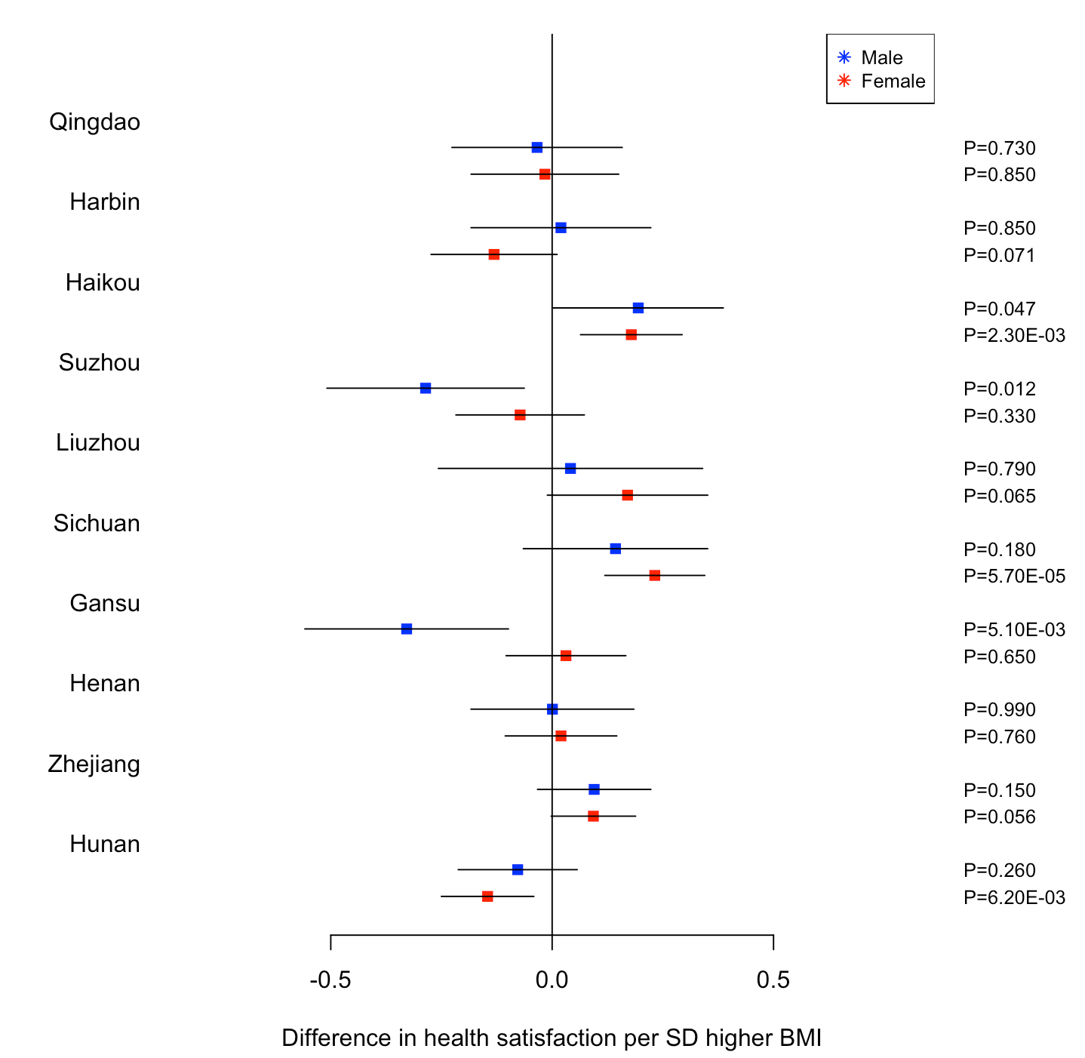
SF2: The observational and 1-sample genetic associations between BMI and life satisfaction in all individuals in the CKB and UKB, stratified by sex.
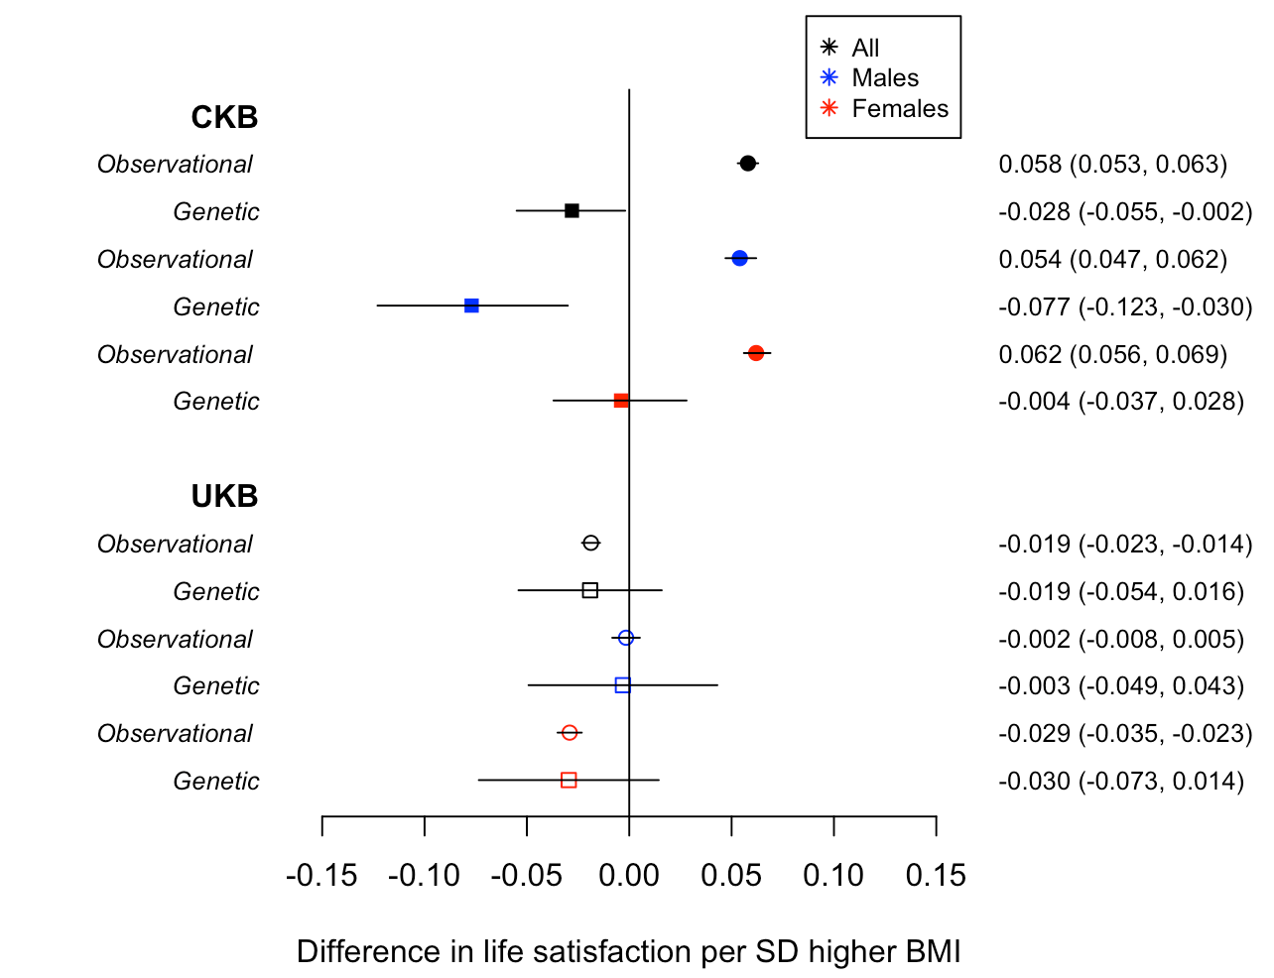

SF3: The 1-sample MR associations between BMI and life satisfaction in all individuals in the CKB and UKB stratified by sex and urban versus rural dwelling.

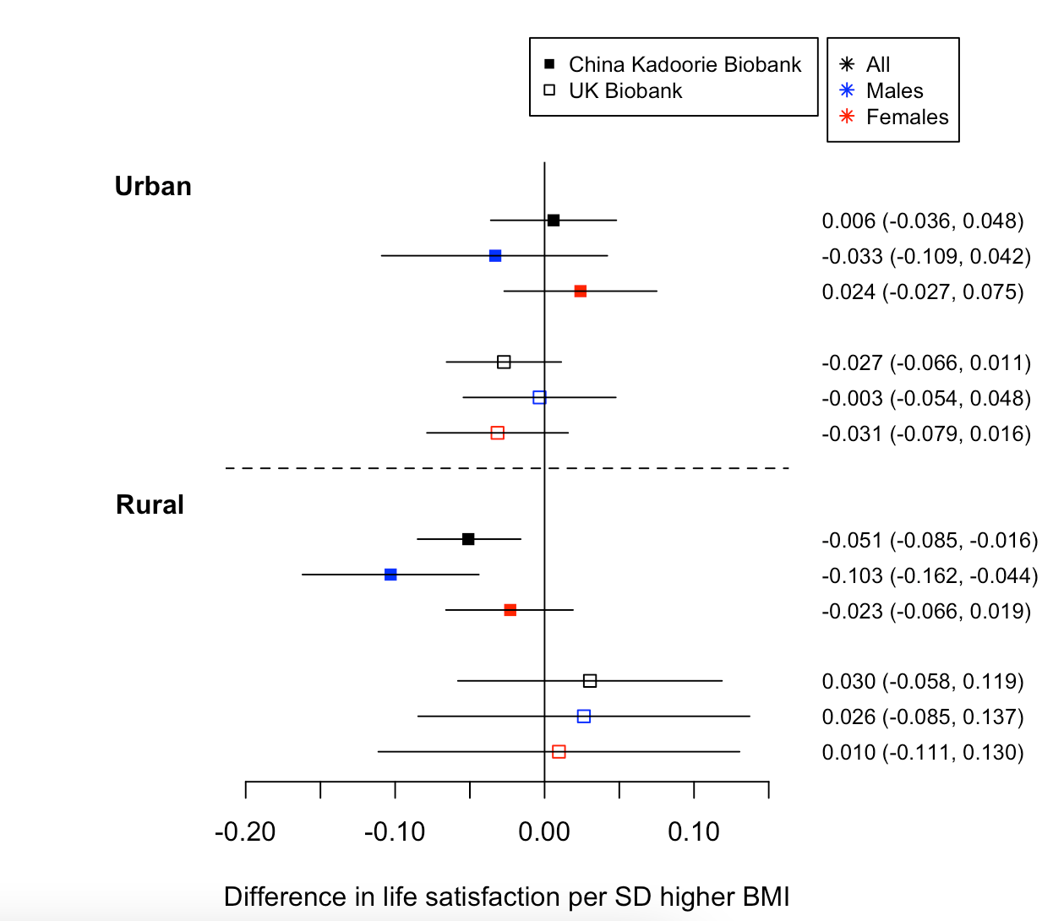
SF4: The genetic 1-sample Mendelian Randomization estimates of BMI to life satisfaction stratified by sex and region of residence within China.
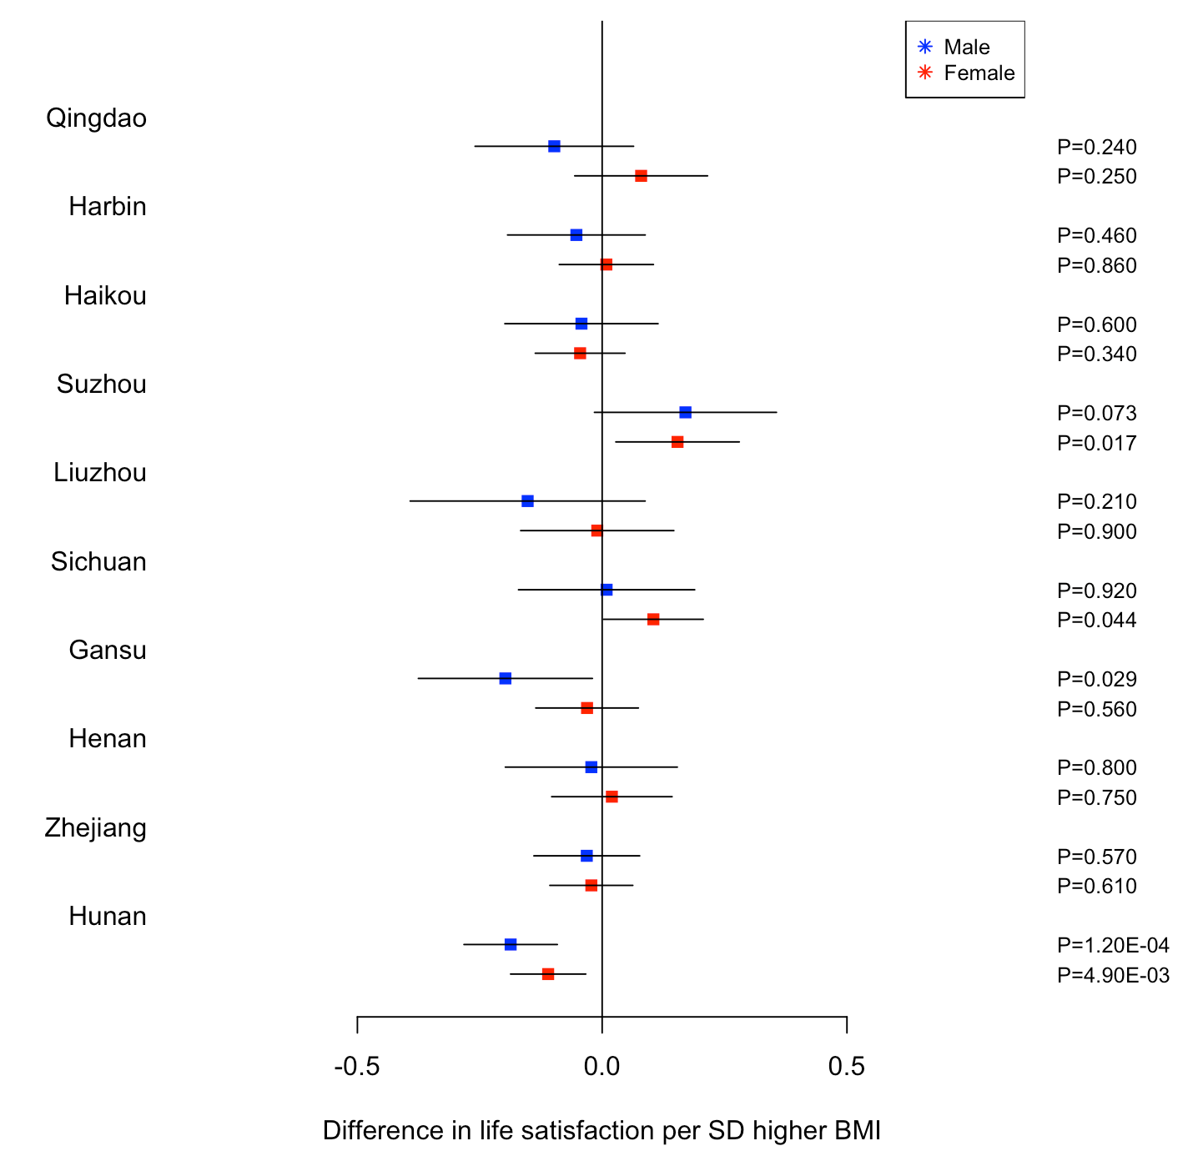
SF5: The observational and 1-sample genetic associations between BMI and life satisfaction in all individuals in the CKB and UKB, stratified by sex. CKB estimates are reported without Hunan as the prevalence of people reporting to be unsatisfied was less than 1%
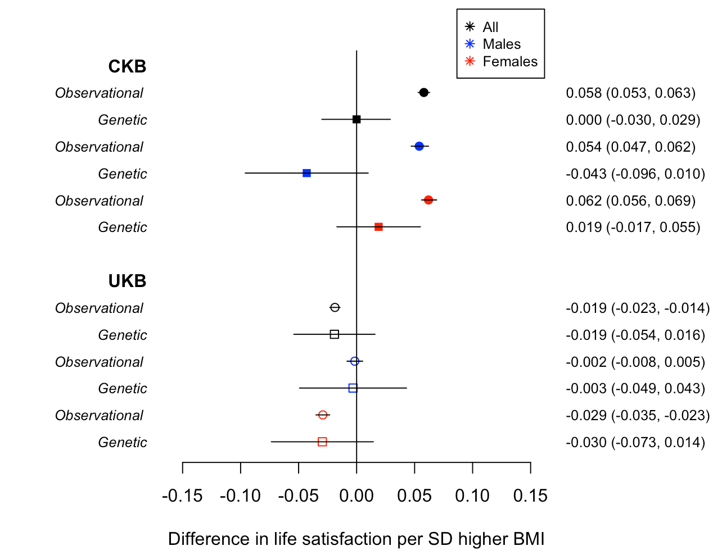
SF6: The 1-sample MR associations between BMI and life satisfaction in all individuals in the CKB and UKB stratified by sex and urban versus rural dwelling. CKB estimates are reported without Hunan as the prevalence of people reporting to be unsatisfied was less than 1%
