SUPPLEMENTARY CONTENT
Table of Contents
SUPPLEMENTARY TEXT 2
sMRI 2
Imaging processing 2
Imaging quality assurance 2
DTI 2
Imaging processing 2
Imaging quality assurance 2
fMRI 2
Imaging processing 2
Imaging quality assurance 2
References 3
SUPPLEMENTARY TABLES 4
Table S1. Prenatal infection and focal brain sMRI (not ICV corrected) (standardized coefficients) 4
Table S2. Prenatal infection and global brain sMRI (intracranial volume corrected) (standardized coefficients) 5
Table S3. Prenatal infection and focal sMRI outcomes (intracranial volume corrected) (standardized coefficients) 6
Table S4. Effect of prenatal fever on significant brain outcomes (standardized coefficients) 7
Table S5. Moderating effect of sex on significant brain outcomes (standardized coefficients) 8
Table S6. Effect of timing of prenatal infection on significant brain outcomes (standardized coefficients) 9
Table S7. Prenatal infection and focal DTI outcomes (standardized coefficients) 10
Table S8. Prenatal infection and focal fMRI outcomes (standardized coefficients) 11
Table S9. Region-based connectivity analysis 12
SUPPLEMENTARY FIGURES 24
Figure S1. Distribution different infection types. Figures 1A-C show the distribution of the infection types for trimester 1, 2 and 3, respectively. 24
Figure S2. Correlation between C-reactive protein levels <18 weeks of gestation (1 fixed time point measurement available in Generation R) and total and trimester-based prenatal infection scores. 25
Figure S3. Correlation plot global brain outcomes. 26
Figure S4. Correlation plot focal brain outcomes. 27

SUPPLEMENTARY TEXT

sMRI

Imaging processing
The data was processed with FreeSurfer analysis suite (version 6.0.0) [http://surfer.nmr.mgh.harvard.edu/]. The images were individually processed with FreeSurfer. Then, raw DICOM data was converted to ‘MGZ-files’, after which skull stripping, intensity normalization, and voxel segmentation of gray and white matter and cerebrospinal fluid took place. The Desikan-Killiany atlas was used to label the gray matter regions.¹ More detailed steps can be found elsewhere.²

Imaging quality assurance
To assure the quality of the scans, FreeSurfer image reconstructions were visually inspected by at least one rater (trained master, PhD, or postdoctoral students). The inspection entailed inspection of the gray-white matter delineating by FreeSurfer. All scans were rated on the Likert scale (poor, questionable, good). Unusably or poor-quality scans were excluded. The visual ratings were compared to an automated quality assessment and the Euler number. More details have been described previously.^{3,4}

DTI

Imaging processing
Probabilistic fiber tractography was applied on each child’s native space diffusion data. This was performed with the FSL plugin ‘AutoPtx’. This plugin automatically identifies connectivity distributions for fiber bundles that are commonly reported. A nonlinear transformation from the FMRIB FA map was applied to generate connectivity distributions to map every child’s native space. The number of successful seed-to-target attempts was used to normalize connectivity distributions. More information can be found elsewhere.⁵

Imaging quality assurance
Both manual and automated quality control was applied. For the manual assessment, visual inspected was performed using the sum-of-squares error of the tensor calculation and the tract reconstructions. For the automated assessment, translation and rotation motion parameters for the eddy tool was used in order to exclude data of children with excessive motion. More information can be found elsewhere.⁵

fMRI

Imaging processing
FMRIPrep pipeline (version 20.1.1) was used to pre-process all the images. This pipeline includes volume realignment for motion from rotation and translation, slice-timing correction, and inter-subject registration. Non-linear registration (antsRegistration tool, version 2.1.0) was used for spatial normalization. More information can be found elsewhere.⁶

Imaging quality assurance
Scans with high motion (based on mean framewise displacement higher than 0.25 mm or more than 20% of the volumes with a framewise displacement higher than 0.2 mm) were excluded. Moreover, the scans were visually inspected for co-registration, major artifacts, and whole-brain coverage. More information can be found elsewhere.⁷

References
1. Desikan RS, Ségonne F, Fischl B, et al. An automated labeling system for subdividing the human cerebral cortex on MRI scans into gyral based regions of interest. NeuroImage. 2006;31(3):968-980. doi:10.1016/j.neuroimage.2006.01.021
2. Fischl B. FreeSurfer. NeuroImage. 2012;62(2):774-781. doi:10.1016/j.neuroimage.2012.01.021
3. Muetzel RL, Blanken LME, van der Ende J, et al. Tracking Brain Development and Dimensional Psychiatric Symptoms in Children: A Longitudinal Population-Based Neuroimaging Study. Am J Psychiatry. 2018;175(1):54-62. doi:10.1176/appi.ajp.2017.16070813
4. White T, Muetzel RL, El Marroun H, et al. Paediatric population neuroimaging and the Generation R Study: the second wave. Eur J Epidemiol. 2018;33(1):99-125. doi:10.1007/s10654-017-0319-y
5. Dall’Aglio L, Xu B, Tiemeier H, Muetzel R. Longitudinal Associations Between White Matter Microstructure and Psychiatric Symptoms in Adolescence. medRxiv. Published online 2022. doi:https://doi.org/10.1101/2022.08.27.22279298
6. Dall’Aglio L, Estevez-Lopez F, Lopez-Vicente M, et al. Exploring the longitudinal associations of functional network connectivity and psychiatric symptom changes in youth. medRxiv. Published online 2022. doi:https://doi.org/10.1101/2022.11.26.22282787
7. López-Vicente M, Agcaoglu O, Pérez-Crespo L, et al. Developmental Changes in Dynamic Functional Connectivity From Childhood Into Adolescence. Front Syst Neurosci. 2021;15:724805. doi:10.3389/fnsys.2021.724805

SUPPLEMENTARY TABLES

Table S1. Prenatal infection and focal brain sMRI (not ICV corrected) (standardized coefficients)
 | $β$-coefficient | 95% Confidence interval |  | P-value
Brain stem | -0.005 | -0.061 | 0.050 | 0.848
Thalamus | -0.038 | -0.093 | 0.017 | 0.177
Caudate | 0.008 | -0.050 | 0.067 | 0.784
Putamen | 0.012 | -0.043 | 0.068 | 0.666
Hippocampus | -0.023 | -0.080 | 0.033 | 0.414
Amygdala | -0.026 | -0.081 | 0.029 | 0.359
Accumbens | 0.055 | -0.004 | 0.114 | 0.067
Banks of the superior temporal sulcus | -0.038 | -0.095 | 0.018 | 0.188
Caudal anterior cingulate | -0.104 | -0.164 | -0.045 | <0.001**
Caudal middle frontal | -0.032 | -0.091 | 0.027 | 0.286
Cuneus | -0.041 | -0.099 | 0.015 | 0.154
Entorhinal | -0.062 | -0.121 | -0.004 | 0.035*
Fusiform gyrus | -0.030 | -0.084 | 0.024 | 0.276
Inferior parietal | -0.019 | -0.074 | 0.035 | 0.484
Inferior temporal | -0.050 | -0.106 | 0.004 | 0.072
Isthmus cingulate | -0.027 | -0.081 | 0.027 | 0.329
Lateral occipital | -0.026 | -0.080 | 0.027 | 0.337
Lateral orbitofrontal | -0.063 | -0.120 | -0.007 | 0.027*
Lingual | 0.003 | -0.055 | 0.061 | 0.909
Medial orbito frontal | -0.047 | -0.102 | 0.006 | 0.086
Middle temporal | -0.018 | -0.073 | 0.036 | 0.514
Parahippocampal | -0.072 | -0.132 | -0.012 | 0.018*
Paracentral | -0.030 | -0.087 | 0.026 | 0.296
Pars opercularis | 0.025 | -0.033 | 0.084 | 0.394
Pars orbitalis | -0.058 | -0.117 | -0.001 | 0.047*
Pars triangularis | -0.001 | -0.058 | 0.056 | 0.969
Pericalcarine | -0.020 | -0.081 | 0.040 | 0.504
Postcentral | -0.054 | -0.110 | 0.001 | 0.055
Posterior cingulate | -0.051 | -0.107 | 0.005 | 0.074
Precentral | -0.053 | -0.108 | 0.002 | 0.062
Precuneus | -0.020 | -0.073 | 0.032 | 0.447
Rostral anterior cingulate | -0.050 | -0.108 | 0.006 | 0.082
Rostral middle frontal | -0.059 | -0.113 | -0.005 | 0.030*
Superior frontal | -0.030 | -0.087 | 0.020 | 0.220
Superior parietal | -0.038 | -0.094 | 0.017 | 0.177
Superior temporal | -0.035 | -0.093 | 0.022 | 0.229
Supramarginal | -0.001 | -0.056 | 0.053 | 0.959
Frontal pole | -0.026 | -0.087 | 0.034 | 0.388
Temporal pole | 0.002 | -0.058 | 0.063 | 0.935
Transverse temporal | -0.068 | -0.127 | -0.009 | 0.023*
Insula | -0.016 | -0.071 | 0.037 | 0.546
Corpus callosum posterior | -0.014 | -0.075 | 0.046 | 0.650
Corpus callosum mid posterior | -0.041 | -0.102 | 0.019 | 0.183
Corpus callosum central | 0.020 | -0.041 | 0.081 | 0.518
Corpus callosum mid anterior | -0.029 | -0.091 | 0.031 | 0.338
Corpus callosum anterior | -0.057 | -0.119 | 0.003 | 0.066
*p < 0.05
**Bonferroni-corrected p < 0.007 for global outcomes
**Bonferroni-corrected p < 0.001 for focal outcomes

Table S2. Prenatal infection and global brain sMRI (intracranial volume corrected) (standardized coefficients)
 |  | $β$-coefficient | 95% Confidence interval |  | P-value
sMRI
 | Lateral ventricles | -0.020 | -0.076 | 0.036 | 0.485
 | Cerebellum | 0.026 | -0.019 | 0.071 | 0.263
 | Cortical gray matter | -0.014 | -0.042 | 0.014 | 0.335
 | Cerebral white matter | -0.034 | -0.064 | -0.004 | 0.024*
*p < 0.05
**Bonferroni-corrected p < 0.007

Table S3. Prenatal infection and focal sMRI outcomes (intracranial volume corrected) (standardized coefficients)
 | $β$ -coefficient | 95% Confidence interval |  | P-value
Brain stem | 0.020 | -0.024 | 0.065 | 0.366
Thalamus | -0.008 | -0.049 | 0.031 | 0.666
Caudate | 0.031 | -0.019 | 0.082 | 0.230
Putamen | 0.031 | -0.018 | 0.082 | 0.216
Hippocampus | -0.003 | -0.050 | -0.045 | 0.915
Amygdala | -0.003 | -0.051 | 0.043 | 0.877
Accumbens | 0.075 | 0.022 | 0.128 | 0.005*
Banks of the superior temporal sulcus | -0.018 | -0.069 | 0.032 | 0.475
Caudal anterior cingulate | -0.084 | -0.137 | -0.030 | 0.002*
Caudal middle frontal | -0.008 | -0.059 | 0.042 | 0.739
Cuneus | -0.026 | -0.080 | 0.027 | 0.332
Entorhinal | -0.051 | -0.108 | 0.005 | 0.074
Fusiform gyrus | -0.004 | -0.048 | 0.038 | 0.823
Inferior parietal | 0.004 | -0.041 | 0.050 | 0.862
Inferior temporal | -0.026 | -0.072 | 0.019 | 0.258
Isthmus cingulate | -0.003 | -0.048 | 0.041 | 0.875
Lateral occipital | -0.003 | -0.048 | 0.041 | 0.879
Lateral orbitofrontal | -0.037 | -0.082 | 0.007 | 0.105
Lingual | 0.022 | -0.030 | 0.075 | 0.403
Medial orbito frontal | -0.023 | -0.068 | 0.021 | 0.299
Middle temporal | 0.006 | -0.038 | 0.051 | 0.777
Parahippocampal | -0.053 | -0.108 | 0.001 | 0.055
Paracentral | -0.008 | -0.058 | 0.041 | 0.734
Pars opercularis | 0.045 | -0.007 | 0.098 | 0.094
Pars orbitalis | -0.040 | -0.094 | 0.012 | 0.132
Pars triangularis | 0.014 | -0.039 | 0.067 | 0.607
Pericalcarine | -0.007 | -0.065 | 0.050 | 0.805
Postcentral | -0.029 | -0.075 | 0.016 | 0.205
Posterior cingulate | -0.026 | -0.073 | 0.019 | 0.257
Precentral | -0.027 | -0.071 | 0.017 | 0.232
Precuneus | 0.005 | -0.034 | 0.046 | 0.775
Rostral anterior cingulate | -0.025 | -0.072 | 0.021 | 0.291
Rostral middle frontal | -0.033 | -0.075 | 0.008 | 0.117
Superior frontal | -0.006 | -0.046 | 0.034 | 0.765
Superior parietal | -0.013 | -0.058 | 0.032 | 0.572
Superior temporal | -0.008 | -0.054 | 0.037 | 0.718
Supramarginal | 0.023 | -0.021 | 0.067 | 0.307
Frontal pole | -0.020 | -0.080 | 0.040 | 0.512
Temporal pole | 0.008 | -0.052 | 0.068 | 0.790
Transverse temporal | -0.047 | -0.100 | 0.005 | 0.077
Insula | 0.008 | -0.035 | 0.052 | 0.699
Corpus callosum posterior | 0.0001 | -0.057 | 0.058 | 0.975
Corpus callosum mid posterior | -0.026 | -0.084 | 0.031 | 0.373
Corpus callosum central | 0.024 | -0.036 | 0.086 | 0.425
Corpus callosum mid anterior | -0.023 | -0.084 | 0.036 | 0.439
Corpus callosum anterior | -0.037 | -0.092 | 0.018 | 0.189
*p < 0.05
**Bonferroni-corrected p < 0.001

Table S4. Effect of prenatal fever on significant brain outcomes (standardized coefficients)
 | $β$ -coefficient | 95% Confidence interval |  | P-value
Caudal anterior cingulate | -0.058 | -0.110 | -0.006 | 0.026*
Cerebral white matter | -0.010 | -0.039 | 0.019 | 0.499
Accumbens | 0.040 | -0.011 | 0.091 | 0.127
*p < 0.05
**Bonferroni-corrected p < 0.007 for cerebral white matter
**Bonferroni-corrected p < 0.001 for caudal anterior cingulate and accumbens

Table S5. Moderating effect of sex on significant brain outcomes (standardized coefficients)
 | $β$ -coefficient | 95% Confidence interval |  | P-value
Caudal anterior cingulate | -0.060 | -0.138 | 0.017 | 0.130
Cerebral white matter | -0.022 | -0.065 | 0.021 | 0.323
Accumbens | 0.047 | -0.030 | 0.124 | 0.231
*p < 0.05
**Bonferroni-corrected p < 0.007 for cerebral white matter
**Bonferroni-corrected p < 0.001 for caudal anterior cingulate and accumbens

Table S6. Effect of timing of prenatal infection on significant brain outcomes (standardized coefficients)
 |  | $β$ -coefficient | 95% Confidence interval |  | P-value
Trimester 1
 | Caudal anterior cingulate | -0.057 | -0.110 | -0.005 | 0.031*
 | Cerebral white matter | -0.025 | -0.054 | 0.004 | 0.096
 | Accumbens | 0.051 | 0.000 | 0.104 | 0.051
Trimester 2
 | Caudal anterior cingulate | -0.077 | -0.130 | -0.024 | 0.004*
 | Cerebral white matter | -0.029 | -0.059 | 0.000 | 0.048*
 | Accumbens | 0.061 | 0.009 | 0.114 | 0.020*
Trimester 3
 | Caudal anterior cingulate | -0.043 | -0.096 | 0.008 | 0.103
 | Cerebral white matter | -0.018 | -0.048 | 0.010 | 0.216
 | Accumbens | 0.046 | -0.005 | 0.099 | 0.080
*p < 0.05
**Bonferroni-corrected p < 0.007 for cerebral white matter
**Bonferroni-corrected p < 0.001 for caudal anterior cingulate and accumbens

Table S7. Prenatal infection and focal DTI outcomes (standardized coefficients)
 | $β$ -coefficient | 95% Confidence interval |  | P-value
Mean diffusivity
Uncinate fasiculus | -0.006 | -0.065 | 0.053 | 0.840
Cingulum | 0.014 | -0.045 | 0.074 | 0.636
Superior longitudinal fasciculus | 0.000 | -0.058 | 0.059 | 0.995
Forceps minor | -0.009 | -0.069 | 0.050 | 0.762
Forceps major | 0.041 | -0.017 | 0.1014 | 0.167
Inferior longitudinal fasiculus | -0.031 | -0.090 | 0.026 | 0.287
Corticospinal tract | -0.020 | -0.080 | 0.039 | 0.505
Fractional anisotropy
Uncinate fasiculus | 0.013 | -0.045 | 0.072 | 0.663
Cingulum | -0.002 | -0.060 | 0.056 | 0.946
Superior longitudinal fasciculus | -0.005 | -0.064 | 0.053 | 0.856
Forceps minor | -0.012 | -0.071 | 0.047 | 0.683
Forceps major | -0.008 | -0.068 | 0.051 | 0.783
Inferior longitudinal fasiculus | 0.016 | -0.042 | 0.075 | 0.580
Corticospinal tract | 0.030 | -0.029 | 0.089 | 0.316
*p < 0.05
**Bonferroni-corrected p < 0.001

Table S8. Prenatal infection and focal fMRI outcomes (standardized coefficients)
 | $β$ -coefficient | 95% Confidence interval |  | P-value
Within network functional connectivity
None | -0.000 | -0.062 | 0.061 | 0.995
Default | 0.016 | -0.045 | 0.077 | 0.602
Parieto occipital | 0.001 | -0.060 | 0.063 | 0.963
Frontoparietal | -0.038 | -0.101 | 0.024 | 0.226
Salience | 0.017 | -0.046 | 0.081 | 0.586
Cingulo opercular | -0.001 | -0.064 | 0.061 | 0.968
Medial parietal | -0.032 | -0.096 | 0.031 | 0.314
Dorsal attention | -0.029 | -0.091 | 0.033 | 0.358
Ventral attention | 0.011 | -0.051 | 0.074 | 0.721
Visual | -0.027 | -0.089 | 0.034 | 0.385
Somatomotor hand | -0.022 | -0.086 | 0.040 | 0.479
Somatomotor mouth | 0.005 | -0.058 | 0.068 | 0.871
Auditory | 0.000 | -0.062 | 0.063 | 0.987
Between network functional connectivity
None | -0.017 | -0.080 | 0.046 | 0.595
Default | 0.014 | -0.049 | 0.078 | 0.655
Parieto occipital | -0.015 | -0.077 | 0.047 | 0.637
Frontoparietal | -0.021 | -0.083 | 0.042 | 0.508
Salience | -0.010 | -0.073 | 0.052 | 0.744
Cingulo opercular | -0.008 | -0.071 | 0.054 | 0.792
Medial parietal | -0.027 | -0.089 | 0.036 | 0.400
Dorsal attention | -0.022 | -0.085 | 0.041 | 0.489
Ventral attention | -0.016 | -0.079 | 0.047 | 0.614
Visual | -0.004 | -0.066 | 0.059 | 0.906
Somatomotor hand | -0.013 | -0.076 | 0.049 | 0.674
Somatomotor mouth | 0.002 | -0.060 | 0.065 | 0.954
Auditory | -0.007 | -0.070 | 0.056 | 0.820
*p < 0.05
**Bonferroni-corrected p < 0.001

Table S9. Region-based connectivity analysis
Gordon parcellation region | beta coefficient | lower CI | upper CI | p-value | FDR p-value
L_None_1 | 0.008 | -0.004 | 0.020 | 0.180 | 0.998
L_None_2 | -0.004 | -0.017 | 0.009 | 0.570 | 0.998
L_None_3 | -0.001 | -0.014 | 0.012 | 0.874 | 0.998
L_None_4 | -0.007 | -0.020 | 0.007 | 0.326 | 0.998
L_None_5 | -0.011 | -0.028 | 0.005 | 0.160 | 0.998
L_None_6 | -0.009 | -0.023 | 0.006 | 0.264 | 0.998
L_None_7 | -0.010 | -0.027 | 0.007 | 0.243 | 0.998
L_None_8 | -0.004 | -0.020 | 0.012 | 0.639 | 0.998
L_None_9 | -0.004 | -0.020 | 0.012 | 0.606 | 0.998
L_None_10 | -0.006 | -0.020 | 0.009 | 0.429 | 0.998
L_None_11 | -0.002 | -0.015 | 0.011 | 0.811 | 0.998
L_None_12 | 0.006 | -0.007 | 0.019 | 0.370 | 0.998
L_None_13 | -0.007 | -0.020 | 0.006 | 0.278 | 0.998
L_None_14 | 0.005 | -0.009 | 0.020 | 0.474 | 0.998
L_None_15 | 0.002 | -0.014 | 0.017 | 0.821 | 0.998
L_None_16 | -0.003 | -0.017 | 0.011 | 0.667 | 0.998
L_None_17 | 0.000 | -0.013 | 0.014 | 0.969 | 0.998
L_None_18 | -0.006 | -0.019 | 0.008 | 0.415 | 0.998
L_None_19 | 0.008 | -0.006 | 0.022 | 0.268 | 0.998
L_None_20 | -0.001 | -0.014 | 0.011 | 0.820 | 0.998
L_None_21 | -0.001 | -0.016 | 0.014 | 0.910 | 0.998
R_None_22 | -0.012 | -0.029 | 0.005 | 0.168 | 0.998
R_None_23 | 0.009 | -0.008 | 0.026 | 0.288 | 0.998
R_None_24 | 0.008 | -0.010 | 0.026 | 0.364 | 0.998
R_None_25 | 0.001 | -0.018 | 0.021 | 0.880 | 0.998
R_None_26 | -0.003 | -0.021 | 0.015 | 0.766 | 0.998
R_None_27 | -0.016 | -0.035 | 0.003 | 0.100 | 0.998
R_None_28 | -0.013 | -0.030 | 0.004 | 0.124 | 0.998
R_None_29 | -0.010 | -0.028 | 0.008 | 0.262 | 0.998
R_None_30 | -0.009 | -0.025 | 0.008 | 0.303 | 0.998
R_None_31 | -0.004 | -0.020 | 0.013 | 0.645 | 0.998
R_None_32 | 0.006 | -0.010 | 0.022 | 0.476 | 0.998
R_None_33 | 0.004 | -0.013 | 0.021 | 0.626 | 0.998
R_None_34 | 0.007 | -0.012 | 0.025 | 0.474 | 0.998
R_None_35 | -0.002 | -0.021 | 0.017 | 0.814 | 0.998
R_None_36 | 0.002 | -0.016 | 0.021 | 0.827 | 0.998
R_None_37 | -0.002 | -0.019 | 0.016 | 0.858 | 0.998
R_None_38 | -0.001 | -0.018 | 0.017 | 0.933 | 0.998
R_None_39 | -0.018 | -0.039 | 0.003 | 0.092 | 0.998
R_None_40 | -0.011 | -0.028 | 0.006 | 0.208 | 0.998
R_None_41 | -0.001 | -0.020 | 0.017 | 0.885 | 0.998
R_None_42 | -0.008 | -0.023 | 0.008 | 0.325 | 0.998
R_None_43 | -0.010 | -0.027 | 0.006 | 0.222 | 0.998
R_None_44 | -0.008 | -0.023 | 0.008 | 0.332 | 0.998
R_None_45 | 0.001 | -0.013 | 0.016 | 0.854 | 0.998
R_None_46 | 0.008 | -0.012 | 0.028 | 0.413 | 0.998
R_None_47 | -0.007 | -0.022 | 0.008 | 0.340 | 0.998
L_Default_1 | 0.003 | -0.016 | 0.021 | 0.782 | 0.998
L_Default_2 | -0.003 | -0.020 | 0.014 | 0.734 | 0.998
L_Default_3 | -0.006 | -0.022 | 0.010 | 0.484 | 0.998
L_Default_4 | 0.006 | -0.012 | 0.024 | 0.499 | 0.998
L_Default_5 | -0.003 | -0.019 | 0.014 | 0.749 | 0.998
L_Default_6 | 0.005 | -0.013 | 0.023 | 0.592 | 0.998
L_Default_7 | 0.000 | -0.018 | 0.019 | 0.969 | 0.998
L_Default_8 | 0.012 | -0.007 | 0.031 | 0.210 | 0.998
L_Default_9 | -0.010 | -0.027 | 0.006 | 0.214 | 0.998
L_Default_10 | 0.003 | -0.015 | 0.020 | 0.747 | 0.998
L_Default_11 | 0.002 | -0.014 | 0.018 | 0.784 | 0.998
L_Default_12 | 0.005 | -0.011 | 0.021 | 0.550 | 0.998
L_Default_13 | 0.000 | -0.017 | 0.017 | 0.993 | 0.998
L_Default_14 | 0.001 | -0.017 | 0.019 | 0.916 | 0.998
L_Default_15 | 0.008 | -0.009 | 0.026 | 0.352 | 0.998
L_Default_16 | 0.003 | -0.015 | 0.021 | 0.727 | 0.998
L_Default_17 | 0.004 | -0.013 | 0.020 | 0.646 | 0.998
L_Default_18 | -0.002 | -0.018 | 0.015 | 0.832 | 0.998
L_Default_19 | 0.002 | -0.015 | 0.018 | 0.854 | 0.998
L_Default_20 | -0.003 | -0.020 | 0.015 | 0.776 | 0.998
R_Default_21 | 0.002 | -0.015 | 0.020 | 0.808 | 0.998
R_Default_22 | -0.009 | -0.026 | 0.008 | 0.308 | 0.998
R_Default_23 | 0.006 | -0.011 | 0.023 | 0.480 | 0.998
R_Default_24 | -0.001 | -0.018 | 0.017 | 0.945 | 0.998
R_Default_25 | 0.001 | -0.016 | 0.018 | 0.926 | 0.998
R_Default_26 | 0.007 | -0.012 | 0.025 | 0.483 | 0.998
R_Default_27 | -0.001 | -0.019 | 0.018 | 0.957 | 0.998
R_Default_28 | -0.007 | -0.022 | 0.008 | 0.377 | 0.998
R_Default_29 | -0.010 | -0.026 | 0.005 | 0.186 | 0.998
R_Default_30 | -0.020 | -0.035 | -0.005 | 0.009* | 0.998
R_Default_31 | 0.002 | -0.015 | 0.019 | 0.827 | 0.998
R_Default_32 | 0.002 | -0.016 | 0.020 | 0.843 | 0.998
R_Default_33 | 0.000 | -0.017 | 0.017 | 0.998 | 0.998
R_Default_34 | -0.002 | -0.019 | 0.014 | 0.768 | 0.998
R_Default_35 | -0.011 | -0.028 | 0.006 | 0.205 | 0.998
R_Default_36 | -0.011 | -0.028 | 0.006 | 0.196 | 0.998
R_Default_37 | -0.008 | -0.025 | 0.009 | 0.377 | 0.998
R_Default_38 | 0.003 | -0.015 | 0.021 | 0.751 | 0.998
R_Default_39 | -0.011 | -0.027 | 0.005 | 0.191 | 0.998
R_Default_40 | -0.015 | -0.031 | 0.001 | 0.063 | 0.998
R_Default_41 | -0.005 | -0.021 | 0.011 | 0.567 | 0.998
L_ParietoOccip_1 | -0.008 | -0.024 | 0.008 | 0.323 | 0.998
L_ParietoOccip_2 | -0.024 | -0.039 | -0.008 | 0.002* | 0.779
L_ParietoOccip_3 | -0.013 | -0.031 | 0.005 | 0.152 | 0.998
L_ParietoOccip_4 | 0.000 | -0.017 | 0.018 | 0.970 | 0.998
R_ParietoOccip_5 | -0.003 | -0.020 | 0.013 | 0.691 | 0.998
R_ParietoOccip_6 | 0.003 | -0.016 | 0.023 | 0.748 | 0.998
R_ParietoOccip_7 | -0.002 | -0.019 | 0.014 | 0.775 | 0.998
R_ParietoOccip_8 | 0.005 | -0.014 | 0.024 | 0.619 | 0.998
L_FrontoParietal_1 | -0.004 | -0.021 | 0.014 | 0.681 | 0.998
L_FrontoParietal_2 | 0.002 | -0.016 | 0.020 | 0.839 | 0.998
L_FrontoParietal_3 | 0.008 | -0.010 | 0.026 | 0.371 | 0.998
L_FrontoParietal_4 | 0.013 | -0.004 | 0.031 | 0.143 | 0.998
L_FrontoParietal_5 | 0.002 | -0.017 | 0.020 | 0.869 | 0.998
L_FrontoParietal_6 | -0.005 | -0.021 | 0.011 | 0.538 | 0.998
L_FrontoParietal_7 | -0.003 | -0.020 | 0.014 | 0.717 | 0.998
L_FrontoParietal_8 | 0.002 | -0.016 | 0.019 | 0.828 | 0.998
L_FrontoParietal_9 | -0.003 | -0.020 | 0.015 | 0.772 | 0.998
R_FrontoParietal_10 | -0.004 | -0.022 | 0.013 | 0.646 | 0.998
R_FrontoParietal_11 | 0.000 | -0.016 | 0.015 | 0.959 | 0.998
R_FrontoParietal_12 | -0.004 | -0.021 | 0.012 | 0.597 | 0.998
R_FrontoParietal_13 | 0.001 | -0.015 | 0.016 | 0.918 | 0.998
R_FrontoParietal_14 | 0.002 | -0.015 | 0.018 | 0.853 | 0.998
R_FrontoParietal_15 | 0.003 | -0.012 | 0.019 | 0.680 | 0.998
R_FrontoParietal_16 | -0.005 | -0.020 | 0.010 | 0.491 | 0.998
R_FrontoParietal_17 | 0.002 | -0.013 | 0.016 | 0.841 | 0.998
R_FrontoParietal_18 | -0.002 | -0.018 | 0.014 | 0.826 | 0.998
R_FrontoParietal_19 | -0.006 | -0.022 | 0.010 | 0.479 | 0.998
R_FrontoParietal_20 | -0.005 | -0.020 | 0.010 | 0.529 | 0.998
R_FrontoParietal_21 | 0.001 | -0.017 | 0.019 | 0.899 | 0.998
R_FrontoParietal_22 | -0.003 | -0.018 | 0.012 | 0.734 | 0.998
R_FrontoParietal_23 | -0.001 | -0.016 | 0.015 | 0.913 | 0.998
R_FrontoParietal_24 | -0.008 | -0.023 | 0.008 | 0.319 | 0.998
L_Salience_1 | 0.001 | -0.016 | 0.018 | 0.931 | 0.998
L_Salience_2 | -0.001 | -0.017 | 0.014 | 0.875 | 0.998
R_Salience_3 | -0.008 | -0.024 | 0.009 | 0.358 | 0.998
R_Salience_4 | -0.012 | -0.027 | 0.003 | 0.122 | 0.998
L_CinguloOperc_1 | -0.009 | -0.026 | 0.007 | 0.279 | 0.998
L_CinguloOperc_2 | 0.009 | -0.007 | 0.026 | 0.275 | 0.998
L_CinguloOperc_4 | 0.000 | -0.017 | 0.017 | 0.973 | 0.998
L_CinguloOperc_5 | 0.003 | -0.014 | 0.020 | 0.735 | 0.998
L_CinguloOperc_6 | 0.005 | -0.013 | 0.022 | 0.603 | 0.998
L_CinguloOperc_7 | 0.004 | -0.014 | 0.022 | 0.664 | 0.998
L_CinguloOperc_8 | -0.003 | -0.020 | 0.015 | 0.779 | 0.998
L_CinguloOperc_9 | 0.011 | -0.009 | 0.030 | 0.275 | 0.998
L_CinguloOperc_10 | 0.010 | -0.009 | 0.028 | 0.307 | 0.998
L_CinguloOperc_11 | -0.005 | -0.021 | 0.012 | 0.576 | 0.998
L_CinguloOperc_12 | -0.004 | -0.021 | 0.013 | 0.633 | 0.998
L_CinguloOperc_13 | 0.006 | -0.011 | 0.022 | 0.486 | 0.998
L_CinguloOperc_14 | 0.007 | -0.010 | 0.023 | 0.441 | 0.998
L_CinguloOperc_15 | 0.007 | -0.010 | 0.024 | 0.414 | 0.998
L_CinguloOperc_16 | 0.012 | -0.005 | 0.030 | 0.154 | 0.998
L_CinguloOperc_17 | 0.001 | -0.015 | 0.017 | 0.877 | 0.998
L_CinguloOperc_18 | -0.006 | -0.022 | 0.010 | 0.459 | 0.998
L_CinguloOperc_19 | 0.005 | -0.012 | 0.023 | 0.542 | 0.998
R_CinguloOperc_21 | -0.001 | -0.017 | 0.014 | 0.878 | 0.998
R_CinguloOperc_22 | 0.004 | -0.012 | 0.020 | 0.637 | 0.998
R_CinguloOperc_24 | -0.009 | -0.026 | 0.008 | 0.312 | 0.998
R_CinguloOperc_26 | 0.003 | -0.013 | 0.020 | 0.688 | 0.998
R_CinguloOperc_27 | -0.010 | -0.026 | 0.007 | 0.254 | 0.998
R_CinguloOperc_28 | 0.001 | -0.017 | 0.019 | 0.936 | 0.998
R_CinguloOperc_29 | 0.006 | -0.012 | 0.024 | 0.491 | 0.998
R_CinguloOperc_30 | 0.010 | -0.008 | 0.028 | 0.260 | 0.998
R_CinguloOperc_31 | -0.004 | -0.021 | 0.014 | 0.684 | 0.998
R_CinguloOperc_32 | -0.013 | -0.030 | 0.003 | 0.114 | 0.998
R_CinguloOperc_33 | 0.007 | -0.010 | 0.025 | 0.419 | 0.998
R_CinguloOperc_34 | 0.004 | -0.014 | 0.023 | 0.650 | 0.998
R_CinguloOperc_35 | 0.004 | -0.012 | 0.020 | 0.642 | 0.998
R_CinguloOperc_36 | 0.003 | -0.014 | 0.021 | 0.714 | 0.998
R_CinguloOperc_37 | -0.004 | -0.022 | 0.013 | 0.611 | 0.998
R_CinguloOperc_38 | 0.000 | -0.017 | 0.018 | 0.962 | 0.998
R_CinguloOperc_39 | -0.001 | -0.018 | 0.015 | 0.871 | 0.998
R_CinguloOperc_40 | -0.001 | -0.014 | 0.012 | 0.924 | 0.998
L_MedialParietal_1 | -0.006 | -0.019 | 0.008 | 0.404 | 0.998
L_MedialParietal_2 | -0.005 | -0.018 | 0.008 | 0.447 | 0.998
L_MedialParietal_3 | 0.010 | -0.002 | 0.021 | 0.112 | 0.998
R_MedialParietal_4 | -0.006 | -0.024 | 0.011 | 0.475 | 0.998
R_MedialParietal_5 | -0.003 | -0.016 | 0.011 | 0.709 | 0.998
L_DorsalAttn_1 | -0.003 | -0.019 | 0.013 | 0.733 | 0.998
L_DorsalAttn_2 | -0.008 | -0.023 | 0.006 | 0.272 | 0.998
L_DorsalAttn_3 | 0.001 | -0.009 | 0.012 | 0.786 | 0.998
L_DorsalAttn_4 | 0.001 | -0.013 | 0.014 | 0.912 | 0.998
L_DorsalAttn_5 | -0.005 | -0.019 | 0.008 | 0.442 | 0.998
L_DorsalAttn_6 | -0.002 | -0.016 | 0.011 | 0.749 | 0.998
L_DorsalAttn_7 | 0.006 | -0.008 | 0.020 | 0.387 | 0.998
L_DorsalAttn_8 | 0.005 | -0.010 | 0.020 | 0.525 | 0.998
L_DorsalAttn_9 | -0.001 | -0.016 | 0.015 | 0.932 | 0.998
L_DorsalAttn_10 | -0.001 | -0.015 | 0.012 | 0.843 | 0.998
L_DorsalAttn_11 | 0.002 | -0.011 | 0.014 | 0.780 | 0.998
L_DorsalAttn_12 | 0.003 | -0.011 | 0.018 | 0.655 | 0.998
L_DorsalAttn_13 | 0.003 | -0.011 | 0.017 | 0.650 | 0.998
L_DorsalAttn_14 | -0.009 | -0.022 | 0.003 | 0.152 | 0.998
L_DorsalAttn_15 | -0.001 | -0.015 | 0.013 | 0.902 | 0.998
L_DorsalAttn_16 | 0.000 | -0.014 | 0.014 | 0.982 | 0.998
L_DorsalAttn_17 | 0.002 | -0.011 | 0.014 | 0.804 | 0.998
L_DorsalAttn_18 | 0.000 | -0.013 | 0.014 | 0.946 | 0.998
L_DorsalAttn_19 | 0.001 | -0.012 | 0.015 | 0.833 | 0.998
R_DorsalAttn_20 | -0.001 | -0.014 | 0.011 | 0.826 | 0.998
R_DorsalAttn_21 | -0.018 | -0.035 | -0.001 | 0.033 | 0.998
R_DorsalAttn_22 | -0.012 | -0.030 | 0.006 | 0.203 | 0.998
R_DorsalAttn_23 | 0.004 | -0.013 | 0.022 | 0.623 | 0.998
R_DorsalAttn_24 | -0.005 | -0.022 | 0.012 | 0.564 | 0.998
R_DorsalAttn_25 | -0.013 | -0.032 | 0.005 | 0.152 | 0.998
R_DorsalAttn_26 | -0.007 | -0.026 | 0.011 | 0.434 | 0.998
R_DorsalAttn_27 | -0.005 | -0.022 | 0.012 | 0.561 | 0.998
R_DorsalAttn_28 | -0.014 | -0.030 | 0.002 | 0.077 | 0.998
R_DorsalAttn_29 | -0.019 | -0.036 | -0.002 | 0.033 | 0.998
R_DorsalAttn_30 | -0.012 | -0.028 | 0.004 | 0.146 | 0.998
R_DorsalAttn_31 | -0.003 | -0.020 | 0.014 | 0.720 | 0.998
R_DorsalAttn_32 | -0.005 | -0.022 | 0.012 | 0.542 | 0.998
L_VentralAttn_1 | -0.025 | -0.046 | -0.004 | 0.020* | 0.998
L_VentralAttn_2 | -0.002 | -0.024 | 0.020 | 0.839 | 0.998
L_VentralAttn_3 | 0.006 | -0.013 | 0.025 | 0.521 | 0.998
L_VentralAttn_4 | -0.005 | -0.024 | 0.014 | 0.610 | 0.998
L_VentralAttn_5 | -0.001 | -0.020 | 0.017 | 0.907 | 0.998
L_VentralAttn_6 | 0.002 | -0.016 | 0.020 | 0.819 | 0.998
L_VentralAttn_7 | 0.000 | -0.019 | 0.019 | 0.993 | 0.998
L_VentralAttn_8 | -0.014 | -0.031 | 0.004 | 0.120 | 0.998
L_VentralAttn_9 | 0.003 | -0.012 | 0.018 | 0.698 | 0.998
L_VentralAttn_10 | -0.015 | -0.031 | 0.000 | 0.057 | 0.998
L_VentralAttn_11 | -0.005 | -0.018 | 0.009 | 0.506 | 0.998
R_VentralAttn_12 | 0.002 | -0.012 | 0.016 | 0.769 | 0.998
R_VentralAttn_13 | 0.004 | -0.009 | 0.018 | 0.531 | 0.998
R_VentralAttn_14 | -0.003 | -0.020 | 0.013 | 0.689 | 0.998
R_VentralAttn_15 | 0.004 | -0.016 | 0.024 | 0.710 | 0.998
R_VentralAttn_16 | -0.003 | -0.020 | 0.013 | 0.681 | 0.998
R_VentralAttn_17 | -0.002 | -0.020 | 0.017 | 0.864 | 0.998
R_VentralAttn_18 | 0.007 | -0.012 | 0.025 | 0.482 | 0.998
R_VentralAttn_19 | 0.004 | -0.013 | 0.021 | 0.646 | 0.998
R_VentralAttn_20 | -0.005 | -0.021 | 0.011 | 0.525 | 0.998
R_VentralAttn_21 | -0.007 | -0.027 | 0.014 | 0.519 | 0.998
R_VentralAttn_22 | -0.013 | -0.031 | 0.004 | 0.139 | 0.998
R_VentralAttn_23 | -0.022 | -0.039 | -0.004 | 0.013 | 0.998
L_Visual_1 | -0.016 | -0.034 | 0.002 | 0.084 | 0.998
L_Visual_2 | -0.006 | -0.024 | 0.013 | 0.541 | 0.998
L_Visual_3 | 0.006 | -0.014 | 0.025 | 0.564 | 0.998
L_Visual_4 | -0.013 | -0.032 | 0.007 | 0.199 | 0.998
L_Visual_5 | -0.008 | -0.027 | 0.011 | 0.394 | 0.998
L_Visual_6 | 0.013 | -0.005 | 0.031 | 0.173 | 0.998
L_Visual_7 | -0.002 | -0.019 | 0.016 | 0.834 | 0.998
L_Visual_8 | 0.007 | -0.011 | 0.024 | 0.453 | 0.998
L_Visual_9 | -0.014 | -0.031 | 0.003 | 0.103 | 0.998
L_Visual_10 | 0.000 | -0.018 | 0.017 | 0.980 | 0.998
L_Visual_11 | -0.002 | -0.018 | 0.015 | 0.851 | 0.998
L_Visual_12 | -0.003 | -0.020 | 0.014 | 0.705 | 0.998
L_Visual_13 | -0.009 | -0.026 | 0.009 | 0.325 | 0.998
L_Visual_14 | -0.001 | -0.020 | 0.017 | 0.908 | 0.998
L_Visual_15 | 0.004 | -0.013 | 0.021 | 0.633 | 0.998
L_Visual_16 | -0.005 | -0.022 | 0.012 | 0.553 | 0.998
L_Visual_17 | -0.006 | -0.022 | 0.010 | 0.457 | 0.998
L_Visual_18 | 0.000 | -0.017 | 0.016 | 0.967 | 0.998
R_Visual_19 | 0.001 | -0.016 | 0.018 | 0.893 | 0.998
R_Visual_20 | 0.000 | -0.016 | 0.017 | 0.975 | 0.998
R_Visual_21 | -0.003 | -0.021 | 0.015 | 0.751 | 0.998
R_Visual_22 | -0.009 | -0.027 | 0.009 | 0.317 | 0.998
R_Visual_23 | -0.002 | -0.018 | 0.015 | 0.852 | 0.998
R_Visual_24 | -0.010 | -0.031 | 0.011 | 0.344 | 0.998
R_Visual_25 | -0.008 | -0.026 | 0.010 | 0.371 | 0.998
R_Visual_26 | -0.002 | -0.016 | 0.013 | 0.826 | 0.998
R_Visual_27 | -0.005 | -0.020 | 0.009 | 0.494 | 0.998
R_Visual_28 | -0.005 | -0.021 | 0.011 | 0.559 | 0.998
R_Visual_29 | -0.004 | -0.021 | 0.013 | 0.660 | 0.998
R_Visual_30 | -0.001 | -0.018 | 0.016 | 0.901 | 0.998
R_Visual_31 | -0.005 | -0.024 | 0.013 | 0.550 | 0.998
R_Visual_32 | -0.012 | -0.030 | 0.005 | 0.165 | 0.998
R_Visual_33 | -0.016 | -0.036 | 0.004 | 0.125 | 0.998
R_Visual_34 | -0.007 | -0.026 | 0.012 | 0.479 | 0.998
R_Visual_35 | -0.005 | -0.021 | 0.011 | 0.548 | 0.998
R_Visual_36 | -0.006 | -0.022 | 0.009 | 0.408 | 0.998
R_Visual_37 | -0.007 | -0.024 | 0.010 | 0.418 | 0.998
R_Visual_38 | -0.001 | -0.019 | 0.017 | 0.890 | 0.998
R_Visual_39 | -0.001 | -0.019 | 0.017 | 0.932 | 0.998
L_SMhand_1 | -0.003 | -0.021 | 0.015 | 0.760 | 0.998
L_SMhand_2 | -0.006 | -0.024 | 0.012 | 0.509 | 0.998
L_SMhand_3 | 0.009 | -0.009 | 0.028 | 0.330 | 0.998
L_SMhand_4 | -0.005 | -0.021 | 0.011 | 0.569 | 0.998
L_SMhand_5 | 0.000 | -0.017 | 0.017 | 0.996 | 0.998
L_SMhand_6 | 0.000 | -0.018 | 0.017 | 0.978 | 0.998
L_SMhand_7 | -0.007 | -0.023 | 0.010 | 0.436 | 0.998
L_SMhand_8 | -0.001 | -0.020 | 0.017 | 0.880 | 0.998
L_SMhand_9 | -0.010 | -0.028 | 0.007 | 0.256 | 0.998
L_SMhand_10 | -0.008 | -0.026 | 0.010 | 0.393 | 0.998
L_SMhand_11 | 0.004 | -0.013 | 0.020 | 0.667 | 0.998
L_SMhand_12 | -0.001 | -0.016 | 0.015 | 0.946 | 0.998
L_SMhand_13 | -0.005 | -0.021 | 0.011 | 0.522 | 0.998
L_SMhand_14 | 0.003 | -0.014 | 0.019 | 0.756 | 0.998
L_SMhand_15 | -0.008 | -0.022 | 0.006 | 0.248 | 0.998
L_SMhand_16 | 0.000 | -0.017 | 0.017 | 0.997 | 0.998
L_SMhand_17 | -0.004 | -0.019 | 0.012 | 0.629 | 0.998
L_SMhand_18 | 0.001 | -0.014 | 0.016 | 0.913 | 0.998
R_SMhand_19 | -0.001 | -0.017 | 0.016 | 0.949 | 0.998
R_SMhand_20 | 0.003 | -0.013 | 0.019 | 0.744 | 0.998
R_SMhand_21 | -0.001 | -0.016 | 0.014 | 0.914 | 0.998
R_SMhand_22 | -0.014 | -0.029 | 0.002 | 0.083 | 0.998
R_SMhand_23 | -0.001 | -0.017 | 0.015 | 0.905 | 0.998
R_SMhand_24 | 0.005 | -0.013 | 0.023 | 0.595 | 0.998
R_SMhand_25 | -0.005 | -0.022 | 0.012 | 0.538 | 0.998
R_SMhand_26 | -0.014 | -0.032 | 0.003 | 0.110 | 0.998
R_SMhand_27 | -0.009 | -0.022 | 0.005 | 0.226 | 0.998
R_SMhand_28 | 0.001 | -0.016 | 0.018 | 0.907 | 0.998
R_SMhand_29 | 0.009 | -0.007 | 0.025 | 0.258 | 0.998
R_SMhand_30 | 0.004 | -0.012 | 0.020 | 0.606 | 0.998
R_SMhand_31 | 0.002 | -0.015 | 0.018 | 0.837 | 0.998
R_SMhand_32 | -0.009 | -0.025 | 0.007 | 0.262 | 0.998
R_SMhand_33 | 0.010 | -0.006 | 0.026 | 0.212 | 0.998
R_SMhand_34 | -0.002 | -0.017 | 0.014 | 0.846 | 0.998
R_SMhand_35 | 0.004 | -0.013 | 0.020 | 0.652 | 0.998
R_SMhand_36 | 0.003 | -0.015 | 0.021 | 0.724 | 0.998
R_SMhand_37 | 0.004 | -0.015 | 0.024 | 0.659 | 0.998
R_SMhand_38 | -0.010 | -0.028 | 0.008 | 0.259 | 0.998
L_SMmouth_1 | 0.000 | -0.018 | 0.018 | 0.984 | 0.998
L_SMmouth_2 | 0.002 | -0.016 | 0.020 | 0.848 | 0.998
L_SMmouth_3 | -0.003 | -0.020 | 0.014 | 0.720 | 0.998
L_SMmouth_4 | 0.003 | -0.014 | 0.020 | 0.711 | 0.998
R_SMmouth_5 | 0.006 | -0.012 | 0.023 | 0.518 | 0.998
R_SMmouth_6 | 0.010 | -0.007 | 0.026 | 0.244 | 0.998
R_SMmouth_7 | 0.005 | -0.011 | 0.022 | 0.546 | 0.998
R_SMmouth_8 | 0.011 | -0.007 | 0.029 | 0.216 | 0.998
L_Auditory_1 | 0.002 | -0.014 | 0.019 | 0.781 | 0.998
L_Auditory_2 | 0.006 | -0.012 | 0.023 | 0.528 | 0.998
L_Auditory_3 | -0.001 | -0.018 | 0.016 | 0.873 | 0.998
L_Auditory_4 | 0.008 | -0.010 | 0.026 | 0.380 | 0.998
L_Auditory_5 | 0.005 | -0.012 | 0.021 | 0.569 | 0.998
L_Auditory_6 | -0.002 | -0.019 | 0.015 | 0.815 | 0.998
L_Auditory_7 | -0.006 | -0.021 | 0.010 | 0.489 | 0.998
L_Auditory_8 | 0.000 | -0.016 | 0.016 | 0.971 | 0.998
L_Auditory_9 | 0.005 | -0.011 | 0.022 | 0.509 | 0.998
L_Auditory_10 | -0.008 | -0.025 | 0.010 | 0.395 | 0.998
L_Auditory_11 | 0.006 | -0.010 | 0.021 | 0.487 | 0.998
L_Auditory_12 | -0.007 | -0.023 | 0.010 | 0.446 | 0.998
R_Auditory_13 | 0.001 | -0.017 | 0.019 | 0.894 | 0.998
R_Auditory_14 | 0.011 | -0.007 | 0.030 | 0.223 | 0.998
R_Auditory_15 | 0.000 | -0.016 | 0.017 | 0.954 | 0.998
R_Auditory_16 | -0.001 | -0.018 | 0.017 | 0.921 | 0.998
R_Auditory_17 | -0.006 | -0.022 | 0.010 | 0.452 | 0.998
R_Auditory_18 | -0.002 | -0.020 | 0.015 | 0.794 | 0.998
R_Auditory_19 | -0.001 | -0.018 | 0.016 | 0.938 | 0.998
R_Auditory_20 | -0.002 | -0.017 | 0.014 | 0.847 | 0.998
R_Auditory_21 | 0.006 | -0.010 | 0.022 | 0.470 | 0.998
R_Auditory_22 | 0.000 | -0.018 | 0.017 | 0.962 | 0.998
R_Auditory_23 | 0.002 | -0.015 | 0.019 | 0.810 | 0.998
R_Auditory_24 | -0.003 | -0.020 | 0.013 | 0.687 | 0.998
*Indicates p<0.05
**Indicates p-fdr corrected p<0.05

SUPPLEMENTARY FIGURES
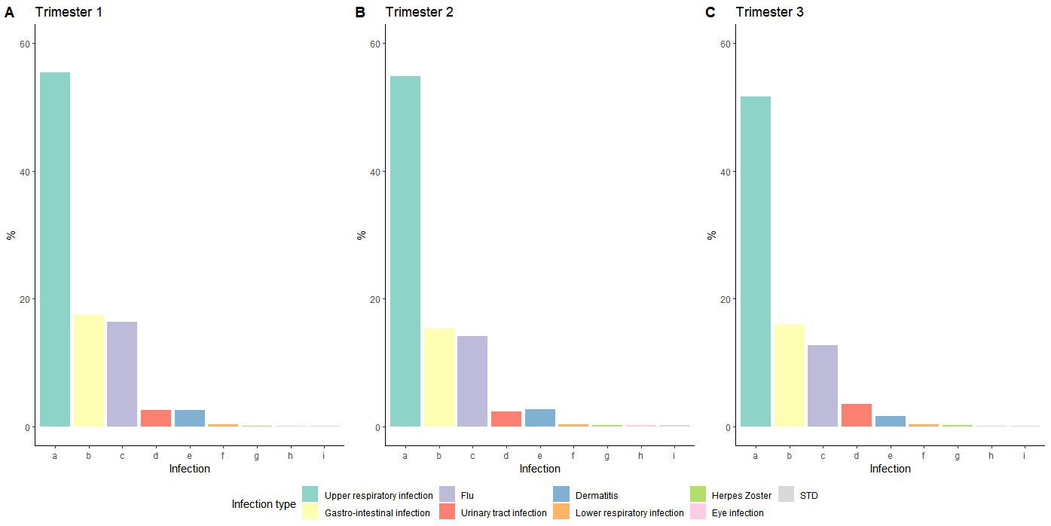

Figure S1. Distribution different infection types. Figures 1A-C show the distribution of the infection types for trimester 1, 2 and 3, respectively.

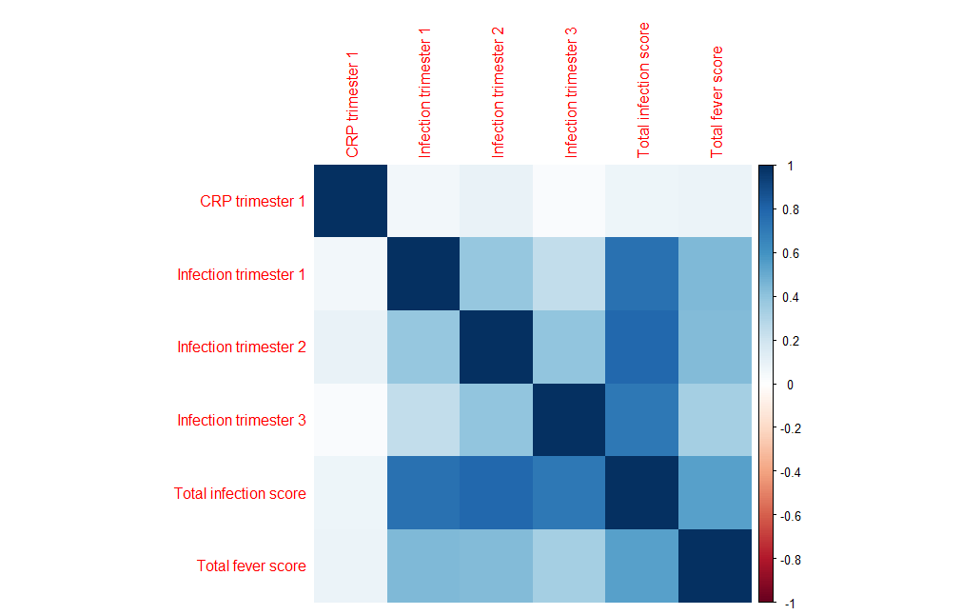

Figure S2. Correlation between C-reactive protein levels <18 weeks of gestation (1 fixed time point measurement available in Generation R) and total and trimester-based prenatal infection scores.

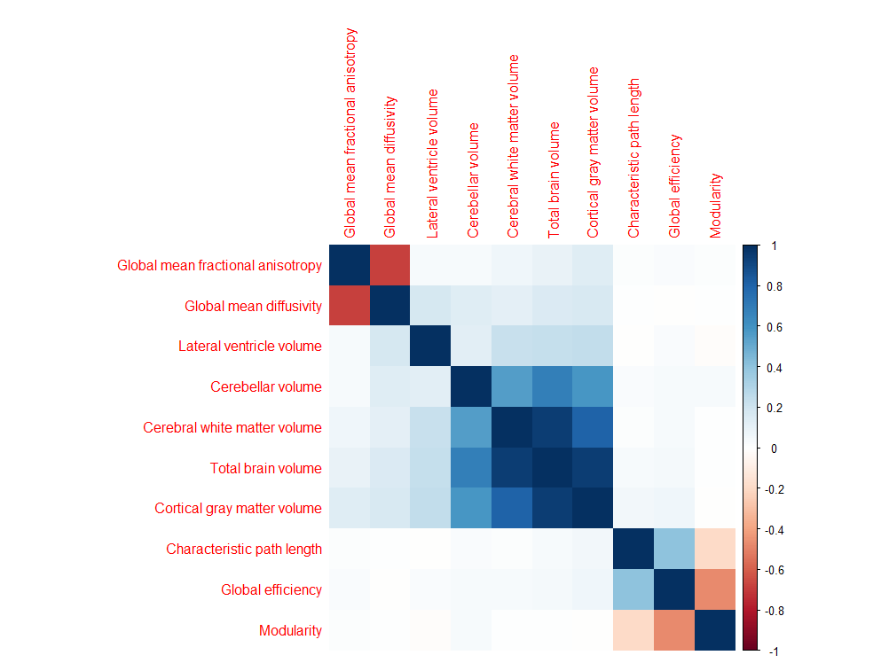

Figure S3. Correlation plot of global brain outcomes.

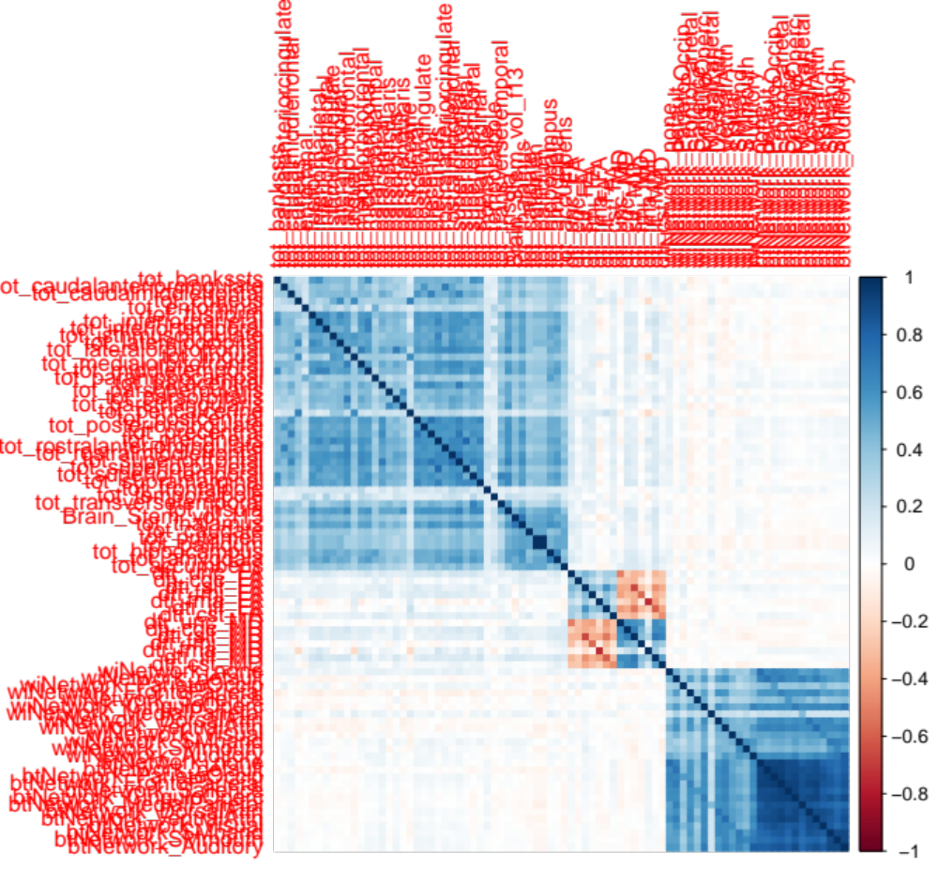

Figure S4. Correlation plot of focal brain outcomes.

